

Certificate of Higher Education in Skills for the Workplace

Task 2
Professional career development report

Student name: Mariya Vasileva Peychinova-Ananova
Student ID:2030288

Module name: Professional Career Development
Module code: (BMSW4005_LON)
Lecturer name: Bianca Sanfilippo

Submission date: 06/05/2022

Contents

Gibbs’ reflective cycle 3
Skills and knowledge which contribute toward working effectively 4
Knowledge of legislation 6
Legislation on DATA PROTECTION 7
Health and safety at work 7
My strengths and areas for further development 9
SWOT ANALYSIS 9
My employment goals and develop a personal career action 10
plan/development plan 10
Conclusion 14
References 15
Appendix 16
Appendix 1: The questions asked as an interviewer/interviewee in the role play (A1) 16
Appendix 2: Application Form completed as an applicant for the role play (A1) 17

Here I present a reflective account of the role play performed in week 9. I played the interviewer and the candidate (10 minutes each). As an interviewer, I pretended to be the Marriott Hotel’s manager and asked these questions (Appendix 1) in order to get to know someone; I wanted to get to know the genuine person. I tried to get a sense of her style, and this is an excellent open-ended question for getting to know the individual, which is a critical component of the interview. I was hoping for a touch of enthusiasm. “Passion reflects your internal belief for a particular role and your ability to demonstrate and articulate this clearly” (Neugebauer, John, and Jane Evans-Brain., 2016). I wanted to ensure she was genuinely interested in being here. Additionally, flexibility is critical; I was looking for in the position, “Once you have considered supporting what to ask and what to say, it is important to consider the skills required for success.” (Tarrant, 2013).
As the applicant, I pretended to be a speech and language therapist because it is my career pathway. With my genuine interest in people and my passion for the functioning of the human body, it was easy to pursue a career in the valuable and vital field of speech therapy.
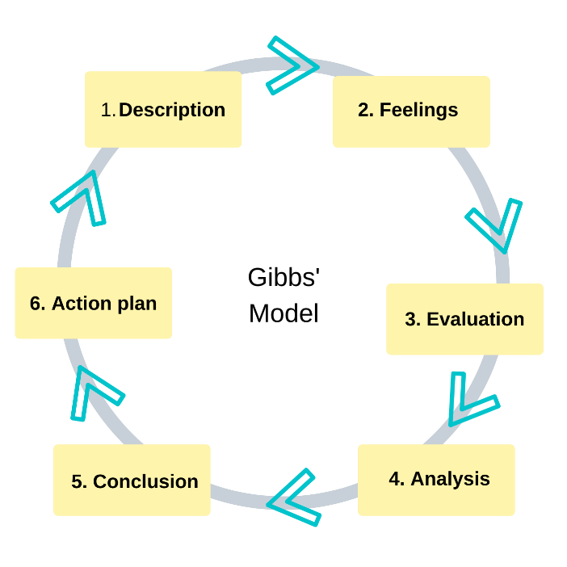
To reflect on this experience, I apply Gibb’s (1988) reflective cycle. Gibb’s model is more suitable to be implemented in this report than the other frameworks.
The Gibbs reflective cycle provides a structure for experiential learning. Feelings and ideas concerning the event. Experience evaluation, good and bad. Analyse to make sense of it. Lessons learned and what I seek to change.

The stages are the following:

Gibbs’ reflective cycle
1. Description of the event: What happened?
I was interviewed as a Speech and language therapist assistant for the job at Ribbons & Reeves, London, Full-time.

2. Feelings What were you thinking and feeling in that event?
I felt anxious but tried to centre myself with the words: confident, clear, concise, engage, informative, concerned, helpful, and even enlighten.
3. Evaluation What was good and bad about the experience?
The interviewer was professional, she was listening to me, and I could see on her face that she was connected to my talk.
The wrong side of the experience was that I wasn’t breathing, I was out of breath which made my voice disappear, and therefore it went worse because I started talking fast.
4. Analysis What sense can you make of the situation?
To be a confident communicator who recognises the impact of language and has a facial expression that reflects the mood and texture of what’s being said, someone whose voice owns the message.
5. Conclusion Draw your conclusion. What else you could have done?
First, to be sure I am breathing. I will write the word “breathe” on every page of my notes to remind me not to seize up. I must change my tone when changing topics, not be monotone. I could use the power of pauses because as I speak quickly, I am not giving people
enough time to hear, listen, think, process, assimilate, and store what I say. Pausing gives people time to think.
6. Action plan. If the same experience arose again, what would you do?
I will make every sentence sound different. I will look at the people I am talking to, watch their faces, and their facial expressions will tell me if I need to stop so they can think about what I said.

Skills and knowledge which contribute toward working effectively
Who is he - a teacher - a speech therapist? A doctor whose task is to help the child overcome an existing disease? A psychologist who is ready to listen, calm down and inspire confidence? Or a teacher who has fun games in his arsenal and answers hundreds of children’s questions?
Тo form the correct sound pronunciation in a child; it is necessary to have knowledge in the field of neuropsychology and anatomy, as well as to be able to apply speech therapy, massage and modern health technologies and to know the methods and techniques for adjusting proper speech breathing and voice. It is important to put the conclusion of the speech correctly and to develop a corrective route. In short, I must be a literate doctor. Recording to Carmel Lum, “these are skills that can be developed to a high degree of proficiency through education and practice (Lum, 2001).”
It is equally vital to interest the child. This spark of curiosity must not be extinguished in children’s eyes. To be able not only to give instructions but also to organise a new, exciting activity for children, in which, through their trials and errors, they will find the right solutions. Patience is one of the primary skills because corrective work is challenging and slow, „…also need to understand that some intervention methods applied to patients may or may not be effective” (Lum, 2001) Many different manuals, tables, games, and cards are used in the work process, most of which are made with their own hands, showing exceptional creativity and skills. I believe that with such an organisation of children’s activities, the child will strive for a positive result and enjoy their achievements. I must be a creative teacher.
The speech and language therapist must certainly be enthusiastic and have something special for his soul. Patients need to enjoy success and learn with interest. It will mean that I am not only a carrier and transmitter of information but also a creator of emotional mood.
The basis of teaching is the individual approach to each child. Yes, they are all different, each of them is unique, and each has its palette of moods and emotions. The main components of pedagogical philosophy are faith in a child, acceptance and concept of his fantastic soul, actions and expectations, and meeting one of his most essential needs - the need for love and approval. I sincerely believe that if we are full of love, understanding and respect in communicating with a child, they imitate us, will take the best and continue.
Speech and language therapy is not only a school for the education and upbringing of a child but also a kind look, affectionate speech, charm, and beauty of a teacher who gives them confidence. The first success, and then many victories, will inspire the child and me and contribute to a strong desire to achieve good results.
Communication with children and parents is vital to provide timely assistance and support. Inspire faith and hope that our efforts will not be in vain. After all, a person who struggles has faith and hope that he will overcome the worst disease, and parents want to give their children a happy and healthy life. I have to be empathetic; I have to be a careful psychologist.
The office, games, and instructions should all be engaging and valuable to them. After all, a child’s curiosity is half the success of learning the right speech. I should use modern teaching techniques and Internet resources to make lessons fun for kids. The innovative pedagogical method fosters children’s growth and interests. It promotes freedom, and I am a brilliant designer.
Constant cultivation and adaptation are other skills because we are evolving - our children are developing. In his statement, the philosopher D. Diderot said: “People stop thinking when they stop reading, and a teacher stops being a teacher if he does not understand anything new.”
Of course, success in work depends on professional knowledge, awareness of local and foreign achievements in the sciences related to speech therapy, the stages of development of the teacher himself, creative work, and initiatives. Therefore, to be competent in my profession, I will constantly be undergoing retraining, working on self-education, improving my professional level, improving my skills and knowledge, and passing them on to children, parents and teachers, “As basic as it may seem, employers require good interpersonal skills – to relate well to other individuals and to relate well across the organisation.” (Neugebauer, John, and Jane Evans-Brain., 2016)
Disadvantages of my profession: The result of work depends not only on my work but also on the participation of teachers and parents in the repair process.
Speech and language therapy is a satisfying career that organically combines the skills of different professions. The speech and language therapist must try to satisfy the needs of the child’s rapidly developing brain, to grow intellectually, to look for his own way, to think outside the box, to strive to find the most effective ways to correct vocal and cognitive-communication impairments, that is, to be a master of my craft, and this is great art.

Knowledge of legislation
Discrimination is when we are treated unfairly because of our identity. The Equality Act of 2010 protects us from discrimination. The Equality Act protects nine traits. Because we all share some of these traits, like sex or age, the Act protects us against discrimination.
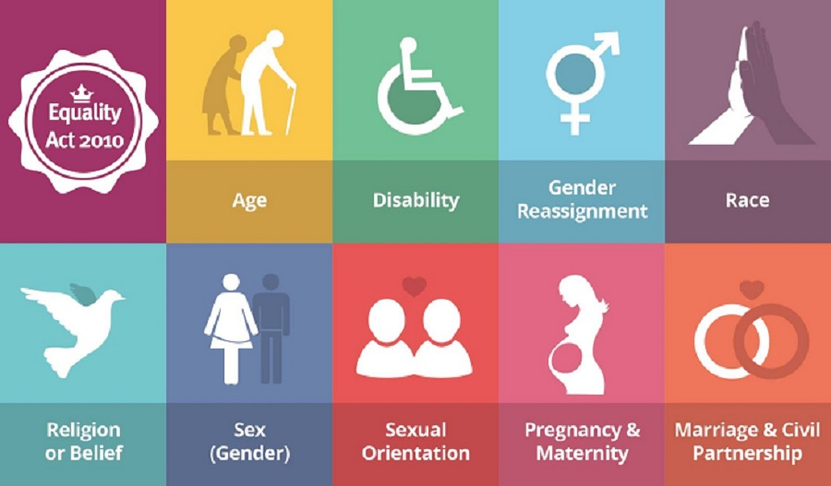

Legislation on DATA PROTECTION
Speech and language therapists are allowed to use your personal data: a legal obligation or public task under various UK legislation.
Personal data is shared between departments and services within the council to keep the information up-to-date, provide cross-departmental support, and improve services to parents and their children.


Health and safety at work


Knowledge Of Rights and Contract
Speech and language therapists are regulated by the Health and Care Professions Council (HCPC). All practising SLTs must be registered with the HCPC.
Human Rights 1998
According to this ACT, EVERYONE HAS THE RIGHT TO express THEIR opinion, be free from forced labour, right to be free/liberty, you have a legal right to join a union. It is illegal for an employer to disadvantage you because you are a union member.


My strengths and areas for further development

SWOT ANALYSIS

SWOT ANALYSIS

STRENGHTS  Humanity  Patience  Communication skills  Organisation skills  Teamwork  Time management  Interpersonal skills  IT skills | WEAKNESSES  Excessive sentiment  Academic and reflective writing skills  Discuss the strengths and weaknesses of other’s work
OPPORTUNITIES  To improve people’s lives | THREATS  Self-esteem loss

My employment goals and develop a personal career action

plan/development plan
My professional career pathway is:
Speech and language therapy
What are my current strengths?
I am highly committed, with excellent interpersonal and organisational skills, a stickler for details, dedicated and driven, flexible, positive, and innovative. Willing to share knowledge and ideas with others and looking forward to working in a team environment.

What are my achievements and areas of success since the beginning of the module/programme.
Since I picked this course based on the modules that are currently being studied, I expect to have a clearer understanding of my own strengths and shortcomings by the end of the course. I found that my future career will be as a speech and language therapist after much research and analysis.

In what areas do I need to develop?
I am originally from Bulgaria and writing academic reports in English is not something I am very adept at.
Speaking about other individuals is not a strength of mine.

Why is it important to improve in these areas?
My long-term ambition, which I believe marks the realisation of my true potential, is to gain enough experience in speech and language therapy and participate in research projects that will contribute to the amount of knowledge in the field.

Who will help me? What resources will I need?
I must read and write in English on a daily basis if I want to be successful. I have plenty of free time and a strong desire, and I am confident that I will succeed.

What are the constraints/ barriers to achieving this key are and how I will manage these– eg time, resources,
I am an ambitious person. The profession I have chosen is a sufficient motive for me to be organised. I always do the tasks that are important to me. I do one hour of gymnastics in the morning and evening, I will also include copying a book for two hours.
What further action do I need to take now?
Actions to be taken – things to do, people to see.
I must have Certificate lever 4, Skills for the Workplace and apply to study Speech and language therapy at the University. The study is 3 years.

My short - medium – long term targets for the development of my professional career plan (using Specific, Measurable, Agreed, Realistic, Time-bound –SMART targets)

Short-term plan (3 -6 months)
Specific | To have Certificate level 4, Skills for the workplace
Measurable | Study and write assignments
Agreed | To reach my goal, I must have read essential books to write assignments. I will be required to keep track of everything in a notebook.
Realistic | This is an actual plan where I can optimise my Academic skills.
Time-Bound | 6 months
Medium-term plan (1-2 years)
Specific | Continue study in course for Speech and language therapy and develops my academic knowledge and skills as well as my professional competencies
Measurable | it is part of the course that includes the social and clinical context of human communication
Agreed | It is necessary to study in the course which will prepare me to rich my goal
Realistic | Must have this knowledge to practice as Speech and language therapist
Time-Bound | Two years
Long-term plan (2-5 years)
Specific | Continue study in School of Health Sciences
Agreed | The programme will broaden my professional knowledge and clinical abilities by exposing me to a variety of client groups and communication challenges.
Realistic | By the completion of the course, I will be qualified to apply for registration with the Health and Care Professions Council (HCPC).
Time-Bound | Three years

Conclusion

The reflection on the assignment “I am a speech and language therapist” is why I examine the profession in detail and attempt to comprehend its meaning for myself and others. To educate the needy with proper, beautiful speech, teach in a fun and energetic manner, and provide an opportunity to believe in yourself and recognise that everyone is gifted and successful - this is the best career for me. “If you successfully choose a job and put your soul into it, then happiness itself will find you.”(Ushynsky, 1871).

References
Anon. (2022) RCSLT guidance to meet HCPC standards. [Online]
Available at: https://www.rcslt.org/speech-and-language-therapy/rcslt-guidance-to-meet-hcpc-standards/
[Accessed 20 4 2022].
Gibbs, G. (1988) Learning by Doing: A guide to teaching and learning methods. Further Education Unit. Oxford Polytechnic: Oxford.
Lum, C. (2001) Scientific Thinking in Speech and Language Therapy. 1 ed. New York: Psychology Press.
Neugebauer, John, and Jane Evans-Brain. (2016) Making the Most of Your Career Development. London: SAGE.
Shermer, M. (1997) Why People Believe Weird Things. 1 ed. New York: Henry Holt and Company, LLC.
Tarrant, P.( 2013) Reflective practice and professional development, London: SAGE Publications.
Ushynsky, D. K. (1871) The Human As a Subject of Education: Pedagogical Anthropology. 2 ed. S.-Peterburg: A.M. Kotomina.

Appendix

Appendix 1: The questions asked as an interviewer/interviewee in the role play (A1)

- Let me know more about you.
- Do you have any special skills that would make you a good match for this role?
- Are there any rules for a group to follow when working together?
- What time frame must you deal with a customer’s enquiry? Give an example?
- What factors influenced your decision to choose this hotel?
- Tell me your weaknesses?

The question/s asked as an interviewee in the role play (A1)

1. You are welcome glad you are here so the first thing I always like to ask people is to tell me a little bit about why you became a speech and language therapist, why you think that was the career for you?
2. Why do you think you can be a good Speech and language therapist?
3. You will work a lot with children in this job. What do you consider specific about working with children?
4. Explain how you would assess a child who is a non-native English speaker.
5. Do you like to work in teams, or are you an individual achiever?

Appendix 2: Application Form completed as an applicant for the role play (A1)
Job application form
Application for Speech and Language Therapy Assistant
Ribbons & Reeves
London
Full-time
Your details
Name: Mariya Vasileva Peychinova-Ananova
Education and training
Please give details:
St Kliment Ohridski Secondary School in Rakitovo, Bulgaria - A Level, 1991
UWTSD–Certificat of High education – 4 Level, 2019
The University City of London with a degree in Speech and Language Therapy – Bachelor, 2022
Qualifications
Please give details:
Postgraduate level 4 - Skills for the Workplace
Bachelor’s degree in speech and language therapy
Employment history
Your current or most recent employer
Name of employer: NHS
Job title: Speech and language therapist – assistant
Length of time with employer: 1 year
Reason for leaving - new opportunities to advance my career. Participate in research projects that will contribute to the amount of knowledge in the field.
Duties:
Develop and prepare visual materials for therapy and classroom sessions
Support a Year 5 pupil with ASC and Speech & Language Communication needs
Carrying out general Teaching Assistant responsibilities in amongst your Speech & Language role
Work under the supervision of the school SENCo and various Class Teachers
Provide effective support to less experienced colleagues, modelling good practice
Previous employers
Self–employed childcare worker May 2010 – June 2019
PA of Anna Panayotova (Artist) 2009 – April 2010
·Internal and external Design
·Decoration
· Arranging club parties
Sofia SM Group2004 – 2005
·Secretary
·PA to Executive Director
·Receptionist and client coordinator
·Arranging material supply
·Bookkeeping and Invoicing
·Credit control
·Liaising with designers, suppliers and maintenance contractors
Speed Ltd Plovdiv2003– 2004
·Administrator for Internet & Game Club
MX Peychinov & Associates Ltd1998 - 2012
Director and Manager
·Printing
·Copying
·Completing Statutory Documents and Declarations
·Designing and printing Marketing Materials
Supporting statement
I am highly committed, with excellent interpersonal and organisational skills, a stickler for details, dedicated and driven, flexible, positive, and innovative. Willing to share knowledge and ideas with others and looking forward to working in a team environment.
With my genuine interest in people and my passion for the functioning of the human body, it was easy to pursue a career in the valuable and vital field of speech therapy.
As a natural communicator with highly developed interpersonal skills, I have always dreamt of a career working as part of a multidisciplinary team that improves people’s lives on a direct and practical level.
During the last ten years of working with children of different backgrounds, I understood their problems and needs easily and quickly, primarily using my experience and knowledge in addition to educational material.
My long-term ambition, which I believe marks the realisation of my true potential, is to gain enough experience in speech therapy and participate in research projects that will contribute to the amount of knowledge in the field.

Right to work in the UK
Do you need a work permit to work in the UK? Yes / No
References
Please give the names and contact details of 2 people who we can ask to give you a reference. We may ask them before an employment offer is made. We will not ask your current employer until we get your permission.
Declaration
I confirm that to the best of my knowledge the information I have provided on this form is correct and I accept that providing deliberately false information could result in my dismissal.
Name: Mariya Vasileva Peychinova-Ananova
Signature:
Date: 28.03.2022

