Ffion John, 2103687,
BA Inclusive Education – ECIE6001.
Element 1- Essay.
According to educational theorist Friedrich Frobel (1837) outdoor education is important for all children to experience to grow and learn. Frobel’s believes his theory of outdoor education is the best way for children to gain experiences within the outdoor nature area, this is through active engagement within their outdoor environment. Frobel also emphasises on the importance of play and hands-on learning experiences (Maynard and Waters, 2014, p.17-18). Since Frobel’s theory childcare practitioners have adapted his theory through practice, this is to ensure that children are able to improve their emotional, cognitive, physical, and social health through outdoors’s. the guidance in Development Matters states that practitioners should provide children with outdoor play for at least 45 minutes a day. This is to allow stress levels to decrease and overall performance to improve (Department for education, 2023). Forest schools is a new way that schools are integrating outdoor education. This allows the children to spend quality time outdoors, whilst still learning in a new environment. Forest schools have been proven to benefit children’s mental, personal health, and physical skills (Nawaz and Blackwell, 2014, p.502). this has allowed children to feel motivated and continue to learn. This approach is child centred and promotes a holistic development. Children will learn to nurture their environment and develop a lifelong love and respect for learning within the outdoors. Forest schools have been used in many different educational settings to contribute a more inclusive education system this will allow all children and abilities to enjoy what forest schools have to offer (James, 2018, p.13-14).
The writer has 6 years of experience with children in an early year setting in a school where the children are between 3-4 years old. This school has adapted their own outdoor learning policy. Where many schools will also have their own outdoor education policy; this will assist children to connect within their natural world and gain opportunities to go outdoors. Outdoor education will be fun for children to learning whilst playing (Pennard Primary School, no date). The children within this setting have access to the outdoor area all day, there are different areas within this: mud kitchen, sand pit, water area, mud patch and more. The write has a desire to learn and teach within an Additional Learning Needs (ALN) setting as they have not done so yet. Within an ALN setting there are children of all ages and abilities (SnapCumru, 2024). Although the writer has not had experience within an ALN setting, several children within the early years setting have ALN. To create a sustainable learning classroom, childcare practitioners will need to follow all aspects of the United Nation Convention on the Right (UNCRC). Article 31 of the UNCRC, states to promote the right for children to engage in leisure, play and activities this links well with outdoor education (The United Nations Convention on the Rights of the Child, 1990).
Outdoor education has brought many different benefits to children within an early year setting. Outdoor education has been proven to improve children’s mental health and wellbeing as the children within this setting are young their minds are still growing (Waite, 2009, p.8). Outdoor education will enable children to understand and undergo safe and sensible risk taking, this will develop the children’s resilience. Risk taking will also enable children to understand and overcome them. Children will learn to understand their judgement and decision-making skills (Little and Wyver and Gibson, 2011). Outdoor education will provide children with a dynamic environment which offers different opportunities for children to experiment with learning physical challenges, social interactions and make strong connections with nature. Risk taking is a big element that children will need to make informed decisions to build their confidence (Solly, 2015, p.25). whilst children are engaging in outdoor education their cognitive development will thrive, this is because within the outdoors there are endless opportunities for hands-on experiences and different problem solving. Children are encouraged to observe and investigate the outdoors and to ask informed questions and make predications inside and outside of the classroom activities (Szczepanski, 2001, p.21).
Although there are many benefits to outdoor learning, it can come with barriers. It will show good practitioners to overcome these barriers to create a happy environment. To ensure that outdoor education will provide the best outcome for children a risk assessment will need to be undertaken. Classroom can become small and have limited spaces, meaning the lack of outdoor area, this will make it challenging to incorporate the new curriculum for Wales in 2022 into outdoor activities. Children may not have access to an outdoor area which will decrease the children’s’ engagement with every day activities within the classroom. This will overlook the guidance set out by Development Matters (John, 2024). Childcare practitioners may become relucted whilst taking children outdoors in the rain and heavy winds, this can be due to the risk of accidents or injuries. To overcome this barrier practitioners will need to plan outdoor activities accordingly and provide the correct materials and to undertake numerous risk assessments and planning (Gilbertson et al, 2022, p.100). Children may not have been provided with the suitable clothing to engage in outdoor learning due to different weathers, as it can come at a high cost. A good way for practitioners to overcome this barrier is for schools to provide outdoor learning clothing, this can be reusables and donated by the community (Barron, 2014, p.3).
Children within an ALN setting will benefit from engaging in outdoor education, this can be portrayed in different ways (Zavhor et al, 2019). Outdoor education will encourage children with an ALN setting to engage with communication, this is because outdoor education will provide a multi-sensory learning experience. Children will be encouraged to touch, feel, see, hear, and taste various materials within the outdoors, within an ALN setting children will need close supervision (Richardson, 2012, p.2). The language development and communication will thrive through various ques for these multi-sensory experiences (Unwin and Powel and Jones, 2021, p.9). Multi-sensory experiences within an ALN setting will algin with educational theorist John Dewey (1899) theory that children learn through hands-on experiences within nature to be able to understand and care for it (Ruether, 2018, p.6). Jean Piaget’s (1920) theory on cognitive development highlights the importance of sensory experiences which also aligns with ALN settings, as children in these settings seek sensory opportunities, outdoor education allows children to engage in this as outdoor education will provide children to explore, which supports their cognitive development, on the other hand, children with ALN can experience sensory overload whilst outdoor learning, which tend to cause children to become overwhelmed. These factors can be the bright sunlight, strong smells, loud noises, unfamiliar textures, and different routine. Childcare practitioners will need to provide a safe space whilst children with ALN are experiencing a sensory overload (Keen and Rodger, 2012, p.206). Outdoor education will offer opportunities for physical development with activities to use their gross and fine motor skills. When children are engaging in these activities they can run, jump, or climb, by participating in these skills it will help improve the child’s coordination, strength, and overall physical abilities which they may have delays in (Syriopoulou-Delli and Folostina, 2021, p.57).
Accessibility can become a barrier to outdoor education with children within an ALN setting, this can be because children may have physical disabilities which will limit their ability to enjoy the outdoors. Many ALN settings are equipped with wheelchair access but there is also a lack of adapted equipment to accommodate all children with ALN, it will also come at a high cost which many settings are not able to afford (Li et al, 2019). Whilst engaging in outdoor education staff may encounter different transition and unfamiliar changes in routine, which many children with ALN will struggle with. Staff are unable to predict changes within an outdoor environment, this can lead to children experiencing behavioural challenges when faced within transitions and changes to their routine, it is required for staff to keep the child’s routine as much as possible, staff may be relucted to engage in outdoor education to avoid these challenges for the children (Wagner, 2002, p.49).
Whilst both settings offer a good approach to outdoor education, they both have their own barriers, it will show good practice for practitioners to be able to overcome these. Outdoor education is proven to enhance all children and young people’s mental health and wellbeing but both classrooms can be small, and this can reduce the overall activities outdoors. Staffing can become a problem within both settings due to staff being unable to provide certain clothing materials for both children to undertake the weather. Staff within an ALN setting may avoid outdoor education due to the unpredictability. Children will be exposed to change prior to outdoor education.
Outdoor education in both early years setting and ALN setting is crucial for children to gain opportunities and skills to develop in life. Within each setting the focus and objectives may be different but the principle of learning through nature and hands-on experiences. The benefits of outdoor learning will benefit both children within an early year setting and an ALN setting. To enable a successful outdoor educational environment practitioners will need to take into consideration the barriers and benefits. Practitioners will follow the UNCRC, educational theorists and their own school policies, when creating a sustainable outdoor educational setting by allowing children to engage within their natural world and active outdoor education. Forest schools is recent way settings are implementing outdoor education to enhance the children’s mental, personal health, and physical skills. Outdoor education within an early year’s setting will allow children to understand and create tactical risk taking. Within an ALN setting children, outdoor education will enhance children’s communication skills. Overall, 45 minutes of outdoor education will enhance children’s hands-on experiences and to promote opportunities for children’s emotional, cognitive, physical, health and social development within an early year setting and ALN setting. Outdoor education is essential is essential for all children in any setting to develop and learn.


(Woodland Bushcraft, 2020).
Surviving the forest.
Surviving the forest through den building.
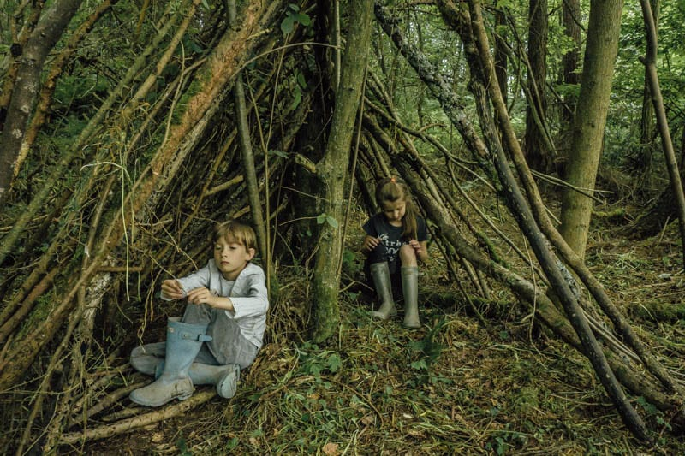
Den building will offer children with learning experiences that link with the objectives of the new curriculum 2022. By engaging in outdoor learning, health, and wellbeing and creative and critical thinking.
Jean Piaget’s cognitive development theory emphasises on the importance of hands-on experiences and active learning experiences (Simply Psychology, 2024).
Den building offers children with experiential learning and outdoor learning and well-being.
Calling all 3–6-year-olds! Who enjoying getting muddy and problem-solving!
Children will be in groups of 6.
The activity will be a 1:6 staff to children ratio.

(Wild About Here, 2024).
Resources you will use:
Sticks, pegs, ropes, leaves, and natural materials, hammer and nails, wooden slats.

How is this beneficial for children:
Their creativity will thrive through this by designing and creating their own spaces and develop their problem-solving skills.
Fine and Gross motor skills by lifting, stretching, and balancing.
Den building will offer team working by sharing ideas and cooperating with others.
Connection with nature.
Children will be able to use their skills elsewhere.

Fun!
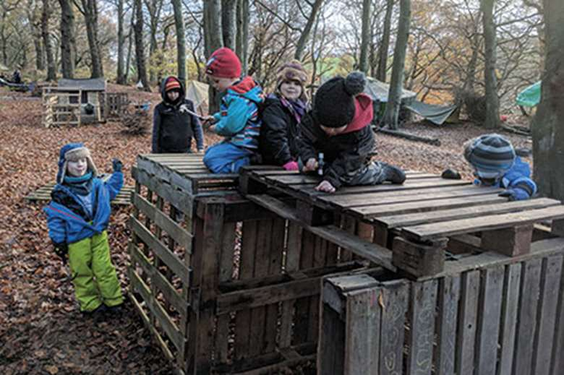
Educational!

Links within the new Curriculum
Theorist lead.
Don’t forget to bring:
- Wellies,
- Waterproofs (To see if our dens can face the rain),
Appropriate clothing (Hats, gloves, coat),
- Lunch boxes.
See you at Pennard Park every Saturday at 11 am.
Session will end at 2 pm.
Please email: Ffion29x@gmail.com to confirm your child’s attendance.
Parents please do not leave your children. unsupervised.

(Nursery World, 2019).
This activity will link with one of the four main aims of the new curriculum for Wales: Enterprising and creativity (Welsh Government, 2022).

Element 3- Risk Benefit Assessment.
RISK BENEFIT ASSESSMENT

Location / Activity: | Outside area in early years garden.  Planting vegetables. | Date: | 20 March 2024.
Assessor: | Ffion John | Review date: | 20 March 2025.

ACTIVITY | How will young people BENEFIT from this activity? | Possible hazards | Who is at risk? | PRECAUTIONS in place to reduce the risk of injury | Overall risk RATING: L/M/H
Planting vegetables in the outdoor area planter. | - Children will be using their fine and gross motor skills to plant their chosen vegetables.  - Children will be able to use problem solving skills.  - Stimulate all five senses.  - Learning about healthy foods.  - Gain valuable life skills.  - Healthy lifestyles.  - Team work.  - Hands on learning experiences.  - Promote science learning, children can learn the plant life cycles.  - Planting vegetables will link within the new curriculum in Wales 2022, where children will be learning through hands-on experiences.  - Planting vegetables is an inclusive activity. | - Water butts and hoses can become a possible hazard due to slips, trips, cuts, and falls.  - Weather hazards, sun burn, illnesses from cold weather.  - Digestion of the seeds.  - Use of tools.  - Insect bites.  - Lifting heavy.  - Touching and handling plants. | Children, young people, and adults. | - Ensure that the area has been investigated before children go outside.  - Weather will need to be considered and the correct clothing and materials used (Sun cream, hats, coats).  - Ensure that the children are well supervised and explain before the activity has started.  - The use of tools will need to be explained by staff members before the activity, all people present should wear appropriate gloves and boots.  - Identify allergies within the group and inspect the area of any signs of insect nests. First aider and first aid kit must be present.  - Ensure that wheelbarrows are not overfilled, do not lift heavy objects use a wheelbarrow.  - Children must wash their hands before and after this activity. Children must use gloves when handling seeds. | Low

Element 4 – Literature review ‘The role of Outdoor Education’.
Outdoor education plays an important role in promoting physical and mental health and wellbeing, environmental awareness and sustainability and the development of skills to children. These themes have been adapted from many educational theorists and researchers that have advocated for outdoor education and recognised the benefits. An education theorist who viewed outdoor education is John Dewey (1938) as connecting theory with practice. Dewey believed that children should learn through hands-on experiences and opportunities that outdoor education will bring. Dewey understood outdoor education as a way for children to develop their curiosity and problem-solving skills (Wainwright, 2021, p.568). Another educational theorist who supports Dewey’s theory is Maria Montessori (1907) who believed children learn best when they are actively engaged in and activity, Montessori’s theory aligns with outdoor education with giving children endless opportunities to explore and learn within their natural environment (Selda and Sari and Kahya, 2012, p.1867). A researcher Learning Through Landscapes (2023) described that outdoor education will enhance children’s intellectual, emotional, and social develop through their lives. Learning Through Landscapes advocates that schools and childcare settings need to make use of their outdoor areas, by engaging in hands-on experiences and promote rich learning experiences (Learning Through Landscapes, 2023). The Welsh Government states that within one of the four aims ‘have access to play, leisure, sporting and cultural activities’, outdoor education has now been implemented throughout all areas of the new curriculum in Wales. All these educational theorist and researchers have had an impact on outdoor education through all different curriculums (Welsh Government, 2014).
Outdoor education covers a range of themes that focus on the new curriculum for Wales 2022, as it will emphasise on real world experiences and offers children the opportunities to learn whilst playing outdoors. Outdoor education provides children with the opportunity for experiential learning and an active approach to learning and education. Outdoor education also allows children to be environmentally aware, it encourages children to develop an understanding of the principles and their role as a responsible citizen (Welsh Government, 2020). Outdoor education links with the new curriculum as it will allow children’s learning experiences to deepen in an exciting and fun way (Learning Through Landscapes, 2024).
The role of outdoor education plays a significant role in promoting physical and mental health and well-being with children. whilst children are engaged in outdoor education it can encourage children to be physically active, this is essential whilst children are young to develop their fine and gross motor skills and overall fitness. Whist children are outdoors they will be encouraged to jump, climb, run, and jump. Outdoor education will enable children to develop these skills during outdoor education and use within their daily life (Jeon and Jun, 2021). Although the new curriculum for Wales 2022 is promoting outdoor education some childcare practitioner may become relucted to follow, this is because of some key educational subjects can become difficult to develop outside a traditional classroom environment. this can be hard to maintain the curriculum requirements (David and Hamilton, 2018). By promoting physical health, it will allow children to engage in these activities (Mygind et al, 2019). As numerous writers have noticed that children who are actively engaging in outdoor education have reached mental health benefits. Being outdoors releases certain positive endorphins, which allows children to reduce stress, anxiety, and depression (Mutz and Müller, 2016, p.106) (Pasanen and Tyrväinen and Korpela, 2014). When children are engaged in outdoor education, they will be exposed to vitamin D which is essential for develop of bone health, immune function, and overall well-being of a child, this will promote their physical and mental well-being. Studies have shown that children who have been exposed to outdoor education are overall better at teamworking skills and cooperation with others, this is because most outdoor education will be required to have good teamwork amongst peers. Good physical and mental health will allow children to have effective communication and collaboration (Solomonian et al, 2022). Outdoor education also requires children to endure in risk taking, having good physical and mental health will allow children to manage and overcomes this risk successfully (Mitten and Itin, 2006, p.85).
Within the new curriculum environmental awareness and sustainability is promoted by using Eco-schools. When children are engaging in outdoor education it will allow children to have the opportunity to have direct access and explore their natural environment. Eco-schools are a programme that empowers children to take a role in creating a sustainable future in schools, many schools are appointed awards from this. Eco-schools can raise environmental awareness to improve the school’s environment and provide the children with the ability to engage with their community (Eco-Schools, 2024). Eco-schools encourage hands-on experiences through having environmental projects, within these projects children are fully involved with the planning, implementing, and carrying outing of the projects. Outdoor education within eco-schools gives children lifelong values and attitude towards the environment which will help children to learn to make eco-friendly choices which they are use within their daily lives (Eco-Schools, 2023). Environmental awareness and sustainability are important for children to learn to protect their future. Children can encourage sustainable practices by exploring topics for example, farming, waste reduction, recycling, by promoting these topics in schools’ children can learn more practice ways to live more sustainably (Hallfreosdóttir, 2011, p.55). By intergrading environmental awareness and sustainability into children’s learning, staff can empower children to make a difference to a more sustainable future. Although many schools in the UK are implementing eco-schools, the weather conditions may influence outdoor education being undertaken because children and staff not having the correct clothing when change of the weather (Csonka, 2023).
Whilst children are engaged in outdoor education there are many skills that can be developed. Children will develop social skills that can encourage teamwork, collaboration, and communication skills, this is by children actively engaging in group activities (Bunting, 2006, p.11). Outdoor education will be able to enhance children’s critical thinking and problem solving skills through hands-on experiences outdoor education will offer children with unexpected changes and challenges that they will need to overcome (Cottrell and Cottrell, 2020). All skills developed whilst engaged in outdoor education can contribute to the child’s personal development that can be used in the real world experiences. The role of outdoor education is when children are interacting with the natural environment as it will create creativity, imagination, curiosity with children. Outdoor education will link to all aspects of the new curriculum in Wales because the nature will provide staff and children the opportunities for children to explore a mathematical side of learning such as counting, measuring, and estimating things within the outdoor classroom (Robertson, 2017, p.4-12).
These themes have collectively contributed to a full educational experience that promotes all aspects of learning allowing the children to thrive. Outdoor education will support the vision of the new curriculum for Wales 2022, to develop confident, capable, and informed children. The writer also agrees with the numerous educational theorists and researchers to provide a high quality, rich engagement, and hands-on experiences that outdoor education has to offer. Physical and mental health and well-being will develop whilst children are involved in outdoor education as it can reduce stress, anxiety, and depression. Outdoor education also releases endorphins. Eco-schools are a new way that schools are adapting sustainable and promoting outdoor education. All themes help achieve a holistic approach to outdoor education to promote overall wellbeing, personal growth and lifelong learning with children and young people’s growth and development. The writing considers the role of outdoor education as one of the most important for children and young people’s growth and development.

