Student Name: Silviu-Nicolae Comanescu
Student Id: 2226638
Module Code: BMIH5003
Module Title: Foreign Languages & Cultural Awareness
Lecturer: Lisa Bassler

Foreign Languages & Cultural Awareness
Intercultural Competence Report

Executive summary
The aim of the report is to demonstrate an understanding of intercultural competence. To lead an intercultural team in the hospitality industry, an organisation must have cultural awareness, flexibility, and adaptability. For the report, the name of the given organisation is Inclusivity Hotel & Spa. The headquarters of the hotel is situated in Spain. A team from the headquarters will join the branch in London. The two countries are highly different in terms of cultures and customs such as communication styles, decision-making approaches, and so on. Based on the Globe project, various dimensions such as future orientation, assertiveness and so on of England and Spain have been evaluated and compared. Moreover, the potential challenges in leading an intercultural team are communication misunderstandings, conflicts in decision-making and so on. To overcome the challenges, the organisation can organise training and development programs, foster open communication and so on.

Table of Contents
Executive summary 2
Introduction 4
Outlining the key differences between England and Spain 5
Analysing and comparing the two countries using the Globe project 5
Critically explaining the challenges of intercultural leadership 8
Conclusion 9
Recommendations 10
References 11

Introduction
A crucial portion of the hospitality industry is the hotel industry which involves organisations that provide individuals with accommodation services. In the UK, there are more than nine thousand hotels such as Premier Inn, Marriott and so on. One of the most vital elements in the hotel industry is cultural sensitivity which aids organisations in ensuring effective communication, leadership, better performance, and decision-making and enhancing customer satisfaction. The aim of the report is to demonstrate an understanding of intercultural competence. For the report, the name of the given organisation is Inclusivity Hotel & Spa. The headquarters of the hotel is situated in Spain. At inception, the key differences between England and Spain have been discussed in the following report. Besides, the leadership and cultural values of the two countries using the Globe project have been analysed and compared. Moreover, the challenges of intercultural leadership have been discussed in the following report.

Outlining the key differences between England and Spain
The two most popular tourist destinations are England and Spain, and various hotel chains operate in both countries. They both have various attractive places such as museums, beaches, infrastructure and so on to visit (Asadi, 2020). However, the two countries are highly different in terms of cultures and customs. The key differences in cultures and customs of England and Spain have been discussed in the following paragraph.
One of the vital attributes of Spanish culture is collectivism as the individuals of Spain provide a special focus on family. On the other hand, individualism is the characteristic of British individuals. Besides, the Spanish are less formal compared to the British in communication. The British are known for their punctuality and, the Spanish have a relaxed attitude towards time (Benavides-Velasco, 2014). Apart from these, equal participation is promoted by England by lowering the power of hierarchies. Hierarchical structure is a vital aspect of Spain culture. The British are more reserved and task-oriented and the Spanish are more expressive and relationship-oriented. Moreover, the Spanish use body language highly compared to the British.

Analysing and comparing the two countries using the Globe project
A well-known research project is the Globe (Global Leadership and Organisational Behaviour Effectiveness) project which provides various international strategies of management. To aid managers in developing, assessing and evaluating leadership theories, this project was developed (Bharwani, 2017). This concentrated on how organisational practices are associated with cultural values and, other vital dimensions. There are nine dimensions. However, the two countries have been compared by using the leadership and cultural study of the Globe project in the following paragraph.

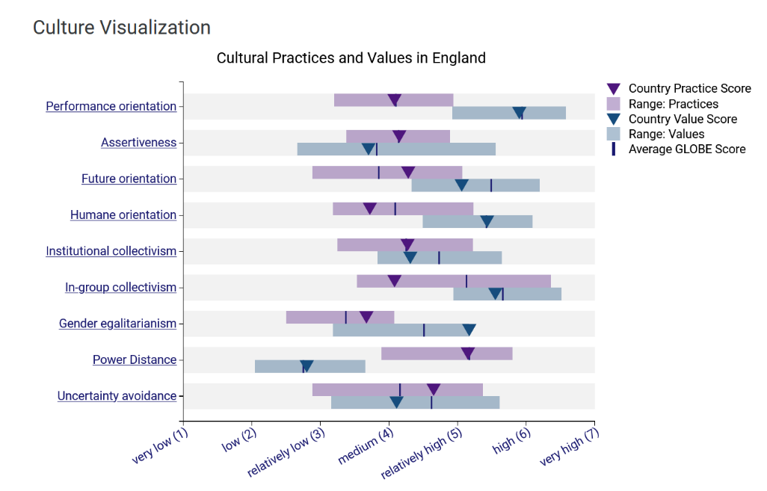
Figure 01: Cultural practices and values in England (Globe Project 2014)
In England, the score of assertiveness is high which indicates that individuals can admit their ideas and opinions in a direct way and the culture is congenial to it. Besides, the performance of orientation is also high that also indicates that the culture suggests shared values. To obtain success, England basically concentrates on individual performance (del Rosario, 2017). The country provides less emphasis on hierarchical structures. It follows a future-oriented approach that concentrates on innovation and planning. Moreover, the culture has a high tolerance of risk-taking and ambiguity.
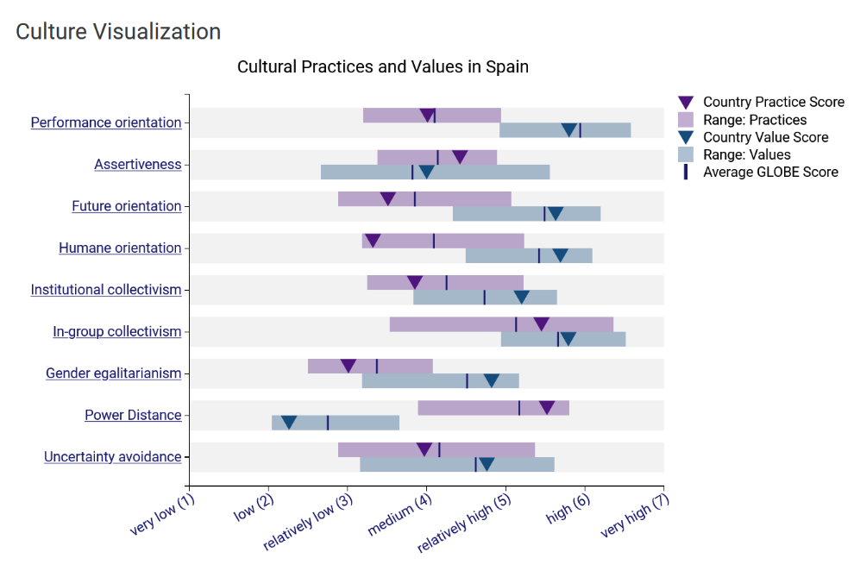
Figure 02: Cultural practices and values in Spain (Globe Project 2014)
In Spanish culture, a relationship-oriented and indirect approach is used for communication. Besides, it focuses on team goals to ensure better performance. Clear rules and regulations are preferred by the Spanish culture. Hierarchy is a crucial aspect of the culture. In various tasks and decision-making, it provides a special focus on group harmony (Nazarian, 2017). However, it focuses on the present-oriented approach that values social relations and traditions.
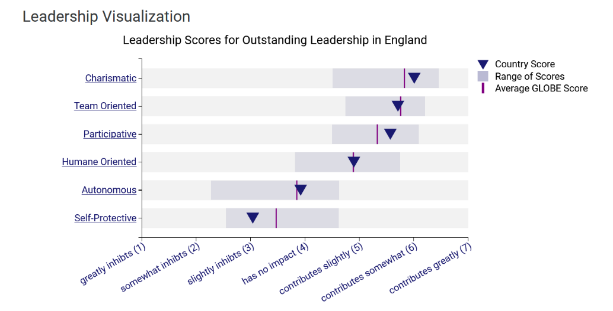
Figure 03: Leadership scores in England (Globe Project 2014)
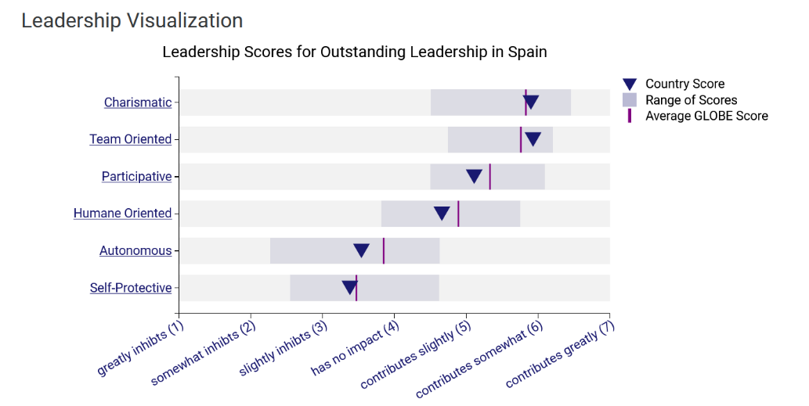
Figure 04: Leadership scores in Spain (Globe Project 2014)
Charismatic and team-oriented leadership approaches scored high in Spain and England compared to other leadership approaches (Papargyropoulou, 2016). But, Spain is more team-oriented than England. However, charismatic leadership scores higher in England than in Spain.

Critically explaining the challenges of intercultural leadership
To manage an intercultural team, the organisation might have to deal with various unexpected situations and conflicts. The challenges that the organisation might face while leading an intercultural team that has been discussed in the following paragraph.
First of all, communication misunderstandings can occur. The British maintain directness and formality in communication which the Spanish could perceive it rude. For instance, the British manager provides direct feedback to a Spanish employee (Sabiote-Ortiz, 2016). The Spanish employee can take it as a personal attack and, they feel unmotivated. Apart from this, the organisation might face conflicts in decision making. For example, the British manager offers bonuses based on individual performance (Torres, 2014). But, the Spanish might prefer team-based rewards. Moreover, different attitudes towards punctuality can also lead to conflict in the organisation.

Conclusion
To lead an intercultural team in the hospitality industry, an organisation must have cultural awareness, flexibility and adaptability. The two most popular tourist destinations are England and Spain. The two countries are highly different in terms of cultures and customs such as communication styles, decision-making approaches and so on. Based on the Globe project, various dimensions such as future orientation, assertiveness and so on of England and Spain have been evaluated and compared. Moreover, the potential challenges in leading an intercultural team are communication misunderstandings, conflicts in decision-making and so on.

Recommendations
To overcome the abovementioned challenges, several recommendations have been provided in the following paragraph.
- Enhancing training and development programs: For all employees, the organsiation should organise training and, development programs to enhance their cultural awareness. They should be aware of the cultural differences related to communication styles, leadership methods, decision-making approaches, and so on. However, these will aid the organisation in reducing conflicts and promoting better understanding (Santa Cruz, 2014).
- Encouraging open communication: Open communication should be fostered within the organisation. A clear communication strategy as well as channels should be developed. For instance, creating a secure space for individuals to share opinions and so on, providing constructive feedback, and so on.
- Implementing team-building activities: The organisation can foster team-based activities which will aid in promoting cultural integration and understanding. These will aid the organisation in breaking cultural barriers (Nazarian, 2017).

References
Asadi, S., Pourhashemi, S.O., Nilashi, M., Abdullah, R., Samad, S., Yadegaridehkordi, E., Aljojo, N. and Razali, N.S., 2020. Investigating influence of green innovation on sustainability performance: A case on Malaysian hotel industry. Journal of cleaner production, 258, p.120860.
Benavides-Velasco, C.A., Quintana-García, C. and Marchante-Lara, M., 2014. Total quality management, corporate social responsibility and performance in the hotel industry. International Journal of Hospitality Management, 41, pp.77-87.
Bharwani, S. and Jauhari, V., 2017. An exploratory study of competencies required to cocreate memorable customer experiences in the hospitality industry. In Hospitality marketing and consumer behavior (pp. 159-185). Apple Academic Press.
del Rosario, R.S.M. and René, D.P., 2017. Eco-innovation and organizational culture in the hotel industry. International Journal of Hospitality Management, 65, pp.71-80.
Globe Project 2014 GLOBE Project. Available at: https://globeproject.com/ (Accessed: 24 February 2024).
Nazarian, A., Atkinson, P. and Foroudi, P., 2017. Influence of national culture and balanced organizational culture on the hotel industry’s performance. International Journal of Hospitality Management, 63, pp.22-32.
Papargyropoulou, E., Wright, N., Lozano, R., Steinberger, J., Padfield, R. and Ujang, Z., 2016. Conceptual framework for the study of food waste generation and prevention in the hospitality sector. Waste management, 49, pp.326-336.
Sabiote-Ortiz, C.M., Frías-Jamilena, D.M. and Castañeda-García, J.A., 2016. Overall perceived value of a tourism service delivered via different media: A cross-cultural perspective. Journal of Travel Research, 55(1), pp.34-51.
Santa Cruz, F.G., López-Guzmán, T. and Cañizares, S.M.S., 2014. Analysis of job satisfaction in the hotel industry: A study of hotels in Spain. Journal of Human Resources in Hospitality & Tourism, 13(1), pp.63-80.
Torres, E.N., Fu, X. and Lehto, X., 2014. Examining key drivers of customer delight in a hotel experience: A cross-cultural perspective. International Journal of Hospitality Management, 36, pp.255-262.

