Effective Team Work and Communication

LAURENTIA ECATERINA ION
STUDENT NUMBER - 2022463

Date – 07/06/2021

Executive Summary
This report is based on discussing the models of communication as well as communication skills that were discussed in class in reference to Barry and communication barriers case study. Moreover, the report will be illustrating poor communication at work places and suggesting ways using theories of how the poor communication can be improved. The findings of this report were searched from academic sources, class notes, journals and academic websites. This report has found out that, models of communication includes the sender, the message and the receiver, it has concluded that for an effective communication there has to be four components which include the sender, the message the channel and the receiver. The reports is recommending:
- Organizations to involve their employees at work places for an effective communication
- The organization should provide clear standards and objectives of what their employees are supposed to do for an effective communication
- Also for an effective communication at work places there has to be a good relationship between employees with their co-workers and the management.

Table of Contents
Introduction 4
Models of Communication 4
Linear Models of Communication 4
Shannon and Weaver Model 4
Berlo’s Basic SMCR Model 5
Circular Model of Communication 7
Schramm Model 7
Poor Communication at Workplaces 9
Improving Communication at Work Places 9
Conclusion 10
Bibliography 10

Introduction
Communication is the act of exchanging information from one person to another through speaking, writing, using sign language, or using other communication mediums. In this report, we are going to discuss the models of communication which include the Shannon and Weaver model, Schramm, and also the Berlo Basic SMCR Model. In this report, we are also discussing some of the communication skills such as listening skills, stress management, emotion control, straight-talking, and also nonverbal communication referring to Barry and the communication barriers case study. Lastly, this report aims at finding some of the communication barriers in workplaces and how they can be improved.

Models of Communication
Models of communication define the entire process of communication and they are three which include linear, interactional, and transactional models of communication. In this report, we are going to discuss linear models which include Shannon and weaver, Basic SMCR Model, and circular model which is Schramm and Berlo (Guidotti, 2013).

Linear Models of Communication

Shannon and Weaver Model
Chris Drew (2019) terms Shannon and weaver model of communication -which is also known as the Shannon theory since Claud Shannon was the main founder of this model- as a linear model of communication which indicates that communication can be divided into six important concepts these include: sending party, encoding, channel, noise, decoding, and receiving party. This model mainly aims at explaining how information is lost and distorted during the communication process. This model is also known as the mathematical theory of communication, it is used to indicate how messages get mixed up and are misinterpreted in the process of communication, through sending and receiving information (Al-Fedaghi, 2012). 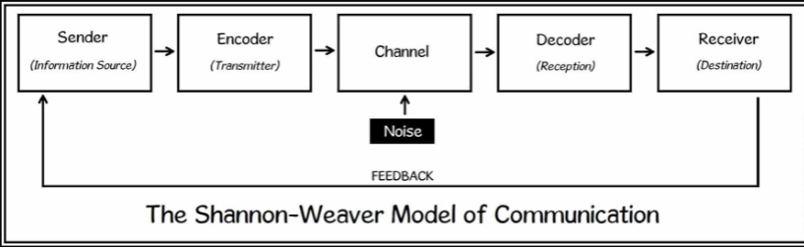
Figure 1 Shannon and weaver model of communication
In fig 1, the model starts with a sender, which is the information source, the source of the information may be a person who has the information to deliver like Barry who is the source of information as a manager to the employees. This process begins by identifying the message to deliver which is about food safety and the media to use to send the message to the other party. This message may be delivered to the other party in different ways by using words being spoken directly, through writing signposts, and other ways. An example of a sender is Barry who uses signposts to send messages to his employees and also putting hand sinks, soap, and towels in place to convey the message of food health through washing hands (Al-Fedaghi, 2012, p. 15).
Shannon's model was aimed at mainly showing communication through the use of computers and telephones that use binary digits and waves when encoding words. The third step on the Shannon model of communication is the channel which is the medium that is used in getting the information from the sender to the receiver. An example of a channel from the case study is the use of signposts to inform the employees of what is required. Noise is also another step on Shannon’s model which are the unwanted sounds that interrupt the conveying of information from the sender to the receiver. Noise may interrupt the understanding of the information which is being conveyed (Al-Fedaghi, 2012, p. 13).
From the case study, the inconsistency of supervisors giving contradicting information is internal noise. External noise is when the information is obstructed by something different from the sender or the receiver like the language barrier. This model tries to understand the causes of noise during the transmission of information and minimize them. Another step is deciding which is the process of putting the information back from waves and binary formats to a format that the receiver can understand which are words. Lastly is the receiver who are the people intended to get the information, like in the case study the employees at the restaurant are the recipients of the message (Al-Fedaghi, 2012, p. 15).

Berlo’s Basic SMCR Model
The sender, message, channel, and receiver model of communication (SMCR) is also a linear model of communication. Berlo formed this type of communication where he borrowed the concept from the mathematical model by Shannon and Weaver. The SMCR Model of communication explains the components that make the communication process but does not include noise like in Shannon and Weaver model. There are four components of communication explained in the SMCR model. They include the sender, the message, the channel, and also the receiver. The sender is referred to as the individual giving out the message like Barry the manager, this is where the message originates from the sender encodes the message (Muyanga and Phiri, 2021).
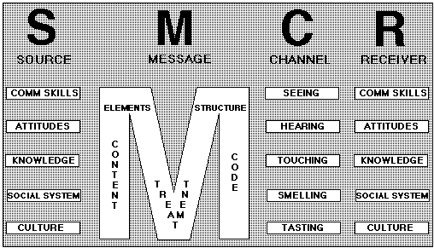
Figure 2 SMCR model of communication
In figure 2 above, the sender transfers information using communication skills which include the ability to write, speak, listen. These affects the message like Barry writing the signpost to ensure the employees practice food safety and speaking verbally to the employees. The sender must be in good possession of quality communication skills to convey effective information. Also, the sender must be having a good attitude towards the receiving party as in the case of Barry having a moody day which makes him feel terrible about his communication towards the employees. The sender must have clarity of the information he/she is transmitting, the sender should also understand certain beliefs, cultures, religions, and also the law while conveying the message which may affect the receiver. Like in the case of Barry he has people of different ages, cultures, languages, and ethnicity The next component is the message being transmitted, the sender creates messages through transforming thoughts into words, voice, or even sign language where he/she sends the message to the receiver. Barry passing the food safety message to the employees (Muyanga and Phiri, 2021, p. 449).
The message is made up of elements. These include the content, which is the whole message the sender is trying to communicate to the receiver from the beginning to the end. It also includes the elements that are non-verbal such as the use of gesture or body language for sign languages, treatment of the message is also another element in messages. This shows how the sender conveyed the message and the reaction of the receiver towards receiving the information- like in the case study most employees are not following the information being conveyed by their manager- and how they treated the message through them not practicing food safety (Saud, Jufri, Rahman and Salam, 2014).
The channel of communication is another component that the SMCR uses to make communication effective, this refers to the medium that is used to pass information from the sender to the receiver. The case study gives examples such as Barry using signposts to convey the message to the employees. Also, giving his employees thermometers to temp food and putting every piece of equipment in place such as the hand sink, soap, and paper towels to encourage them in washing their hands frequently. The receiver is the last component of communication where the receiver is the person getting the information. The receiver gets the message and tries to know what information the sender tries to pass through decoding, if the receiver understands he/she will reply or give feedback. SMCR model shows that there can be effective communication only if the sender and the receiver are equal for the message to be effective. The receiver also to get good information he/she must have good communication skills, listening skills, have a good attitude towards the message, know the information being conveyed, be familiar with the laws, beliefs, culture, and religious rules with the information sent (Saud, Jufri, Rahman and Salam, 2014).

Circular Model of Communication

Schramm Model
The Schramm model of communication is a circular model of communication, this model was built by Wilbur Schramm from the idea of Shannon and Weaver's model of communication. Egerton Osgood further emphasized that communication should be circular where the sender and the receiver are given turns to speak. Wilbur Schramm added the field of experience which explains what the sender and receiver understand on the information being sent and received.
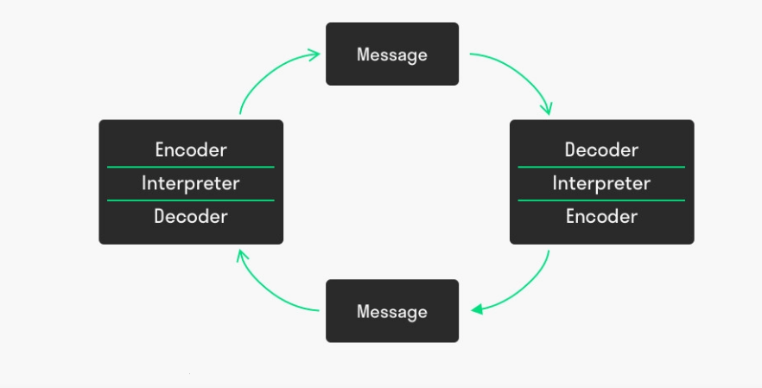
Figure 3 Schramm model of communication
In fig 3 above, the model consists of three components of communication, the communication is circular where the sender and the receiver of the message may be the same person. The message is encoded and then sent to the next person where the next person decodes the message interprets the message. If they decide to send it to another new person, they then encode it (Adams and Singh, 2018).
This model consists of the sender or the encoder of the message like Barry, who is the person sending the message and is clear on when he is sending the message and also gives the importance of the employees knowing the message. The encoder ensures that the message is effective, accurate, has relevance, and is useful. Encoding the message makes the recipient have a clear knowledge of the sender. Encoding of the message is affected by cultural factors, beliefs, laws, knowledge of the sender. Also, the attitude of the sender towards the message as well as the experience and skills of the sender (Guidotti, 2013, p. 1167).
The receiver of the message or the decoder of the message is the employee to whom the message has been sent. Decoding of the message sent depends on the clear understanding and knowledge of the recipient towards the message sent. The recipient must have an idea of the topic of the message that has been sent, its main purposes, and reasons. Also, the recipient must have trust with the source that has sent the information. The recipient's interpretation of the message sent is influenced by cultural factors, laws, beliefs, knowledge of the message, attitude towards the message, experience, and also skills (Guidotti, 2013, p. 1170).
Some messages are encoded with hidden meaning so it’s upon the receiver to know about decoding the message, process the message, and interpret the meaning of the sent message. From the case study, the employees know the signpost from Barry means they should practice food safety as well as the facilitation of washing equipment. When the employees receive the message and maintain hygiene then it shows they have understood the message. The recipients of the message sometimes give their feedback if they have received the message successfully or not. This helps the senders to improve on their message constructions and encoding. The last component of communication in the Schramm model is the message, which is the information being conveyed from the sender to the receiver. The information in our case study is in the form of verbal communication towards the employees and the use of words on signposts. The message is also in non-verbal form by equipping hand sinks, soaps, and towels at the restaurant (Guidotti, 2013, p. 1175).

Poor Communication at Workplaces
Poor communication in workplaces happens when there is no consistency in information between what is said and what is heard, people misunderstanding what is being said, or not having clear information of what has been said. This may be between colleagues, employees, and employers, and even with clients and suppliers. Poor communication is like employees and leaders who refuse or ignore speaking directly to other employees which are seen as a form of aggressiveness. Also, using emails and memos to communicate without speaking with the recipients ever while in office. Another of poor communication is shouting at co-workers or a leader shouting at the employees and also using abusive language. Correcting an employee or co-worker loudly in front of other employees gives the employees shame. Lastly, co-workers or employees failing to listen (Mahanta and Ali, 2018).

Improving Communication at Work Places
Shannon (2018) terms communication theory as a framework for providing effective communication between the employees and the employer. Effective communication in a workplace leads to productivity and engaged organizational culture. For effective communication at workplaces employees and employers should develop a positive attitude towards themselves and other people also creating trusting relationships at workplaces. Furthermore, the management at the workplace and employees should develop a positive communication exchange that involves being friendly, making smart decisions, and making sure the employee's needs are being met (Sarros, Luca, Densten, & Santora, 2014). The workplace should also engage employees at workplaces through giving feedback, creating team works as well as setting clear standards and expectations which are consistent (Scholarworks.waldenu.edu, 2021).

Conclusion
From the above information, the models of communication have identified the source of the message, the message itself, the channel used to pass the information. Also, the people receiving the information. The models have also brought out some of the communication skills used in showing how they have been used in then Barry and the barriers of the communication case study. Also, the report has identified some of the poor communication at workplaces and how they can be improved using the communication theory by Shannon (2018). Some of the solutions identified involve engaging employees as well as having a friendly work environment

Bibliography
Adams, R. and Singh, A., 2018. Analytical models for communication links in emergency
management simulation. International Journal of Communication Systems,
31(5), p.e3500.
Al-Fedaghi, S., 2012. A Conceptual Foundation for the Shannon-Weaver Model of
Communication. International Journal of Soft Computing, 7(1), pp.12-19.
Guidotti, T., 2013. Communication Models in Environmental Health.
Journal of Health Communication, 18(10), pp.1166-1179.
Mahanta, P. and Ali, A., 2018. Psychiatric Social Work Intervention in Person with
Schizophrenia Having Poor Social, Communication and Work Functioning. Indian Journal of Psychiatric Social Work, 9(1).
Muyanga, C. and Phiri, J., 2021. Assessment of Effective Communication in International
Schools in Developing Countries Based on the Berlo’s SMCR Model. Open Journal of Business and Management, 09(01), pp.448-459.
Sarros, J. C., Luca, E., Densten, I., & Santora, J. C. (2014). Leaders and their use of motivating
language. Leadership & Organization Development Journal, 35, 226240.
Doi:10.1108/LODJ-06-2012-0073
Saud, S., Jufri, A., Rahman, M. and Salam, S., 2014. Learning Devices Development on
Descriptive Writing for Foreign Language Based on Berlo’s SMCR Communication Model of Secondary School Student. Journal of Language Teaching and Research, 5(5).
Scholarworks.waldenu.edu. 2021. [online] Available at:
<https://scholarworks.waldenu.edu/cgi/viewcontent.cgi?article=7058&context=dissertations>[Accessed 5 August 2021].

