Qualitative Research Report
How do counsellors understand and experience professional boundaries in their counselling practice?

AI Acknowledgement

I acknowledge the use of Copilot on 10/11/2025 using the prompt(s):
- How to write an abstract - break it down, tell me what it needs to do, do I write it in first or third person.
- Top tips for writing a qualitative research report for psychology.
- Find me journal evidence to answer this research question: how do counsellors understand and experience professional boundaries in their counselling practice?
I acknowledge the use of Copilot on 22/11/2025 using the prompt(s):
- Give me Braun & Clarke’s steps for TA in order and explain them
- What does a pluralistic approach in counselling mean
- How do you cite an appendix in an APA-style research report
I acknowledge the use of Copilot on 29/11/2025 using the prompt(s):
- How do I present my appendix in a research report
- What should be included in the findings section of a qualitative research report
I acknowledge the use of Copilot on 1/12/2025 using the prompt(s):
- Define pluralistic approach
- Define relationship
- Explain what codes mean in Thematic Analysis
- What does supervision mean in therapy
- What is self-awareness
I acknowledge the use of Copilot on 2/12/2025 using the prompt(s):
- Check that these APA 7th references are in alphabetical order

I confirm that I have not presented any AI-generated text as my own work. I confirm I
have copies of my drafts, notes, and other resources I used before and after the use of
AI tools which I may be asked to provide in evidence.

Abstract
The study aimed to explore the question ‘How do counsellors understand and experience professional boundaries in their counselling practice?’. The concept of boundary is widely discussed within psychotherapy, but a definitive explanation is difficult to find. This doesn’t stop the word itself from being used in many professional competency frameworks, with the assumption of comprehension. The participant is a qualified practitioner based in the UK, where research into counsellors’ understanding and experience of boundaries remains limited.
Introduction
Boundaries have long been discussed and adapted within psychotherapy and counselling practice; they are also mentioned regularly within the British Association for Counselling and Psychotherapy’s (BACP) ethical framework (BACP, 2019), Boundaries are a key concept and often underpin discussions around ethics, competency frameworks, good practice guidance, professional training and even in the literature that is available to clients (Blundell, 2017). The term boundary is rarely defined, often ambiguous, and holds the expectation of general comprehension (Blundell, 2017). The primary focus of past research is on safeguarding the client; there is a lack of data examining how counsellors understand and experience boundaries. This could be down to the inherent power imbalance in therapeutic relationships (Amis, 2017).
Boundaries in counselling aim to protect the client and practitioner from abuse. They ensure clarity of purpose, of standards, confidentiality and equality within the therapeutic relationship. This must be discussed before any therapeutic work is commenced (Amis, 2017). Boundaries can differ within counselling therapies; a person-centred approach is flexible, focused on the therapeutic relationship, and usually follows Carl Rogers’ core conditions (Rogers, 2020/1951). Cognitive Behavioural Therapy (CBT) challenges the client and follows a goal-oriented approach aimed at measurable change and efficiency within a time-limited, structured method (Fenn & Byrne, 2013). In psychoanalytic practice, boundaries are rigid, therapeutic interactions are contained within the secure frame of the session, established through confidentiality, privacy, and consistency (Kotze, 2023).
Method
This study presents qualitative research with the aim of enhancing the understanding and experience of boundaries within counselling practice. A phenomenological approach was chosen to gain empirical data about real experience. A face-to-face, one-to-one, semi-structured interview was conducted with Chris, a practising and qualified counsellor based in the UK (see Appendix A). A reflexive interview technique was applied, ensuring that the 14 structured questions provided consistency whilst leaving room for discretionary exploration by the interviewer (see Appendix A, p. 12). The interview was analysed using Braun & Clarke’s (2020) 5-step thematic analysis.
Participant
The transcript was provided specifically for this assessment. Chris (a pseudonym) participated in an interview, identifying as a qualified humanistic integrative counsellor. At 43 years old, Chris is of White British ethnicity and operates an independent practice.
Procedure
Interviews were transcribed and then analysed (Appendix A). Analysis of the transcript was completed using Braun & Clarke’s 5-step thematic analysis (Braun & Clarke, 2013). The transcription was studied by the researcher until familiar, and initial notes were made (Appendix A). The researcher then highlighted meaningful segments or words relating to boundaries, emotions and the humanistic approach (Appendix B). These segments were collated into codes and grouped based on similarity of semantic meaning of the latent concepts, e.g. safety, reliability, therapeutic relationship, and collaboration (Appendix C). The segments were coded and subsequently grouped based on shared semantic meanings of underlying concepts, including safety, reliability, the therapeutic relationship, and collaboration (Appendix C). Themes are then searched for and listed based on grouping codes together and arranging them by their relationship to the boundary topic (Appendix D). The initial themes are subsequently reviewed to confirm that they accurately represent the overall interview and that they encapsulate the preliminary themes identified while remaining aligned with the research question (Appendix E). The finalised themes are then named (Appendix G), the analysis is developed, and a report can then be produced.
Findings
During the analysis, three themes were identified. These themes were labelled by grouping together the similar words that were highlighted during the first stage of the thematic analysis, which the researcher further linked to the research question (Appendix A, B & C).
Main themes were emerging; the first one was the therapeutic relationship between the client and the counsellor. The word relationship and similar derivatives were mentioned in the transcript 10 times (see Appendix B). These, alongside other words like respect, honesty, clarity, transparency, depth, trust, and reliability, were coded and grouped based on how these words are usually understood to be experienced between two people (Appendix A, B & F). These words suggested a connection and were therefore clustered (Appendix F). This then became the beginning of an initial theme, the therapeutic relationship, which ultimately became the final theme of primary agent of change (Appendix B–G). Named in reference to Carl Rogers’ views on effective therapy, this theme echoes the foundational elements of humanistic theory that Chris consistently mentions in the interview (Appendix A).
Chris directly cites the strength of the relationship when answering the question about self-disclosure, “is the relationship strong enough to hold it?” (Appendix A, p.3, l.68). “They need to know the relationship can hold mistakes.” (Appendix A, p.5, l.123-125). Boundaries, as Chris understands them, “are love with edges. They’re the reliable shape that lets two people meet with depth and honesty. Held with warmth and transparency, they don’t limit the relationship – they allow it” (Appendix A, p. 11, l. 270-272). The interview transcript shows that warmth, growth, depth, honesty, kindness, dignity and respect are essential elements for Chris in understanding and experiencing boundaries. The therapeutic arrangement of client and counsellor can uncover difficult emotions like vulnerability and fear – by working toward creating a secure, respectful relationship, Chris can establish a professional identity which permits safety and protection (Blundell, Oakley and Kinmond, 2022).
Collaboration, codesign, framed, consent, ethics, secure, competence, protects, freedom, safety and structure. These words were highlighted during the coding process of thematic analysis (Appendix B & G). They were categorised under the overarching theme of collaboration, representing the ongoing contracting agreements and adaptive processes within psychotherapy. Chris mentions how anticipating situations outside of therapy sessions is part of his contracting stage. “I anticipate it in contracting…The humanistic piece is honesty and client choice, anchored by ethics” (Appendix A, p.4, l.91-96). He also mentions the importance of collaborating and relational work. “I try to meet the whole person, not a diagnosis, and to work relationally rather than technique first” (Appendix A, p.1, l.13-14). The theme of collaborative contracting emerged, highlighting the importance of working together in a fluid and adaptive manner to maintain boundaries, a pattern evident throughout the transcript. “The container protects the contents” (Appendix A, p.8, l.178-179). The container here is the contract. Non‑negotiables, together with ethical and professional boundaries, are outlined and clarified for the client before therapy. Flexibility is given when able and appropriate. “The structure remained, the delivery changed” (Appendix A, p.10, l.240-241). This suggests that adjustments can be made positively when collaboration is experienced.
The final theme uncovered the importance of supervision when discussing boundaries. Supervision enables the therapist to work towards the best possible practice and efficacy for their clients. According to the UK Council for Psychotherapy (UKCP, 2018), the purpose of supervision is to safeguard competent practice through regular, formal meetings, thereby ensuring psychotherapy remains safe and beneficial for both client and therapist. The BACP ethical framework (2023) also echoes this, stating that boundaries serve to safeguard the client, the therapist and the practice of psychotherapy. Using this information, the theme supervision is safeguarding developed. Supervision provides Chris with a means of managing potential burnout and addressing feelings that highlight areas requiring exploration and resolution. “Burnout taught me that I can’t offer deep presence if my boundaries leak.” (Appendix A, p.9, l.214-215). Chris recognises the difficulty of managing boundaries and encourages others to “take it to supervision when it's hard” (Appendix A, p.9, l.210). These remarks from Chris about supervision, feedback, clarity and competence convey the value and necessity of safeguarding within psychotherapy.
Discussion
Prior qualitative studies have found that boundaries for counsellors are not only shaped by professional, ethical and compliance structures but are also shaped through collaboration, congruence, self-awareness and empathy. The theme primary agent of change encapsulates the idea that the therapeutic relationship is the central component that drives transformation and, therefore, equates to positive modifications through therapy. The use of the three core conditions in person-centred therapy alongside boundaries and consistency are the integral workings that foster trust, growth and transformation that allow space for positive change (Rogers, 2020/1951). Chris explains that “Boundaries aren’t a punishment; they’re the shape that keeps the work therapeutic rather than something else.” (Appendix A, p.11, l.254-254). This aligns with Carl Rogers’ emphasis on empathy, congruence, and unconditional positive regard as the “necessary and sufficient conditions for therapeutic personality change”, forming the foundation of person‑centred therapy (Joseph, 2025, p.15). Tyler (1999) emphasises that unconditional positive regard is only meaningful when paired with empathic understanding. Rogers (2020/1951) claimed the true expert in therapy isn’t the counsellor but the client, and that by applying the core conditions, therapists foster a safe environment in which constructive personality change can occur. Amos, Morris, Mansell & Edge (2019) discuss the idea of psychological change and give evidence showing that “the relationship between client and therapist has also been shown to positively correlate with client outcome” (Amos et al., 2019, p.567). To create this safe space, a good therapeutic relationship is needed. An understanding of boundaries and their implications is a necessary process included in the building of the relationship itself. Therefore, the therapeutic change in the client is more likely to be observed within a positive relationship between them and the therapist. In their 2011 study, Horvath, Del Re, Flückiger, and Symonds established that the therapeutic alliance is a significant and dependable predictor of psychotherapy outcome. They conclude that treatment success is strongly linked to alliance quality, reinforcing the importance of therapists prioritising its development and preservation. While scholars interpret boundaries in CBT and psychoanalytic theory differently from those in humanistic approaches, a common thread remains that effective psychotherapy depends on the therapeutic relationship, with boundaries providing the safety, consistency, and structure for it to thrive.
Collaborative contracting reflects the notion that co‑creating the contract with the client increases the likelihood of maintaining agreed boundaries. Blundell (2017) identified that a lack of negotiation in contracting and limited use of collaboration resulted in negative experiences for the client. Client complaints most commonly concern boundary issues; therefore, it is valuable to examine boundaries from the therapist’s perspective (Blundell, 2017). This aligns with Blundell’s 2017 findings; he suggested that a pluralistic approach offers a flexible way to maintain boundaries. Pluralistic is the use of many differing theoretical approaches, rather than a one-size-fits-all approach. His results show that counsellors’ beliefs and values affect their attitudes towards boundaries. This study from 2017, highlights the importance of considering clients’ needs and requirements when implementing boundaries. Blundell’s research shows that the participants (7 qualified, practising counsellors) used boundaries to protect themselves from potential threats, e.g. fear of losing control or shame of being judged. This can be explained using Hartmann-Kottek’s Amoeba Principle - when under threat, boundaries thicken (Hartmann-Kottek, 2022). This shows how counsellors use boundaries to keep themselves and their clients safe and the need for collaborative boundary setting (Blundell, 2017, pp.105-106).
The final theme highlights the importance of therapist supervision and discusses the idea that supervision is safeguarding. In Blundell’s 2017 study, the results highlight the importance of emotional regulation as reactions, reflections and thoughts can characterise boundary experiences. Counsellors used boundaries to find a sense of self and to protect themselves from emotional overload and to stay in control (Blundell, 2017). Chris’s evaluation of how boundaries are working in practice explains the need for supervision to discuss his emotions, how his body feels and to understand the feedback he receives (Appendix A, p.11, l.261-267). Shame and fear from both the client and counsellor are two of the main emotions that can cause boundary issues in practice. Boundaries are discussed within the BACP (2019) ethical framework but, as Blundell explains, there is a “lack of clarity for counsellors about the relationship between making boundary-related decisions versus ethical decision making” (Blundell, 2017, p.31). Further research into this is suggested to uncover the differences in how counsellors view boundaries in comparison to psychotherapeutic ethics.
Self-awareness is necessary for supervision. Lohani & Sharma (2023) discuss the importance of clinical supervision in their study as “imperative for the development and maintenance of psychotherapeutic competencies” (Lohani & Sharma, 2023, p.291). The study concluded that effective supervision leads to increased self-efficacy, self-awareness, and positive outcomes with clients. The study also highlighted the importance of goal setting and the need for structure in supervision. The themes highlighted help visualise psychotherapy through the use of boundaries and together form an understanding of how these are experienced and understood by practitioners.
The primary limitation of this research report lies in the small sample size, as it draws upon only a single interview and perspective. Thematic analysis findings accentuate the need for further investigation into how counsellors perceive and navigate boundaries. The three themes identified and examined provide clear evidence that boundaries play a crucial role in the effective practice of psychotherapy.
In summary, the findings suggest that when counsellor and client engage collaboratively, boundaries are more likely to be upheld, understood, and experienced positively. Moreover, the presence of a strong therapeutic alliance within the client–counsellor relationship is a key factor in facilitating effective therapy. Supervision serves as a central tool for enhancing counsellors’ self-awareness, self-efficacy and professional competence while simultaneously safeguarding both practitioners and clients.

References
Amis, K. (2017). Boundaries, power and ethical responsibility in counselling and psychotherapy. Sage Publications. https://doi.org/10.4135/9781473919976
Amos, R., Morris, L., Mansell, W., Edge, D. (2019). Clients’ experiences of one-to-one low-intensity interventions for common mental health problems: An interpretative phenomenological analysis. Psychology and Psychotherapy: Theory, Research and Practice. 92 (4), 565-583. BCAP. https://doi.org/10.1111/papt.12200
Blundell, P. J. (2017). The concept of ‘boundary’ within the field of counselling. [Doctoral dissertation, Manchester Metropolitan University]. Espace. https://e-space.mmu.ac.uk/618828/
Blundell, P, Oakley, L and Kinmond, K. (2022). Who are we protecting? - Exploring counsellors’ understanding and experience of boundaries. European Journal of Qualitative Research in Psychotherapy, 12,13-28. https://doi.org/10.24377/EJQRP.article3036
Braun, V., & Clarke, V. (2013). Successful qualitative research: A practical guide for beginners. Sage Publications.
British Association for Counselling and Psychotherapy. (2020). Boundaries within the counselling professions GPiA 110 [Fact Sheet]. BACP - British Association for Counselling & Psychotherapy
Fenn, K. & Byrne, M. (2013). The key principles of cognitive behavioural therapy. InnovAiT: Education and inspiration for general practice. 6(9), pp. 579-585. Sagepub. https://doi.org/10.1177/1755738012471029
Hartmann-Kottek, L. (2022). General Psychotherapy: Principles and Common Theoretical Aspects-Rediscovering Humanity. Springer. https://doi.org/10.1007/978-3-030-87466-7_8
Horvath, A. O., Del Re, A. C., Flückiger, C., & Symonds, D. (2011). Alliance in individual psychotherapy. In J. C. Norcross (Ed.), Psychotherapy relationships that work: Evidence-based responsiveness (2nd ed., pp. 25–69). Oxford University Press. https://doi.org/10.1093/acprof:oso/9780199737208.003.0002
Joseph, S. A. (2025). The Humanistic Psychology of Carl Rogers: Understanding the Person-Centered Approach. (1st ed.). Oxford University Press, Incorporated. https://doi.org/10.1093/9780197790632.001.0001
Kotze, A. (2023). The Therapeutic Frame: an illusion of the past? The Psychologist. The British Psychological Society (BPS). The Therapeutic Frame: an illusion of the past? | BPS
Lohani, G., & Sharma, P. (2023). Effect of Clinical Supervision on Self-Awareness and Self-Efficacy of Psychotherapists and Counselors: A Systematic Review. Psychological Services, 20(2), pp.291–299. https://doi.org/10.1037/ser0000693
Rogers, C. R. (2020). Client-centred therapy: 70th Anniversary edition. Robinson. (Original work published in 1951).
Samstag, L. W. (2007). The necessary and sufficient conditions of therapeutic personality change: Reactions to Rogers’ 1957 article. Psychotherapy: Theory, Research, Practice, Training, 44(3), 295–299. https://doi-org.ezproxy.uwtsd.ac.uk/10.1037/0033-3204.44.3.295
Tyler, K. (1999). Examining unconditional positive regard as the primary condition of therapeutic personality change. The Person-Centred Journal, 6(2), 100–107. https://api.semanticscholar.org/CorpusID:208137819

Appendix
Appendix A
Transcript of interview (P1-12)
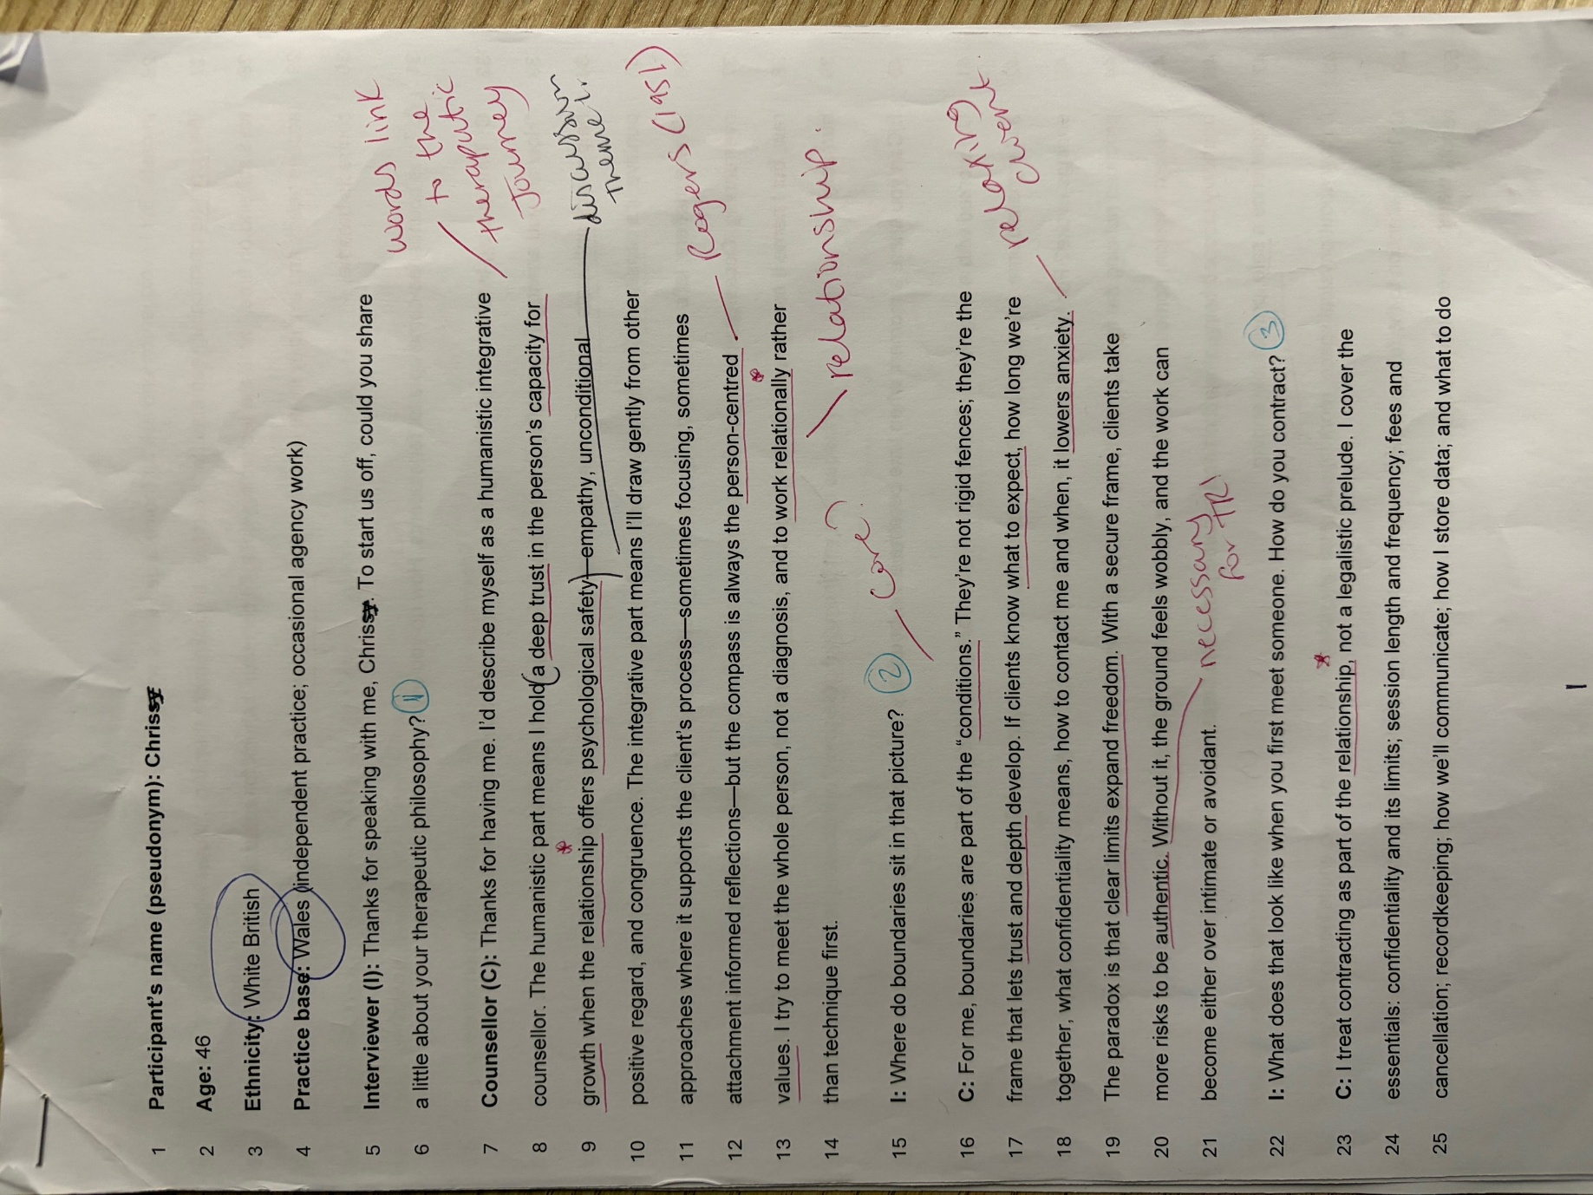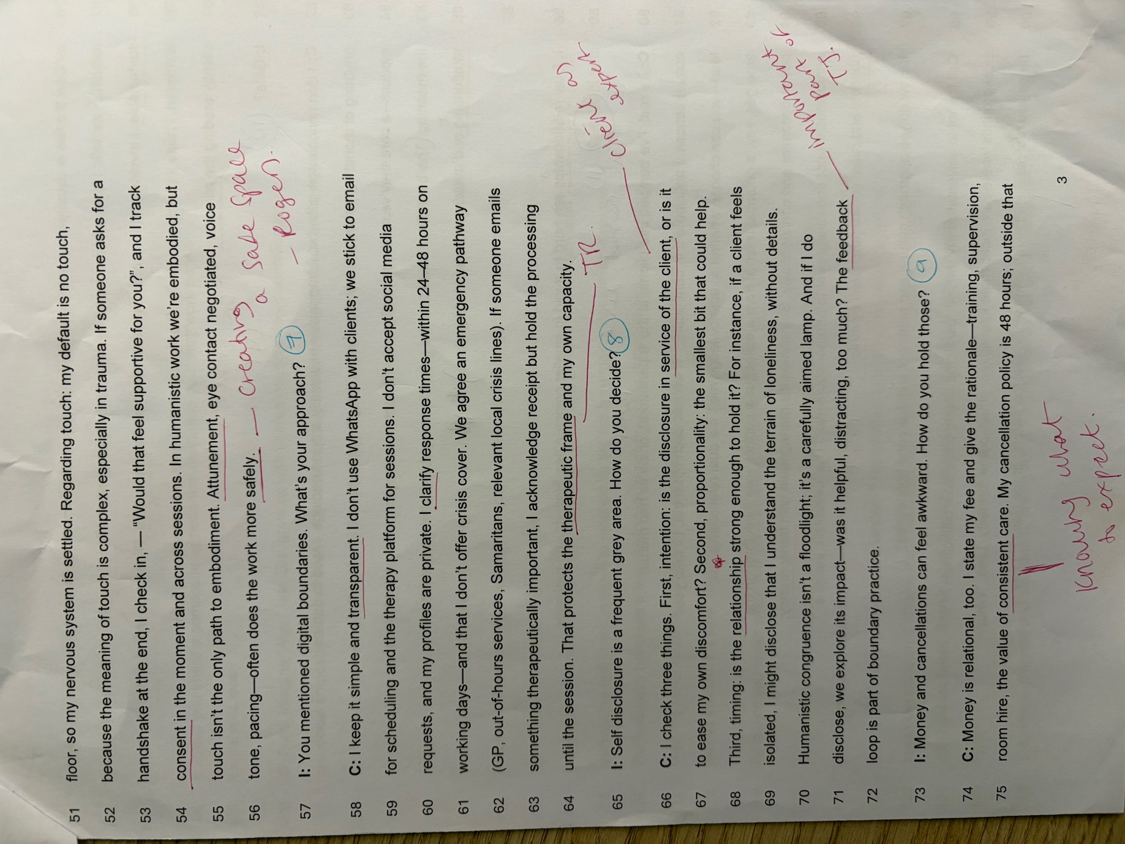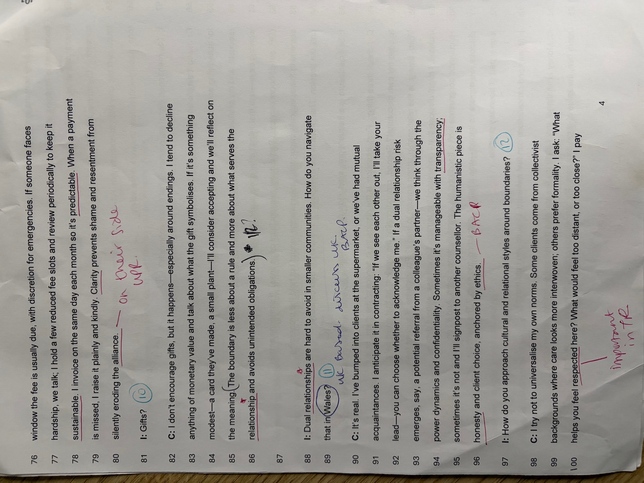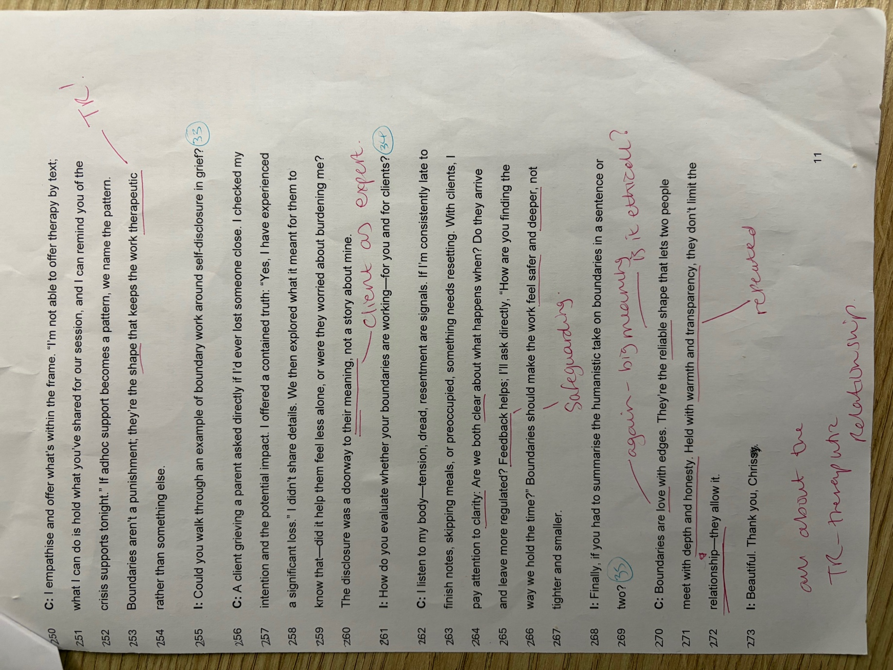

Appendix B
List of highlighted data from transcript (TA stage 2)
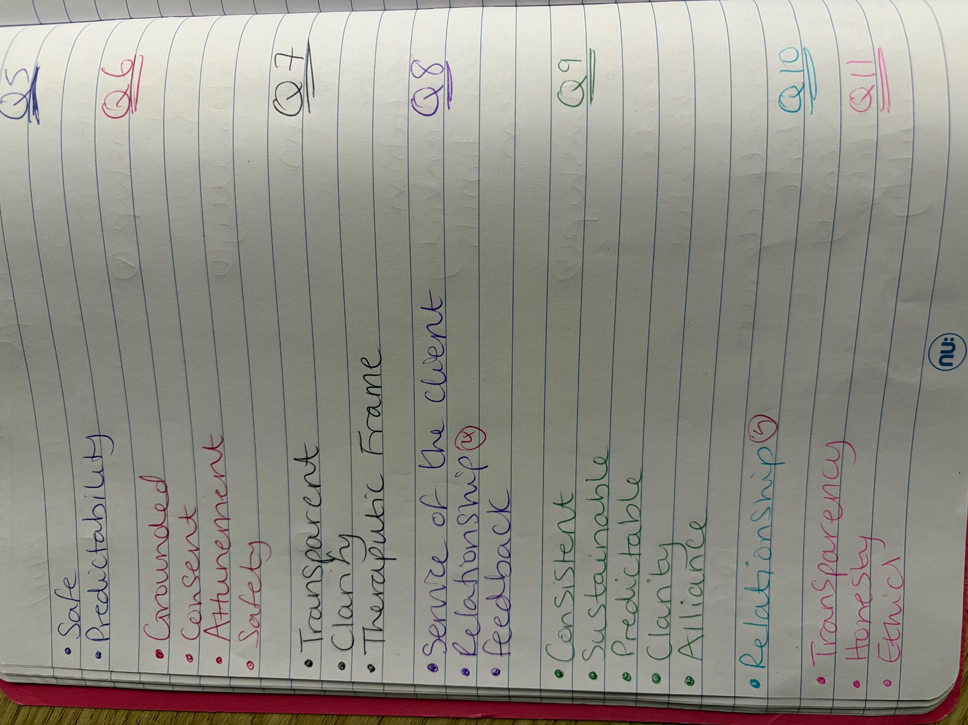

Appendix C
Initial Coding from TA of transcript (see Appendix B)
- Collaborative, Codesign, Framed, Consent, Protects, Sustainable, Freedom – Contract development.
- Reliable, Predictable, Consistency, Expectations, Flexibility – Building trust.
- Clarity, Honesty, Transparency, Safe, Codesigned, Respect – Ethical Humanistic practice.
- The relationship between the client and the professional – Therapeutic Relationship.

Appendix D
Initial Themes
- Collaborative Autonomy – Collective creation including individual rights.
- Client-therapist relationship – Respect, Core Conditions, Kindness, Support.
- Ethical Grounding – BACP guidelines, Confidentiality, Contracting.

Appendix E
Reviewing Themes
- Therapeutic Relationship (TR) – The primary agent of change!
Discussion points –
- Strong TR means effective/successful therapy (l.19-20).
- The TR dictates effectiveness (l.8-10).
- The relationship is the therapy
- Boundaries are relational safety
- Supervision maintains the relationship
- Primary agent of change (Rogers, 1951)
- Clearest limit is the kindest act (l.96-97)

- Collaborative Contracting –
Discussion points –
- When contracts are created collaboratively, there is a greater likelihood that boundaries will be maintained
- Flexibility with non-negotiables
- Feedback loop is part of boundary practice (l.71-72).
- Collaborative goal-setting predicts stronger therapeutic alliance and outcomes (Horvath et al., 2011).
- Working collaboratively builds trust (links to 1)

- Supervision is Self-Care –
Discussion points –
- Supervision is checking in with yourself
- Humanistic congruence – self-awareness (l.44)
- Feedback is encouraged
- Rupture & Repair – deepens trust
- Reality check judgements (l.41).
- Supervision protects the client & therapist |(l.44-45).
- Personal history – life experience (l.43-44).
- Burnout – safeguarding (l.114).
- Can’t offer deep presence if boundaries leak (l.115).
- Steady is better than always available (l.117).
- Also, a place to celebrate wins (l.45).

Appendix F
Thematic Map –
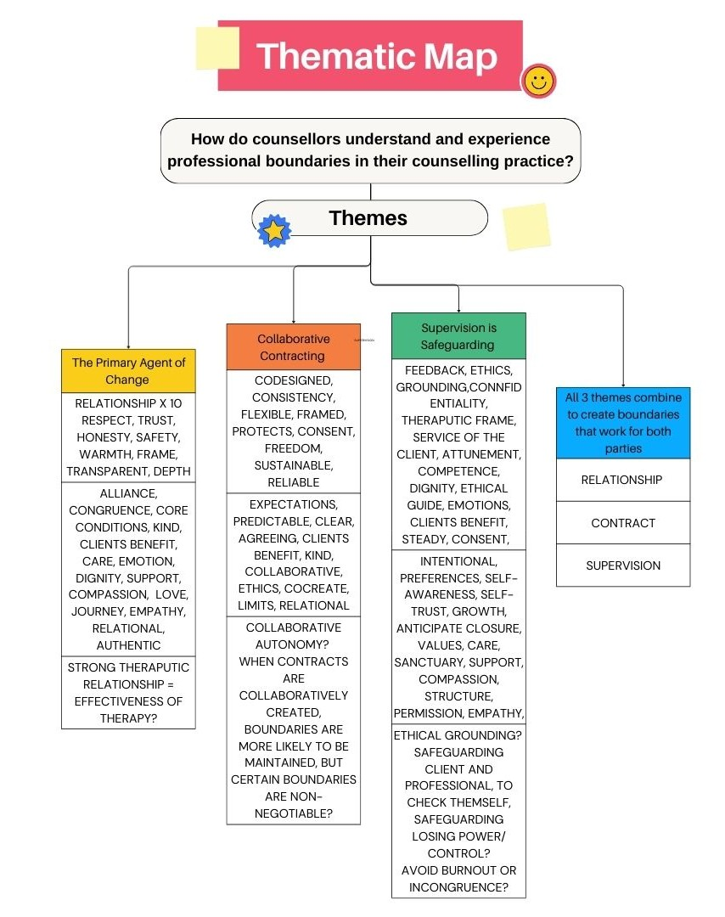

Appendix G
Finalised Themes
- The Primary Agent of Change

- Collaborative Contracting

- Supervision is Safeguarding

