

LIVING WITH CARE: THE OLDER PERSON

Module code: BMH 6009

TOPIC - The impact of loneliness and social isolation on the elderly population.

Lecturer name – Dr Laila Surani

Student name – Yuliana Abadzhieva
Student ID – 1818406
Submission date – 29.08.2023

Table of contents

1.Introduction………………………………………………………………………………..
2.Definition of older population UK vs France……………………………………………..
3.Statistic on the elderly population UK vs France……………………………………….
4.Relevant theories of loneliness……………………………………………………………
5.The impact of loneliness and isolation on an older person living within care setting
6.Legislation and policies…………………………………………………………………
7.Nation provision of service for older person…………………………………………..
8.Prospective future of the care of older person……………………………………………
9.Recommendation………………………………………………………………………….
10.Conclusion………………………………………………………………………………
11.Reference list…………………………………………………………………………….
12.
13.

Introduction

Social isolation and loneliness are serious issues that have received much attention, especially in the context of the senior population. The experiences of older people are significantly altered when societies evolve due to things including urbanisation, technological improvements, and changing family patterns. Older people might experience significant negative impacts on their physical, psychological, and emotional health due to loneliness, characterised by a subjective perception of social isolation and social isolation, which refers to a lack of meaningful social interactions and relationships. (Dury, R., 2014).
The complex relationship between societal changes and the experiences of the aged population can be understood via the lens of modernization theory. According to the notion of modernization, civilizations go through various growth stages marked by changes in economic, social, and cultural paradigms. How communities are organized, how families are viewed, and how social interactions are conducted alter as these changes occur. The elderly, frequently valued for their experience and wisdom, must navigate this changing environment, which may affect how connected and isolated they feel (Crewdson, J.A., 2016).

Definition of older population UK vs France
UK
The "state pension age" is frequently used in the UK to classify the elderly population. The state pension age determines the age at which a person is qualified to receive the state pension, a significant social benefit for retirees. The main point is that the state pension age will change after September 2021. These modifications are impacted by variables like changes in governmental policies and life expectancy. The state pension age represents the age at which people normally move into retirement and become dependent on pension-related support, making it a helpful baseline for categorising the older population ( Topalov, C., 2001).
The UK's pension system is currently at a critical juncture, as it faces some challenges that demand careful analysis and initiative-taking solutions. As people age and demographics shift, pension arrangements' sustainability, adequacy, and equity have become pressing concerns for policymakers, economists, and citizens alike. The complexities of modern life, including changing work patterns, longer lifespans, and economic fluctuations, have exposed vulnerabilities within the pension system that require a comprehensive assessment and potential overhaul (Cribb, J., Emmerson, C. and O'Brien, L., 2022).

FRANCE
In France, the term "retirement age" or "âge de la retraite" is frequently used to define the elderly population. The French government established this age as a benchmark for those transitioning from working to retirement. Due to considerations including demographic changes and the financial viability of pension systems, the retirement age in France has been the topic of discussion and policy revisions (Beland and Viriot Durandal, 2012).
While the older population in the UK and France are defined using retirement and pension eligibility criteria, the age thresholds and the variables influencing changes in these thresholds vary between the two nations. These criteria are influenced by economic factors, public policy, the societal backdrop of ageing, and demographic trends. As they examine the complex definitions of the older population in the UK and France, it becomes clear that these categories are fluid and subject to constant change. Understanding the differences between these definitions is essential for well-informed policy creation and meeting the needs of older people in various nations. These definitions illustrate the complex interplay between ageing, policy, and societal expectations. Gilbert,T. et.al.,(2022).

Statistics on the elderly population UK vs France
UK
The proportion of the elderly in the UK (those sixty-five and over) has risen rapidly over the past few decades. An estimated 15% of the population in 1990 was above 65. This percentage will increase to 18% by 2020; predictions indicate it will reach 25% by 2030. The rising older population has caused numerous meaningful results in numerous disciplines. The healthcare industry is one of those affected most visibly. The need for healthcare services, those geared towards chronic illnesses and disorders associated with ageing, is growing as the older population grows. As a result, resource allocation and service delivery modifications are required, placing pressure on the hospital infrastructure.
(Ageuk.org.uk. 2019).
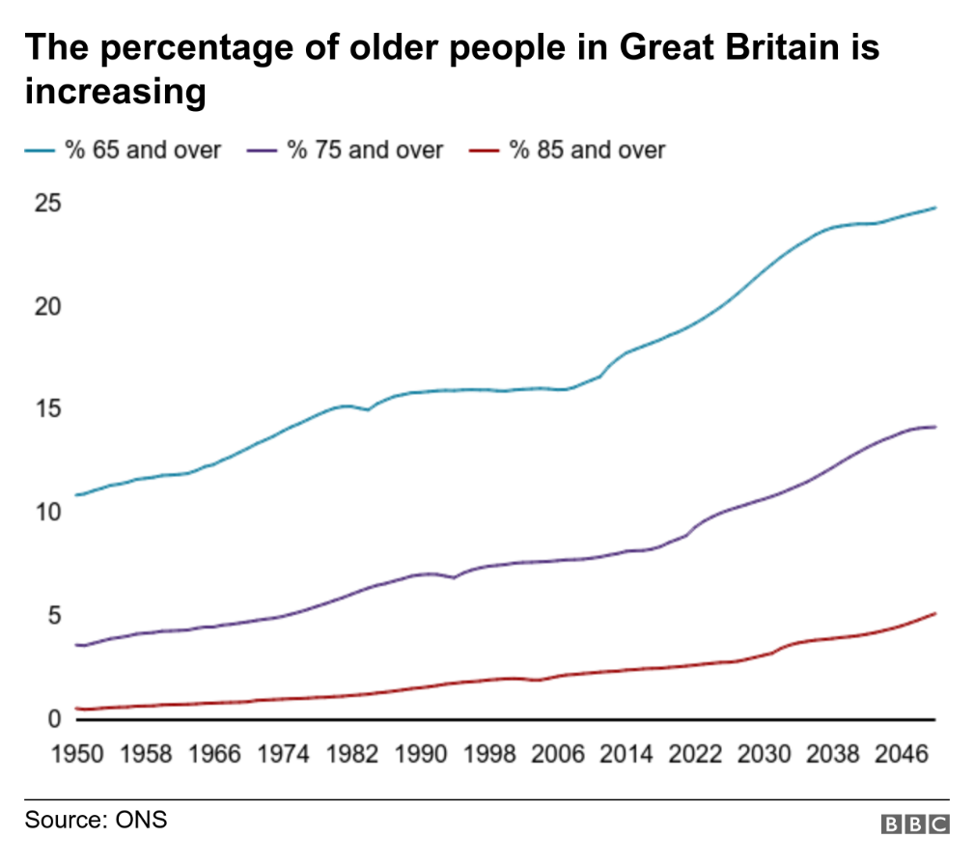

FRANCE
According to the research (Beland and Viriot Durandal,2012 a) ,around 16% of the population in France was 65 years of age or older in the mid-2000s, which was average for the European Union (EU). Its proportion of people sixty-five and older was higher than that of Ireland (11%) and the Netherlands (13%), but it was lower than that of Italy (18%). The proportion of French people sixty-five and older will steadily rise over the coming decades, reaching 25% in 2030 and 30% in 2050. Ages eighty-five and older will represent a larger share of the population than any other age group, growing from one million in the mid-2000s to about 2.5 million in 2030.

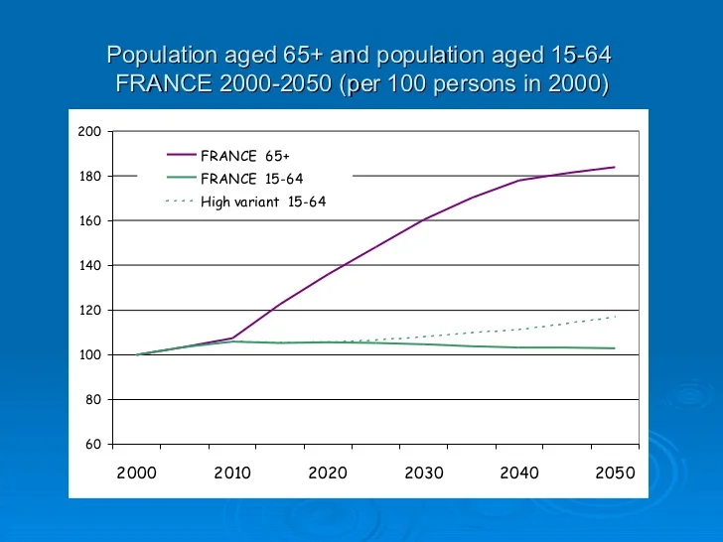
Source:
https://image.slidesharecdn.com/france602/95/france-14-728.jpg?cb=1188308074

Relevant theories of loneliness
Various theoretical vantage points have been used to study the complicated phenomena of loneliness and social isolation. The sources, effects, and underlying mechanisms of these experiences are all subject to various theories. The following list includes critical theories of isolation and loneliness as well as terms used to describe these emotions in the literature:
Social Cognitive Theory: Social cognitive theories contend that people's perceptions of social interactions significantly influence how lonely they feel. According to this hypothesis, false social views, unfavourable self-perceptions, and misinterpretations of other people's behaviour can all contribute to loneliness. Loneliness is more likely to occur in people who interpret social signs as implying rejection or exclusion ( Hawkley, L. C., & Cacioppo, J. T.
2010).

The picture below shows descriptive statistics for each variable in the proposed model. Over the 18-month study period, there were slight but substantial increases in expectations for social, self-evaluative, and physical outcomes. Throughout the 18-month trial period, there was a nonsignificant drop in goals and disability restrictions and a significant decline in exercise self-efficacy( Gothe, N.P., 2018).

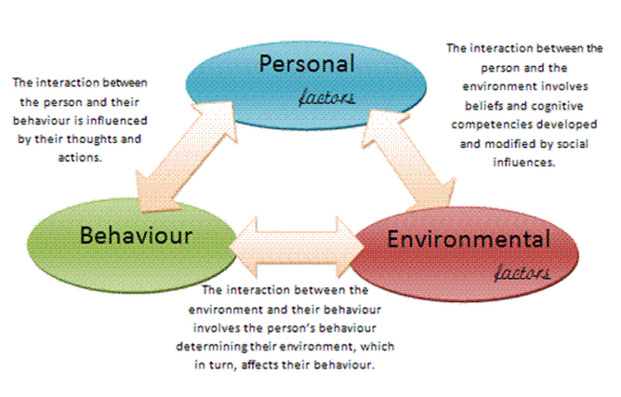
Source:
https://i.pinimg.com/originals/0b/ee/94/0bee94d759cd5a7afc9299e403e3240b.gif

The impact of loneliness and isolation on an older person living within care setting
Loneliness and social isolation can negatively impact all ages, which are widespread problems. However, older adults-particularly those residing in care settings, are notably affected more by these emotional states. The conversation below has explained some evidence of how loneliness and isolation can affect older people's quality of life and overall well-being in care facilities.( Lapane ,K.L.,et. al.,2022).
Cognitive Decline: Chronic loneliness and isolation have been related to cognitive decline and a higher chance of contracting diseases like dementia. Cognitive skills may deteriorate due to a lack of social interaction and cognitive stimulation in care settings. Targeted treatments are needed to combat the effects of isolation and loneliness on older people in care settings. Care facilities can implement social interaction-promoting programmes, including team-building exercises, field trips, and shared meals. Feelings of loneliness can also be reduced by creating deep connections with family, peers, and carers. Connecting with loved ones who might not nearby be made possible by technology like video calls and online groups (Azeem, F., Durrani, R., Zerna, C., and Smith, E.E., 2020).

Legislation and policies that deal with reduce of loneliness and isolation in the elderly people`s life ( Care Act 2014).
The Care Act 2014, an essential legislation in the United Kingdom, created a comprehensive framework for adult social care. The Care Act's principal goal addresses many facets of social care and support. However, through some crucial rules and concepts, it also indirectly helps to decrease loneliness and isolation among the senior population ( Lyu, J.Y., Hu, B., Wittenberg, R. and King, D., 2023).
The Care Act strongly emphasises a change towards wellness promotion and preventative measures. It is required of local authorities to provide or arrange services that aid in delaying the emergence of care and support needs. The Act encourages social interaction and opportunities for older people to connect with others by providing community-based activities, support groups, and day centres, which lowers feelings of loneliness and isolation (Stanley, T., 2016).
Greater coordination and integration of health and social care services are encouraged under the Care Act 2014. This partnership improves the all-encompassing assistance offered to senior citizens by attending to their physical and social requirements. As part of overall care planning, coordinated services offer chances for social contact (Manthrope ,J.,et.al.,2023).
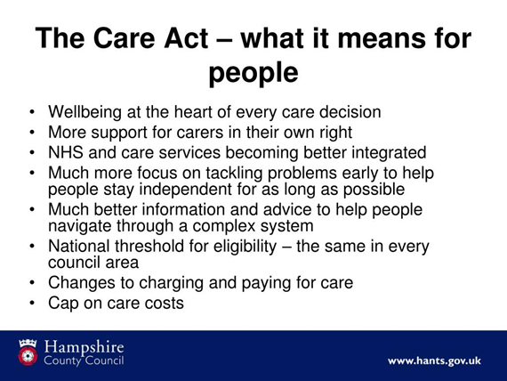
In the United Kingdom, the Care Act 2014 is an important law that significantly impacts the care and support given to older adults. Its goal is to reform social care and strongly emphasise promoting the well-being of individuals, especially those who are vulnerable due to their age. One of the most critical aspects of the Care Act 2014 is its focus on prevention. The Act highlights the importance of preventing the need for care and support in the first place, which is especially important for elderly individuals. The Act supports preventive measures such as providing information, advice, and support for independence. It aims to delay or reduce the need for more intensive care services so that older people can enjoy a better quality of life.
The Care Act 2014 stresses the significance of collaboration and teamwork among different parties responsible for caring for elderly individuals. This supports the overall objective of offering complete and personalized care to senior citizens, comprehensively catering to their physical, emotional, and social requirements. Additionally, the Act prioritizes the values of choice and control, granting older people the authority to voice their opinions in their care and support plans. This demonstrates respect for their independence and confirms that their preferences should determine the care they receive (Prowse, Prowse, & Snook, 2021).
The Care Act 2014 is incredibly significant for the elderly population in the UK. It upholds the values of dignity, respect, and personal choice when providing care and support. The act strongly emphasises prevention, personalized care plans, and support for caregivers, all to improve the overall quality of life and well-being of older individuals. Furthermore, the Care Act prioritizes safeguarding and integration to protect vulnerable older people from neglect and abuse while receiving comprehensive care that addresses their needs (Wikipedia Contributors, 2019).

National provision of service for older person –“ Four Years on”- How the National Service Framework for Older People has affected older people's Perspectives, expectations, and Experiences.

The NSFOP is a comprehensive strategy designed to provide fair, high-quality, coordinated healthcare and social services to elderly individuals in England. The report emphasizes the importance of services that promote independence and good health, as well as specialized care for critical conditions such as stroke, falls, and mental illness. Additionally, the report advocates for a cultural shift in how services are provided, focusing on treating older people and their caregivers with respect, dignity, and fairness. The plan is set to be implemented over ten years starting in 2001( Bracken, P. and Thomas, P., 2001).
Method: Ten carefully chosen English locales were evaluated using a mixed methods approach. With older persons and carers, various procedures (listening sessions, nominal groups, and interviews) were used to focus on processes and results and to account for the likelihood of contradictory or divergent assessments of the quality of the services( Tyrer, P., 1999).
According to the research, 1,839 people participated in public listening events, while 1,639 individuals participated in nominal groups. Additionally, 120 people were interviewed individually. Local implementation teams and voluntary sector activists knew the National Service Framework for Older People (NSFOP). Although many older people identified themselves as part of a group experiencing age discrimination that affected the quality of their care, not everyone did. The group included those who cared for others, but the rights of older people were less emphasized. It was challenging to access general practice, and while primary care services had some positive changes, they were impersonal. The quality of social care varied from being sensitive and personal to fragmentary, rushed, and impersonal. Hospitals were perceived as having improved in speed and quality of treatment, but they were also seen as risky and insufficiently caring, with disorganized and over-zealous discharge practices (Manthorpe et al., 2007b).
In 2007, Jill Manthorpe and her team published "Four Years on The Impact of the National Service Framework for Older People on the Experiences, Expectations, and Views of Older People." The article aimed to examine how the National Service Framework for Older People (NSFOP), a policy framework aimed at improving the quality of care and support for elderly individuals in the United Kingdom, has affected their well-being and perspectives. The study delves into the impact of the NSFOP on the experiences, expectations, and viewpoints of older individuals (Jill Manthorpe and others, 2007).

Prospective future of the care of older person

Looking into the future of caring for the elderly requires considering the changing needs of ageing populations and what adjustments are necessary to maintain their well-being. One major obstacle is tackling loneliness among older individuals, a crucial problem affecting their mental, emotional, and physical health. Moreover, incorporating technology into the care of lonely older people is a promising approach (Hajek, A., Riedel-Heller, S.G. and König, H.H. eds., 2023).
To provide the best care for seniors, we must prioritize holistic approaches that consider their physical, mental, emotional, and social well-being. Providing person-centred care that caters to everyone’s unique preferences and needs while preserving their dignity and independence is essential. A critical aspect of this is Aging in Place, where technology can be a valuable tool in helping seniors remain in their homes and communities for as long as possible. This can involve offering home-based care services, aids, and remote monitoring systems to enable independent living ( Hagan, R., 2021).
Social clubs, hobby groups, and volunteer work are essential for older individuals to participate in activities and feel a sense of belonging. These programs can facilitate communication and foster a stronger sense of community( Fakoya, O.A., McCorry, N.K. and Donnelly, M., 2020).
Intergenerational programs are a powerful tool in the fight against loneliness. They create meaningful connections between younger and older generations, encouraging social interaction and mutual support. To combat loneliness, older individuals require support services and counselling. These resources provide a safe space to express their thoughts and feelings, helping them overcome social isolation challenges( Akhter-Khan,2023).
As the population ages, staying connected with others and maintaining our mental and physical well-being is vital. Fortunately, there are numerous technology-based options available to seniors. They can use video calls, social media platforms, and online communities to interact with our friends, family, and peers from our homes. Telehealth and telecare enable individuals with mobility limitations to access medical care. Companion robots and AI-powered devices offer companionship, medication reminders, and help with everyday tasks. Virtual and augmented reality applications can transport us to recent places, facilitate group activities, and stimulate our minds. Lastly, online courses and brain-training apps keep us mentally engaged and connected with a larger community of learners (Kojima,G.,et.al.,2015).
To sum up, the future of elderly care will involve a comprehensive approach that focuses on the individual and utilizes technology to tackle issues such as loneliness. We can improve older individuals' quality of life and overall well-being by prioritising community involvement, intergenerational programs, and technology-driven solutions( Abdi, S., Spann, A., Borilovic, J., de Witte, L. and Hawley, M., 2019).
Maintaining emotional well-being is crucial for older individuals and communication tools can be a wonderful way to stay connected and prevent feelings of loneliness and isolation. However, it is essential to recognize that not all seniors may feel comfortable or familiar with digital communication tools. To ensure that everyone can fully participate in modern communication, it is vital to adapt strategies to individual preferences and encourage the use of technology( Dawson-Townsend, K., 2019).
Older people must maintain good emotional health; communication tools can help prevent loneliness and isolation. However, some seniors may need to become more familiar with or comfortable with digital communication tools. To ensure everyone can participate, it is crucial to adapt strategies to individual preferences and encourage technology use( Chopik, W.J., Newton, N.J.et al., 2019).

Recommendations
- According to a recent study by Victor, Dobbs, Gilhooly, and Burholt (2021), government, community organizations, and healthcare professionals must focus on reducing loneliness among midlife and elderly individuals from ethnic minority populations in England and Wales. The study highlights the need for culturally sensitive solutions that consider the challenges faced by individuals from diverse backgrounds. By focusing on validating measures and accurately estimating prevalence, interventions can be tailored to meet the unique needs of these groups and effectively address loneliness.
- Creating age-friendly communities is essential to cater to the diverse needs of older people. This involves making public spaces accessible, ensuring safe mobility, and promoting social engagement through community centres and local activities (World Health Organization, 2007).

Conclusion
In conclusion, the research conducted by Victor et al. (2021), explains how common loneliness is among older persons and those in their mid-life from ethnic minority populations in England and Wales. The study emphasises how crucial it is to recognise and address loneliness as a significant issue in these communities. The study's validated measures and prevalence estimates provide helpful information for designing focused interventions that can strengthen social support systems, encourage community involvement, and enhance the general well-being of members of ethnic minority groups. With the help of this research, older individuals from all levels of society can make well-informed decisions and put measures into action that will lessen their isolation and give them a feeling of community.

Reference list
Dury, R., 2014. Social isolation and loneliness in the elderly: an exploration of some of the issues. British journal of community nursing, 19(3), pp.125-128.
Marshall, K., & Rossman, J. (2013). Raising the state pension age: A review of issues and evidence. Social Policy and Society, 12(3), 469-480.
Sundström, G., Fransson, E., Malmberg, B. and Davey, A., 2009. Loneliness among older Europeans. European journal of ageing, 6, pp.267-275.
Ageuk.org.uk. (2019). Finding and using health services | Health and wellbeing | Age UK. [online] Available at: https://www.ageuk.org.uk/information-advice/health-wellbeing/health-services/ [Accessed 2 Aug. 2023].
Beland, D. and Viriot Durandal, J.-P. . (2012a). Aging in France: Population Trends, Policy Issues, and Research Institutions. The Gerontologist, 53(2), pp.191–197. doi:https://doi.org/10.1093/geront/gns149.
Topalov, C., 2001. A Revolution in Representations of Work: The Emergence over the 19th Century of the Statistical Category" Occupied Population" in France, Great Britain, and the United States. Revue française de sociologie, pp.79-106.
Gilbert, T., Cordier, Q., Polazzi, S., Bonnefoy, M., Keeble, E., Street, A., Conroy, S. and Duclos, A., 2022. External validation of the hospital frailty risk score in France. Age and ageing, 51(1), p.afab126.
Gomes, B., and Higginson, I.J., 2008. Where people die (1974—2030): past trends, future projections, and implications for care. Palliative medicine, 22(1), pp.33-41.
Gaymu, J., Ekamper, P. and Beets, G., 2008. Future trends in health and marital status: effects on the structure of living arrangements of older Europeans in 2030. European journal of ageing, 5, pp.5-17.
Beland, D. and Viriot Durandal, J.-P. . (2012b). Aging in France: Population Trends, Policy Issues, and Research Institutions. The Gerontologist, 53(2), pp.191–197. doi:https://doi.org/10.1093/geront/gns149.
Hawkley, L. C., & Cacioppo, J. T. (2010). Loneliness matters: A theoretical and empirical review of consequences and mechanisms. Annals of Behavioral Medicine, 40(2), 218-227.

Gothe, N.P., 2018. Correlates of physical activity in urban African American adults and older adults: Testing the Social Cognitive Theory. Annals of Behavioral Medicine, 52(9), pp.743-751.
Lapane, K.L., Lim, E., McPhillips, E., Barooah, A., Yuan, Y. and Dube, C.E., 2022. Health effects of loneliness and social isolation in older adults living in congregate long term care settings: A systematic review of quantitative and qualitative evidence. Archives of Gerontology and Geriatrics, 102, p.104728.
Azeem, F., Durrani, R., Zerna, C., and Smith, E.E., 2020. Silent brain infarctions and cognition decline: systematic review and meta-analysis. Journal of Neurology, 267, pp.502-512.
Lyu, J.Y., Hu, B., Wittenberg, R. and King, D., 2023. The relationships between informal and formal social care for older people in England: A comparison before and after the Care Act 2014. Journal of Aging & Social Policy, pp.1-18.
Stanley, T., 2016. A practice framework to support the Care Act 2014. The Journal of Adult Protection, 18(1), pp.53-64.
Manthorpe, J., Moriarty, J., Damant, J., Brimblecombe, N., Marczak, J., Knapp, M. and Fernández, J.L., 2023. Local Online Information for Carers in England: Content and Complexity. Practice, pp.1-25.
Tyrer, P., 1999. The national service framework: a scaffold for mental health: Implementation is key to determining whether it is a support or a gallows. BMJ, 319(7216), pp.1017-1018.
Bracken, P. and Thomas, P., 2001. Postpsychiatry: a new direction for mental health. Bmj, 322(7288), pp.724-727.
Kojima, G., Masud, T., Kendrick, D., Morris, R., Gawler, S., Treml, J. and Iliffe, S., 2015. Does the timed up and go test predict future falls among British community-dwelling older people? Prospective cohort study nested within a randomised controlled trial. BMC geriatrics, 15(1), pp.1-7.
Abdi, S., Spann, A., Borilovic, J., de Witte, L. and Hawley, M., 2019. Understanding the care and support needs of older people: a scoping review and categorisation using the WHO international classification of functioning, disability, and health framework (ICF). BMC geriatrics, 19(1), pp.1-15.
Akhter-Khan, S.C., Prina, M., Wong, G.H.Y., Mayston, R. and Li, L., 2023. Understanding and addressing older adults’ loneliness: the social relationship expectations framework. Perspectives on Psychological Science, 18(4), pp.762-777.
Hajek, A., Riedel-Heller, S.G. and König, H.H. eds., 2023. Loneliness and Social Isolation in Old Age: Correlates and Implications. Taylor & Francis.
Hagan, R., 2021. Loneliness, older people, and a proposed social work response. Journal of Social Work, 21(5), pp.1084-1104.
Fakoya, O.A., McCorry, N.K. and Donnelly, M., 2020. Loneliness and social isolation interventions for older adults: a scoping review of reviews. BMC public health, 20, pp.1-14.
Dawson-Townsend, K., 2019. Social participation patterns and their associations with health and well-being for older adults. SSM-population health, 8, p.100424.
Chopik, W.J., Newton, N.J., Ryan, L.H., Kashdan, T.B. and Jarden, A.J., 2019. Gratitude across the life span: Age differences and links to subjective well-being. The journal of positive psychology, 14(3), pp.292-302.
Victor, C. R., Dobbs, C., Gilhooly, K., & Burholt, V. (2021). Loneliness in mid-life and older adults from ethnic minority communities in England and Wales: Measure validation and prevalence estimates. European Journal of Ageing, 18, 5-16.
Prowse, J., Prowse, P., & Snook, J. (2021). What about care work and in-work poverty? The case of care workers in the UK. In The Living Wage (pp. 65-78). Routledge.
Jill Manthorpe and others. (2007). Four years on: The impact of the National Service Framework for Older People on the experiences, expectations, and views of older people. Age and Ageing, 36(5), 501–507.[ Available at] https://doi.org/10.1093/ageing/afm078.
McDonald, B., Scharf, T. and Walsh, K., 2023. Older people's lived experience and the World Health Organization age-friendly policy framework: a critical examination of an age-friendly county programme in Ireland. Ageing & Society, 43(8), pp.1784-1809.
Wikipedia Contributors (2019). Care Act 2014. [online] Wikipedia. Available at: https://en.wikipedia.org/wiki/Care_Act_2014 [Accessed 24 Aug. 2023].
Cribb, J., Emmerson, C. and O'Brien, L., 2022. The effect of increasing the state pension age to 66 on labour market activity (No. W22/07). IFS Working paper.

