Seaview Case Study
BMIH5007
Kobirul Islam
2130690
Tristan Hawkins

Table of Contents
Introduction 1
Analyzation of the financial performance of The Seaview Resort 1
Total revenue 1
Operating expenses 1
Gross profit 1
Net profit or loss 2
Net profit Margin 2
Key reasons behind the decline in profitability 2
Comprehensive turnaround strategy to revitalize the financial health of The Seaview Resort 5
Conclusion 6
References 7

Introduction
The report will present information based on a case study named The Seaview Resort which is a hotel and resort business that offers hotel services to people who seek to enjoy their vacation in cities and beaches. The report will analyse the financial performance of The Seaview Resort and present information on where the company was ineffective in operating its business. The report will first analyse the financial performance of the past three years of The Seaview Resort and present the main areas behind the reduction in the profitability of the company. Later, the report will present a comprehensive turnover strategy for The Seaview Resort to revitalize the company's financial situation as well as the business’s brand image.

Analyzation of the financial performance of The Seaview Resort

Total revenue
The total revenue of the company in 2020 was £520,000 which is pretty good but it started to decline in the upcoming years. In 2021, the revenue was £480,000 and in 2022, the amount of revenue was £430,000. The decline in revenue shows that the company has lost its market share and the amount of sales has declined which has decreased the amount of revenue (Yusuf, 2021).

Operating expenses
The operating expenses are those expenses or costs of the company which are needed to operate the business. They are not connected with the production of the company directly but they are essential to provide effective service. The operating cost of The Seaview Resort has increased over the years. The cost in 2020 was 390,000 which increased by 400,000 and 450,000 in the years 2021 and 2021 respectively (Yusuf, 2021). Therefore, it can be seen that The Seaview Resort is unable to control the cost of the company which has increased the expenses and it will also impact the profit of the company directly.

Gross profit
Gross profit is the amount of money which a company gets by deducting the direct cost from the revenue. The gross profit is the first stage of profit and it highlights how much money the company has obtained by selling products while deducting the costs. The Gross profit of The Seaview Resort shows that the company had a gross profit of 130,000 in 2020. However, the gross profit decreased by 80,000 in 2021 as well as 2022 (Tiebout, 2022). Therefore, the cost of the company had increased in those years which has decreased the gross profit rate.

Net profit or loss
The net profit of the company is the amount of money which a company gets after deducting all types of costs from the total amount of earnings. The amount of net profit of The Seaview Resort was 78,000 pounds in 2020. However, the amount decreased by 40,000 and a loss of 47,500 pounds in the years 2021 and 2022. The reason for the reduction of net profit is the increase in operating cost and the reduction of gross profit as well as the revenue of The Seaview Resort.

Net profit Margin
The net profit margin is the percentage of money which a company obtains from the amount of revenue as net profit. For example, the 15% net profit margin shows that if The Seaview Resort sells 100 pounds, the company will get 15 pounds as net profit after giving every type of cost. The net profit margin of The Seaview Resort was 15% in the year of 2020 but it decreased by 8% and -11% in the year of 2021 and 2022. The reason for the decline in profit margin is the increased operating cost of the company and the decreased amount of revenue.

Key reasons behind the decline in profitability
After analysing the case study, various factors can be identified and marked as the reasons for the decline in profitability of The Seaview Resort. Based on the case study of The Seaview Resort, the company has faced less in occupancy rate and the ARR average room rate which is presented below:
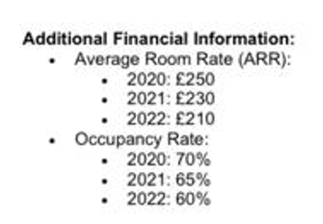
The average room rate or ARR is the price for taking the room of the hotel by the customers. the room rate of The Seaview Resort in 2020 was 250 but the rate of the room decreased as the company faced less customer interaction. In 2021 and 2022, the price of hotel rooms decreased by 230 and 210 respectively (Simon, 2022). The rate of the room decreased because of the decisions of the company because the management of The Seaview Resort thought that customers would increase their level of purchase if the company provided less charge for rooms compared to other hotel and resort companies. However, the plan of The Seaview Resort did not work out because the occupancy rate of The Seaview Resort shows that the amount purchased has decreased with time (Schwert, 2019). In 2020, the occupancy rate was 70% which has decreased by 65% and 60% in the years of 2021 and 2022 respectively. Therefore, the ability of the company to generate profit has decreased with time and it impacted negatively on the financial condition of The Seaview Resort. Some other issues can also be seen based on the case study which is presented below:
Competitive market: In the hotel and tourism market, the rate of competition has increased and various new companies are emerging in the scenario to conduct business. Some of the competitors of The Seaview Resort are more innovative and use the modern approach to business which helps them to get more customers (Rubin, 2022). They offer business and leisure tourism packages and other innovative tourism approaches which attract the attention of tourists. For that reason, The Seaview Resort is unable to obtain more market share and customers prefer other hotel brands to gain more effective and innovative services.
Changing customer preferences: As times are changing, the customers of the tourism business are also changing and focusing more on positive approaches to tourism like eco-friendly tourism and experiential tourism. Customers want to take hotel and tourism services from those companies who take special care of the environment and make sure that the business operations of the company do not impact negatively the environment which is known as eco-friendly tourism (Rosen, 2021). On the other hand, experiential tourism is the tourism process where the customer visits a place and adopts the living conditions of the locals. It helps them to gain a type of experience and understand the value of the culture and history of that place. These types of tourism approaches are becoming more popular and people are not looking for classical approaches to tourism. On the other hand, The Seaview Resort has not applied any types of innovative tourism approaches which has decreased the attention of the customers and it dropped the profitability of the company (Reijonen and Komppula, 2019).
Outdated amenities: Another factor that impacted and declined the profitability of The Seaview Resort is the outdated amenities of the company. The Seaview Resort uses old technologies like telecommunication to communicate with customers in this era of the Internet. Therefore, the customers are facing issues in communication and the other services like online payment and online ordering process in unavailable in the company. Therefore, the preferences of the customers are diverting to other companies which are declining the profitability of The Seaview Resort (Reijonen, 2021).
Declining quality of service: The declining quality of the service of The Seaview Resort is another factor which is reducing the profitability rate of the company. Based on the feedback of the customer, The Seaview Resort is unable to provide effective service because the company is unable to understand and study the needs and demands of the customers. As the company have no idea what the customers wants, The Seaview Resort company is unable to provide effective service to the customers and the customers are reaching out to other companies in the tourism industry which is decreasing the sale and decreasing the amount of profitability (Nelson, 2022).
Increased operating cost: From the analysis of the income statement of The Seaview Resort, it can be seen that the operating cost of the company has increased in the years 2021 and 2022. Therefore, it can be addressed that the company is using more money compared to the earnings of the company. To gain a standard rate of profitability, companies must follow the balance of earnings and expenses (Lerner and Haber, 2021). If companies are unable to control the cost compared to the earnings, the profitability will decrease which can be seen in the scene of The Seaview Resort.

Comprehensive turnaround strategy to revitalize the financial health of The Seaview Resort
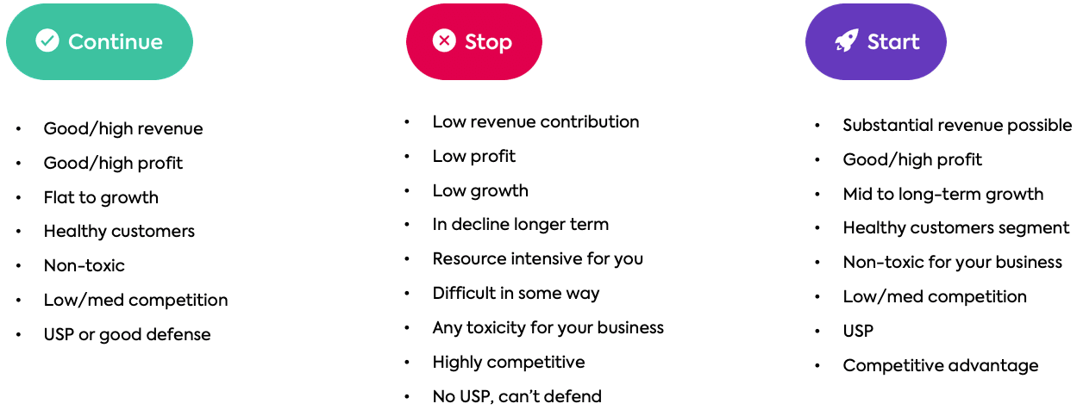
Figure: Comprehensive turnaround strategy for The Seaview Resort.
Source: (Lancaster, 2021).
To make the financial situation of The Seaview Resort positive, the company will need to apply a comprehensive turnaround strategy which has three different types of tasks and they are presented below:
Continue: The “Continue” plan shows various things that a company should continue doing to make the business more effective and successful. To improve the financial condition of The Seaview Resort and to restore the brand image, the company will need to make a high rate of revenue and profit which will help the company to survive. The company will also need to find scopes to make growth for the company and expand the business The Seaview Resort will also need to continue searching for good customers who want to make a purchase (Jarvis, Weeden and Simcock, 2020). The Seaview Resort will also need to be positive with the customers and train workers on how to deal with toxic customers. To gain business success, The Seaview Resort will need to operate the business in a less competitive market because if the number of competitors is low, it will allow The Seaview Resort to gain more customers and increase the profit rate of the company (Fisher, 2023).
Stop: The “Stop” plan presents various actions that a company should not do to increase the chance of achieving business success. Companies should stop these works because they impact negatively on the brand image of the company as well as reduce the profitability of the company. For instance, to gain a more effective business brand image and to increase the rate of profit, The Seaview Resort will need to stop operating businesses with low-profit plans. The company will also need to enhance the low revenue contribution in the business and resource allocation has to be effective (Darby and Karni, 2019). If The Seaview Resort can stop misusing or wasting its resources, the company will be able to reduce the operating costs which will increase the brand image as well as the profitability rate of the company. The Seaview Resort will also need to stop operating business in a highly competitive market and remove all the toxic approaches to conducting business (Dahlman, 2019).
Start: The Seaview Resort will also need to start a handful of approaches to increase its profitability ratio and the brand image of the company (Bishop et al., 2021). The Seaview Resort will start conducting business with the target of high profit and a substantial revenue approach. The Seaview Resort will also need to start operating the business with innovative minds and approaches and also operating the business with a highly competitive advantage (Coase, 2020). The Seaview Resort will need to make sure that the company offers more innovative and advantageous services to the customers compared to the competitors.

Conclusion
To operate the business successfully, The Seaview Resort will need to focus on financial success because if the company is not able to gain success in the financial field, the company will lose its existence. The case study of The Seaview Resort shows that the revenue, gross profit and net profit of the company have decreased but the expenses have increased. Also, the company is less competitive in the market which also impacted negatively and the company had to face a decline in business. to overcome the situation, The Seaview Resort will need to make a comprehensive turnover approach which will help the company to increase its brand image as well as reach for a high level of profit.

References
Avci, U., Madanoglu, M. and Okumus, F. (2021). Strategic orientation and performance of tourism firms: Evidence from a developing country. Tourism Management, 32(1), pp.147–157.
Balassa, B. (2021). The Purchasing-Power Parity Doctrine: A Reappraisal. Journal of Political Economy, [online] 72(6), pp.584–596. Available at: http://digamo.free.fr/balassa64.pdf [Accessed 16 Jul. 2019].
Bishop, J., Kapila, S., Hicks, F., Mitchell, P. and Vorhies, F. (2021). New Business Models for Biodiversity Conservation. Journal of Sustainable Forestry, 28(3-5), pp.285–303.
Coase, R.H. (2020). The Problem of Social Cost. The Journal of Law and Economics, 3(3), pp.1–44.
Dahlman, C.J. (2019). The Problem of Externality. The Journal of Law and Economics, 22(1), pp.141–162.
Darby, M.R. and Karni, E. (2019). Free Competition and the Optimal Amount of Fraud. The Journal of Law and Economics, 16(1), pp.67–88.
Fisher, L. (2023). Determinants of Risk Premiums on Corporate Bonds. Journal of Political Economy, 67(3), pp.217–237.
Jarvis, N., Weeden, C. and Simcock, N. (2020). The Benefits and Challenges of Sustainable Tourism Certification: A Case Study of the Green Tourism Business Scheme in the West of England. Journal of Hospitality and Tourism Management, [online] 17(1), pp.83–93. Available at: https://www.sciencedirect.com/science/article/pii/S1447677000000668.
Lancaster, K.J. (2021). A New Approach to Consumer Theory. Journal of Political Economy, 74(2), pp.132–157.
Lerner, M. and Haber, S. (2021). Performance factors of small tourism ventures. Journal of Business Venturing, 16(1), pp.77–100.
Nelson, P. (2022). Information and Consumer Behavior. Journal of Political Economy, 78(2), pp.311–329.
Reijonen, H. (2021). Understanding the small business owner: what they aim at and how this relates to firm performance. Management Research News, 31(8), pp.616–629.
Reijonen, H. and Komppula, R. (2019). Perception of success and its effect on small firm performance. Journal of Small Business and Enterprise Development, 14(4), pp.689–701.
Rosen, S. (2021). Hedonic Prices and Implicit Markets: Product Differentiation in Pure Competition. Journal of Political Economy, 82(1), pp.34–55.
Rubin, P.H. (2022). The Theory of the Firm and the Structure of the Franchise Contract. The Journal of Law and Economics, 21(1), pp.223–233.
Schwert, G.W. (2019). Using Financial Data to Measure Effects of Regulation. The Journal of Law and Economics, 24(1), pp.121–158.
Simon, H.A. (2022). Bounded Rationality and Organizational Learning. Organization Science, 2(1), pp.125–134.
Tiebout, C.M. (2022). A Pure Theory of Local Expenditures. Journal of Political Economy, 64(5), pp.416–424.
Weppen, J. avon der and Cochrane, J. (2022). Social enterprises in tourism: an exploratory study of operational models and success factors. Journal of Sustainable Tourism, 20(3), pp.497–511.
Yusuf, A. (2021). Critical Success Factors for Small Business: Perceptions of South Pacific Entrepreneurs. Journal of Small Business Management, 33(2), p.68.

