

Student name: Bouadoua sylvie Kouao
Student ID: 2417904

Module name: Introduction to Physiology

Module code: BMHP5023

Lecturer name: Shaila Hussain

Assessment: Understanding and Managing Asthma in Adolescents

Table of Contents

1. Introduction

2. Structure of the respiratory system

3. Gas exchange in lungs

4. Recording and tracking respiratory functions

5. Recommendations

6. Conclusion
7. reference

.

1. Introduction
Asthma is a chronic inflammatory disorder of the airways that causes recurrent episodes of wheezing, breathlessness, chest tightness, and coughing (National Institute for Health and Care Excellence [NICE], 2021). The condition is characterised by airway hyper-responsiveness and reversible airflow obstruction that vary in intensity and frequency among individuals. In the UK, asthma affects approximately 5.4 million people, including 1.1 million children and adolescents (Asthma + Lung UK, 2024).
Adolescents are particularly vulnerable because of lifestyle and behavioural factors that can trigger or worsen asthma. These include exposure to allergens, tobacco smoke, vaping aerosols, air pollution, and poor medication adherence (Global Initiative for Asthma [GINA], 2024). Social behaviours such as attending crowded places, alcohol use, or lack of sleep can also increase respiratory vulnerability. These factors can heighten airway inflammation, leading to more frequent and severe exacerbations.
Figure 1 below illustrates key factors associated with asthma during adolescence.
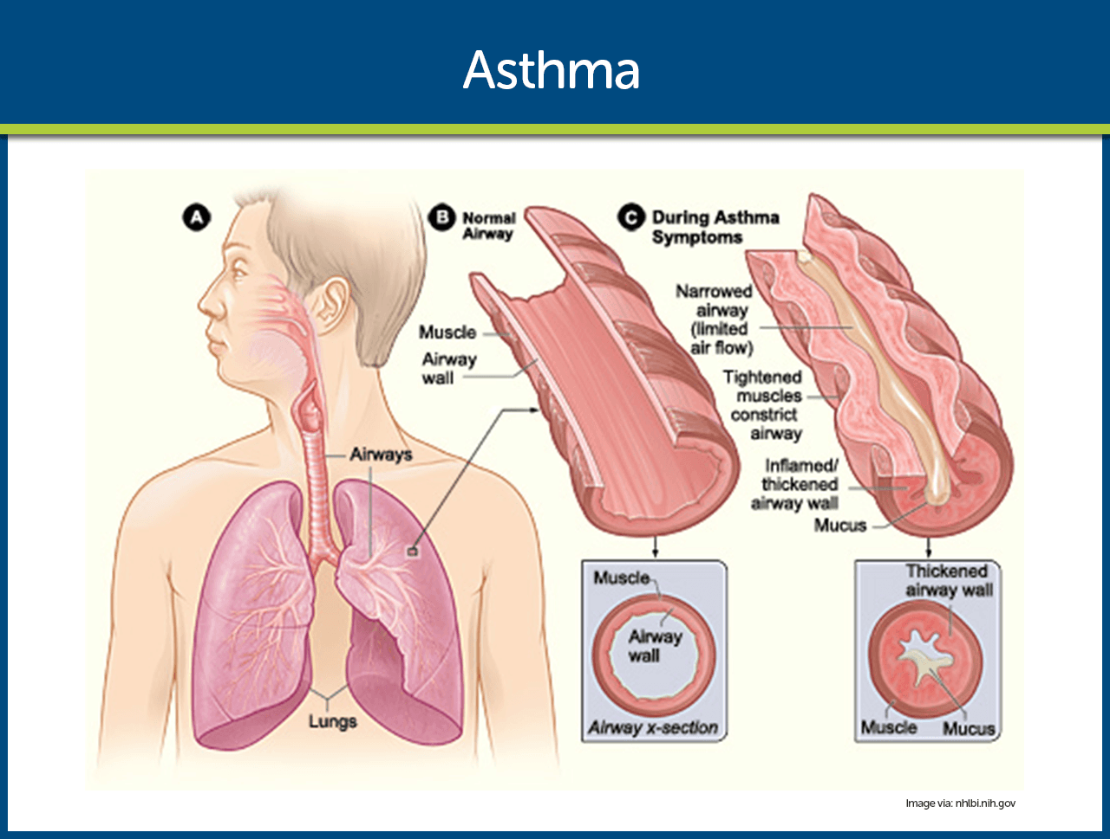

Figure 1: Asthma in Adolescence
(: Pathophysiology of asthma, 2024)
Comment:
This diagram effectively highlights both biological and environmental factors influencing asthma in adolescence. It clearly presents common triggers such as allergens, air pollution, stress, smoking, and poor medication adherence. The depiction of inflammation and narrowed airways helps explain the physiological processes underlying asthma symptoms. Overall, it provides a simple yet comprehensive visual understanding of how adolescent behaviours and environmental exposure can exacerbate asthma symptoms.

2. Structure of the Respiratory System
The respiratory system enables gas exchange between the body and the external environment. It consists of the upper airways—nose, nasal cavity, pharynx, and larynx—and the lower airways—trachea, bronchi, bronchioles, and alveoli (Marie & Hoehn, 2019). Air enters through the nose, where it is filtered, warmed, and humidified before passing into the trachea. The trachea then divides into two bronchi leading to the lungs, where these further branch into bronchioles ending in alveoli—microscopic sacs surrounded by capillaries where gas exchange occurs.
Figure 2 illustrates the structure and physiological changes that occur in the airways during an asthma episode.

Figure 2: Asthma Symptoms and Airway Structure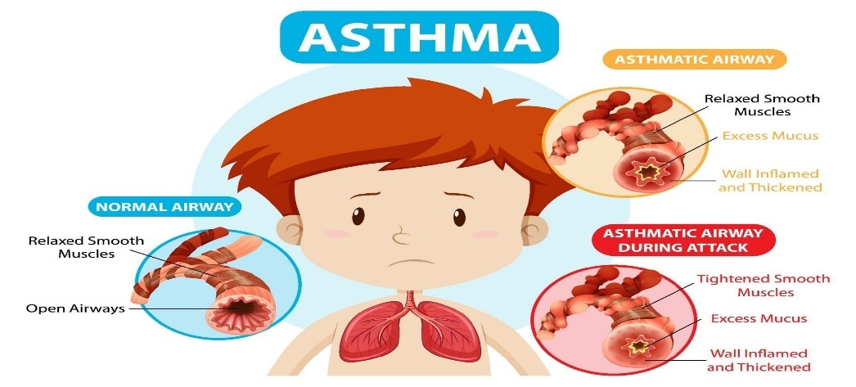
https://www.vecteezy.com/vector-art/3244164-asthma-diagram-with-normal-airway-and-asthmatic-airway
Comment:
This diagram demonstrates how asthma causes airway narrowing and inflammation. The comparison between a normal and an asthmatic airway clearly shows the thickening of the airway wall, muscle tightening, and mucus accumulation. These changes restrict airflow, leading to breathing difficulty and wheezing. The visual clarity helps explain the mechanical and physiological aspects of asthma attacks in an educational and clinical context.

3. Gas Exchange in the Lungs
Gas exchange takes place in the alveoli, where oxygen (O₂) diffuses from inhaled air into pulmonary capillary blood, while carbon dioxide (CO₂) diffuses out for exhalation. The thin alveolar–capillary membrane facilitates rapid diffusion (Tortora & Derrickson, 2021). Oxygen binds with haemoglobin to form oxyhaemoglobin, while CO₂ is expelled through exhalation (Martini, Nath & Bartholomew, 2020).
In asthma, airway inflammation and mucus buildup reduce airflow to the alveoli, leading to less efficient oxygen exchange and increased CO₂ retention. This can cause shortness of breath, fatigue, and reduced exercise tolerance. Understanding this process helps adolescents recognise the importance of medication adherence and avoiding triggers that impair gas exchange.

4. Effect of Irritants on Lung Tissue and Respiration
Exposure to irritants such as cigarette smoke, vaping aerosols, and air pollution provokes airway inflammation—one of the defining characteristics of asthma (GINA, 2024). Smoking introduces harmful chemicals like tar and carbon monoxide, which damage cilia and impair mucus clearance (Public Health England [PHE], 2019). Vaping also contributes to airway irritation through nicotine and propylene glycol exposure, leading to coughing and wheezing (McNeill et al., 2023).

5. Recommendations

Lifestyle and Behavioural Changes
- Avoiding Triggers:
Adolescents should identify and avoid allergens such as dust, smoke, pollen, and pet dander. Minimising exposure to air pollution and respiratory irritants can significantly reduce asthma exacerbations (Asthma + Lung UK, 2022).
- Physical Activity:
Regular moderate exercise improves lung capacity and strengthens respiratory muscles. However, exercise should be adapted to individual tolerance and combined with appropriate use of reliever inhalers (British Lung Foundation, 2023).
- Healthy Diet:
A diet rich in fruits, vegetables, and omega-3 fatty acids can reduce inflammation and enhance immune function (Johnston et al., 2022). Maintaining a healthy weight also helps optimise breathing.
- Smoking and Vaping Cessation:
Both smoking and vaping worsen asthma symptoms. Adolescents should receive behavioural support and access cessation programmes to reduce respiratory risks (PHE, 2021).

Health Promotion and Social Care Support
- Education and Self-Management:
Health professionals should educate adolescents on inhaler techniques, early symptom recognition, and stress management strategies to promote autonomy in asthma care (NHS, 2023).
- Community Support:
Access to asthma support groups and counselling can improve emotional wellbeing, reduce anxiety, and enhance adherence to treatment (Asthma + Lung UK, 2023).
- Environmental Health Promotion:
Policies aimed at reducing air pollution and tobacco exposure can improve asthma outcomes across communities (World Health Organization [WHO], 2023).

6. Conclusion
Asthma in adolescence is influenced by both biological and behavioural factors. Adolescents face unique challenges due to hormonal changes, social pressures, and exposure to environmental irritants. Effective asthma management relies on education, trigger avoidance, adherence to prescribed treatment, and supportive social care. Health promotion strategies including smoking cessation, physical activity, and community engagement are vital to improving quality of life and reducing asthma-related complications.

References
Asthma + Lung UK (2022) Asthma triggers and management. London: Asthma + Lung UK.
Asthma + Lung UK (2023) Support for people living with asthma. London: Asthma + Lung UK.
Asthma + Lung UK (2024) Asthma statistics. Available at: https://www.asthmaandlung.org.uk.
British Lung Foundation (2023) Physical activity and asthma management. London: BLF.
Global Initiative for Asthma (GINA) (2024) Global strategy for asthma management and prevention.
Johnston, S., et al. (2022) ‘Dietary influences on inflammation in asthma’, Journal of Respiratory Health, 18(3), pp. 210–219.
Marieb, E.N. & Hoehn, K. (2019) Human Anatomy & Physiology. 11th edn. Harlow: Pearson.
Martini, F.H., Nath, J.L. & Bartholomew, E.F. (2020) Fundamentals of Anatomy and Physiology. 11th end. London: Pearson.
McNeill, A., Brose, L.S., Calder, R. & Bauld, L. (2023) E-cigarettes and vaping among youth. London: PHE.
National Institute for Health and Care Excellence (NICE) (2021) Asthma: diagnosis, monitoring, and chronic asthma management. London: NICE.
NHS (2023) Asthma self-management and education. Available at: https://www.nhs.uk.
Public Health England (PHE) (2019) Health effects of smoking and air pollution. London: PHE.
Public Health England (PHE) (2021) Stop smoking support for young people. London: PHE.
Tortora, G.J. & Derrickson, B.H. (2021) Principles of Anatomy and Physiology. 16th edn. Hoboken, NJ: Wiley.
World Health Organization (WHO) (2023) Air quality and health promotion. Geneva: WHO.

