

Strategic Management for SMEs (BMSW6104)
Task 01: Strategic Plan
2107037
Touqir hanif
Abdallah Naser

Table Contents
1. Introduction 3
2.0 A brief overview of the case study firm 3
2.1 The organisation’s current strategic direction 3
3.0 Environment Analysis 4
3.1 External environment analysis: PESTLE 4
3.2 Internal environment analysis: SWOT 6
4.0 Stakeholder analysis: Mendelow Matrix 8
5.0 Strategic Growth Choice for the SME 11
6.0 Strategic recommendations and implementation 13
7.0 Conclusion 15
8.0 References 16

1. Introduction
This report conducts an in-depth environmental scanning of Miss Macaroon, identifying the organisation's external and internal environments through the use of tools such as PESTLE and SWOT, which assist in critiquing the strategic directions of the firm; a female entrepreneur who specialises in baking macaroons. This is a process of assessing necessities and power disparities among diverse stakeholders. Furthermore, the report deliberates on strategic growth options, suggesting a way forward to adopt an integrated approach to create a sustainable long-term strategy and providing key recommendations for the successful future development of SME space.

2.0 A brief overview of the case study firm
Launched in 2011, Birmingham-based social enterprise Miss Macaroon has earned a reputation for producing high-end macarons (Miss Macaroon, 2024b). The business began relatively small and has now grown with a presence for good in the local market, involving delectable connections with a robust social mission (Miss Macaroon, 2024a). Its competitive advantages are its scientific way of making macarons, accurate measurements of ingredients, and even a matching Pantone service where customers can order macarons simply to give them their own unique hue.

2.1 The organisation’s current strategic direction
With its current strategic positioning, Miss Macaroon focuses heavily on embedding social impact and product excellence (Miss Macaroon, 2024b). A macaron manufacturer designed to make high-quality, visually appealing macarons while also bringing social issues to light by providing employment and training to marginalised young people in conjunction. Miss Macaroon is unique in targeting both social enterprise and premium product quality things that are usually mutually exclusive within the confectionery market (Miss Macaroon, 2024b).

3.0 Environment Analysis

3.1 External environment analysis: PESTLE
Political Factor
Brexit has also been identified as one of the key political issues that impact Miss Macaroon and food businesses of similar size due to the current uncertainty surrounding it and the regulatory changes that are now instigated by it (Hendry et al., 2019). Brexit has resulted in greater customs checks, tariffs, and regulatory compliance obligations, mainly affecting the importation of needed ingredients and the exportation of finished products (Hendry et al., 2019). These changes have resulted in an increase in operational costs and the promise of potential delays for businesses like Miss Macaroon, which relies on European-sourced high-quality produce.
Economic Factor
One beneficial economic trend for Miss Macaroon is the increasing premiumisation in the food sector (Heide and Olsen, 2018). Higher disposable incomes and growing consumer inclination towards premium, artisanal items are boosting sales of premium confectionery (Heide and Olsen, 2018). This trend provides an opportunity for Miss Macaroon, whose luxury and visually appealing macarons tap right into this uprising cult market. These high-quality, tailored garments give the company decent profit margins -- enough so that they can have an upward social mobility program. The bottom line is that this is an environment where the business can invest and grow sustainably, not only in terms of market presence but in fulfilling its social enterprise remit.
Social Factor
One big positive social trend influencing Miss Macaroon is the increase in consumer demand for ethical and responsible lead businesses. More and more businesses are realising the rewards of giving back, which has strengthened demand for companies that invest in social causes (Kuokkanen and Sun, 2020). Having a purpose like Miss Macaroon's to help unemployed young people and familiarity with the language millennials use can work well together, especially with socially conscious consumers. Greater brand loyalty is earned as an adaptive culture becomes contagious, spreading to those who align with consumer values, and helping them attract the right type of customer who no longer has to Google their 'purpose of choice' (Kuokkanen and Sun, 2020). This results in increased brand exposure for Miss Macaroon, which feeds into further referrals and higher levels of customer engagement, ultimately helping to grow our organisation and increase social impact.
Technological Factor
One of the most important technological effects that are pushing Miss Macaroon to a better position is increasing digitalisation in marketing and e-commerce platforms (Nanda, Xu and Zhang, 2021). These technologies help the company to cater for a wider audience and customer engagement by advertising specifically to them through digital space, mainly social platforms. As a result, e-commerce platforms offer a first-class experience for both online orders and customer interaction. Miss Macaroon calls on such technologies to broaden its market reach, improve operational efficiencies and provide personalised product lines, like Pantone colour-matched macarons.
Ecological Factor
One of the main negative ecological forces influencing Miss Macaroon is climate change, and with this comes an increase in the number of extreme weather events. Such events can affect the stability and disrupt the supply chain and the quality and availability of key ingredients like almonds (Suali, Srai and Tsolakis, 2024). Price fluctuations and threats to almond-producing regions from droughts and other extreme weather events have also degraded the amount of almonds that are exported (Gee et al., 2020). Production costs such as this have a big impact on Miss Macaroon and how they are able to produce quality goods. This, in turn, increases the operational costs and the demand for sustainable, eco-friendly packaging materials, and it contributes towards saving the environment from further degradation.
Legal Factor
Miss Macaroon is one of many SMEs affected chiefly by one significant legal force in the UK: the strict food safety and hygiene regulations. There is a lot of investment involved with them as one has to invest in setting up quality control systems, training staff, and ensuring regular audits are accommodated (Green and Kane, 2014). If the company were found not to meet these standards, it would face heavy fines, its products would be recalled, and its image as a brand would be tarnished. Maintaining compliance can be particularly costly for a small enterprise like Miss Macaroon.

3.2 Internal environment analysis: SWOT
The SWOT analysis table for Miss Macaroon is shown below.
Table 1: The SWOT analysis table for Miss Macaroon
SWOT Points | Importance | Weight | Score
Strengths
Premium quality, visually appealing macarons. | 8 | 3 | 24
Strong social mission supporting youth employment. | 7 | 3 | 21
Unique Pantone matching service. | 9 | 2 | 18
Weaknesses
High dependency on European-sourced ingredients. | 5 | 2 | 10
Limited scalability due to artisanal production methods. | 2 | 1 | 2
Higher operational costs from strict regulatory compliance. | 3 | 2 | 6
Opportunities
Rising demand for ethical, socially responsible products. | 11 | 3 | 33
Expansion into new markets through e-commerce. | 10 | 3 | 30
Partnerships with high-end events and corporate clients. | 6 | 2 | 12
Threats
Supply chain disruptions due to extreme weather. | 4 | 3 | 12
Intense competition in the premium confectionery market. | 1 | 2 | 2
Regulatory changes post-Brexit increasing costs. | 12 | 3 | 36

(Miss Macaroon, 2024a; Miss Macaroon, 2024b; Green and Kane, 2014; Oke, Ladas and Bailey, 2020; Panova and Hongsheng, 2019; Hendry et al., 2019)
Strengths
Its higher performance on premium quality visually appealing macarons (score 24), strong social mission (score 21) and the uniqueness in its Pantone matching service (score 18) led Miss Macaroon to be ahead of the rest. Upmarket macarons have won a faithful clientele who are prepared to shell out more for the product, which is reflected in profits. The social mission appeals to socially responsible consumers, which makes them more likely to remain loyal and return (Miss Macaroon, 2024b). In addition to the outstanding branding, Miss Macaroon offers bespoke products unique with a Pantone matching service that none of its competitors can offer; translating into great sales opportunities at high-end events and corporate clients (Miss Macaroon, 2024b). Together, these have helped build the reputation of our brand, increased customer engagement and strengthened our market positioning, which has driven a significant portion of our growth and social impact.
Weaknesses
Miss Macaroon also scores highly (score 10) for its reliance on ingredients sourced from Europe (score 10), scalability restrictions due to the artisanal nature of production methods (score 2), and higher operating costs associated with it complying fully with strict and transparent regulations (score 6). The company relies on European ingredients lending it to supply chain disruption and cost volatility, particularly given Brexit (Hendry et al., 2019). Initial production using artisanal methods makes quality control easy but prohibits significant scale to meet larger demand. Not only that, adherence to strict food safety and hygiene norms bloat operational costs, eroding profitability (Green and Kane, 2014). Now, it is important for Miss Macaroon to address these shortcomings in order to continue having a competitive positioning and sustainability in the long run.
Opportunities
The Miss Macaroon score is reflected in the potential growth for ethical, socially responsible products (score 33), e-commerce expansion into new markets (score 30) and high-end events and corporate client partnerships (score 12). The increasing consumer demand for ethical products is going hand in hand with Miss Macaroon's social mission, which is cultivating greater brand loyalty and market differentiation (Oke, Ladas and Bailey, 2020). The scalability of the e-commerce expansion provides a platform to access new markets and hence improve revenue potential (Panova and Hongsheng, 2019). It drives more revenue and branding awareness to work with high-calibre events, as well as corporate clients. These opportunities translate into vast potential, which can catapult the company to heights of growth and profitability as well as social impact, keeping the company alive and ahead for the long haul.
Threats
Top threats to Miss Macaroon - cost rise due to Brexit regulation change (score 36), extreme weather disruption of the supply chain (score 12) & competitive nature of the premium confectionery market (score 2). Post-Brexit regulatory changes could increase operational costs and pose a hassle when importing ingredients from abroad at an expense that does not make sense for maintaining profitability (Hendry et al., 2019). Ingredients and other necessary product inputs could become more unstable if the industry is subjected to increasingly frequent cinnamon products, risking shortages and increased production time and costs.

4.0 Stakeholder analysis: Mendelow Matrix
The stakeholder analysis for Miss Macaroon is conducted below. Mendelow Matrix has been used to conduct the analysis (Albats et al., 2020). The summary of the results is presented in Figure 1 below.
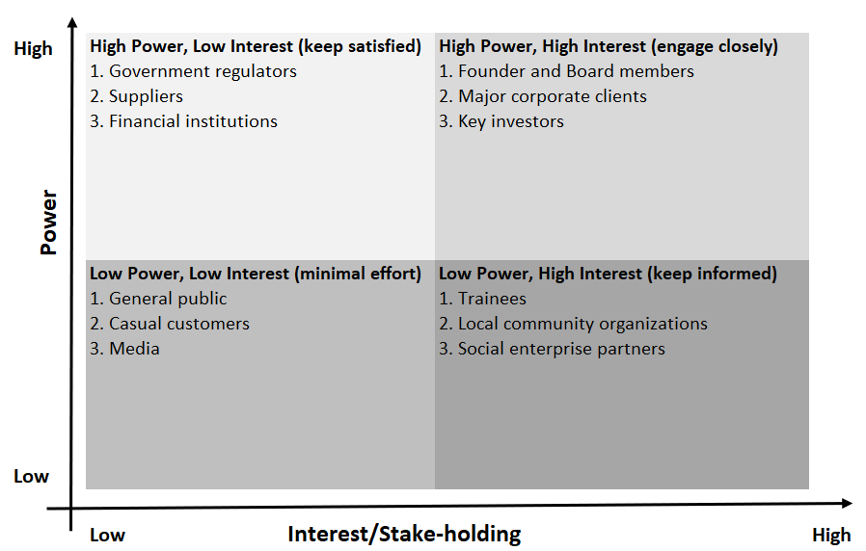
Figure 1: Stakeholder analysis: Mendelow Matrix
(Self-created based on Albats et al., 2020)
High Power, Low Interest
Government regulators have a substantial influence, as they can enforce food safety and hygiene standards (Khojastehpour and Shams, 2020). First and foremost, they focus on following all the rules for consumer safety. If the firm wants to keep the quality of its ingredients and the stability of its supply chain, suppliers need to be paid on time and have a long-term business relationship (Albats et al., 2020). Their leverage comes from the impact they can have on production continuity. Miss Macaroon is required to maintain good financial standing so that the financial institutions providing crucial funding and financial services are confident of being reimbursed. Since these stakeholders are less interested in day-to-day operations (Albats et al., 2020).
High Power, High Interest
The founder and board members have high power and interest in Strategic direction & decision-making (Rusconi, 2019). This includes expectations of sustainable growth, social mission adherence, as well as operational excellence. The firm caters to big corporate clients (the ones paying the big bucks) who demand top-notch premium products and services, as well as bespoke flavours like Pantone-matched macarons (Rusconi, 2019). They derive their power from their greater purchasing power. Major shareholders want their ROI and strategic plan along with it, watching performance and plans closely.
Low Power, Low Interest
Members of the public, casual customers and media have low power and interest in how Miss Macaroon operates. Their expectations are around the quality of the product as well as overall brand perception (Vershinina et al., 2020). Casual customers want a good value and an enjoyable experience, but they have few opportunities to impact the company strategically. Miss Macaroon will occasionally feature in the media but it has little impact on our operations. As they wield only a little power and care for very little, engaging with them on a positive but cursory level (eg providing decent product satisfaction ratings and keeping a good public image) is enough to ensure their contentment without having to put in many resources (Vershinina et al., 2020).
Low Power, High Interest
Trainees, local community organisations and social enterprise partners - high interest but less power. Trainees come to us expecting a great training experience, support and a career opportunity that is aligned with the Miss Macaroon social mission (Breuer and Lüdeke-Freund, 2019). Local community groups want to see a strong community benefit and collective effort. Their social enterprise partners anticipate shared values and actions which lead to combined successes in projects. Their extension of power is far from long but their interest in company affairs means the frequent updates, communication and participation need to be on-point (Breuer and Lüdeke-Freund, 2019). By keeping these stakeholders informed, Miss Macaroon: retains their support increases engagement with the local community reinforces dedication to its social goals, thus furthering its social impact as well as community engagement opportunities.

5.0 Strategic Growth Choice for the SME
Ansoff Matrix is a strategic planning tool to identify growth opportunities by analysing market, and product dimensions (Lynch, 2018). Market penetration, product development, market development, and diversification are the components of this. This is suitable for UK SMEs in the bakery market, such as Miss Macaroon, as it provides a methodical way of investigating potential routes to grow whilst tentatively managing risk and opportunity (Lynch, 2018).
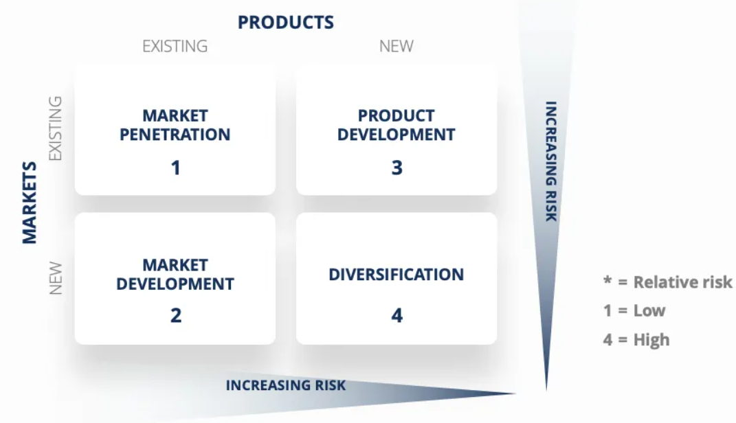
Figure 2: Ansoff Matrix
(Freely available on the internet)
Market Penetration
In the case of existing categories, the growth strategy utilised is Market Penetration (Dyer et al., 2021). This can be realised by SMEs in the UK bakery market through improved marketing, loyalty programmes, and competitive pricing. Increased market share through customer retention and new promotions, as well as improved customer service (Dyer et al., 2021). Similarly, promoting its brand across social media channels and through local partnerships can also drive brand visibility and consumer engagement and reinforce the SME's presence in the market which would result in increased sales volume.
Product Development
Product development is the creation of new products for existing markets. Innovation in a UK bakery SME could mean bringing new flavours to the market, trying out seasonal specialities or attempting to cater for health-conscious consumers with gluten-free or vegan options (Lasserre, 2017). By creating unique, rich content, its reach expands the customer base, and it feeds consumer preferences. Spending money on R&D to refine recipes and use high-quality ingredients can help set a brand apart. Partnering with local chefs or food influencers can also boost product appeal to make new offerings seem geared toward the formative customer base (Lasserre, 2017).
Market Development
This strategy involves entering new markets with existing products (Henry, 2021). UK bakery SMEs can also consider expanding regionally or accessing international markets by running businesses through e-commerce platforms. Diversifying from restaurant customers, maybe by catering more to corporates or supplying to the hospitality industry, can open a whole new revenue stream. The firm can expand its market reach by entering into distribution partnerships or attending food festivals and trade shows (Henry, 2021).
Diversification
Product development to produce new markets is diversification. This may push bakery SMEs into similar product lines, such as selling baked goods along with a drink or adding savoury products to their offerings, etc. (Ansoff et al., 2018). Entering new geographies and products can help lower the risk associated with a singular market. This option would require additional investment in market research, product development and marketing to stay current with growing consumer trends. Well-planned diversification will also give rise to more income sources and make its brand more resistant to market volatility.
A strategic choice for Miss Macaroon
Miss Macaroon should focus on developing new macaron flavours and provide health-conscious options with gluten-free and vegan macarons. Yet, this capitalises on both the quality and innovation Miss Macaroon is already known for, as well as consumer demand for greater diversity and health in products.
Increasing the range of products will make it appealing to a wider customer base, especially for those with special dietary needs or health-conscious choices (Lasserre, 2017). The quality of its offerings can be above its competitors, and this is helped by using premium, locally sourced ingredients and keeping to strict quality standards to boost brand loyalty. It makes sense given the current trend in the market towards artisanal and ethically made products and underpins Clove's social mission, making it a favourite among ethical consumers.
Moreover, the firm can take advantage of an individual Pantone matching service, as used with macaroons made especially for events and other corporate clientele, to fill in even the gappier market segments there (Ansoff et al., 2018). Branded collaborations with local chefs and influencers can add additional credibility to the brand and expand into new customer segments.

6.0 Strategic recommendations and implementation
Diversify Product Offerings to Include Health-Conscious Options
To cater to the rising popularity of dietary-based products and consumer demand, Miss Macaroon must offer a wider-ranging product mix that also includes gluten-free and vegan macarons. The approach supports today's consumer focus on healthier choices and inclusivity around food.
Expand E-commerce Capabilities to Reach Broader Markets
Miss Macaroon needs to widen its e-commerce offering to be able to access wider markets other than local. COVID-19 and the accelerating movement to online shopping have propelled e-commerce to become an essential growth channel for businesses. This volume expansion will help drive additional sales direct-to-consumer, decrease dependence on physical retail stores through a hedged versus verticalised channel strategy, and create real-time consumer preference and behaviour data allowing for more granular marketing and product execution.
Strengthen Supply Chain Resilience by Sourcing Alternative Suppliers and Local Ingredients
Miss Macaroon needs to ensure that the company builds resilience into its supply chain by diversifying sourcing from suppliers and providing alternative sources and local ingredients in order to reduce the risk of supply chain disruptions. Its use of European ingredients also means it is at risk - especially after Brexit, which could lead to changes in regulations and supply problems.
The implementation plan of the recommendations is provided in Table 2 below.
Table 2: The implementation plan
Recommendations | Resources Needed | Roles Responsible | Milestones to Review | Possible Challenges | Strategic Actions to Solve Challenges
Diversify product offerings (gluten-free, vegan) | R&D investment, new ingredients, staff training | Head Chef, Product Development Team | New product launch, customer feedback review | Ingredient sourcing issues, staff adaptation | Develop strong supplier relationships and comprehensive training programs
Expand e-commerce capabilities | Website upgrade, digital marketing budget | IT Department, Marketing Team | Increased online sales, website traffic analysis | Website maintenance, cybersecurity threats | Regular website audits, enhanced cybersecurity measures
Strengthen supply chain resilience | Supplier contracts, local sourcing partnerships | Procurement Manager, Operations Team | Supplier performance review, cost analysis | Supply chain disruptions, cost fluctuations | Establish backup suppliers, negotiate flexible contracts

7.0 Conclusion
The report suggested that Miss Macaroon's premium product quality, social mission, and unique Pantone matching service were all strategic strengths of the business. However, it also found that the brand was largely reliant on European ingredients that place potential limitations on robustness, and their rather high operational costs Native to Birmingham are some limitations on their scale. Threats - these include changes in regulations as well as supply chain disruptions, while opportunities - this market offers potential for higher demand for ethical products and e-commerce expansion. This plan aims to address those problems by outlining new product diversification, bolstered e-commerce ramps, and a more effective supply chain. Guided by market trends to drive sales and widen impact for a strong operational base, found success steering Miss Macaroon toward true growth with the purpose of providing the greatest testimonial.

8.0 References
Albats, E., Alexander, A., Mahdad, M., Miller, K., and Post, G. (2020). Stakeholder management in SME open innovation: Interdependences and strategic actions. Journal of Business Research, 119, 291-301.
Ansoff, H. I., Kipley, D., Lewis, A. O., Helm-Stevens, R., and Ansoff, R. (2018). Implanting strategic management. Springer.
Breuer, H., and Lüdeke-Freund, F. (2019). Values-based stakeholder management: Concepts and methods. In Rethinking Strategic Management (pp. 217-239). Springer, Cham.
Dyer, J. H., Godfrey, P., Jensen, R., and Bryce, D. (2021). Strategic management. John Wiley and Sons.
Gee, I. M., Heard, B. R., Webber, M. E., & Miller, S. A. (2020). The future of food: environmental lessons from E-commerce. Environmental science & technology, 54(23), 14776-14784.
Green, R. M., and Kane, K. (2014). The effective enforcement of HACCP based food safety management systems in the UK. Food control, 37, 257-262.
Heide, M., and Olsen, S. O. (2018). The use of food quality and prestige-based benefits for consumer segmentation. British Food Journal, 120(10), 2349-2363.
Hendry, L. C., Stevenson, M., MacBryde, J., Ball, P., Sayed, M., & Liu, L. (2019). Local food supply chain resilience to constitutional change: the Brexit effect. International Journal of Operations & Production Management, 39(3), 429-453.
Henry, A. (2021). Understanding strategic management. Oxford University Press.
Khojastehpour, M., and Shams, S. R. (2020). Addressing the complexity of stakeholder management in international ecological setting: A CSR approach. Journal of Business Research, 119, 302-309.
Kuokkanen, H., and Sun, W. (2020). Companies, meet ethical consumers: Strategic CSR management to impact consumer choice. Journal of Business Ethics, 166(2), 403-423.
Lasserre, P. (2017). Global strategic management. Macmillan International Higher Education.
Lynch, R. (2018). Strategic management. Pearson UK.
Miss Macaroon, (2024a). Our premium macaroons are available in-store and online for home delivery. [Online] Available at https://missmacaroon.co.uk/ [Assessed date 24 June 2024]
Miss Macaroon, (2024b). About Us. [Online] Available at https://missmacaroon.co.uk/about-us/ [Assessed date 23 June 2024]
Nanda, A., Xu, Y., and Zhang, F. (2021). How would the COVID-19 pandemic reshape retail real estate and high streets through acceleration of E-commerce and digitalization?. Journal of Urban Management, 10(2), 110-124.
Oke, A., Ladas, J., and Bailey, M. (2020). Ethical consumers: an exploratory investigation of the ethical food consumption behaviour of young adults in the North East of Scotland. British food journal, 122(11), 3623-3638.
Panova, Y., and Hongsheng, X. (2019). Expansion of cross-border e-commerce through digital enterprise development. International Journal of Business Performance and Supply Chain Modelling, 10(4), 339-368.
Rusconi, G. (2019). Ethical firm system and stakeholder management theories: a possible convergence. European Management Review, 16(1), 147-166.
Suali, A. S., Srai, J. S., and Tsolakis, N. (2024). The role of digital platforms in e-commerce food supply chain resilience under exogenous disruptions. Supply Chain Management: An International Journal, 29(3), 573-601.
Vershinina, N., Rodgers, P., Tarba, S., Khan, Z., and Stokes, P. (2020). Gaining legitimacy through proactive stakeholder management: The experiences of high-tech women entrepreneurs in Russia. Journal of Business Research, 119, 111-121.

