BMSW5102

DEVELOPING RELATIONSHIPS AND WORKPLACE ACHIEVEMENT

Introduction

Developing individuals in the workplace has a significant impact in the life of the organization and the individuals. This impact can influence positively as negatively by working on building greater self-confidence, enhancing communication skills, developing leadership skills and improving people’s attitude regarding reducing stress. (Carnegie, 2009).

This essay is about the potential benefits to the organization and the individual on developing individuals in the workplace.

In addition, management theories will be applied for a better understanding of which theory best fits individuals and organisation to improve their outcomes.

As argued by Broadly (2018) leadership is a social process that involves the influence of others. This is to explain that developing individuals is fundamental to long-term organizational success.

Four management areas will be critically examined in this essay: Motivation, Performance, Employee Engagement and Training, and development.

Motivation

Motivation is the contrast between action and inaction. It is the difference between thinking about doing something and getting it done. Without motivation, there is nothing.

Definition

Motivation can be defined as an exciting force that induces actions. (Parks & Guay, 2009).
It is closely related to goals or objectives (Mitchell,1977). From this point, four keys aspects of motivations can be described:
- Arousal: having an interest in a particular goal (for instance: wanting to be promoted);

- Direction: being focused on a particular goal (for example: working hard to be promoted instead of reading a good book);

- Intensity: Effort expended in pursuing a particular goal (for example: being prepared to work one extra hour per day to get that promotion);

- Persistence: Sustained to pursue the goal in spite of issues, challenges or barriers (Although my colleagues are highly qualified for that promotion, I am still going to work for it).

Model of Motivations

This section will briefly explain two models of motivation for a good improvement. MacRae & Furnham stated that in exactly the same situation, two people with similar backgrounds and experiences may behave in very different ways. (MacRae & Furnham, 2017).
To better understand this enigma, it is important to understand what Herzberg’s two factors theory is about.

Herzberg’s Two Factors Theory

Herzberg approach aimed on the individual in the workplace. He believed that humans have two sets of needs, lower level and higher level. (Herzberg, Mausner and Snyderman, 1959).

In order to motive employees, organization needs to meet both of these which became his two-factor theory.
Two-factor theory then distinguishes between:

- Motivating factors (intrinsic) such as challenging work, recognition for one’s achievement, being given responsibility, opportunity to do something meaningful, involvement in decision making, sense of importance to an organisation.

- Hygiene factors (extrinsic) such as job security, salary, fringe benefits, good pay, paid insurance and vacations do not, paradoxically, give positive satisfaction or motivation, though dissatisfaction results from their absence.

Although employees in the workplace are satisfied by motivating factors, dissatisfaction among employees is caused by hygiene factors (extrinsic) as claimed Herzberg (MacRae & Furnham, 2017).
The table in appendices illustrates better this theory. (Appendice1)

The Hierarchy of Needs

Maslow’s hierarchy of Needs was defined in 1943 as part of a paper called “A theory of human motivation” commonly illustrated as a pyramid but never by Maslow himself. It outlines the basic necessities a person must have before they can move towards a “higher” stage of concerns and reach self- actualisation.

From the base of the pyramid to the top, the needs are:

- Physiological: food, water, warmth and rest;
- Safety: personal and financial security, health and wellbeing;
- Social belonging: friendship, kinship and intimacy;
- Esteem: achievement, independence, respect and status;
- Self-actualisation: the realisation of personal potential through growth.

Benefits of a highly motivated individual

As previously explained that motivation can occur from the entertainment of one’s effort of willing to achieve certain objectives. Having a sense of satisfaction or achievement can also be source of motivation. In addition, a performance of employees is a result of both their potential and motivation.

However, a skilled employee who feels demotivated is doubtful to execute well his job, while a motivated employee can frequently carry out up to a point than is envisaged from them.

Without being exhaustive, the following benefits my be conceivable for a highly motivated workforce.

- Better productivity: lower cost of production;
- Lower levels of absenteeism: as they are happy with their working lives;
- Lower levels of staff turnover: leading to lower training and recruitment costs;
- Improved industrial relations;
- Motivated employees are plausible to enhance product quality which is linked to the customer service.

Understanding motivation is the initial step, but understanding the gap linking individual motivation and motivators provided at work provides a much more nuanced explanation of a person’s motivation, and potential occurrence of related behaviours. (
This is why the management staff should help unmotivated employees to improve their performance.

Performance

Human resource departments expend a lot of time and effort into improving their performance management processes.

Definition

Performance management is a process which purpose is to promote individuals with the essential attachment, skills and competencies for working with regard to a shared important objective within an organisational framework. (Lockett, 1992).
The area of performance management is adjustable as it is continuously developing as the years go by, its determination change and acclimate to employee and business needs. To do this, it is useful to understand what a performance management cycle is, what the stages of the performance management are and how the performance management cycle has adapted and developed from a traditional 12-month cycle to a more continuous, fluid procedure.

The traditional performance management cycle

There are many versions of the performance management cycle, the most popular is the cited by Michael Armstrong represented below:

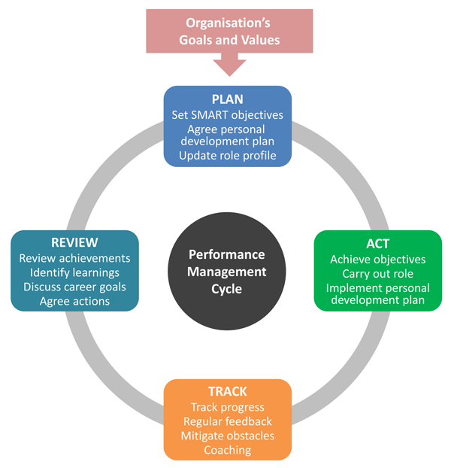
Fig.2 -Traditional Management Performance cycle

- Stage 1: Planning- Implemented only once each year;
Setting up SMART objectives to contribute to one or more of the company’s objectives;
Including the formation of Personal Development Plan and reviewing the employee’s job requirements.
This stage certifies that individual performance is associated with the global plan of the organisation.

- Next stages: ‘Act’ and ‘Track’- Happen throughout the year
Employees aim to achieve their objectives by carrying out their role effectively, tracking progress, and providing feedback.

- Final stage: Review- Employee performance ratings;
Discussion and evaluation of goal completion and completion between employee and manager;
Reviewing performance issues, training and development, and opportunities for advancement.

However, it has significantly admitted that it is more prolific and motivating to discuss performance and giving feedback frequently, rather than once or twice a year.

This mentality has permitted for the creation of a continuous approach to performance management cycle which is an ongoing process of evolving performance discussions and feedback.
It allows employers and mangers to treat performance management as a process that “connects an organisations culture, business goals and strategy to individual performance and contribution”. (Hearn, 2017)

Importance of Performance management

Performance management benefits to increase Employee Engagement and productivity in the workplace
Engaged employee stay longer, actively involve themselves in the work place with better results.

Furthermore, performance management highlight training needs, boost morale, identify the right employees to promote, support the workforce planning, increase employee retention and deliver greater employee autonomy.

However, employee’s morale may drop with routine leading to become demotivated. In addition, fabricated or misleading information can affect the review stage and bring employees to become burn out.

On the other hand, organisations need employees that are able to get the job done, because employee performance is life-threatening to the global success of the company. It helps to fix strengths, weaknesses and potential managerial gaps in the organisation.

Taking in account an article written by New York time at Amazon claimed that one major downside of the feedback system at Amazon is that it does not enable employees to see feedback themselves. They can only hear about it from their managers although it goes against the whole purpose of performance management, which is to help your employees grow.

Another issue with Amazon’s feedback system is the complete anonymity of the feedback. This makes it easy to abuse feedback for sabotaging others.

It is very important to facilitate more regular and continuous conversations between Managers and their team members to improve effectively performance and engagement. By doing so, it improves trust and increase opportunities for growth and development throughout the year.

This empowers Managers to build to more engaged and high performing teams, but it also saves everyone time because people are more aligned when it comes to reviews period which is a win-win all round.

As explained previously that one of the benefits of performance management is to increase Employee Engagement, the following lines will explain a bit more in details on what is Employee Engagement.

Employee Engagement

John G. Stumpf quoted “Everything we do is built on trust. It does not happen with one transaction, in one day on the job or in one quarter. It is earned relationship by relationship”.

Definition & Importance

Employee engagement is an emergent and working condition as a positive cognitive, emotional, and behavioural state fixed toward organizational outcomes. (Shuck & Wallard, 2013).

Employee engagement is a workplace approach ensuing in the right conditions for all members of an organisation to give of their best each day, committed to their organizational success, with an improved sense of their own happiness.

Employee engagement is very important for both the employee and the organisation as it is based on trust, integrity, two-way commitment and communication between the organisation and its employees.
It is an approach that increases the chances of business success, contributing to organizational and individual performance, productivity and well-being. It varies from poor to great. It can be nurtured and dramatically increased, it can be lost and thrown away.

However, comparing on Amazon’s employees, it shows that some of their employees are not engaged as their first motivation are to satisfy their needs as explained by Maslow on his hierarchy theory needs.
In addition, the management process at Amazon is a bit abusive on how individual performers can be treated. Managers are forced to give sometimes good employees bad overall ratings because of politics and stack ranking.

At Amazon, each employee is responsible for his own career progression and finding the places and teams that doing the stuff you want to do. No one is going to take you by the hand and help you with that. Being self-motivated is a key as no one will hold your hand and tell you that you are doing a great job.

However, employee need to complete their targets for a better promotion of the organisation. Regularly failing on completing one’s target pushes you to the exit door of the organisation.

Moreover, new employees are not safe in term of long-term employment which lead them to not be engaged but working with the only purpose on what they get from Amazon in terms of needs.

Managers should promote employees who are motivated and engaged for a better performance by empowering them with regular training.

Psychological Contract

The Psychological contract is the perceptions of both parties to the employment relationship, organisation and individual of the obligations implied in the relationship. (Herriot & Pemberton, 1995).

The psychological contract is built by trust, justice and fairness as perceived by Equity theory (motivation by fairness, comparison) initiated by Adams in 1965.

As an implicit contract, each part agreed to respect terms established. Without being exhaustive, the following terms can be found within both parties.

Employees will:  -work hard  -uphold loyalty and commitment  -work extra hours when required  -develop new skills and update old ones  -be flexible, for example, by taking on a colleague’s work  -be courteous to clients and colleagues  -come up with new ideas | Employer will:  -pay for performance  -ensure safety  -give opportunities for promotion  -give recognition for innovation or new ideas  -give opportunities for training and development  -give feedback on performance  -provide reasonable job security

For example, an employee of the month is chosen and should be rewarded.

Although the psychological contract brings agility, loyalty, empathy and communication, it is inconsistent, redundant, unwritten and has the impact of the bottom line.

Training and Development



