building services 2 - integration
Case Study Analysis – Low Energy Design

Mark Preston – ID 2223676
HND / BSc Construction Management

Contents Page

Introduction – Page 2
Legislation – Page 2, 3
Net Zero Carbon Buildings – Page 4
Energy Hierarchy for Planning – Page 5
Heating Demand – Page 5
The Passive House Planning Package (PHPP) – Page 6
Residential Typology Scenario – Page 7, 8
Key Changes to Building Services from AD: L (Wales) 2025 to LETI – Page 8
Comparing Operational Specifications from AD: L (Wales) 2025 to LETI – Page 9
Comparing Operational Energy from AD: L (Wales) 2025 to LETI – Page 9, 10
Comparing Operational Output from AD: L (Wales) 2025 to LETI – Page 11
Comparing Embodied Costs from AD: L (Wales) 2025 to LETI – Page 12
Comparing Embodied Carbon from AD: L (Wales) 2025 to LETI – Page 13
Guidance Documents to Help Mitigate Thermal Bridging – Page 14
Guidance Documents on Air Permeability / Air Tightness - Page 15
Conclusions for Residential Typologies from AD: L (Wales) 2025 to LETI – Page 15
Conclusions for Operational Scenarios from AD: L (Wales) 2025 to LETI – Page 15
Conclusions for Embodied Scenarios as per Spring Design’s PowerPoint – Page 16
Full Report Conclusion – Page 16
References – Page 17, 18, 19

Introduction

Buildings are more than just structures. They shape how we live and interact with our environment. As the world moves towards sustainability, designing homes that are energy-efficient and environmentally responsible has never been more important. This report takes a close look at the integral part of building services, the Mechanical and Electrical (M&E) design of a proposed new-build home in Wales that currently meets building regulations standards approved document L (conservation of fuel & power), identifying areas where improvements can make the home more efficient, lower its carbon footprint, reduce costs over time and trying to achieve to bring it forward to a higher energy standard.

Through a critical evaluation of mechanical, electrical, and ventilation systems, the report explores ways to align the building with low-energy design standards. It considers factors such as Net Zero targets, sustainable technologies, and long-term financial savings. The goal is to justify key design choices while balancing practicality, environmental impact, and future resilience. Illustrated sketches and schematics will help visualize recommendations, ensuring a clear understanding of the proposed solutions. By refining the design and construction approach, this report aims to contribute to a more sustainable vision for residential homes in Wales.

Legislation

There is critical legislation out there to follow in Wales. These include:

- Well-Being of Future Generations (Wales) Act 2015 – one of the reasons this was introduced was for “a society in which people’s physical and mental well-being is maximised and in which choices and behaviours that benefit future health are understood.” (Crown, 2015)

- Environment (Wales) Act 2016 – With the 2050 emission target, “the Welsh Ministers must ensure that the net Welsh emissions account for the year 2050 is at least 100% lower than the baseline” (Crown, 2016)

- Energy Generation in Wales 2017 – “The Welsh Government has set a target of generating 70% of Wales’ electricity consumption from renewable sources by 2030” (Welsh Government, 2017)

- Prosperity for All: A Low Carbon Wales – “Our highest priority is to reduce demand wherever possible and affordable”. “Opportunities include: Buildings – new products and delivery models for low carbon new-builds and retrofitting.” (Welsh Government, 2019)

On 30th April 2019 the Welsh Government published a written statement: Welsh Government declares Climate Emergency. The diagram below represents the global temperature variations & carbon dioxide levels over the last 2023 years from 2023.
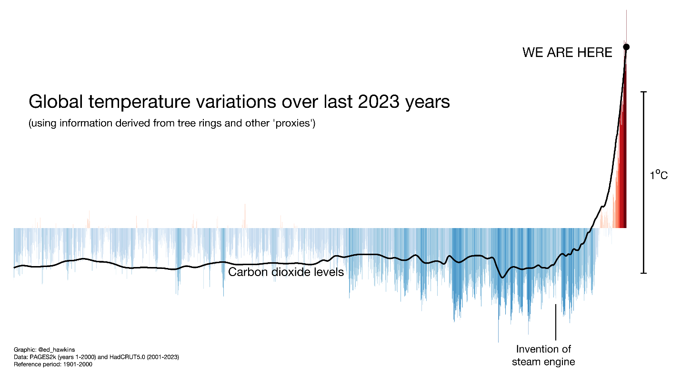
(Hawkins E, 2023)
More Relevant legislation

‘Future Wales The National Plan 2040’ is a National Development Framework (NDF) for Wales and has development plan status. The Planning (Wales) Act 2015 requires an NDF which this fulfils. The ethos is ‘A Wales where people live in places which are decarbonised and climate resilient.’ “The challenges of the climate emergency demand urgent action on carbon emissions and the planning system must help Wales lead the way in promoting and delivering a competitive, sustainable decarbonised society. Decarbonisation commitments and renewable energy targets will be treated as opportunities to build a more resilient and equitable low-carbon economy, develop clean and efficient transport infrastructure, improve public health and generate skilled jobs in new sectors.” (Welsh Government, 2020)

‘Net Zero Wales Carbon Budget 2 (2021-25)’ is a Building sector ambition statement which states “By 2025 all new affordable homes in Wales will be built to net zero carbon, and our ambition is that our net zero standards are adopted by developers of all new homes regardless of tenure by this date.” (Welsh Government, 2021)

The ‘Vale of Glamorgan Council Climate Change Challenge Plan 2021-2030’ aims to “ensure our planning policies” & “work to adapt to and mitigate the effects of climate change” to “work with developers to develop zero carbon buildings” & “create more energy efficient buildings through planning policy.” (Vale Of Glamorgan Council, 2021) Local Policy can also be adopted and emerged.

Net Zero Carbon Buildings

Within the ‘Whole life carbon assessment for the built environment’ under ‘5.3.1 Energy modelling for buildings’, it states “In the UK, the results of Part L 2021 calculations must not be used under any circumstances, as they are not a prediction of energy consumption.” (RICS, 2023).

The diagram below is from the net zero guidance documents. It is the whole life carbon assessment for the built environment and shows the different building life cycle stages of upfront carbon bonding, embodied carbon, with additions to illustrate sequestered biogenic carbon as well as operational carbon. This is all part of our net zero climate challenge 2050.

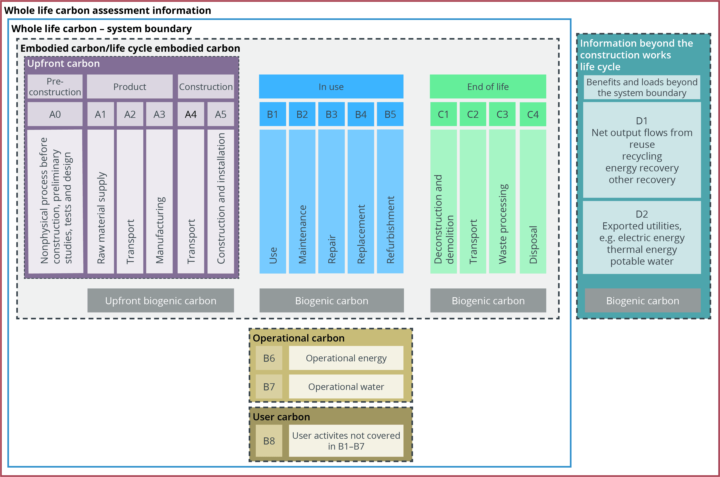
(RICS, 2023)

Energy Hierarchy for Planning

The ‘Planning Policy Wales’ document states “The Welsh Government’s highest priority is to reduce demand wherever possible and affordable.” “Reducing energy demand and increasing energy efficiency, through the location and design of new development, will assist in meeting energy demand with renewable and low carbon sources” (Welsh Government, 2024).

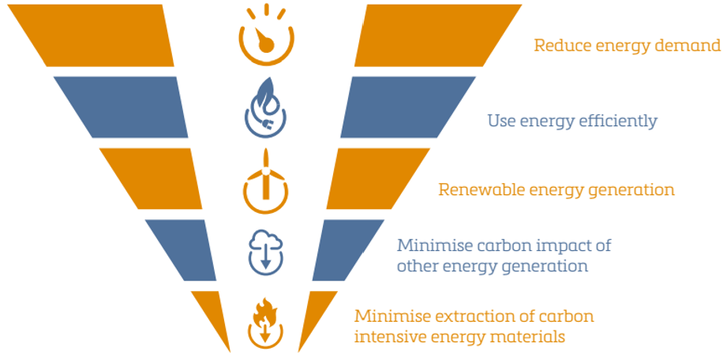
(Welsh Government, 2024)

Heating Demand

The heating demand is the amount of energy required to heat a space annually.
energy / area (TFA) / annum. (kWh / m2 (TFA) / yr). TFA stands for treated floor area. The diagram below demonstrates the heating demand of UK’s housing stock by typology LETI from the ‘Climate Emergency Retrofit Guide (2021).

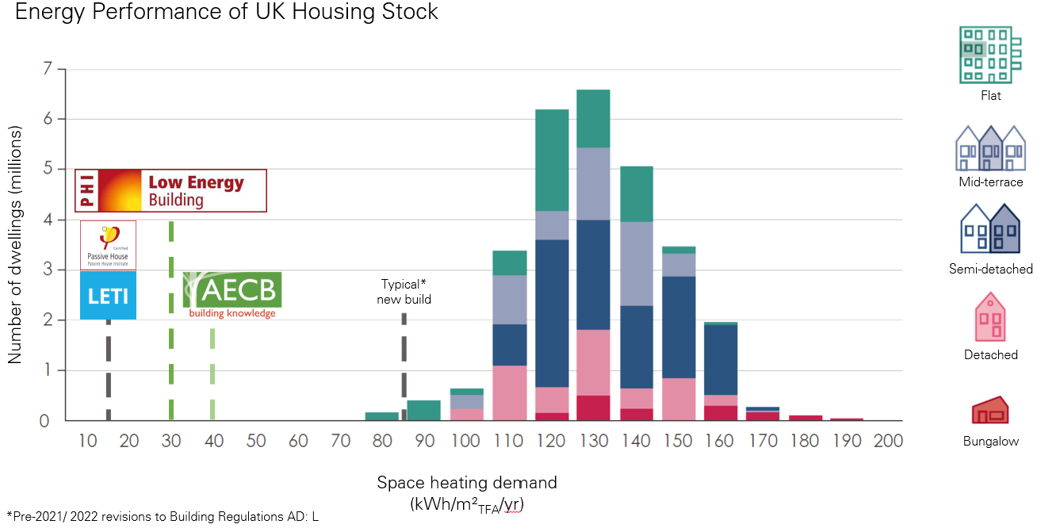
(LETI, 2021)

Energy Use Intensity (EUI) = All energy consumed by a building annually*
Energy / Gross Internal Area (GIA) / annum
kWh / m2 (GIA) / yr
*excludes EV charging

Net Zero (operational) = Balancing annual consumption with on-site generation
The Passive House Planning Package (PHPP)

The Passive House Planning Package is a design tool used to plan & analyse buildings for energy efficiency and will be utilised for this report to see the changes / difference between buildings. You are able to change scenarios such as climate, the u-values, areas, component information (ventilation), window information, shading etc as per the diagram below. On the variance tab of this unique PHPP, we are able to switch between different standards to see the relative figures / diagrams associated with them. This unique PHPP has been provided by Spring Design who are experts in their field. This report will concrete on the conservation of fuel & power, Approved Document Part L 2025 (Referred as AD: L (Wales) 2025) which will be our baseline (this is what is being built right now) and the Low Energy Transformation Initiative Building Standard (Referred as LETI) which is an improved energy standard which is consistent to Passivhaus standards. Outlined in red in the below diagram, you can see the different figures associated with AD: L (Wales) 2025 and LETI. Some of the information remains the same such as U-values, area etc. The below image is the PHPP Specification & Figures relative to building regulation part L & LETI Building Standard.

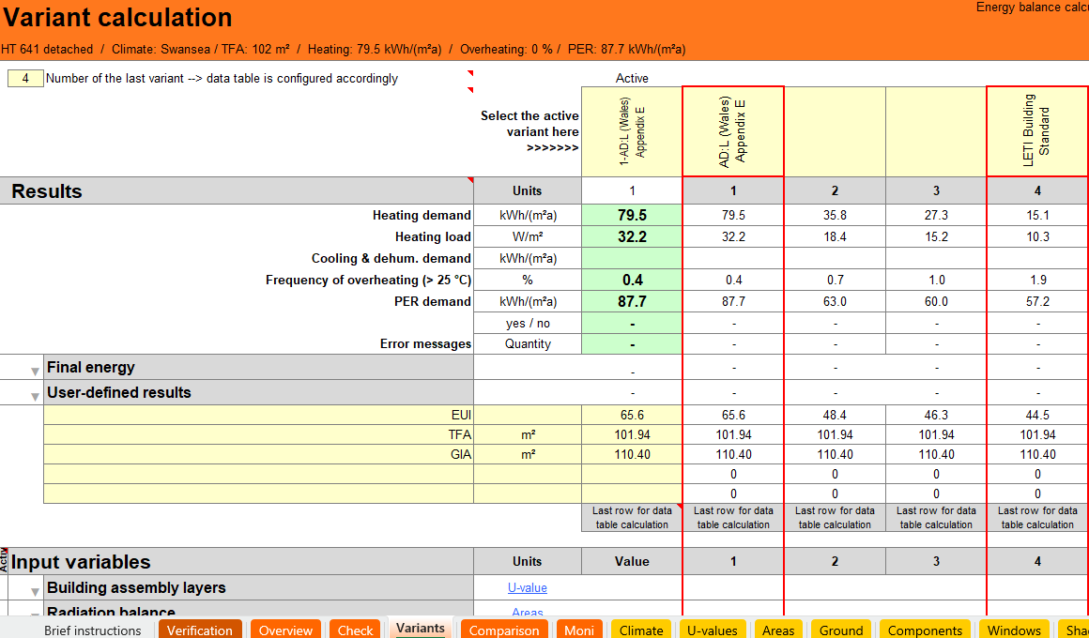
(Spring Design, 2025)

PHribbon is a software tool developed by the Association for Environment Conscious Building (AECB) that integrates with the Passive House Planning Package (PHPP). It helps users model buildings and calculate their carbon footprint, including both embodied carbon (from materials) and operational carbon (from energy use). PHribbon makes the process of using PHPP faster, easier, and more comprehensive by incorporating carbon calculations directly into the modelling process.

Residential Typology Scenario

The building typology for this report is a new build 1 unit, 6 person, 4-bedroom dwelling (Referred as HT641) with 110.4m2 per dwelling. This Specification makeup includes masonry with PIR (refer to below specification). The orientation of the building is west/east facing which is the least energy efficient design. This is based on the worst-case scenario therefore any other orientation scenario would be better. It is arguably a small building for a 6 person, 4-bedroom property but with a small building with a smaller surface area, you’re effectively heating less space which means less energy used and less embodied carbon across the board. As per the plans below (to LETI standard), there is currently an air source heat pump (ASHP) (Vaillant aroTHERM plus 5kW), Mechanical Ventilation Heat Recovery System (MVHR) (envirovent enrgiSava 200) and Hot Water Cylinder as part of the building services. Please see below for plans and specification.
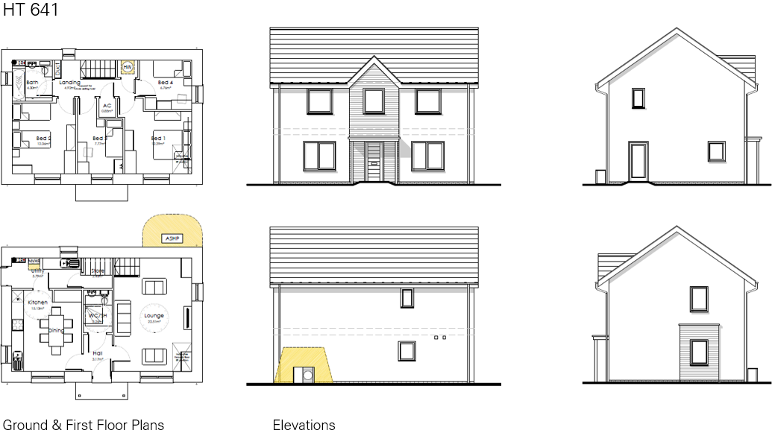

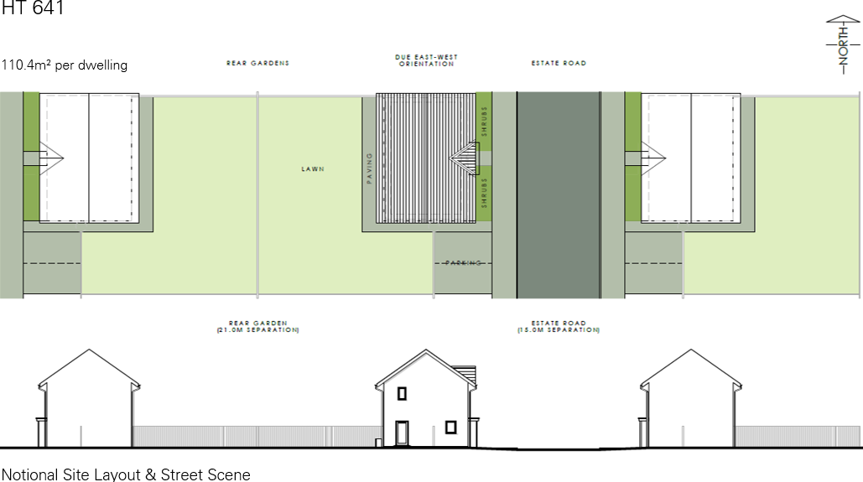
(Spring Design, 2025)
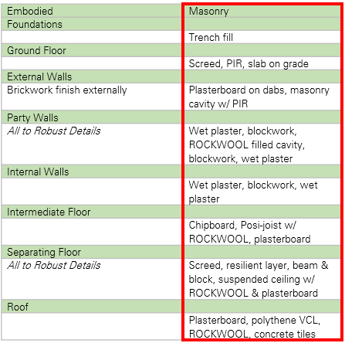
Building make-up specification provided by (Spring Design, 2025)

Key Changes to Building Services from AD: L (Wales) 2025 to LETI

This report focuses on key improvements related to air tightness and thermal bridging. While we are not altering the building fabric itself, our fabric-first approach prioritizes airtightness and thermal bridging to enhance overall performance. Traditional insulation methods, such as excessive loft insulation, reach a point where they no longer significantly improve efficiency—thermal bridging must be addressed instead.
High levels of airtightness require a well-designed ventilation strategy. Current buildings to AD: L (Wales) 2025 relies on natural ventilation and basic extraction systems. To meet Passivhaus / LETI standards, the ventilation system needs to be upgraded. Relevant guidance documents include ‘Good Practice Guide MVHR for single dwellings’ (Passivhaus Trust, 2018).

Key Changes to Building Services from AD: L (Wales) 2025 to LETI include:
- Windows & Doors: Upgrading from double glazing to triple glazing
- MVHR System: Replacing mechanical extraction with a more efficient MVHR (mechanical ventilation with heat recovery) system.
- Building Services Response: By improving airtightness and thermal bridging, the need for heating demand significantly decreases. As a result, the heat pump system will reduce in size, lowering its embodied energy impact.

Comparing Operational Specifications from AD: L (Wales) 2025 to LETI

In the below diagram are the specification changes from AD: L (Wales) 2025 to LETI. The specification changes as discussed are the air permeability, the thermal bridging, the window changes to a better frame and triple glazed. We're not breaking the bank; we're just going for better quality. The ventilation changes significantly from AD: L (Wales) 2025 which is extract only and we're going to a 92% high performance Passivhaus certified Zehnder ComfoAir MVHR unit. The air source heat pump becomes smaller and associated solar becomes smaller because there is a smaller yield required to heat / power the home. Other than that, the building services remain the same.

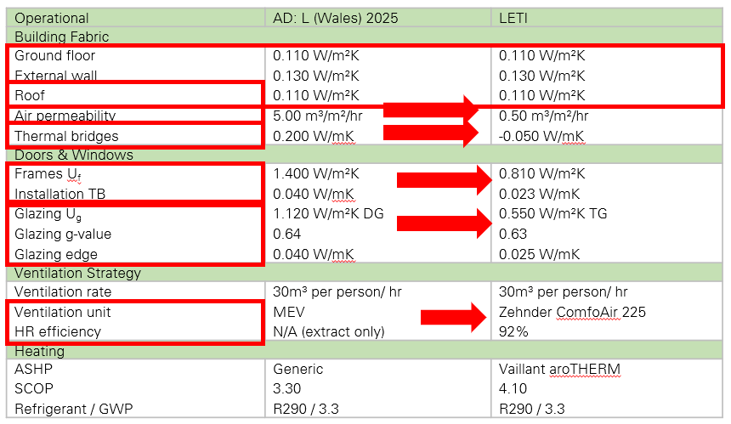
(Spring Design, 2025)

Comparing Operational Energy from AD: L (Wales) 2025 to LETI

The performance of any house in Wales has to be compliant with AD: L (Wales) 2025. This has a minimum ventilation standard (as per Building Regulations Approved Document F (Wales) 2025), a minimum u value associated and has minimum overheating controls (as per Building Regulations Approved Document O (Wales) 2025), although AD: L (Wales) 2025 currently has no requirement to have a limit in terms of heating demand, such as LETI / Passivhaus. Passivhaus has a 15 kWh/m2/yr as a benchmark similar to LETI.

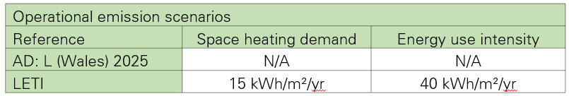
(Spring Design, 2025)

The heating demand of the building in question is 79.5 kWh/m2/yr following AD: L (Wales) 2025. The energy required to keep that building warm is 129.4 kWh/m2/yr, but we're taking the solar gains and internal gains away from that. We need to be careful when we establish AD: L (Wales) 2025 information. Currently, there is no requirement in terms of kWh/m2/yr for the total heating demand. What we can see in the below diagram is by modelling an efficient building that meets AD: L 2025, this is the typical type of demand we're going be seeing. However, out of the energy required to keep the property warm, we're only looking at the heating demand, which is the total energy minus eternal gains and the solar gains, because this is essentially free energy that we get from just living in the property and having the windows where they are.

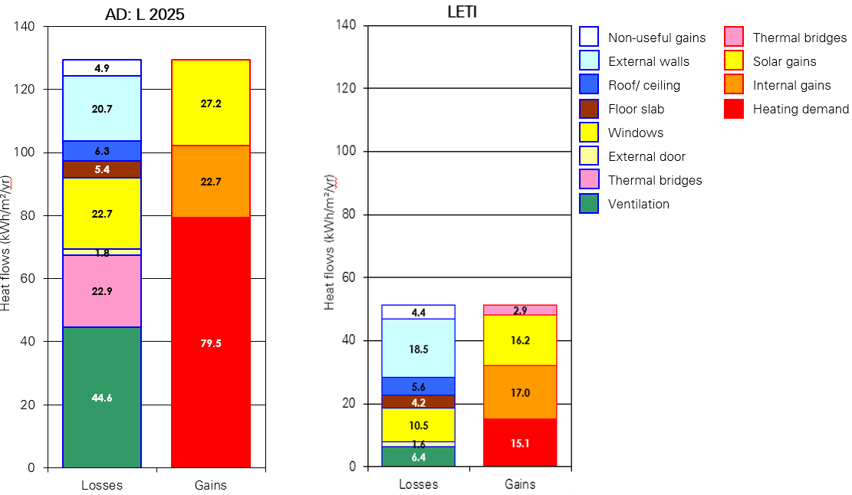
(Spring Design, 2025)

From refining the information and taking away the solar and internal gains, you can see there is an operational energy saving of 81% in the diagram below.

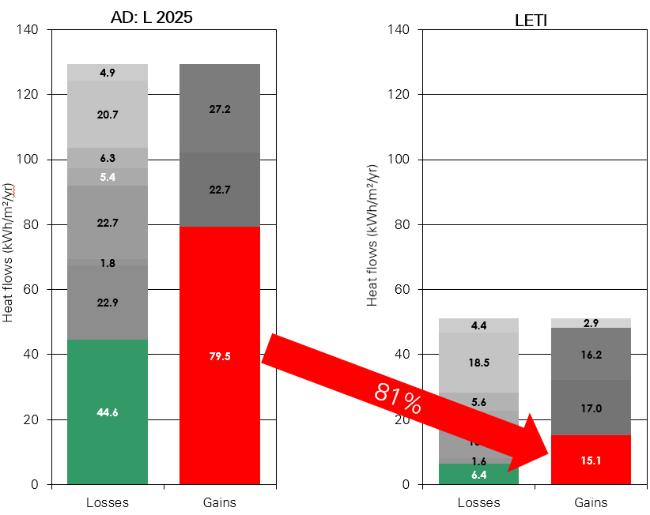
(Spring Design, 2025)
Comparing Operational Output from AD: L (Wales) 2025 to LETI

The operational output figures provided by Spring Design also show a significant decrease of energy use intensity (EUI), annual energy use for the dwelling, CO2 emissions excluding PV (60 yrs) and kWp of PV to Net Zero per dwelling of up to 32%.
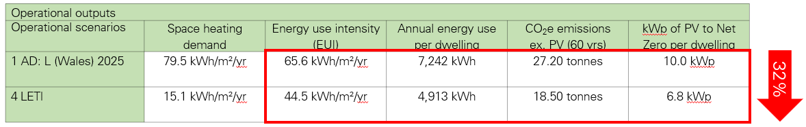
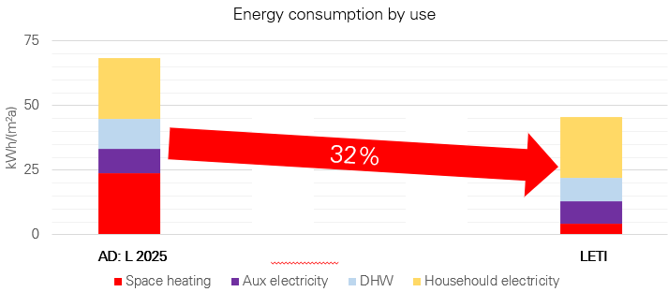
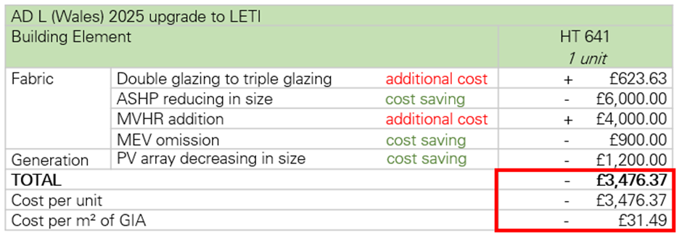
(Spring Design, 2025)

The projected annual electricity bills from this information for a 4-bedroom, 6-person occupancy for AD: L (Wales) 2025 is £1,774.29 & LETI is £1,203.69. That is a reduction of £570.60 Both exclude standing charge and PV offsets.

The headlines to take away from the diagrams above is that there are EUI & CO₂e reductions of 32% in upgrading from AD: L (Wales) 2025 to LETI. The ASHP reducing from 7 kW to 3.5 kW is due to reduced space heating demand. PV provision reduces 32% to achieve Net Zero with reduced EUI. And that PV provisions for AD: L (Wales) 2025 do not fit on a single roof slope.

(Spring Design, 2025)

Comparing Embodied Costs from AD: L (Wales) 2025 to LETI

Furthermore, on the diagrams below we have the embodied scenario costs established in terms of overall additional / omission cost changes per square meter. If the overall cost per square metre is £1,366.50 for AD: L (Wales) 2025 & £31.49 less per square meter for LETI, there’s a 2.3% decrease per square metre. So, it’s actually a small saving on the build cost to achieve a greater standard.

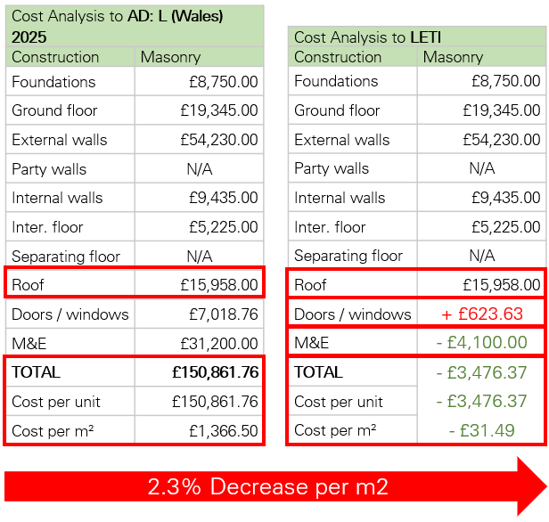

(Spring Design, 2025)

Comparing Embodied Carbon from AD: L (Wales) 2025 to LETI

Currently, there is no embodied energy requirement in building regulations but it is overdue and will be in years to come. There will be a requirement of embodied energy attached to every building that is built to say you cannot exceed a certain amount. It will be like credits. In the PHPP modelled by Spring design, the U value is an indicative figure because it meets the embodied carbon associated with them. The information we are concentrated on this occasion is the masonry make-up to show the embodied carbon for this project. Spring Design chose the RIBA 2030 (cradle to grave) approach of showing embodied carbon. It is also broken down in the net zero approach the upfront carbon A1-5, the embodied carbon within the actual building and the sequestered carbon that takes place with the building, with the materials growing etc.

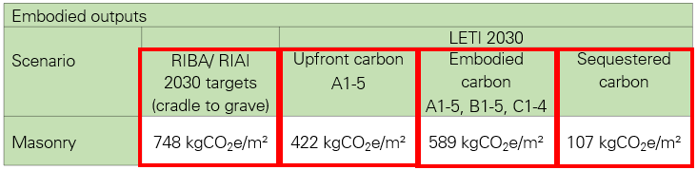
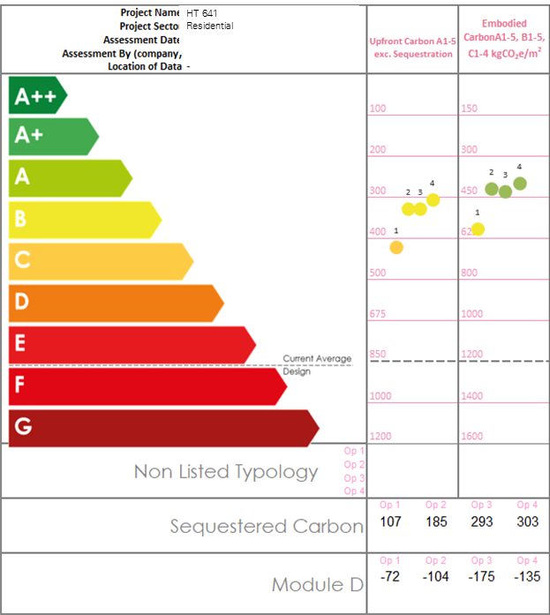

(Spring Design, 2025)

Guidance Documents to Help Mitigate Thermal Bridging

We have to design out thermal bridges. The envelope in this scenario remains the same. For thermal Bridging, there is a Zero Carbon Hub thermal bridging guide. It shows how to mitigate thermal bridges. It illustrates different structured types and talks about how you achieve better thermal bridges on a building. It's a NHBC guide and it will tell you best practise. It'll tell you the current PSI values as well. The PSI value is that thermal leak that happens by building junctions such as floor to wall. It's the value that we input into the PHPP document which tells us about how the buildings have been put together. Effectively, this is the thermal bridges value. Below is a diagram showing you how to get from 0.17 PSI to 0.06 PSI on an external wall detail.

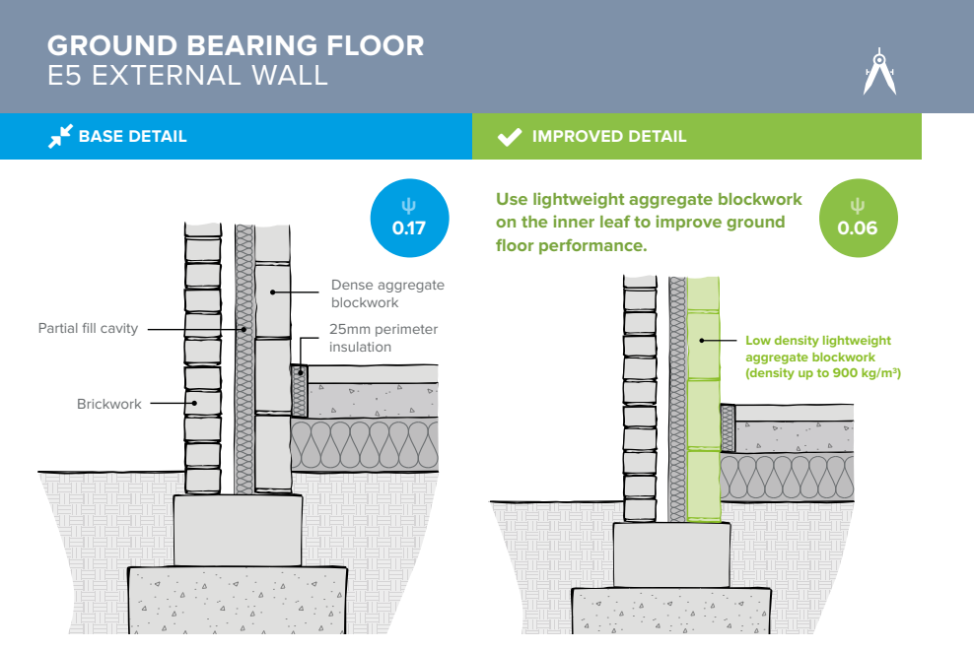
(Zero Carbon Hub, 2016)

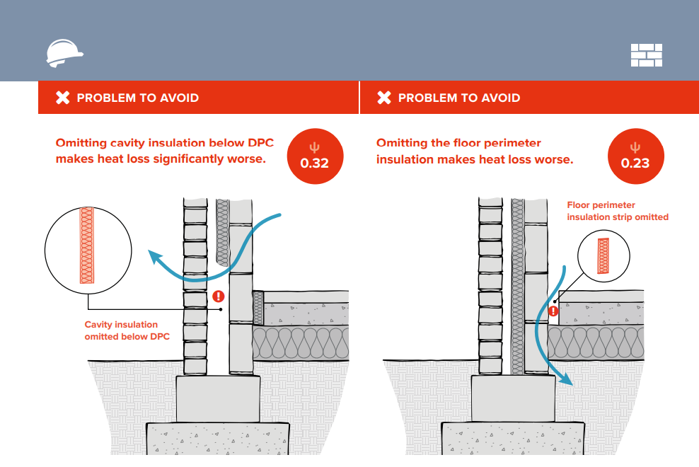
(Zero Carbon Hub, 2016)

Guidance Documents on Air Permeability / Air Tightness

The Air Tightness Testing & Measurement Association (ATTMA) is a leading authority on air testing. Their Technical Standard L4 document provides guidance on air permeability measurement for passive house and low-energy buildings. (ATTMA, 2023). This document explains best practices for achieving airtightness and is endorsed by the Passive House Trust.
Other recognized organizations in this field include Building Services Research and Intelligence Association (BSRIA) and Chartered Institution of Building Services Engineers (CIBSE).

Conclusions for Residential Typologies from AD: L (Wales) 2025 to LETI

- The performance of identical buildings is heavily influenced by factors such as airtightness, thermal bridging, and ventilation. By optimizing these aspects, it's possible to achieve an over 80% reduction in heating demand.

- Upgrading Approved Document L (Wales) 2025 to align with LETI standards can lead to a 35% decrease in Energy Use Intensity (EUI) and carbon emissions (CO₂e). This reduces the need for extensive photovoltaic (PV) panel installations to achieve Net Zero, ultimately cutting capital costs.

- Buildings with a better form factor and higher-density development tend to have significantly lower heating demands. By optimizing the design of a development, it may be possible to justify a lower fabric specification, reducing insulation requirements and further realizing capital cost savings.

Conclusions for Operational Scenarios from AD: L (Wales) 2025 to LETI

- Operational scenarios that exclude Mechanical Ventilation Heat Recovery (MVHR) tend to be less efficient and can increase the cost of achieving Net Zero. This is because they require larger photovoltaic (PV) arrays and heating systems to compensate for the energy loss.

- Without the benefit of the Coefficient of Performance (COP) from an Air Source Heat Pump (ASHP), significantly larger PV arrays would be necessary to balance energy consumption. However, due to space constraints, many building typologies would not be able to accommodate such extensive arrays.

- Constructing buildings to meet LETI standards shows cost equality with Approved Document L (Wales) 2025 when targeting Net Zero operational energy, meaning the two approaches achieve similar financial outcomes while optimizing energy efficiency.

- Energy efficiency is increasingly recognized as a valuable asset, contributing to a property’s desirability, supporting higher market values, and ensuring resilience in fluctuating property markets

Conclusions for Embodied Scenarios as per Spring Design’s PowerPoint

- Masonry construction can be cost-effective, but it tends to have the highest carbon footprint. As a result, it often falls short of meeting the carbon reduction targets set by RIBA, RIAI, and LETI for 2030, for most building typology.

- Switching from masonry to timber frame construction could significantly cut carbon emissions (CO₂e) by 20-30%. However, this shift does come with an increase in capital cost—typically ranging from 6-18%.

- Timber frame construction, when combined with biogenic insulants, has the ability to sequester three to five times more CO₂e compared to masonry construction that uses PIR insulation. This makes it a much stronger option for carbon storage and long-term sustainability.

- While external finishes play a major role in project costs, property sale values, and embodied carbon, they do not directly affect the building’s performance in terms of energy efficiency or heating demand.

Full Report Conclusion

To Conclude from the whole report, achieving Passivhaus / LETI standard primarily involves reducing air permeability through quality control and design improvements rather than material changes. By removing thermal bridges, improving airtightness, and optimizing ventilation, energy efficiency can be greatly enhanced, proving a reduction in cost and is crucial to achieving Net Zero targets and aligning with UK energy standards.

References

ATTMA. (2023). ATTMA Technical Standard L4 (TSL4) – Measuring Air Permeability in Passivhaus & Low Energy Buildings Fan Pressurisatio. [Online]. ATTMA (The Air Tightness Testing & Measurement Association). Last Updated: June 2023. Available at: https://www.bcta.group/attma/download/attma-technical-standard-l4-tsl4-measuring-air-permeability-in [Accessed 30 April 2025].

BRE. (2025). Passivhaus primer: Designer’s guide A guide for the design team and local authorities. [Online]. BRE. Available at: https://passivehouse-international.org/upload/BRE_Passivhaus_Designers_Guide.pdf [Accessed 30 April 2025].

Crown. (2016). Environment (Wales) Act 2016. [Online]. legislation.gov.uk. Available at: https://www.legislation.gov.uk/anaw/2016/3/pdfs/anaw_20160003_en.pdf [Accessed 30 April 2025].

Crown. (2015). Well-being of Future Generations (Wales) Act 2015. [Online]. Future Generations. Available at: https://futuregenerations.wales/wp-content/uploads/2017/01/WFGAct-English.pdf [Accessed 30 April 2025].

Hawkins, E. (2023). Global temperature variations over last 2023 years. [Online]. Spring Design Powerpoint. Available at: https://uowtsd.sharepoint.com/:p:/r/teams/BuildingServices2-IntegrationACBA5017_GRP/_layouts/15/Doc2 [Accessed 6 May 2025].

LETI. (2020). Climate Emergency Design Guide. [Online]. LETI. Last Updated: 27 January 2020. Available at: https://www.leti.uk/cedg [Accessed 30 April 2025].

LETI. (2021). LETI Climate Emergency Retrofit Guide How existing homes can be adapted to meet UK climate targets. [Online]. leti.uk. Last Updated: October 2021. Available at: https://www.leti.uk/_files/ugd/252d09_c71428bafc3d42fbac34f9ad0cd6262b.pdf [Accessed 30 April 2025].

NHBC. (2025). 5.2.9 Thermal insulation and thermal bridging. [Online]. NHBC. Available at: https://nhbc-standards.co.uk/welcome/?wppb_referer_url=https%3A%2F%2Fnhbc-standards.co.uk%2F5-substr [Accessed 30 April 2025].

Passive House Institute. (2023). Criteria for Buildings Passive House – EnerPHit – PHI Low Energy Building. [Online]. Passive House Institute. Last Updated: January 2023. Available at: https://passiv.de/downloads/03_building_criteria_en.pdf [Accessed 30 April 2025].

Passivhaus Trust. (2023). ATTMA Technical Standard L4 (TSL4). [Online]. Passivhaus Trust. Last Updated: June 2023. Available at: https://passivhaus.uk/attma-technical-standard-l4-tsl4/ [Accessed 30 April 2025].

Passivhaus Trust. (2018). Good Practice Guide MVHR for single dwellings. [Online]. Passivhaus Trust. Last Updated: September 2018. Available at: https://www.passivhaustrust.org.uk/UserFiles/File/Technical%20Papers/2018%20MVHR%20Good%20Practice%2 [Accessed 30 April 2025].

Passivhaus Trust. (2025). How to Build a Passivhaus - Rules of Thumb. [Online]. Passivhaus Trust. Available at: https://www.passivhaustrust.org.uk/UserFiles/File/Technical%20Papers/ROT/How%20to%20build%20a%20Pass [Accessed 30 April 2025].

RICS. (2023). Whole life carbon assessment for the built environment RICS PROFESSIONAL STANDARD Global 2nd edition, September 2023 Ver. [Online]. rics.org. Last Updated: August 2024. Available at: https://www.rics.org/content/dam/ricsglobal/documents/standards/Whole_life_carbon_assessment_PS_Sept [Accessed 30 April 2025].

Spring Design. (2025). Net Zero Carbon Buildings Feasibility Study & Cost Assessment (Powerpoint). [Online]. Microsoft Teams. Available at: https://uowtsd.sharepoint.com/:p:/r/teams/BuildingServices2-IntegrationACBA5017_GRP/_layouts/15/Doc2 [Accessed 30 April 2025].

Sturgis, S. (2024). Whole life carbon assessments: where should architects start?. [Online]. The RIBA Journal. Last Updated: 15 April 2024. Available at: https://www.ribaj.com/intelligence/whole-life-carbon-assessments-practical-implementation-by-archite [Accessed 30 April 2025].

Spring Design. (2025). Passive House Planning Package (PHPP). [Online]. Microsoft Teams. Available at: https://uowtsd.sharepoint.com/:x:/r/teams/BuildingServices2-IntegrationACBA5017_GRP/_layouts/15/Doc2 [Accessed 30 April 2025].

Vale Of Glamorgan Council. (2021). PROJECT ZERO – DRAFT CLIMATE CHANGE CHALLENGE PLAN (L/PR) (SCRUTINY – CORPORATE PERFORMANCE AND RESOURCES). [Online]. valeofglamorgan.gov.uk. Available at: https://www.valeofglamorgan.gov.uk/Documents/_Committee%20Reports/Scrutiny-ER/2021/21-04-20/Ref-from [Accessed 30 April 2025].

Welsh Government. (3 April 2017). Approved Document F: ventilation. [Online]. gov.wales. Last Updated: 18 March 2025. Available at: https://www.gov.wales/approved-document-f-ventilation [Accessed 30 April 2025].

Welsh Government. (14 June 2016). Approved Document L: conservation of fuel and power. [Online]. gov.wales. Last Updated: 20 March 2025. Available at: https://www.gov.wales/approved-document-l-conservation-fuel-and-power [Accessed 30 April 2025].

Welsh Government. (24 May 2022). Approved Document O: overheating. [Online]. gov.wales. Last Updated: 19 March 2025. Available at: https://www.gov.wales/approved-document-o-overheating [Accessed 30 April 2025].

Welsh Government. (2017). Energy Generation in Wales 2017. [Online]. gov.wales. Available at: https://www.gov.wales/sites/default/files/publications/2019-06/energy-generation-2017-report.pdf [Accessed 30 April 2025].

Welsh Government. (2020). FUTURE WALES The National Plan 2040 Working Draft National Development Framework Document: September 2020 Version. [Online]. gov.wales. Last Updated: September 2020. Available at: https://www.gov.wales/sites/default/files/publications/2020-11/working-draft-national-development-fr [Accessed 30 April 2025].

Welsh Government. (2021). Net Zero Wales Carbon Budget 2 (2021-25). [Online]. gov.wales. Available at: https://www.gov.wales/sites/default/files/publications/2021-10/net-zero-wales-carbon-budget-2-2021-2 [Accessed 30 April 2025].

Welsh Government. (2024). Planning Policy Wales Edition 12 / February 2024. [Online]. gov.wales. Last Updated: February 2024. Available at: https://www.gov.wales/sites/default/files/publications/2024-07/planning-policy-wales-edition-12.pdf [Accessed 30 April 2025].

Welsh Government. (2019). Prosperity for All: A Low Carbon Wales. [Online]. gov.wales. Available at: https://www.gov.wales/sites/default/files/publications/2019-06/low-carbon-delivery-plan_1.pdf [Accessed 30 April 2025].

Zero Carbon Hub. (2016). THERMAL BRIDGING GUIDE. [Online]. Zero Carbon Hub. Last Updated: February 2016. Available at: https://greenbuildingencyclopaedia.uk/wp-content/uploads/2016/10/ZCH-ThermalBridgingGuide-Screen_0.p [Accessed 30 April 2025].

