Information Engineering
Task 1
Universal Sports

By
Zlatka Ciorica
Student ID: 1905836
BCs Cloud Computing Level 4
University of Wales
Trinity Saint David London Campus

Date:10/05/2020

One to many relationship
1.ERD showing the relationships in database created for Universal Sports
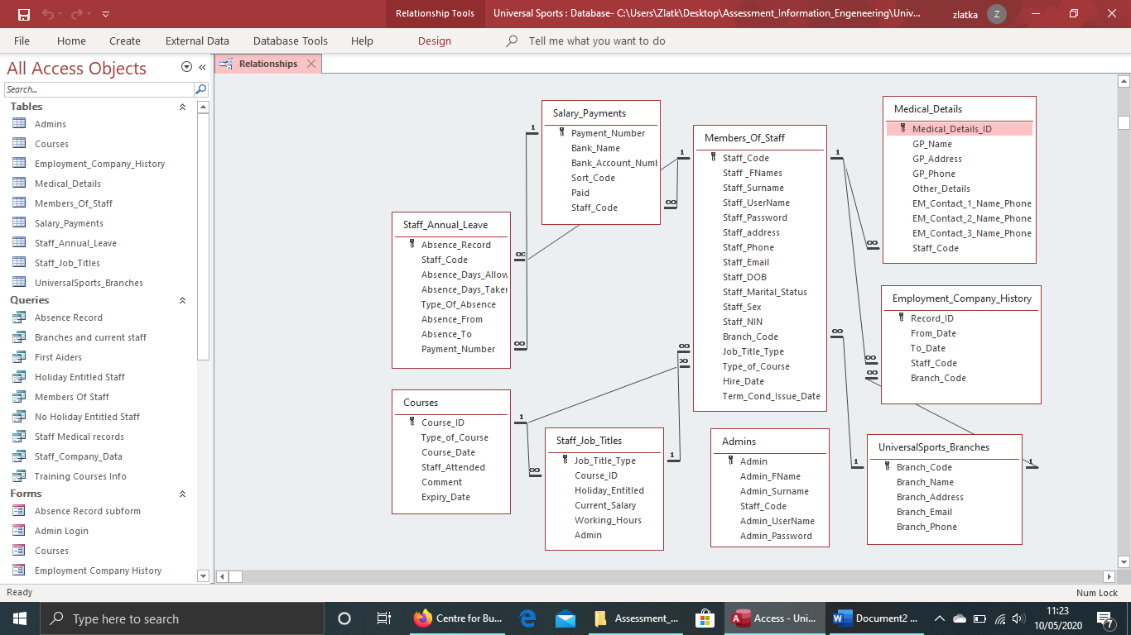
  - Members_Of_Staff Table
The main entity is Members of Staff. The database is based on employees in the company and the purpose is to store, access and edit information related to them. The main mother table is Members_Of_Staff. The primary key in it is Staff_Code with is individual for every member and its in 3-digit format as required. Image is included with fields and data type. Some drop down fields are included to make easier adding new details. In Maritual_Status: single, married, divorced, widowed. Sex: male or female. Branch_Code field which is related one to many with table for branches and displays drop down menu with Branch codes. Job_Title_Type field which is related many to one with the table for jobs and displays drop down menu with job titles. Type_Of_Course field many to one related to Course Table. With drop down menu displaying all the courses.
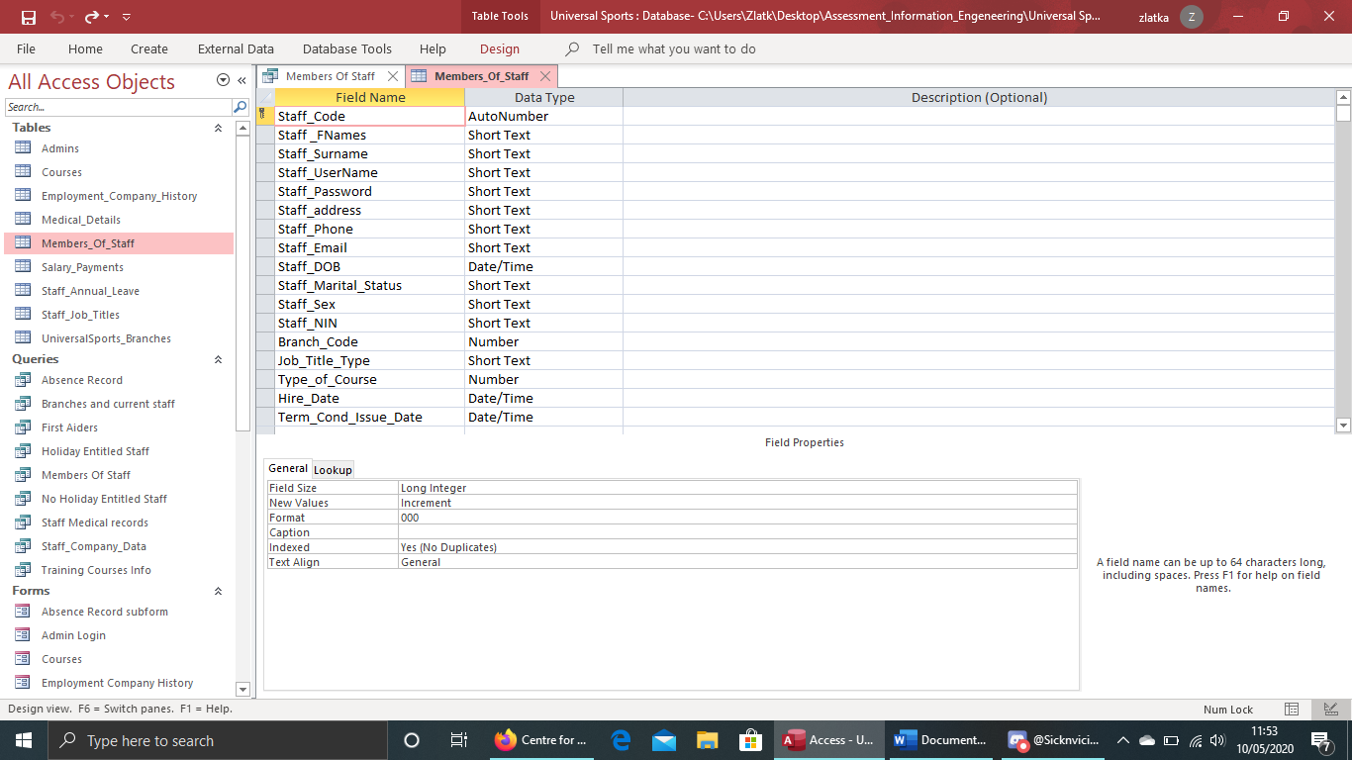
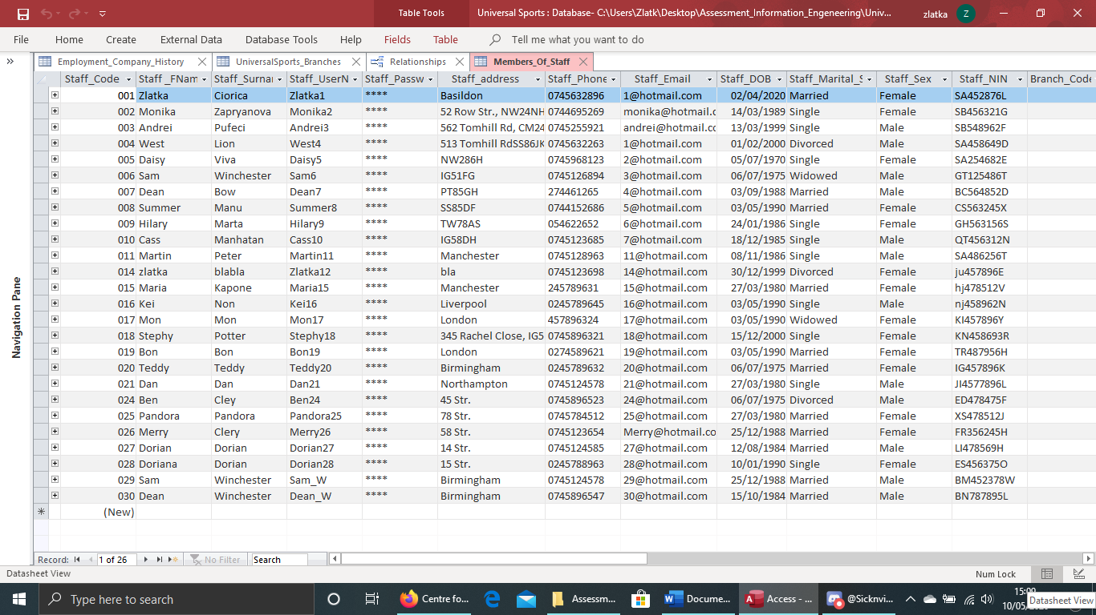
  - Medical_Details
This table is related to the main Members_Of_Staff-many to one. Primary key IS Medical_Details_ID as one member of staff can have certain ID and for example he moved in another city and still works in same company will have a new record for some of the fields with new record ID. There are fields for GP name, address and phone number. Fields for up to 3 emergency contacts, fields for additional information if needed and the field Staff_Code related to the main table of staff.
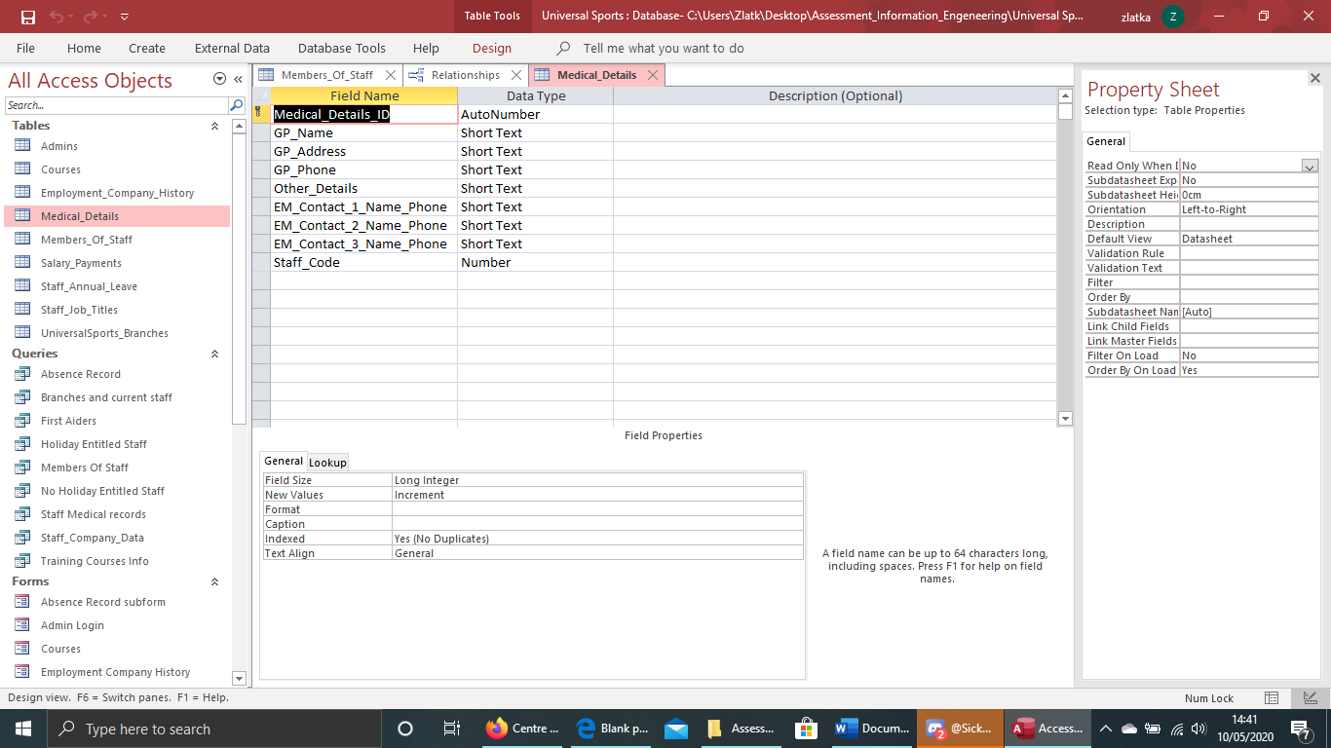
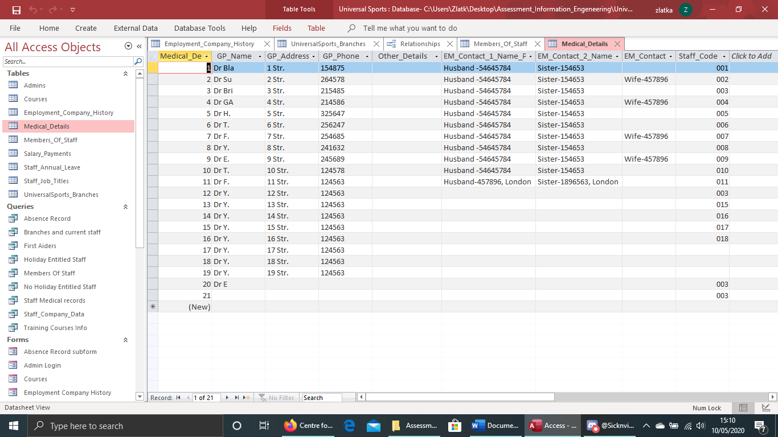
  - Employment_Company_History
Related to main table and Branches table. It is a primary key Record_ID with autonumber as they can be many records per person and branch. Fields for working in certain branch dates. Staff_ID related to the main table to display the employee code. And Branch_Code related to Branches table to display destination of work.
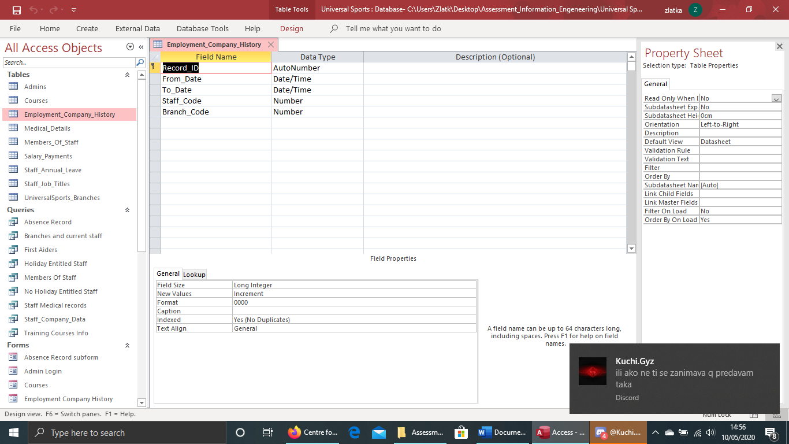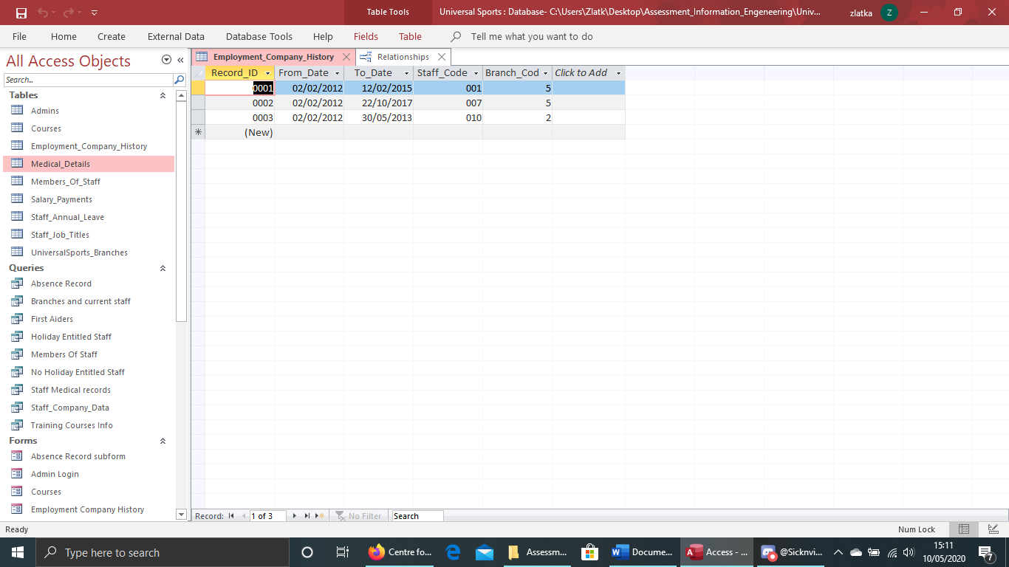
  - UniversalSports_Branches
I gave autonumber for Branch_Code. There are six branches details given with headquarter in Birmingham. Names, addresses, phone numbers and emails fields. Branches table is related one to many with Members_Of_Staff and Employment_Company_History.
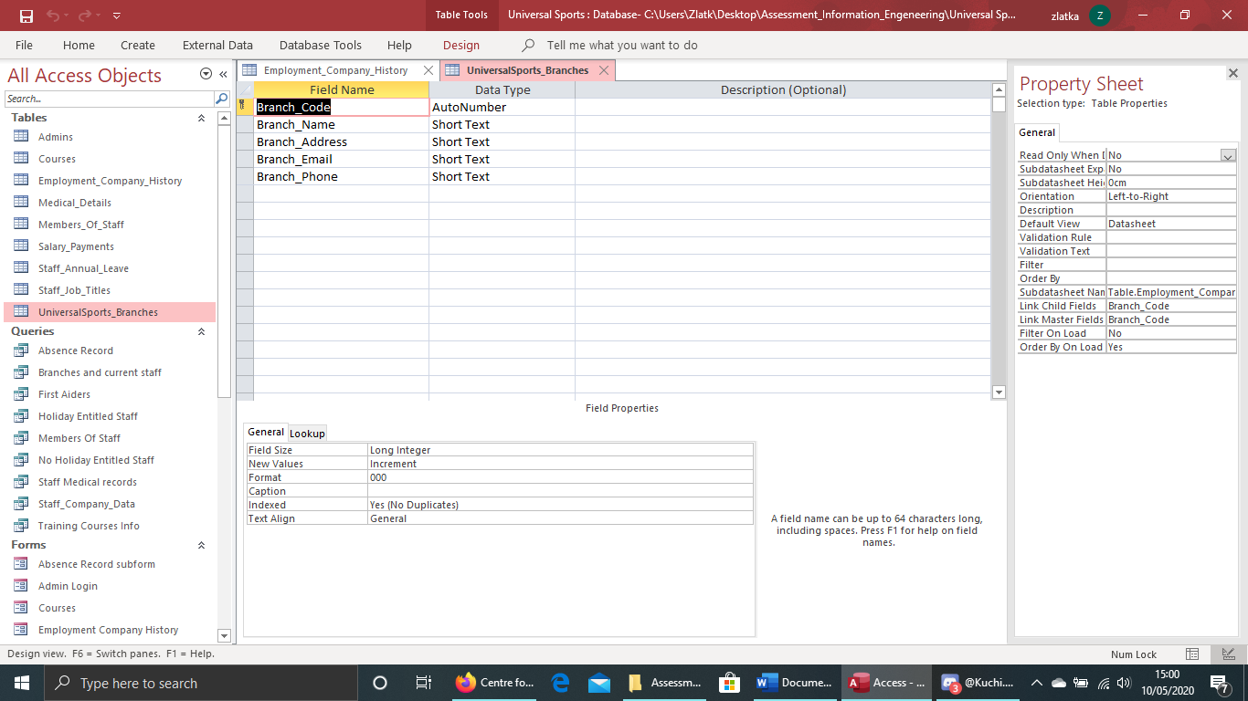
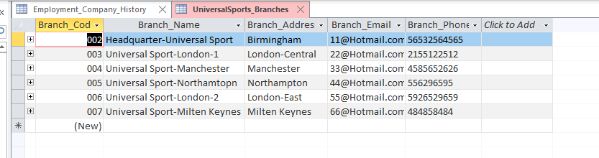
  - Salary_Payments
This table is created to store bank details with the purpose of paying salaries. Primary key is Payment_Details related to Staff_Annual_Leave table. There are fields for bank name, account number, sort code. Staff_Code field related to Members_Of_Staff.
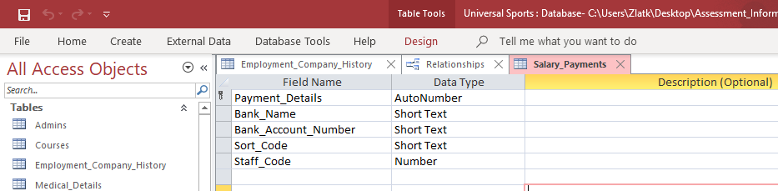
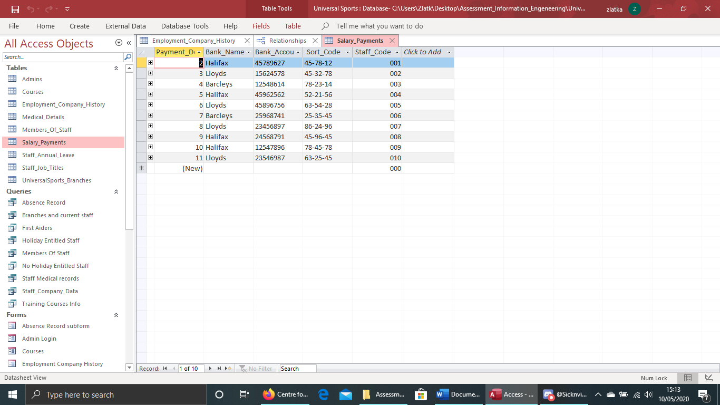
  - Staff_Annual_Leave
Table for storing information for the employee absence. Primary key is Absence_Record. There are fields for Absence_Days_Allowed, which are 28 days paid holiday, Days taken, what type or reason for absence, dates from-to. There are fields staff code connected many to one to the main table of members, payment details related to the salary table-many to one.
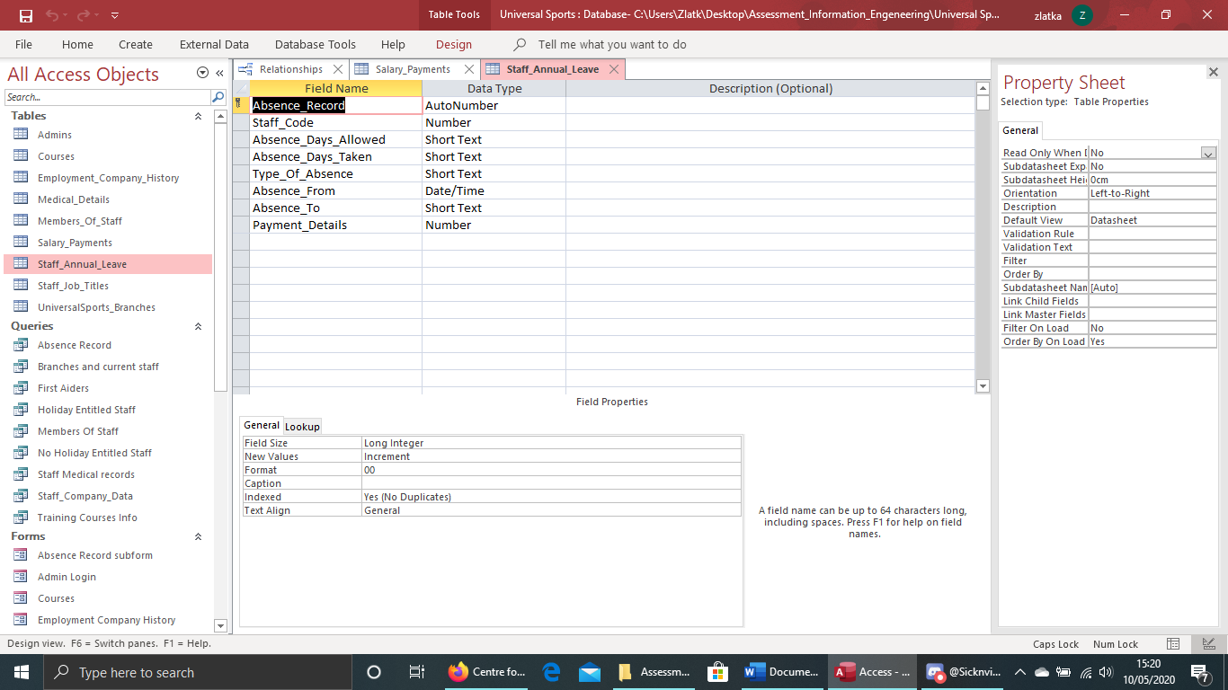
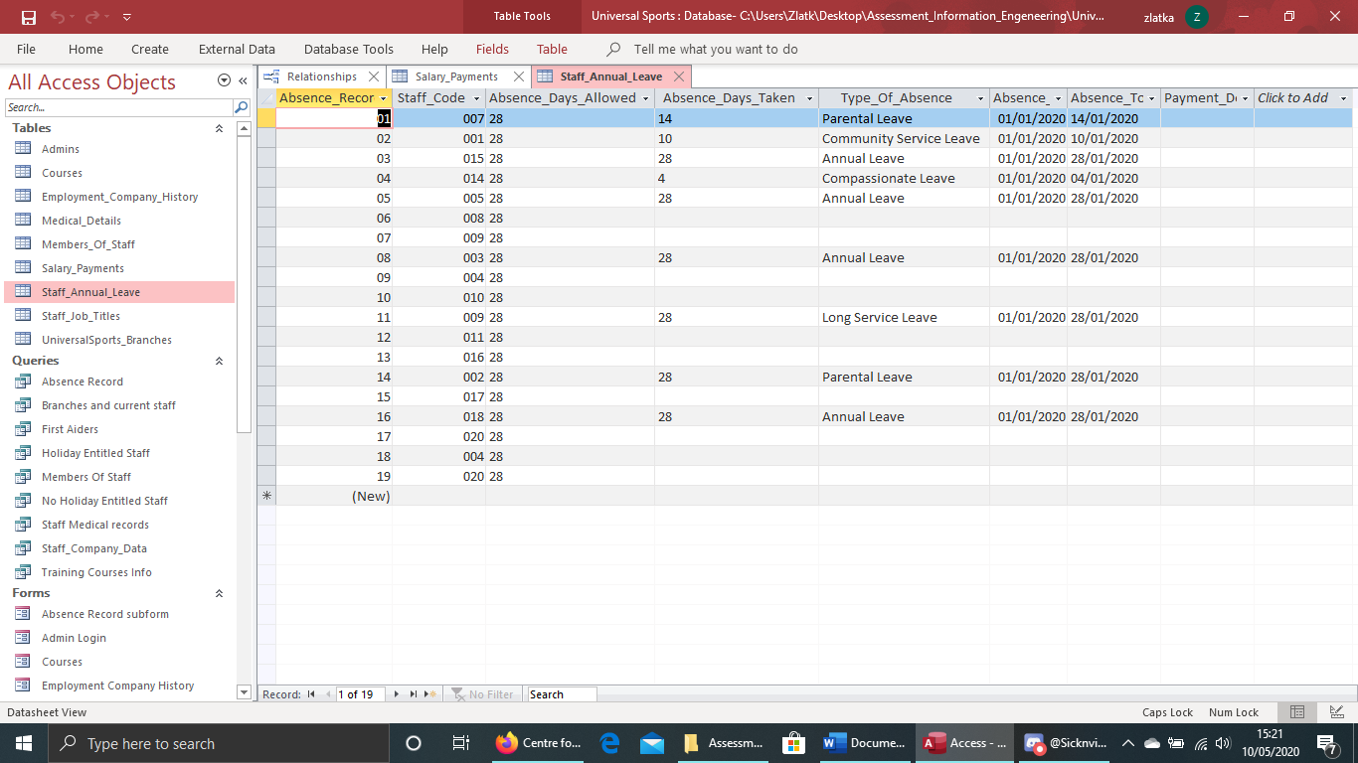
  - Courses
Courses is table for storing courses details. It is given primary key Course_ID. Fileds for the name of the course, course date, expiry date, field to mark if staff attended, and comment field. Table is related one to many with Members_Of_Staff and Staff_Job_Titles.
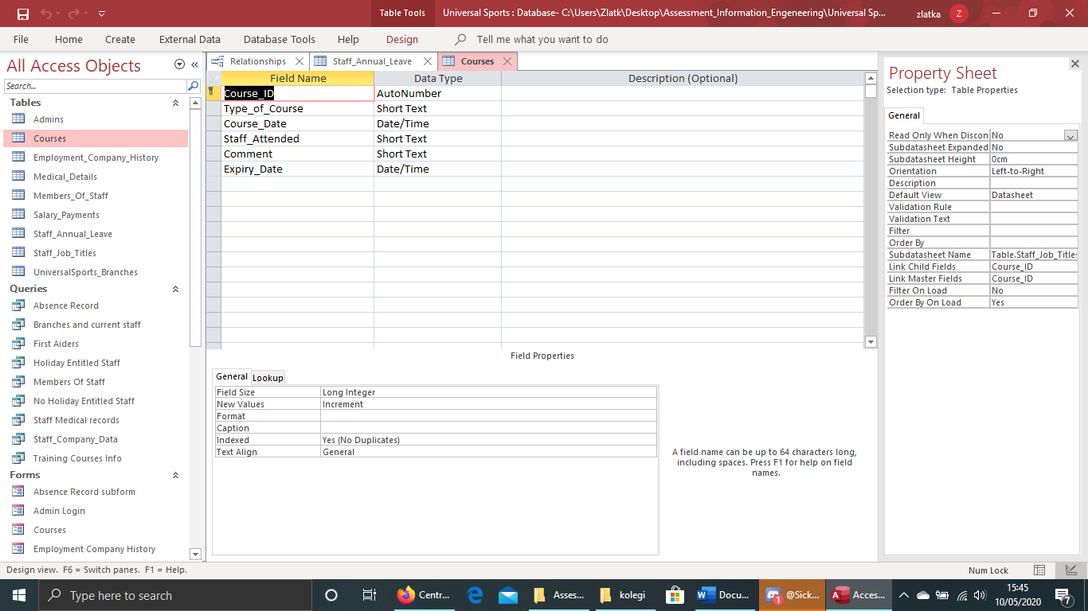
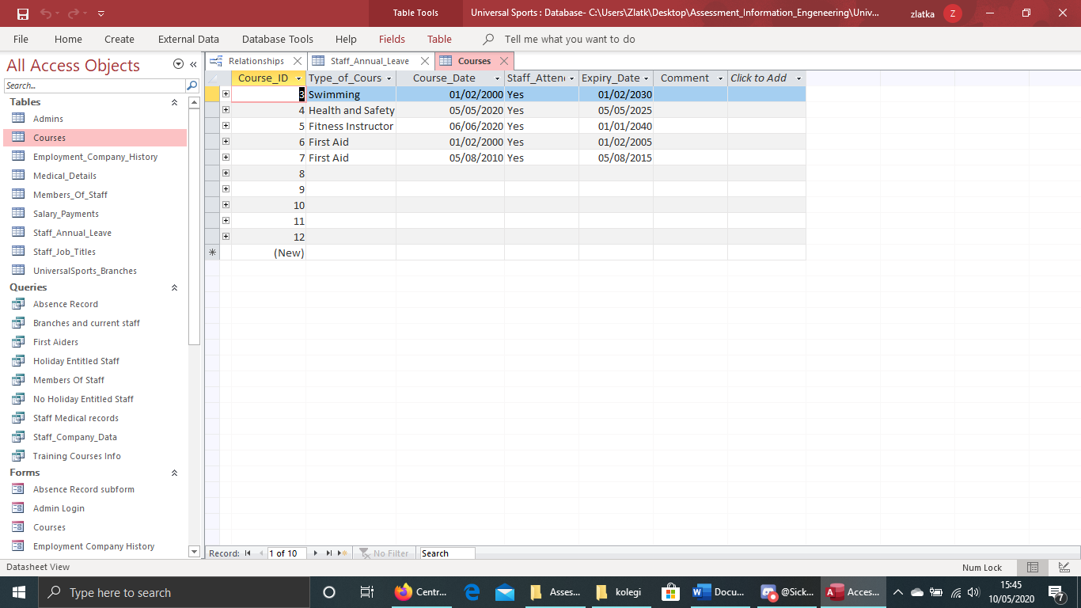
  - Staff_Job_Titles
In this table are stored different jobs in the company. Primary key is Job_Title_Type, related one to many with Members_Of_Staff. There are fields with current salary, holiday entitled with drop down menu-entittled, not entitled, working hours and field yes/no type (true/false) for admin. Table is also related with Courses as they can affect and change the job title of certain employees.
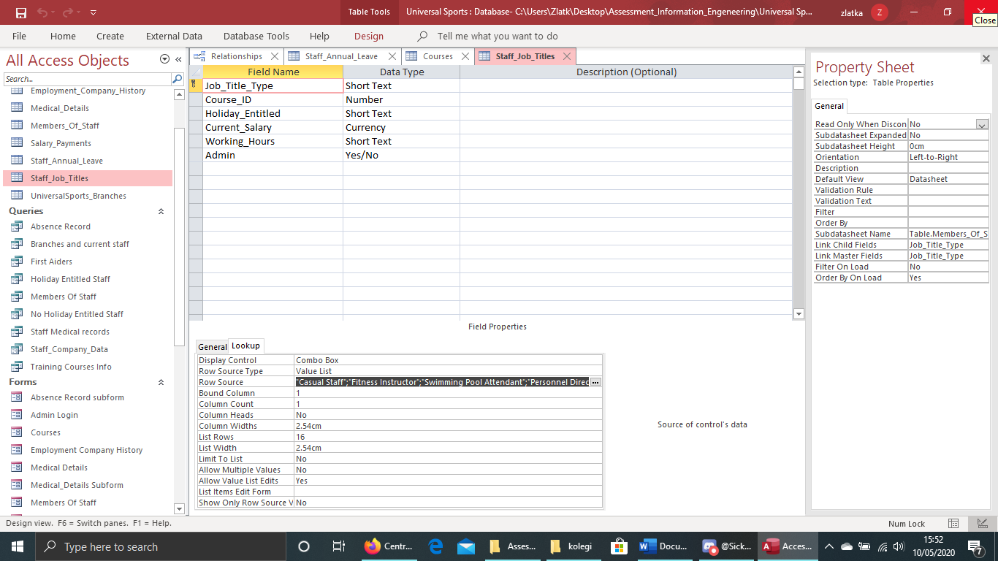
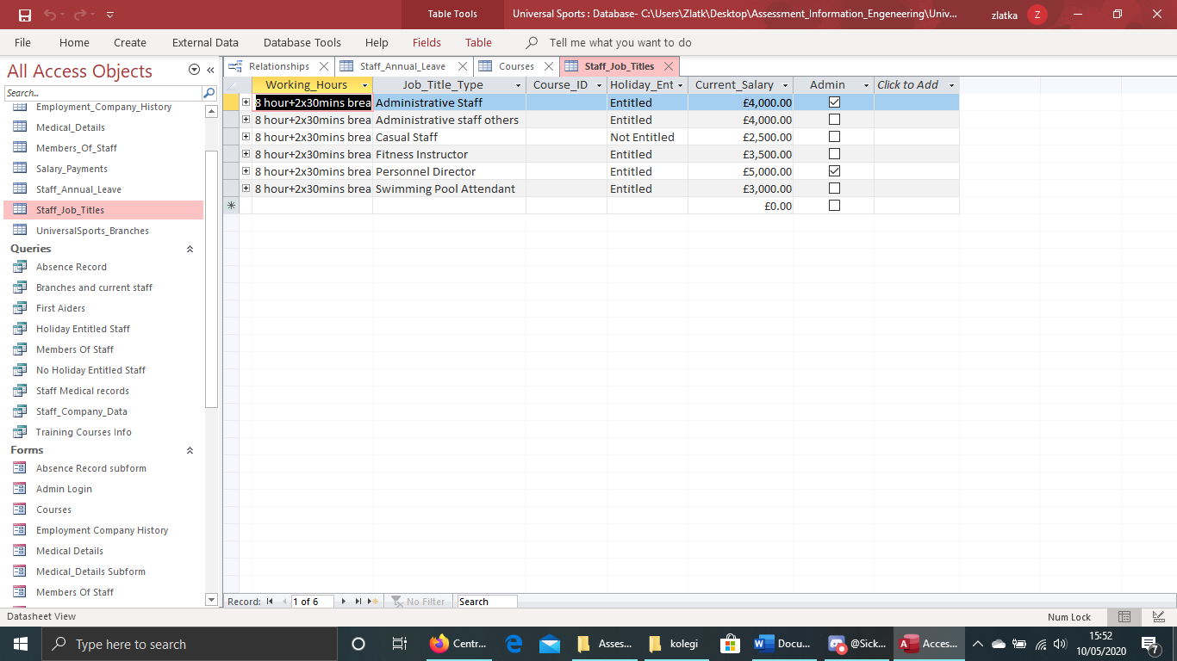
  - Admins
I chose to add table for Admins containing the employees with unlimited access to the database. This way I can easy do the coding in the login form and send the admin to admin form containing access to every form. Primary key is Admin containing values: personnel director and administrative staff main access. Name, Surname, Username and Password fields.
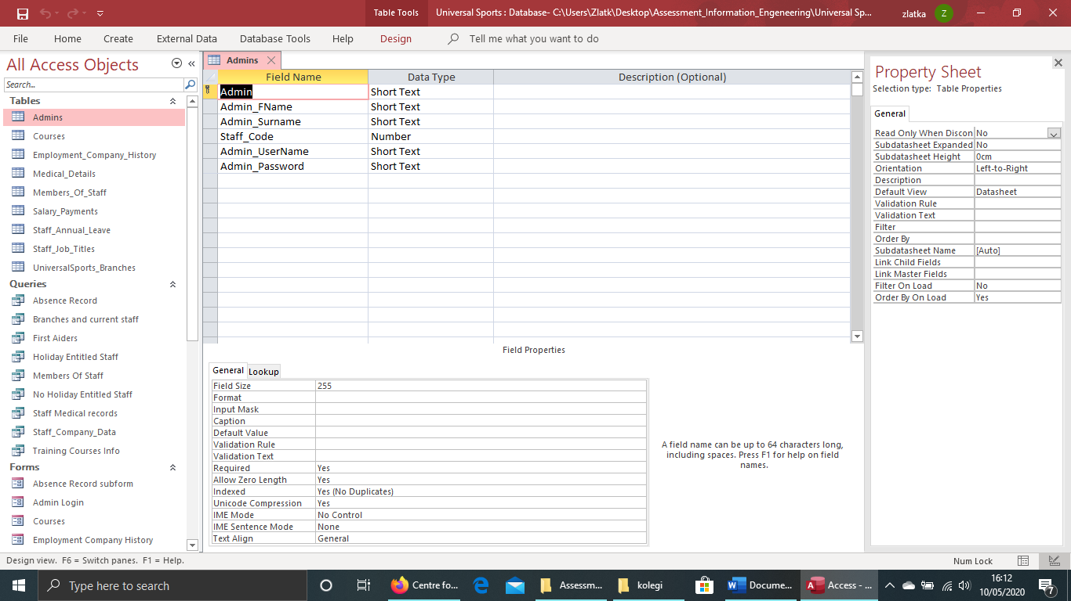
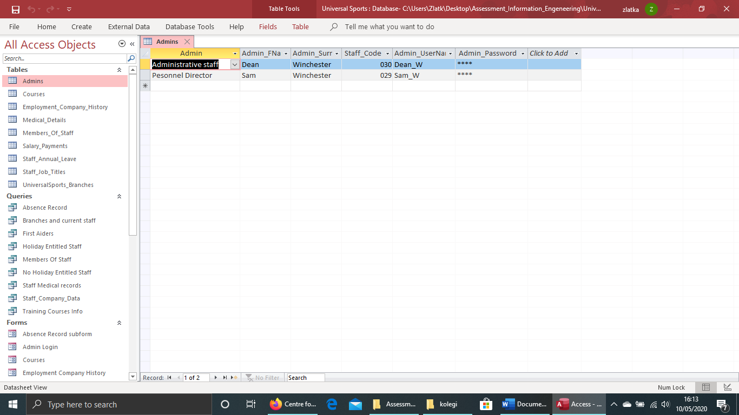

1.Biography used for the creating of the database
-Access Database Design & Programming, 3rd Edition
by Steven Roman
Released January 2002
Publisher(s): O'Reilly Media, Inc.

-Access 2019 For Dummies
By Laurie A. Ulrich, Ken Cook

-Udemy Online lessons
Available online at: https://www.udemy.com/course/microsoft-access-2016-access-from-beginner-to-advanced/?utm_source=adwords&utm_medium=udemyads&utm_campaign=MicrosoftAccess_v.PROF_la.EN_cc.UK_ti.6712&utm_content=deal4584&utm_term=_._ag_73899889153_._ad_375956901083_._kw__._de_c_._dm__._pl__._ti_dsa-774930041169_._li_9045012_._pd__._&matchtype=b&gclid=CjwKCAjw7-P1BRA2EiwAXoPWA2-RVzghySP-qXdrGS4AB0xe2MY7xhfRK-ru3oNzPa4dY--ah3FnkxoCgm0QAvD_BwE
Accessed on 7 May 2020

