
Applied Leadership and Management in the Workplace
Module Assignment Submission
Student Name: | Beverley Williams
Student Number: | 2421756
Module No: | BMSK5013
Module Title: | Knowledge & Information Management Skills

Statement of Confirmation of Authenticity
By the act of making this submission, the student declares that this is the work of the student named above. The work has not, in whole or in part, been knowingly presented elsewhere for assessment, or where assessment has been built on a previous assessment, this has been identified. Where materials have been used from other sources it has been properly acknowledged. If this statement is untrue, the student acknowledges that an assessment offence has been committed.
Attention is drawn to the plagiarism and unfair practice policies of both the University and of ILM.

Contents
1 Introduction 3
2 The Relationship Between Data, Information, and Knowledge 4
2.1 Data, Information, Knowledge, and Wisdom (DIKW Model) 4
Figure 1 4
Figure 2 5
2.2 Individual vs Organisational Knowledge 5
Figure 3 6
2.3 Knowledge Flow in DSAR Operations 7
Figure 4 7
2.4 Knowledge Governance and Ethical Considerations 7
3. Developing a Framework for a Knowledge Management Culture 9
3.1 Establishing a Business Case for Knowledge Management 9
3.2 Requirements to Create, Store, and Use Knowledge 10
3.3 Technology Integration and Future Trends 10
3.4 Applying the CIA Triad in KM 11
Figure 5 11
3.5 Identifying Current Systems for Storing Information 12
3.6 Business Information Requirements 12
3.7 Defining Knowledge Assets in the Workplace 13
3.8 Creating Key Performance Indicators (KPIs) 14
Figure 6 Proposed Key Performance Indicators for DSAR Processes 15
3.9 Proposed KM Framework for DSAR 16
Figure 7. Proposed Knowledge Management Framework for DSAR Operations 16
4. Conclusion 18
Reference List 19

1 Introduction
In financial services, knowledge is both an organisational asset and a practical requirement for decision-making. This is particularly evident where regulatory pressure and operational speed mean access to knowledge directly affects decision quality. The Data Subject Access Request (DSAR) process relies on precise and understandable information; yet fragmented systems and dispersed knowledge sources create operational constraints that slow case handling.
Dalkir (2023) describes KM work as a cycle of organising, maintaining, and sharing knowledge to support operational decision-making.
However, the effectiveness of KM systems in DSAR operations does not rely as much on formal design as on consistent day-to-day use in practice. The DSAR function at Lloyds Banking Group (LBG) shows this clearly.
Under UK GDPR, DSAR requests should be completed within one month, according to the Information Commissioner’s Office (2023). In reality, the knowledge people need is not always easy to reach quickly. When information is scattered or hard to access, it naturally slows case handling and can create uncertainty. When this happens, it highlights just how much DSAR work relies on people making sense of information in the moment — finding it, interpreting it, and applying it under pressure.
It’s the judgment that forms slowly over time — experience-shaped knowledge people lean on when the guidance doesn’t quite meet the reality of the case in front of them.
This report critically examines how knowledge is created, shared, and used within financial services by exploring DSAR practice through three established KM models — the SECI model (Nonaka & Takeuchi, 1995), Wiig’s framework (Wiig, 1997), and the DIKW model (Wani, 2025). The aim is to examine how these theories manifest in DSAR case handling. This report also argues that traditional KM models do not fully reflect the time-pressured and interpretive nature of DSAR work.

2 The Relationship Between Data, Information, and Knowledge

2.1 Data, Information, Knowledge, and Wisdom (DIKW Model)
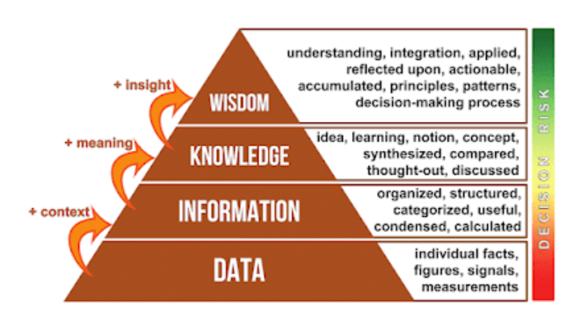
Figure 1 Data, information, knowledge and wisdom (DIKW) model. Note. From Wani, I. H. (2025). Data, information, knowledge and wisdom (DIKW), Library and Information Science Cream.
Data: In DSAR work, data sits across many different systems, often as small pieces that only start to make sense once someone looks at them closely. As Zins (2007) notes, “data are sets of symbols that represent empirical observations or facts,” reminding us that these details begin as simple observations before anyone has interpreted them.
Information: Information is what emerges when those pieces of data are organised and given context so they can support decision-making (Rowley, 2007). It is the stage where data is structured into meaningful context.
Knowledge: Knowledge develops when people bring their own experience and judgement to that information. Nonaka and Takeuchi describe this as an interpretive process, and in DSAR operations, this is especially true. Much of the day-to-day work depends on staff making sense of complex, case-specific details and drawing on what they’ve learned from previous cases.
Wisdom: Wisdom sits at a broader level. It is the thoughtful application of knowledge in wider decision-making contexts, where people draw on experience, judgement, and a sense of what is appropriate in the situation. However, in DSAR operations, the concept of ‘wisdom’ is constrained by procedural rules and strict statutory timelines, limiting reflective decision-making.
Figure 2 DIKW Hierarchy in DSAR
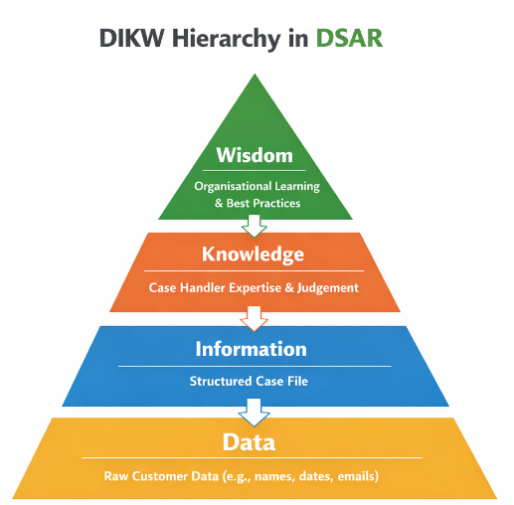
Figure 2 DIKW hierarchy in DSAR. Note. Adapted from Wani, I. H. (2025). Data, information, knowledge and wisdom (DIKW). Library and Information Science Cream.
Figure 2 represents the transformation of raw data into actionable knowledge and organisational wisdom within DSAR operations.
Although DIKW is often presented as a linear hierarchy (Rowley, 2007), DSAR operations demonstrate that knowledge transformation is non-sequential and shaped by ambiguity, time pressure, and incomplete information.

2.2 Individual vs Organisational Knowledge
In DSAR operations, case handlers rely on both professional judgement and organisational systems to support consistent decision-making.
At an individual level, knowledge grows gradually through repeated exposure to cases. Over time, people build judgement, problem-solving ability, and a deeper, experience-based understanding of the work (Polanyi, 1966).
Organisational knowledge is spread across systems, workflows, and documents that support these activities, yet people do not use it in the same way. Instead, they draw on what feels most relevant and accessible to them at a given moment. As Argote and Miron-Spektor (2011) note, this knowledge is built into processes and systems; in reality, it is not always used consistently. The Knowledge-Based View positions knowledge as a key organisational resource (Grant, 1996), although it underemphasises the risk of knowledge loss when experienced staff leave the organisation.
Figure 3 illustrates how the SECI model and the concept of ‘Ba’ support knowledge creation through shared context and interaction.
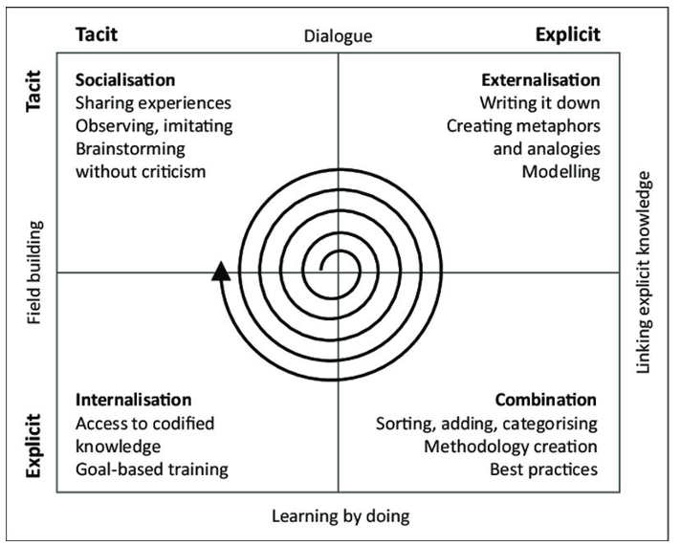

Figure 3 SECI model and “Ba” theory. Note. From Liu, X. (2024). How organizational structure facilitate pedagogy knowledge sharing in online and distance higher education (Doctoral thesis, University of Wales Trinity Saint David).
In DSAR operations, knowledge sharing emerges through informal interactions in day-to-day work. These exchanges are shaped by lived experience and by how people support one another in the flow of the work.
While the SECI model provides a useful lens for knowledge conversion, DSAR environments demonstrate their limitations in contexts where time pressure prevents systematic externalisation of tacit knowledge. Heavy workloads and tight time pressures mean that only small parts of this tacit knowledge ever make it into written guidance. It often remains a lived experience rather than being formally captured. As a result, a great deal of valuable experiential knowledge is applied every day without ever fully reaching the organisation’s formal systems.

2.3 Knowledge Flow in DSAR Operations

Knowledge does not move in a linear sequence or in clearly defined stages. The diagram below illustrates how knowledge flows within DSAR operations and is shaped by everyday team interactions. DSAR operations are shaped by time pressure, reliance on tacit knowledge, and the limits of formal KM systems.

Figure 4
Case Handling → Experience → Team Discussion → Documentation
↑ ↓
│ Compliance Review
│ ↓
└────────── Reuse in New Cases ← Knowledge Base ←──────┘

Figure 4. Knowledge flow in DSAR operations, showing cyclical movement of learning, documentation, and reuse. Created by Beverley Williams.
Wiig’s categorisation framework is limited in DSAR contexts because knowledge states shift dynamically during case handling rather than remaining stable categories.
Across DIKW, SECI, and Wiig’s framework, a shared limitation is the assumption that knowledge processes are stable and fully traceable. This does not fully reflect the more fluid and time-pressured reality of DSAR decision-making.
This analysis of knowledge flows provides a foundation for examining how organisations attempt to formalise knowledge through KM frameworks, which is explored in the next section.

2.4 Knowledge Governance and Ethical Considerations
DSAR decision-making involves dealing with sensitive personal data, so there are serious ethical duties attached.
Ethical considerations are more than a set of rules to follow; they quietly guide professional judgement and help staff hold the balance between delivering a supportive service and meeting regulatory expectations.
Knowledge governance is about respecting the rights of the people whose data we work with. It also has a human purpose: offering staff the confidence, clarity, and gentle reassurance they need to handle information in ways that feel lawful, secure, and genuinely supported.
This aligns with Article 5 of the UK GDPR (European Union, 2016, Art. 5), which asks organisations to collect data only for clear reasons and to keep no more than is genuinely needed.
In DSAR work, this can feel challenging. The pace is naturally quick, and statutory deadlines create a sense of urgency that doesn’t always leave much room to slow down. People often move through complex information quickly, pausing when they can to double-check decisions and correct errors. Managing knowledge well means paying attention to the ethical considerations side of the work, including trust, ownership, and accountability, and how information is handled (Khanal, 2025). Studies in this area, such as Davenport and Prusak’s work (1998), remind us that organisations need clear ways of taking responsibility for how they use and share information, particularly when it relates to someone’s personal story. This sits closely with the accountability expectations within the UK GDPR (European Union, 2016).
Delays or errors in DSAR responses can result in complaints to the Information Commissioner’s Office, reputational damage, and potential financial penalties.
These responsibilities form the backdrop for how organisations try to build a culture of knowledge management, which the next section explores.
In this context, knowledge governance is not only regulatory but also a mechanism for shaping how knowledge is accessed, interpreted, and acted upon.

3. Developing a Framework for a Knowledge Management Culture
Developing a knowledge management culture in DSAR operations is necessary because existing systems are insufficient to maintain consistent decision-making when operating within regulatory timelines and strict statutory timeframes. As a result, there is variation in how cases are interpreted and processed, especially with complicated or slightly unusual requests.
A KM culture is not just about systems or tools, it’s also about the official process steps, and behaviours, such as everyday communication habits that become routine in practice. In this setting, knowledge management becomes an organisational practice involving people, communication, and processes rather than a purely technical process. That means it needs some formal structure, but also informal ways of sharing insight in day-to-day practice; otherwise, consistency in decision-making is difficult to maintain.

3.1 Establishing a Business Case for Knowledge Management
In DSAR operations within the financial sector, knowledge management is not just a technical exercise but a critical component for regulatory compliance and operational performance.
Organisations need to treat KM as a strategic asset because poor knowledge sharing leads to regulatory breaches and increased operational costs due to repeated work across cases and remediation activity.
Alavi and Leidner (2001) note that effective knowledge management can boost operational efficiency and consistency in decision-making. This helps reduce duplicated effort, and in DSAR work it also means cases are revisited less often, which supports a steadier, more consistent response for the individual making the request.
Recent research also highlights the importance of reliable information governance and structured knowledge systems in supporting organisational decision-making (Lasky, 2024).
KM is therefore not optional infrastructure but a compliance-critical capability in regulated environments.

3.2 Requirements to Create, Store, and Use Knowledge
Creating knowledge
As discussed earlier, DSAR work operates under conditions that limit formal knowledge development. Although Nonaka and Takeuchi (1995) highlight the importance of turning tacit insights into explicit organisational knowledge, in practice, this is constrained. Most knowledge is developed in practice—during case handling, informal team discussions, and when requests fall outside standard procedures.
Storing knowledge
In DSAR operations, information is often distributed across multiple platforms. Even where information exists, it is not always easily accessible, so teams tend to rely on experiential knowledge.
Applying knowledge
Using knowledge in DSAR contexts involves interpretation, and not just retrieval. Karl Wiig’s framework (1997) makes the point that knowledge only becomes genuinely valuable when it is used effectively in decision-making. However, standardising this is challenging because DSAR cases often come with ambiguity, incomplete data, and significant contextual judgement. As a result, applying knowledge is shaped more by experience and collaborative problem-solving than by formal KM structures. In regulatory environments, not all knowledge can be neatly captured or formalised, so people often fall back on their own judgement and experience to handle the gaps systems can’t cover.
These patterns reveal several barriers to effective knowledge management in DSAR work, including dispersed systems, limited time for reflection, uneven use of guidance, and the ongoing challenge of capturing tacit knowledge in fast-paced environments.
These barriers mean that knowledge management in DSAR work cannot rely on formal systems alone; it must also recognise the practical limits of what staff can realistically capture, share, and use while working under constant regulatory pressure.

3.3 Technology Integration and Future Trends
As organisations place greater reliance on digital systems, new challenges begin to emerge. One of these challenges is automation bias, where staff may come to trust system outputs more than intended and, in doing so, give less attention to the detailed checking that would normally support their decisions. Cummings (2014) also argues that automated systems cannot fully replace human judgement in situations where decisions depend on interpretation rather than fixed rules, which aligns closely with the realities of DSAR work. In DSAR decisions, this is particularly problematic where data is incomplete or ambiguous and requires interpretation.
This risk is heightened in DSAR environments, where staff often work quickly and may lean on system prompts for reassurance, even when the situation still requires careful human judgement.

3.4 Applying the CIA Triad in KM
In financial organisations, people are expected to work in a manner that requires consistent adherence to security practices and professional responsibility.
One way of looking at these expectations is through the CIA triad (Henderson, 2015): confidentiality, integrity, and availability.
Confidentiality means protecting sensitive information and sharing it only with those who genuinely need to see it. Security controls support this, but much of the protection comes from the everyday choices staff make — double-check something, and make sure information isn’t passed on more widely than it should be.
Integrity is about being able to trust the information to remain unchanged from its original state throughout its lifecycle.
Availability is making sure the information is there when people need it. Within DSAR operations, this matters because the case turnaround expectations are tight and any delay can have a real impact on the outcome.

Figure 5
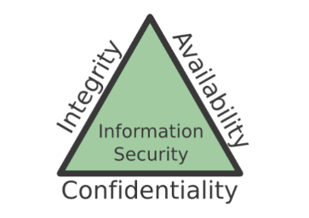
Figure 5
The CIA triad.
Note. From The CIA triad: Confidentiality, integrity, availability, by A. Henderson, 2015, July 5, Panmore Institute.

Knowledge management supports these principles in a practical way — by helping to keep information safe, accurate, and dependable, and by making sure people can reach what they need according to scheduled times. It protects confidentiality, cares for the quality of the data, and ensures that access feels timely, appropriate, and secure.
The CIA triad offers a clear structure for thinking about information security — confidentiality, integrity, and availability — but it doesn’t fully capture what happens in real DSAR work. Many decisions rely on interpretation, especially when records are incomplete or unclear, and staff must use their judgement to make sense of what they are seeing. This creates a gap between system controls and the level of human judgement that DSAR decisions require.

3.5 Identifying Current Systems for Storing Information
LBG (Lloyds Banking Group) uses a range of systems to hold and share knowledge across its departments, each one supporting a different part of the organisation’s work. For the DSAR team, this means drawing on several systems to retrieve, verify, and integrate the information needed for each case.
Customer information platforms act as the main places where DSAR‑relevant details are stored. They bring account information, transactions, and past communications, supporting staff in constructing a complete view of the customer’s case history.
Intranet sites and policy libraries provide the organisation’s formal knowledge repository, ensuring access to standardised guidance and procedures, allowing staff to verify information and follow up-to-date processes.
Email and Microsoft Teams enable informal knowledge sharing between staff, supporting rapid clarification of DSAR-related queries.
Workflow and case‑management systems help guide the flow of DSAR work by keeping track of tasks, showing where each case currently sits, and offering a steady structure for the team to follow. It is fragmented across multiple platforms, and staff must actively integrate information across systems.

3.6 Business Information Requirements
Effective DSAR operations depend on understanding the key information required for decision-making and compliance. The organisation relies on accurate, complete, and up-to-date information to manage DSAR operations and financial service delivery across its core areas.
Customer identity details — things like names, addresses, account numbers, and the steps we use to verify them — help teams check that a DSAR request is genuine and truly coming from the right person.
Financial and transactional records — including account activity, payments, and earlier interactions — help show what’s been happening on an account and give some basic background to the request.
Customer interaction data, including emails, call notes, and letters, builds on that by showing how information has been communicated over time.
Regulatory and compliance information — such as GDPR requirements, ICO guidance, and internal policies — establishes the regulatory framework within which DSAR decisions must operate.
Operational case data — Operational case data, such as tracking systems, timestamps, and workflow stages.
Even when all of this information is available, it doesn’t automatically mean it will be used well. Staff still need to interpret it, make sense of it, and apply it carefully in complex DSAR situations. Day-to-day practice, judgment, and lived experience often matter just as much as the data itself.

3.7 Defining Knowledge Assets in the Workplace
Knowledge assets are often categorised into explicit, tacit, relational, and embedded forms (Sveiby, 1997). These classifications remain helpful when designing knowledge-management systems, particularly for shaping training and documentation, even if they do not fully mirror day-to-day operational practice.
Explicit knowledge refers to information that can be clearly articulated, systematically documented, and easily communicated to others. (Md. Ashikuzzaman, 2025)
Tacit knowledge develops through practice. In DSAR operations, this lived knowledge enables staff to navigate complex requests that do not fit standard procedures (Nonaka, 1994; Polanyi, 1966; Davenport & Prusak, 1998).
Relational knowledge refers to knowledge embedded in professional networks and informal support structures.
Embedded knowledge lives within the systems and workflows that support and organise DSAR task execution.
Together, these knowledge forms illustrate how DSAR decision-making depends on the interaction of documentation, experience, and system design rather than any single dominant source of knowledge.

3.8 Creating Key Performance Indicators (KPIs)
Key Performance Indicators (KPIs) offer a practical way for organisations to understand how well their knowledge-management activities are working in everyday practice. The Balanced Scorecard (Kaplan & Norton, 1992) encourages organisations to look beyond efficiency alone and consider areas such as learning, development, and compliance, helping teams connect their operational performance with longer-term strategic aims.

Figure 6 Proposed Key Performance Indicators for DSAR Processes

KPI | What it Measures | How it is Calculated | Relevance to Knowledge Management
DSAR Completion Within Deadline | How consistently does the team meet the one-month regulatory timeframe | (Number of DSARs completed within 1 month ÷ Total DSARs) × 100 | Shows whether people can quickly find and apply the right information when working under time constraints
Average Case Resolution Time | The typical amount of time it takes to work through a request | Total time spent on DSARs ÷ Number of cases | Indicates how efficiently staff can locate guidance and move through cases without delays
Error or Rework Rate | How often decisions need correcting or revisiting | (Number of cases requiring correction ÷ Total cases) × 100 | Highlights knowledge gaps or unclear guidance
Knowledge System Usage | How regularly staff engage with the organisation’s KM tools | Percentage of staff accessing knowledge systems on a weekly basis | Helps show whether knowledge is being shared, used, and trusted in day-to-day work
First-Time Resolution Rate | How often cases are completed without escalation or rework | (Cases completed without escalation ÷ Total cases) × 100 | Reflects the strength of available knowledge and the confidence of staff using it
Knowledge Update Frequency | How often guidance, templates, or policies are refreshed | Number of updates made to knowledge assets per month | Ensures the information people rely on stays accurate, current, and genuinely helpful

Note. Created by Beverley Williams.

However, KPI-driven measurement can prioritise what is easy to measure, while overlooking the quieter, tacit knowledge practices that are harder to capture but remain central to DSAR decision-making.

3.9 Proposed KM Framework for DSAR
Knowledge in DSAR operations is shared through informal discussions and collaboration tools, reflecting Wenger’s (1998) view that learning is socially situated and occurs through participation in communities of practice rather than solely through formal documentation systems.
This leads to a framework that better reflects how knowledge is managed in DSAR operations, while not replacing existing working practices.
Compared with more traditional KM models, this framework explicitly accommodates informal knowledge flows and delayed externalisation, making it more suitable for time-constrained and judgement-based DSAR environments.

Figure 7. Proposed Knowledge Management Framework for DSAR Operations
Knowledge Creation
(Case handling, experience)

Knowledge Sharing
(Team discussion, Teams, formal collaboration)

Knowledge Formalisation
(Guidance, templates, documentation)

Knowledge Storage
(Intranet, systems, document repositories)

Knowledge Application
(DSAR case decision-making)

Feedback & Improvement
(Learning, gaps identified)

(cycle repeats)

Figure 6 Proposed knowledge management framework for DSAR operations. Note. Created by Beverley Williams.

The model begins with knowledge creation, which usually comes from dealing with cases that fall outside standard procedures. In these situations, staff rely heavily on their own judgement, which builds up over time.
Some of this knowledge is later formalised into guidance and templates. This links to Ikujiro Nonaka’s idea of externalisation, although in practice, this step does not always occur in a linear or consistent manner. Sometimes knowledge stays informal for quite a while before being captured, if it is captured at all. These knowledge storage systems are intended to improve accessibility, although having multiple systems can also reduce efficiency.
When working on new DSAR cases, staff can then draw on this stored knowledge. However, they do not rely on it completely. Wiig (1997) and Dalkir (2023) have both emphasised that KM systems are most effective when they support rather than replace operational work.
Overall, the framework shows that effective KM in DSAR contexts depends not on enforcing structured knowledge cycles, but on supporting the interaction between formal systems and professional judgement.
This makes the framework suitable for DSAR work, where knowledge is often applied before it can be formalised and judgement must bridge gaps in incomplete information.
Even though this framework fits DSAR work better than the traditional KM models, it still has its limits. It depends on people having the time and space to share what they know, and in a fast-moving environment that isn’t always possible. It also has to work around the systems we already have, which can still feel quite fragmented at times.

4. Conclusion
Models such as DIKW, SECI, and Wiig’s framework provide useful starting points for understanding how knowledge is structured and applied in organisations, but the analysis in this report shows that they do not fully capture the realities of DSAR work. DSAR decision-making is shaped by time pressure, fragmented systems, and the need for interpretive judgment, meaning knowledge often has to be applied before it can be formally captured. This reflects the lived experience described earlier in the report, where people often move through complex information quickly, pausing when they can to double-check decisions.
The proposed DSAR-specific framework responds directly to these challenges by recognising that knowledge creation, sharing, and application do not occur in neat cycles. In practice, this means that much of what guides decision-making is built slowly, collectively, and shaped by the moments where people make sense of complex situations together.
This approach recognises where traditional KM models fall short and offers something that feels much closer to the real pace of DSAR work — a structure that supports people when decisions need to be made quickly, often with information that is only partial or not entirely clear.
Taken together, the analysis shows that effective knowledge management in DSAR operations isn’t about applying rigid theoretical models. It’s about supporting the everyday interaction between organisational systems and the professional judgement people build over time. When organisations recognise the value of tacit knowledge, the pressure of regulatory timelines, and the practical realities of case handling, they are better placed to create KM practices that genuinely support people in their work. This alignment between theory and lived experience is what helps keep decisions accurate, consistent, and grounded in trust.

Reference List
Alavi, M., & Leidner, D. E. (2001). Review: Knowledge management and knowledge management systems: Conceptual foundations and research issues. MIS Quarterly, 25(1), 107–136.
Argote, L., & Miron-Spektor, E. (2011). Organizational learning: From experience to knowledge. Organization Science, 22(5), 1123–1137.
Cummings, M. L. (2014). Man versus machine: Autonomous system design and the limits of human decision-making. Ashgate Publishing.
Dalkir, K. (2023). Knowledge management in theory and practice (4th ed.). MIT Press.
Davenport, T. H., & Prusak, L. (1998). Working knowledge: How organizations manage what they know. Harvard Business School Press.
European Union. (2016). Regulation (EU) 2016/679 of the European Parliament and of the Council (General Data Protection Regulation). https://eur-lex.europa.eu/eli/reg/2016/679/oj
Grant, R. M. (1996). Toward a knowledge-based theory of the firm. Strategic Management Journal, 17(S2), 109–122.
Henderson, A. (2015, July 5). The CIA triad: Confidentiality, integrity, availability. Panmore Institute. https://panmore.com/the-cia-triad-confidentiality-integrity-availability
Information Commissioner’s Office. (2023). Right of access (subject access requests). https://ico.org.uk/for-organisations/uk-gdpr-guidance-and-resources/individual-rights/right-of-access/
Kaplan, R. S., & Norton, D. P. (1992). The balanced scorecard—Measures that drive performance. Harvard Business Review, 70(1), 71–79.
Khanal, K. (2025). Ethics and governance in knowledge management. In S. K. Saha & M. K. Saha (Eds.), Knowledge sharing and fostering collaborative business culture (pp. 349–362). IGI Global. https://doi.org/10.4018/979-8-3373-0710-7.ch018
Lasky, J. (2024). Confidentiality, integrity and availability (CIA triad). EBSCO Research Starters. https://www.ebsco.com/research-starters/information-technology/confidentiality-integrity-and-availability-cia-triad
Liu, X. (2024). How organizational structure facilitate pedagogy knowledge sharing in online and distance higher education (Doctoral thesis, University of Wales Trinity Saint David). https://repository.uwtsd.ac.uk/id/eprint/3913/1/Liu_X_DBA_Thesis.pdf

Md. Ashikuzzaman. (2025, August 20). What is Explicit Knowledge? Library & Information Science Education Network; Library & Information Science Education Network. https://www.lisedunetwork.com/what-is-explicit-knowledge/cit
Nonaka, I. (1994). A dynamic theory of organizational knowledge creation. Organization Science, 5(1), 14–37.
Nonaka, I., & Takeuchi, H. (1995). The knowledge-creating company: How Japanese companies create the dynamics of innovation. Oxford University Press.
Polanyi, M. (1966). The tacit dimension. Routledge & Kegan Paul.
Rowley, J. (2007). The wisdom hierarchy: Representations of the DIKW hierarchy. Journal of Information Science, 33(2), 163–180.
Sveiby, K. E. (1997). The new organizational wealth: Managing and measuring knowledge-based assets. Berrett-Koehler.
Wani, I. H. (2025). Data, information, knowledge and wisdom (DIKW). Library and Information Science Cream. https://www.libraryinfoscience.in/2022/07/data-information-knowledge-and-wisdom.html
Wenger, E. (1998). Communities of practice: Learning, meaning, and identity. Cambridge University Press.
Wiig, K. M. (1997). Knowledge management: An evolving concept. Knowledge and Process Management, 4(3), 139–154.

