Explainable Artificial Intelligence for Financial Fraud Detection in Digital Banking: A Research Proposal

STUDENT ID – 2434584

STUDENT NAME – PARTH KAMLESHKUMAR SUTHAR

COURSE – MSC DATA AND AI

MODULE TITLE – RESEARCH METHODS AND PROFESSIONAL DEVELOPMENT

MODULE CODE – ACFA7004

LECTURER NAME – VIJEYANANTHAN THAYANANTHAN

Abstract—The increasing adoption of digital banking has heightened the risk of sophisticated financial fraud. Although Artificial Intelligence (AI) models assist in the detection of fraud, its lack of transparency raises an issue of faith, responsibility, and regulation. The paper examines the concept of Explainable AI (XAI) as a tool to ensure fraud detection systems are becoming more visible and understandable. The research objectives by the secondary qualitative research and thematic synthesis will help find how XAI can be used to match AI-based systems with ethical principles and regulatory requirements in digital financial settings.
Keywords— Explainable Artificial Intelligence (XAI), Financial Fraud Detection, Digital Banking, Transparency, Accountability, Ethical AI, Machine Learning, Regulatory Compliance, Federated Learning, Interpretability

I. Introduction

A. Context and Background
Digital banking is one of the most impacted sectors in which Artificial Intelligence (AI) has revolutionized many industries. The progressive process of digitalizing financial services has caused a booming influx of the size, velocity, and sophistication of transactions, which subsequently have amplified the level and advanced phases of financial fraud [1], [2]. Traditional rule-based fraud detection methods have not been able to manage this complexity, and new AI-based methods that have the ability to detect concealed patterns and anomalies within large amounts of data have emerged [3], [5]. Although these improvements have been made, there is still a critical shortcoming, and that is lack of transparency in most AI models. Most existing systems, especially those that are deep-learning-based, are black boxes, or capable of giving accurate predictions but with explanations that are not understandable by a human being [11], [12]. This obscurity brings serious challenges in controlled fields such as finance, where interpretability becomes key to compliance, auditability and customer trust [13], [14].
In order to address this, the issue of Explainable Artificial Intelligence (XAI) has become a subdiscipline that aims to create models able to preserve their predictive capabilities and still provide an insight into the mechanisms of their decision-making [15], [16], [18]. Explainability is particularly important in the financial sector in order to justify decisions of high stakes, like blocking transactions or identifying fraud [25]. The advancements of federated learning, neural-symbolic reasoning, and post-hoc explanation tools have made their way to the system of XAI integration with real-time fraud detection [6], [7]. However, there are major issues in the balancing of accuracy, interpretability, ethical integrity and scale of operations [19], [20].

B. Research Problem
Although AI is widely applied in the detection of fraudulent financial transactions, a major weakness is the lack of interpretability of such models. The majority of fraud detection systems in the present age use opaque algorithms that cannot prove their results to regulators, auditors and end-users [9], [16]. This “black box" issue brings about a system of lack of transparency that compromises the credibility and legal responsibility of financial choices. Furthermore, the existing fraud detection algorithms frequently are weak in extrapolating to new patterns of frauds or adversarial instances, particularly in the absence of explanations or instructions to unbiased explanations [17]. It is further complicated during the digital banking context where the transaction happens instantly and a decision will need to be provided on the spot to defend the user-related actions like freezing funds or blocking an account [5], [19].
Moreover, financial institutions must withstand regulatory pressures like GDPR, which require algorithmic decisions to be interpretable and auditable. The majority of current fraud detection programs cannot achieve that, and this brings an urgent research void [29]. Therefore, the weakness of this study is the lack of implementation of explainable AI in fraud detection checks in digital banking networks.

C. Research Aim and Objectives
Research Aim
This study will examine how Explainable Artificial Intelligence (XAI) can be used to enhance the detection of financial fraud in online banking. The study aims to learn how XAI leads to transparency, trust, and enhanced decision-making within AI-driven fraud mitigation systems of financial institutions through secondary qualitative analysis of the recent academic literature on the topic.
Research Objectives
- To examine current applications of AI in financial fraud detection and identify limitations in transparency.
- To analyze key explainability frameworks (e.g., SHAP, LIME, neural-symbolic models) used in fraud detection.
- To explore how XAI models can address ethical, legal, and technical challenges in digital banking.
- To synthesize secondary qualitative data on best practices for implementing XAI in real-time fraud detection systems.
- To identify future research directions and technological innovations that may enhance explainability and trust in AI-driven financial security tools.

D. Significance of the Research
The study is important as it fills an important gap between predictive accuracy and model interpretability in fraud detection systems. Although the overwhelming academic and industry interest has centered on enhancement of detection rates, little has been done on how and why AI models indicate dubious behavior as fraudulence [13], [20]. This study contributes to the recent trend in regulation, ethics, and societal requirements in regard to explainable AI. The practical implications of the research are also important. A deeper explainability can result in increased user trust, increased regulatory compliance and even increased detection through the revealing of latent patterns that are comprehensible and remediable by human analysts [22], [30]. Besides, it will support the overall resilience of systems by assisting their defense in audits and legal proceedings conducted against financial institutions. Overall, this study has made contributions to both the theoretical and practical literature on the future of responsible AI, which is the high-stakes field of financial cybersecurity.

II. Literature Review

A. Introduction
The literature review provides a critical analysis of academic studies in the interconnection of Explainable Artificial Intelligence (XAI) and financial fraud detection in digital banking. It is aimed at establishing the existing trends, technical structures and conceptual shortcomings in this dynamic area. The review will be based on the peer-reviewed literature published between 2019 and 2025, which is relevant to the topic and has a high level of scholarly applicability. Through the thematic organization, clarity and coherence are achieved and there are five main themes that are covered: AI methods of fraud detection, the Black box problem of the AI system, XAI development and limitations, applications of XAI to fraud detection, and ethical, regulatory, and operational issues. This theme can be used to organize the study to give a more systematic insight into the way the underlying AI technologies have been developed into greater transparent and accountable systems, particularly in high-stakes financial settings where interpretability and trust are central.

B. Theme 1: AI Techniques in Financial Fraud Detection
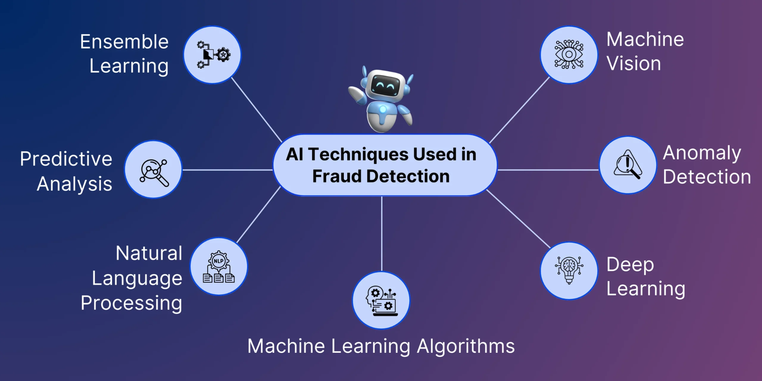
Figure 1: AI Techniques Used in Fraud Detection
(Source: Ali et al., 2022)
Financial fraud detection has also become part of artificial intelligence (AI) technologies, especially because of their ability to identify unusual transactions through large amounts of transactional data at high cost. According to [1], AI-based systems are increasingly being used in banking to computerise the entire process of detecting fraud so as to limit manual intervention. [10] highlighted machine learning (ML) models like Random Forests, Decision Trees, and Gradient Boosting are highly classified and are commonly applied in marking suspicious transactions due to their supervised models. Additionally, [3] emphasizes that AI integration would go a long way to better digital banking systems in terms of speed in detecting fraud cases with user satisfaction due to real-time analytics. Furthermore, [8] states that unsupervised or semi-supervised models are essential in detecting newer or hitherto unrecognized patterns of fraud which traditional ones may fail to capture.
In spite of these advantages, [9] identifies one of the critical weaknesses asserting that most AI models aim to maximize a performance measure at the cost of expediency, posing issues in understanding and the rationale of decisions in regulated, high-stakes financial settings.

B. Theme 2: The Black Box Problem in AI Models
Although artificial intelligence has greatly led to more accurate financial fraud detection, there has been a big challenge, which is the so-called “black box” issue whereby models, especially the complex models such as deep neural networks, are nondestructive in generating their outputs [11]. The problem with this is that these kinds of models work with millions of parameters and nonlinear interactions, which a human user can not easily be able to interpret. As stated in [11], the deep learning algorithms cannot furnish humans with explanations of the selection they made, which marks the obstacle in validating the fraud warnings and complicates the evaluation of whether the flagged actions can be considered a fraudulent activity or not. This natural obscurity creates significant disincentives to the financial system, particularly where compliance with regulations, auditability and trusted usage are key factors. According to [9], commercial banks and especially those located in the U.S. are under greater scrutiny by regulatory authorities who have increasingly sought to instill greater transparency and fairness in artificial intelligence-based decision-making processes.
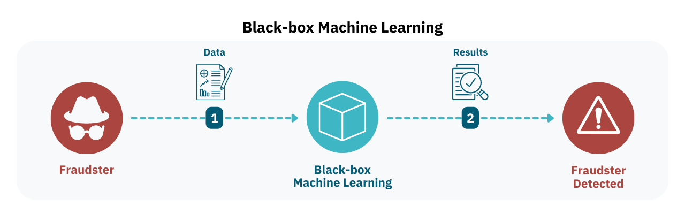
Figure 2: Black Box Machine Learning
(Source: Hussain, 2019)
The authorities will ensure that fraud detection machines in institutions must justify their results, particularly within the context of customer accounts or access to finances. The absence of explainability, in turn, may compromise the observance of law and subject institutions to the risk to their reputations and financial losses. Furthermore, lack of interpretability of AI decisions would destroy the sense of user confidence and lead to ethical issues, particularly where false positives or service denials occur. Such concerns give prominence to the pressing need of developing solutions that can help in filling the gap existing between the high-performance AI and the logic that can be understood by humans. Consequently, the black box dilemma has led to the emergence of Explainable Artificial Intelligence (XAI) that aims to be more predictive while also being more interpretable.

C. Theme 3: Explainable Artificial Intelligence (XAI) – Frameworks and Limitations
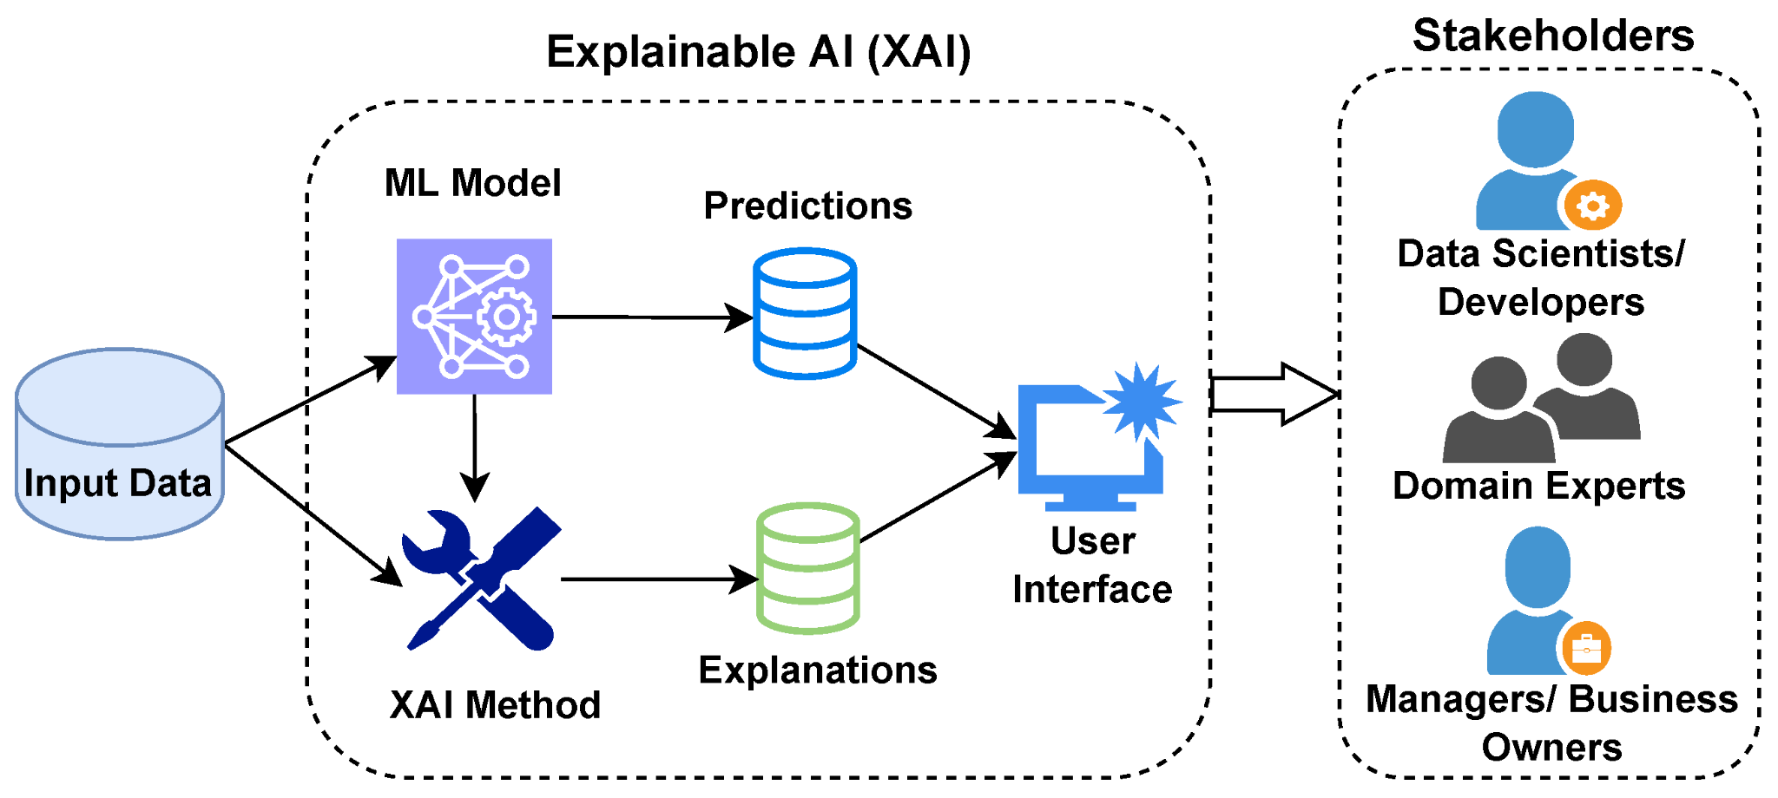
Figure 3: Explainable AI (XAI) Framework Integrating ML Predictions
(Source: Barredo Arrieta et al., 2019)
Explainable Artificial Intelligence (XAI) has become an essential development in the solution to the interpretability concerns related to the classical AI models, especially in areas with high stakes, like financial fraud identification. The methods of XAI are interested in closing the performance accuracy and the interpretability of complex models with the human interpretation through the design of inherently interpretable models or by applying post-hoc procedures to offer explanations to black-box systems [14], [15]. The methods of XAI are also divided broadly into two, namely intrinsic and post-hoc, according to [14]. Predictive algorithms that are inherently transparent like decision trees and linear regression other such intrinsic models can be less predictive. Post-hoc approaches, such as SHAP (Shapley Additive Explanations), LIME (Local Interpretable Model-Agnostic Explanations) and counterfactual explanations, seek to give interpretability to more complex trained models [13], [14], [16]. Post-hoc methods are increasingly being criticized with respect to their reliability, despite the massive adoption of these models.
According to [16], LIME and SHAP can be easily manipulated by adversary attackers who can create erroneous explanations to distract the actual decision logic of the model. Moreover, [17] states that when such approaches are applied, complex relations could be simplified and as a result, the explanations might not have the ability to reflect the behavior of such models. The weaknesses present a particular problem in the financial arena where transparency, accountability, and regulating standards are highly important. According to scholars like [12] and [13], the post-hoc explanation may not be effective in explaining domains where rigorous accountability is mandatory. They suggest the development of neuro-symbolic and human-centered explanations, which would have semantic interpretability and would be more compatible with the reasoning of humans. This change highlights a wider movement on XAI research to develop explanations that are typically valid, and practically useful and relevant to context.

D. Theme 4: XAI Applications in Financial Fraud Detection
Introduction of Explainable Artificial Intelligence (XAI) into real time financial fraud detection systems has been a huge momentum in recent times which is being propelled by financial institutions with the need to not only have high-performance models but transparency, trust, and regulatory compliance. As stated in [5], the XAI can be integrated with the fraud detection structures to offer immediate and understandable details on flagged transactions. It helps the banking staff gain a fast insight about the AI-generated alerts and verify or refute them to enhance operational performance and decision making. An augmented federated learning framework with XAI to allow safe collaboration between banks whilst preserving customer information privacy was proposed by[6]. The model enables various institutions to learn their fraud-detecting algorithms using decentralized data and also be able to interpret them at the node. The authors suggest that using federated learning with XAI is not only increasing the accuracy of fraud detection, but it can resolve the emerging concerns in data governance and privacy.
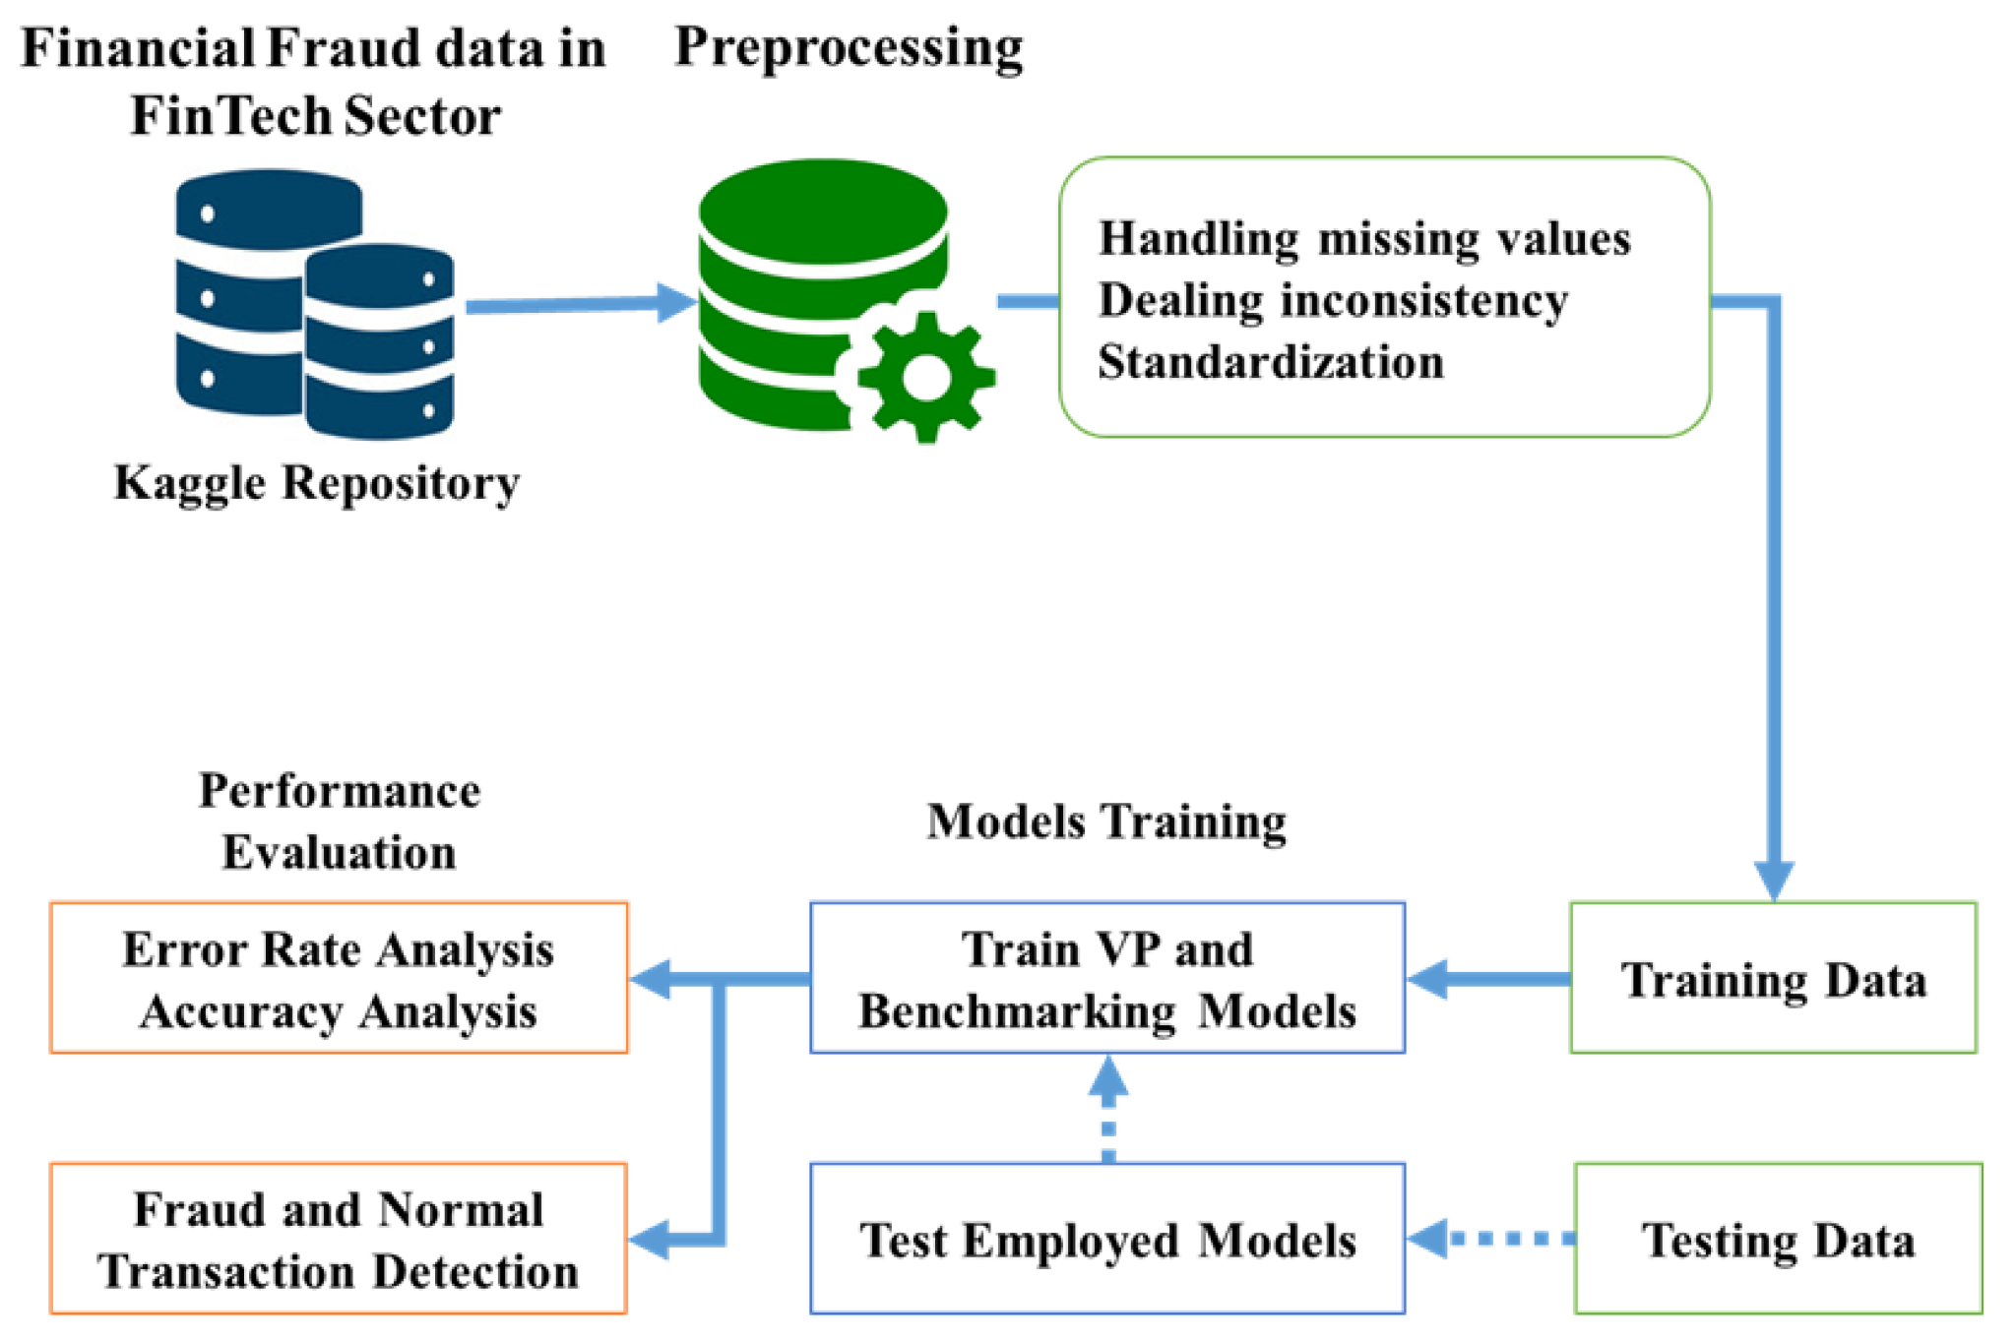
Figure 4: XAI-Enhanced Fraud Detection Ecosystem
(Source: Fatunmbi, 2024)
Moreover, [19] has presented a systematic research agenda on implementing XAI in real-time banking situations. Although the research adopts the position that adding interpretability could slightly deteriorate performance in certain instances, the research paper argues that the scorecard is worth the loss in terms of trust, transparency, and debugging. Continuous monitoring and audit supported by real-time interpretability are especially essential with the rise in strict financial rules. In the context of money laundering detection, [7] found that incorporating XAI techniques facilitates the use of domain knowledge during model tuning, leading to better detection of suspicious activities. In the same vein, [20] highlighted the importance of the latest data science and XAI techniques in fraud mitigation in real-time, which supports their status as a mandatory tool in the new digital banking environment.

E. Theme 5: Ethics, Regulation, and Fairness in XAI for Finance
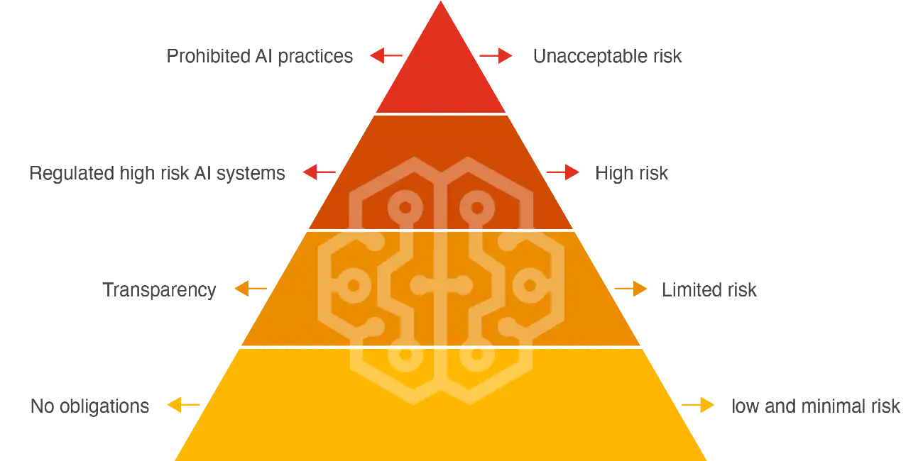
Figure 5: Responsible AI Pyramid in Finance
(Source: Agu et al., 2024)
The use of Explainable Artificial Intelligence (XAI) in the financial industry is not a technical project but also an ethical and regulatory one. As AI applications start to take over large-stake decisions in the realm of digital banking, it has become extremely important to ensure fairness, transparency, and accountability, particularly when juridical regulations are closely regulated, like the General Data Protection Regulation (GDPR) and other financial compliance regulations. As pointed out by [28], algorithmic bias, disparate impact on demographic groups, and less accountable decision-making are the risks frequently brought about by the data-centric ontologies of AI systems. These issues are viewed as critical and can be resolved through explainability as a critical mechanism that can make models auditable and outputs of new models intelligible to human stakeholders. Similarly, [29] emphasises that the idea of fairness related to AI-assisted financial services does not boil down to the accuracy of the algorithms.
According to them, the ethical AI systems should also feature transparency, traceability, and redressability mechanisms, which XAI could be transformative in terms of service. It is especially relevant in a situation where there is the issuance of loans, red flags of fraud, or credit checks, with the risk of opaque judgments causing a lawsuit or a tarnished reputation of financial institutions. Moreover, [21] emphasises the tension between the fast AI development and the restraint of the regulations. They suggest that the design of financial AI systems must proceed according to human-centered design principles and focus on interpretability, which will ensure that the stakeholders can know how and why decisions are made. These values assist in balancing the interest of the people and legal norms with technological development. Besides, [22] support the opinion that explainability serves as the middle ground between performance and accountability, particularly in high-risk settings.
Interpretability of AI decisions would help financial institutions not only enhance the level of user trust, but also address regulatory standards and inculcate a culture of responsible AI usage. Finally, XAI stands out as a technological protection and a regulatory system on accountable AI application in finance.

F. Theoretical and Technical Frameworks
The literature analysis leads to the emergence of theoretical and technical frameworks that can be used as a solid basis in the assessment and application of Explainable Artificial Intelligence (XAI) in financial fraud detection systems. In theory, the Design Science Research (DSR) framework [23] is commonly used to organize the evolutional process of creation and verification of the AI-based artifacts into the complex socio-technical contexts like banking. DSR enables strict enquiry by repeated cycles of problem solving to fit the technology advancement with the organizational demands. Also, to determine user satisfaction and trust toward AI-based digital banking services, the Expectation-Confirmation Model (ECM) is employed with a specific emphasis on how the expectations of given users correlate with the performance of the system and its ability to be explained [3]. Technically, XAI deployment also depends on post-hoc explanation methods like SHAP (Shapley Additive Explanations), LIME (Local Interpretable Model-agnostic Explanations), and counterfactual explanations [15] movement through explaining decisions made by opaque models.
More sophisticated models such as neuro-symbolic models combine symbolic reasoning with deep learning to improve both interpretability and performance [18], [22]. Privacy-preserving architectures such as federated learning and ensemble-based approaches make models more resilient and regulatory-heightened [6], [19]. XGBoost, Random Forest, and CNNs are the core machine learning algorithms which support fraud detection mechanisms and provide high predictive value on a variety of data [1], [7], [10].

G. Relation to Current Study
The present proposal will be placed at the intersection point of these five themes as it gathers the knowledge in the technical, ethical, and regulatory literature. Contrary to the preceding research that focuses only on technical performance, the present study has a qualitative synthesis approach, which emphasizes on the human-oriented, interpretable systems of fraud detection, which are not necessarily in contravention of regulatory expectations. It is also the only study that suggests the application of secondary qualitative research through thematic analysis to understand the application and shortage of XAI. According to Rampioni et al. [26] and Christou [27], thematic analysis enables the researcher to reveal profound patterns in textual information, which works well in conceptual topics such as AI ethics and interpretability.

H. Summary
The use of AI in fraud detection shows a significant consensus, and the literature can highlight some issues, such as mystery of the models, risks associated with ethics, and the barriers to their usage in practice. XAI becomes a viable opportunity, whereas the existing approaches such as SHAP and LIME contain methodological weaknesses. Recent models such as neuro-symbolic models, human-centric design and federated architectures are promising. The study is based on these insights because it explores the ways in which XAI can operationalize alive, explainable, and trust in financial fraud detection by qualitatively and thematically reviewing the recent scholarship. It leads to technical growth and ethical justification of AI in digital banking.

III. Research Design and Methodology

A. Research Design
The proposed study uses a secondary research design of qualitative research since it entails gathering, synthesizing, and analyzing the existing academic and industry information to explain the concept of Explainable Artificial Intelligence (XAI) as it applies to detecting financial fraud in digital banking systems. The design suits an exploratory study in the proposal phase, which aims to learn the existing trends, the conceptual gaps and provide concrete premises to conduct an empirical study in the future. The application of Design Science Research (DSR) as the theoretical framework has been considered to be appropriate with the objective of the research due to the complexity and dynamism of AI and fraud detection technologies. DSR puts emphasis on the production and the assessment of artifacts (e.g., models, frameworks, systems) that are aimed at addressing the conducted identification of problems in information systems. Here, the research will inform the creation of the XAI-led conceptualized system of fraud detection by first analyzing the existing models, processes, and their weaknesses within the current literature [23].
The design is appropriate in generating conceptual generalizations and framework level insights, particularly when dealing with complex socio-technical systems in which interpretability, fairness, and regulatory compliance are as important as performance.

B.Research Methods and Materials
Methods
The proposed research that uses a qualitative method of secondary research is aimed at synthesizing and interpreting scholarly and professional literature published within the period between 2019 and 2025. Peer-reviewed journal articles, technical white papers, industry reports, and regulatory frameworks used in Explainable Artificial Intelligence (XAI) and financial fraud detection in online banking systems are considered peer-reviewed materials in the data corpus. Secondary qualitative research is justified because of the high number of the quality literature published in this field and exploratory nature of the research [26].
The research strategy is based on thematic analysis, a method well-suited for identifying patterns and constructing meaning from qualitative data. This study adopts Braun and Clarke’s (2006) six-phase model of thematic analysis [31].
- Familiarization with the data
- Generation of initial codes
- Searching for themes
- Reviewing themes in relation to research questions
- Defining and naming themes
- Producing the final report
Anticipated themes include

- AI techniques in financial fraud detection
- The black-box problem in AI models
- Post-hoc XAI techniques and their limitations
- Ethical and regulatory concerns in finance
- Emerging frameworks like federated learning and neuro-symbolic AI
The coding and data analysis will be conducted manually in the Microsoft Excel, where the source materials will be structured, the coded parts will be traced, and the repeated topics will be categorized. Excel provides a loose, ordered, environment to hold out qualitative analysis in addition to providing transparency in the thematic mapping proceeding [26],[27]. The approach to this manual provides the essential level of clarity between the insights of literature and the research questions of the study, as well as, elaborates an in-depth and reflective comprehension of multifaceted problems in the XAI and detecting fraudulent activities.
Materials
Research Data
- Data Sources: The articles are peer-reviewed journal articles, published conference papers, industry white papers and regulatory publications which were obtained through reliable sources, including IEEE Xplore, MDPI, Springer, SSRN, and ScienceDirect. Such sources guarantee a high rigor of the academic credibility and applicability to the fields of AI and XAI and financial fraud detection.
- Data Collection Method: The search strings based on key words in academic databases such as Google Scholar, ResearchGate, and IEEE Xplore were used to conduct structured literature sampling because it is consistent, and the source may also be followed back [24].
Tools and Justification
Software Tools
- Microsoft Excel: Used for thematic mapping and data coding.
- Google Drive: Employed for collaborative work and cloud-based storage.
Justification
The transparency, replicability, and organization are supported by these tools in the case of qualitative secondary research [25]. Excel enables entering the data in a manual way and coding the themes without specific qualitative software.
Ethical Considerations
This research does not engage any human participants or personal information. All information is publicly available, and such ethical principles like proper attribution, no plagiarism, and IEEE-formatted citation are not going to be overlooked [26].
Hardware Requirements
A standard laptop or desktop is sufficient. No GPU or high-performance computing resources are needed since there is no model training or simulation involved.

IV. Expected Outcome
Even though no direct data gathering or experimental analysis will be performed, it is expected that the expected result of this study is a well-organized thematic synthesis of the role of Explainable Artificial Intelligence (XAI) in the context of detecting fraud in online banking settings. The analysis is likely to point at the fact that the methods of SHAP, LIME, counterfactual explanations, and neuro-symbolic AI contribute to the reduction of the gap between predictive and interpretable accuracy typically sought by financial systems conducted under a specific regulatory form of microscopy [13], [14], [18]. The findings can also draw the dichotomy of the performance and transparency, and it is possible that hybrid models or federated learning structures can offer viable trade-offs between these two opposing needs [6], [19]. The results might be generalized into the research community and practical measures of deploying interpretable models of fraud detection into real-world banking systems.
There are notable limitations to this study and primarily, the use of secondary qualitative data can restrict the possibility of obtaining real-time working constraints, implementation issues, or subtle views of the end-users that could be obtained through primary empirical study [24]. This may influence the granularity of insights, especially those of user trust, system usability or integration with an organization. Moreover, the blistering development of AI and digital finance creates the chance that certain results are going to become obsolete as fresh technologies and regulation norms are introduced, which could restrain the applicability of the findings conclusions in the long term. With these limitations, the study is still useful in summarizing the available items of knowledge and developing practical implications to various stakeholders. It aids in the matching of AI development with new demands concerning transparency, accountability, and equity in financial services [21], [28], which will provide a conceptual framework to future studies and policymaking.

V. Timeline

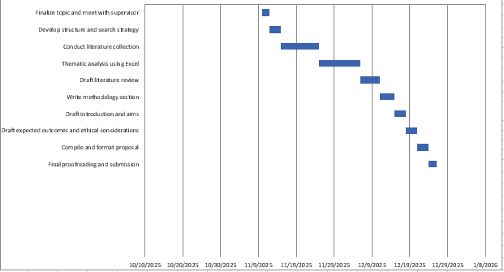
Figure 6: Gantt Chart
(Developed in MS Excel)

VI. Conclusion
The proposed research is a detailed study on the application of Explainable Artificial Intelligence (XAI) on improving financial fraud detection in digital banking systems. The qualitative secondary research approach will help the study to learn the development of AI methods, the difficulties of black-box model interpretability, and why more financial technologies require transparency, fairness, and compliance with ethics. This study seeks to establish the best practice, technical frameworks, and conceptual gaps by integrating current literature on the subject matter that influence the marketing of XAI in practical banking situations. Its results will be beneficial in informing the scholastic, technocrats, regulators as well as financial institutes in their quest to strike a balance between performance and accountability. It is important to note that although secondary research has certain drawbacks, the proposal provides an excellent basis for conducting the empirical research and practical applications of AI innovation to the human-oriented values and regulatory principles of finance in the future.

Reference List
- Jain, A. 2025. AI-Driven Models for Financial Fraud Mitigation: A Data-Centric Approach to Detecting and Preventing Fraudulent Transactions, Darpan International Research Analysis, 13(2), pp. 1-14. https://dira.shodhsagar.com/index.php/j/article/view/164
- Olowu, O., Adeleye, A.O., Omokanye, A.O., Ajayi, A.M., Adepoju, A.O., Omole, O.M. and Chianumba, E.C., 2024. AI-driven fraud detection in banking: A systematic review of data science approaches to enhancing cybersecurity. Advanced Research and Review, 21(2), pp.227-237. https://www.researchgate.net/profile/Ernest-Chianumba/publication/386276951_AI-driven_fraud_detection_in_banking_A_systematic_review_of_data_science_approaches_to_enhancing_cybersecurity/links/67863f622be36743a5d571d6/AI-driven-fraud-detection-in-banking-A-systematic-review-of-data-science-approaches-to-enhancing-cybersecurity.pdf
- Alnaser, F.M., Rahi, S., Alghizzawi, M. and Ngah, A.H., 2023. Does artificial intelligence (AI) boost digital banking user satisfaction? Integration of expectation confirmation model and antecedents of artificial intelligence enabled digital banking. Heliyon, 9(8). https://www.cell.com/heliyon/pdf/S2405-8440(23)06138-8.pdf
- Aziz, L.A.R. and Andriansyah, Y., 2023. The role artificial intelligence in modern banking: an exploration of AI-driven approaches for enhanced fraud prevention, risk management, and regulatory compliance. Reviews of Contemporary Business Analytics, 6(1), pp.110-132. https://www.researchgate.net/profile/Yuli-Andriansyah/publication/373489510_The_Role_Artificial_Intelligence_in_Modern_Banking_An_Exploration_of_AI-Driven_Approaches_for_Enhanced_Fraud_Prevention_Risk_Management_and_Regulatory_Compliance/links/64eecb546d6b3c6a2bac49ac/The-Role-Artificial-Intelligence-in-Modern-Banking-An-Exploration-of-AI-Driven-Approaches-for-Enhanced-Fraud-Prevention-Risk-Management-and-Regulatory-Compliance.pdf
- Ahmadi, S., 2022. Advancing fraud detection in banking: Real-time applications of explainable ai (xai). Journal of Electrical Systems, 18(4), pp.141-150. https://hal.science/hal-04881704v1/file/Advancing-Fraud-Detection-In-Banking-XAI.pdf
- Aljunaid, S.K., Almheiri, S.J., Dawood, H. and Khan, M.A., 2025. Secure and transparent banking: explainable AI-driven federated learning model for financial fraud detection. Journal of Risk and Financial Management, 18(4), p.179. https://www.mdpi.com/1911-8074/18/4/179
- Kute, D.V., Pradhan, B., Shukla, N. and Alamri, A., 2021. Deep learning and explainable artificial intelligence techniques applied for detecting money laundering–a critical review. IEEE access, 9, pp.82300-82317. https://ieeexplore.ieee.org/iel7/6287639/9312710/09446887.pdf
- Ali, A., Abd Razak, S., Othman, S.H., Eisa, T.A.E., Al-Dhaqm, A., Nasser, M., Elhassan, T., Elshafie, H. and Saif, A., 2022. Financial fraud detection based on machine learning: a systematic literature review. Applied Sciences, 12(19), p.9637. https://www.mdpi.com/2076-3417/12/19/9637
- Chukwu, B. and Ebenmelu, C., 2023. Artificial intelligence and fraud detection in US commercial banks: Opportunities and challenges. World Journal of Advanced Research and Reviews, 27, pp.1083-1091. https://www.researchgate.net/profile/Bridget-Chukwu/publication/395664765_Artificial_Intelligence_and_Fraud_Detection_in_US_Commercial_Banks_Opportunities_and_Challenges/links/68cdb6a711d348252ba6661c/Artificial-Intelligence-and-Fraud-Detection-in-US-Commercial-Banks-Opportunities-and-Challenges.pdf
- Mohammed, A., 2025. Fraud Detection in Banking Data by Machine Learning Techniques. https://www.researchgate.net/profile/Amer-Mohammed-17/publication/390411352_Fraud_Detection_in_Banking_Data_by_Machine_Learning_Techniques/links/67ecd89e03b8d7280e1bde9e/Fraud-Detection-in-Banking-Data-by-Machine-Learning-Techniques.pdf
- Hussain, J., 2019. Deep learning black box problem. https://www.diva-portal.org/smash/get/diva2:1353609/FULLTEXT01.pdf
- Hassija, V., Chamola, V., Mahapatra, A., Singal, A., Goel, D., Huang, K., Scardapane, S., Spinelli, I., Mahmud, M. and Hussain, A., 2024. Interpreting black-box models: a review on explainable artificial intelligence. Cognitive Computation, 16(1), pp.45-74. https://link.springer.com/content/pdf/10.1007/s12559-023-10179-8.pdf
- Dwivedi, R., Dave, D., Naik, H., Singhal, S., Omer, R., Patel, P., Qian, B., Wen, Z., Shah, T., Morgan, G. and Ranjan, R., 2023. Explainable AI (XAI): Core ideas, techniques, and solutions. ACM computing surveys, 55(9), pp.1-33. https://orca.cardiff.ac.uk/id/eprint/152361/1/3561048.pdf a
- Barredo Arrieta, A., Tabik, S., García López, S., Molina Cabrera, D., Herrera Triguero, F. and Díaz Rodríguez, N.A., 2019. Explainable Artificial Intelligence (XAI): Concepts, taxonomies, opportunities and challenges toward responsible AI. https://digibug.ugr.es/bitstream/handle/10481/77982/24.%20main.pdf?sequence=1&isAllowed=y
- Das, A. and Rad, P., 2020. Opportunities and challenges in explainable artificial intelligence (xai): A survey. arXiv preprint arXiv:2006.11371. https://arxiv.org/pdf/2006.11371
- Slack, D., Hilgard, S., Jia, E., Singh, S. and Lakkaraju, H., 2020, February. Fooling lime and shap: Adversarial attacks on post hoc explanation methods. In Proceedings of the AAAI/ACM Conference on AI, Ethics, and Society (pp. 180-186). https://dl.acm.org/doi/pdf/10.1145/3375627.3375830
- Hooshyar, D. and Yang, Y., 2024. Problems with SHAP and LIME in interpretable AI for education: A comparative study of post-hoc explanations and neural-symbolic rule extraction. IEEE Access. https://ieeexplore.ieee.org/iel8/6287639/6514899/10684198.pdf
- Swamy, V., Frej, J. and Käser, T., 2025. The future of human-centric eXplainable Artificial Intelligence (XAI) is not post-hoc explanations. Journal of Artificial Intelligence Research, 84. https://www.jair.org/index.php/jair/article/download/17970/27222
- Mill, E.R., Garn, W., Ryman-Tubb, N.F. and Turner, C., 2023. Opportunities in real time fraud detection: an explainable artificial intelligence (XAI) research agenda. International Journal of Advanced Computer Science and Applications, 14(5), pp.1172-1186. https://openresearch.surrey.ac.uk/esploro/fulltext/journalArticle/Opportunities-in-Real-Time-Fraud-Detection/99768966602346?repId=12184120980002346&mId=13184120970002346&institution=44SUR_INST
- Fatunmbi, T.O., 2024. Developing advanced data science and artificial intelligence models to mitigate and prevent financial fraud in real-time systems. https://www.academia.edu/download/122130100/Developing_advanced_data_science_and_artificial_intelligence_models.pdf
- Ridzuan, N.N., Masri, M., Anshari, M., Fitriyani, N.L. and Syafrudin, M., 2024. AI in the financial sector: The line between innovation, regulation and ethical responsibility. Information, 15(8), p.432. https://www.mdpi.com/2078-2489/15/8/432
- Singh, S. and Yadav, D., Explainable AI: Bridging Performance, Transparency, and Accountability in High-Stakes Systems. Next-Gen Machine Learning: Algorithms for Adaptive Intelligence, p.84. https://www.researchgate.net/profile/Arihant-Pattnaik/publication/395467777_Neuro-Symbolic_AI_Bridging_Reasoning_and_Learning/links/68c662a59534473a6d4aa74e/Neuro-Symbolic-AI-Bridging-Reasoning-and-Learning.pdf#page=93
- Ushaka, I., 2019. An exploratory design science study on theory testing using crowdsourcing (Doctoral dissertation, Open Access Te Herenga Waka-Victoria University of Wellington). https://openaccess.wgtn.ac.nz/articles/thesis/An_exploratory_design_science_study_on_theory_testing_using_crowdsourcing/17138813/2/files/31693811.pdf
- Darrigo, A., 2025. Artificial Intelligence in Financial Portfolio Management: Archival Research based on Secondary Data in form of Relevant Publications. https://www.theseus.fi/bitstream/handle/10024/880420/Darrigo_Abel.pdf?sequence=2
- Hentzen, J.K., Hoffmann, A., Dolan, R. and Pala, E., 2022. Artificial intelligence in customer-facing financial services: a systematic literature review and agenda for future research. International journal of bank marketing, 40(6), pp.1299-1336. https://arvidhoffmann.nl/Hentzen%20et%20al.%202021%20IJBM.pdf
- Rampioni, M., Moșoi, A.A., Rossi, L., Moraru, S.A., Rosenberg, D. and Stara, V., 2021. A qualitative study toward Technologies for Active and Healthy Aging: A thematic analysis of perspectives among primary, secondary, and tertiary end users. International Journal of Environmental Research and Public Health, 18(14), p.7489. https://www.mdpi.com/1660-4601/18/14/7489
- Christou, P.A., 2022. How to use thematic analysis in qualitative research. Journal of Qualitative Research in Tourism, 3(2), pp.79-95. https://www.academia.edu/download/104208431/How_to_use_thematic_analysis_in_qualitative_research.pdf
- Patil, D., 2024. Artificial Intelligence In Financial Risk Assessment And Fraud Detection: Opportunities And Ethical Concerns. Available at SSRN 5057434. https://papers.ssrn.com/sol3/Delivery.cfm?abstractid=5057434
- Agu, E.E., Abhulimen, A.O., Obiki-Osafiele, A.N., Osundare, O.S., Adeniran, I.A. and Efunniyi, C.P., 2024. Discussing ethical considerations and solutions for ensuring fairness in AI-driven financial services. International Journal of Frontier Research in Science, 3(2), pp.001-009. https://www.researchgate.net/profile/Angela-Abhulimen/publication/383561166_Discussing_ethical_considerations_and_solutions_for_ensuring_fairness_in_AI-driven_financial_services/links/66ddabb4bd20173667bf8a97/Discussing-ethical-considerations-and-solutions-for-ensuring-fairness-in-AI-driven-financial-services.pdf
- Patel, K., 2024. Ethical reflections on data-centric AI: balancing benefits and risks. Available at SSRN 4993089. https://papers.ssrn.com/sol3/Delivery.cfm?abstractid=4993089
- Terry, G., Hayfield, N., Clarke, V. and Braun, V., 2017. Thematic analysis. The SAGE handbook of qualitative research in psychology, 2(17-37), p.25. https://uwe-repository.worktribe.com/index.php/OutputFile/888534

