

Assessment 1 – Reading Task Template
PART 1:
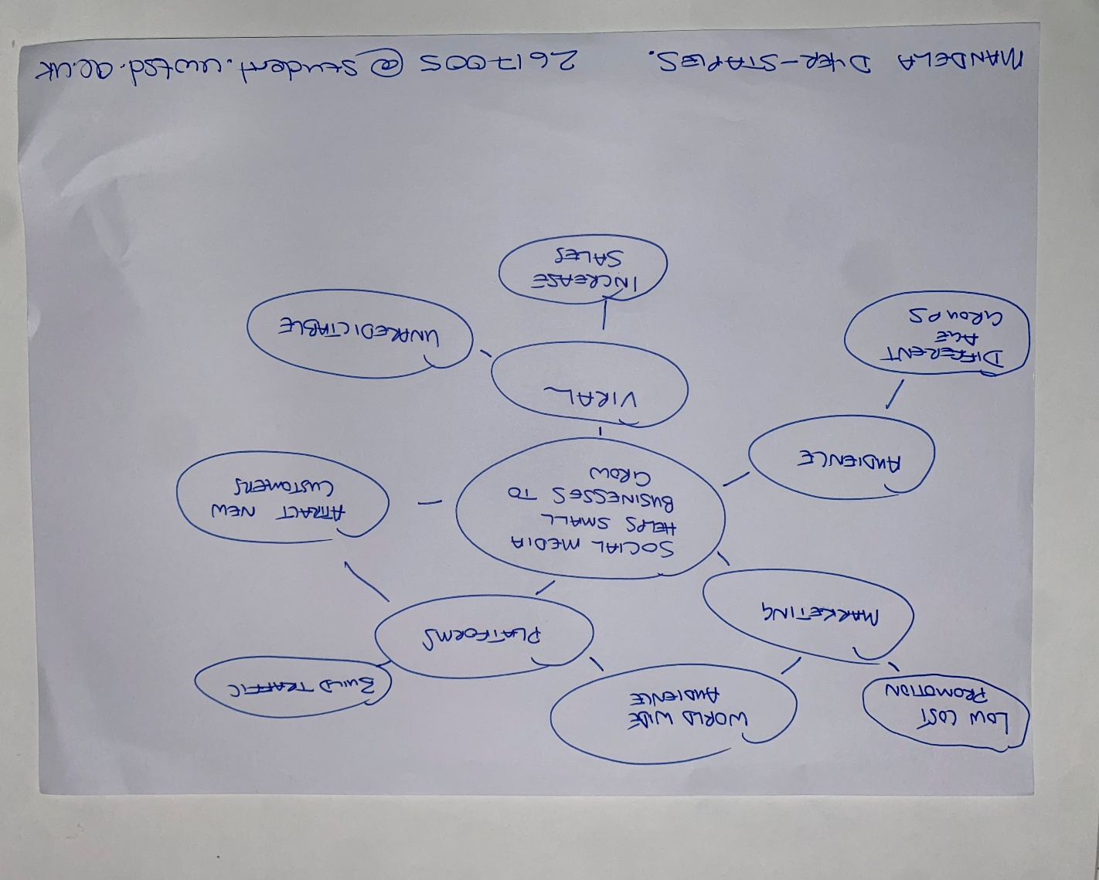

PART 2:

- What is the main idea of the whole text?
The main idea of the overall text is highlighting that social media platforms have made it easier for businesses to become viral and become noticed.

- What is one key point that supports the main idea, and which specific example from the text shows this?
Business posts can reach further afield causing customers from afar to travel 3 hours for a chicken burger.

- What is a different key point that supports the main idea, and which specific example from the text shows this?

Another key point that supports the main idea is that it uses different platforms with many users. One example from the text would be about 1.5 million Uk businesses operate on TikTok.

- Which part of the text do you think is most important, and why?
The title and header as this gives you an understanding of the text and highlights how social media has made it easier for businesses to market and go viral.

Reflection:
- What did you find difficult in this task (including in-class components), and why was it difficult?
The part I found most difficult in the task was listing the key details for the mind map. This was difficult as I found most of the key details to be similar and felt like I was repeating myself.

- What helped you with this difficulty, and how did it help you?
What helped me with this was looking on different social media platforms to help me pinpoint the key details to highlight for the mind map.

