

Adam Foley

Fault tree analysis and the effect of human factors on the probability of mission success

University of Wales: Trinity Saint David
ACDA5021: Systems Engineering

BEng
Academic Year: 2025 - 2026

Supervisor: Dave Holley
Associate Supervisor: Jenni Steen
April 2026

Academic integrity declaration
I declare that:
- the thesis submitted has been written by me alone.
- the thesis submitted has not been previously submitted to this university or any other.
- that all content, including primary and/or secondary data, is true to the best of my knowledge.
- that all quotations and references have been duly acknowledged according to the requirements of academic research.
I understand that to knowingly submit work in violation of the above statement will be considered by examiners as academic misconduct.

Abstract
This report will discuss the Systems Engineering tool Fault Tree Analysis (FTA), highlighting the strengths and weaknesses of the methodology and showing why and how it can be implemented both theoretically and graphically through the completion of a worked example in addition to an in-depth discussion concluding the application and use of FTA in real world engineering environments.

Table of Contents
Academic integrity declaration i
Abstract ii
List of Figures iv
List of Abbreviations v
1 Introduction 6
1.1 What is Fault Tree Analysis 6
1.2 How does Fault Tree Analysis Work 7
1.2.1 AND Gates 8
1.2.2 OR Gates 8
2 Fault Tree Analysis Calculations 9
2.1 Gate Probabilities 9
2.2 Scenario 10
2.2.1 Hot Water 12
2.2.2 Cup Selection 14
2.2.3 Ingredients in Cup 15
2.2.4 Hot Drink, Milk and Sugar 17
3 Application of Human Factors 18
4 Conclusions 20
References 21

List of Figures
Figure 1 - FTA Example [3] 7
Figure 2 - AND Gate [3] 8
Figure 3 - OR Gate 8
Figure 4 - Hot Drink Production Process Chart 10
Figure 5 - Process Chart Event Probabilities 11
Figure 6 - Hot Water FTA 12
Figure 7 - Cup FTA 14
Figure 8 - Ingredients FTA 15
Figure 9 - Hot Drink Milk and Sugar FTA 17

List of Abbreviations
FTA  US  ISO  WiK  PtE  HW | Fault Tree Analysis  United States  International Organisation for Standardisation  Water in Kettle  Power to Element  Hot Water

Introduction

What is Fault Tree Analysis
Fault-Tree Analysis (FTA) is a top-down engineering tool used to evaluate the root cause of failure within a complex system by breaking down the ‘root cause of a failure into its contributing factors and representing it through a graphical model called a fault tree’ [1]. It is often used to troubleshoot flawed systems/processes or to find out ways to improve the system whether that be through the assessment of regulatory compliance or user focused upgrades. FTA was first developed in 1961 by H. A. Watson before being brought into use by the U.S. Airforce before being used on extraordinary engineering projects such as the US Apollo shuttle. [2]

How does Fault Tree Analysis Work
FTA works by identifying a top level failure event, an example shown in Figure 1 identifies ‘a bad address for your customer’, this is a failure event as the organisation in question is required to fulfil online/ delivery orders and should the address be incorrect then they would have to reimburse the customer and potentially lose the item being delivered.
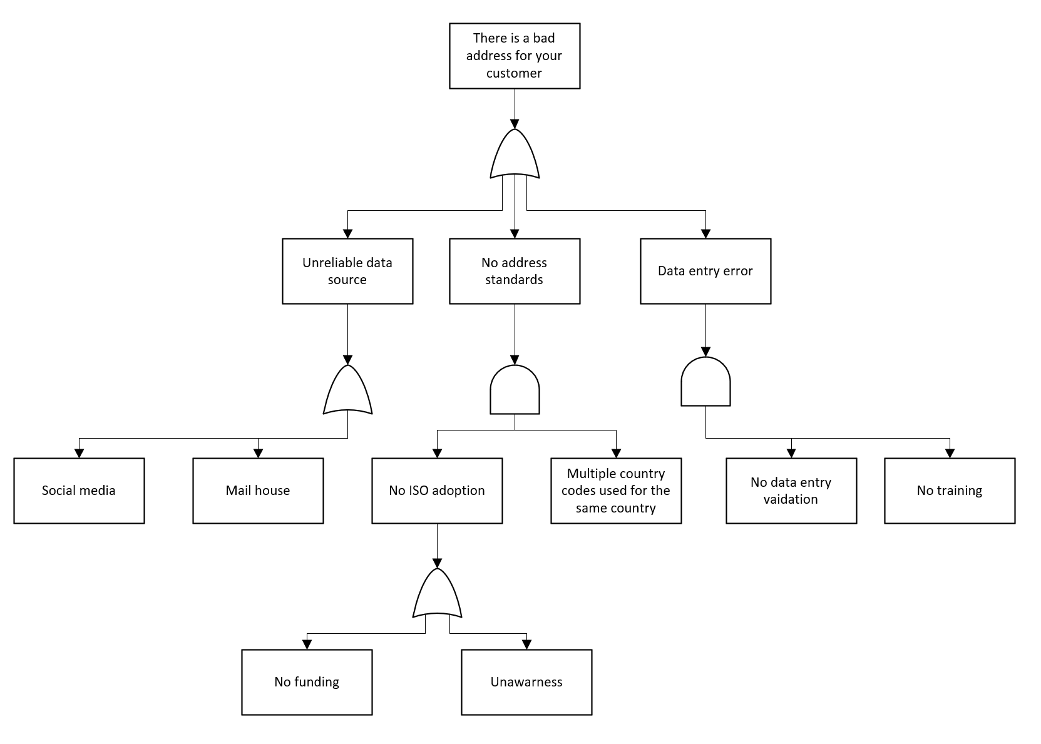
Figure 1 - FTA Example [3]

Following the identification of the top-level fault, you can then start to identify the first level of events that would cause the failure; this is done using ‘AND’ & ‘OR’ gates.

AND Gates
‘AND’ Gates are represented by the diagram shown in Figure 2, implemented within the example shown in Figure 1. ‘AND’ gates are used to represent basic failure factors which require both events simultaneously occur, e.g. in Figure 1, ‘Data Entry Error’ is a failure mode when both ‘No data entry validation’ and ‘No training’ events occur.
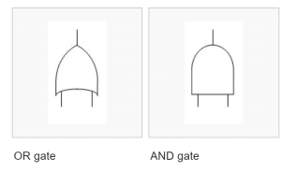
Figure 2 - AND Gate [3]

OR Gates
‘OR’ Gates are represented by the diagram shown in Figure 3, implemented within the example shown in Figure 1. ‘OR’ gates are used to represent basic failure factors which happen when either event occur, e.g. in Figure 1, ‘No ISO Adoption’ is a failure mode which happens when either ‘Unawareness’ OR ‘No Funding’ occurs.

Figure 3 - OR Gate

Fault Tree Analysis Calculations

Gate Probabilities
AND Gate Calculations
To calculate the total probability of failure from an FTA with an ‘AND’ gate, you are required to identify each event, understand the probability of each event occurring and subsequently multiply these values together. The formula for the calculation of an AND gate failure mode is as follows:
- P = A x B x C
P = Probability
A = Failure Event 1
B = Failure Event 2
C = Failure Event 3
This shows the formula for an ‘AND’ gate with three failure events but can be altered to reflect however many failure events occur.
OR Gate Calculations
To calculate the total probability of failure from an FTA using an ‘OR’ gate, you are required to identify each event, understand and assign the probability of each event occurring and subsequently multiply these values together. The formula for each calculation of an OR gate failure mode is as follows:
- P = 1 – [(1-P(A)) (1-P(B)) (1-P(C))]
This shows the formula for an ‘OR’ gate with three failure events but can be altered to reflect however many failure events occur.

Scenario
The following scenario represents the production of a hot drink though a process chart and event probabilities table.
‘Bill wants to make a cup of tea. Use the process chart provided to calculate his chance of success.’
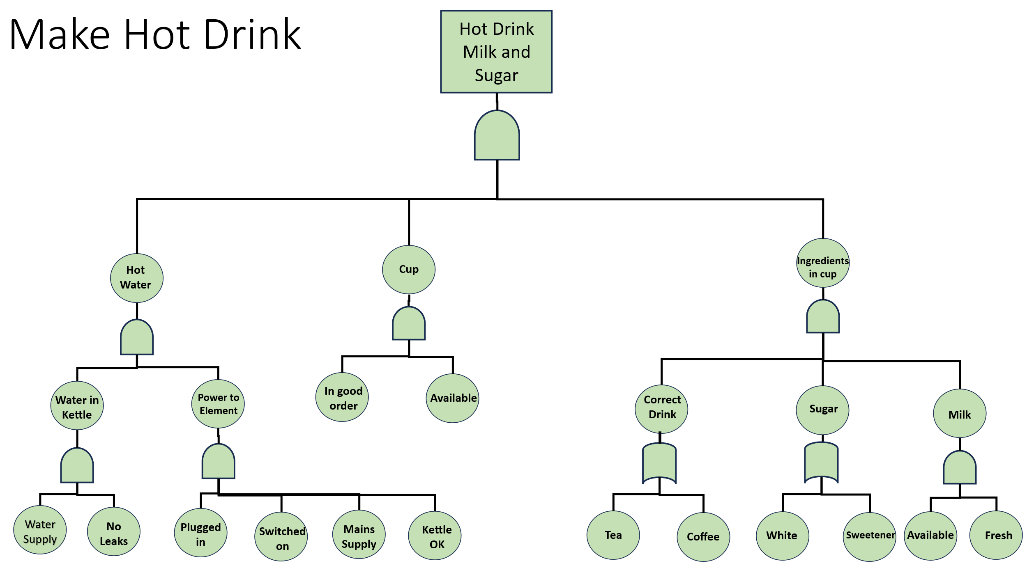
Figure 4 - Hot Drink Production Process Chart

Event | Probability
Tea availability | 0.98
Coffee availability | 0.98
Chance of leaky Kettle | 0.001
Chance of water supply failure | 0.01
Kettle reliability | 0.99
Plug in operation reliability | 0.89
Switch on reliability | 0.89
Mains supply failure chance | 0.01
Cup availability | 1
Cup reliability | 0.99
Milk availability | 0.95
Milk freshness | 0.95
Sugar availability | 0.88
Sweetener Availability | 0.99
Figure 5 - Process Chart Event Probabilities

Hot Water
The following diagram shows the full FTA for the heating of water to make a successful hot drink.
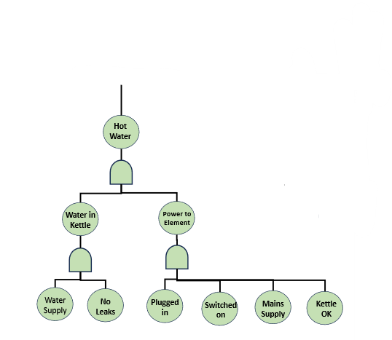
Figure 6 - Hot Water FTA
The first layer of failure events includes an ‘AND’ gate with both ‘water in the kettle’ and ‘power to element’. Both of which are high level events and are subsequently broken down further into an additional two ‘AND’ gates. To calculate the probability of failure for the hot water, we must find out the failure probabilities for the initial failure modes. These values can be obtained through the probability calculation equation for ‘AND’ gates, using the values provided in Figure 5.

Water in Kettle (WiK):
- A - Water Supply: 0.99
- B - No Leaks: 0.999
P(WiK) = A x B
P(WiK) = 0.99 x 0.999 = 0.98901
The probability of water being in the kettle is 0.98901.

Power to Element (PtE):
- A – Plugged In: 0.89
- B – Switched on: 0.89
- C – Mains Supply: 0.99
- D – Kettle OK: 0.99
P(PtE) = A x B x C x D
P(PtE) = 0.89 x 0.89 x 0.99 x 0.99
P(PtE) = 0.77633721
The power to the kettle is 0.77633721.
Finally, the top-level probability ‘Hot Water’ would be:
P(HW) = WiK x PtE
P(HW) = 0.98901 x 0.77633721
P(HW) = 0.76780526406

Cup Selection
The following diagram shows the full FTA for the selection of a cup to make a successful hot drink.

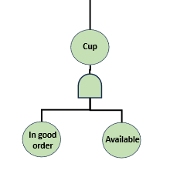
Figure 7 - Cup FTA
This is a basic tree showing an ‘AND’ gate with two final events. To calculate the probability of successful cup selection the equation P = A x B would be used, where P = Probability of successful cup selection, A = In good order and B = Available with the values obtained from Figure 5.
P = 1 x 0.99 = 0.99

Ingredients in Cup
The following diagram shows the full FTA for the ingredients in the cup, required to make a successful hot drink.

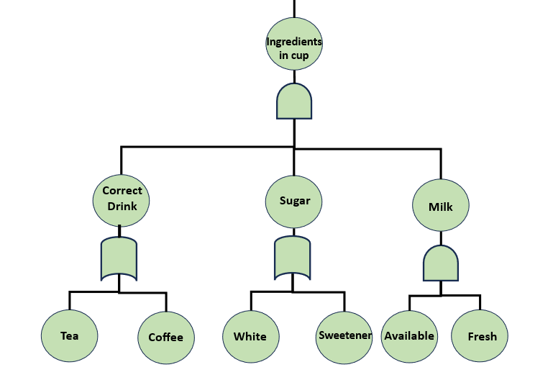
Figure 8 - Ingredients FTA

This FTA diagram shows the first level of failure modes under an ‘AND’ gate. These events are subsequently broken down further with the ‘Correct Drink’ and ‘Sugar’ events being split into two second level events under an ‘OR’ gate whilst the ‘Milk’ event is split into two final events under an ‘AND’ gate. To calculate the probability of the ‘correct ingredients in cup’ we are required to use the following equation due to the presence of a three event ‘AND’ gate:
- P (Ingredients in Cup) = A (Correct Drink) x B (Sugar) x C (Milk)
To calculate this, we require the probabilities for A, B and C.
A - Probability of the correct drink:
P (Correct Drink) = 1 – [(1-P(Tea)) (1-P(Coffee))]
P = 1 – [(1-0.02)) (1-0.02))]
P = 0.9996

B – Probability of correct Sugar:
P (Sugar) = 1 – [(1-P(White)) (1-P(Sweetener))]
P = 1 – [(1-0.12)) (1-0.006))]
P = 0.994

C – Probability of correct milk:
P (Milk) = A (Availability) x B (Milk)
P = 0.95 x 0.95
P = 0.9025

P (Ingredients in Cup) = A (Correct Drink) x B (Sugar) x C (Milk)
P = 0.9996 x 0.994 x 0.9025
P = 0.896726166

Hot Drink, Milk and Sugar
The probabilities previously calculated can be combined into an ‘AND’ gate to calculate the top event of a Hot Drink Milk and Sugar, as seen in Figure 4.
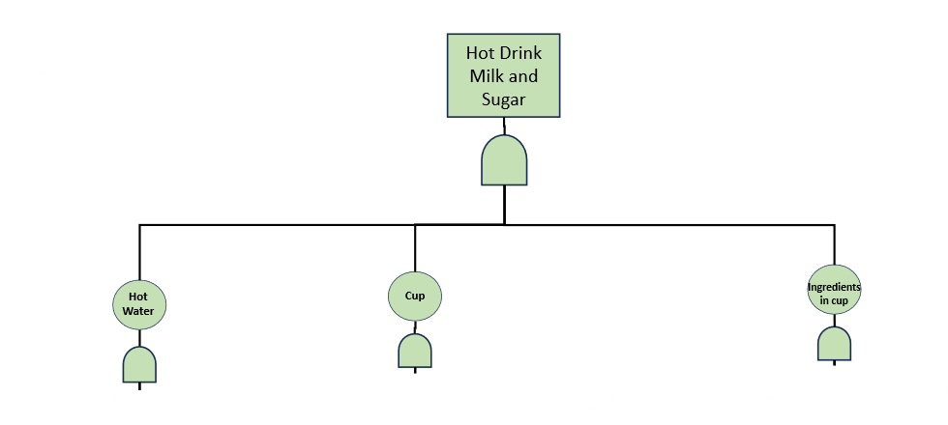
Figure 9 - Hot Drink Milk and Sugar FTA
P (HDMS) = A(HW) x B(C) x C(IC)
P = 0.76780526406 x 0.99 x 0.896726166
P = 0.68162596
The probability of the successful production of a perfect hot drink with milk and sugar is 0.68162596/ 68% likelihood.

Application of Human Factors
Previous discussion used an FTA for the perfect production of a hot drink with milk & sugar. However, this scenario completely disregarded the application of human factors to the process; the subsequent brief states ‘Bill has woken up in the middle of the night and wants to make a cup of tea. Use the probability multipliers provided to show where his key errors may lie when acting under fatigue’.
Due to Bill waking up in the middle of the night, one would assume he would be extremely tired due to lack of sleep leading to potential errors occurring in the production due to fatigue causing changes to someone’s: Focus, awareness and operational capability.
- ‘Bill’s ability to plug in and switch on the kettle will drop to 75% of normal and his ability to select a cup will drop to 90% of normal’
This provides us information on what probabilities will change and what will stay to same to reflect the changes to Bills capability by reviewing the three top level events against the reduced ability to plug in and switch on the kettle as well as his ability to select a cup.
Hot Water – The probability of Bill producing hot water perfectly has fallen. This is due to the reduction in Bills ability to plug in and switch on the kettle dropping to 75% effecting the ‘Power to Element’ event fault tree by reducing the ‘Plugged in’ and ‘Switched on’ values from 0.89 to 0.6675.
0.89/100 x 75 = 0.6675
The updated value for the probability of ‘Power to Element’ is now:
P(PtE) = 0.6675 x 0.6675 x 0.99 x 0.99
P = 0.43668968062
The probability for Hot water would be this value multiplied by the probability for the unchanged ‘Water in Kettle’:
P (HW) = 0.43668968062 x 0.98901
P = 0.43189046103. A significant reduction from the initial value of 0.77633721.

Cup – The probability of Bill selecting a cup ‘In good order’ has fallen from 0.99 to 90% of this value. 0.99/100 x 90 = 0.891
The top-level probability of bill having a perfect ‘Cup’ would change from 0.99 to P = 0.891 x 1 = 0.891.
Ingredients in Cup – This event remains unchanged due to the process of gathering the correct ingredients not including a kettle or the physical cup itself. The probability of this event remains at 0.896726166 or 89%.

Bill’s ability to successfully produce a hot drink with sugar and milk will fall from 0.68162596 (68%) to:
P = 0.43189046103 x 0.891 x 0.896726166 = 0.345073142 (34.5%)

Conclusions
Fault Tree Analysis is an extremely useful Systems Engineering toolset which can be used to quantify probabilities of success or failure to highlight points of weakness within a system process, so that they can be rectified or changed to ensure the highest level of quality and reliability remains throughout the system.
However, in systems where human factors are prevalent, it is vital to ensure that they are captured and measured. This is shown in the example worked calculated within the ‘Application of Human Factors’ part of this report where a ‘simple’ process evaluating the probability of success when producing a hot drink falls from 68% to 34.5%, effectively slicing in half purely from the change in awareness shown by Bill from sleep deprivation. Although this is not a major safety concern in this instance, processes within high risk environments such as manufacturing or development where dangerous machinery and set safety processes are to be followed, FTA provides evidence that the human factor is a major concern and must be addressed through the issuance of safety measures; in this theoretical case measure such as shift length, time between shifts and ensuring workers are not under the influence of awareness/ performance detrimental substances such as drugs &/or alcohol could be implemented to minimise human factors.

References

[1] | “What is fault tree analysis (FTA)?,” IBM, [Online]. Available: https://www.ibm.com/think/topics/fault-tree-analysis. [Accessed 12 April 2026].
[2] | C. A. Ericson II, “Fault Tree Analysis - A History,” in The 17th International System Safety Conference, Seattle, 1999.
[3] | G. Firican, “What is fault tree analysis?,” LightsOnData, 30 October 2019. [Online]. Available: https://www.lightsondata.com/what-is-fault-tree-analysis/. [Accessed 2026 April 1].

