BMIH6001 Contemporary Themes in the Hotel & Hospitality Sector

“Technology in The Hotel & Hospitality Sector”
Conference Presentation

Student name: Robert-Cristian Matyas
Student number: 2111528
Module Lead: Natalie Brailsford

Slide 1
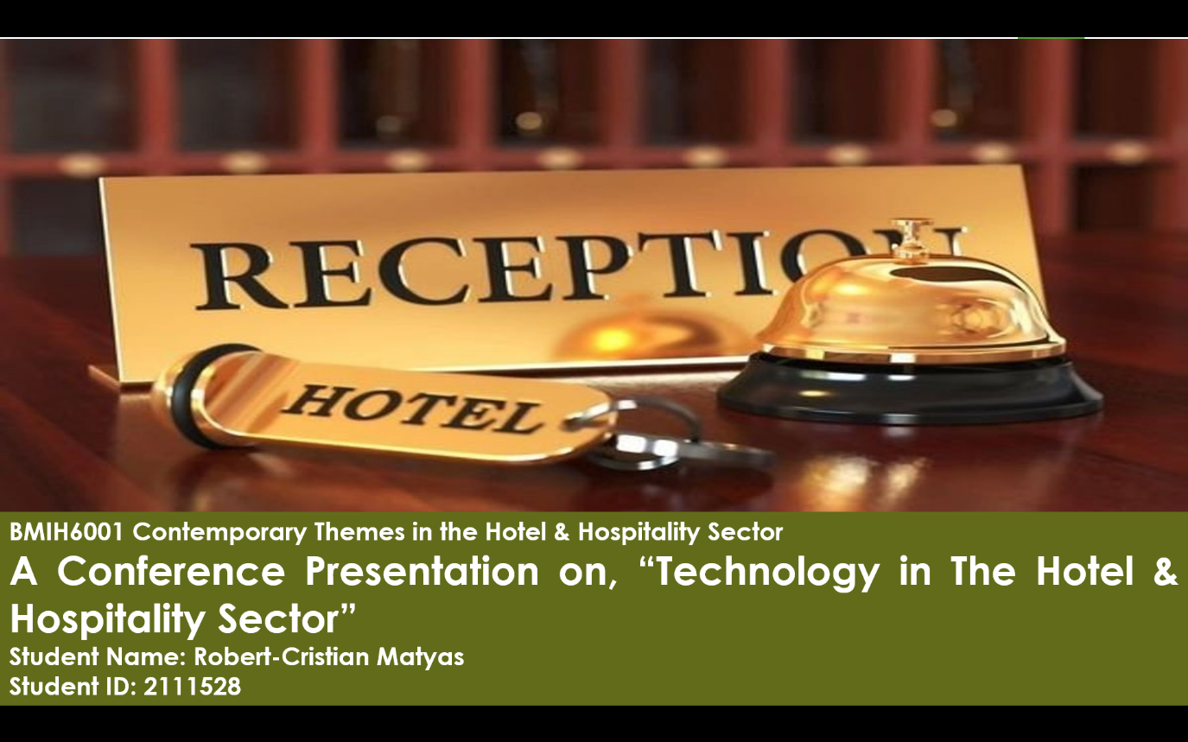

Slide 2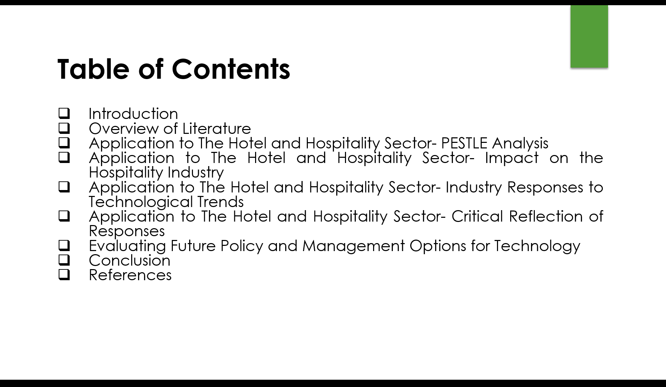
Slide 3
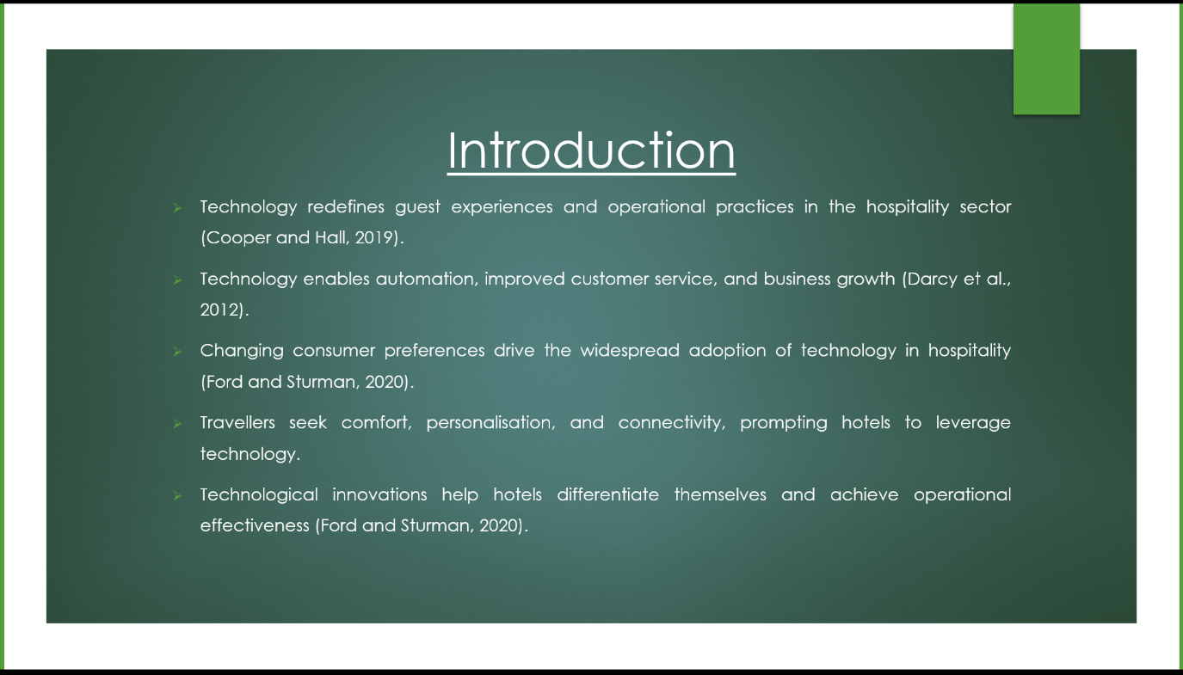

Slide 4
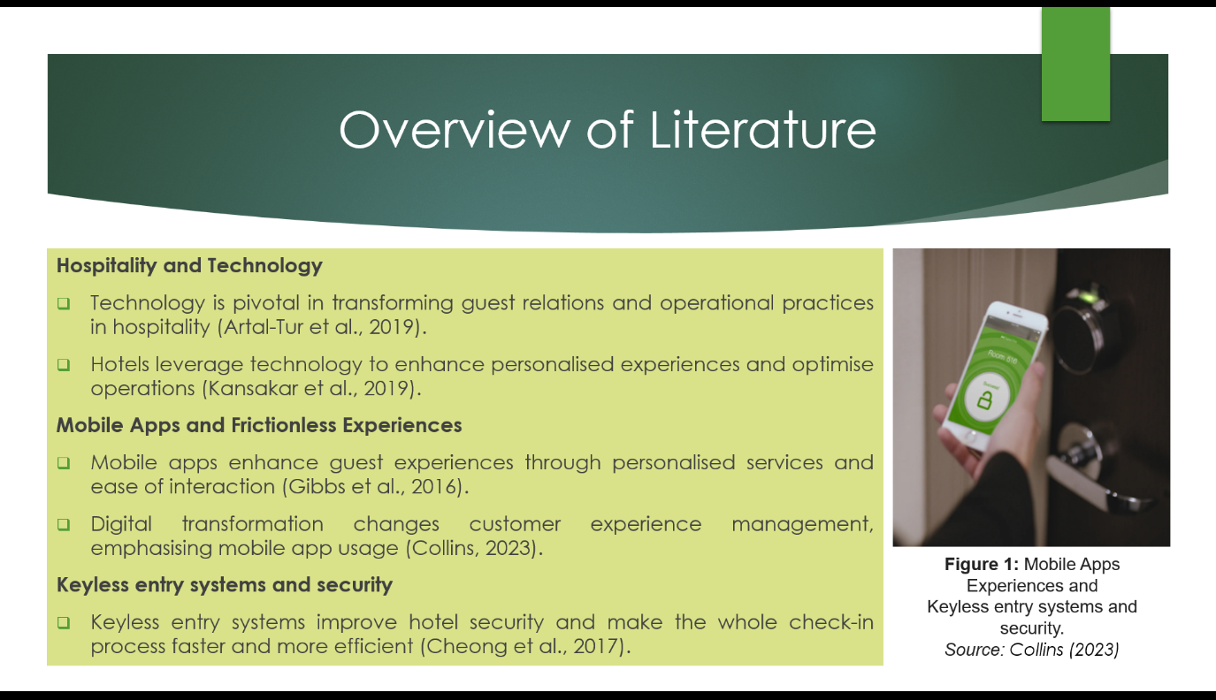

Slide 5
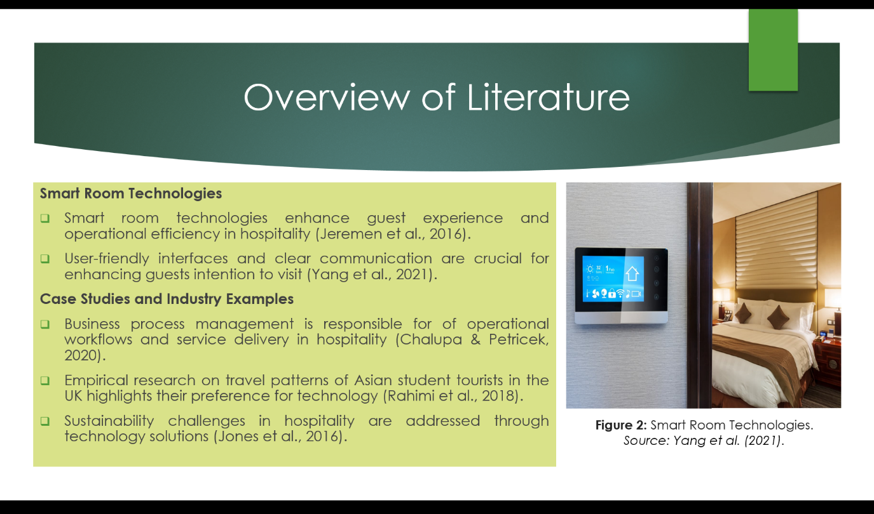

Slide 6
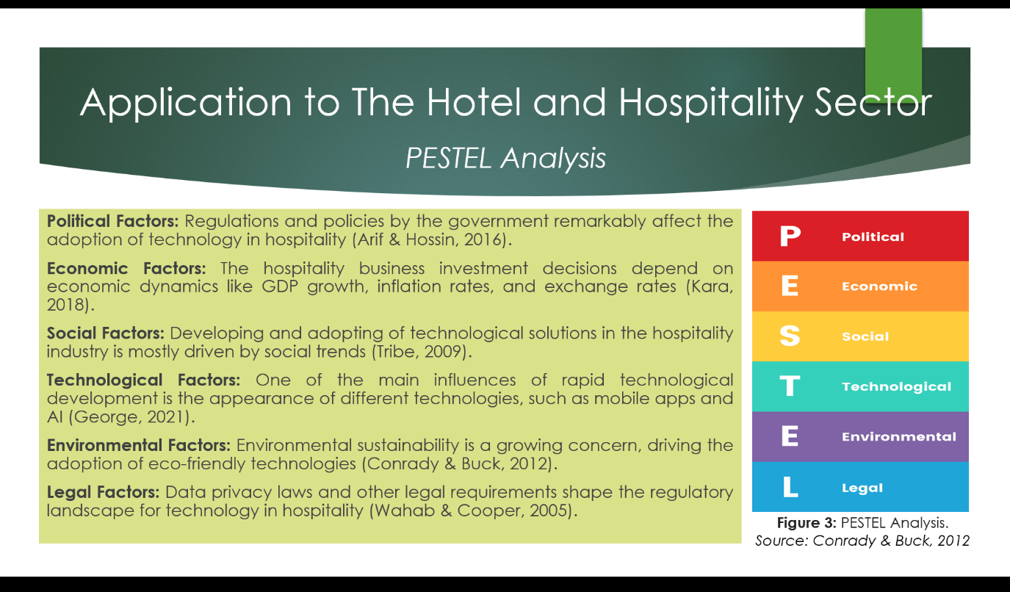

Slide 7
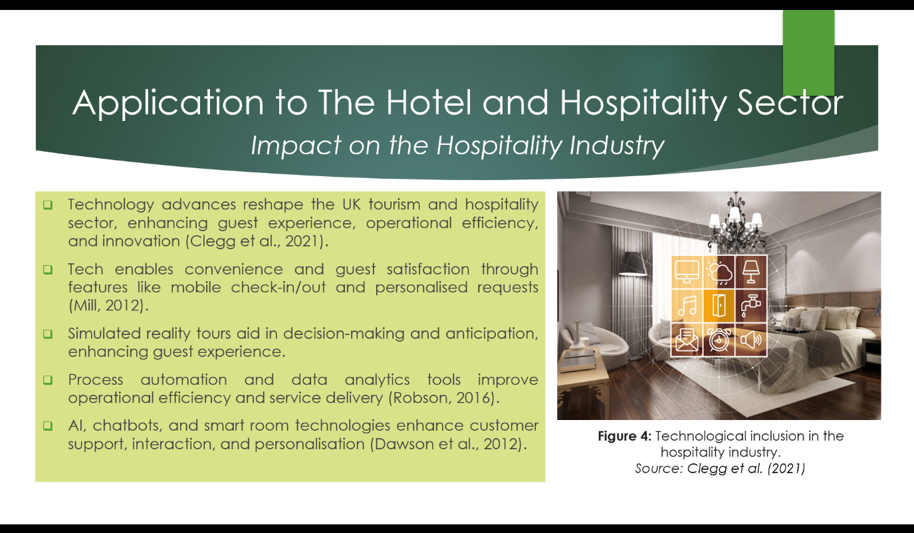

Slide 8
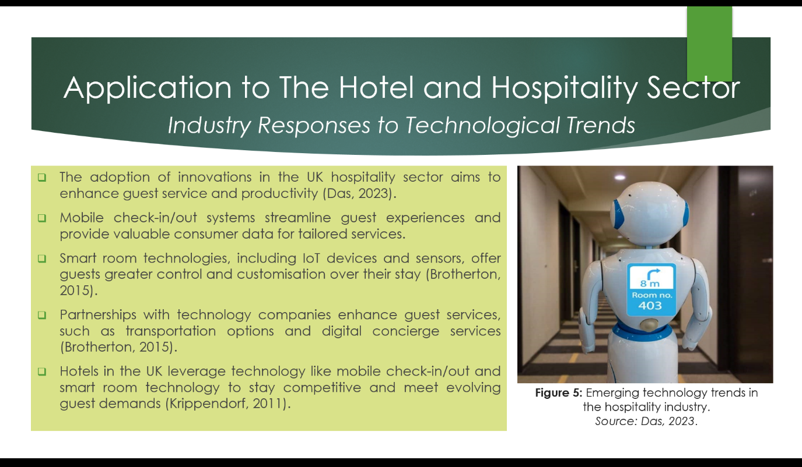

Slide 9
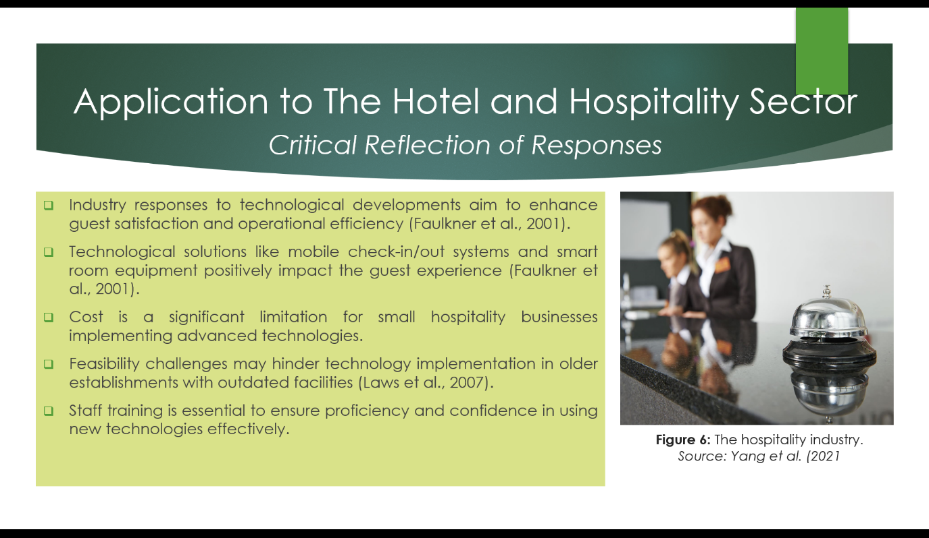

Slide 10
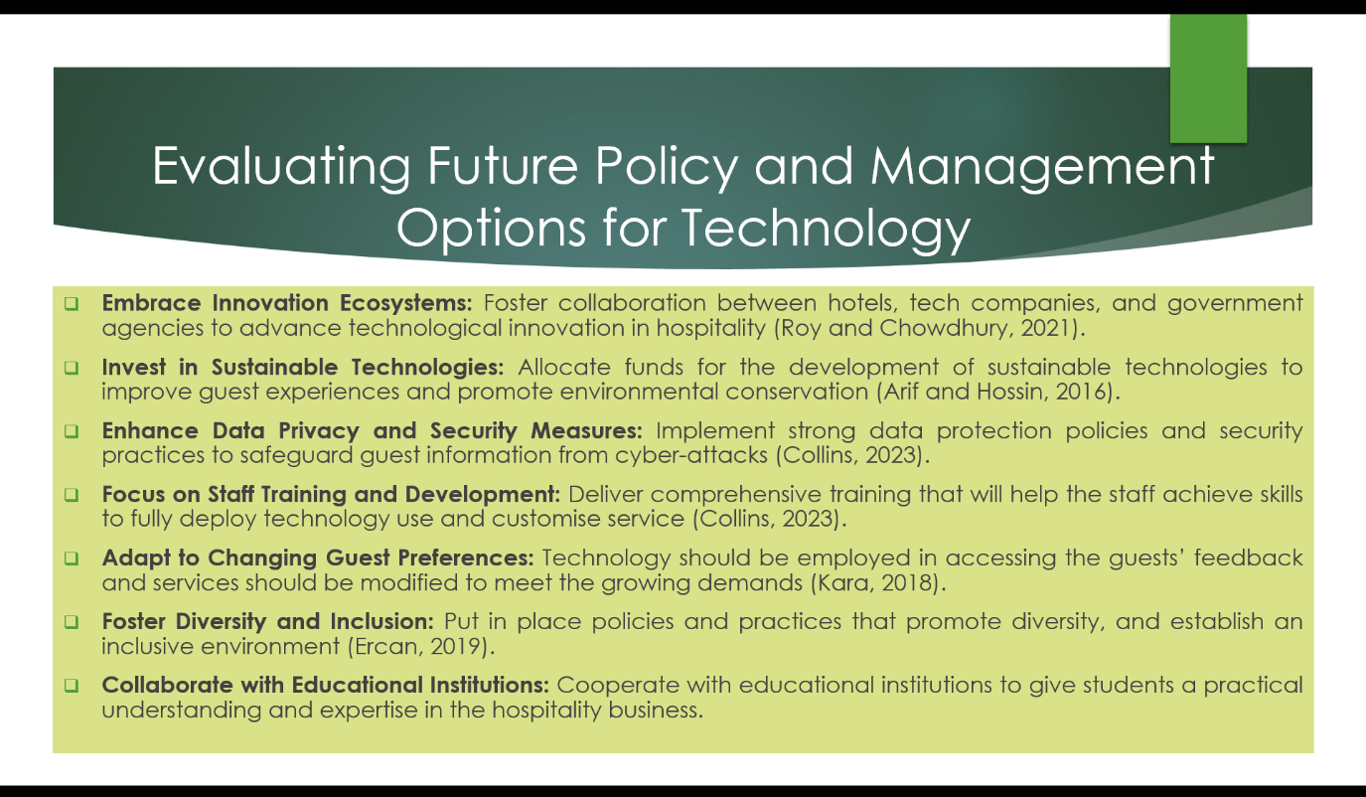

Slide 11
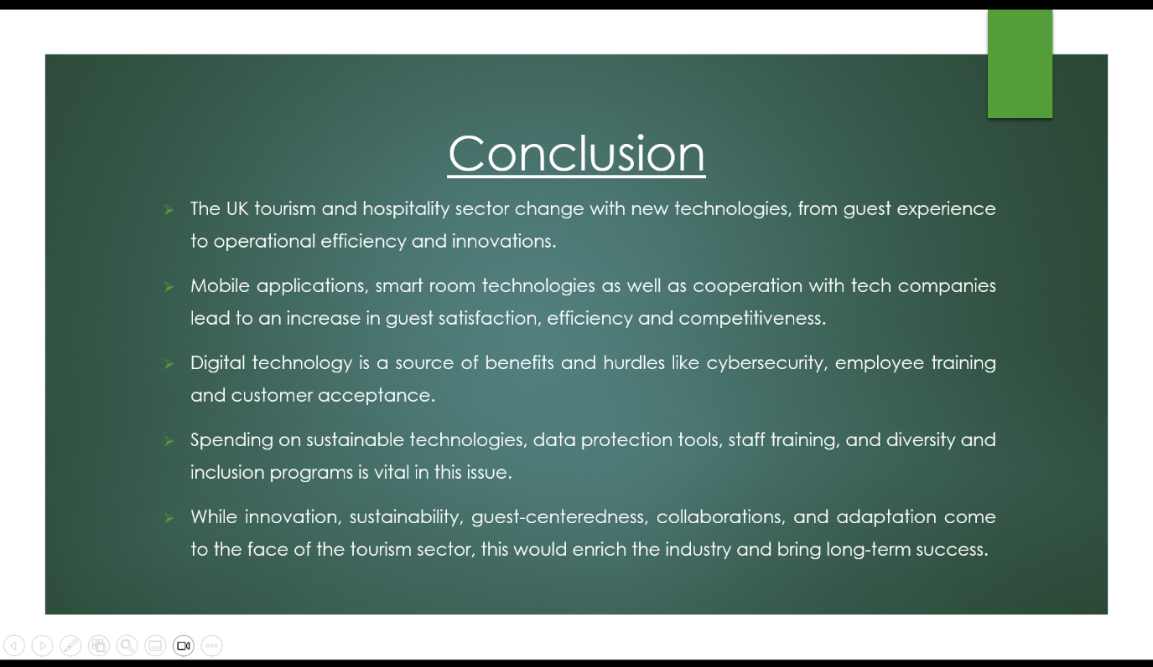

Slide 12


