Student Name: Cristian Rogoz]  Student ID: 2220458  Module Title: Foreign Languages & Cultural Awareness  Module Code: BMIH5003  Lecturer: Lisa Bassler  Date: 03/02/2024 | 
ASSIGNMENT 1: PORTFOLIO
(4 Components)

Component 1: Professional Reflection (500 words +/- 10%)

Weighting: 25%
Reflecting understanding happens when an individual learns from his or her own experience. This happens in many different criteria such as self-criticism also by looking back at the day and how the work environment could have been better (Kehe, 2022). A person always goes back from work and starts asking questions to himself and herself about what could have been done to avoid future mistakes and provide better services. I was working on the F&B section of a five-star hotel. I had to go through a huge misunderstanding which was more on the cultural aspect. As we become more global people from different cultures start mixing. From the workplace to home front, from food stores to grocery stores different people from different backgrounds are mixing. Sometimes this cultural intermixing creates confusion and misunderstandings in the work and study places as well (Laster, 2023). It was no different for me as I was working in the food and bar section. Two misunderstandings happened at the same time with the same customer. This misunderstanding took place at dinner time with an American guest. The table setup of the Americans and British are not that much of a difference but still, there is a slight difference. This American gentleman and his family were very particular about table manners and table settings. The way he was talking was also taking me out of the equation. I was happier with the British form of English than the American style. His accent was more of a southern accent which caught me off guard. Firstly, I had to deal with the accent then at the same time I had to understand the table setup which was also causing a lot of commotion. The difference in the setup is that the dinner fork would come first and the salad fork second. The reason for this difference is that in Europe, salad is frequently served after the entrée instead of before the entrée. At one point not knowing the table manners and setup started arguing with the guest, which was also a red flag on my behalf. Finally, I had to apologize and the manager had to calm the situation. I was given a casual warning by the manager as this was my first mistake. This all happened due to cultural differences and language barriers. My behaviour also played a part in the escalation of the situation. From the above situation, I can say that tiny details in the service industry cannot be overlooked and the employees should be able to deal with these situations with proper detailed training. My behaviour also needs to be rectified. I forgot one simple rule “Customer is always right”. In the service industry or any other industry patience is the key and I as an employee cannot get irritated at any cost. To improve my behavior few corporate training strategies can assist me to become a better employee. The few key corporate training strategies that can help me improve my workplace behaviour are as follows: experiential learning, feedback, nudges etc.

References:
Glover, J. and Friedman, H.L. (2020) ‘Recognizing cultural differences.’, Transcultural competence: Navigating cultural differences in the global community., pp. 29–42. doi:10.1037/14596-003.
Kehe, D. and Kehe, P.D. (2022) Cultural differences: Read, discuss, and write: Exploring and understanding cultures using academic skills. Brattleboro, VT: Pro Lingua Associates.
Laster, K. (2023) Cultural differences: The family courts’ reactions. Richmond, Vic.: Clearing House on Migration Issues.
Component 2: Training Plan (500 words +/- 10%)

Weighting: 25%

Based on my above experience I decided to prepare a training plan for my superiors which can help the organization avoid such incidences. In the ever-changing world, organizations should focus more on development by implementing strategically designed training plans. These training plans can then be divided into different subgroups and sub-divisions. There will be one common platform where all the employees will be trained on organizational behaviour. Then from there the training will be divided and subdivided into more focused and specialised schedules. A proper training plan is very important cause it will create the foundation for the organisation and make it move forward. Some organizations misunderstand or confuse training plans with employee development plans. Firstly, the organization has to adopt corporate training strategies which will help employees learn organization and customer service behaviour. The organisation must specify to their staff “why” their behaviour needs to change. If the organization can establish the why then it becomes relatively easy for the staff to learn and practice new procedures. The strategies that will help the organisation change their employee behaviour successfully are listed below:
- Experiential Learning – this type of learning where employees are asked to do role plays. They are immersed in simulations and case studies which creates an environment which is conducive to behaviour change (Patel, 2021).
- Feedback – it is also important for the employee to get feedback which will help modify employee behaviour. In a successful feedback loop, the managers and training teams all play very important roles (Mallo, 2023).
- Nudges – micro learnings which can be strategically placed can also help employees in their behaviour change. Short videos and infographics can be shared with the employees through their email and learning platforms can help the employee refresh their minds and act as a revision of the training that the employees learned previously.
Once the behaviour training is in the middle and there are certain changes are seen in the behaviour of the employees then the organization can look into more specialized training programs. The training program can include the following:
- Communication Skills – clear communication is very important otherwise there can be a lot of misunderstanding between the employees and the customer as happened in the above case. The second phase for effective communication is that the employees should be multilingual which helps and enhances the service of the restaurant. So employees must take language classes and also focus on different dialects and accents (Crappell, 2022).
- Conflict Management and Customer Complaint Resolution – it is absolutely important that the employees should be trained in customer complaints and how to resolve the issues that will give the customer the best satisfaction. By equipping employees with the above-mentioned skills restaurants can turn a negative experience into a positive experience.
- Cultural Sensitivity and Diversity – in today's world this training is very much essential. Once an employee is equipped with this training the employees will be attuned with table manners and will be able to make a customer feel more valued and respected.

References:
Chappell, C. (2022) ‘Training sequencing and planning strategies’, Teaching Piano Pedagogy, pp. 122–157. doi:10.1093/oso/9780190670528.003.0006.
Mallo, J. (2023) ‘Training Strategies for Team Sports’, Team Sports Training, pp. 164–196. doi:10.4324/9781003020141-8.
Patel, K. (2021) The Complete Guide to bodyweight training. London: Bloomsbury.

Component 3: Student Self-Reflection (500 words +/- 10%)

Weighting: 25%
Self-reflection is taking time out for myself and evaluating the situations that I am in. It is about giving thought to my motivations and desires and the path I am following is this the path I want to follow or do I want to do something else? All the mentioned and many more things that help me to critically judge myself is a reflection. Reflections can be an effective way of learning when it can be used in a properly structured way. There are a few reflection models that can used to assess one’s experience (Hudson, 2021). Gibbs's reflective cycle, Kolb’s Learning Cycle, and Johns's model of structured learning are a few of the self-reflection models. I prefer Johns's model of structured reflection. I prefer this model of reflection because I feel it is more structured and to the point and precise. This model was specifically developed for use in the context of nursing. Later on, it became relevant to other contexts as well. I feel it can assist in more complex situations and can be helpful in the learning process of reflection. The thing that drives me towards this reflection model is it teaches me to look inward first and assess the situation. John also suggested that involving someone superior in one’s reflection makes the analysis more powerful. As the world is getting smaller and smaller cultural awareness is a must to work in a multicultural society. It is more important that an employee is culturally aware of his surroundings to provide the best services to the customers (Mallo, 2020). In the hospitality industry, an employee has to be culturally aware as the individual has to give services to the customers who are visiting them from all over the world. My incident with the Americans taught me even tiny details can hurt someone’s feelings and make the customer feel less valued. To sustain in this industry, it is imperative to know one’s culture and on the other hand, it will help the customer feel valued and respected. For my reflection, I chose Johns's Model of Structured Learning. It helped me understand the situation more. Firstly, I described the situation to myself and the things that were involved in the incident. Once the describing part was over then I started asking the reflective questions. Questions such as what was I trying to achieve, what were the consequences of my action, what was my feeling, when it was happening and what was the other person involved feeling about the entire situation. Then the other question that arose is that if the situation could have been handled differently, did I have any other choice to handle the situation, was this the best action? Finally, the consequences that arose because of the situation for myself, my employee and my customer. The entire incident made me rethink my approach. Now I think cultural awareness is a must for everyone. Even a slight misunderstanding due to cultural differences can jeopardize not only myself but also my organization. For example, the table incident taught me to be aware of other people’s cultures and values. This incident was important it taught me that I needed training both in hospitality management and also needed behavior change. This experience will help me build my career accordingly (Wills, 2023).

References:
Hudson, W. and Hudson, C.W. (2021) Recognize!: An anthology honouring and amplifying black life. New York: Crown Books for Young Readers.
Mallo, J. (2020) ‘Training Strategies for Team Sports’, Team Sports Training, pp. 164–196. doi:10.4324/9781003020141-8.
Wills, M. (2023) Managing the training process: Putting the principles into practice. Aldershot, England: Gower.

Component 4: Training Presentation (6 Slides)

Weighting: 25%
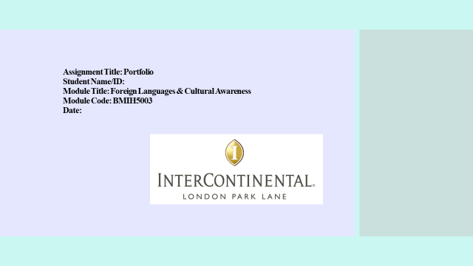
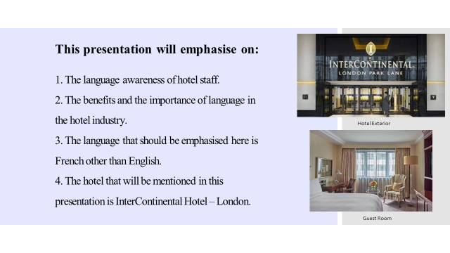
Speaker Note:
This presentation will emphasise the language awareness of hotel staff. The benefits and the importance of language in the hotel industry. The language that should be emphasised here is French other than English. The hotel that will be mentioned in this presentation is InterContinental Hotel – London.
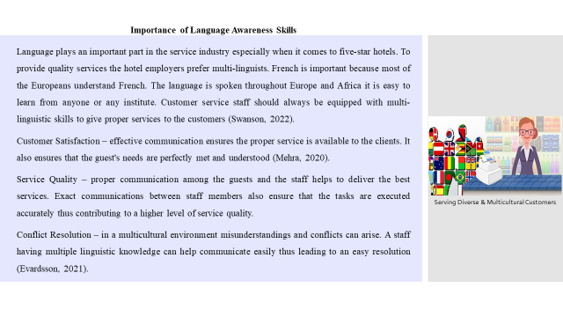
Speaker Note:
Language plays an important part in the service industry especially when it comes to five-star hotels. To provide quality services the hotel employers prefer multi-linguists. French is important because most of the Europeans understand French. The language is spoken throughout Europe and Africa it is easy to learn from anyone or any institute. Customer service staff should always be equipped with multi-linguistic skills to give proper services to the customers (Swanson, 2022).
Customer Satisfaction – effective communication ensures the proper service is available to the clients. It also ensures that the guest's needs are perfectly met and understood (Mehra, 2020).
Service Quality – proper communication among the guests and the staff helps to deliver the best services. Exact communications between staff members also ensure that the tasks are executed accurately thus contributing to a higher level of service quality.
Conflict Resolution – in a multicultural environment misunderstandings and conflicts can arise. A staff having multiple linguistic knowledge can help communicate easily thus leading to an easy resolution (Evardsson, 2021).

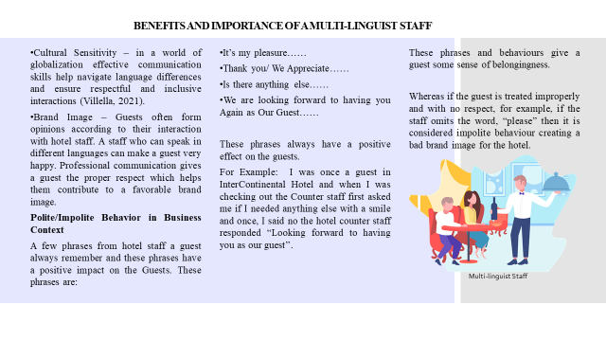

Speaker Note:

BENEFITS AND IMPORTANCE OF A MULTI-LINGUIST STAFF (continued)
- Cultural Sensitivity – in a world of globalization effective communication skills help navigate language differences and ensure respectful and inclusive interactions (Villella, 2021).
- Brand Image – Guests often form opinions according to their interaction with hotel staff. A staff who can speak in different languages can make a guest very happy. Professional communication gives a guest the proper respect which helps them contribute to a favorable brand image.
Polite/Impolite Behavior in Business Context
A few phrases from hotel staff a guest always remember and these phrases have a positive impact on the Guests. These phrases are
- It’s my pleasure……
- Thank you/ We Appreciate……
- Is there anything else……
- We are looking forward to having you Again as Our Guest……
These phrases always have a positive effect on the guests.
For Example: I was once a guest in InterContinental Hotel and when I was checking out the Counter staff first asked me if I needed any else with a smile and once, I said no the hotel counter staff responded “Looking forward to having you as our guest.
These phrases and behaviours give a guest some sense of belongingness.
Whereas if the guest is treated improperly and with no respect for example if the staff omits the word, please then it is considered impolite behaviour creating a bad brand image for the hotel.

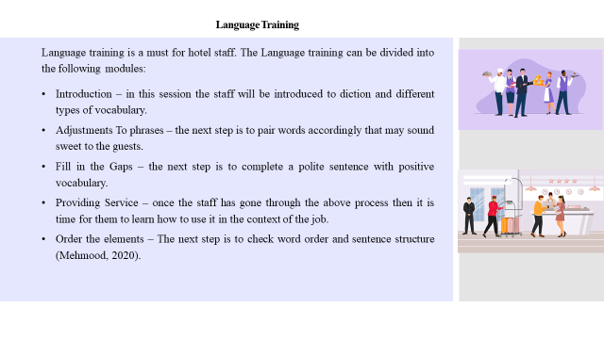 Speaker Note:
Language Training
Language training is a must for hotel staff. The Language training can be divided into the following modules:
- Introduction – in this session the staff will be introduced to diction and different types of vocabulary.
- Adjustments To phrases – the next step is to pair words accordingly that may sound sweet to the guests.
- Fill in the Gaps – the next step is to complete a polite sentence with positive vocabulary.
- Providing Service – once the staff has gone through the above process then it is time for them to learn how to use it in the context of the job.
- Order the elements – The next step is to check word order and sentence structure (Mehmood, 2020).
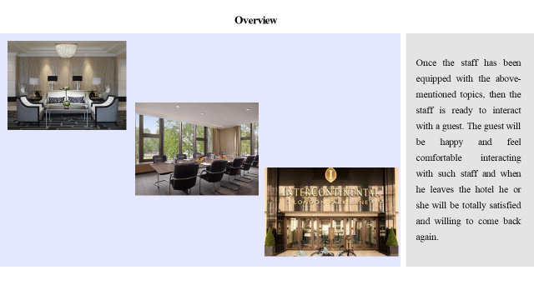
Speaker Note:

Overview
Once the staff has been equipped with the above-mentioned topics, then the staff is ready to interact with a guest. The guest will be happy and feel comfortable interacting with such staff and when he leaves the hotel he or she will be totally satisfied and willing to come back again.

References (no screenshots):
Evardsson, B. (2021) ‘Editorial’, International Journal of Service Industry Management, 19(5). doi:10.1108/ijsim.2008.08519eaa.001.
Mehmood, M. (2020) ‘Finance in the hospitality industry’, Contemporary Management Approaches to the Global Hospitality and Tourism Industry, pp. 185–212. doi:10.4018/978-1-7998-2204-2.ch011.
Mehra, S. and Inman, R.A. (2020) ‘JIT implementation within a Service Industry: A case study’, International Journal of Service Industry Management, 1(3), pp. 53–61. doi:10.1108/09564239010003413.
Swanson, H. (2022) Medieval British towns. New York, NY: St. Martin’s Press.
Villella, J.A. (2021) The hospitality industry: The World of Food Service. New York: McGraw-Hill.

