Student Name: Catalina Chirila  Student ID: 2233497  Module Title: Foreign Languages & Cultural Awareness  Module code: BMIH5003  Lecturer: Heidi Prosser  Date: 09.02.2024 | 
ASSIGNMENT 1: PORTFOLIO
(4 Components)

Component 1: Professional Reflection (500 words +/- 10%)

Weighting: 25%
At the time of breakfast in Bulgari Hotel London I, a trainee worker, approached a table occupied by Italian tourists. Greeted them cheerfully with a Good morning and asked them to place the other.
The lady smiled but was looking confused. Realizing the language barrier I tried to communicate in simple language along with the hand gestures. However, this method was still not useful because there was still confusion. The lady was trying to communicate with me in the Italian language but I could not understand anything. I was very much frustrated due to the situation and could not find a solution. The confusion was due to the language barrier, none of us knew each other's language properly. The hand gestures did not play any important role because there could be differences in the interpretation of the gestures due to cultural differences. The limited assumption on my side was that they needed the navigation in the buffet which was according to Western culture but there could be the possibility that they preferred the new approach. This incident made me realize the importance of cultural awareness in my role. Learning about the cultures could be the most important factor in the success of my career.
The things I need to focus on in the future include, developing language skills as it is a key role for the communication among customers. The next thing to consider is paying close attention to nonverbal cues like, gestures, eye contact, and personal space can help in preventing possible misunderstandings. It is also important to pay close attention during communication with foreigners which will help in understanding their nonverbal cues as well and fulfil their needs. The last thing to consider is making sure not to assume things on my own as it will increase the chances of misunderstanding. Instead should ask further to clarify things by asking questions from all the individuals to be safe from misunderstanding.
It is very important to learn about cultural diversity when working in hospitality services, it will help us in preventing any misunderstanding. Learning about cultural differences is very important for customer service roles (Fam et al., 2023). To increase the quality of the job you must understand the cultural differences, which will increase the quality of the work of all the individuals and will increase the worth of the person in the working environment. In the social service profession learning about new languages will increase the chances of customer satisfaction (Bogicevic et al., 2017). Improvement in hospitality service is refining continuously with the help of learning new languages, this will create new potential for the employees (Zhang et al., 2022).
References:
Bogicevic, V., Yang, W., Bujisic, M. and Bilgihan, A., 2017. Visual data mining: Analysis of airline service quality attributes. Journal of Quality Assurance in Hospitality & Tourism, 18(4), pp.509-530.
Fam, K.S., Liat Cheng, B., Cham, T.H., Tan Chia Yi, M. and Ting, H., 2023. The role of cultural differences in customer retention: evidence from the high-contact service industry. Journal of Hospitality & Tourism Research, 47(1), pp.257-288.
Zhang, Y., Xi, W. and Xu, F.Z., 2022. Determinants of employee innovation: An open innovation perspective. Journal of Hospitality Marketing & Management, 31(1), pp.97-124.
Component 2: Training Plan (500 words +/- 10%)

Weighting: 25%

Identified cultural misunderstanding (in a few words):

In the above case, the misunderstanding arose due to the lack of knowledge about different cultures and languages. The training plan for Bulgari London Hotel prepared to solve this problem is Cross-Cultural sensitivity Program.

Training plan (Why/What//Who/Where/When):
Hospitality as a globalized industry welcomes customers from diverse backgrounds. The industry needs to provide training programs that will help in understanding diverse cultural backgrounds. Resulting in fewer misunderstandings due to the cultural differences. It will help in creating connections between people with different backgrounds. The target audience for this training program will consist of all the employees related to the role of serving people in the community. This includes housekeepers, receptionists, bartenders, and restaurant servers. The training content will include, language and communication skills, providing cultural awareness, decreasing cultural misunderstandings, and welcoming diversity and inclusivity.
To understand cultural diversity, providing awareness and understanding the importance of cultural awareness in hospitality is the most essential part of the training. Understanding the needs of the customers will have a positive impact on the business (Erdoğan, and Villi, 2021). Learning cultural values and nonverbal communication is one of the key concepts to be learned during the training. Learning about common cultural differences related to greetings, gestures, personal space, time perception, and communication style. These are a few of the important that every employee must learn.
The next step is to learn about language strategies and communication to the extent of understanding the basics of any language or culture. That could include how to say greetings, requests, and saying thank you. Emphasizing the use of strategies to promote active listening as there is a limitation to only understanding the basic phrases. Also giving attention to the nonverbal cues will help in understanding the individual with less communication. Using the resource will help in the translation of the language and create opportunities to learn more.
Identifying the signs of potential misunderstanding will decrease the chances of misunderstanding among individuals. Realizing the importance of active listening, asking questions in moments of confusion, and not making assumptions will help in understanding others' needs. Provide proper training to prevent frustration and solutions to help the guests when they get frustrated. Using techniques that will help in calming the customers.
The last element could be introducing them to welcome cultural diversity and the need for innovations. Celebrating cultural holidays within the domain of respect. Encouraging the employees to respect and .welcome cultural diversity within the team members. Different workshops and training programs should be arranged for the employees to learn about all these cultural diversities. Then their learnings should evaluated time by time to evaluate how much they have learned. To understand the efficiency of the training program continuous evaluation is very much important. Providing the employees with knowledge about cultural values will be beneficial for the hotels and it will also increase the domain of knowledge of the employees (Ciasullo et al., 2021).
By providing cultural awareness to the employees the hotels will be able to give more productive results. They will become the source of connections among different cultures. Restaurants learning about the different cultures will increase the satisfaction levels of the customers, adding value to their services (Yang, 2017). They will be able to perform better and provide the best services to their customers, resulting in high levels of customer satisfaction and the chances of excelling in the market will become very high.
References:
Ciasullo, M.V., Montera, R. and Palumbo, R., 2021. Online content responsiveness strategies in the hospitality context: exploratory insights and a research agenda. The TQM Journal.
Erdoğan, K.O.Ç. and Villi, B., 2021. Transformation of tourism and hospitality customers’ perception of risk and customers’ needs for control. Journal of multidisciplinary academic tourism, 6(2), pp.117-125.
Yang, F.X., 2017. Effects of restaurant satisfaction and knowledge sharing motivation on eWOM intentions: the moderating role of technology acceptance factors. Journal of Hospitality & Tourism Research, 41(1), pp.93-127.

Component 3: Student Self-Reflection (500 words +/- 10%)

Weighting: 25%
For self-reflecting on the importance of cultural awareness in the hospitality industry, I have employed a reflective model of Gibbs’ model of reflection so that better understanding can be gained.
In the beginning, I did not understand the importance of cultural awareness in the field of hospitality industry. But now with my growing experience, I have realized the importance of learning about cultural diversity, especially in the hospitality industry. It helps in removing the gaps that we face due to cultural differences and to provide the best of the services.
As an employee whose main job is to understand the needs of the guests, it is very important to understand their needs and preferences (Manoharan et al, 2023). And this it can be only possible when you remove all the barriers that can create the gap to understanding them. Making sure that there are no potential barriers between you and the guest is the only way to understand the guests completely. That is why it is very important for such employees who are connected with the role of hospitality to understand cultural diversity and take all the possible steps to learn about the values and languages of other cultures (Moscardo, 2021).
I realized the importance of cultural diversity after facing different problematic situations in which I was not able to understand the needs of the people around me. Not understanding and complying with their needs created frustration as I was not able to perform my job properly. I also realize that it could create a sense of frustration among the customers, hence leaving them unsatisfied is one of the most problematic things in the industry of hospitality, therefore it is more important to learn about cultural diversity (Messner, 2020).
In my experience, I was not able to serve customers who have different cultural backgrounds and could not understand their language created the reason for me to learn about different languages. This experience became the turning point of my professional life and made me realize the importance of learning about cultural diversity. That also created a sense of respect and understanding about others' cultures within myself.
I choose learning about different cultures to not face the same situation ever again in my life. To save myself from such an embarrassing and frustrating experience. Becoming the source of happiness and benefit for others, this new realization will also help me, in the long run, to succeed in my personal happiness and professional life.

References:
Manoharan, A., Madera, J.M. and Singal, M. eds., 2024. The Routledge Handbook of Diversity, Equity, and Inclusion Management in the Hospitality Industry. Routledge.
Messner, W., 2020. Cultural and individual differences in online reviews. Journal of International Consumer Marketing, 32(5), pp.356-382.
Moscardo, G., 2021. Using systems thinking to improve tourism and hospitality research quality and relevance: a critical review and conceptual analysis. Tourism and Hospitality, 2(1), pp.153-172.

Component 4: Training Presentation (6 Slides)

Weighting: 25%
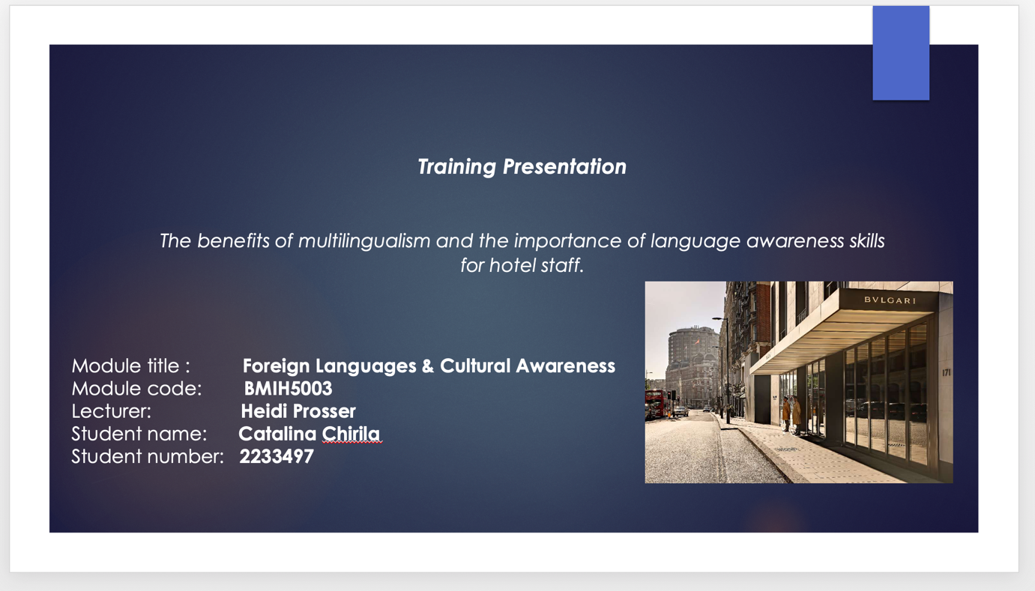
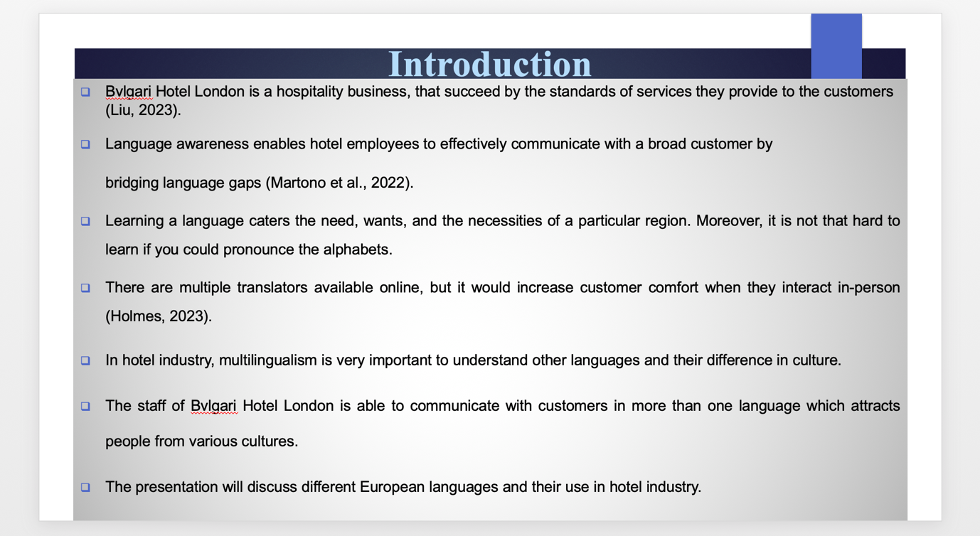
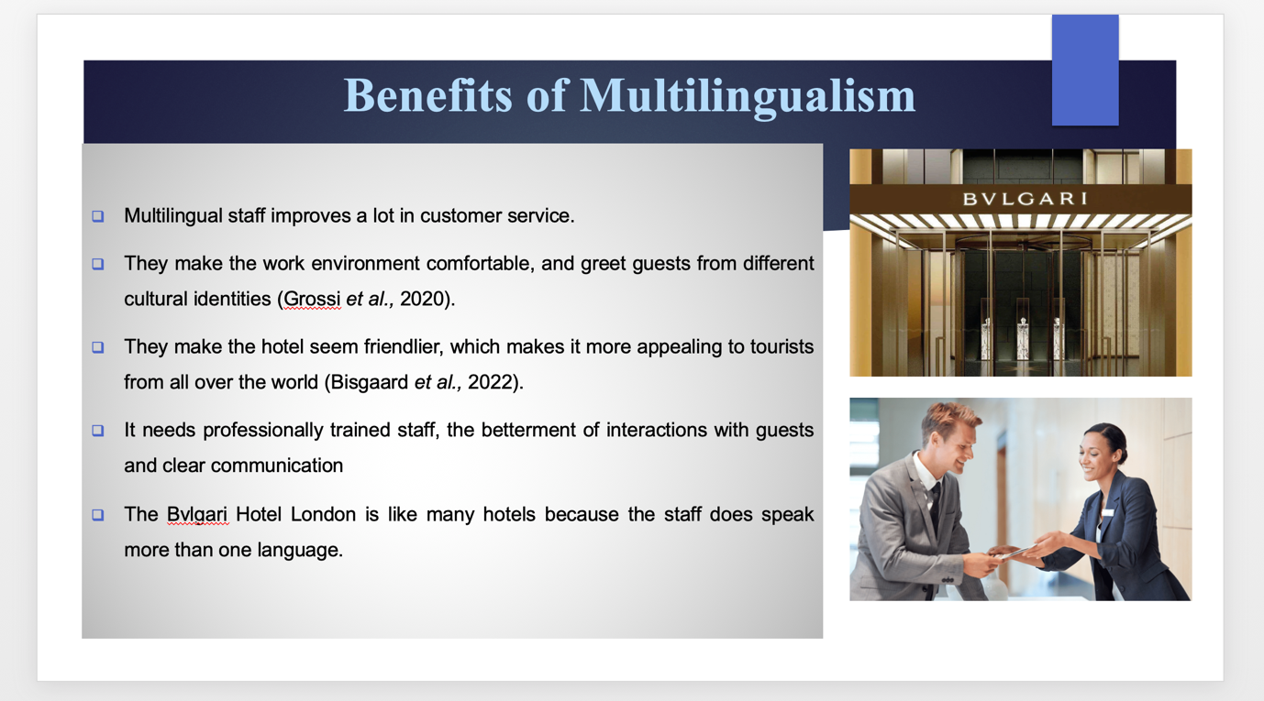
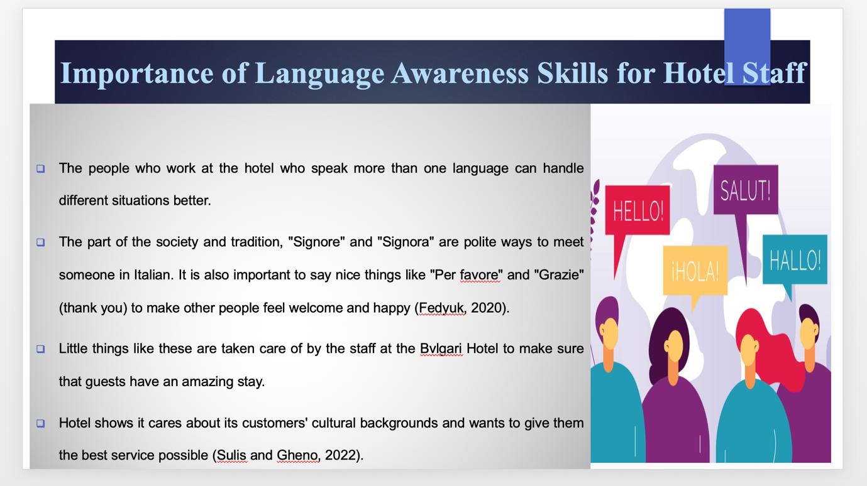
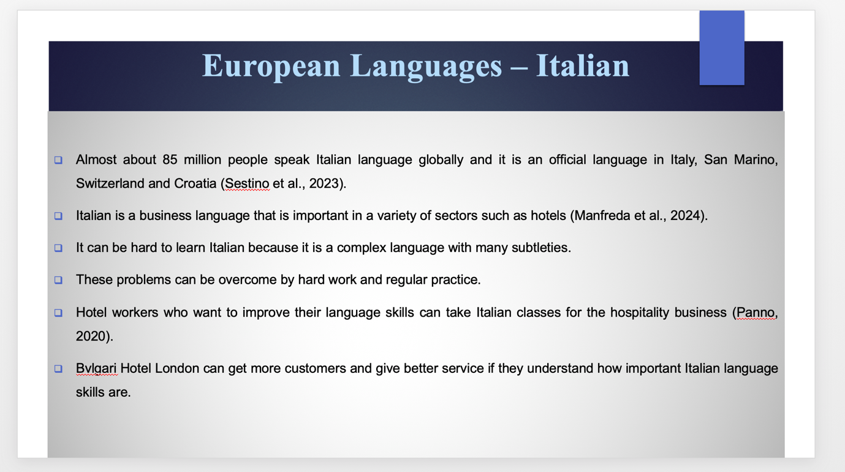
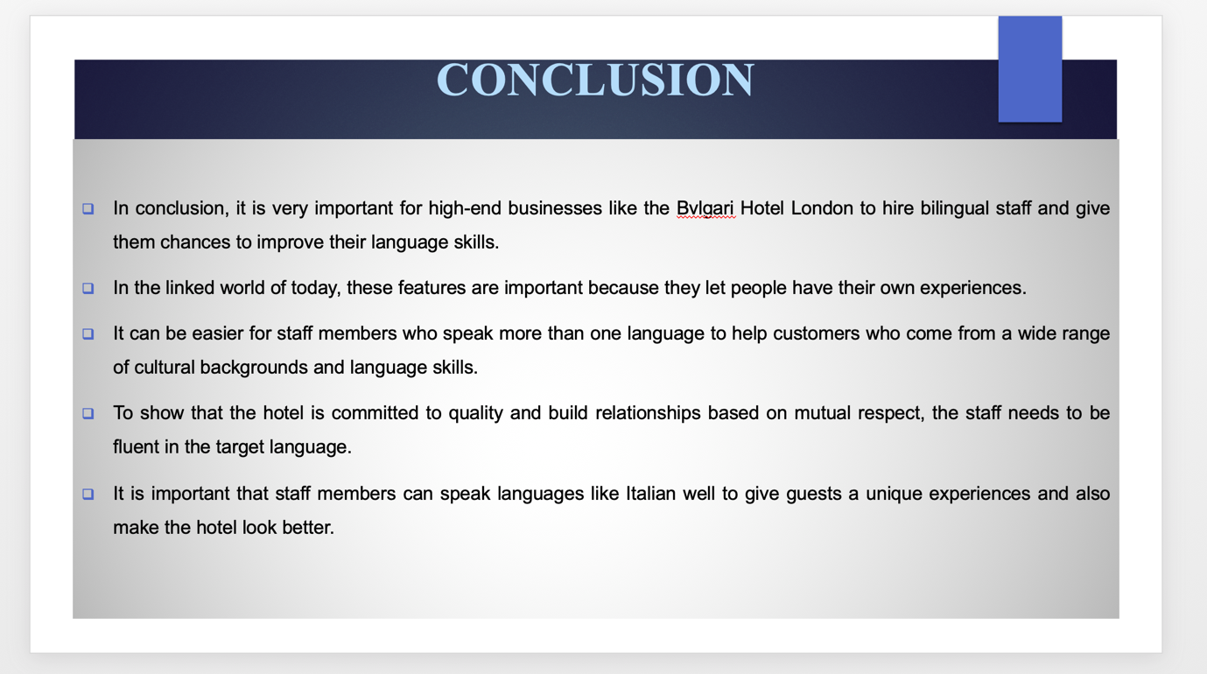
References (no screenshots):
Fedyuk, O., 2020. Migrants’ embodied geographies: spaces and boundaries of care work. Case study of Ukrainian care workers in Italy. Towards a scarcity of care, pp.143-165.
Franck, L.S., Bisgaard, R., Cormier, D.M., Hutchison, J., Moore, D., Gay, C., Christensen, H., Kriz, R.M., Mora, J., Ekno, M. and Hackett, H., 2022. Improving family-centered care for infants in neonatal intensive care units: Recommendations from frontline healthcare professionals. Advances in Neonatal Care, 22(1), pp.79-86.
Holmes, L., 2023. Language, hospitality, and internationalization: exploring university life with the ethical and political acts of university administrators. Current Issues in Language Planning, 24(1), pp.42-59.
Liu, B., 2023, September. Haute Couture Hotels: A Systematic Review on the Practice of Brand Extension by Luxury Fashion Labels into the Hospitality Industry. In 3rd International Conference on Economic Development and Business Culture (ICEDBC 2023) (pp. 269-274). Atlantis Press.
Manfreda, A., Bisson, A., Lee, C., Scerri, M. and Presbury, R., 2024. Conceptualising the “Hospitable Service Mindset” for the future hospitality workforce. Journal of Hospitality and Tourism Management, 58, pp.115-128.
Martono, M., Dewantara, J.A., Efriani, E. and Prasetiyo, W.H., 2022. The national identity on the border: Indonesian language awareness and attitudes through multi‐ethnic community involvement. Journal of Community Psychology, 50(1), pp.111-125.
Pino, A., 2020. Performance measurement and management in small companies of the service sector; evidence from a sample of Italian hotels. Measuring business excellence, 24(2), pp.133-160.
Sestino, A., Amatulli, C., Peluso, A.M. and Guido, G., 2023. Integrating Internet-of-Things technologies in luxury industries: the roles of consumers’ openness to technological innovations and status consumption. Technology Analysis & Strategic Management, pp.1-15.
Sulis, G. and Gheno, V., 2022. The Debate on language and gender in Italy, from the visibility of women to inclusive language (1980s–2020s). The Italianist, 42(1), pp.153-183.
Tsedendamba, N., Grossi, V. and Volkov, M., 2020. Language-focused feedback and written communication difficulties of multilingual students: Improving teacher preparedness. Multilingual Education Yearbook 2020: Teacher Education and Multilingual Contexts, pp.95-112

