BMIH5003
Foreign Languages and Cultural Awareness
Intercultural Competence Report
Shahekur Rahman
2210706
Heidi Prosser
Word Count: 970

Executive Summary
Cultural awareness can have a significant impact on a hotel’s performance, especially at the national and global levels. This report contains an example of a culture report from France. It provides key information the culture and leadership visuals. It shares knowledge on how to become more culturally competent and recommendations on how this can be communicated with employees.

Content Table
Introduction…………………………………………………………………………….…….. 04
Frances Cultural visualisation………………………………………………………….…... 05
Frances Leadership visualisation……………………………………………………….…. 06
Conclusion………………………………………………………………………………….… 06
Recommendations………………………………………………………………………,….. 07
References…………………………………………………………………………………… 08

Introduction
The capacity to think and behave appropriately, interact and collaborate with others from diverse cultural origins both domestically and internationally, and operate well across cultural boundaries is known as intercultural competence. Before opening a hotel in a foreign country, it is important to understand their culture and customs. There are many countries under the Globe project, where research has been carried out on foreign countries, their leadership and cultures. The most significant information to take from the Project GLOBE for global managers is that, as cultures fluctuate, the selection of leaders for particular international assignments should take into account the real leadership based on cultural values and variations in leader behaviour. Additionally, it recommends that foreign managers engage with managers from other cultural backgrounds in a manner consistent with the nation's desired style of leadership. France is a country with a rich cultural heritage and a diversified tourism industry. Many travellers come to Paris, known as the "city of love," to see its historical sites, which define the country's medieval history. (GB Plant, 2023). France's official language is French, which is spoken by 88% of the country's people. About 3% of individuals speak German in France, where other languages are discouraged. In France, finding English speakers is somewhat challenging. It can be difficult for managers to communicate with staff members who speak French. Therefore, one of the management's responsibilities will be to pick up French as soon as feasible. It is rare for French individuals to feel at ease speaking other languages. (Kessler, 2009).

Main Body
An individual's attitudes and behaviours are regulated and controlled by their cultural knowledge. Numerous factors, such as religion, the allocation of political power, charismatic and strong leaders, historians, and storytellers, all influence culture (Choi & Kim, 2013). A society's common and accepted values, way of life, and practices are reflected in its culture. A person's awareness of their identity, roots, historical background, and sense of belonging to a particular community are all facilitated by their culture (Luka et al, 2013). The Globe project researched on the cultural visualisation of France and the findings are as can be seen on Appendix 1.
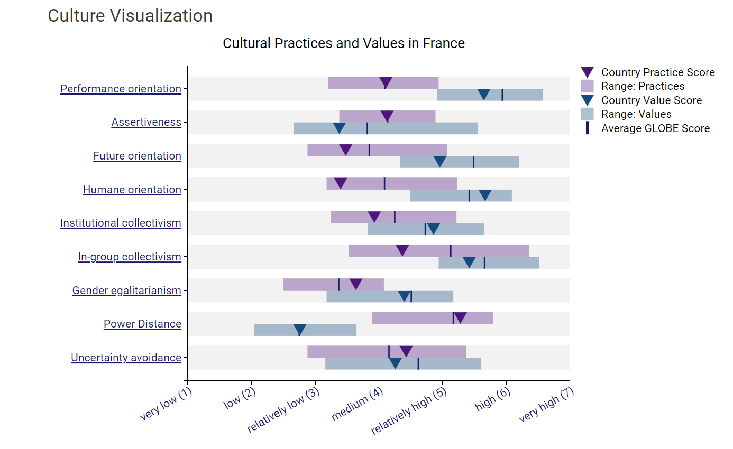
Appendix 1: The Globe Project: Culture Visualization of France (2020)

Focusing on countries practice scores, it can be seen from the chart that France has a high-power distance which means they accept inequality. It also indicates a preference of hierarchical organisation and employees highly depend on the direction of their leaders. In group collectivism is also medium to high, this shows that there is some group collectivism, where a group of people take care of themselves in exchange of loyalty. Where as in individual will take care of themselves and their family only. In 2005, the societal behaviours for this cluster had relatively high scores on group and family collectivism and high scores on power distance. The lowest score went to gender equality, while the highest score went to future orientation. The remaining dimensions are in the middle: assertiveness, humanitarian orientation, and uncertainty avoidance (Liddell, 2005). The difference since 2005 and 2023 is very clear, the power distance is still very high but gender egalitarianism is now slightly higher than future orientation. Women's advancement in organisations is specifically correlated with organisational culture practices that exhibit high levels of gender parity, high humane orientation, high performance orientation, and minimal power distance. Furthermore, there is a connection between women's advancement and organizational ideals that emphasize strong gender parity and a humanitarian approach (Bajdo & Dickson, 2002).

Cross-cultural leadership is a type of leadership that assesses a leader's capacity for adaptability and ability to lead in the face of cultural barriers (Khan, 2019). As can be seen on Appendix 2 below of leadership scores in France, the highest score for the best leadership type is participative. This type of leadership focuses by making joint decisions and shared influences between leaders and subordinates.
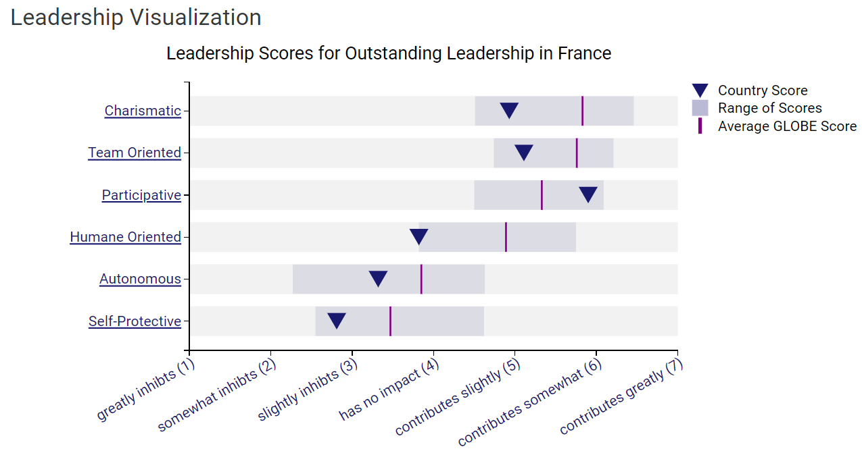
Appendix 2: The Globe Project: Leadership Visualization of France (2020)

Therefore, it is important for the leader and General Managers of the hotel to be aware of the culture of the country so that your employees can see the same through you. An essential component of cultural sensitivity is honouring the traditions and customs of the visitors. For instance, hotel employees should be aware that certain cultures may have certain clothing codes or customs for saying hello and goodbye (Joseph, 2023). Policies that support inclusivity should be established, as should routine training and daily staff meetings that emphasize the value of accepting (Lacalle, 2021).

Conclusion
The knowledge and understanding of foreign cultures are highly important before setting up a business in a foreign country. In order to be culturally competent, it is important to explore the countries leadership styles, the current trends and cultural values. For a hotel to succeed, they must train their employees to see their vision clearly. France is power driven, therefore to influence the staff and to direct them, managers need to be aware of their culture, language and have excellent communication skills.
Recommendations
- As a manager, one factor to consider is to learn French so communication is clearer and staff feel like you are a part of the team.
- Promote intercultural awareness by having staff members share their own experiences and traditions.
- If it’s the holiday time, you could even organize a dinner where each staff member brings a traditional holiday dish, which is a great way to celebrate differences.
- Taking an active role in ensuring that your leadership and staff understand the value of diversity in your company and that anyone who feels disrespected has someone to talk to or a place to go, and that there is a protocol in place to handle such a situation, is part of managing a diverse workforce.
- Educate staff on different cultures and languages
- Introduce training programs on cultural awareness.

References
(2020) The Globe Project: Culture and Leadership Visualisation. Available at: Results - France GLOBE Project [Accessed on 03 November 2023]
(2023) G B Pant IHM: Why French is Mandatory in Hospitality? Available at: Why french is mandatory in hospitality? - GB Pant Institute of Hotel Management, Haldwani (gbpantihm.com) [Accessed on 03 November 2023]
Bajdo, L.M., Dickson, M.W. (2000). Perceptions of Organizational Culture and Women’s Advancement in Organization: A Cross-Cultural Examination, Vol 45 (5/6), pp 399-414.
Choi K H, Kim D Y. (2013) A Cross Cultural Study of Antecedents on Career Preparation Behavior: Learning motivation, Academic Achievement, and Career Decision Self-efficacy. Journal of Hospitality, Leisure, Sport & Tourism Education. Vol 13. pp19–32. Available at: A cross cultural study of antecedents on career preparation behavior: Learning motivation, academic achievement, and career decision self-efficacy - ScienceDirect [Accessed on 03 November 2023]
Joseph, Y (2023) Medium: The role of cultural sensitivity in the hospitality industry. Available at: The role of cultural sensitivity in the hospitality industry | by Yvonne Joseph | Medium [Accessed on 03 November 2023]

Kessler E, Wong-MingJi D. (2009) Cultural Mythology and Global Leadership. 1st Ed. Cheltenham: Edward Elgar. Pp 416. Available at: Cultural Mythology and Global Leadership (e-elgar.com) [Accessed on 03 November 2023]

Khan M.Y.H. (2019) Cross Cultural Leadership and the Hospitality Industry: A Leadership Style Towards Success in Organizational Goals in France. Art Human Open Acc J. Vol 3(1). Pp 25-30. Available at: Cross cultural leadership and the hospitality industry: a leadership style towards success in organizational goals in France - MedCrave online [Accessed on 03 November 2023]

Lacalle, E. (2021) Mews: What is cultural diversity and why is it important in the hospitality industry? Available at: Message from Mews [Accessed on 03 November 2023]

Liddell, W.W. (2005). Project GLOBE: A Large-Scale Cross-Cultural Study of Leadership. Problems and Perspectives in Management, Vol 3(3). Available at: PPM_EN_2005_03_Liddell.pdf [Accessed on 03 November 2023]
Luka I, Vaidesvarans S, Vinklere D. (2013) Educating Tourism Students for Work in a Multicultural Environment. Journal of Teaching in Travel & Tourism. Vol 13(1), pp 1–29.

