

Student name: AHOU ANNA YASMINE KRAMO
Student ID: 2437213

Module name: Introduction to Health and Social Care
Module code : LCHS4003
Lecturer name : Muhammad Aliyu
Content page

Task 1
1.Introduction ……………………………………………………………...1
2.History of the service …………………………………………………. 2
3.Current Functioning …………………………………………………... 3
4.Two challenges Faced………………………………………………… 4

Task 2
1. Introduction …………………………………………………………… 1
2. The historical origins of Pharmacy…………………………………2
3. Evaluations of Current Practice …………………………………....3
4. Importance for Quality of Life ……………………………………... 4
5.Conclusion….……………………………………………………………5
6.References ………………………………………………………………6
INTRODUCTION
NHS England, (2024), highlights that community mental health services are essential in supporting adults and older people with serious mental health conditions. These services aim to provide care within local communities, allowing patients to receive treatment close to where they live. These services aim to promote recovery, independence, and improve overall wellbeing while reducing the need for hospital admission.
HISTORY
According to Burns (2020) Community mental health services were developed following key legislation. During the mid-20th century, care gradually moved away from large psychiatric institutions towards community-based services. Firstly, The Mental Health Act 1959 placed local authority social services at the centre of care for people with severe mental illness in the United Kingdom. marked a significant turning point in the organization of mental health services. Indeed, it prioritized care within the community, encouraging the gradual closure of large psychiatric institutions in favour of providing care closer to patients’ homes. As a result, this shift helped promote social inclusion and reduced the isolation often experienced by individuals with mental health conditions.
Community mental Health Services.

Student Name, Course Name, Email Details Go Here

Community mental health services support people with conditions such as depression, anxiety, schizophrenia, and bipolar disorder. They are especially important for vulnerable groups like young people and those facing social challenges. These services help individuals stay independent, build relationships, and reduce mental health stigma. According to (Mental Health Foundation 2025) Community support helps people with mental health difficulties manage their symptoms and feel less alone. Furthermore, having a strong community helps to protect individuals.

CURRENT FUNCTIONING OF COMMUNITY MENTAL HEALTH
Today, these services include psychologists, nurses, social workers, and support staff. They offer therapy, medication management, crisis support, and home visits. According to NHS England (2024), community-based care will include access to talking therapies, better physical health care, help with finding work, personalised and trauma-informed support, medication management, and support for self-harm and substance use problems.
TWO CHALLENGES: The two main challenges relate to funding and significant inequality in access to care. According to (BMA 2025), The mental health workforce is not growing at the rate required to meet current demand. Moreover, it is also insufficient to respond to the expected increase in demand, driven by factors such as population growth and the impact of the pandemic.

According to (AIMS Center -, 2025)
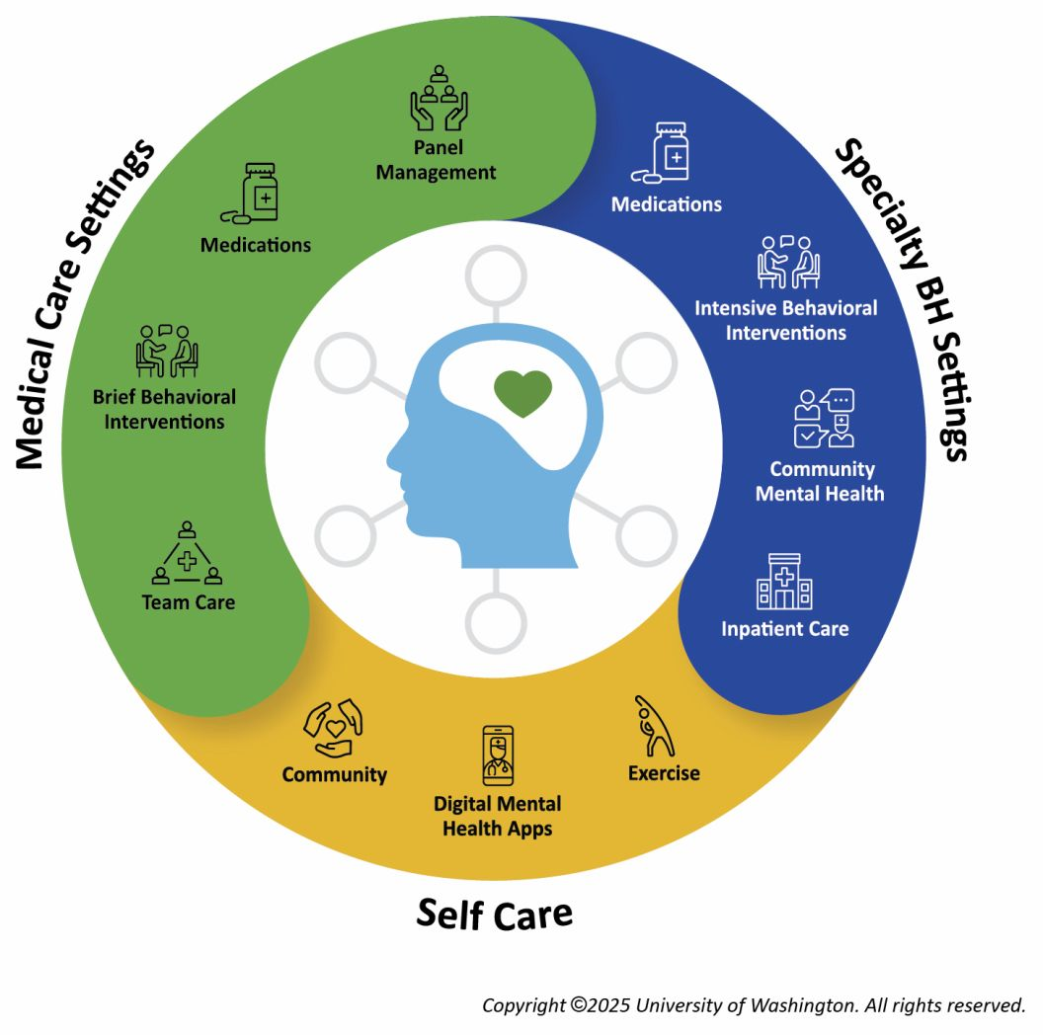

Task 2
PHARMACY SERVICES

1. INTRODUCTION

Pharmacy services are an essential of modern healthcare systems. First, in United Kingdom the pharmacy builds a key on the NHS community Pharmacist Consultation Service which has run since October 2019. According to research (NHS England,2024), the Community Pharmacist Consultation Service, which has been running since October 2019, provides easier access to healthcare. Community pharmacies can support people with healthy eating, exercise, stopping smoking, checking blood pressure, and providing services such as contraception and flu and COVID-19 vaccinations.

2. THE HISTORICAL ORIGINS OF PHARMACY SERVICES

The modern history of pharmacy in Great Britain began with the creation of the Pharmaceutical Society in 1841. After this, the 19th century saw pharmacy become more professional, with the introduction of exams and official registration.
At that time, pharmacy work mainly focused on preparing and selling medicines and sometimes providing prescribed medicines to patients. However, for individuals who could not afford to consult a doctor, local pharmacists were an accessible and important source of healthcare advice on a wide range of issues, according to Anderson (2007). This marked the beginning of pharmacy as a recognised profession. Today, pharmacists have a wider role, including giving advice and supporting patient care, which shows their importance in the healthcare system.
This advisory role was informal and unpaid, it changed significantly over time. After the war, improvements in pharmacists’ education led to higher expectations for newly qualified professionals. In addition, the creation of the NHS in 1948 resulted in major changes to pharmacy practice and helped to shape the modern role of pharmacists.
Overall, this marked the beginning of pharmacy as a recognised profession. Today, pharmacists have a wider role, including giving advice and supporting patient care, which shows their importance in the healthcare system.

3. EVALUATIONS OF CURRENT PRACTICE

Today, Community pharmacists are often the first healthcare professionals that patients contact. They provide advice on minor illnesses, help with medicines, and guide patients on when they may need to see a doctor or other healthcare service.
One key strength of pharmacy services is their accessibility, as patients can receive support without an appointment. As a result, this helps to reduce pressure on general practitioners and emergency services. In addition, pharmacists play an important role in ensuring medication safety and preventing errors.
Also, there are also some challenges. Increasing demand for pharmacy services has led to higher workloads for staff. Moreover, limited funding and staff shortages may affect the quality and availability of services. Therefore, while pharmacy services are highly valuable, improvements are needed to ensure they can meet future demand.
Community pharmacies are under extreme financial pressure, largely due to high levels of inflation. Consequently, many pharmacy staff feel that the payment for clinical services is insufficient, which affects their ability to provide these services effectively.
Secondly, service users are often motivated by the convenience and speed of services offered in community pharmacies compared to other healthcare settings. Additionally, existing relationships and high levels of trust in pharmacy staff encourage people to use these services. Nevertheless, limited public awareness remains a challenge and may reduce the use of available services. According to Rang.org (2019).

4. IMPORTANCE FOR QUALITY OF LIFE

Pharmacies in the UK are integral to improving quality of life by providing accessible, community-based healthcare. They offer services that go beyond dispensing medication, including preventative care, chronic condition management, and expert advice. As a result, they play an important role in supporting overall health and wellbeing.
In addition, Community pharmacists are often the first healthcare professionals that patients contact. They provide advice on minor illnesses, help with medicines, and guide patients on when they may need to see a doctor or other healthcare service.
Furthermore, by offering services and support in areas with fewer resources, pharmacies help reduce inequalities between different socioeconomic groups. For example, This helps ensure that everyone can access the support they need, no matter their background or financial situation., according to Hollowoodchemists.com (2025).

5. CONCLUSION

In conclusion, local pharmacies have an important role in public health in the United Kingdom. They provide essential services that are not only about giving out medicines. They also offer easy access to healthcare, advice, prevention support, and help in managing long-term conditions. In addition, they support reducing health inequalities. It is important to recognise the value of local pharmacies in modern healthcare. They are an important part of the community and help improve the health and well-being of people and society. Also, despite challenges such as increased demand and limited resources, pharmacy services remain essential in improving health outcomes and enhancing quality of life.

6. REFERENCES

Burns, T. (2020a). Community-Based Mental Health Care in Britain. Consortium Psychiatricum, 1(2), pp.14–20.doi:https://doi.org/10.17650/2712-7672-2020-1-2-14-20. Accessed 5 April 2026.
NHS England (2024). NHS England Community Mental Health Services. [online] England.nhs.uk. Available at: https://www.england.nhs.uk/mental-health/adults/cmhs/. Accessed 5 April 2026.
AIMS Center -. (2025). The Behavioral Health Ecosystem - AIMS Center. [online] Available at: https://aims.uw.edu/the-behavioral-health-ecosystem/ . Accessed 05 April 2026.
Mental Health Foundation (2025). How community benefits your mental health. [online] Mental Health Foundation. Available at: https://www.mentalhealth.org.uk/our-work/public-engagement/mental-health-awareness-week/how-community-benefits-your-mental-health. Accessed 05 April 2026.
BMA (2025). Mental health pressures data analysis. [online] The British Medical Association. Available at: https://www.bma.org.uk/advice-and-support/nhs-delivery-and-workforce/pressures/mental-health-pressures-data-analysis. Accessed 05 April 2026.
NHS England (2024). Pharmacy First. [online] www.england.nhs.uk. Available at: https://www.england.nhs.uk/primary-care/pharmacy/pharmacy-services/pharmacy-first/. Accessed 05 April 2026.
Anderson, S. (2007). Community pharmacy and public health in Great Britain, 1936 to 2006: how a phoenix rose from the ashes. Journal of Epidemiology & Community Health, 61(10), pp.844–848. doi:https://doi.org/10.1136/jech.2006.055442. Accessed 05 April 2026.
Rand.org. (2019). Evaluation of Clinical Services in Community Pharmacy. [online] Available at: https://www.rand.org/randeurope/research/projects/2024/clinical-community-pharmacy.html.priority_high . Accessed 05 April 2026.
Hollowoodchemists.com. (2025). Blocked. [online] Available at: https://hollowoodchemists.com/blog/the-impact-of-local-pharmacies-on-uk-public-health. Accessed 05 April 2026.

