

Name: Naima Nadimahmed Arab.
Student no.: 2503320
Programme: Master of Business Administration
Module: Marketing Management
Module code: LCMB7024

Table of Contents
Element 1: Segmentation, Targeting, Differentiation and Positioning (STDP) Analysis for the New Morrisons ‘Little Heroes’ Brand 3
1.1 STDP Analysis 4
Element 2: Marketing Mix (4Ps) for Morrisons ‘Little Heroes’ 10
2.1 Product 10
2.2 Pricing 12
2.3 Place 14
2.4 Promotion 15
Element 4: Reflection 16
Reference list 18
Appendices 21
Element 3: Marketing Strategy Pitch 21

Element 1: Segmentation, Targeting, Differentiation and Positioning (STDP) Analysis for the New Morrisons ‘Little Heroes’ Brand
Morrisons is a one of the “Big Four” supermarkets in the UKoffers quality food and sourced in the UK.Overall, underlying EBITDA of the company was £835 million and revenue was £3.8 billion (Morrisons PLC, 2024).
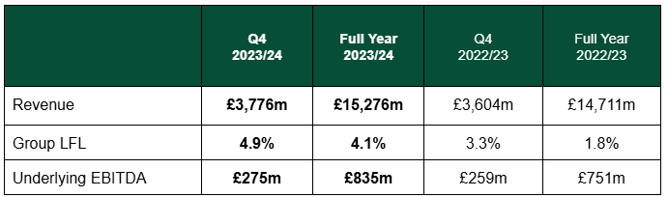
Figure 1: Financial performance of Morrisons
(Source: Morrisons PLC, 2024)
The idea of Morrisons Little Heroes is aimed at providing children with an affordable, healthy, organic, nutritious and fun approach to food with a focus on meal and snack options.
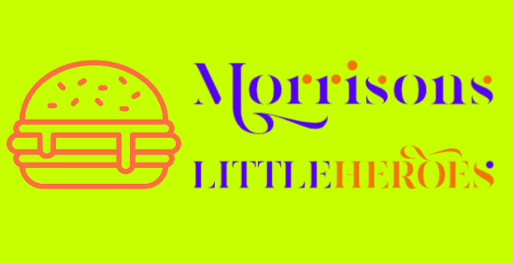
Figure 2: Morrisons Little Heroes
(Source: Self-developed)
This brand extension enhances on Morrisons' existing strengths and knowledge of the market, and provides a direct answer to consumer expectations regarding children's food, the environment, and price.

1.1 STDP Analysis
Segmentation
UK children's food market has three major categories of demographics, psychographics, and usage pattern. Demographics show middle-high income households with children of 1-10 age-group is the largest growth segment of the overall UK children’s food market which will grow at 6.12% CAGR and increase from USD 6.96 Billion in 2024 to USD 11.87 Billion in 2033 (Globenewswire, 2025).
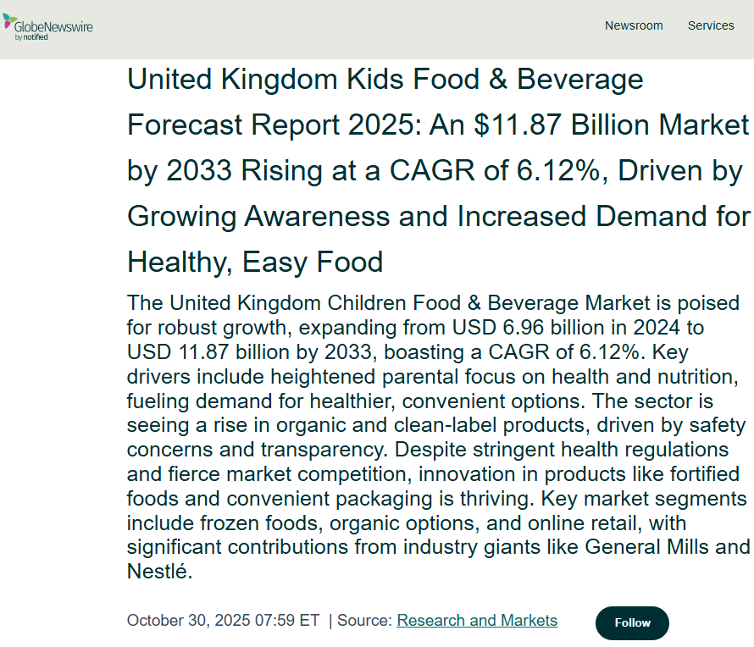
Figure 3: UK Kids Food and Beverage market
(Source: Globenewswire, 2025).)
Psychographically, parents are becoming aware of their health and place value on long-term health and sourcing transparency. According to Usage pattern, busy families are looking for convenient ways to prepare meals and snack items including preparing lunchboxes, pre-portioned snack packs and simple-to-prepare dinner options.
Another important issue is the requirement by nurseries and primary schools to buy larger quantities of wholesome and safe food products demanding a supermarket brand that meets nutritional requirements, contains lower levels of salt and sugar and cares about the environment would provide both reliability and price/value/ease-of-use.
Targeting
Morrisons Little Heroes primarily serves a demographic of working parents in the middle-high income bracket with kids (1-10 age). This demographic with large grocery purchases creates increase in food prices impacting purchasing groceries and making people sensitive to prices compared to previous years (Renub Research, 2025). The UK baby and child food sector experienced sales over £917 Million in 2022, and is on pace to see sales rise to £1.15 Billion by 2029 (Statista, 2024) indicating that despite current economic pressures there will be continued ability to purchase goods during these times of uncertainty. Additionally, although this demographic values convenience, as many households lack enough time to prepare lunch for their child and thus seek out easy-to-handle products to put in their child's lunchbox, this is an opportunity to promote the launch of a new supermarket children’s brand.
This niche of consumers use online resources like parenting influencers, nutrition educators, and branded communities, create the potential for campaigns, community building, and promotional activities for review, research before buying, and many more, providing opportunities to create value through online marketing.
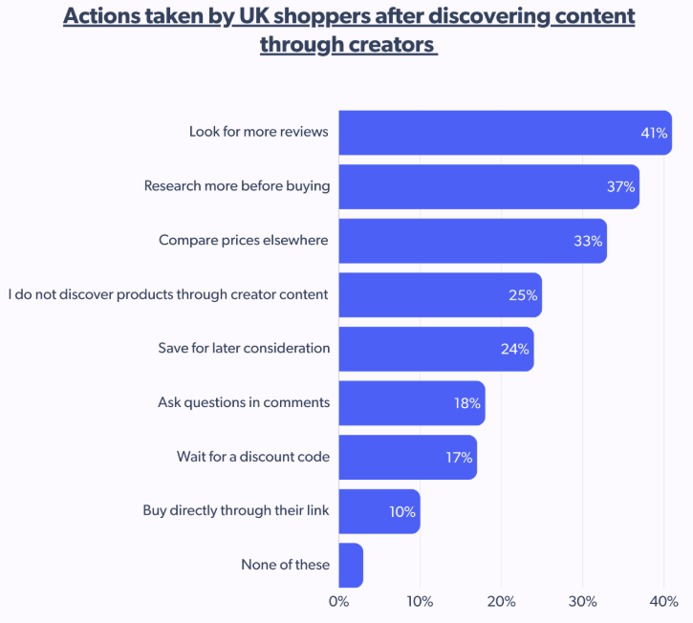
Figure 4: Activities of shoppers
(Source: Sinha, 2025)
Differentiation Strategy
The differentiators of Little Heroes are based upon Health Affordability, Provenance and Sustainability. Little Heroes will offer organic products at accessible price points ranging between £2-10 opposite to premium organic brands giving opportunity for the Morrisons to remain major supermarket chain offering a single brand of baby food. It provides customers choice between variety of organic sources, UK-grown ingredients, nutrition and affordability. Morrisons has a vertically integrated supply chain (Morrisons PLC, 2021) and established partnerships with UK Farmers having competitive advantage on transparency and local product sourcing.
Sustainability is an important element of the Little Heroes differentiation. Growing environmental awareness cautioned parents to increasingly seek recyclable packaging with lesser waste. The baby-food packaging market is projected to achieve $11.42Billion by 2032in continuously growing market supported by the increasing demand for eco-friendly materials (Fortunebusinessinsights, 2025).
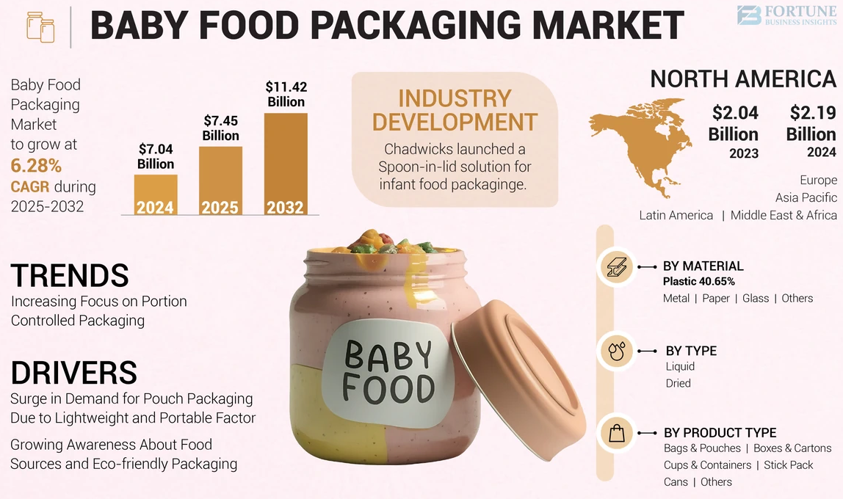
Figure 5: Baby food packaging market
(Source: Fortunebusinessinsights, 2025)
Little Heroes incorporates reduced sugar recipes, recyclable packaging, and a colourful, child-friendly design helping to support both nutritional and environmental values.
Positioning
Morrisons has positioned Little Heroes as a "Healthy, fun and affordable food for growing children, trusted by parents and enjoyed by kids." The brand encapsulates nutritious, fun and affordable food for children and includes safety and enjoyment. Little Heroes sits between premium organic products and not premium, standard children's snacks. The brand represents the essence of the Morrisons brand - value, quality and freshness and allows Morrisons to enter into a fast-growing, evolving niche with changing parental expectations. In the development of the Little Heroes brand, the company puts sustainability, transparency and health benefits at the forefront so that they may become a supportive partner to modern families faced with financial pressures and concerns about their health and well-being and compete with the existing brands like Ella’s Kitchen and Organix.
Morrisons
Little Heroes
Ella’s Kitchen
Health
Affordability
Heinz
Organix
KIDDYLICIOUS

Figure 6: Brand positioning map
(Source: Self-created)

Little Heroes provides Morrisons with a strategically and directionally aligned extension into the UK market because it meets the needs of the modern English families with respect to contemporary trends in nutrition, sustainability and affordability.
The STDP analysis clearly demonstrated opportunities for serving the needs of families in the UK more effectively; gaining market share and increasing long-term consumer loyalty.

Element 2: Marketing Mix (4Ps) for Morrisons ‘Little Heroes’
As Little Heroes' organic and healthy children’s food is a product-based brand extension, the 4P’s (Product, Price, Place, and Promotion) of Marketing Mix (Kenton, 2024) are critical to providing a framework for developing a strong market offer consistent with UK trends towards wellness, sustainability, and affordability.

2.1 Product
The Little Heroes line consists of a wide variety of organic, nutritious, and entertaining meals and snacks for kids ages 1 to 10. The company's product strategy is designed to encompass the four pillars of health, convenience, provenance, and sustainability demanded by parents of children in the UK today. In fact, according to The Food Foundation (2025), 84% of UK parents rate nutrition as the number one priority, while 56% consider the cost of children’s food as the number two priority.
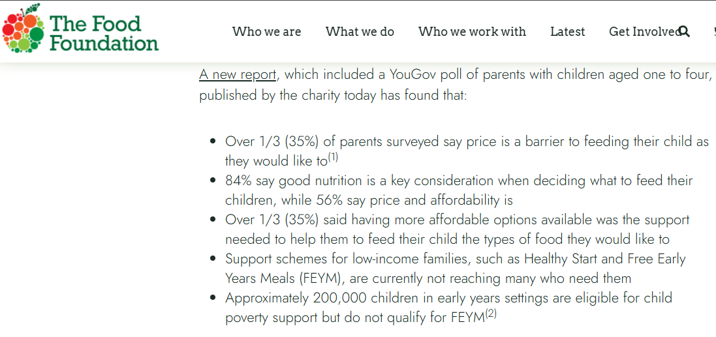
Figure 7: Parents’ priorities about child food
(Source: The Food Foundation, 2025)
Little Heroes directly meets both of these needs. The range includes:
- Organic lunchbox snacks (fruit bars, yogurt bites, mini crackers)
- Ready-to-eat meals (pasta pots, veggie bowls, lentil stews)
- Pre-portioned snack packs for nurseries and schools
- Fortified essentials (high-fibre cereals, reduced-sugar drinks, vitamin-fortified purées)
The Recipes for Little Heroes will follow UK Government recommended Nutritional Guidelines for children and will contain reduced sugar, reduced salt and high amounts of dietary fibre. According to NHS England (2024), approximately 1 in 8 children (2-10 years) in the England are classified as obese.
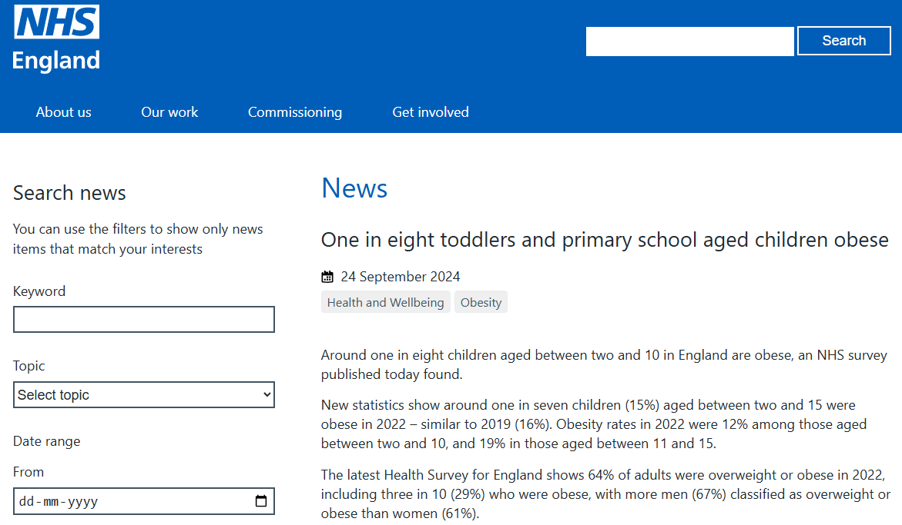
Figure 8: Child obesity in England
(Source: NHS England, 2024)
Morrisons has established a significant point of differentiation via its Vertical Integration Supply Chain and its commitment to make partnerships with over 3,000 British farmers (Morrisons PLC, 2021) to provide clear traceability and increased trust. This is important, as 66% of parents want clear provenance of ingredients (Businesswire, 2025). Moreover, the product packaging will be created using 100% recyclable materials, lightweight pouch style, and resealable tubs.

2.2 Pricing
Cost is a major consideration for most consumers and therefore is an important factor for attracting Cost-Conscious Customers (Families) in an environment where UK Food Inflation continues to be a worry. According to CGTN (2025), Food Prices were up 4.3% (year on year) in 2025, and Morrisons needs to be positioned as an Affordable retailer without compromising their position as a Retailer of Healthy Foods.
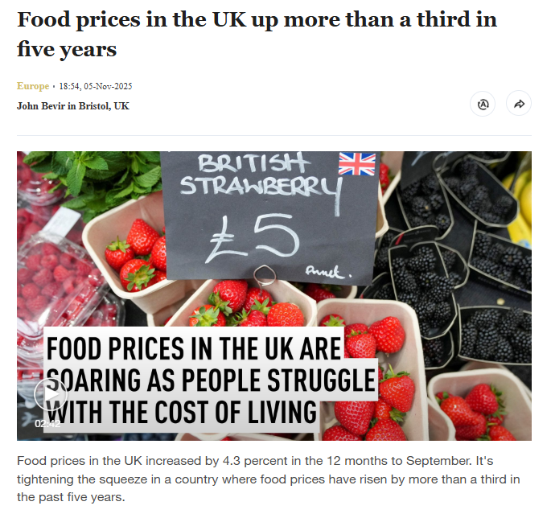
Figure 9: High food price in the UK
(Source: CGTN, 2025)
The Little Heroes product line is designed to be affordable to a broad spectrum of families by offering a price point of between £2 and £10, while remaining competitive with premium organic products, such as Ella's Kitchen or Organix, whose prices are higher. The following pricing strategies will be used for Little Heroes products:
- Psychological Pricing: This pricing is based on emotional motivations rather than intellectual ones. The organic nature and freshness of the product of Little Heroes brand will target the parents who are worried about the nutritious value of their child’s food.
- Value based Pricing: Parents consider a nutritious diet to be a necessity, rather than an option. The UK market for Baby Foods and Infant Foods is forecast to grow to £1.15 billion by 2029 (Statista, 2024), indicating parents are willing to pay a premium for health-focused products. As such, Little Heroes will be found at a lower price point than premium brands, but at a higher price point than the generic snacks available.
- Loyalty Integration through “Morrisons More”: The loyalty programme will offer points on purchase of every product from Little Heroes.
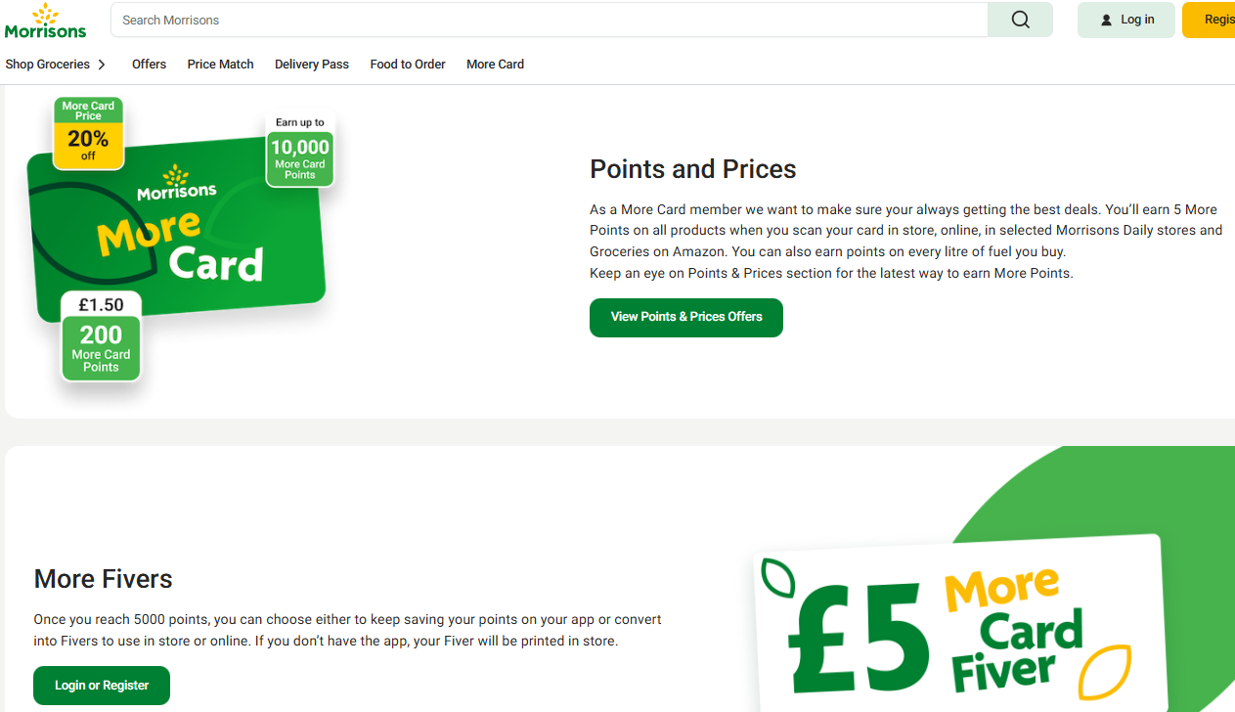
Figure 10: Morrisons More
(Source: Morrisons, 2025)
In addition to this, discounts will be available for monthly bundle like lunchbox packs. Moreover, there will be subscription-style savings for recurrent buyers. These can significantly boost repeat purchase and enhance brand loyalty, giving the brand competitive advantages.

2.3 Place
Morrisons Little Heroes will follow a multi-channel Intensive distribution strategy to ensure accessibility of maximum people. The brand will have the following distribution channels:
- In-Store Retail (Morrisons Supermarkets): Morrisons has more than 500 stores in the UK. It will allocate shelf spaces in children's food aisles, Grab & Go lunch stations, chilled sections, and fresh produce section. The products will be placed eye-level of the children with kid friendly visuals, enhancing visibility and encouraging impulse buys. The products will have clear nutritional labels for parents’ information.
- Online Shopping: With the rapidly advancing technology and customers’ preference for online shopping, online grocery sales of Morrisons have increased to 1,105.5 million in 2024 in the UK (Statista, 2025).
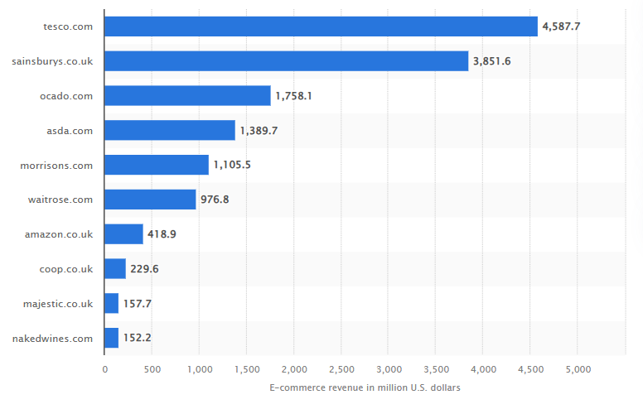
Figure 11: Online sales of Morrisons
(Source: Statista, 2025)
Following this trend, Little Heroes will have a dedicated online category pages, next day delivery options, and auto-replenish option for repeat buyers.
- Wholesale and Schools: The secondary segment, including nurseries and after-school clubs, will be served through Morrisons for Business wholesale program, bulk-packs with discounted pricing, and nutritional compliance support for school menus.

2.4 Promotion
To promote the new brand, Morrisons will firstly focus on brand awareness and increase trust among customers. As in this digital era parents highly rely on digital marketing and community feedback, a digital first and mobile first promotional strategy will be the main focus of Little Heroes.
Digital and Social Media Marketing: The brand will run its campaigns on various social media channels like Facebook to engage parents (Henström et al., 2025). It will collaborate with influencers and family bloggers to provide tutorials and give information about the products.
In-Store Marketing: The shelves containing the Brand’s product will be covered with colourful displays. Brochure about the brand will be provided in the stores which will contain details about products and their sustainability natures and there will be also a free tasting booth in weekends.
Content Marketing and Community Building: Morrisons will launch a “Little Heroes Club” offering meal plans. It will also offer nutrition tips to the parents to improve emotional engagement with the customers.
Loyalty Promotions: The “Morrisons More” app will focus on discounts, product bundles for limited time, and extra points for school lunches. Repeat purchase and customer retention can be maintained with these promotion strategies.

Element 4: Reflection
The development of “Little Heroes” brand concept of Morrisons and corresponding marketing strategy was very engaging for me with insightful experience helping me to understand how the theoretical models are implemented in the practical brand-building. The Gibb’s Reflective Cycle enabled me to critically explore the process of identifying my strengths and find out the areas of improvement.
The task involved with designing a new children’s food brand for the Morrisons to creating a strategic pitch using the STDP and 4Ps framework. I analysed the current UK retail and consumer trends, developing segmentation and positioning. It created a transparent marketing mix aligned with the recent data. Finally I made and delivered a presentation on how “Little Heroes” connects the parents with their child with nutritional, affordable and sustainable needs.
I was really excited during the development of a real-world brand proposal as it allowed me to apply the marketing theory in a creative way. During this time, I felt pressure due to the data volume required and the need for maintaining accuracy of the data with transparency in the written analysis and the marketing pitch. I felt little nervousness while presenting the strategy but as time goes, I became more confident because of my thorough understanding of the brand’s logic.
One of my key strength is the ability to collect updated statistics and integrate them in the marketing mix efficiently. This strength made the strategy more realistic and credible. I communicated the brand’s value proposition clearly pertaining to the balance of health, fun and affordability. In the meantime, I realised that I can strengthen the competitive analysis by assessing the rival brands in a more systematic way. During the pitch, I noticed that I was too much relied on the slides rather than delivering the message with confidence body language, mass eye contact, strong and willing appearance and audience engagement.
This project has enhanced my knowledge on how the segmentation and positioning decisions should align with the marketing mix choices. It improved my skills in research, while selecting the reliable market insight sources. Delivering the pitch helped me to notice about how much important is the concise storytelling in case of marketing mix, while presenting the same to the decision makers.
While going through the entire project and delivering the marketing pitch, the experiences have increased my confidence many fold in the field of brand development and strategic presentation. The project was really challenging but it helped me to improve my academic knowledge, research skills and professional confidence.
In future projects, I will exploit these knowledge and confidence, I gained from this assignment. I will deepen my competitive and customer behaviour analysis in the early stages. I have made plan to practise pitch delivery in a more extensive way to improve my presentation presence like mass eye contact, confident in body language and strong appearance while engaging the audience with voice modulation. Lastly, I will continue to develop my data analysis skill to support more rigorous marketing recommendations.

Reference list
BizzyCar (2025).U.S. Vehicle Recalls Reach Highest Quarterly Total in Nearly Two Years. [online] Prnewswire.com. Available at: https://www.prnewswire.com/news-releases/us-vehicle-recalls-reach-highest-quarterly-total-in-nearly-two-years-302583067.html.
Businesswire (2025). 72% of Consumers Consider Organic Ingredients Important in Personal Care Products. [online] Businesswire.com. Available at: https://www.businesswire.com/news/home/20250306907252/en/72-of-Consumers-Consider-Organic-Ingredients-Important-in-Personal-Care-Products.
CGTN (2025). Food prices in the UK up more than a third in five years. [online] Cgtn.com. Available at: https://newseu.cgtn.com/news/2025-11-05/Food-prices-in-the-UK-up-more-than-a-third-in-five-years-1HGoJnlHmPS/p.html.
Fortunebusinessinsights (2025).Baby Food Packaging Market Size, Share | Growth Report [2032]. [online] Fortunebusinessinsights.com. Available at: https://www.fortunebusinessinsights.com/baby-food-packaging-market-109581.
Globenewswire (2025).United Kingdom Kids Food & Beverage Forecast Report 2025: An $11.87 Billion Market by 2033 Rising at a CAGR of 6.12%, Driven by Growing Awareness and Increased Demand for Healthy, Easy Food. [online] GlobeNewswire News Room. Available at: https://www.globenewswire.com/news-release/2025/10/30/3177325/28124/en/United-Kingdom-Kids-Food-Beverage-Forecast-Report-2025-An-11-87-Billion-Market-by-2033-Rising-at-a-CAGR-of-6-12-Driven-by-Growing-Awareness-and-Increased-Demand-for-Healthy-Easy-Fo.html.
Grandviewresearch (2025).UK Organic Baby Food Market Size & Outlook, 2030. [online] Grandviewresearch.com. Available at: https://www.grandviewresearch.com/horizon/outlook/organic-baby-food-market/uk.
Henström, M., Esplin, T., Schwartzkoff, E., Duncanson, K., Popovic, G. and Ball, R. (2025). Engaging Parents With Child Nutrition and Feeding Information on Facebook: A Retrospective Content Analysis. Food Science & Nutrition, 13(6). doi:https://doi.org/10.1002/fsn3.70326.
Investing (2025).Ford Q2 2025 slides: revenue up 5% but EBIT falls 22% amid EV challenges. [online] Investing.com. Available at: https://www.investing.com/news/company-news/ford-q2-2025-slides-revenue-up-5-but-ebit-falls-22-amid-ev-challenges-93CH-4325763.
Kenton, W. (2024). Marketing Mix: The 4 Ps of Marketing and How to Use Them. [online] Investopedia. Available at: https://www.investopedia.com/terms/m/marketing-mix.asp.
Moore, C. (2022). Marketing to Parents: How to Sell to Busy Moms and Dads. [online] Heymarket. Available at: https://www.heymarket.com/blog/marketing-to-parents/.
Morrisons (2025). Say hello to Morrisons More. [online] Morrisons.com. Available at: https://www.morrisons.com/more.
Morrisons PLC (2021). Morrisons Leads Green Farming Revolution with Pledge to have First Net Zero British Farms by 2030. [online] Morrisons. Available at: https://www.morrisons-corporate.com/media-centre/corporate-news/morrisons-leads-green-farming-revolution-with-pledge-to-have-first-net-zero-british-farms-by-2030/.
Morrisons PLC (2021). Morrisons Works with Food and Drink Suppliers to Reduce Greenhouse Gases. [online] Morrisons. Available at: https://www.morrisons-corporate.com/media-centre/corporate-news/morrisons-works-with-food-and-drink-suppliers-to-reduce-greenhouse-gases/.
Morrisons PLC (2024). Morrisons trading update for Q4 and Full Year 2023/24. [online] Morrisons. Available at: https://www.morrisons-corporate.com/media-centre/corporate-news/morrisons-trading-update-for-q4-and-full-year-202324/.
NHS England (2024). NHS England» One in eight toddlers and primary school aged children obese. [online] England.nhs.uk. Available at: https://www.england.nhs.uk/2024/09/one-in-eight-toddlers-and-primary-school-aged-children-obese/.
Renub Research (2025). United kingdom Kids Food & Beverage Market Size and Forecast 2025-2033. [online] Renub.com. Available at: https://www.renub.com/united-kingdom-kids-food-and-beverage-market-p.php.
Sinha, R. (2025). UK consumer behavior gets deal-driven, digital-first, brand-selective. [online] Bazaarvoice. Available at: https://www.bazaarvoice.com/blog/uk-consumer-behavior-gets-deal-driven-digital-first-brand-selective/.
Statista (2024).Topic: Baby and children’s food market in the UK. [online] Statista. Available at: https://www.statista.com/topics/8346/baby-and-children-s-food-market-in-the-uk/?srsltid=AfmBOoq_ecFCrnZrnuGDQsSmM_7bna-ZjJq_1Soj9cnVyqMkFpasz_O1.
Statista (2025). UK: top grocery online stores 2024| Statista. [online] Statista. Available at: https://www.statista.com/forecasts/870373/top-online-stores-food-beverages-united-kingdom-ecommercedb?srsltid=AfmBOorL67FOCcYJ3G19_BB67ycq08K7jZCPWbqS0KO94V6ONW_7Qx1Q.
The Food Foundation (2025).More than a third of parents say price is a barrier to being able to feed their child what they’d like to. [online] Foodfoundation.org.uk. Available at: https://foodfoundation.org.uk/press-release/more-third-parents-say-price-barrier-being-able-feed-their-child-what-theyd.

Appendices

Element 3: Marketing Strategy Pitch

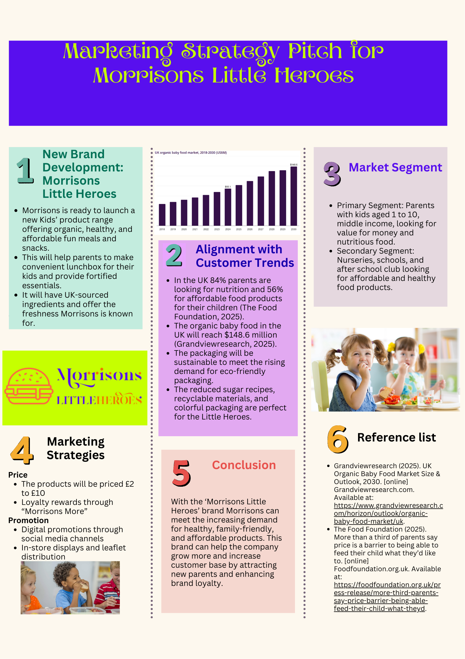
Morrisons Little Heroes
1. New Brand Development: Morrisons Little Heroes
- Morrisons is ready to launch a new Kids’ product range offering organic, healthy, and affordable fun meals and snacks.
- This will help parents to make convenient lunchbox for their kids and provide fortified essentials.
- It will have UK-sourced ingredients and offer the freshness Morrisons is known for.
2. Alignment with Customer Trends
- In the UK 84% parents are looking for nutrition and 56% for affordable food products for their children (The Food Foundation, 2025).
- The organic baby foodin the UK will reach $148.6 million (Grandviewresearch, 2025).
- The packaging will be sustainable to meet the rising demand for eco-friendly packaging.
- The reduced sugar recipes, recyclable materials, and colorful packaging areperfect for the Little Heroes.
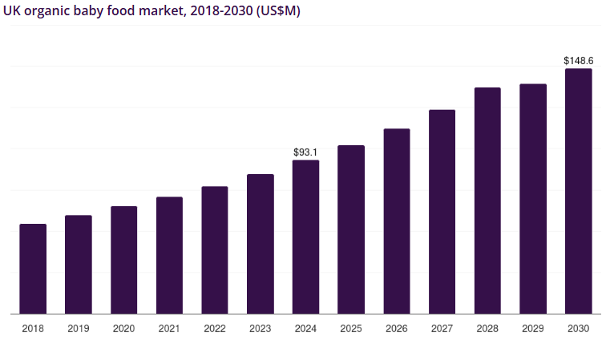
3. Market Segment
- Primary Segment: Parents with kids aged 1 to 10, middle income, looking for value for money and nutritious food.
- Secondary Segment: Nurseries, schools, and after school club looking for affordable and healthy food products.
4. Marketing Strategies
Price
- The products will be priced £2 to £10
- Loyalty rewards through “Morrisons More”
Promotion
- Digital promotions through social media channels
- In-store displays and leaflet distribution
5. Conclusion
With the ‘Morrisons Little Heroes’ brand Morrisons can meet the increasing demand for healthy, family-friendly, and affordable products. This brand can help the company grow more and increase customer base by attracting new parents and enhancing brand loyalty.

