

MBA
Master of Business Administration
Digital Marketing
LCMB7010

Digital Marketing Analysis of clothing-retail company H&M

Assignment (5000 –6000 words)
Student: Gabriela Vasileva - 2011883
Lecture: Sadeque Shaikh

Contents
Introduction 2
Digital Marketing 3
Benefits of Digital Marketing 3
The impact of Digital Marketing to Traditional Marketing 4
Digital Marketing impact in Global Business of the fashion industry 4
Digital Marketing assets, tools, and architectures 5
Digital impact on marketing mix and digital barriers affecting consumers 6
Digital Marketing performance of H&M company 6
Analysis of the Digital Assets and Infrastructure of the H&M company 6
Digital Marketing tools and Techniques of H&M company 10
Digital Communication Methods of H&M company 11
Digital Marketing Strategies and H&M activities 11
Disadvantages of the Digital Marketing 13
Artificial Intelligence Technology 14
Artificial Intelligence in Digital Marketing and Customer Behavior Analysis 14
References 16

Introduction
Living in a modern world where the innovations are changing the way how people are communicating is necessarily for small and large organizations to build solid understanding and practical skills of the digital business. This course work is going to introduce in detail the digital business and e-commerce management by critically reviewing the digital marketing opportunities and issues. In the first part provide a knowledge of the core of the digital marketing and impact to the fashion industry. Then is analyzing the digital presents of the second- largest global clothing retailer company H&M particularly for United Kingdom country. The analysis is including what types of digital tools and techniques the company is using to communicate with people and what types of strategies is integrating to attract more visitors. Second part is focusing on how the Artificial Intelligence is transforming the digital marketing industry and what can be the future usage to the companies.

Digital Marketing
Digital marketing is referring to the marketing of products or services that utilize internet and online based technologies like mobile phones, desktop computers and digital media platforms. Definition of Internet is physical network that connect computers across the world. Internet can be used for researching and identifying the customers’ need and wants. It can make anticipating by accessing channels where people can find companies information and make direct purchases. And key factor also is to satisfy the customers through good electronic channel experience as easy to use site, fast, to have acquired information and delivery details of the physical product. Digital marketing is increasing the competitiveness of the organizations by applying the digital technologies to easily link the business and people (James, n.d.). This is happening through online selling products or services by using different digitals tools, electronic communications, and digital social media channels. In other words, is a result delivered by technology that is in result of digital marketing investment. It is typical for digital marketing to be in a real-time, social, friendly, and very inspiring. Besides, digital marketing is supporting the main marketing objectives, organizational profitability, and customer retention through different marketing tactics for e-communication, data bases collection, and analyzing the customer behavior. (D. Chaffey, 2019)
Benefits of Digital Marketing
In recent years people spend more time online compared ever before and this is changing the way how they live, communicated, and spend money. Benefits of the digital marketing are created automate customers relationship process in sales, marketing, and customer services. Digital marketing is reaching more people globally and allows targeting the costumer’s far easier, faster, and precisely compare to traditional marketing (D. Chaffey, 2009). The instant access and 24/7 availabilities are also important characteristics of the digital marketing. The process of targeting exactly who you want to see the offer is saving a lot of money to the marketer and results can be measurable of the end of the campaign. Digital marketing provides a direct feedback from the consumers and this is allowing the marketers to get closer to the people needs and wants. And finally, digital marketing is increasing the sales of the company from direct online and offline sales. (D. Chaffey, 2019)

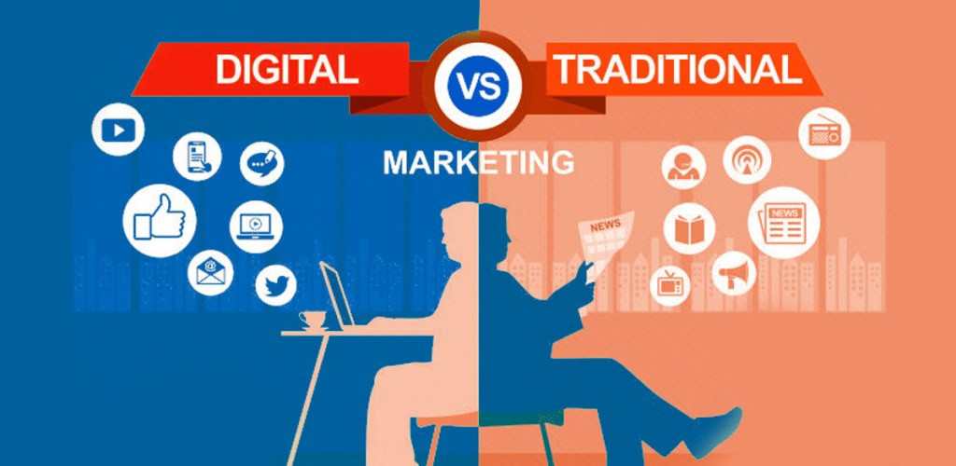
Figure 1 Digital vs Traditional Marketing (Anon., n.d.)

The impact of Digital Marketing to Traditional Marketing
The traditional marketing can be describe as attracting customers by identifying customers need and wants and applying individual marketing activities that companies are using to promote and sell goods and services. Marketing can operate and direct their products between business to business (B2B) and business to consumer (B2C). The e-commerce classification is B2B, B2C, consumer to consumer (C2C) and consumer to business (C2B). The idea of C2C and C2B is that consumer can offer a goods or service to other consumer or business (D. Chaffey, 2019).
Digital Marketing and digital technologies provide many opportunities to the traditional business and the impact on the Marketing is big. The customer relation management (CRM) and Business models are good example of that. Digital Marketing integrates and automates many of the processes in sales, marketing, and customer services. This is happening by account management as collection and analysis of relevant date about every past activities of the customers. Provides sales tools such as cross-selling and up-selling activities. Marketing fulfilment helps for direct targeting the potential customers by digital campaigns and marketing emails. And the customer service and support access in real time client database by software tools (Financial Times, n.d.).

Digital Marketing impact in Global Business of the fashion industry
People are using clothing to identifies themselves and they take an important role in daily life. The fashion industry is dramatically transforming in global scale and is changing the way that business organizations are engaging and selling the products to the customers. Reason of that is the wide range of digital marketing approach and opportunities for the companies and growing usage of internet and mobile devices. Innovations in digital world are improving the way the technologies and introducing new communicational and business models. The online impact on the consumer behavior is changing the way how consumers prefer to shopping. Main motivation is the price and product choice available one clicks a way. In fact, purchasing online is saving time and money. Before 10, 20 years was normal if you need to buy clothing to go in the physical store but now shopping but now everything is available online and is not need id to live to home. The pandemic Covid-19 also is affecting and increasing the grow usage of digital presents and digital advertisement of the companies. Now competition in the fashion retailer industry is extremely high and many companies which have traditional physical stores are moving to digital stores. (Roger Lay, 2018) The tendency more brands to be presented digitally is reflecting in the raising online sales and this is well represented in figure 1.

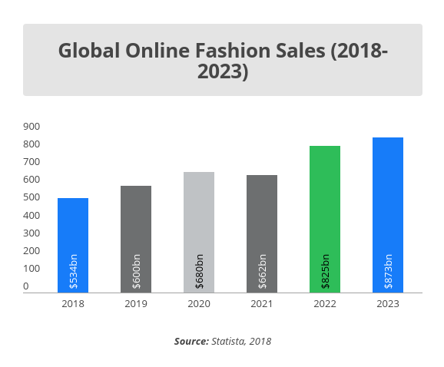
Figure 2 Illustat comparison of sales between 2018 and prediction for 2023 (Charlton, 2019)

Digital Marketing assets, tools, and architectures
The term digital assets mean digital objectives (intangible) which are owned by individual or company. Examples of based digital assets are digital: documents, content, pictures, video, and date which are stored as files in storage devices like personal computers, tablets, and a cloud-based storage network. In the digital marketing the assets are described as companies’ website, social media account, and emails. The digital marketing tools from other site are helping the marketer to create and share content, monitor and analysis the customers traffic much easier and convenient. Some examples of them are Google ad Word, Google Analytics, Google Map Facebook Advertising, and much more. The digital infrastructure is described as combination of hardware(servers), software, content, and date used to deliver digital services to the people. Digital Infrastructure also includes the digital marketing architecture of the networks, hardware, and software which companies are using to be more attractive and convenient to the customers. (D. Chaffey, 2019)

Digital impact on marketing mix and digital barriers affecting consumers
The digital marketing in some cases can negatively affect the marketing mix in different ways such as delayed communication, lack of real time resources, difficulty to reach target audience and can be expensive (D. Chaffey, 2009). Very important part of the successful digital marketing development is to understand the possible consumer barriers and digital adoption. Briefly the barriers are weak digital engagement due to no perceived benefits of digital opportunities and development. Not understanding the digital technologies and lack of skills typically for older generation. And lack of knowledge and trust using the bank details for internet shopping. Those digital barriers are challenging for every digital marketer and need to be analysis in details to minimize the risk of them.

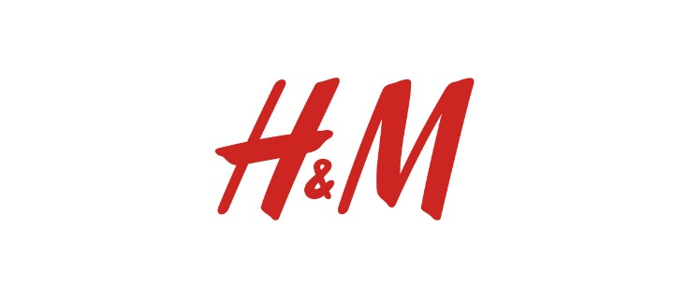
Digital Marketing performance of H&M company
The Swedish company H&M (Hennes & Mauritz) has found in 1947 by Erling Persson and run by Stefan Perrson. The original idea of the brand was to selling exclusive women’s clothing but after the company acquired hunting shop begin production to men’s collections as well. The popularity of the H&M and growing demand lead to more diversification and now company is offering a wide range of products for females, mans, kids, and for home. Now the fashion brand has 7,372 stores around the world, 74 store markets and 52 online marketers (H&M Group, n.d.). H&M company is a second largest global clothing retailer and continue to gain huge success from selling on the High Street Stores and online. The social media and digital technologies help the company to focus more on the customer and gain strong competitive advantages. The power of the online marketing in combination of latest fashion clothing on affordable price is what dive the company forward and inspire the consumers. Investigating the company website show that the H&M Digital Marketing is using wade range of engagement through different social media channels and all of them have impact on the elements of the marketing mix. (H&M Group, n.d.)

Analysis of the Digital Assets and Infrastructure of the H&M company
Digital assets of H&M for United Kingdom are the company website, social media channels: Facebook; Twitter; Instagram; YouTube, Pinterest, and software with Artificial Intelligent (AI) program for digital assistance. As well as all the content, pictures, videos, email, H&M magazine, logo, and mobile app. (H&M, 2021)These assets are clearly displayed on the main page of the company website and are easy to be seen. Investigating the main page in the H&M website is helping us to understand better the digital present of the company and what digital marketing approach is using to influence the customer behavior. (Kingsnorth, 2019)

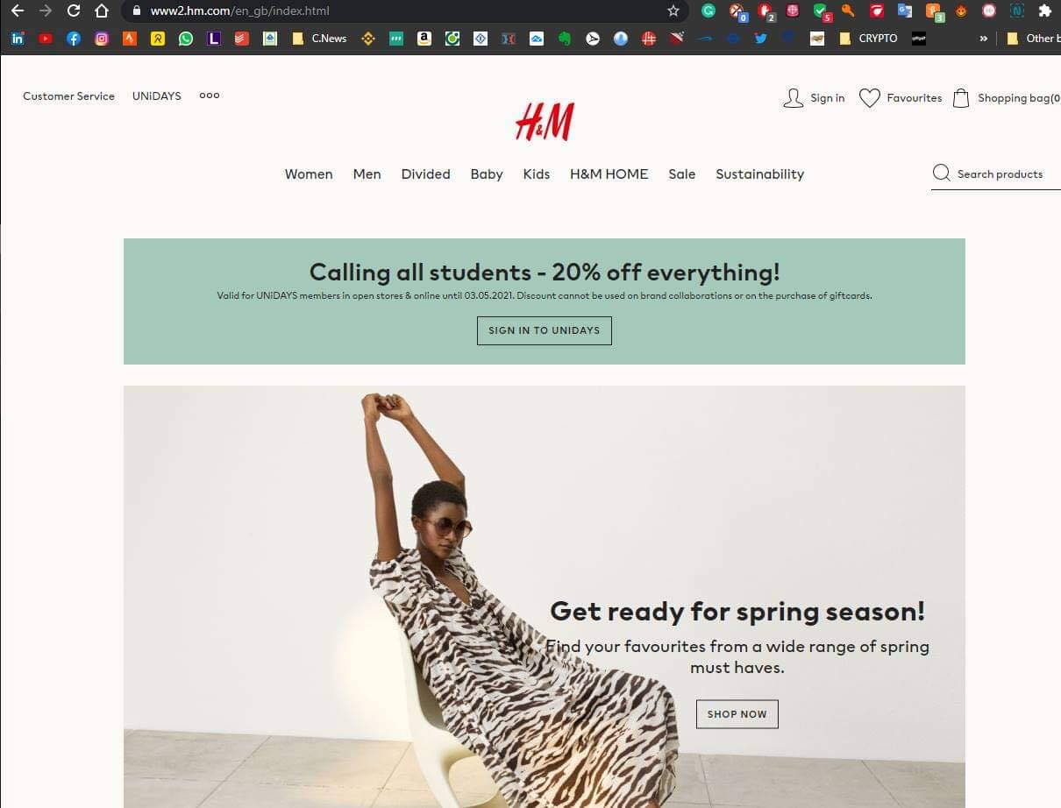
Figure 3 Website view of the main H&M page
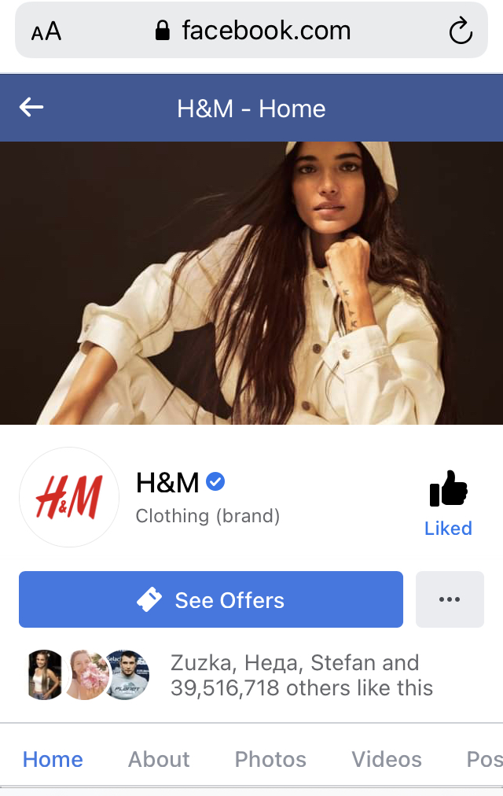
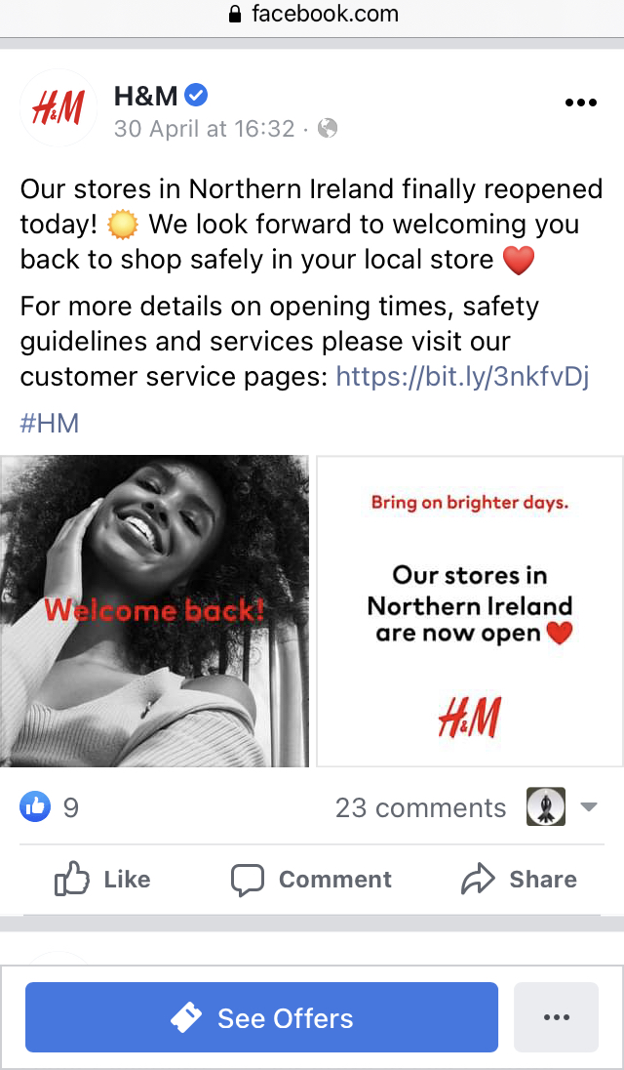
The company website has modern, stylish design with light colors of gray and is very logically structured. The main menu for products is on the top line and is including digital catalogs for: Women, Men, Divided, Baby, Kids, H&M Home, Sales and Sustainability. This is clearly presenting for who and what are the products. As well on the top have Customer service drop menu and options for store locator, navigation for sign in account, favorites, shopping bag and search box. This allows the customer very quickly to find what they need and buy. Under that company has placed the digital banners for an exclusive discount promotion, an images and content of the company proposition. They are very popular way company to advertise the products and motivated consumers to order them. Indeed, company has created a digital H&M magazine with different stories and suggestions which is great way of encouraging with audience and building brand awareness. Then in the bottom of the page has a menu with Corporate Information, Help center and Social media channels. Is important to mention that company is providing customer services menus on the top of the website and in the bottom and this is actually very useful, well visual, and easily accessible. The information include delivery, payments, return and contacts. They have Virtual assistance 24/7 which is a chatbot answering the most frequent questions and connecting with agent if need it. In the contact is as well provided telephone number and opening hours. The website is not providing email address but for more information and communication is invitation the visitors to connect to the Facebook, Twitter, and Instagram. (H&M, 2021)
Figure 4 Telephone screen view of H&M Facebook page Figure 5 Telephone screen view of the H&M post in Facebook

The Facebook H&M page is accessible from following the link in company website. To be able to discover this page is needed to have account with the social media. Facebook is the largest social media in the world with more than 1 billion users and is used for connecting the people worldwide and easily sharing content. This digital platform provides many opportunities for the business and digital marketing. Now we are going to investigate the digital present of the H&M company for United Kingdom (UK). In the front page in Facebook is the cover picture of young women with modern cloths and profile picture with the logo of the company. Displayed on the left side is a menu boxes with company information as mission and vision, posted pictures and videos. There is also a box with more options which is providing information for upcoming events, offers and community information. Observing the company information is visible that 39,425,461 people are following and almost the same number 39,422,094 are like this page and 744,753 people checked in there. Generating this traffic of people is a great benefit for the digital marketing of H&M and indicator for measurement of page development. On the right side of the page is available all the company posts or in other words digital advertisement. They are presented by pictures containing news as clothing collection, product, collaboration partners or new shops and motivational contents to fully engage the audience. Under every post are visible all comments, likes and share with friends. Typically, one post is collecting between 30 to 200 likes and around 50 to 100 comments which is quite low. Company is posting every 3 to 5 days something and replying on comments frequently. Generally, company is presented well in this social media but the engagement with people is looking weak. The contact details information is linking customers to the website and the telephone number is not provided. Another interest think is that the page has a quick button for Offers but insight is nothing. (Facebook H&M, n.d.)

Instagram is the most popular social media network for sharing a pictures and videos. Main features are uploading pictures that can be edited by filtering and pined geographical location and different hashtag. Under the post users can use the options to like the content, live a comment, tag another user, or share with Instagram friends. Sharing a post can be public or privet for page flowers. On the top of this social media is the information about the company number of posts, total followers, how many people company is following back and short description about the company. (H&M, n.d.) The Instagram page of H&M have 36.8 million followers, 6,171 posts and 512 they are following. The company description is welcoming visitors to other hm pages such as @hm_kids, @hmhome, @hm and @hmbeauty. In Instagram, the @ (at) sign is used to mention and direct customers to other pages. The page also provides a button for ‘‘view Shop’’ where followers can directly purchase from the catalog the latest collections, message the brand and sending them email. The fashion brand is crating and sharing posts every day. The content of the post is present of pictures and videos of women dressed in clothing of H&M and is very well engaging with the followers. The general performance of the company in this social media is very good and the digital marketing strategy that the brand is using are well managed to increase the brand awareness, promote new products and increase the revenue. (H&M, n.d.)

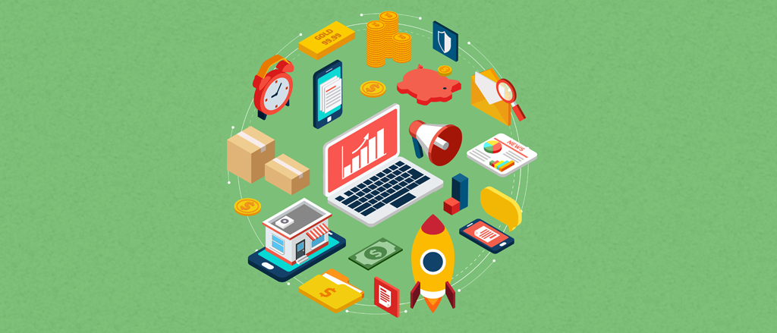
Figure 6 Digital Marketing tools and Techniques (Anon., n.d.)

Digital Marketing tools and Techniques of H&M company
The fashion brand is using different techniques to perform digital marketing and understanding them is the fundamental. There are five techniques that are applied in the digital marketing. First one is Search Engine Marketing (SEM) which is promoting the websites and is paid. This can be described as a process of generating traffic from visitors to the website. It is also increasing the company visibilities by ranking them on the top of the page. Example of SEM platforms that H&M is using are Google AdWords and Bing Ads. Second one is Social Media Marketing (SMM), which is the process referring to the use of social media and websites for promoting products or services by digital marketing campaigns and communications. Main examples for H&M are Facebook, Twitter, YouTube, and Instagram. Company also is using the SMM for tracking the customers activities and for direct feedback. Third way is Search Engine Optimizations (SEO), which is generating free traffic from organic search engine. When many people search the same website is natural coming on the top of the results. As an example, are on-page SEO and off-page SEO. As a Global leader H&M generate huge traffic and is organically on the top the searching results. The fourth way of Digital Marketing is Content Marketing which is strategic marketing that can creating and distributing relevant and valuable information to attract and engage target audience. Benefits of that are increasing sales and customer loyalty and is cost effective. The fashion brand is creating very inspirational and modern content with interactive pictures and text. And the last technic is Email Marketing which is dealing with sending emails to potential customers to develop a relationship with them. Besides H&M company is sending emails to the existing customers as well with the latest trends and products. (D. Chaffey, 2019) (H&M, 2021)
Digital Marketing tools are websites and programs that are making digital task easier to be complete, analysis and compared. H&M is using five of the largest website’s tools to maximize the company performance and they are in Google, Facebook, Instagram, YouTube, and Company website. The main Google Business tools are Google AdSense, Google Trends, Google Analytic, Google AdWords and extra. The main tools of Facebook (Fb) which H&M is using are Fb Advertising, Hosting Fb content, Sponsored Stories, Fb open graph and Fb exchange (Facebook H&M, n.d.). The digital marketing tools of Instagram are Schedugram, Repost, Picflow, Quick and Cleam (H&M, n.d.). And the digital marketing tools of YouTube are VidlQ, Agorapulse, Canva, Tubics and Biteable. All of them provide great analytical opportunities. The main company website has a very powerful digital tools such as cookies, log in details option or chatbot. The importance of those digital tools is so big because they collect personal information from consumers and management team can trac people activities and analysis the customer behavior. (D. Chaffey, 2019)

Digital Communication Methods of H&M company
Marketing communications have wade range availabilities and communicational techniques for increasing the visitors to a company’s websites. To analysis the methods that H&M company is using is need it to be review the world wide web, the domain website, and social media of the brand. The first online communication that is visible company is using Search Engine Optimization. By taping H&M as key words Google show the brand website organically on the top of the list with results. Second online communication is digital PR, company is using this communication to maximize the brand awareness by using third-party sites as social networks and bloggers that are visible to the brand target audience. H&M is using as well digital partnerships communication to create and maintain for long term the brand image. This is happening through digital sponsorships with different celebrities. Another communicational method that fashions company utilize to encourage clickthrough is Interactive advertisement or simply said digital ads. Example of them are all paid banners in the digital media. To increase the customer retention company is using email marketing and regularly is sends newsletters with the last online offers. And the final and most important digital communications which H&M is using is Social media marketing. For example, company is encouraging customers to share their experience and satisfaction in the social media and send a direct message for instant contact with the brand in case of problem. Those are the main communication methods that H&M company is integrating with people and coordinating to deliver clear message about company and products that is offering. (D. Chaffey, 2019)

Digital Marketing Strategies and H&M activities
Digital strategies are approaches that provides a competitive business advantages and apply new technologies to existing marketing activities. The strategy itself defines is future direction the organization for achieving specific goal and is long-term actions of a company. The strategies process includes a clear statement vision and objectives, strategic development, strategic implementation and monitoring the strategies effectiveness. (Achkanova, 2021)

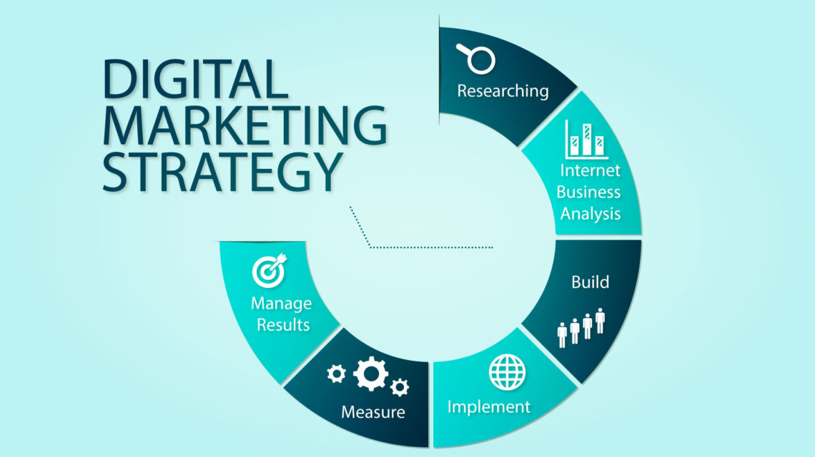

Figure 7 Digital Marketing Strategies (D. Chaffey, 2019)

The digital marketing strategies provide directions for the future Internet marketing goals. They are very different one of another but together they provide the full information for the company success. Strategies can be divided also by duration in three groups. Strategic for long term from 2 to 5 years, Tactical for medium term around 12 months and Operational for short term as day do day. Now will mention some of them and analysis others. The situational analysis involves the macro and micro environmental analysis of the company. Examples of external environmental analysis is PESTEL and Porters 5 forces model. PESTEL analysis of the political, environment, social, technological, ethical, and legal factors. The Porters model is analyzing the impact of the Internet on the 5 forces which are the Bargaining power of buyers, Bargaining power of suppliers, Threat of substitutes, Barriers to entry and Rivalry among existing competitors. The Internet marketing activities are supplementing the main marketing objectives and incorporate typical marketing formulation as STP strategy. The strategy can be explained as segmenting the customers in groups, target them by the specific needs and position the company. The resource analysis strategies are reviewing how company is utilizing together the human resources, technological financial resources, the internal structure, and SWOT together to increase the efficiency of the organizational process. The SWOT is powerful tool that companies are using to analysis the strengths, weaknesses, opportunities, and threats which are the internal resources. The SMART strategy is effective for planning and measuring the results. It is helping the organization to set and identify the goal. The SMART is an acronym that is explaining the goal features as S-specific, M- measurable, A-achievable, R- relevant, and T-time related (Kingsnorth, 2019).
The brief explanation of the Internet Marketing Strategy which is presenting six stages that need to be build and on a regular basis to be review for their effectiveness. The digital strategies provide future direction to Internet marketing activities, as the first one is scanning of the internal and external environment of the company and analysis of the factors that may affect the company performance. Second stage is developing Internet marketing strategy that will help the organization to meet the marketing goals and contribute to the overall business success. Third one is to establish a clear Interne marketing plan how is going to achieve the strategy and set a budget. Then is need it to create or update the online presents of the company. Afterwards is execute the e-marketing communication and applying digital technologies and tools. The final one is maintaining and monitor the results by employing digital metrics. Summarize the first three activities belong to strategy development and the following one to strategy execution of the company. (D. Chaffey, 2019)

Digital Marketing implementational strategy of H&M company is combination of good content, social media marketing, mobile marketing, and SEO. As an example, brand is producing valuable content specific to the different audiences through H&M app. This technology has “in store mode” that allows shoppers to find available products, size and colors in store and visual search features to find products by using customer photos. The app work with supplemented scan and find option that allows customers to scan product in store and see if is available for online order and home delivery. Those digital improvements raise the company sales, mobile usage and deliver positive client experience.

Disadvantages of the Digital Marketing
Digital Marketing have a wide range of advantages which was listed earlier but also have disadvantages too and understanding them will help the marketer to be aware of possible issues that company may experience in future. First, main disadvantages of digital marketing are weaker consumer trust from the large number of Internet scams. Second one is the level of easily accessible information generate huge competition between the brands and time bond, the shared content gets older faster. Besides the ad clutters that people receive everyday makes them to not pay attention to all digital advertising. And final one is the abilities to glitches as not working websites or different pages, mobile apps, or the Internet speed of them is to slow. All mentioned disadvantages can affect the digital marketing performance of the company by reducing the promotional campaign, traffic of customers and brand recognition.
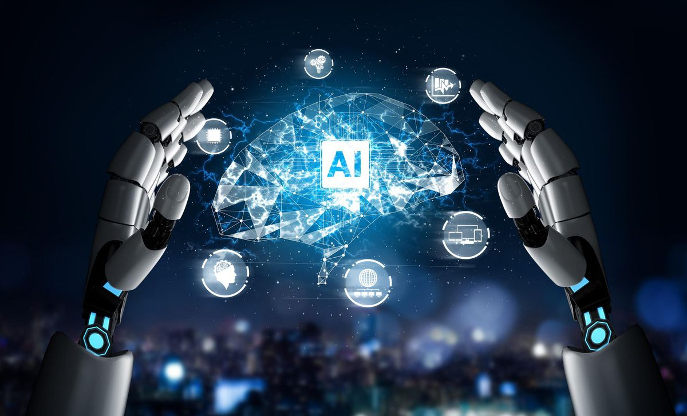
Figure 8 Artificial Intelligence (Marr, 2020)

Artificial Intelligence Technology
The definition of Artificial intelligence (AI) is a complex of algorithms and intelligence used by machines programed to think like human and mimic their activities. In other words, the AI makes it possible for machines to learn from experience and perform human-like tasks. Characteristics of AI is the abilities to think through and take actions that have the best attempt to reach the main organizational goals. The types of AI technologies are machine learning which can recognize speech and other human activities, natural language processing that can recognize human emotions, and the computer vision that can train computers to interpret and understand the visual world. The robots are programable and multifunctional machines that can help and replace human activities. Popular types of robots are mobile robots, virtual robots, stationary robots, remote controlled robot, and autonomous robot. Advantages of the robots are many and examples of that are safety to use, seed up the tasks, consistency non distractions, productive, and open 24/7. Disadvantages of the robots are need of power, regular maintenance, can be expensive and robots can reduce the people job positions. (Hall, 2019)

Artificial Intelligence in Digital Marketing and Customer Behavior Analysis

The AI is essential part of the digital marketing tasks in particularly in the target marketing and predictive customer analysis. AI marketing is a method using advance digital technology to gain insight into your target audience and to improve the customer journey. This technology can help the business to speed up many marketing activities and improve the existing marketing task in different ways. In recent years predictive analytics are the growing trend in AI and companies are invest a lot of money to used it. The Internet provide a giant data based that marketers cannot analyze all alone. The AI technology can collect useful date and analysis the customers activities on the website. That information may be used again from AI to make predictions based of the patterns and personalize special offers like products or services to the consumer. In other words, using machine learning and date analysis AI can improve the individual customer personalization and make future recommendation based on the previous interaction with the company. This is possible only when the customer is log in to the website and searching in the browser. Many big organizations are already using this method to analysis the customer activities such as product browsing history, items that you wish to buy and what services that you used. Based on that information AI can offer dynamic pricing such as discounts or to set a price of product depending on the demands, availabilities, and other factors. This is a reliable way to gain and increase overall sales of the companies. (Anshuman Sharotri, 2020)
The AI can increase the communication and interaction with visitors. This is possible by the customer service chatbots. They are programed to answer the most frequent question of consumer and assist them to find information that they need. The digital assistants are providing faster respond to the customers information, open 24/7 and if need it connecting to available agent. They also reduce the workload and like that save money to the companies from staff. Example of virtual assistant are Alexa and Siri. (Anshuman Sharotri, 2020).
The Search Engine Organization are constantly improving in different ways such as small database product searches and search engines for the big organizations. Integrating AI within search may correct the wrong spalling and provides alternatives (Hall, 2019). With AI algorithms companies can continuously and automatically optimize the brand ads depending on conversations and interactions with people. In other words, based on complex algorithms and big data the programmatic advertising system operate autonomously and is placing the right kinds of ads in front of the right kinds of customers. This is very successful strategies for the businesses advertisement because is targeting and delivering the right message. Influence the people and increase sales also is possible with content creation. In recent years this is very big part of the digital marketing. The AI technologies can help marketers to create and generate new stories and make reports easy and quickly compared to before where take hours. The automate content also can be placed it in front of the right people in the chosen social media by using digital tools such as filters (Hall, 2019).

Conclusion
This course work provides detailed information and knowledge about the digital marketing activities, tools, techniques, and digital strategies to develop the digital business success. In summary the investigating of H&M and how they interact with visitors to increase the brand value and reach the marketing objectives. Digital Marketing activities of the company shows that brand is focusing on the website together with other digital platforms and media as mobile app and social media email marketing. All those digital presets are integrated together in order to increase the company interaction with users and to add business value. The coursework reviews the Artificial Intelligence and robotics briefly and explain the future opportunities to the digital marketing. The analysis also explain how AI can help solving different marketing problems and reduce the risk of human error.

References

Achkanova, Z., 2021. Marketing strategies and their psychological impact on customers in 2020. THESEUS.
Anon., n.d. Medium. [Online]
Available at: https://medium.com/myanmar-digital-marketing/10-benefits-of-digital-marketing-v-traditional-marketing-b2f4a3886bf
Anon., n.d. Paldesk. [Online]
Available at: https://www.paldesk.com/10-best-digital-marketing-tools-to-help-grow-a-business-in-2020/
Anshuman Sharotri, S. M., 2020. Artificial Intelligence Fueling Digital Marketing for Enhanced Business Impact. Businessworld, Issue 18 June.
Charlton, G., 2019. Sale Cycle. Online Fashion Retail: 11 Essential Statistics, Issue 29 JULY.
D. Chaffey, F. E.-C. R. M. K. J., 2009. Internet Marketing - Strategy, Implementation and Practice. s.l.:Prentice Hall/Financial Times.
D. Chaffey, T. H. D. E.-B., 2019. Digital Business and E-comerce Management. 7th ed. s.l.:Pearson.
Facebook H&M, n.d. H&M. [Online]
Available at: https://www.facebook.com/hmunitedkingdom/?ref=page_internal
Financial Times, n.d. Digital ad market set to eclipse traditional media for first time. Financial Times.
H&M Group, n.d. H&M. [Online]
Available at: https://hmgroup.com/about-us/history/
H&M, 2021. H&M Main page. [Online]
Available at: https://www2.hm.com/en_gb/index.html
H&M, n.d. H&M. [Online]
Available at: https://www.instagram.com/hm/
Hall, J., 2019. How Artificial Intelligence Is Transforming Digital Marketing. Forbes, Issue 21st of August.
James, C., n.d. James Hopkins Marketing: Why Digital Marketing Is Important for Small Business. NEWSANYWAY, Issue 2020.
Kingsnorth, S., 2019. Digital Marketing Strategy. 2nd ed. s.l.:Kogan Page.
Marr, B., 2020. 3 Important Ways Artificial Intelligence Will Transform Your Business And Turbocharge Success. FORBES.
Roger Lay, D. M. L. D. D. S., 2018. Digital transformation - the ultimate challenge for the fashion industry. Deloitte, Issue 09.08.

