Component 2 - Research Report

Student Name: Waheda Begum
Student Number: 2211436
Lecturer Name: Chuen Leung

LCHS4002_BIRM

Digital Skills and Research Methods.

Contents

1. Introduction 3
2. Research design 4
2.1. Research Question 4
2.2. Method 4
2.3. Ethical Considerations 7
3. Results 7
4. Discussion 9
5. Conclusion 11
6. Reference List 12
7. Appendix A – A blank copy questionnaire. 14

Introduction.


(Edu.hku.hk,2020)

Technology is the accumulation of knowledge that enables people to create artefacts or processes by modifying the environment in order to create welfare and meet human needs. A current technological method for producing artefacts and processes is the use of tools and devices (Calderón, 2008).
Collaborative research can be defined as research that involves coordination among researchers, institutions, organisations, and/or communities (Bansal et al., 2019).
This report will look at how the researchers addressed their chosen question, 'Is there a need to provide training on how to use technology to collaborate at the University of Wales Trinity Saint David?' and how it put their hypothesis to the test. This will also enable the researchers to determine whether the collected data is statistically significant (Blog, 2017).
Hypothesis
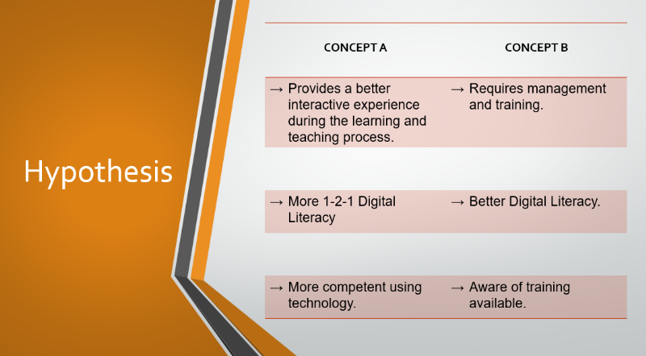
- Management and training are required for a better interactive experience during the learning and teaching process; (b) More one-to-one time is required to gain more digital literacy, and (c) Being aware of available training expands your knowledge and, as a result, your ability to use technology.

Research Design



Research Question

For this assignment, how do students use technology to collaborate the at University of Wales Trinity Saint David? 'Is there a need to provide training on how to use technology to collaborate at the University of Wales Trinity Saint David?' is the researchers chosen research question. The researchers chose this question due to the mixed knowledge and ability regarding technology usage in a classroom setting.
Throughout this research, the researchers hoped to test their hypothesis and be able to provide students with resources for additional technical support available at University of Wales Trinity Saint David that they may not have been aware of.

Method

The methodology for this study will be divided into two parts: data collection and analysis. Questionnaires will be used for data collection, and once collected, the data will be analysed qualitatively. The assignment was completed collaboratively. It was decided to collaborate with another student on the research question. Both researchers highlighted their concerns and developed their hypothesis. Once it had been agreed upon, the researchers then decided to put their hypothesis to the test.
The researchers also devised a timeline as a guide to ensure that they met their deadline and completed their presentation on time. The following steps were included in the timeline: developing the initial research idea, drafting the research proposal, finalising the research proposal, presenting the proposal, collecting data, and finally analysing the data.
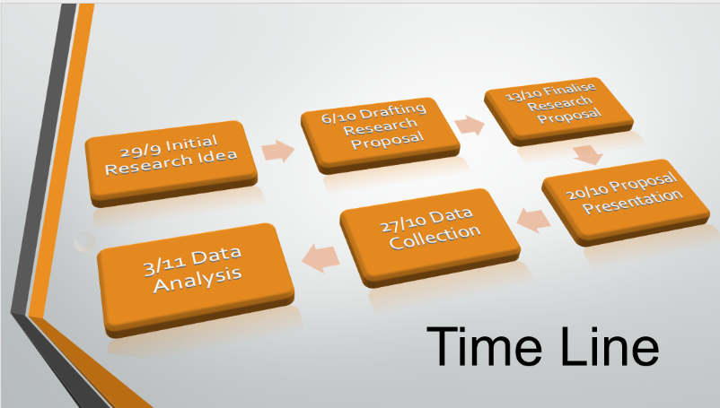
The researchers used a questionnaire to ask University of Wales Trinity Saint David students a series of questions. This was accomplished by approaching students and requesting for their permission and willingness to participate in this research.
During study hours, researchers approached two other classes - health and social - that were taking the same course. There were twenty-five individuals that took part in total. Participants were given the questionnaire on paper, which had been created in Microsoft Word and then printed. To ensure a fair outcome, researchers chose this method over the online Ms Form as they wanted to approach people of various ages, genders, and abilities to ensure a fair outcome. This was accomplished by performing it in person. The researchers returned at the end of the day to collect the completed questionnaires from the students.
This method was successful because the participants were keen to provide verbal feedback and input to aid with the research.
The following questions were posed: 1) Do you give consent for data collection? 2) How confident are you in using technology to collaborate? 3) Are you aware of any technical support being provided at the University of Wales Trinity Saint David? 4) What do you think will help you be more confident in using technology to collaborate? Finally, age and gender must be considered.
The results were then organised and graphed for easy comparison and testing of their hypothesis.
The researchers then decided on the structure of their presentation and the information they wanted to present on each slide. The following are the contents of their presentation on their chosen research question.

- Introduction
- Hypothesis
- Timeline
- Is there a need to provide training?
Questionnaire
Data Collection
Ethical Consideration
- Training Available
- Facts
- Conclusion
After the presentation ended, the audience was requested to take a picture of a QR code that the researchers had generated. This would then take the audience to an online Ms Form for feedback.

However, because the presentation was only presented in front of their tutor, the researchers were unable to receive any constructive feedback.

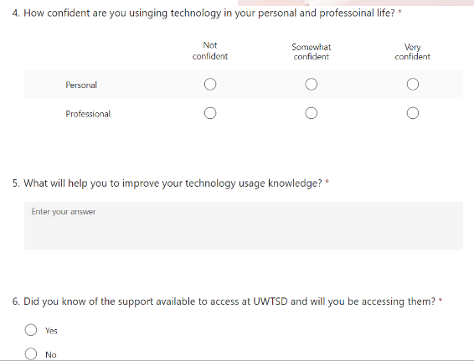
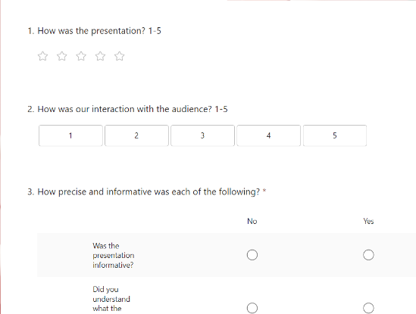

Ethical Considerations

In research, ethical considerations are a set of principles that guide your research designs and practices. When collecting data from people, researchers must always follow a set of rules. (Bhandari, 2022)
Throughout the research, the researchers were very careful not to reveal any personal information about any of their twenty-five participants. They accomplished this by ensuring that everything was kept anonymous and that only their consent, age, and gender were requested. Furthermore, the researchers made certain that they did not ask any questions that would reveal or imply that a participant might require additional assistance. As a result, the researcher’s research and findings would be fair and true when tested against their hypothesis.

- Results

In the form of graphs, the researchers presented the details of their research findings.
Questions one, two, and three are shown below. As we can see, all twenty-five of their participants has agreed to take part in the research.
It can also be seen that eighteen of the participants are at ease with technology, while the remaining seven are not.
The findings also show that twenty-two students are aware of the available technical support, while three are not.

Question four allowed participants to freely express and share what they believed would help them be more confident while collaborating with technology at the University of Wales Trinity Saint David. The results were then categorised as group, one-to-one, and both.
The graph shows that ten participants preferred group learning. Twelve participants said they preferred one-to-one learning, while the remaining four said they preferred both methods of learning to help them be more confident using technology to collaborate.
Finally, questions five and six are shown, with the age group and gender indicated. The researchers chose these questions with the understanding that no personal information would be disclosed and that everything would be kept confidential.
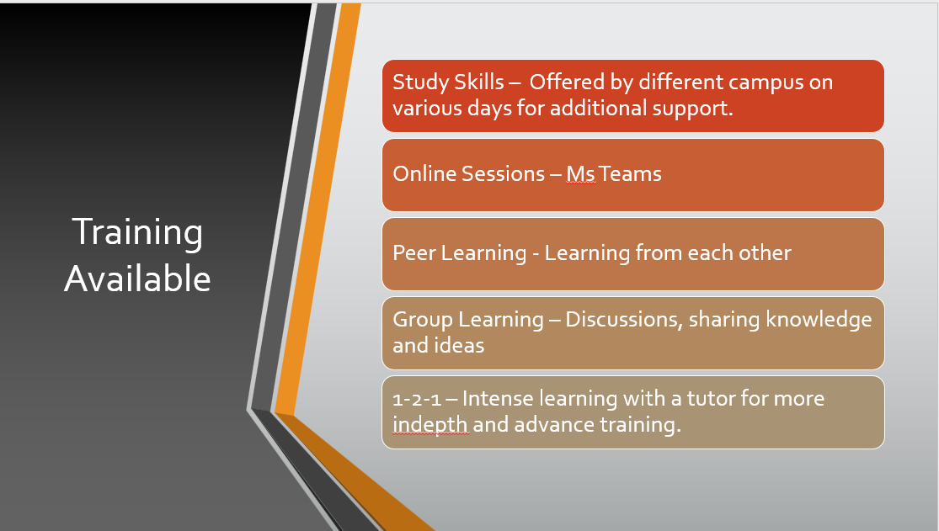
The researchers then continued to support the participants by informing them about the various types of training and support that are available to them. For example, different campuses may offer study skills sessions on different days. Online meetings - Microsoft Teams, Zoom. Peer learning from one another. Group learning via discussions, knowledge sharing, and ideas, followed by one-to-one intensive learning with a tutor for more in-depth and advanced training.

Discussion

According to the researcher’s findings, questions two and three clearly show that twenty-two participants are aware of the technical support provided and available for additional assistance at the University of Wales Trinity Saint David, with eighteen participants stating that they are confident in using technology to collaborate. This confirms that those eighteen participants have most likely taken advantage of the additional assistance available.
In response to question four, twelve participants from the University of Wales Trinity Saint David suggested that one-on-one learning is more effective than group learning for providing support on how to use technology to collaborate.
Furthermore, during the researcher’s presentation, slide eight a page of facts backed up their research.

According to the first fact, students' active technology-based learning strategy can support students' constant learning, absorb knowledge, and strengthen their skills when performing cognitively challenging tasks (Tsuei, 2011).
It appears that active in-class learning also provides students with informal feedback on how well they understand the material (www.queensu.ca, n.d.).
The second fact mentioned tools at the University of Wales Trinity Saint David provides the opportunity to use the Information and Communication Tools application in a technology-enhanced digital skills lesson. Digital skills here refer to the use of digital devices, communication, and social networking via the Information and Communication Tools application (Sun, Zhang and Kok, 2019) emphasises how Information and Communication Tools assist students in developing new skills and becoming more creative. Information and Communication Tools encourage the development of both imagination and initiative. It improves students' academic performance while also vastly improving their classroom experience (Francesc, 2021).
Information and Communication Tools could support collaborative learning as an interpersonal communication tool to support collaborative learning strategies used in face-to-face settings, as well as computer-supported collaborative learning, which focuses on facilitating the negotiation of meaning among a group of learners (Ching Sing Chai, Chee and Tan, 2010).
Lastly, the third fact mentioned in the slide talks about collaborative learning strategies, in which students collaborate to achieve academic goals, which have been identified as promising classroom-based techniques. (Oikarinen et al., 2022) this can be seen suggesting that when educators collaborate, they form important professional and personal bonds. Teachers frequently rely on one another for support and can delegate tasks that allow each teacher to feel effective. Collaboration among teachers helps to improve schools’ and students' success (Arkansas State University, 2017).
Furthermore, simply providing access to technology is insufficient. All learners must develop meaningful technology-based knowledge to maximise their learning (OECD, 2010). There will be challenges encountered during the implementation of the proposed training programme, such as the availability of resources. Some training resources may be unavailable at the University of Wales Trinity Saint David, which will cause a problem. Another difficulty will be the amount of time required to complete the training programme.
The solution to the aforementioned challenges is to find ways to overcome them. University of Wales Trinity Saint David, for example, could devise a timetable that allows for more time to complete the training programme. Furthermore, the University of Wales Trinity Saint David could coordinate various training programmes so that they are integrated into a unified programme. Finally, by using less expensive tools and platforms, the University of Wales Trinity Saint David could reduce the cost of the training programme (Ahmadi, 2018).
The researchers therefore can confidently state that the findings of their research can be confirmed as true and tested against their hypothesis which has been supported by facts.
Technology improves the interactive experience of learning and teaching; however, it necessitates management and training. The more one-on-one training you receive, the better your digital literacy will be, and in order for students to be more competent in using technology, they must be aware of the training and support available.

- Conclusion


After conducting their research, the researchers have discovered that in order to collaborate successfully using technology, students must use the resources available at the University of Wales Trinity Saint David.
By utilising technology to facilitate a collaborative approach to education, teachers can provide a more dynamic learning experience. Classes can be tailored to meet the specific needs of each student.
Using online tools allows students to work at their own pace and pursue interests while interacting with their peers (Entertainment et al., n.d.).
The training provided will help students improve their understanding of technology usage, and as a result, students will be more confident in collaborating using technology.
Research also suggests that one-to-one learning can be effective and beneficial as most students will learn at their own pace and with a better understanding; however, these advantages can only be realised in an active and operational learning setting.

- Reference List
‌‌Ahmadi, Dr.M.R. (2018). The Use of Technology in English Language Learning: A Literature Review. International Journal of Research in English Education, 3(2), pp.115–125. doi:10.29252/ijree.3.2.115.

Arkansas State University (2017). The Importance of Teacher Collaboration | A-State Online. [online] A-State Online. Available at: https://degree.astate.edu/articles/k-12-education/importance-of-teacher-collaboration.aspx.
‌Bansal, S., Mahendiratta, S., Kumar, S., Sarma, P., Prakash, A. & Medhi, B. (2019). Collaborative research in modern era: Need and challenges. Indian J Pharmacol., 51(3), 137–139. 10.4103/ijp.IJP_394_19
Bhandari, P. (2022). Ethical Considerations in Research | Types & Examples. [online] Scribbr. Available at https://www.scribbr.co.uk/research-methods/ethical-considerations/.
Blog, F. (2017). Hypothesis Testing: Definition, Uses, Limitations + Examples. [online] www.formpl.us. Available at: https://www.formpl.us/blog/hypothesis-testing.
Calderón, C.E.J. (2008). Technology Research Methodology. [online] gestiopolis. Available at: https://www.gestiopolis.com/technology-research-methodology/.

Ching Sing Chai, Chee, S. and Tan (2010). Collaborative Learning and ICT. [online] Available at: http://cogtools.weebly.com/uploads/6/9/3/8/69389575/04_collaborative_learning_280409.pdf.
Edu.hku.hk. (2020) Dialogic Teaching: Developing Effective Online Pedagogy For Productive Dialogue – E-Learning Team. [online] Available at: https://elearning.edu.hku.hk/2020/04/13/dialogic-teaching-developing-effective-pedagogy-and-dialogue-in-online-learning-environments/ [Accessed 27 Oct. 2022].
Entertainment, J.K.J.K. is the co-founder of A., co-creator, Smarted? host of the podcast W. and Games, showrunner of N.G.B. (n.d.). Why Is Collaborative Education Key in 2022? [online] Technology Solutions That Drive Education. Available at: https://edtechmagazine.com/k12/article/2022/06/why-collaborative-education-key-2022.
Francesc (2021). Using ICT tools in class. [online] Additio. Available at: https://additioapp.com/en/using-ict-tools-in-class/.

Organization for Economic Co -operation and Development (OECD 2010). Are the new millennium learners making the grade? Technology use and educational performance in PISA: Centre for Educational Research and Innovation, OECD.
Oikarinen, R.M., Oikarinen, J.K., Havu-Nuutinen, S. and Pöntinen, S. (2022). Students’ collaboration in technology-enhanced reciprocal peer tutoring as an approach towards learning mathematics. Education and Information Technologies. doi:10.1007/s10639-021-10799-3.
‌Sun, Y., Zhang, C. and Kok, Robert A. W. (2019). The role of research outcome quality in the relationship between university research collaboration and technology transfer: empirical results from China. Log in, [online]. Available at: https://link.springer.com/article/10.1007/s11192-019-03330-6. [Accessed 1 Jan. 1970].
Tsuei, M. (2011). Development of a peer-assisted learning strategy in computer-supported collaborative learning environments for elementary school students. Citing Literature, [online] 42, (2), pp.214-232. Available at: https://bera-journals.onlinelibrary.wiley.com/doi/abs/10.1111/j.1467-8535.2009.01006.x. [Accessed 1 Jan. 1970].
www.queensu.ca. (n.d.). Active Learning Strategies. [online] Available at: https://www.queensu.ca/teachingandlearning/modules/students/22_active_learning_strategies.html.
‌

- Appendix A – A blank copy questionnaire.



