Marketing Fundamentals
LCBB4004
Student Name:Alexandru Baractaru
Student ID:2129397
Lecturer: Dr Mohammad Rahman

Table of Contents
Introduction 3
STP Process 3
STP process of Marks & Spencer 3
Segmentation Process of Spencer 4
Targeting Strategy of Marks & Spencer 4
Positioning Strategy of Marks & Spencer 5
Marketing Mix: A Collection of Marketing Tools 5
Marketing Mix of Marks & Spencer 5
Primary Four P's of Marks & Spencer 6
Subordinate 3 P's of Marks & Spencer 7
Conclusion 7
References 8

Introduction
Marketing is defined as a activity of promoting, selling, distributing which a firm undertakes to promote the desired product or service(Pride & Ferrell, 2020). This is a significant tool of involving actions undertaken by company to engage the customers with its product and maintain relationship with them to accomplish business success and growth. This study aims to elaborately illustrate the STP Process and Marketing mix of the renowned company "Marks & Spencer" and how these tools affect a company's Relationship and engagement with customers.

STP Process
STP is a marketing signification that benefits the process to assess and determine the most profitable market for certain product or service. Utilization of marketing models converts business tools and sales strategies easier to manage and communicate with the targeted audience. Marketing through segmentation, targeting, and positioning (STP) benefits firms to determine their specific target audience and build marketing campaigns accordingly(Armstrong et al., 2023). This marketing tool is hugely recommended as it provides a platform for a company to identify the most desired and profitable customer base and simultaneously develop products or services tailored to the needs of those customers. This model gives access to make collaboration with each target audience with more efficiency. This could help a company to grow its sales and continuously achieve organizational goals.

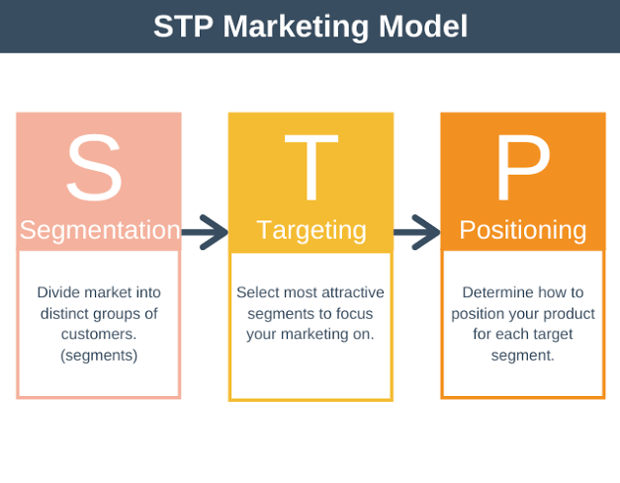
Figure Name: STP Marketing Model
Source: (Armstrong et al., 2023)

STP process of Marks & Spencer
Marks & Spencer is one of the best luxury brands in the globe which combines comfortability and Styling to make a unique fashionable pattern in its clothing which tasteful finishing touches to the customers. The company specializes in styling, fashion, and comfortable products selling products of beauty, clothing, home, and food products. The company has made a very specific and analytical STP model that is contributing to the company's success and growth more rapidly and effectively (Marks & Spencer and the internationalization, 2007). The Segmentation of M&S benefits the company to manage sustainability and business growth in its operations. Here we would individually analyze the Segmentation, Targeting, and Positioning process of M & S.

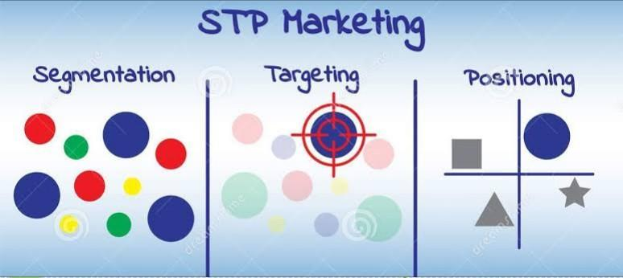
Figure Name: STP Model of Marks & Spencer
Source: (Bodea, 2013)

Segmentation Process of Spencer
The procedure of dividing a company's target audience into separate groups of future buyers with similar characteristics is known as Segmentation(Bodea, 2013). This process primarily includes four kinds such as demographic, geographic, psychographic, and behavioral segments. It is very significant for companies to understand each of time segments to tailor the products and offerings and to last longer in the competitive market. MARKS & SPENCER has considered all four of the segmentation types. The demographic section is considered based on age, gender, personality, and Income earnings; the Geographic section considers advanced locations; the psychological section has considered the lifestyle, interests, personality, opinions, and activities of the target audience. The firm uses psychographic segments to carve up the potential buyers into different sections. Last but not least the behavior section included engaging frequently with products, customer loyalty, and so on.

Targeting Strategy of Marks & Spencer
Market Targeting refers to the breakdown of the target customers into segments and then planning marketing functions and procedures that will impact the divided sections that would be most responsive to the marketing efforts and functions(Dibb & Simkin, 2004). It is beneficiary for aims to boost the successful firms have in outstretching the potential audience. MARKS & SPENCER has targeted the youngest and middle-aged groups of people from 15 to 55 years of age in demographic sections and it also took into consideration of Clothing interested or enthusiasts people and high-income earners to offer the products of the company. The gender-based subsection is for all kids, men, and women of the specified age generation. Consider the geographical section, emphasizing the Urban areas and highly sophisticated international locations as those locations include most likely high-income groups. MARKS & SPENCER''s psychographic segment gears offering its buyers a selection of products which is matched people relatively engaged with Clothing and their personality, lifestyle, and activists are most likely to be connected to the Clothing industry. Moreover, the company has emphasized customer loyalty and regular purchasing people that engage with their product and offerings significantly.

Positioning Strategy of Marks & Spencer
Effective positioning illustrates a product as unique and engages the customers to consider using the offering as a specified benefit to the people. Positioning determines where a firm's product stands compared to others provided offering the same products and services in the market and what idea the product generates in the head of the potential customers(Ries et al., 2013). Marks & Spencer has been able to position its products as the most desired Clothing products in the market by using innovative technology to improve products and provide premium comfortability to the users compared to their counterparts in the marketplace. It has the vision to excel in making a connection between the products and successful prominent Clothing person to build brand awareness among its present and potential customers.
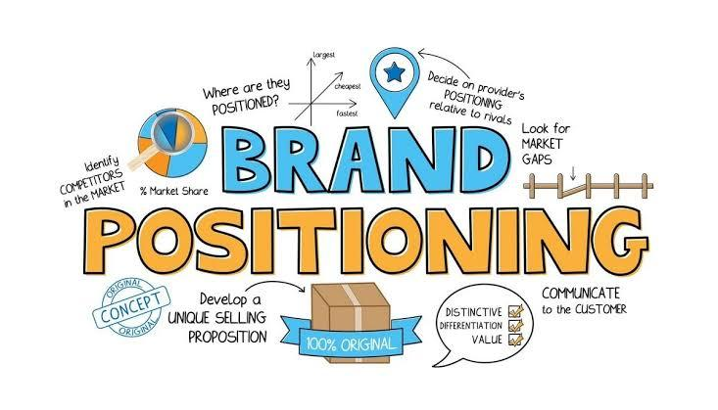
Figure Name: Brand Positioning
Source: (Ries et al., 2013)

Marketing Mix: A Collection of Marketing Tools
The "collection of marketing tools that the firm utilizes to accomplish its marketing objectives in the target market" is what the Chartered Institute of Marketing refers to as the "marketing mix." To put it another way, the marketing mix is the "collection of marketing instruments that the firm utilizes to pursue its marketing objectives in the target market (Westhuyzen & Merwe, 2017)." An effective marketing mix benefits a corporation in numerous ways such as providing a proper understanding of what a product or service can offer to the desired buyers, giving direction to plan a successful product offering, benefits planning, and improving and managing effective marketing operations and tools. Moreover, it helps a firm in maintaining business success and avoiding any unnecessary expenditures and situations.
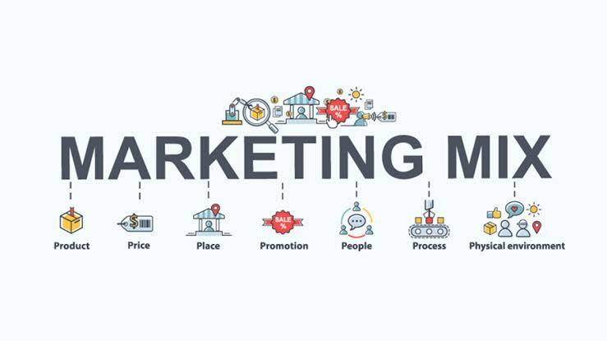
Figure Name: Marketing Mix
Source: (Westhuyzen & Merwe, 2017)

Marketing Mix of Marks & Spencer
The marketing plan for Marks & Spencer analyzes the company's leading brand using the seven elements that make up the marketing mix (Product, Price, Place, Promotion, Process, Physical Evidence, and people ). The marketing mix is made up of many different components, such as but not restricted to product development, price policy, promotional strategy, and others. As you can see from the previous statement, the foundation of these commercial tactics, which have proven successful for Marks & Spencer, is the marketing mix of the business. The marketing plan used by Marks & Spencer helps the business solidify its presence in the world and opens the path for it to meet its financial goals.
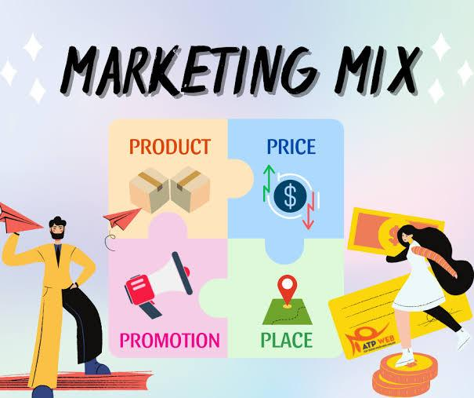
Figure Name: Four P's Of Marketing Mix
Source: (Smith, 2017)

Primary Four P's of Marks & Spencer
Product Strategy: The department store brand Marks & Spencer was founded in the UK and has since gained acclaim and popularity on a global scale. The selling of a wide variety of goods appropriate for kids and individuals of all ages is part of Marks & Spencer's marketing strategy. To accomplish its goal of obtaining and promoting environmentally friendly products, the company has been working with sustainable vendors(Ferrell & Hartline, 2008). The natural environment is not harmed in any way during the production of such products. Whenever possible, recyclable materials are used in the product packaging.
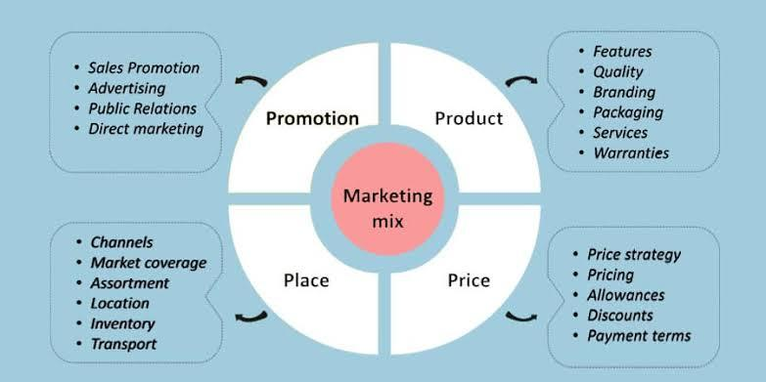
Figure Name: Components under 4P's of Marketing Mix
Source: (Kelley & Sheehan, 2017)

Pricing Strategy: For its product assortment, Marks & Spencer uses a competitive price differentiated marketing strategy. The company's goods are less expensive. With this strategy, it will be simpler for more customers to support the company's environmental objectives(Smith, 2017). The company also takes into account value-based pricing because it gives greater discounts on products to attract more customers and often lists the older stock at a lower price than the more recent stock.
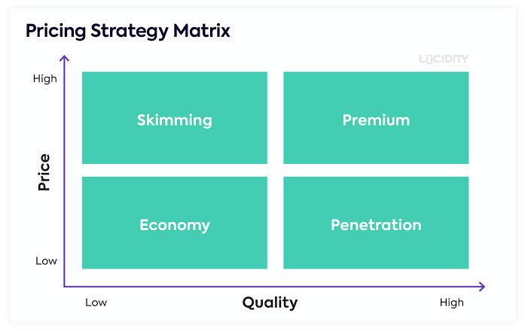
Figure Name: Pricing Strategy Matrix
Source: (Altman, 2021)

Promotional Strategy: Marks & Spencer chooses its marketing approach extremely carefully so that it can work in tandem with department store management, digital marketing, and its promotional campaign (Kelley & Sheehan, 2017). M&S wants to convey a unified message across all communication channels. Additionally, the marketing plan inspires more individuals to protect the environment. The supply chain is finished utilizing the greatest methods for protecting the environment.
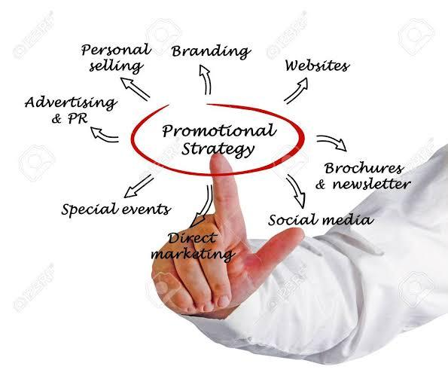
Figure Name: Promotional Strategy
Source: (Kelley & Sheehan, 2017)
Placement Strategy: The sustainability of M&S's premises and retail spaces was stressed. The achievement of CSR goals and objectives also places a high priority on energy saving. Marks & Spencer has a website where people may order things and have them delivered to their homes. For a select few products, M&S also offers the option of international delivery.

Subordinate 3 P's of Marks & Spencer
People Strategy: Marks & Spencer provides specialized programs such as training and development schemes for its new trainees. These programs give opportunities to pursue other career opportunities as they become more skillful in handling customers through improvising their interpersonal skills (Altman, 2021). M&S also places a strong emphasis on diversity in each location to encourage the hiring of women by implementing more female-friendly rules.
Process Strategy: Malls and suburban regions are where you can find Marks & Spencer stores. Compared to other stores like Pantaloons, Wills Lifestyle, etc., these stores are gorgeous and well-organized.
Physical Evidence Strategy: Marks & Spencer operates its functions over a thousand stores spread across more than 50 countries globally. Marks & Spencer manages most of its business in the United Kingdom, where it manages more than 850 stores.

Conclusion
Segmentation, Targeting and Positioning process as combined improves the emphasis, relevance, and personalization of a firm's marketing communications for the target audience(Baines et al., 2013). Simply said, STP is a marketing strategy in which the company categorize its specified audience, engages the audience groups that are most appropriate for the offering, and places that product to successfully reach your target segment. Marketing mix and STP process both are vital marketing tools to reach the targeted audience and help the company to make improved relations with them to fulfill business goals and objectives.

References
Altman, J. (2021) People strategy: How to invest in people and make culture your competitive advantage. Hoboken, NJ: Wiley.
Armstrong, G., Kotler, P. and Opresnik, M.O. (2023) Marketing an introduction. Harlow: Pearson Education Limited.
Baines, P., Fill, C. and Page, K. (2013) Essentials of marketing. Oxford: Oxford University Press.
Bodea, T. (2013) Segmentation. London: Routledge.
Dibb, S. and Simkin, L. (2004) Marketing briefs: A revision and study guide. Amsterdam: Elsevier Butterworth-Heinemann.
Ferrell, O.C. and Hartline, M.D. (2008) Marketing strategy. Mason, OH: Thomson South-Western.
Kelley, L.D. and Sheehan, K.B. (2017) Advertising strategy: A 360 degree brand approach. Irvine, CA: Melvin &amp; Leigh, Publishers.
“Marks &amp; Spencer and the internationalization offashion” (2007) Fashion for the People [Preprint]. Available at: https://doi.org/10.5040/9781847887160-ch-005.
Pride, W.M. and Ferrell, O.C. (2020) Marketing. Boston, MA: Cengage.
Ries, A., Trout, J. and Wied, L. (2013) Positioning: Wie marken und unternehmen in übersättigten Märkten Überleben. München: Franz Vahlen.
Smith, T.J. (2017) Pricing strategy: Setting price levels, managing price discounts, &amp; establishing price structures. Delhi, India: Cengage Learning.
Westhuyzen, B.V.der and Merwe, J.V.der (2017) The marketing mix. Mowbray, South Africa: Future Managers.

