Electro Hydraulics and Pneumatics
M4X00385

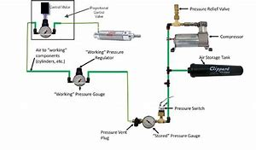

Matthew Porch

Introduction
For this assessment the task was to design and construct a Pneumatic circuit, this must include circuit diagrams, costings along with evidence such as photos of the constructed circuit on the Mechatronic training rig.
The task, in a polymer processing plant, blister pack thermoplastic sheets are to be welded together. The two sheets are placed onto a fixture which contains a heating element, with another heating element lowered to make contact with the sheets, this is fixed to two double acting cylinders, A and B, which extend and retract simultaneously. The sheets are to receive 12 seconds of contact then the heating element retracts once welded together. The whole process is contingent on a guard being lowered which will initiate the extension of the elements, once complete the guard will raise to allow new sheets to be placed in position to start the process all over again.
Statement of the problem
If A and B are to be the two double acting cylinders that move the mobile heating element and if cylinder C (single acting) move the guard. First cylinder C extends bringing down the guard. Cylinders A and B then simultaneously extend, pressing together the thermoplastic sheets. The position is then held for 12 seconds. Once complete, cylinders A and B simultaneously retract, cylinder C can then and only then retract once both cylinders A and B have fully retracted.

Control task using notational form:
Cylinder A advancing step is designated as A+
Cylinder A retracting step is designated as A-
Cylinder B advancing step is designated as B+
Cylinder B retracting step is designated as B-
Cylinder C advancing step is designated as C+
Cylinder C retracting step is designated as C-

Therefore, given sequence for the guard and pressing is C+A+B+A-B-C-
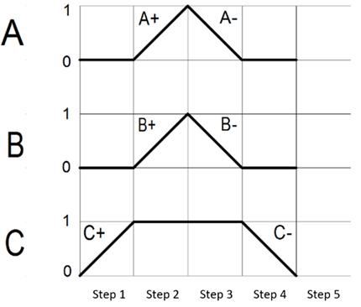

Health and Safety
While working within the workshop, safety was paramount at all times. So, with this in mind and following certain rules formed from the health and safety at work act 1974, PPE was worn at all times. In our case this was safety glasses, as we were working with HP air this was very important to follow and also use brother’s keeper to ensure the safety of our peers. Before starting on the Mechatronics rig, first job was to ensure we had a means of fire escape from both sides of the room, once this was achieved the next thing was to ensure that sufficient space around the rig both on the floor to eliminate slips, trips and falls, removing any bags and tidying any fallen components and also around the tool chests. This not only made constructing the circuit easier but also in the event of an emergency we could exit the workstation in a safe and controlled manor. By sticking to the rules, it eliminated many hazards, such as isolating the air supply when making alterations on the rig. ERIC PD should be followed when assessing the risks, Eliminate, Reduce, Isolate, Control, PPE and Discipline.

First up was to construct my pneumatic circuit on the Mechatronic rig in the workshop:

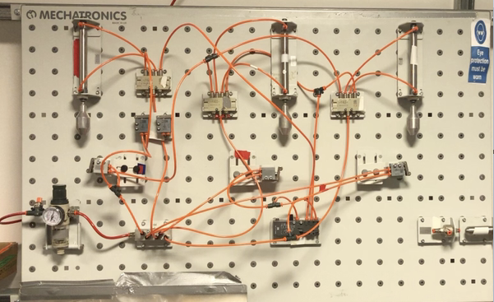

Above is the finished circuit, but to get to this stage it took a lot of fault finding, time and effort. Problems that I faced, double acting cylinders failing to extend. And the cycle wasn’t lasting the 12 seconds as stated in the task. One method I used was the half split technique, once I had constructed the circuit and it wasn’t working correctly, as the name suggests, I split the circuit in half and checked at the half-way point in case of an absence of an output. This helps to isolate the failing circuit in the first or second part. When I had determined the fault/issue, I could then split that half into half again for further isolation. This splitting is continued until the fault or component issue was found. In my case a lot of my issues came from the components of the rig, such as faulty manifolds or sticking switches. After changing component’s, I finally had my circuit up and running.

Using my knowledge from constructing the circuit on the rig, I then drew and simulated the circuit using the CAD OFT2 software below:

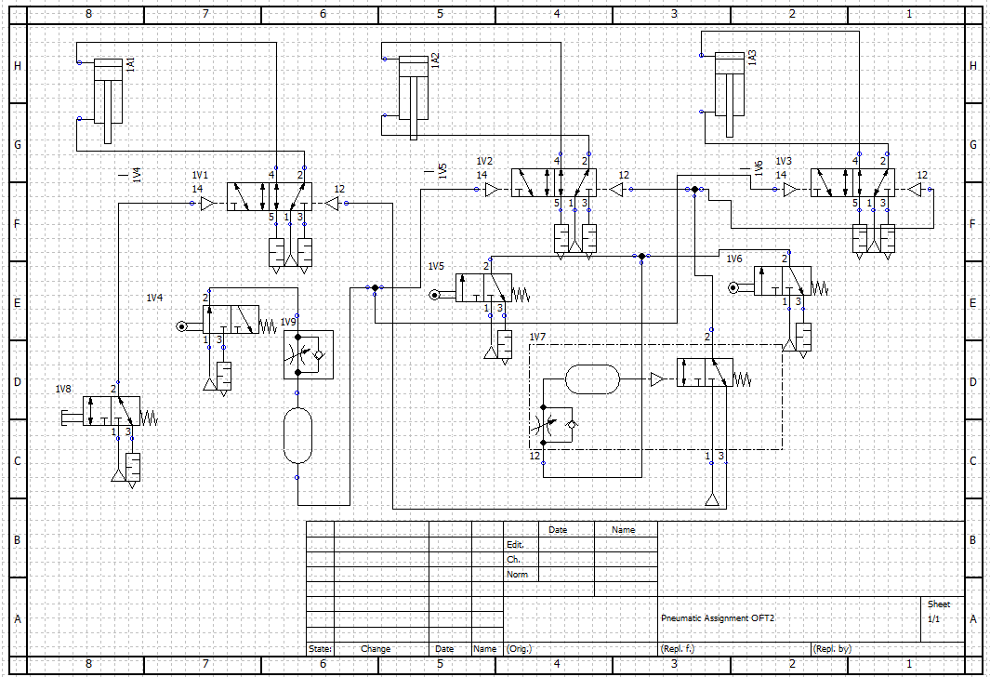

Below is a part list from the above CAD drawing:
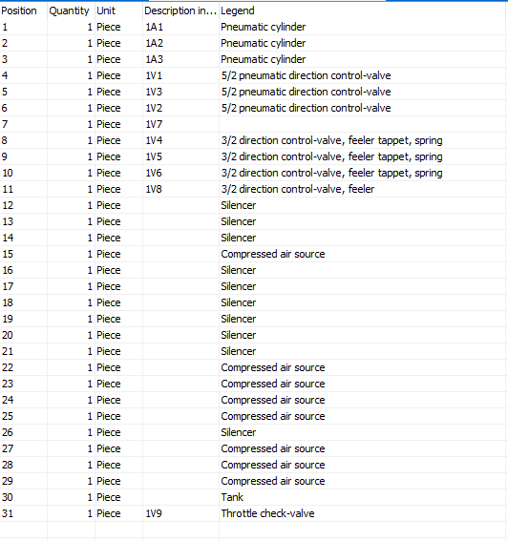
Pneumatic Circuit costings:
Breakdown of the individual prices for each component for the pneumatic circuit.
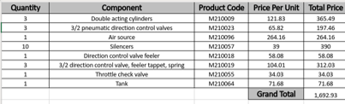

Electro Pneumatic Circuit Rig:
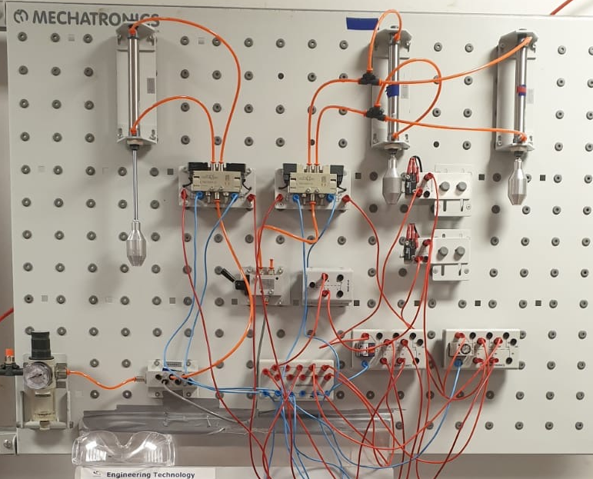

Above is the electro pneumatic circuit that I constructed onto the rig and worked exactly as I intended as per the task, it was a lot simpler to build than the pure pneumatic circuit. The one fault that I came across with this design was that the guards were operating in the opposite way I wanted, the cylinder would retract instead of extending however, this was a quite a simple fix.
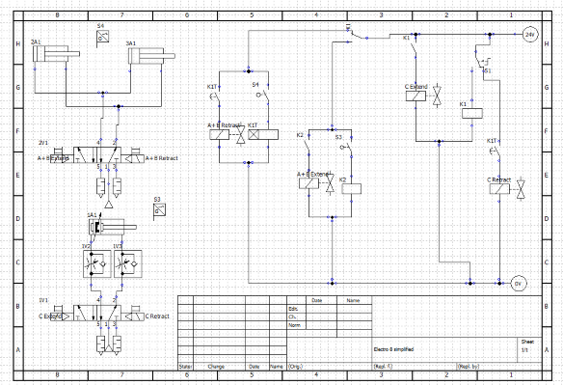

Above is the electropneumatic circuit built on to the software CAD OFT2, this type of circuit is the option most likely to be used in industry as they have more enhancing control, lower maintenance, produce high force and have less parts. Even though this circuit would cost more than a pure pneumatic circuit due to the electrical components, I believe this to be the better of the two circuits and the one I would pick.

Electropneumatic Circuit costings:
Breakdown of the individual prices for each component for the pneumatic circuit.
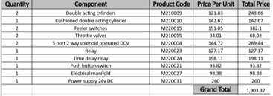

References:
- www.hse.gov.uk
- https://www.aisolutions.co.uk/Community/Knowledge/Topic/747/900/Pressure-Systems-Safety-Regulations-2000
- http://www.smc.nu/drawings/2-D/pn_symbols_EU.pdf
- https://www.scribd.com/document/319226845/pneumatic-Lecture-40-1

