
An Analysis into the problems of asda


March 20, 2020
Carly North
1904917

Title Page

Executive Summary

This report shows that the main problem identified for Asda is that Asda is having competition with other stores. This problem can be supported and resolved, to resolve any problems firstly the problems need to be identified and to identify any of the problems faced such as competition a Nature, scope and impact was undertaken in this report highlighting a swot analysis of the strengths, weaknesses, opportunities and the threats this will help improve the selected problem.
The main method used to communicate, monitor and review any of the problems is to highlight key issues pin pointing the errors and establishing the baseline of the problems by communicating with the employees, even if its setting up an assessment plan to measure the performance and efforts withing the store and communicating with staff to help satisfy customers.

Contents Pages
Contents
Title Page 1
Executive Summary 2
Contents Pages 3
Introduction 4
Findings 5,6,7,8
Conclusion 9
Options 10
Action Plan 11
Appendices 12
Acknowledgements………………………………………………………………………………………………………………………….13
Reference List…………………………………………………………………………………………………………………………………..14

Introduction
This report was requested by Laura James the date requested was the 20th January. The report was compiled by myself Carly North and the date of submission was 20th March.
The purpose of this report was to analysis current problems Asda are facing using useful tools such as a Swot and a Pestle to gather and find information, by doing this a conclusion can be drawn up by gathered information and research on how to improve Asda’s process of their communication, monitoring and reviewing processes of the strengths, weaknesses, opportunities and threats. In order to compile this report academic journals, books and some sites were used to research and gather information to compile this report. From this research options will be offered.

Findings
Asda is a company also known as a public limited company. Asda’s purpose is to make their goods and services more affordable for everyone. Metro, (2018), The reason “Asda’s called Asda is due to two companies who came together and merged in 1965 after they were both formed in the 1920s, the two firms were associated as being dairies and farm stored both run by a family called the Asquith family who were butchers based in Knottingley, West Yorkshire.” Both families had the ambition for growth and success. Their rising aspirations meant that they expanded their business to seven butcher’s shops in the area later their two sons Peter and Fred become founding members of Asda. In 1965 Peter built its first store from scratch next to a large carpark knowing cars would change the way people shop. The letters and the meaning of the word Asda stands for as= Asquith family and the Da stands for = dairy both apart of the upbringing of Asda. Years ago, you weren’t trusted to go around the shop you needed to get goods you were handed the goods you asked for over a counter leaving you with no choice to just have what you were given.
Asda’s advertisement was using physical actions on adverts by using slogan with the catch phrase people knew what they were talking about, that was the tapping on the trouser pocket saying “Asda price”. 1977 Asda used their first ever advert to hit the tv making the advertisement of Asda come alive by using an advert so appealing of the tapping on the pocket physical movement to attract attention of customers the advert was a success pushing up the sales. Asda, (2020), Asda is famous for its slogan “saving you money every day” and their iconic “bottom pat” advert, and also this has a strong online presence.
Asda offers a range of services from services such as:
Online shopping- Online shopping can be easier due to some people can order their shop from home
or work to be delivered saving them a journey. Sometimes it can also have its pros and cons as some supermarkets offer money off when you order online but Asda don’t so some people get put off ordering online with Asda as they can go to another supermarket where they offer money off online over a certain amount. Love money, (2011) Asda charge Asda £2.50 to £4 delivery charge (minimum order £25).
click and collect- Click and collect can be easier due to the fact you can order your food shopping online then just go when its ready and pick it up ordering midday and collecting after 4pm.
Pharmacy- Asda pharmacy can be handy as they accept Nh’s plus private prescriptions and a pharmacist is always there on hand to give advice. Asda pharmacy took a lot of custom from other pharmacies.
Filling stations- You can go and fill up your vehicles as and when needed which is handy. Having the prices of fuel being cheap and prices advertised attracts customers to then go into store to shop for products. Asda started selling fuel in 1967 to Britain. Cheap products and cheap fuel attract people.
Scan as you shop- People can do their shopping by scanning their products and bagging them straight away using a hand held scanner.
Café- Having a café situated in Asda is very handy for people to recoup before or after their shopping.
Christmas saving cards- Many people like to save using the Christmas card save scheme to help them towards their Christmas food shop as every little help people can get towards a busy period is handy and a good way to advertise to have more customers.
Pay points- You can pay bills even get your top up on your gas and electric.
George clothing also is one of the attractions to customers as Asda. In 1990 George Davies was approached by Asda, one of the largest out of town retailers, to help and create fashionable clothing, the brand was called ‘George’ offering ladieswear, menswear and children’s wear at great value with quality and style.
George w Davies, (2017) “The George brand was a great success, creating a key competitive difference to the other supermarkets, Tesco and Sainsbury’s, who eventually followed suit”. Before many people hunted out for discounted food products, they also liked to shop for discounted clothes that had good quality. A man called George Davies who was a fashion retailer and designer a founder of Next retail superstar in the 1980s, implied to others that if you want good quality clothes you will need to give them at good prices to attract people to buy. People who shop at Asda not only will go in for the odd milk or loaf of bread but they also like to have a sneak peek at the clothes as the pricing is at a good price range to afford to add a top or jumper in to the weekly shop. Some families shop at George for the children’s school uniform as you can get a whole uniform for children for £26.50 which is amazing.
These are the strong points and advantages of what Asda offer as people don’t have to leave their home to do their dreaded food shop or wait in dreaded long ques. Asda also offers a range of George clothing, large range of fresh food and frozen food products.
There are a number of problems for this report Asda are facing, however one of the problems Asda Is facing is that Asda stores are in competition with other retailers such as Aldi’s and Lidl’s. Aldi’s and Lidl’s stores sell cheap products and you can get more for your money although they sell one brand Asda sell many different brands.
Nature, scope and impact
The nature of the problem is that there’s a lot of competition between Asda and other supermarkets and other competition from online. It is caused by product features, the number of sellers, barriers to entry and location. Customers want to go to Aldi’s or Lidl’s as these can be a lot cheaper and better quality. Asda sacked a lot of people this had a big impact on the organization as customers deserted the company needed a savior as in 1991 Asda was in £1 billion debt. Mail online, (2017) “A gentleman called Archie Norman who had retail experience and a track record in business and creating bigger and better things to help improve failure joined Asda in 1991 as a CEO”. He was known as a turnaround king with businesses who were struggling helping them overcome the problems to resolve issues.
Scope- The scope of this problem is it has effect on employees as they will end up loosing their job’s if the company hasn’t got much custom. It has effect on steak holders such as unions and project managers, CEO, shareholders and project manager.
Impact- This has taken a huge impact on Asda as they are losing profit because of it. There are more and more customers going to places cheaper than Asda.
Swot Analysis.
A swot analysis is a strategic planning technique framework used to help an organization or an individual identify the strengths, weaknesses, opportunities, and threats. (2018), “A swot analysis is important it can help someone get a better perspective of the potential threats and opportunities a business faces, it gives you a chance to create strategies and policies in regards to how you want your company to operate.”
This is a SWOT analysis of ASDA. It aims to examine the strengths and the weaknesses of ASDA. Examining the opportunities Asda should explore and the threats they should keep a close eye on to help and resolve the problems faced.
Strengths- There’s a lot of strengths with Asda as it has been Established a long time and it is a well-known store. Asda is the third largest retailer in the Uk which has many has many choices of brands.
Weaknesses- Aldi’s and Lidl’s is cheaper than Asda that’s why people prefer to shop there. This has a lot of Competition with Asda.
Opportunities- Asda has a great opportunity to secure market share as there’s a lot of customers doing online shopping this can convert into a strength as they are making profit off online shoppers.
Threats- The threat that Asda face are that prices are cheaper elsewhere, also there’s online retailers competing with Asda and this Is where competition comes into it.
Pestle
(2020) “Pestle analysis is a very important framework for planning. It is used by strategic planning to analyze the macro-environmental factors that affect a business”. PESTEL stands for Political, Economic, Social, Technological, Legal and environment. Pestle analysis, (2013) “These are the four meanings of Pest.” Pestle analysis is a framework used by organizations to track macro-economic factors that are important. The major external and uncontrollable factors that influence an organization’s decision making and the affects it has on its performance and strategies. These factors include the economic factors, demographics, legal conditions, technology changes and natural sources. It’s also a useful strategic tool for understanding the market growth. The technique is used to help identify factors involved in change rather than the solutions to any of the factors understanding the big picture.
Here’s a pestle on Asda:
Political- The government may charge tax rates. For example, VAT may range and may need different prices, this will affect the selling price on products. This will have a big impact on the staff that work in the store and the customers. Its extremely important for managers and staff to consider factors such as new laws coming in, government polices changes will bring a huge impact on Asda. High costs of living such as fuel costs, high supermarket price and this could all lead to a low demand.
Economical- Asda are in competition with Aldi’s and Lidl’s customers as they like to go to Aldi’s or Lidl’s as they can be cheaper. Asda need their custom to pay their staff. Goods and services can be highly affected if economic conditions of customers wages drop. If Asda’s food market does ever slow down, then this will have a massive effect on Asda’s performance.
Social-Asda do a lot of work to do with charity within their business which is a good factor, they’ve also earned quite a bit from this as they sell “clothing” representing a charity.
Technology- The use of technology is growing, having the internet and mobile apps along with click & collect delivery services are extremely important for Asda as it goes in their favor more services that they can offer to customers. Technology factors are one of many external factors than can affect businesses.
Legal- Have to abide by laws within every country for example all products must be accurate to the description if this isn’t done correctly trading standards will get involved. Competition law imposes restrictions and acquisitions to efficiency gained through competition.
Environmental- use of plastic bags for goods
By analyzing a swot and doing a pestle on Asda found that some strengths and opportunities for Asda helping to overcome their weaknesses to improve and avoid some of the threats faced. Although Asda is a store that’s been established and known for a long time it also has competition with other stores as other stores can compare their prices to being cheaper therefore making more custom. Asda does have many different ranges of products whereas Aldi’s and other cheaper stores just have one brand. These problems can be resolved by continuous systematic improvement to the organizations ability to be successful. Ben-Mulholland, (2018), Continuous systematic improvement means a method to make sure that your processes, methods, and practices are accurate, and effective. This is done by examining and improving your processes using the best software and sources, taking advantage of the most efficient methods possible. The benefits of a pestle alert organizations to different threats helping them be aware and checking their performance. (2010), Asda having competition with other stores can be resolved by defining there brands as not all brands can appeal to customers. Asda could also choose a competitive advantage to draw and keep their customers from going elsewhere by offering a superior quality than other stores beating prices by offering lower prices and offering unforgettable customer service. To monitor to see if competition is affecting Asda they could create a customer database.

Conclusion

Over all this report tells us that the information researched and gathered found that Asda is a well-known branch in many different areas.
This report shows that the main areas of concern to Asda are that Asda are struggling to maintain customer base due to the efficiency of their rivals. This can be supported and resolved, to resolve any problems firstly the problems need to be identified and to identify any of the problems faced a Nature, scope and impact was undertaken highlighting the strengths, weaknesses, opportunities and the threats.
By analyzing a swot analysis and doing a pestle on Asda found that some strengths and opportunities that Asda had helped Asda to overcome their weaknesses to improve and avoid some of the threats. Although Asda is a store that’s been established and known for a long time it also has competition with other stores. Problems to any store such as Asda can be resolved once the problems identified by continuous improvement. One of the main problems identified withing this report is Asda having competition with other stores.
An organization that will not show signs of improvement is a called a standstill. Therefore, if Asda show signs of not improving then Asda will be known as a standstill.

Options

The options to resolve the identified problem in this report known as Asda having competition with other stores is to refine the brands as not all Asda’s brands can appeal to customers. Asda could also choose a suggestion and come up with an advantage to draw and keep their customers from going elsewhere by offering them superior quality and appealing products also by offering lower prices on their products not forgetting unforgettable customer service from staff. The options are suitable for the CEO of Asda to resolve the problems in the organization to improve the situation from occurring.
For Asda to develop strategies to improve financial positions withing the workplace they should develop a sales strategy to improve their prices so customers will keep shopping at Asda, also Understand their customers. Good sales will enable Asda to survive and grow.

Action Plan

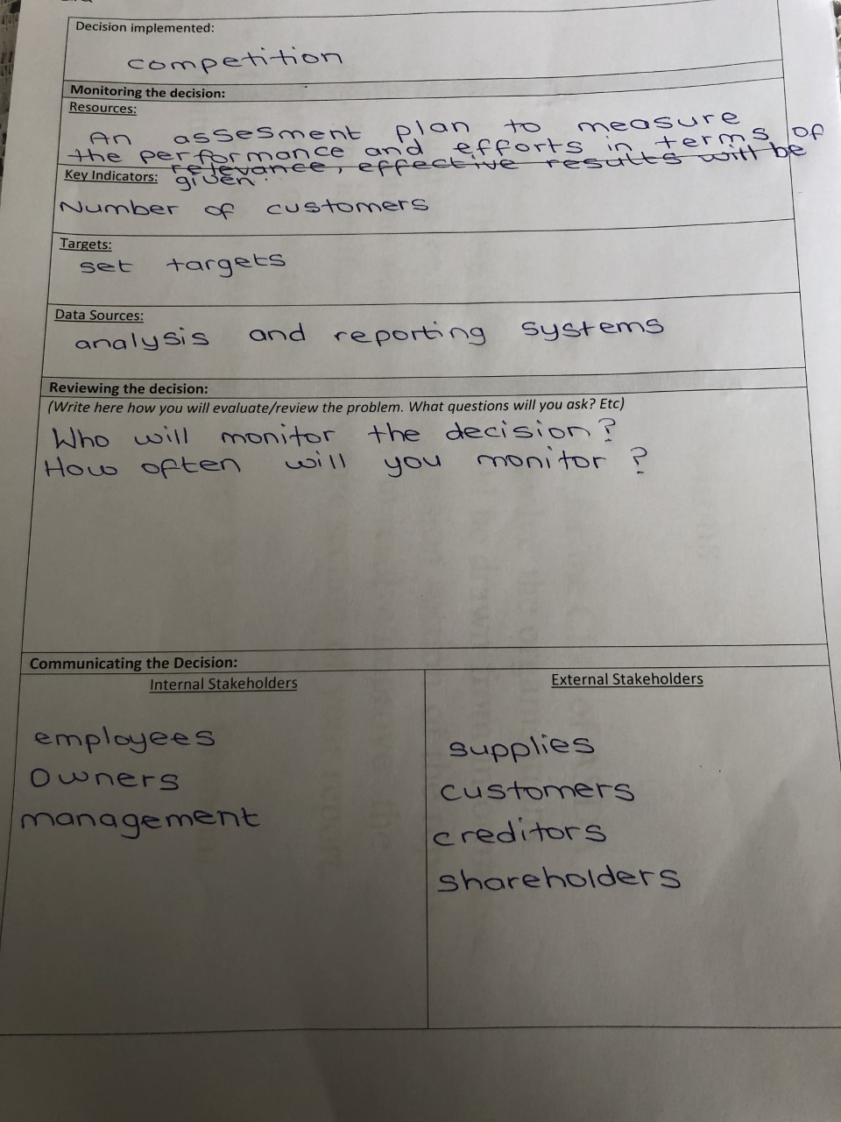

Appendices

Swot Analysis
Strengths
Established a long time
Asda is the third largest retailer in the UK
Well known store
Deliveries nationwide
Threats
Competition of other stores
Aldi’s is cheap but Asda have better quality goods
Price wars

Opportunities
New products
Expanding in new areas of pharmacies, opticians, jewelry and photo department.
Acquisition of smaller companies can help ASDA grow further

Weaknesses
Aldi’s or Lidl’s is cheaper
Competition
Quality of food substandard

Acknowledgements

The information to help compile this report was gathered from libraries, websites and articles.
Thank you for taking the time to read and understand this report by appreciating the help that was needed to compile this report with the assistance to gather all the information that was needed.

Reference List

Metro, (2018), “Asda is due to two companies who came together and merged in 1965 after they were both formed in the 1920s, the two firms were associated as being dairies and farm stored both run by a family called the Asquith family who were butchers based in Knottingley, West Yorkshire” available on https://www.bing.com/search?q=two+companies+who+merged+together+asda&FORM=AWR [accessed on 15-3-20]
Career addict, (2018) “A swot analysis is important it can help you get a better perspective of the potential threats and opportunities a business faces, it gives you a chance to create strategies and policies in regards to how you want your company to operate” available on https://www.careeraddict.com/why-swot-analysis-is-important-for-your-business [accessed on 15-3-20]
George w Davies, (2017) “The George brand was a great success, creating a key competitive difference to the other supermarkets, Tesco and Sainsbury’s, who eventually followed suit” available on www.georgedavies.com [accessed on 19-3-20]
Mail online, (2017) “Archie Norman who had retail experience and a track record in business and creating bigger and better things to help improve failure joined Asda in 1991 as a CEO.” Available at https://www.dailymail.co.uk/news/article [accessed on 19-3-20]
Bright hub, (2020) “Pestle analysis is a very important framework for planning. It is used by strategic planning to analyze the macro-environmental factors that affect a business” available at www.brighthubpm.com [accessed on 20-3-20]
Pestle analysis (2013) “understanding Pest analysis with definitions and example”, available at https://pestleranalysis.com/pest-analysis/ [accessed on 19-3-20]
Asda, (2020), Asda is famous for its slogan “saving you money every day” and their iconic “bottom pat” advert available at https://www.bing.com/search?q=asda+slogan&form=EDGEAR&qs=PF&cvid=326e2768c8d042468ccef4d33ab25d02&cc=GB&setlang=en-US&DAF1=1&plva [accessed on 20-3-20]
(2010), Asda having competition with other stores can be resolved by defining there brands as not all brands can appeal to customers. Asda could also choose a competitive advantage to draw and keep their customers from going elsewhere by offering a superior quality than other stores beating prices by offering lower prices and offering unforgettable customer service. To monitor to see if competition is affecting Asda they could create a customer database. Available at https://www.naijapreneur.com/2010/09/19/beat-the-competition/ [accessed on 20-3-20]
Love money, (2011), “Asda charge Asda £2.50 to £4 delivery charge (minimum order £25)” available at https://www.lovemoney.com/news/11193/the-pros-and-cons-of-online-supermarket-shopping accessed on [20-3-20]
Ben Mulholland, (2018), Continuous systematic improvement means a method to make sure that your processes, methods, and practices are accurate, and effective. This is done by examining and improving your processes using the best software and sources, taking advantage of the most efficient methods possible available at https://www.process.st/continuous-improvement [accessed on 21-3-20]

