Cover page
Matthew Neale

NEA20856038

HND in Electrical and Electronic Engineering

Gower College Swansea/ UWTSD

Management, Innovation and Sustainability

Submission date: 06/03/2025



Table of Contents
Cover page 1
Abstract 3
Introduction 4
SWOT 5
What is SWOT and should it be used? 5
SWOT analysis 5
PESTLE 7
What is PESTLE and should it be used? 7
PESTLE analysis 7
Marketing 9
Marketing mix 9
Product life cycle 11
Is machine quality an issue? 13
Management and Leadership 14
Motivation 14
Management 16
Leadership 17
Change management 19
Conclusion 21
Recommendations 22
References 23

Abstract
This assignment has tasked me with assessing the issues of a small aviation component manufacturer. This assignment includes techniques such as SWOT, PESTLE and investigates different motivational theories. These are all put into perspective of how they can help to get this company back on its feet again. This also investigates the issues the company may be facing from the aging machinery. It also looks at the marketing mix with accordance to the company and their current product life cycle. All these are given as recommendations to the company so they can fix their issues and improve.

Introduction
This assignment focuses on trying to revitalise and restore a failing engineering manufacturing company that faced and the solutions and recommendations that I feel will benefit the company. I have also been asked to create a presentation for the management to showcase how to keep a successful company. This company has been struggling for a while with many issues,
The issues faced by the company are as follows:
- Falling sales
- 10% reduction in production targets
- 5% increase in product rejection rates
- Escalating maintenance costs
- Unusually high turnover of staff
- High staff absenteeism
- 3 ‘7 day’ + lost time accidents

SWOT

What is SWOT and should it be used?
SWOT analysis is a tool that companies can use to evaluate and identify their Strengths, Weaknesses, Opportunities and Threats.
“The primary goal of SWOT analysis is to increase awareness of the factors that go into making a business decision or establishing a business strategy. To do this, SWOT analyzes the internal and external environment and the factors that can impact the viability of a decision.” (Bigelow, 2023)
SWOT analysis would be a good tool to use in this scenario as the company is failing and needs to identify what its strengths are and how to turn the weaknesses and threats into new strengths and opportunities.

SWOT analysis
Strengths  - Licencing and Regulations- The company should be up to date with all the regulations and licenses to be able to sell the products.  - Partnership agreements - The company has got long standing supply contracts with major airlines, providing the business’ income.  - Current employees - The company already has trained staff who know the machinery | Weaknesses  - High turnover of staff – This is due to low team spirit and low morale among staff, this could be caused by the seeming lack of management and outdated machinery. This could be where the company is losing money as they would be spending out more on recruitment and training.  - Escalating maintenance costs – This could be down to the aging machinery as this would lead to higher and more frequent repair costs. This would also create a quality control issue with the machines.  - Increase in product rejection rates – This links to the maintenance cost due to the machines being old they would not have the same accuracies with tolerancing as newer models. This could be why rejection rates and sales are decreasing as their customers are sourcing their components elsewhere.
Opportunities  - Reaching new markets – As there is a higher demand currently for Aerospace parts so the company could branch off into that sector.  - Research and development – If the company spent some more money on their research and development, they could find newer composited and higher performance materials to compete with the other companies on the market.  - Maintenance services – The company could train up existing staff members to offer repair services for the components that they sell. | Threats  - Falling sales – contributing to the falling sales the company has recently had a 10% loss in its production targets. This loss of profits slows the company’s possibility to do more research or branch to other markets as they will not be able to afford it.  - High staff absenteeism – This negatively impacts the company as staff are taking more days off on sick as they may may not feel safe in the working environment. This contributes to the previous point of falling sales and a loss in production targets

You have provided a clear explanation of SWOT analysis and its relevance to the company's situation. The SWOT analysis itself is detailed and identifies key strengths, weaknesses, opportunities, and threats. However, the analysis could benefit from more specific examples and a deeper exploration of how these factors interrelate.

PESTLE

What is PESTLE and should it be used?
“A PESTLE analysis studies the key external factors (Political, Economic, Sociological, Technological, Legal and Environmental) that influence an organisation. It can be used in a range of different scenarios and can guide people professionals and senior managers in strategic decision making.” (Battista, 2024)
It would be useful to perform a PESTLE analysis in this situation as the business can find the external factors that it needs to overcome.

PESTLE analysis
The PESTLE analysis is well-structured and covers all relevant external factors. You have identified political, economic, social, technological, legal, and environmental influences. Further elaboration on how each factor directly impacts the company would enhance the analysis.
Political-
- Increased safety regulations from leading aviation authorities could lead to slower production at higher costs which can then contribute to the high rejection rates and falling sales. This can be fixed by investing some profits into the companies’ research department to constantly be monitoring a change in regulations.
- Trading policies and exchange rates may impact the availability and costs of the materials used in the manufacturing process. This can be resolved by finding different suppliers to try to lower the import costs and restrictions.
Economical –
- Fluctuations in currency, this can lead to unpredictable revenues. This may then create increased costs to import or export vital components and resources.
- A major economic downturn can be catastrophic as it would reduce profits from airline companies and would create a reduced demand for the manufacture of aircraft components.
- Company merges and acquisitions in the airline industry could reduce the number of clients as they may create deals with other manufacturers.
Social –
- Large growth in commercial air travel.
- Sustainability and Environmental consciousness.
Technological –
- Technological advancements within the aviation industry
Legal –
- Local government policies
Environmental –
- Sustainable initiatives globally to reduce manufacturing process’ carbon footprint.

Marketing

Marketing mix
McCarthy’s marketing mix framework is used in businesses to effectively market their products, it comprises of, product, place, price, and promotion. These include features of the product, the cost of the product and pricing strategy. Place is about the distribution channels used and the promotion focuses on the advertising. Using this theory gives a company a plan on how to reach their intended target audience and meet their profits targets. (Coursera, 2024)
Within this company the marketing mix is as follows.
Product
The company has recently seen declining sales and increased rejection rates, this could suggest that competitor companies have got better features or a more competitive price to product ratio.
Improvement strategies for this could be for the company to invest more in their research department this would allow them to create a fresh design with newer features to try to win back the market. Instead of this they could try to refresh their product lineup to by updating some features and changing the design slightly to appear as a new product.
Price
Currently, as sales are dropping it shows that the current pricing strategy should be evaluated.
The best way to do this would be for them to analyse their competitors pricing and try to beat it for user functions. The competitive pricing strategy would be a good way to correct the falling sales, as prices would match the competition. This is a good strategy to gain back consumers but cannot sustain the company in the long run. Once the company has gained back its trust from the consumers then they can investigate a different strategy like the value-based pricing method where they set the price at the highest that they believe the buyers would pay for them.

Place
The current distribution channels may have an adverse effect on the company as it may not be able to reach much of the target audience. This could be down to new regulations and economic downturns as mentioned in the PESTLE analysis.
This can be resolved by optimising the current distribution channels by ensuring that the products are ready when consumers want them. This option would mean resolving the machinery issues and fixing the current reduction in the production targets.
The other option would be channel expansion, this would involve possible partnerships with larger retailers or even a direct-to-consumer sales approach.

Promotion
The current marketing efforts may not be reaching its intended target audience, this would lead to the loss of sales as companies would be sourcing parts elsewhere.
This can be resolved by targeting the marketing campaigns to focus on a specific customer segment, using data to understand customer preference.
They could also revitalise the brands message. This would ensure that the brand message is clear and compelling, showing the uniqueness of their product. They could also use social media and digital marketing to reach a wider audience. This would allow them to engage with consumers and directly promote their products.

Product life cycle
The product life cycle is a model that helps businesses analyse their sales and what business strategies need to be taken at what time. “The product life cycle describes the stages that a product is likely to experience. It is a useful tool for managers to help them analyze and develop strategies for their products as they enter and exit each stage.” (CFI, 2022)
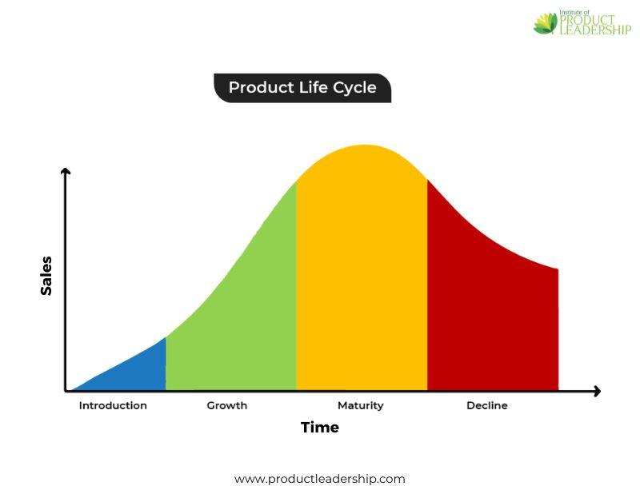 (Institute of Product Leadership, 2023)
With this company it seems that the products have reached the decline stage, and instead of revitalising them it looks like they are still trying to get sales from it.
At this stage there are a few different options the company can do, the best option to maximise profits would be to give a discontinuation date for the current products, while designing a newer version to replace it on or after that date. This would continue with sales on the current product without damaging the life of the future one by selling it too early.
Altering the product for the next generation model would be a way for the company to show that they have fixed any problems with the previous product and are offering some newer features.
This would put the company back into the introduction stage as the products would be perceived by the market as new options and would gain a lot of publicity and the sales would start to increase for the newer product. The company can then analyse the best pricing strategy to try to beat the competition.
Once the product has been established the company can then promote the product more to their desired consumers to boost more sales while trying to keep ahead of the competition.
To help maintain the growth stage of the product, the company could try to bring out new features that can be added on to existing products to keep sales fresh and add more value for money.
The discussion on the marketing mix and product life cycle is comprehensive. You have suggested practical strategies for product improvement, pricing adjustments, and distribution channel optimisation. The section on promotion could be expanded to include more innovative marketing techniques and digital strategies.

You have addressed the issue of aging machinery effectively, recommending leasing as a viable short-term solution. The analysis is thorough, but it could be strengthened by considering long-term strategies for technological upgrades and employee training.

Is machine quality an issue?
Some of the major concerns highlighted within the company are the increased product rejection rates and the escalating maintenance costs. These infer to me that the machinery is no longer fit for purpose and is causing the company unnecessary costs and problems. The poor machinery could also be contributing to the staff taking sick days and then the high turnover, as the staff may not feel safe in the current working environment. The machine issues were identified in the SWOT analysis as a company weakness.
Replacing these machines would one of the best courses of action towards amending some of these issues. There are a few options of how to go about this. The first is to buy new machinery, this would not only be costly for the company, but they may not be able to afford it with the current loss in sales. The other options would be to either buy second hand equipment or to find a supplier to lease them from.
The best option for this company currently would be to lease the equipment, this option would not include high initial costs compared to buying second. Another benefit of them leasing equipment is that they would be newer and would not cost as much to maintain. Once the company is then back on its feet, they would be able to choose whether they wanted to continue to lease the equipment or if they would rather buy their own equipment.
Long term, leasing the equipment would result in higher costs but the machines would be more reliable, and the maintenance costs may be included within the conditions of the lease.
The only major issue with this company would be their falling reputation. “Lenders don’t just look at your credit score; they also consider your available collateral and how long you’ve been in business. If you’re a new business and don’t have two to three years of financial records, banks may deny your credit request depending on your specific situation.” (Hayes, 2023)

Management and Leadership

Motivation
The next step to look at would be Management and leadership. This would help to decide what styles are best suited to implement into this company.
Motivation plays a huge part in having successful management as if employees feel motivated to do the work and are backed by management then there would be a higher increase for work ethics and production targets. If management were not helping to motivate staff, it would likely lead them to taking time off and being less productive when working. This not only costs the company time but also money due to the slower production of components.
Maslow’s Hierarchy of needs
“According to Maslow (1943, 1954), human needs were arranged in a hierarchy, with physiological (survival) needs at the bottom, and the more creative and intellectually oriented ‘self-actualization’ needs at the top.” (McLeod, 2024)
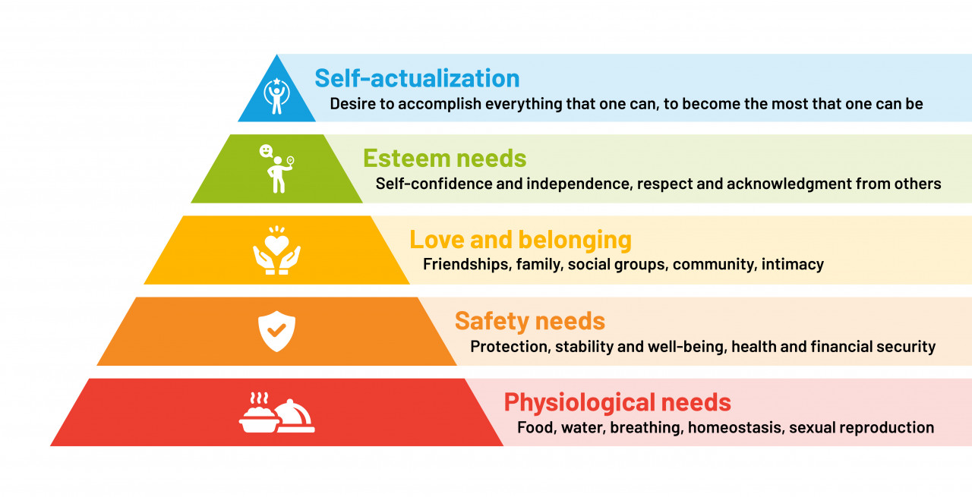 (Gallagher, 2024)
Within this company it is implied that the employees are fulfilling the first level of the pyramid and are stuck in the second level as they are taking days off on sick leave and are leaving the company frequently. This was identified as a weakness in the SWOT analysis. This level could be fully fulfilled by them by newer machinery and more safety checks from supervisors to ensure that the employees feel safe in their working environment. These improvements would allow the employees to increase to the higher level.
If the company then kept its standards at this level the employees may even increase to the fourth tier, this would make employees feel more valued and important. If the employees then stay at this level, management could implement a scheme where they nominate employees to go and do more and allow them to reach the final stage where they accomplish the most they can. This can be done by promotions or extra training courses to improve staff skill sets.
Self-Determination Theory (Deci & Ryan)
Self-determination theory is a more personal style of motivation as it is centred around making people feel in-control of their lives. They believe in two types of motivation (intrinsic and extrinsic). These include internal factors like self-belonging and esteem and external factors like the working conditions and team coordination and management. (Ackerman, 2018)
This theory could be implemented by the company to improve staff morale and lower sickness levels by ensuring that staff feel safe in their working environment by checking regulations and repairing or changing the old/ outdated machinery. This would lead to them feeling safer and have a higher belonging and esteem while in work.
An example of this theory working well is in Google, they give employees 20% of their working time to spend on projects of their own choosing. This ensures that the company maintains a high productivity while staff can be more creative and innovative. (Theatretrain HQ, 2024)

Management
Management is a necessity within a company to keep the balance between happy employees and an effective business. Within this company it seems like there is a lack of clear management, this could be the cause for the 10% reduction in production targets. An effective manager would be able to balance their staffs’ feelings and any concerns and still keep up with the desired production target.

Blake Mouton Managerial Grid
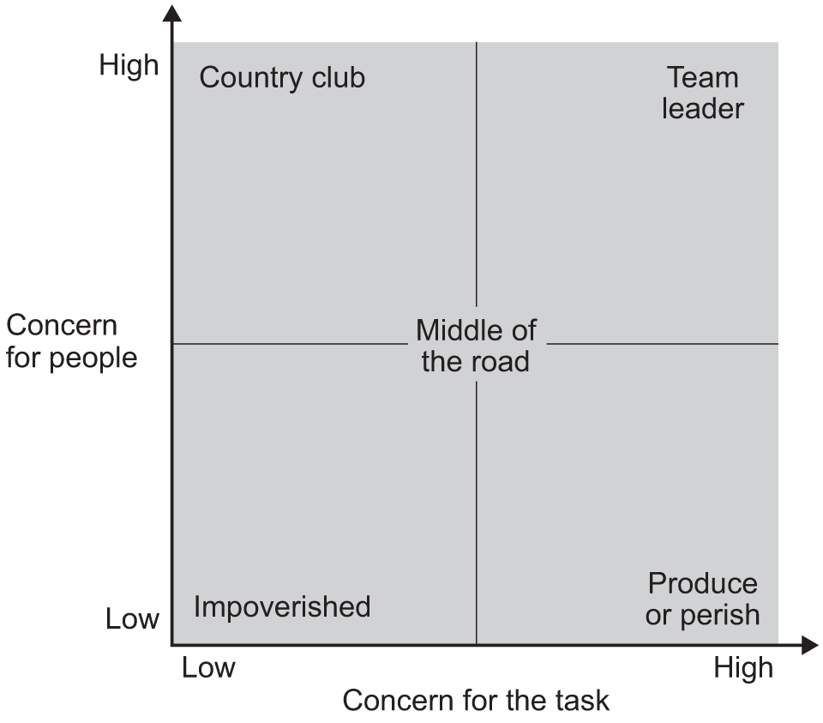 (The Tutor Academy, 2025)
For any given company the Ideal manager would score a high for their concern for people and a high in their concern for the task. With the given information about this company it implies that currently this company has impoverished management as they have let the machinery and working environment get run down. They also seem to have little to no concern for the workers as the staff turnover is unusually high as is the number of days taken off sick.
Ideally, management needs to settle on a democratic approach to its leadership and management style as it would see the employee’s engagement increase. Along with the increased staff satisfaction the sales targets would be met or exceeded.

Leadership
Kurt Lewin modelled his theory on his research into different leadership styles. “This early study was very influential and established three major leadership styles that have provided a springboard for more defined leadership theories.” (Leadership & Performance Partners, 2022) This theory established the baseline to which other leaderships styles are categorised, as most fall under these major ones.
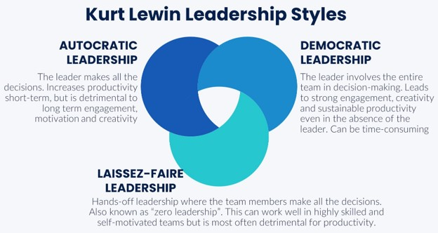 (Leadership ahoy, n.d.)
There are many different styles of leadership that can be used successfully within a business. Some work better than others, but it can largely depend on the work performance and employees.
From the company’s problems, it seems like there is either a lack of current leadership or that the managers are following a laisse faire approach. This is assumed due to the recent slip in product quality and staff consistently taking sick days. This leadership style would make employees feel alone when faced with problems therefore leading them to leave the company. This would contribute to the high turnover of staff and overall lower production rates.
To improve on this the company should temporarily employ a more autocratic leadership style so that employees must seek approval from managers. This would boost productivity, and the leaders would be more accountable for the low profits and high staff absenteeism. This shift in accountability would leave the managers more inclined to fix the falling sales and accident rates by looking into different ways of either replacing the equipment or finding new ways to boost their products sales through advertising.
Once the company is back on its feet the participative leadership style could then be implemented to encourage employees to think more independently. This could lead to a boost in team spirit and therefore improve employee satisfaction. This leadership style falls under the democratic leadership style in Lewin’s theory. You have explored various motivational theories and management styles, suggesting Maslow’s hierarchy and self-determination theory for improving employee morale. The application of Blake Mouton’s managerial grid and Lewin’s leadership styles is insightful, though a more detailed plan for implementation would be beneficial.

Change management
Change management is the process of guiding an organisation and employees through a major transition. Utilising change management is crucial in enabling a change that will not fail. It is about understanding how people are a big part of the change not just the organisation.
ADKAR is one of the most widely used theory for change management
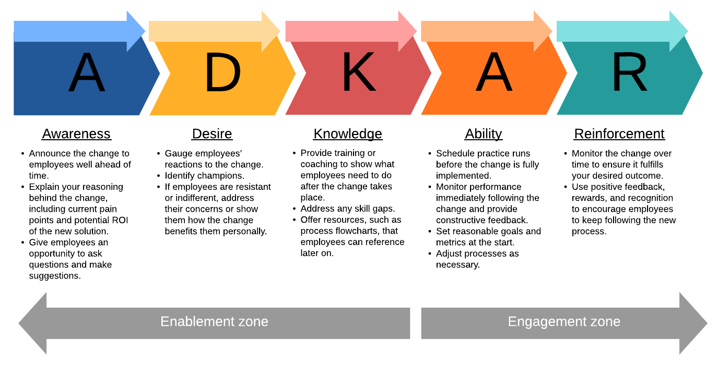 (Lucid Chart, 2019)
The ADKAR model gives employers the necessary steps to secure a peaceful change in the workplace, it makes employees part of the system.
By using this theory, the company would be able to effectively make the changes mentioned previously with minimal resistance. This model would allow management time to convince staff that this change is necessary and that they are welcome to give feedback on the new system. The ADKAR model is appropriately chosen for managing organisational change. You have outlined the steps clearly, but additional practical examples of how these steps could be applied within the company would enhance understanding.
Conclusion
To conclude, this assignment has showcased different ways the company can change and improve. These changes are in the hope that the company will begin to regain its sales losses within the next six months. The new pricing strategy would allow them to excel and stay above competitors with a better product to cost ratio. This change will keep the company driving forward with more motivated staff within the next few years, leading it to be one of the best aircraft component manufacturers. The conclusion summarises the key points effectively, and the recommendations are practical and relevant. However, you could provide a more detailed action plan with timelines and measurable outcomes.

Recommendations
- Falling sales and 10% reduction in production targets
  - The pricing strategy of the current products needs to be evaluated.
  - To meet the production targets, employees need to be motivated more to boost their productivity.
- 5% increase in product rejection rates and escalating maintenance costs
  - The product life cycle needs to be reviewed, and a decision must be made regarding the current products at the decline stage.
  - The machinery needs to be replaced to reduce maintenance costs.
- Unusually high turnover of staff and high absenteeism
  - Apply self-determination theory and Maslow’s hierarchy of needs to employees to make them more motivated to work.
  - Switching to a different management style would positively influence productivity and staff morale making them seem more motivated to work and stay with the company.
- 3 ‘7 day’ lost time accidents
  - New machinery needs to be implemented to avoid these accidents.
  - Leasing machinery or buying used machinery are cheaper alternatives to buying new.
The referencing is generally accurate, but there are minor inconsistencies that need to be corrected. Ensuring a consistent format and thorough engagement with a wider range of sources would strengthen the academic credibility of the work.

References
Ackerman, C., 2018. Self-Determination Theory of Motivation: Why intrinsic motivation matters. [Online]
Available at: https://positivepsychology.com/self-determination-theory/
[Accessed 11 February 2025].
Battista, M., 2024. PESTLE analysis. [Online]
Available at: https://www.cipd.org/uk/knowledge/factsheets/pestle-analysis-factsheet/
[Accessed 05 February 2025].
Bigelow, S. J., 2023. SWOT analysis (strengths, weaknesses, opportunities and threats analysis). [Online]
Available at: https://www.techtarget.com/searchcio/definition/SWOT-analysis-strengths-weaknesses-opportunities-and-threats-analysis
[Accessed 22 January 2025].
CFI, 2022. Product Life Cycle. [Online]
Available at: https://corporatefinanceinstitute.com/resources/management/product-life-cycle/
[Accessed 20 February 2025].
Coursera, 2024. The 4 Ps of Marketing: What They Are and How to Use Them. [Online]
Available at: https://www.coursera.org/articles/4-ps-of-marketing
[Accessed 20 February 2025].
Gallagher, F., 2024. Understanding Abraham Maslow and the Hierarchy of Needs. [Online]
Available at: https://training.lirbusinesscentre.com/blog/understanding-abraham-maslow-and-the-hierarchy-of-needs
[Accessed 11 February 2025].
Hayes, C., 2023. Leasing vs. Buying Equipment: How to Make a Major Purchase Wisely. [Online]
Available at: https://www.simplybusiness.com/resource/leasing-vs-buying-equipment/
[Accessed 28 February 2025].
Institute of Product Leadership, 2023. Product Lifecycle Management (PLM) for Product Managers. [Online]
Available at: https://www.productleadership.com/product-lifecycle-management/
[Accessed 18 February 2025].
Leadership & Performance Partners, 2022. Lewin's Leadership Theory Explained - Leadership and Performance. [Online]
Available at: https://leadershipandperformance.com.au/leadership-development/lewins-leadership-theory-explained/
[Accessed 1 March 2025].
Leadership ahoy, n.d. Leadership Styles. [Online]
Available at: https://www.leadershipahoy.com/leadership-styles/
[Accessed 05 March 2025].
Lucid Chart, 2019. Using the ADKAR Model for Change Management | Lucidchart Blog. [Online]
Available at: https://www.lucidchart.com/blog/using-the-adkar-model-for-change-management
[Accessed 05 March 2025].
McLeod, S., 2024. Maslow's Heirarchy of Needs. [Online]
Available at: https://www.simplypsychology.org/maslow.html
[Accessed 20 February 2025].
The Tutor Academy, 2025. Blake Moulton Grid – The Tutor Academy. [Online]
Available at: https://www.thetutoracademy.com/revision-notes/blake-moulton-grid-section/
[Accessed 03 March 2025].
Theatretrain HQ, 2024. Unleashing Creativity with Google's "20% Project": A Model for Innovation and Structured Freedom - Theatretrain. [Online]
Available at: https://theatretrain.co.uk/unleashing-creativity-with-googles-20-project-a-model-for-innovation-and-structured-freedom/
[Accessed 11 February 2025].

