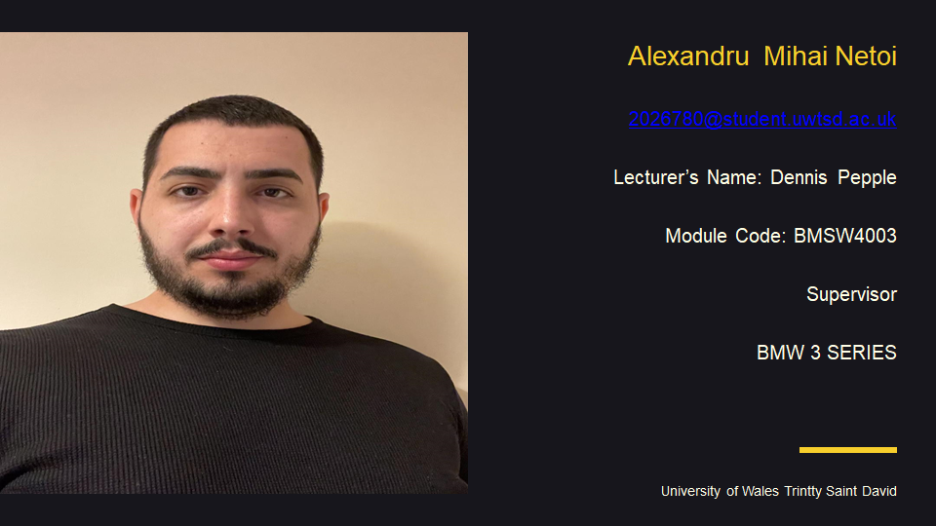
Hi! First thing I would like to say is thank You because You gave me the opportunity to introduce myself .
- My name is Alexandru Mihai Netoi, I’m from Romania and I’m 29 years old.
- I live in Wellingboroug Northamptonshire and I’ve been here in Uk for 4 years now .
- I went to high school and I studied till 12 class diploma. I study at University OF Wales Trinity Saint David. My favorite module is Digital Skills and Research Methods . Now I work in Uk for a logistics company and my current role there is SUPERVISOR .
I like playing computer games, surfing the internet. In my free time I also like to listen music . I like to travel and my favorite place is Italy . I like this country because Italy’s history goes back thousands of years and the legacy of that long and often tempestuous history can be found throughout the country. I’m a big fan of history and art so it’s not difficult to imagine why Italy always fascinated me.

In the introduction my report is about to evaluate Angela Duckwort researches meet the CRAAP test and I will going to show how to conduct researches in DIKW and then I will talk about Angela’s reseaches order.In her research she will give a definition of self-control is like to have the ability to do something that benefits your long-term goals. Basically, self-control is the ability to do something that benefits your long-term goals and not just what might make you feel good at the moment. However, for many of us, short-term gratifications are irresistible - we sacrifice our future selves if we don't exercise self-control. Why is self-control so difficult for some, and how can you find your own restraint? Duckworth advises, finally, that you should lay a foundation of self-control that you can build on in the future. It's happened to all of us at some point--not enough sleep the night before, or a poor breakfast--that created unproductive workdays. Living a healthy lifestyle away from the workplace can give you the strength and stamina you need to control your worst impulses when it counts.I will add for you the link with my video where I talk about Angela’s Duckworth video.
Link of the video .. https://web.microsoftstream.com/video/5827cdea-ad6e-4ca8-9331-539b94388391

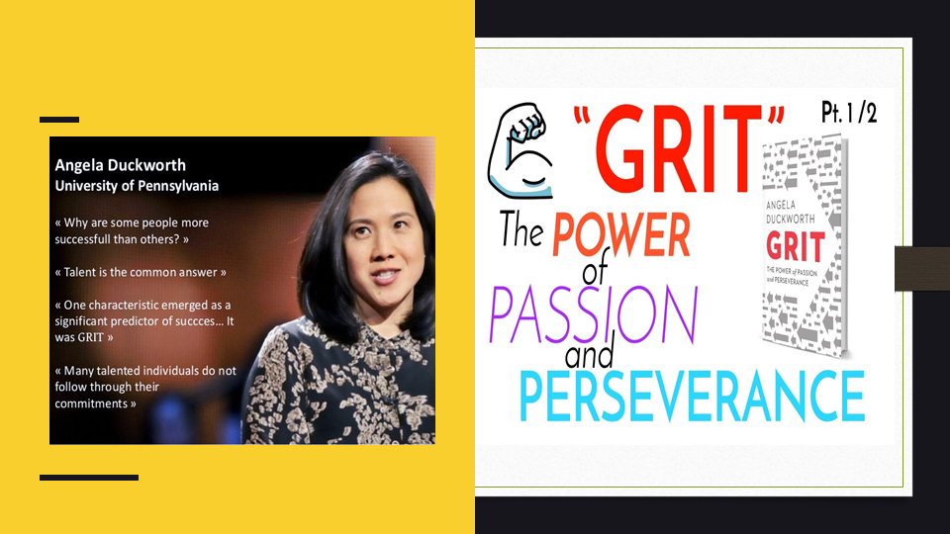

As a high school and middle school teacher, Angela Duckworth taught math before becoming a psychology professor. A seemingly obvious point took her a long time to think about: Students who worked hard did the best, and those who didn't work hard did not do as well. During Duckworth's interview, he asked a question: How is effort related to success? Her research focuses on a personality trait called "grit," which she calls a personal trait. Grit is defined as the ability to persevere over the long-term until you master the subject. The gritty individual approaches success like a marathon; the advantage they possess is stamina. Grit may be as important to high achievement as intelligence, according to Duckworth's research. It's an interesting finding since intelligence has long been considered the key to success. Among all the traits of human psychology, intelligence is "probably the best-measured one," says Duckworth. "Intelligence can be measured in just a few minutes." Duckworth's research falls within a growing area of psychology research focused on what is loosely described as "noncognitive skills." Human success and development can be enhanced by measuring skills and traits other than intelligence. According to Duckworth, the "Grit Scale" measures grit. You rate yourself on a series of 8 to 12 items. The following are two examples: "I have overcome setbacks to conquer an important challenge" and "Setbacks do not discourage me. As the test is completely self-reported, you could game it, but Duckworth's findings show that someone's grit score is highly predictive of their ability to succeed under challenge. “ Persons with "some college" but no degree have less grit than people with college degrees, according to Duckworth's earlier studies. Does this imply that charter school pupils who do not complete college have a lack of grit? Is it possible to learn grit if this is the case? These are difficult problems, and the answers aren't yet available. Before assuming that students who don't finish college aren't hardworking. There are a few things to consider. “ Money, where universities students attend, and what Duckworth refers to as "social-psychological" barriers all play a role in college achievement. She claims that low-income and minority students often feel out of place on college campuses, particularly at more prestigious institutions where the majority of students are upper-income, white, and have parents who have earned a college diploma.
“Nothing was acutely wrong,” she told me when I asked her about her pathway to psychology, which eventually led to her fame. “I felt angst-ridden…like I was desperate to have a calling and I didn’t. I wasn’t unemployed, I wasn’t struggling financially, but I felt like I wasn’t getting anywhere.” [Anderson C., pg. 121]


The positivist reasoning will be connected in this consider to help within the prepare of having precise and specific nature of data for the computation and appraisal of the participants' coarseness score. It'll be based on the application of a coherent strategy to help within the filtering and examination of the obtained information. The survey technique will be appropriate for ensuring that data is acquired from a diverse group of people in order to improve decision-making and comprehension. “ [ Wilcox, pg. 249 Since essential information is connected to particular people, it'll offer assistance guarantee that data is more solid and precise. “Why is cultivating wisdom in the workplace so important? Amid a time when businesses and brands are endeavoring to break free from the status quo and reevaluate themselves – two components are diverse nowadays than at any other time in cutting edge history
1) The speed of change: What may be relevant today, may be extinct sooner than you might think;
2) The cultural demographic shift: that it’s becoming less about the business defining the individual and much more about the individual defining the business.” [ Llopis G., pg. 31 ]
A survey was developed for this report by getting information from 23 members who were chosen at irregular. In arrange to progress scholarly accomplishment, auxiliary information will be collected. It is utilized as an critical portion of venture and overview execution for information collection, which can offer assistance progress the project's steadfastness, rightness, and realness, which is intensely dependent on the information collection method. In arrange to form a reliable information base, it is critical to utilize an approach and procedure for this objective.
This approach and method are employed in the current investigation as follows:
In research philosophy, there is a concept known as positivism.
Methodology of survey and research
The research method was chosen as a deductive method with a qualitative approach.
Data collecting methods: both primary and secondary procedures will be used to acquire data.



“Grit, which is originally conceptualized as passion and perseverance for long-term goals, has been associated with optimal performance. Although previous meta-analytic and systematic reviews summarized how grit relates to performance outcomes, they possess considerable shortcomings like: (a) absence of summary on the association of grit with well-being outcomes; (b) absence of discussion on social, psychological, and emotional mechanisms linking grit to well-being; and (c) lack of elaboration on how alternative models can resolve fundamental problems in the grit construct. “[ Feld. C., pg.71 ]
Q1) Do you think that your information almost scholastic level of insights and and coarseness score are sufficient?
Scale
a) Yes
22
b) No
1
The chart appears that 22 of the 23 respondents had information of scholastic insights and coarseness score. One understudy, on the other hand, was totally careless of this essential notion.
Q2) On a scale from 1 to 5 (1 being the most reduced and 5 the most noteworthy ) how will you rate your principles level that incorporates physical bravery and components such as careful & carefulness
Frequency
a) 1 1
b) 2 1
c) 3 13
d) 4 5
e) 5 3
Concurring to the answers, 23 members were inquired to rate their level of boldness. One individual shown a lower level of scruples than the others. 13 people assessed their honesty and mettle as 3, 5 individuals appraised their scruples and strength as 4, and the remaining 3 members surveyed it as 5.
Q3) In your individual conclusion what is the show state of flexibility on a scale from 1 to 5 ( 1 being the most reduced and 5 being the most elevated ) ?
a) 1 1
b) 2 1
c) 3 10
d) 4 7
e) 5 4
In this circumstance, one of the members contains a lesser degree of diligence and versatility. One other person gotten a 2 rating, whereas the remaining ten members gotten a 3 rating for versatility and diligence. Seven individuals have given themselves a 4 rating for versatility and tirelessness, whereas four have given themselves a 5 rating.
Q4) How would you rate the present grit score and passion level on a scale from 1 to 5 ( 1 being the lowest and 5 being the highest ) ?
a) 1 Nil
b) 2 1
c) 3 12
d) 4 6
e) 5 4
Answers show there were no members with a lower degree of coarseness and eagerness. 1 member gotten a 2 rating, whereas the remaining 12 understudies gotten a 3 rating for coarseness and energy. With this gather, six members accept they have four levels of energy and coarseness, whereas four others accept they have a tall degree of enthusiasm and coarseness.
Q5) On a scale from 1 to 5 ( 1 being the lowest and 5 being the highest ) how would you rate your academic level that you may have achieved in the professional and educational sector?
Lowest
a) 1 5
b) 2 13
c) 3 2
d) 4 2
e) 5 1
Highest
Five members accepted that two of them had the next scholastic level, which may help them get proficient and taught encounter. Thirteen individuals favored the rating of three. 2 individuals voted for 4 as their scholarly level. Separated from that, two understudies had a tall scholastic level of 5 and had earned involvement within the processional and instructive segments, whereas fair one had a tall scholarly level of 6.

Four students have an academic level of two and a grit score of three and a half, according to the findings of the school survey. In addition, 126 kids have a grit score of 3.45 and an academic level of 3. The other 27 respondents had a griot score of 3.73 and an academic level of 4. Finally, the remaining 14 poll participants had a grit score of 3.99 and an academic level of 5.
Based on the data gotten, 5 understudies have a lower scholastic level but an fitting coarseness score, illustrating that coarseness appears a level of fervor and boldness that's autonomous of IQ or scholarly level. As a result, it illustrates that the two concepts have no coordinate relationship. It was moreover decided that 13 understudies had the most noteworthy scholarly level and coarseness score of 4.25, whereas the other two understudies had the most elevated scholastic level and coarseness score of 4.25. With a coarseness score of 4.7, 1 understudy has the most elevated scholastic level of 6 and a coarseness score of 4.15, proposing that all of these results lead to the method of information creation, and coarseness score is irrelevant to a student's scholastic level and has no coordinate interface to any of these concepts.
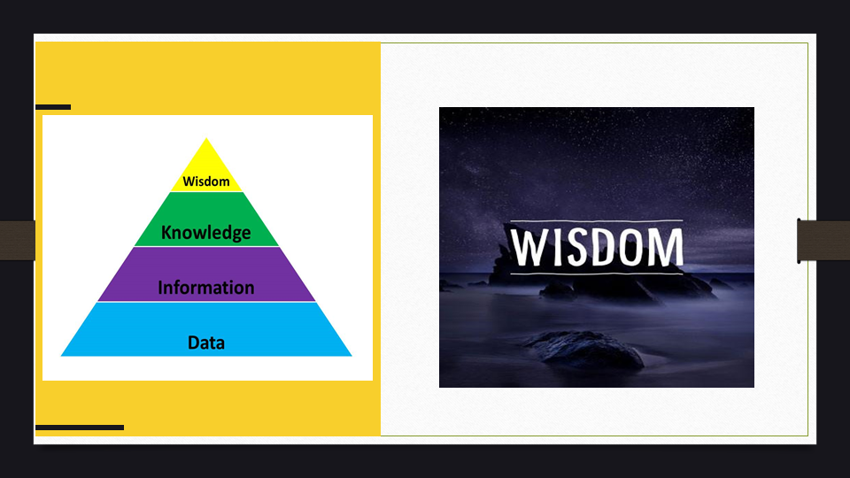
According to the information provided by the primary research study conducted by Angela Duckworth, there is no direct relationship between self-control and grit score, but it is concluded that people who have high grit tend to have a low level of self-control. In the wisdom creation process, it is important to integrate and interpret information that might assist with good decision-making. Angela Duckworth's information and the entire primary study were created by integrating the grit and the self-awareness process..

Also, a more successful strategy can be a result of research that is innovative, consistent, and resilient. Finally, a summary of academic brilliance and grit can lead to the conclusion that such ideas are not mutually exclusive. This study demonstrates that the DIKW can be viewed as a pyramid, each layer contributing quality and assisting in the support and analysis of skills and research. “ Having grit is having the courage and conscientiousness to achieve long-term goals.” [ Wilcox, pg 394 ]. Additionally, it is important to mention that according to Angela Duckworth's research, having a bachelor degree is not a guarantee of someone's success; however, wisdom is necessary to become successful in achieving the knowledge acquired.


- Llopis G., (2016), 5 Ways Great Leaders Cultivate Wisdom In The Workplace, Published on May 25th, Accessed on November 30th 2021. [ Llopis G. ]
- Anderson C., (2019), The Fierce Vulnerability of Angela Duckworth, Bestselling Author of 'Grit’, Published on May 29th, Accessed on November 30th 2021. [Anderson C. ]
- Baroni C., (2021), DIKW pyramid, what it is and how it is used in business, Published on July 2nd, Accessed on November 30th 2021.
- Bleiklie I., Powell W. W., (2005), Universities and the production of knowledge, 49:1-8 pp., Accessed on November 30th 2021.
- NPC Library, (2019), Fake News and Information Literacy: CRAAP & REAL TESTS, Accessed on November 30th 2021. [ NPC L. ]
- Feldman C. B., (2017), What is grit, and why is it important?, Published on October 3rd, Accessed on November 30th 2021. [ Feld. C ]
- Public Relations: Strategies and Tactics (11th Edition), 11th Edition, Dennis L. Wilcox, Glen T. Cameron, Bryan H. Reber [ Wilcox ]

