

EFFECTIV TEAM WORKING
AND COMMUNICATION

STUDENT NAME: ENACHE DANIELA MIHAELA
STUDENT NUMBER: 1908328
LECTURE NAME: BENEDICT MAHER
MODULE NAME: EFFECTIV TEAM WORKING AND COMMUNICATION
MODULE CODE: BMSW 4002 LONDON

Table of Contents

Introduction 3
Main body 3
Different types of communication 3
Relevant theories of communication 4
Importance of effective communication (own experience as Customer Executive) 6
Role of culture in communication 7
Communication work between management and employees 7
Effective communication strategies 8
Conclusion 9
References 10

Introduction
Communication is defined as the process used for passing information in order to carrying out every activity with a proper clarity. Moreover, in order carry out any teamwork activity in workplace, communication is highly important for setting proper coordination with each. Additionally, effective communication is important for both managers in the organisation for performing the basic operations of management like planning, organising and controlling. Hence, communication is important for guiding the employees so that they can perform their jobs and responsibilities.

Main body

Different types of communication
As mentioned by Van Laar et al. (2017), four types of communication are mostly used for sharing information between one another. These are mentioned below:
Verbal communication: This communication is used for transferring information using sign language or speaking. This is the most common form of communication used mainly in presentations, one-to-one conversations, meetings, phone calls and video conferences. In workplace, customer executive for giving verbal direction to the staff members uses verbal communication.
Non-verbal communication: This communication form is based on gestures, language and facial expression. Burgoon et al (2016) commented that non-verbal communication is important for understanding feeling and thoughts of the individual. Therefore, it can be said that customer executive of the organisation using this communication can be able to understand the interests of customers.
Written communication: This method is used form writing, printing or typing symbols like numbers, letters and others to convey message to others. Written communication is essential as it give record of data for reference. This communication is used for sharing data in the form of book, blogs, pamphlets, memos and letters.
Visual communication: This form of communication is done using drawing, sketch, photograph, graphs and charts for delivering information. In any conference or meeting, visual communication enables the executives to visualise the graphs, charts or others for consuming information and ideas.

Effectiveness of communication in business organisation
In organisations, communication is vital for boosting the employee morale. For example, if employee feels that they are having proper information about the vision and direction of the company, they can perform their role accurately. On the contrary, the customer executive of any workplace using verbal communication can be able to set positive relationship with the customers. Moreover, adopting non-verbal communication skills like shaking hands, and keeping a smile on the face can help in gaining attention from the customers. Gordon and Druckman (2018) have stated that bringing clarity in words can help the employees of organisation to perform the work effectively. Customer executives of any workplace need to use effective communication for hearing the food orders of customers properly and placing right time order according to their demands.

Relevant theories of communication
Shannon and Weaver theory: Application of business communication theory is important for implementing best communication practices in the organisation. According to Shannon and Weaver, it is analysed that setting effective communication channel is required to pass information between sender, encoder, channel, decoder, and receiver properly. Gillespie and Schiffman (2018) pointed that this theory deals with sources of information, message, noise, channel, encode, and decode. In any workplace, it is observed that customer executive directly communicate with the customers about the offers, promotions and others order related enquiries. Hence, using Shannon and Weaver theory, the executives can pass the information by removing noise level. Therefore, the customers can provide positive feedback to the executives that can help them to understand if the message has reached them clearly or not. However, use of this model is mostly suitable for interpersonal communication instead of mass or group communication. Hence, the customer executive can use this model for placing orders to the customer and meeting individual query of the staffs.

Figure 1 Shannon-Weaver communication theory
(Source: Gillespie and Schiffman, 2018)
Schramm and Berlo
In the year 1960, David Berlo is found to develop Schramm model of communication for identifying the variables of communication like transmitters, media, encoding, decoding and receiver. This model is built on two-way street communication between sender and receiver by travelling through encoder, interpreter and decoder. Yusoff (2016) has mentioned that this model needs to be implemented in the organisation as it has certain advantages like providing clarity in information, gaining distinct feedback and others. Hence, adopting this model in any workplace can help the customer executives to gain a straightforward approach while communicating with the customers. This will allow both intended customers and executives to share the feedback equally, which is important for bringing change in the food quality and taste. However, Culache (2017) argued that the negative side of the model is that sometimes, using this model for communication can create misunderstanding, if any semantic noise or differences interest the message. Moreover, this model is based on one-to-one communication more rather than multiple respondents.
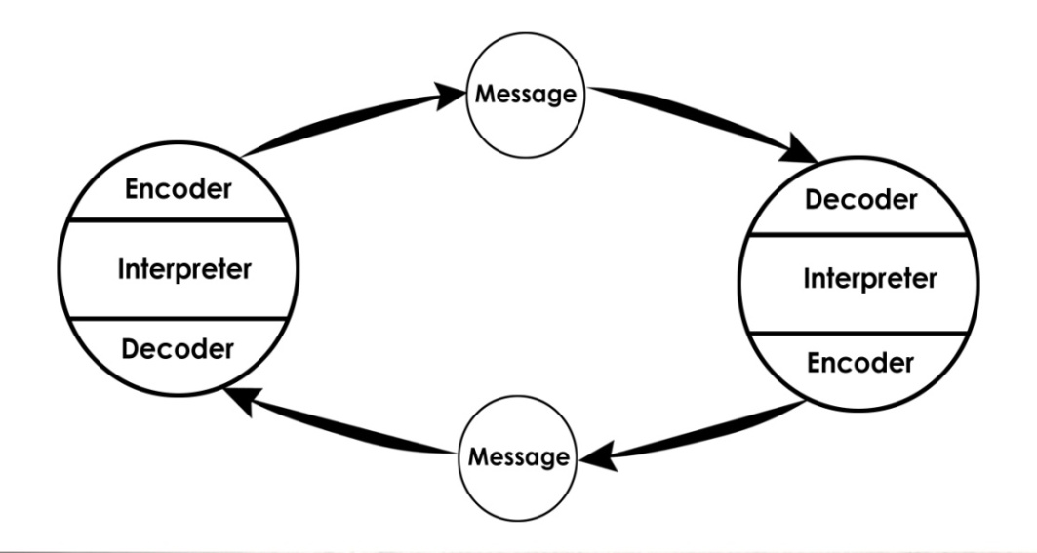
Figure 2 Schramm and Berlo communication model
(Source: Communicationtheory.org, 2019)

Importance of effective communication (own experience as Customer Executive)
Being a customer executive, I have faced several issues of employee bullying and harassment in my organisation. Apart from this, as I came from Japan I have lack in speaking English language, hence I sufferer from bullying and teasing in my workplace. For example, I mostly used simple words in order to ignore any sentence construction and misunderstanding, however, other staffs made fun of me in the workplace. Hence, this has reduced my self-confidence and made me disappointed to work in any workplace. However, I decided to inform the internal communication team that helps in improving the communication process of the staffs and stakeholders. I found that people working in the organisation are having different personalities, different interaction process and communication style. However, when I tried to interact with other staffs, I had to suffer from teasing and harassment. Hence, this has decreased by performance level and I fear of being terminated from the organisation because of my poor communication and performance. Because of my poor communication, my co-workers made fun of me and everyone rejected to take in their team, which has hampered my performance.
However, I have attended Ragan Training session was conducted in year 2017 where all the chief executives were provided important notes for building presence of communication system in the organisation. I took part in this session where I learned different techniques of handling multiple customers at a time.

Role of culture in communication
Due to difference in culture and communication there, their colleagues may harass someone different in culture, colour and race. Her I am describing the experience of my friend; He faced harassment and bullying because of intense level of misunderstanding, misinterpretation and his and his colour with my co-workers due to difference in communication styles. In any workplace, it is found that there is employee bullying and teasing because of mix culture, hence, providing staffs training on cross-cultural communication is important to reduce cultural difference. For an instance, British employees believe in eye contact with the managers or other senior executives. However, this non-verbal communication is treated as rude and disrespect in other culture. Thus, providing cross-cultural communication training would help in reducing miscommunication and misinterpretation of message (Yusoff, 2016).
Cultural differences is found to cause differences in personality and behaviour such as body language, thinking process, manners, communication and norms that can bring miscommunication in the business process. For example, People from Japanese culture, working in British company has resulted in bullying and teasing because of huge cultural difference and language. For example, different cultures are having different forms of gestures, and words. Hence, it can be said that culture helps in shaping the type of communication that are used in business organisation. For instance, in UK, Canada and Germany, it is found that organisations rely on electronic technology and written communication than face-to-face and verbal communication (forbes.com, 2019). However, in Japan or other Asian countries, the companies mostly rely on face-to-face communication rather than any written mode.

Communication work between management and employees
To et al (2015) mentioned that managers play a major role in developing prominent lines of communication with the employees of the organisation. Different issues that are found to occur in the workplace like bullying, harassment and teasing can be removed if discussed properly with the management team. For example, discussing the issues faced in the organisation with the managers, employees can be able to generate new ways of dealing with the issues. Moreover, for improving communication work, two-way communication is important as this enables the employees to gain new ideas about their work process. For instance, if the employee is facing issues with the workplace culture, his complaint can help the management team to gain solicits knowledge about the issues. Hence, developing communication system between employees and managers by conducting regular meeting, one-to-one meeting is important for evaluating the associated issues of bullying, teasing and others taking place in organisation.
Two-way communication that takes place between managers and staffs enable the management team to know about the bullying or teasing related issues in order to reduce any conflict in the organisation. Holding meeting with the staffs enable in understanding the level of job satisfaction, conflict, stress, employee relation between staffs and others.

Effective communication strategies
In order to mitigate the communication issues like bullying, teasing and other language related problem in the workplace, the following strategies can be used:
KEYS: The KEY components of communication strategies that need to be used in the workplace is understand of communication challenge, examining the employee audience, setting goals and KPIs. Additionally, selecting a communication platform and using a communication system record can help in improving confidence level in communication (Cloutier et al, 2015). In my experience, I feel that using email, digital signage and other communication platform, I can be able to improve my communication process. Moreover, I will use metrics for measuring my communication level. I will focus on developing good content by investing time on blog posts, intranet and videos; this will help me to grow by self-confidence level to communicate with co-workers.
SOLER: This strategy of communication needs to be used in workplace for making the staffs of the company realise about the importance of non-verbal communication skills like Sit Squarely, Open, Lean, Eye contact and Relax. The issues of bullying and teasing that has risen in the workplace can be resolved if knowledge on these components are gained by the staffs (ADEOSUN et al, 2017). For example, using this strategy, the employee can use an open posture and provide respect to one another, which is important to mitigate the communication issue.
Seven C’s of communication: This communication strategy would help in gaining a proper checklist related to both verbal and written communication (Austin and Pinkleton, 2015). These are completeness, courtesy, concreteness, correctness, clarity, conciseness and consideration. As I am facing bullying and teasing issues in the workplace, use of this model can provide complete idea about the communication system. This will help in bringing improvement in my communication process.
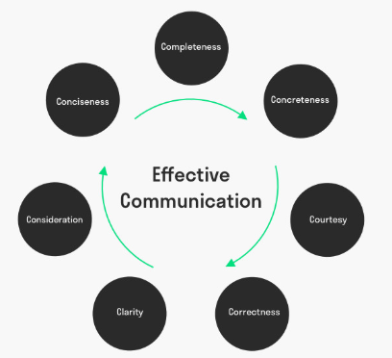
Figure 3: 7 C's
(Source: Austin and Pinkleton, 2015)

Conclusion
This study has found that there are different types of communication methods that can be used for overcoming workplace issues of bullying and teasing. Moreover, discussing the issues with the managers of the company enable the employees to gain strength and work on the communication problems largely. Moreover, it is figured that taking level of communication models like Shannon-Weaver and others can help in understanding different stages of passing information between sender and receiver. In conclusion, it can be said that dealing with workplace communication requires using of 7C’s, SOLER and other communication strategies effectively.

References:
Adeosun, K., Onifade, C., AkeRredolu-ale, B.I., Bodunde, H. and Lawaladebowale, O. (2017). Communication Strategies for Resolving Work-Related Conflicts in Selected Tertiary Institutions. Journal of Sustainable Development, 11(1), pp.133-141.
Austin, E.W. and Pinkleton, B.E. (2015). Strategic public relations management: Planning and managing effective communication campaigns. Routledge.

Burgoon, J.K., Guerrero, L.K. and Floyd, K. (2016). Nonverbal communication. Routledge.

Cloutier, O., Felusiak, L., Hill, C. and Pemberton-Jones, E.J. (2015). The Importance of Developing Strategies for Employee Retention. Journal of Leadership, Accountability & Ethics, 12(2).
communicationtheory.org (2019). OSGOOD- SCHRAMM MODEL OF COMMUNICATION. Available at: https://www.communicationtheory.org/osgood-schramm-model-of-communication/ (Accessed: 29 November 2019).

Culache, O. (2017). Shifting from Channels and Codes to Modes: a Reconceptualization of Brand Communication Via Multimodality. TICS, p.717.

forbes.com 2019. How Culture Controls Communication (2019). Available at: https://www.forbes.com/sites/carolkinseygoman/2011/11/28/how-culture-controls-communication// (Accessed: 29 November 2019).

Gillespie, D.J. and Schiffman, R. (2018). A Critique of the Shannon-Weaver Theory of Communication and Its Implications for Nursing. Research and theory for nursing practice, 32(2), pp.216-225.

Gordon, R.A. and Druckman, D. (2018). Nonverbal behaviour as communication: Approaches, issues, and research. In The handbook of communication skills (pp. 81-134). Routledge.

To, W.M., Martin Jr, E.F. and Billy, T.W. (2015). Effect of management commitment to internal marketing on employee work attitude. International Journal of Hospitality Management, 45, pp.14-21.

Van Laar, E., Van Deursen, A.J., Van Dijk, J.A. and De Haan, J. (2017). The relation between 21st-century skills and digital skills: A systematic literature review. Computers in human behavior, 72, pp.577-588.

Yusoff, S.H. (2016). Western and Islamic Communication Model: A Comparative Analysis on A Theory Application. Al -‘Abqari: Islamic Social Sciences and Humanities, 282(3646), pp.1-14.

