7a Using loops (1 continued) – While

3. Write a program to count up from 1 using a while loop. The user will decide where we stop (store this in a variable called userStop. Count up using a variable called counter.)

Sample output:

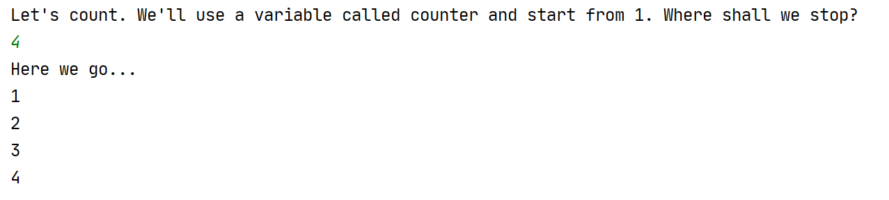

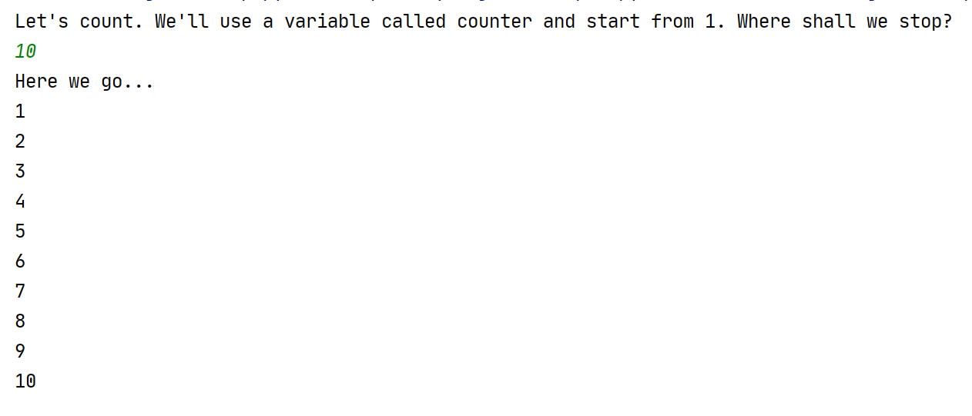

4. This time, count down. The user will decide where to start the countdown (use a variable called counter) and we will finish at 1.

Sample output:

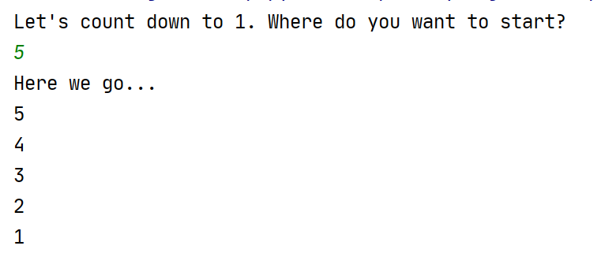

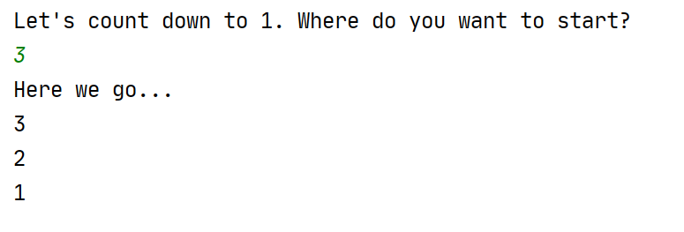

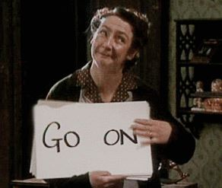
5. Mrs Doyle (pictured right) likes her employer, Father Ted Crilly, to drink tea. She will not take no ('n') for an answer. Write a program that will not exit until you agree ('y') to have a cup of tea.

Note: This is a reference to the classic Channel 4 comedy Father Ted.

Sample output:

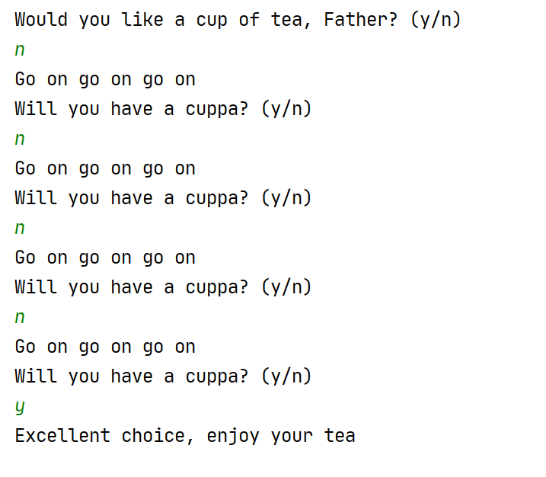

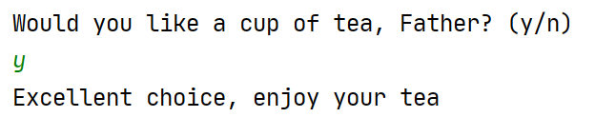

6a. Write a program to allow the user to guess my age (we'll set this as 21 years)

Sample output:

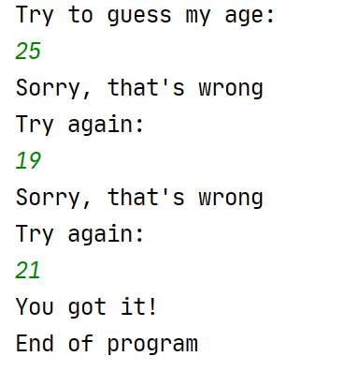

6b. For fun, put in an extra output if the users guesses a number that is "too old" – let's say over 70.

(Hint: use an if statement within your while to do this. Think carefully about where to place it and be careful about the tabs)

Sample output:

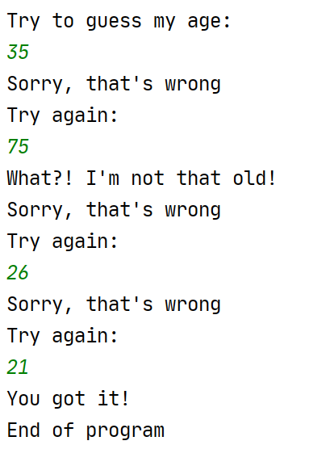

7. Write a calculator program to add two numbers. Let the user add as many sets of numbers as they like, until they decide to stop (use a while loop for this)

Note: Break the problem down by doing the calculator program on its own first (no loop). Once it is working, add the loop on.

(Hint: there is a tiny sting in the tail with this one. There is a bit of logic around initialising the value of the variable containing 'y'/'n' to get the program to enter the loop in the first place – everything else behaves as normal)



