Viktoriya Adalbertova
Student number 1818237
Lecturer:Tushara Baladran

Marketing Fundamentals
AirBus

Table of Contents
Introduction 3
Question 1 3
Question 2 7
Question 3 8
Question 4 9
Conclusion and Recommendation 11
Reference 12

Introduction
Marketing is an essential process in which all the business organisation can place their products and services in a market. It can be stated that marketing is a process of meeting the customers’ satisfaction level through delivering high-quality services and products. In this context, the study aims to provide a brief knowledge about the fundamentals of marketing process. Moreover, the study also evaluates the processes and stages of marketing of a company named as Airbus. In the below-given figure, the distinct marketing phases of the company have been elaborated –
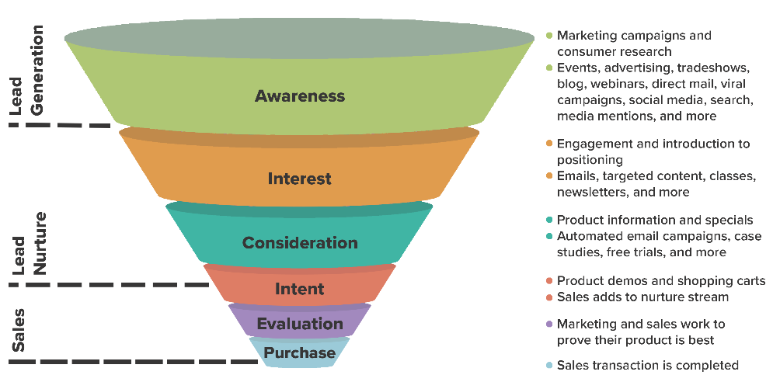
Figure 1: Stages of Marketing
(Source: Shaw, 2016)

Question 1
Situational analysis
Pestle analysis
Pestle analysis is a kind of business tool which helps to define the external factors of the industry that directly or indirectly influence the company effectively. This is a vital stage in the marketing process to enhance the profitability of the firm.
Political factors influence the chances of sustainability of Airbus. Political stability of the country has majorly influenced the organisation. Politicians and their roles in corruption lead to possible resignation of government workers. The country enforcement law such as the law of contract is not allowed to do by Airbus. Military invasion risks by antagonistic countries may be detrimental to Airbus. These conditions are highly favourable for the company because it acts as a shield for the company during trading activities.
Economic factors such as interest rate, GDP rate, inflation rate, exchange rate can influence the aggregate investment, demand and the business climate to make the firm highly profitable or likely to experience a loss. The GDP rate affects Airbus concerning its growth in the nearer future. Interest rate of the nation would influence how much potentials are prepared to invest or borrow. Higher interest rates would derive greater investment to increase the growth of Airbus. The exchange rates would influence Airbus to enhance its profitability, thus turning out to be favourable for the firm, especially if the company is involved in international trade (Zahari and Romli, 2019).
Social factors are reflecting the issues related to society, might influence the business of Airbus. The population demography includes people’s ages and genders respectively, would impact vastly. The educational background of the marketers and the target market can create a difficult situation or an unfavourable condition to draw out the business lineup effectively. Therefore, Airbus should handle this problem carefully by keeping the connection with the interests and priorities of the target market.
The new technological advantages or rather advancements can be favourable for the firm that are implemented by the competitors, may lead to reduce the profitability of Airbus. Therefore, Airbus needs to invent new techniques by using upgraded technologies can encounter the situation to gain popularity in the industry.
The government develops intellectual property laws, data protection laws, have to be followed by the companies to protect their patents and ideas (Walther and Wäldchen, 2017). Discrimination laws must be followed by Airbus to control the workers to treat them equally based on their age, gender, religion, ethnicity and sexual orientation. The current condition of weather is unfavourable for the firm. The climate change would impact the company to control the transportation of resources and deliverable outcomes both significantly. Airbus should rely on renewable energy, as it does not harm the environment.
Porter’s five forces model
This analysis will describe five key points including bargaining power of suppliers, bargaining power of buyers, threat of substitutes, threat of new entrants and rivalry between competitors.
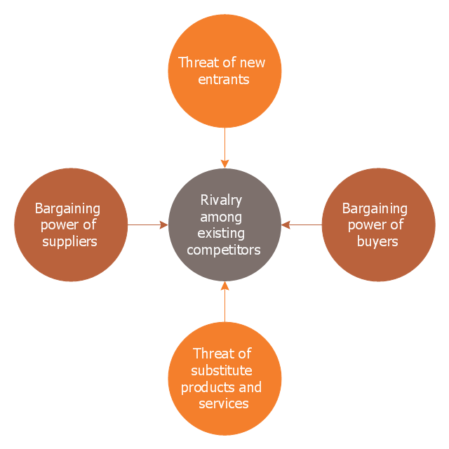
Figure 2: Porter's Five Forces Model
(Source: E. Dobbs, 2014)

Bargaining power of suppliers
Airbus has relied on the global and a large supply chain as companies like 3M, Honeywell, Siemens, Rolls Royce from several parts of the world are under the supply chain. Airbus also upgraded its products by advanced resources and technology. Therefore, the company has dominated its suppliers that help to reduce bargaining power. It can be stated that the power of suppliers is moderate (Baxter, 2019).
Bargaining power of buyers
Customers’ requirements are mostly needed to make the airline’s brands efficient in fuel and technologically rich. As the company has made many aircraft with greater efficiency, the brand image of Airbus moderates the power of the buyers by catering high-quality services and products. Therefore, the customers’ power for the company is significantly high.
Threat of substitutes
The performance of Airbus in the making of aircraft is very well in the industry. Therefore, some factors including quality, delivery on time, technology and customer support help to reduce the threats of substitutes in the market. Therefore, the threats of substitutes are low for the company.
Threat of new entrants
The newcomers have to be financially strong and skilled to take a position in the aerospace market. As it is difficult for them to make a huge investment in supply chain and infrastructure, they can’t make an influence on the customers. However, the risks of new entrants remain low as they are challenged both legally and financially.
Rivalry between competitors
Other competitors like Embraer, Bombardier are also involved in the market of Aerospace. Thus, the companies are facing intense competition within them. Therefore, the rivalry between the existing firms is getting very high.
Objectives of the company
- To focus on the task that has motivated more people of all backgrounds and profiles in engineering
- To promote social equality, gender balance, intergenerational collaboration while securing a comprehensive environment
- To maintain integrity, reliability, teamwork, creativity and customer focus
- To anticipate the competencies, the organisation publishes a Global Workforce Forecast to provide all workers with relevant information
Strategies
Segmentation strategy: This strategy consist of demographic, psychographic and geographic strategies based on the factors like age, gender, lifestyles and income etc. Demographic segmentation is done between income status, age gender as well as religion. The age group of Airbus is based on the diverse range of offerings, such as civilian and military aircrafts, helicopters, etc. From a broader perspective, the age group of this brand ranges across 16 years to 45 years and above. Social class is also one of the important segmentation aspects, which need to be considered by a company. In this case, the firm designs aircrafts for diverse social classes to retain required revenue margins. As per the geographic segmentation, the company has attempted to capture the global market space, ranging from European countries to North America and so on. Behavioural segmentation helps a company to divide its customers according to the pattern of buying. As per the views of Han et al (2019), Psychographic segmentation aids a company to set their customers’ status according to their lifestyles, attitudes and interests.
Targeting strategy: Targeting strategy can be defined by analyzing the growth potentials and commercial influences of different segments. Airbus can select on or more than that depending on the characteristics of the segment and resources, potentials and growths of the company respectively.
Positioning strategy: To develop the positioning strategy, Airbus needs to improve the positioning statements by answering some questions like what the brand should stand for, what are the requirements of the market, how can the company cater those needs, how differently would the company present its offering. The positioning statement of Airbus is centred towards offering aircraft services based on value. The brand positioning also extends to offering technologically advanced products, which are secured, safe and aesthetically designed.

4ps of marketing mix
Marketing mix of the company determines the marketing strategy that includes product, price, place and promotion. The following points will describe four areas of 4P’s strategy mix.
Product: The fits and foremost step to develop the price strategy is to introduce different sizes and designs of the model. To increase the satisfaction of customers, Airbus gives assurance that it would deliver products timely not to negotiating the quality of goods (Milana, 2017).
Price: The price strategy is dependent on the strategy of competitors and the requirements of aircraft products in the industry. Satisfaction of customers also affects the price of goods. Currently, the company employs cost-plus pricing strategy to accomplish set goals. Airbus takes into consideration the manufacturing costs and then adds a certain profit margin to get the estimated price of its offerings.
Place: Airbus delivers its products to the different corners of the world such as Malaysia Airlines, Qantas Airways, Emirates, Singapore Airline, Lufthansa and other places. The company has delivered the aircraft according to the locations that are specified by the customers (Telfer, 2017).
Promotion: As the demands for aircraft are getting high around the world, the aerospace companies have promoted their products at Air shows. As a result, the costs, world traffic development, and environmental concerns, the demand for airlines has increased at a higher rate.
Implementation
Airbus should design its strategies based on the knowledge and skills of efficient employees and leaders. Implementation is the ongoing process where the products and services are served for the customers as per their requirements (Chuck, 2016). Therefore, the company should focus on the strategy through which it can process the products effectively.
Control
After implementing the strategies to manufacture quality goods, it is necessary to control the products’ quality according to the needs of customers. The efficient employees and engineers who can understand the advantages and usage of the products majorly check the deliverable outcomes (Wagner and Eggert, 2016). The company also has handed the responsibility to the management for gathering the customers’ reviews after using the product frequently so that Airbus can improve the quality of the goods and serve standard products to the buyers.

Question 2
Societal marketing
Societal marketing process is mainly dependent on the principle of welfare of society. The process of societal marketing helps an organisation to identify and evaluate the key requirements of customers while offering its services or products (Schönhoff, 2014). In respect to Airbus, it has been identified that the organisation has committed towards mitigating the negative impact of social and environmental challenges. In addition, the company is also involved in promoting the sustainability practices of UN Sustainable Development Goals (Airbus.com, 2019).
Branding strategy of the company
Airbus has been involved in connecting its brand, business as well as culture to the population of the world. The organisation has focused on helping people to improve their communications at divisional and corporate level (Pamatong and Abocejo, 2017). The logo of Airbus and types of aircraft designation is based on the preferences of customers. Alternatively, the customers help the company in the case of naming of different type of aircrafts such Airbus A220, A350 and A380 (Airbus.com., 2019).

Question 3
Concept of stakeholders
Stakeholders in a business play a vital role in operation and development of the business. Stakeholders are the one who is willing to invest in a business to generate earnings. The action of the stakeholders decides business outcomes (He, et al., 2014). The key stakeholders of the Airbus are their employees, customers, shareholders and investors. However, partner have contributed largely as a stakeholder in the business development of the Airbus.
Difference between internal and external stakeholders
Internal stakeholders are the entities that are involved in management and making investment physically or financially for internal development of business. The internal stakeholders of the Airbus are its employees, manager and the board of directors.
External stakeholders are the individual or a group of people those are involved in investing in a business for the benefit of earnings at a higher rate of dividends. The external stakeholders of the Airbus are Investment Company, suppliers, customers, shareholders and the government as regulators.
Identifying ways to communicate with a stakeholder and impact of stakeholders to Airbus
The procedure followed by the Airbus group in communicating with the stakeholders is as follows
- Scheduling of meetings with internal and external stakeholders
- Sending of newsletter with updates
- Online screen meeting
- By sharing and distributing summary report at the end of financial year
In most cases stakeholder might influence the policies, objective and the operational action of the Airbus business. Non-cooperation of an organisation with stakeholders could create an issue of conflict that affect the business strategy and profitability directly. The authorities and employees of the Airbus seeks similar approach and objectives in order to proceed with business operation and aims at reaching business goals (Elad et al., 2017).

Question 4
Communication means sharing insights with each other. In organisational context, communication is an important tool that helps an organisation to make a strong coordination within a workplace. It addition, it also helps in developing teamwork, problem-solving skills as well as decision (Saugnac, 2015).
Communication model
The communication model of Airbus is generally based on internet media. The communication strategy of the organisation follows Schramm’s model, which is often called as convergence or interactive model. In this model, the management team sends a message through internet media such as an email to the customers about their products or services (Petersons and Khalimzoda, 2016). Alternatively, customers also share their potential feedback through internet.
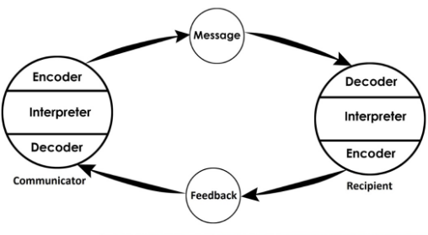
Figure 1: Diagram of communication model
(Source: Petersons and Khalimzoda, 2016)

Integrated marketing communication
Integrated marketing communication can be described as the simplest form of communication. In this context, it can be stated that the integrated marketing communication defines that all types of communication and messages are interrelated. Moreover, this type of communication helps an organisation to gain competitive edge from the marketplace and fosters the sales volume. In the case of Airbus, this marketing communication helps in developing a strong relationship with the customers.
Promotional strategies of the organisation
The company mainly focuses on targeting strategy that helps to attract more customers within the market. On the other side, these strategies also have negative sides within the business operation of the organisation (Freimuth, 2016). Airbus faces tough competition with Boeing. Hence, the firm invests in promotional strategy to stay ahead of the competition. To be more precise, the company launches commercials on traditional platforms, such as radio, television, etc., so that people are aware about the brand offerings (Aalmoes et al., 2018). On the other hand, the company to promote their services and even their various CSR practices in order to facilitate brand promotion is also using social media platforms, such as Facebook.

Conclusion and Recommendation
Based on the findings the study has concluded that marketing process of Airbus is based on generally social and relationship trends. It helps the organisation to improve its products and services. Along with this, different types of marketing have also evaluated in this study. Moreover, the study has also stated about the communication model, which have been implemented within the organisation.
The exchange rates would influence Airbus to enhance its profitability, especially if the company is involved in international trade. Therefore, Airbus should handle this problem carefully by keeping the connection with the interests and priorities of the target market. Airbus should rely on renewable energy, as it does not harm the environment. The government in manufacturing products supports the company often, as it is expensive to produce goods with the help of renewable energy.

Reference
Aalmoes, R., Boer, M. and Veerbeek, H., 2018, December. Virtual reality aircraft noise simulation for community engagement. In INTER-NOISE and NOISE-CON Congress and Conference Proceedings (Vol. 258, No. 6, pp. 1559-1566). Institute of Noise Control Engineering.
Airbus.com. 2019. Airbus Purpose. Available on: https://brand.airbus.com/our-brand/airbus-purpose.html [Accessed on: 9th December, 2019]
Airbus.com. 2019. Aircraft. Available on: https://brand.airbus.com/brand-guidelines/product-branding/aircraft.html [Accessed on: 9th December, 2019]
Baxter, G., 2019. A Strategic Analysis of Cargolux Airlines International Position in the Global Air Cargo Supply Chain Using Porter’s Five Forces Model. Infrastructures, 4(1), p.6.
Chuck, C. ed., 2016. Biofuels for aviation: feedstocks, technology and implementation. Academic Press.
E. Dobbs, M., 2014. Guidelines for applying Porter's five forces framework: a set of industry analysis templates. Competitiveness Review, 24(1), pp.32-45.
Elad, F., Wong, M.N. and Bongbee, N., 2017. The Role of board characteristics in effective corporate governance: The case of Airbus Group. Available at SSRN 2902928.
Freimuth, D., 2016. Financial evaluation of the Airbus A380Neo program (Master's thesis, BI Norwegian Business School).
Futatsumori, S., Morioka, K., Kohmura, A., Yonemoto, N., Hikage, T., Yahagi, K., Shirafune, M., Yamamoto, M., Nojima, T. and Narahashi, S., 2017, March. Aircraft electromagnetic field estimation for wireless avionics intra-communication band using large-scale FDTD analysis—Field estimation of A320 class passenger aircraft at 4 GHz band. In 2017 International Applied Computational Electromagnetics Society Symposium-Italy (ACES) (pp. 1-2). IEEE.
Han, D., Yu, J., Song, Y., Tang, D. and Dai, J., 2019, August. A distributed autonomic logistics system with parallel-computing diagnostic algorithm for aircrafts. In 2019 IEEE AUTOTESTCON (pp. 1-8). IEEE.
He, S., Hipel, K.W. and Kilgour, D.M., 2014, October. A hierarchical approach to study supply chain conflicts between Airbus and Boeing. In 2014 IEEE International Conference on Systems, Man, and Cybernetics (SMC) (pp. 1559-1564). IEEE.
Milana, B., 2017. Valuation of Product Line Extension Success: Airbus and Boeing Case.
Pamatong, A. and Abocejo, F., 2017. Airbus and Boeing Manufacturing Performance, Income and Earnings Per Share: A Comparative Analysis. Recoletos Multidisciplinary Research Journal, 2(1).
Petersons, A. and Khalimzoda, I., 2016, May. Communication Models and Common Basis for Multicultural Communication in Latvia. In Proceedings of the International Scientific Conference. Volume IV (Vol. 423, p. 433).
Saugnac, F., Airbus, 2015. Aircraft communication system comprising an aircraft terminal and a portable resource. U.S. Patent 9,003,085.
Schönhoff, A.M., 2014. Does Multi-stage Marketing Pay?: Creating Competitive Advantages Through Multi-stage Marketing. Springer Science & Business.
Shaw, S., 2016. Airline marketing and management. Routledge.
Telfer, R., 2017. 15 Improving aviation instruction. Aviation Psychology in Practice, p.340.
Wagner, S.M. and Eggert, A., 2016. Co-management of purchasing and marketing: Why, when and how?. Industrial Marketing Management, 52, pp.27-36.
Walther, J. and Wäldchen, D., 2017. Open innovation in the aviation sector. In Supply Chain Integration Challenges in Commercial Aerospace (pp. 57-71). Springer, Cham.
Zahari, A.R. and Romli, F.I., 2019. Analysis of suborbital flight operation using PESTLE. Journal of Atmospheric and Solar-Terrestrial Physics, 192, p.104901.

