

LCLM4006
Enterprise and Entrepreneurship
Task 1: Individual Written Business Plan

Title: Business Plan for GreenBite Kitchen Ltd.: A Sustainable Casual Dining Restaurant in Manchester, United Kingdom

Executive Summary
GreenBite Kitchen Ltd. is a business that is to be created in the United Kingdom in Manchester with the intention of being a sustainable casual dining restaurant. The restaurant's goal is to serve healthy, affordable, and environmentally friendly food, made from fresh ingredients that are locally grown by farmers or bought from local suppliers. The business is meeting the growing demand of consumers in the UK for health-conscious products, sustainable businesses and ethical businesses. Additionally, GreenBite Kitchen will provide excellent food service, utilising AI technology to reduce food waste and provide surplus food in edible form to local food banks and charities. This is a part of environmental and/or community programmes. The company will be a private limited company (Ltd), making it easier to acquire the confidence of customers, suppliers and potential investors and will also provide limited liability protection to these individuals. Management team members will include the founder, restaurant manager, head chef, kitchen staff, service staff and marketing coordinator. This will ensure that this structure will work well and provide high-quality service to customers and carry out daily business efficiently.

Table of Contents
Executive Summary 2
1. Overview of the Business Idea 4
1.1 Business Description 4
1.2 Products and Services 4
2. Market Research 5
2.1 PESTEL Analysis 5
2.2 Competitor Analysis 7
3. Marketing Communications 8
3.1 Target Market 8
3.2 Branding Strategy 8
3.3 Digital Marketing 9
4. Financial Plan 10
4.1 Funding Requirement 10
4.2 Funding Sources 10
4.3 Estimated Start-up Expenses (First Month) 11
4.4 Revenue Forecast 11
5. Conclusion 12
References 13

1. Overview of the Business Idea

1.1 Business Description
GreenBite Kitchen Ltd. is a new restaurant which is proposed to be opened in Manchester, United Kingdom and is a sustainable casual dining restaurant. The restaurant will provide healthy, nutritious, fresh and affordable food to different groups such as people, families, employee groups in the workplace, university students and tourists. The company's business is to offer a high-quality food product to the consumer and to ensure that all the requirements of the environment are met (Chaturvedi et al., 2022).
GreenBite Kitchen will be sustainable in all aspects of its business and practice, unlike many traditional restaurants. Wherever possible, local farmers and suppliers will be used to ensure that ingredients are sourced locally, which helps to minimise the transportation of ingredients and supports local businesses.
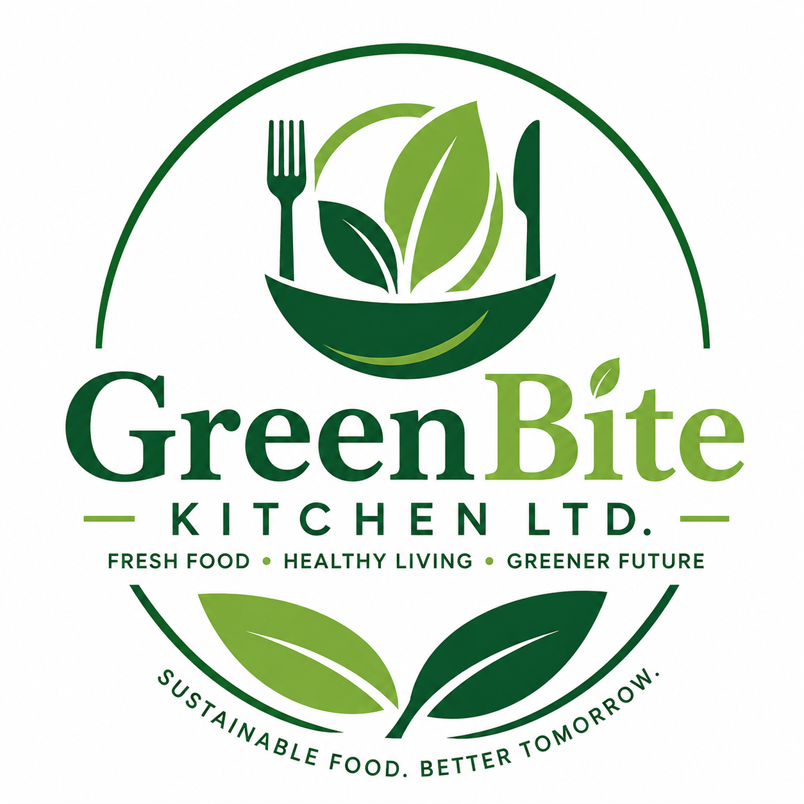
Figure: GreenBite Logo (Self-Prepared)

1.2 Products and Services
At GreenBite Kitchen, locally sourced, freshly cooked food will be available, offering a range of options. Traditional British food, fresh food, healthy salad, vegetarian/vegan, soups, sandwiches, dessert, specialty coffee/ organic beverages, smoothies and fresh juices will be served on the menu. All year round, seasonal line items will be added to ensure fresh products and repeat customers.
The restaurant will also offer 'takeaway' and 'click and collect' options and delivery services via Uber Eats, Deliveroo and more. Consumers will also have the opportunity to place orders directly, via the restaurant's website and mobile app (Ji et al., 2024). All corporate, private, university, and community functions are catered. A loyalty programme will be introduced, where customers will be rewarded with points for their loyalty and be able to use them to get discounts or free meals.

2. Market Research

2.1 PESTEL Analysis
GreenBite Kitchen is going to use PESTEL analysis to gain insights into the external factors which may affect its operation in the restaurant industry in the UK.
Political Factors
The UK government has introduced business policies to reduce carbon emissions and make them eco-friendly. Food businesses are subject to the laws on food safety and hygiene, employment and waste management (Madanaguli et al., 2022). There are also opportunities for new restaurant businesses with small business support, including Start Up Loans and business advice programmes.
Economic Factors
The UK economy is affected by the cost of energy, food inflation and inflation in general. Any of these can impact how much disposable income a consumer has and raise the costs of running restaurants. Despite these obstacles, the restaurant sector in the UK is still expanding, with people keen on going out to eat and ordering food online.
Social Factors
UK consumers' preferences are changing rapidly. Consumer preference is increasingly for purchasing from healthy businesses, vegetarian and vegan food and more environmentally friendly businesses. Young consumers are particularly important with regard to sustainability and are ready to work with companies that invest in waste reduction and sustainability (Attiq et al., 2021). In the same way, people are busy, and there's been an increase in the demand for takeaway and food delivery services as well.
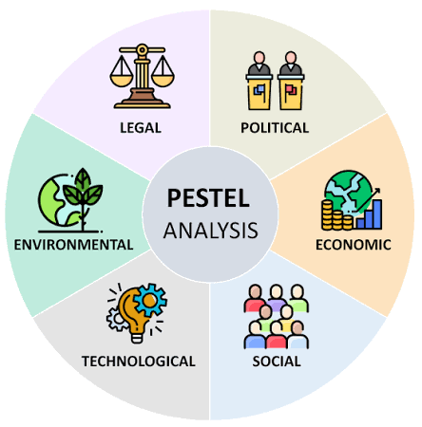
Figure: PESTEL Analysis (Attiq et al., 2021)
Technological Factors
In today's world, technology is a must for restaurants. This will be solved by the use of AI for inventory management at GreenBite Kitchen, which will end food waste. Food will also be sold online through the restaurant's website and app, and the restaurant's delivery services, such as Deliveroo, Uber Eats and Just Eat. Improved customer convenience and business efficiency through digital payment systems, customer relationship management (CRM) software and social media marketing.
Environmental Factors
A key competitive advantage of the business is environmental sustainability. The restaurant will implement strategies to reduce food waste, including better stock management and waste management of packaging, the use of biodegradable take-away containers and buying locally to cut emissions from transportation. The restaurant goes the extra mile when it comes to sustainability, with the kitchen making use of energy-efficient equipment and responsible waste management (Baloglu, Raab and Malek, 2022).
Legal Factors
The requirements for GreenBite Kitchen in relation to food safety & hygiene, employment laws, environmental laws, licensing laws, fire safety and GDPR for data protection are all UK regulations that must be adhered to (Pizzutti dos Santos, De Nascimento and Nique, 2023). Customers, employees and the business's reputation will be safeguarded, and legal risks will be minimised by keeping high standards of legal compliance.

2.2 Competitor Analysis
The UK restaurant industry is an extremely competitive market, and in large cities such as Manchester, competition can be particularly robust. GreenBite Kitchen will compete with the large restaurant chains and local restaurants.
Competitor 1: Nando's
Nando's is one of the U.K.'s most popular chains of casual dining restaurants. It's no secret that it's known for its grilled chicken sandwiches, a well-known brand, consistent food quality and plenty of restaurant locations throughout the nation (Batat, 2020). There is a good online ordering and delivery system at Nando's.
Competitor 2: Aon Hewitt
Pret A Manger is famous for its delicious fresh sandwiches, salads, soups, coffee and fast food. The firm has taken steps towards sustainability and is favoured by the working professionals who want fast food.
These are definitely not enough to classify Pret a a as a true casual restaurant; it is a chain that is designed to please people more with a bite to eat and a snack. GreenBite Kitchen will be unique not only due to the variety of food options, but also because of the many different programs the restaurant will be offering for the community and the emphasis on using local ingredients (Clark et al., 2025).
Competitor 3: Independent Local Restaurants
There are numerous independent restaurants in Manchester that serve a variety of cuisines. They can even provide a tailored customer service and special menus as well. However, for many small restaurants, marketing systems are less integrated, marketing budgets are smaller, and the frequency of marketing for sustainability is lower.

3. Marketing Communications
GreenBite Kitchen will use an integrated marketing communication (IMC) approach to build brand awareness for the brand, pull customers and encourage repeat customers. The marketing strategy will revolve around the restaurant's principles of healthy food, sustainability, affordability and great service.

3.1 Target Market
GreenBite Kitchen will serve at a variety of events for groups such as:
- Youth looking for a healthy and convenient meal.
- Students who would like to have a meal at a cheaper rate at the University.
- Healthy food for families in a family-friendly environment.
- Persons interested in fresh food and organic food and who prefer a healthy lifestyle.
- Individuals with a vegetarian or vegan lifestyle who wish to have an array of food choices available.
- Anyone looking for a taste of home in Manchester.

3.2 Branding Strategy
The GreenBite Kitchen brand will be a reflection of health, sustainability, freshness, and community responsibility. The restaurant logo, colour scheme, the design of the menus and the interior will be natural green and earthy colours to show values for the environment (Camilleri, 2023).
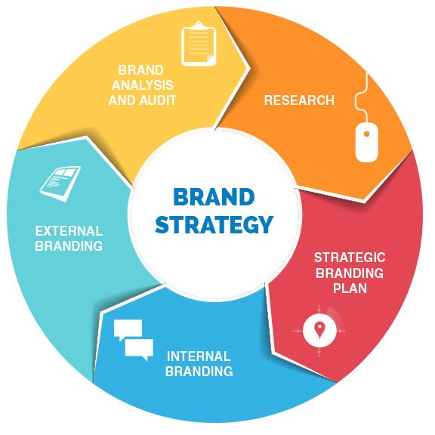
Figure: Brand Strategy (Camilleri, 2023)
The slogan of the brand will be:
Fresh Food. Healthy Living. Greener Future.
This is a strong message in terms of the restaurant's commitment to the well-being of its customers and its environment.

3.3 Digital Marketing
Most customers research restaurants online prior to making a purchase, which is why digital marketing will be the key marketing strategy.
Instagram, Facebook and LinkedIn will be active accounts for the restaurant. There will be regular images of meals, behind-the-scenes of the kitchen, customer reviews, chef interviews, season sales and sustainability efforts (Onyeaka et al., 2023). Interactive elements such as polls, competitions, and giveaways will help to increase customer engagement.
The website for the business will offer customers the opportunity to:
- View the menu.
- Book tables online.
- Place takeaway orders.
- Order home delivery.
- Read customer reviews.
- Know about activities relating to sustainability.
This will increase the restaurant's visibility when it comes to people looking for a healthy restaurant in Manchester online via Search Engine Optimisation (SEO).

4. Financial Plan

4.1 Funding Requirement
GreenBite Kitchen Ltd are planning to start up and run their restaurant in the early years, estimating revenue to be £180,000 over the first three years. The investment will enable the business to be registered, the restaurant will be renovated, the place will be equipped, furniture will be purchased, technology solutions will be implemented, the restaurant will be marketed, staff will be hired, and working capital will be provided (Onyeaka et al., 2023). Having sufficient start-up capital is essential to get the restaurant right and build a customer base in its first couple of months.

4.2 Funding Sources
GreenBite Kitchen will finance its start-up through a combination of different funding sources to reduce financial risk.
Funding Source | Amount (£)
Owner's Personal Investment | 60,000
UK Start Up Loan | 70,000
Private Investor | 50,000
Total Funding | 180,000

4.3 Estimated Start-up Expenses (First Month)
Expense | Estimated Cost (£)
Restaurant lease deposit and first month's rent | 20,000
Kitchen equipment | 45,000
Dining furniture and interior decoration | 25,000
Initial food and beverage inventory | 12,000
Staff recruitment and training | 10,000
Licences, permits and business registration | 5,000
Website development and online ordering system | 8,000
Marketing and grand opening promotion | 10,000
Utilities and internet installation | 4,000
Insurance | 3,000
Working capital reserve | 38,000
Total Estimated Start-up Cost | 180,000

4.4 Revenue Forecast
The number of revenue sources will be reduced, as GreenBite Kitchen will be able to have a few different revenue streams.
Food and beverage sales, mainly in the form of dine-in, will be the primary source of money. Increased funds will come in from take-out, Internet orders, catering for business or private events, sales of beverages and seasonal promotions (Onyeaka et al., 2023).

5. Conclusion
GreenBite Kitchen Ltd. has a great story to tell and is well on its way to making a big splash in the growing sustainable restaurant sector in the UK. Overall, there is a mixed perception of the business as both health and quality food, and environmentally friendly business practices, which can prove attractive to the modern consumer who places a high value on sustainable and ethical business practices. Despite the restaurant sector being very competitive in the UK, as the market research shows, the demand for healthy restaurants, locally sourced food, and more sustainable businesses is still on the rise.

References
Attiq, S., Habib, M.D., Kaur, P., Hasni, M.J.S. and Dhir, A. (2021) 'Drivers of food waste reduction behaviour in the household context', Food Quality and Preference, 94, p. 104300. https://doi.org/10.1016/j.foodqual.2021.104300.
Baloglu, S., Raab, C. and Malek, K. (2022) 'Organizational motivations for green practices in casual restaurants', International Journal of Hospitality and Tourism Administration, 23(2), pp. 269–288. https://doi.org/10.1080/15256480.2020.1746216.
Batat, W. (2020) 'Pillars of sustainable food experiences in the luxury gastronomy sector: A qualitative exploration of Michelin-starred chefs' motivations', Journal of Retailing and Consumer Services, 57, p. 102255. https://doi.org/10.1016/j.jretconser.2020.102255.
Camilleri, G. (2023) 'Satisfaction on the driving seat: Exploring the influence of social media marketing activities on followers' purchase intention in the restaurant industry context', Sustainability, 15(9), p. 7207. https://doi.org/10.3390/su15097207.
Chaturvedi, P., Kulshreshtha, K., Tripathi, V. and Agnihotri, D. (2022) 'Investigating the impact of restaurants' sustainable practices on consumers' satisfaction and revisit intentions: a study on leading green restaurants', Asia-Pacific Journal of Business Administration, 16(4), pp. 1042–1063. https://doi.org/10.1108/APJBA-09-2021-0456.
Clark, Q.M., Kanavikar, D.B., Clark, J. and Donnelly, P.J. (2025) 'Exploring the potential of AI-driven food waste management strategies used in the hospitality industry for application in household settings', Frontiers in Artificial Intelligence, 7. https://doi.org/10.3389/frai.2024.1429477.
Ji, X., Nicolau, J.L., Law, R. and Liu, X. (2024) 'Repeat customers and satisfaction: uncovering new intricacies through restaurant reviews', Journal of Hospitality & Tourism Research. https://doi.org/10.1177/10963480221141613.
Madanaguli, A., Dhir, A., Kaur, P., Srivastava, S. and Singh, G. (2022) 'Environmental sustainability in restaurants. A systematic review and future research agenda on restaurant adoption of green practices', Scandinavian Journal of Hospitality and Tourism, 22(4–5), pp. 303–330. https://doi.org/10.1080/15022250.2022.2134203.
Onyeaka, H., Tamasiga, P., Nwauzoma, U.M., Miri, T., Juliet, U.C. and Nwaiwu, O. (2023) 'Using artificial intelligence to tackle food waste and enhance the circular economy: maximising resource efficiency and minimising environmental impact: a review', Sustainability, 15(13), p. 10482. https://doi.org/10.3390/su151310482.
Pizzutti dos Santos, C., De Nascimento, C.P.S. and Nique, W.M. (2023) 'Social media, brand communication and customer engagement in Michelin-starred restaurants during a time of crisis', British Food Journal, 125(13), pp. 16–33. https://doi.org/10.1108/BFJ-04-2022-0363.

