

MODULE CODE/LCBB4004

LECTURE: Tushara Balendran

Marketing Fundamentals

Hristiyan Parvanov ID:1817604​
​
​

Table of contents

1. The marketing process and the marketing mix............... 3​,4,5,6,7,8,9,10,11,12,13,14

2. The advantages of marketing to consumers …............... 14,15,16,17,18

3. Stakeholders ……........................................................... 18

4. Promotion ....................................................................... 18,19,20
​
5. Recommendation ………………………………………….. 20

6. Conclusion ………………………………………………….. 20

7. References …………………………………………………. 21

Question 1 : The marketing process and the marketing mix
There are many definitions for marketing. The better ones provide guidance on market orientation and meeting and meeting customer needs.
Marketing is a social process. It delivers what people and organizations need and want by creating value feedback with others. (Kotler, Amsterdam 2010). Kotler and Armstrong created their first definition of marketing, recognizing the importance of a long-term relationship with the client. This is done through marketing interactions and customer relationship management (CRM). According to the definition of CIM (professional body for marketing in the UK), not only the needs of the clients but also their satisfaction (in the short term) and their preservation in the future (in the long term) are important. This definition also draws attention to the other major components of marketing - goals and results. CIM is one of the most sophisticated marketing body in the world. The strength of marketing is that it is the pioneer in people's business and is nevertheless considered the newest discipline (Baker, 1976). Gibson et al (1993) found about 100 definitions of marketing.

Definition of the marketing process:
Marketing is at the heart of every business. Not every company (Samsung) can recruit and retain customers without the so-called marketing planning process. In order to properly plan each company, it has to use marketing processes, on the basis of which it will develop and plan every step of the process for success. Samsung's strategic plan is based on business goals; the market in which the products are positioned; the target audience; customer tastes; the processes for success and its evaluation. A strategic plan is not a piece of paper stuck in someone's folder. It is a living document that creates and defines work and is constantly updated to reflect changes in business customers and competition. Strategic marketing is achieved through strategic thinking. The strategic marketing planning process helps in:
- Clarifies the goals and their achievement;
- The overall objective - to unite all stakeholders and their involvement in the process of opportunity and challenge of the company (Samsung);
- The right products in the right places. More and much more - Samsung's motto;
- Increase market share and production of new product ranges to increase revenue. For example, Samsung's smartphone achieved one of the highest market shares. Samsung's strategic marketing plan focuses on two main priorities - products and customers. The marketing plan must be in line with the overall business plan of the company. If they did not work together, they would not be successful.
A successful strategic marketing process consists of a series of steps that take you to succeed. These are:
- Mission - A key message that sets the marketing strategy. The mission is based on answers to questions such as: What is the purpose? ; What is the strategic impact of the business? ; How the mission statement works for the strategy and unification of the company;
- Situation analysis; - Marketing strategy ;
Marketing mix; and implementation and control.
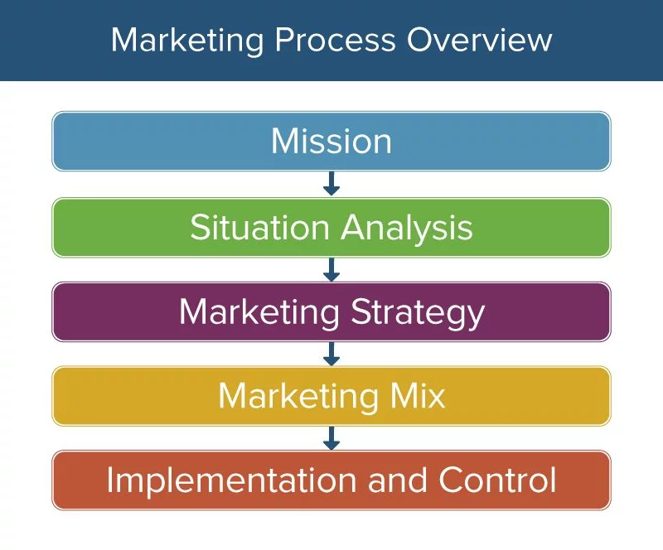Fig. 1
https://www.smartsheet.com/strategic-marketing-processes-and-planning

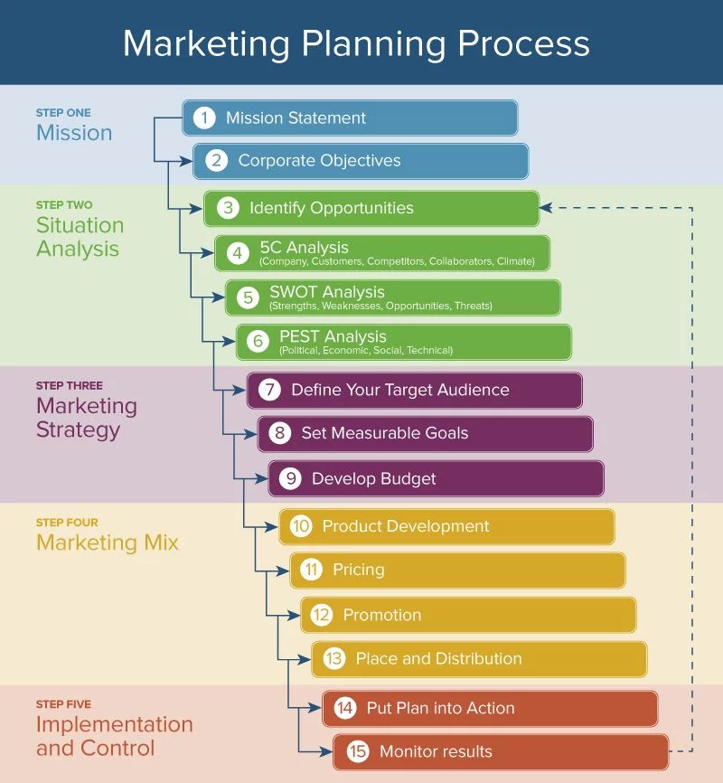Fig. 2
https://www.smartsheet.com/strategic-marketing-processes-and-planning

Strategic marketing planning defines goals and objectives, analyzes the impact of internal and external factors, product upgrades and customer needs studies. For example, here is a strategic marketing plan for one of the world's most successful Asian company Samsung:
Mission: Samsung is committed to manufacturing some of the most advanced and high-tech products.
Situation Analysis: Samsung is one of the top performing companies on the market. It combats competition with the innovations and new modern technical characteristics of its products, managing to capture the desires and technical needs of its customers. Like the Note 10 smartphone.
Marketing Strategy: Samsung is one of the first places on the market. It creates innovative new products that respond to the rapidly changing times, but also relies on brand loyalty to already known customers.
Marketing mix: Samsung offers a wide variety of products that reach customers through good and large-scale distribution and premium pricing.
Control: Each Samsung product is in sync with the rest and operates in a homogeneous ecosystem, which retains ongoing customer interest.
The strategic marketing process involves and works all the parts and the goal is the success of the company. Combining goals, tasks and tactics in a solid plan leads to customer satisfaction and victory over competitors.

Situation analysis:
It is an assessment of the internal and external factors that affect the business and the market. Situation analysis presents the strengths and weaknesses identified by internal resources or external competition. This analysis gives a clear and objective assessment of the health of the business of a company. There are several methods of doing this analysis. It is called SWOT - strengths and weaknesses; opportunities and threats.
Strengths are internal factors under the control of the company. What are you doing right? ; and how your products outperform others.
Weaknesses: Where the company performs less well. How the misuse of resources affects success.
Opportunities: What are the unexplored markets?
And where is the field of expression for new business? How to make best use of market potential and trend.
Threats: What are the problems caused by external invoices (political, technological and economic).
The following figure will present a SWOT analysis of Samsung.


1. World famous brand
2. Rich in product mix
3. Design and innovation
4. Competitive price
5. Customer loyalty


1. Samsung doesn't have its own software
2. Canon and Nikon cameras are market leaders unlike Samsung cameras
3. Samsung failed to surpass LG in vacuum appliances
4. Strong competition: Apple and others


1. Increased market share for smartphones
2. An evolving tablet business
3. I'm interested in processors


1. Rapid technological change
2. Strong competition

Samsung's SWOT analysis shows that the company has enough strengths and opportunities to remain one of the market leaders. Although there is competition like the giant Apple, Samsung has not abandoned its development.

The next situational analysis for Samsung is the five-stage model. It includes an analysis of the company, how successful it is and what its position is in the market. For example: With its successful product innovation, Samsung is in the top 10 in global branding. Customer Analysis: What is Samsung's audience and what motivates customers to make brand purchases. Samsung customers are customers who carry the spirit of modern times. They are attracted by the numerous technical innovations that have made Samsung products come true. Also important for the analysis are competitors, Who are they?, What are their weaknesses and strengths?
One of Samsung's biggest competitors is Apple, with Samsung pursuing a number of annual cases because Apple violates one of Samsung's intellectual characteristics. Collaborators: Who are the distributors and partners and suppliers? For example: Samsung prefers to contract in one of the larger cities with a single vendor to distribute its products in order to reduce its costs when setting discounts.
Climate: What government regulations affect political and economic invoices in the market ?
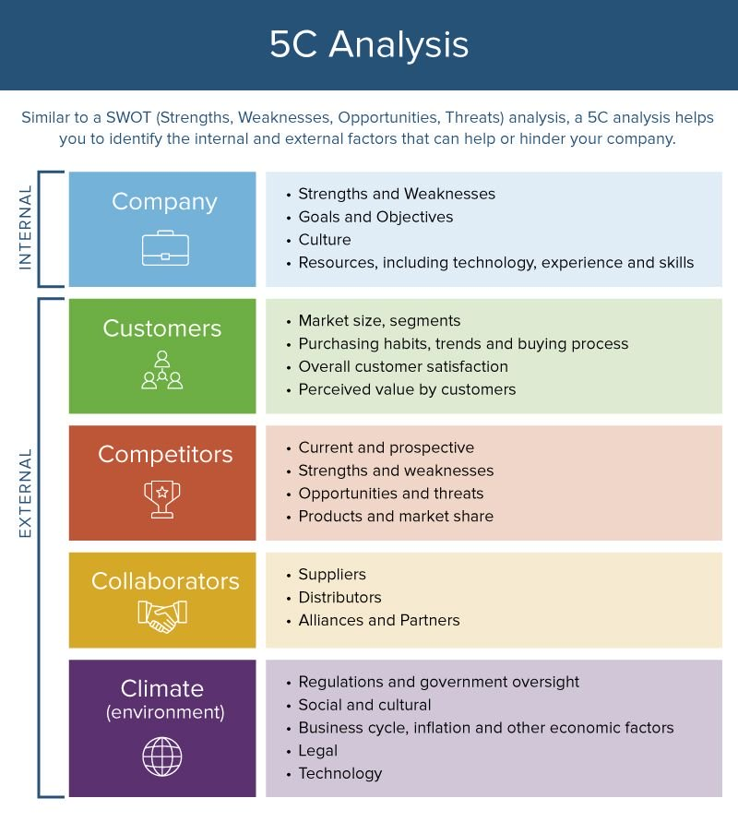Fig 3. https://www.smartsheet.com/strategic-marketing-processes-and-planning

PESTEL analysis is the analysis of the external influence of the development of a business. For example: Political vilification (Laws and regulators affect clients and businesses). Economic Impact: Interest, taxes and inflation and their impact. Social Factor - Lifestyle and how it determines shoppers' habits. Technical - Patents, innovations and licenses regulate a company.
Samsung's PESTEL analysis.
Politically:
1. Samsung's patent cases;
2. Competitive judgments that violate its innovative characteristics;
Economically:
1. Best Creator of Android Smartphones.
Social:
1. Demographically aging;
2. Population growth rate;
Technology:
1. Advanced technologies;
2. Phones with sensitive HD screen;
3. Reducing costs by expanding market leadership in the memory business;
Social culture:
The highest quality of life in Singapore, with extensive retail experience;

Strategy:
The three main processes of targeted marketing are:
- Segmentation - Divides the large market into small groups based on demographic, geographical lifestyle.
Samsung has managed to change its structure to become one of the most respected manufacturers.
Targeting - Choosing the most potential buyers to grow your business because of the day-to-day tastes of Samsung technology marketers has followed the pace and offered smart and evolving gadgets to its customers.
Positioning - Proper presentation of products so that they appeal to customers. Samsung has strict rules for advertising and for its distribution network, which work to best represent the brand to its customers. Every organization uses this S - T - P approach to capture the attention of the best customers.
The 4Ps marketing strategies:

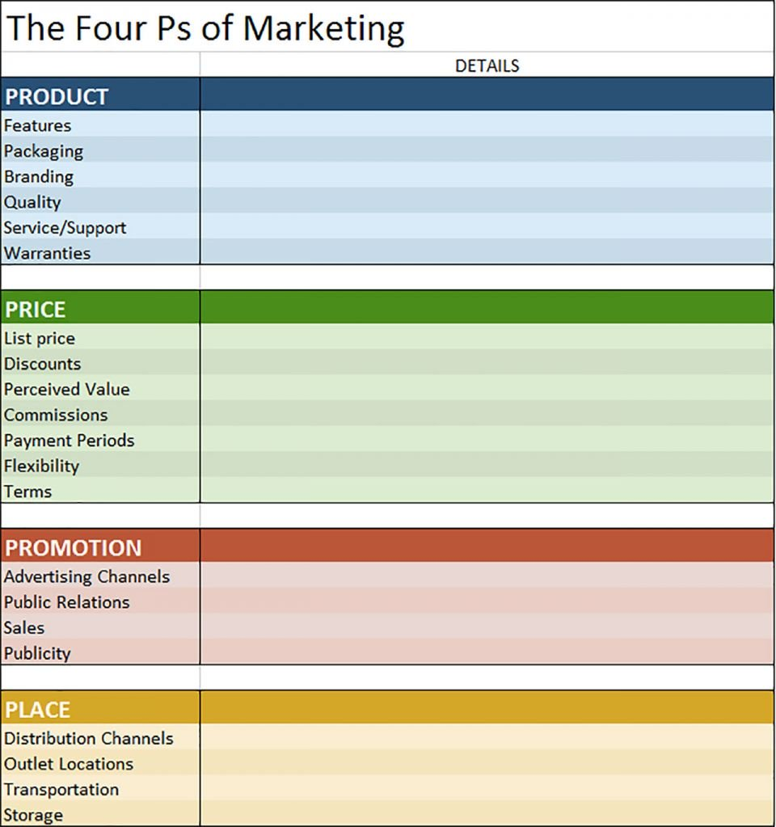Fig. 4
https://www.smartsheet.com/strategic-marketing-processes-and-planning
Samsung's marketing mix is ​​a combination of the so-called 7ps. It represents price, people, product, promotion, location, process and evidence. It offers designs that meet customer needs. High quality and necessary guarantees. Technology is high-level Samsung is the highest brand with the best price. It is neither very high nor very low. The price is available to all customers. Samsung has successfully advertised and promoted its products at festivals and major holidays to psychologically attack and motivate its customers. Samsung has also launched its online network, which helps grow the global market. By interacting with media, news outlets, she is increasing her marketing. Choosing a place to supply goods is not the best side of Samsung because it is difficult to know which store is located in each city. But any customer is happy to buy a product because of the high technology Samsung has been using for the past few years. Samsung has emerged with a new vision, using the mission of its marketing strategy properly.
Products:
Marketing mix. Samsung has reached incredible heights by launching its new smartphone models. The brand has become a reliable and sought after brand. Samsung also has the advantage of having a great product mix. It offers phones, laptops, tablets, TVs, appliances, insurance and more.
Promotions:
Samsung has various forms of promotions. Although Samsung does not focus its attention on advertising like Coca - Cola or Pepsi, it always manages to promote its most important products.
Place :
Now a day Samsung brands have 25 generation base around the world and more at that point fifty deals backups in close approximately 50 countries. Their worldwide technique includes eight fundamental regions. Samsung too offers its item through free retailers. Customers can see and handle items they are considering buying.
Price:
Pricing moreover appeared to have played a critical part in Samsung’s success. Samsung seeking out for its administrations available to as numerous individuals as possible. It offers a part of estimating structures to suit diverse clients groups. The cost plans are accessible month to month premise as well as prepay option.
Question 2: The benefits of marketing to consumers.
The innovation of marketing automation makes communication between the company and customers stronger. Dynamic content is created after the user data is collected. Customers do not collide with inappropriate ads, on the contrary, the company is already familiar with the tastes of its users and directly directs them to its sales network. Samsung 's marketing strategy is one of the most successful, created and operational because of the fact that it helped to change its structure and it became one of the best manufacturers of technology. The company follows the pace of changing times and tastes and offers progressively refined products on the market. The new strategy proved to be the key to the future of the brand, and it was based on the fact that the customer always wants the best. Society prefers a technique that enhances life comfort. Today, Samsung is passionate about innovative technology, it has an interesting and significant product foil. In addition to the product, Samsung is known for its fast and productive customer service and delivery. Samsung's pricing strategy is an asset for its customers. It includes two prices:
1. Skimming Price - the so-called skimming price that Apple uses with the iPhone.
2. Competitive pricing - lowering the price for new and retaining customers. Samsung is the first and never fails to produce its innovative products.
Samsung’s energy to be everything to everybody all of the time implies it has one clear advantage over Apple, its close add up to need of commitment to a plan decision. Samsung has demonstrated time and once more that it is upbeat to switch plan and highlight choices in arrange to keep the tech press and clients cheerful. It turns this as being a great audience and putting clients to begin with, but there’s continuously the faintest whiff of freeze when Samsung does an awfully open U-turn or holds onto a highlight long after others have jettisoned it.
Expelling expandable memory within the System S6 is the culminate illustration. Samsung’s thinking was that counting expandable memory moderated down the phone’s generally execution, but other producers like LG and HTC overseen to form it work that year. The Korean company took a few fire, bore the anger of Samsung proprietors on item forums, and in the long run bought the SD card opening back within the System S7, with no execution related issues. Elsewhere Samsung likes to create a parcel of commotion around keeping highlights Apple has jettisoned, or it likes to tout how much superior its comparable but-definitely-not-copied highlights are. It may see frantic but, eventually, for the client, it’s nothing but great news.
Why? Since not as it were do Samsung proprietors get to keep much-beloved highlights just like the headphone jack, but they get to undertake out an sincere endeavor at well known iPhone highlights without exchanging to iOS - like AR Emoji. Moreover, this makes the transition from iPhone to Android somewhat less excruciating, which may be a showcase Samsung forcefully works in. Moving the unique finger impression scanner is additionally completely based on customer input, which Samsung was upbeat to oblige. These changes and inversions conclusion up as fabulous promoting fabric for the company, and lets it charge reasonably essential highlights and little plan changes as gigantic, engaging wins for clients. You talked, we listened.
It’s almost the polar opposite of Apple’s strategy. Where Apple breaks new ground (in some areas) and makes considered decisions about its features and design choices that are part of a larger evolutionary plan, Samsung plays to the crowd and its whims. It’s comfort food versus a healthy meal.
https://www.forbes.com/sites/jaymcgregor/2018/03/02/samsung-has-one-clear-advantage-over-apple-galaxy-s9-offers-specs-release-date-price-headphone-jack/#679814ad2e71

What is the Ansoff Matrix? Ansoff Network too alluded to as the Product/Expansion Lattice, may be a key apparatus which is utilized by businesses towards analyzing and arranging their development strategies.
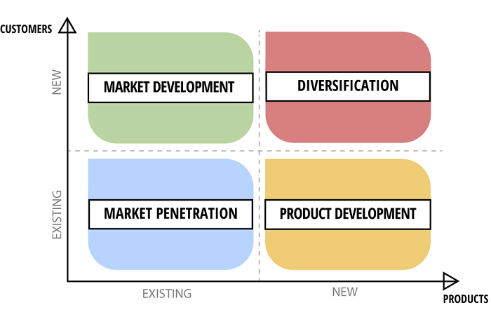Fig.5
Ansoff Matrix Source: http://www.elma-bpm.com

https://www.superheuristics.com/ansoff-matrix-samsung/

This framework offers firms 4 distinctive development procedures which can be received by the trade post examination of chance included in each strategy.
Samsung Market Penetration
Samsung is stepping into all markets by leveraging its existing capabilities and resources to increase its market share. The company throws aggressive marketing and promotions, offers competitive prices and so on. For example, Samsung lowers its smartphone prices several months before launching its next model.

Samsung Market Development
Samsung started as a small business based in Sung-dong, South Korea and today is a global brand with products in 180 countries. This is due to Samsung's Ansoff Matrix market development strategy.
Samsung Product Development
Samsung's product development strategy is the foundation for the company to become a diversified global brand. Samsung is exporting new products that target well-known markets and regions.
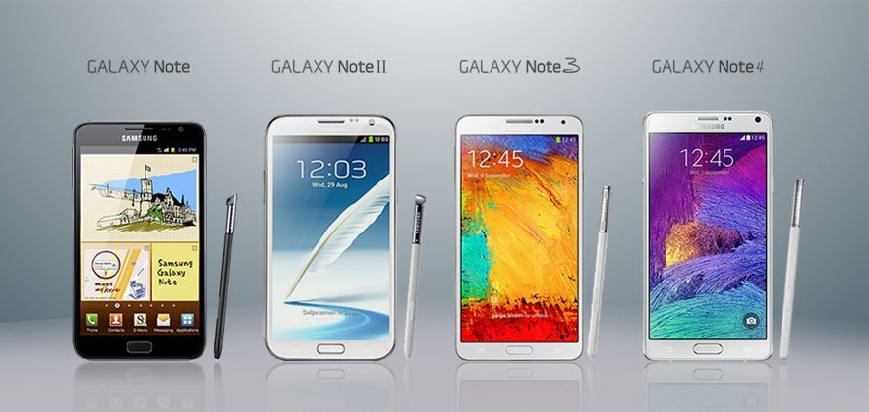Fig. 6
https://www.samsung.com/uk/
As a result, Samsung enjoys a high market share in smartphones.

Samsung Diversification
Samsung's large product portfolio, which has solid-state apparel, consumer electronics, electronic equipment, home appliances, semiconductors, says a lot about the company's diversification strategy.
Question 3 Stakeholders
A stakeholder is any person who can influence or be affected by a company, strategy or project. They are internal or external and can be grouped at senior or junior levels (stakeholdermap.com). Another stakeholder definition is a person or group with the power to control, negotiate and change the future of the organization (Eden, Ackermann, 1998: p.117) According to Reuters sources, Samsung is looking to deliver 300 million smartphones in 2020 on the world markets. One-fifth will be manufactured by Chinese ODM and Wingtech partners. Counterpoint analysts estimate that ODMs can buy most smartphone components at $ 100 - $ 250 for 10-15% cheaper. This means that Wingtech will receive up to 30% discount on the purchase of some components, compared to the price Samsung is paying for manufacturing in Vietnam. Research firm IHS Markit notes that Wingtech will produce 24 million Samsung smartphones in 2019, or 8% of the volume of the world's largest smartphone provider. In 2017, this share was about 3%.
Question 4 : Promotion
Communication is the transmission or exchange of information by speaking, writing or transmission through another medium. (Wikipedia.org.,2019).
Communication models are conceptual - they explain the process of communication between people. The first major communication model was introduced in 1948 by Claude Ellwood Shannon (Wikipedia.org.,2019).

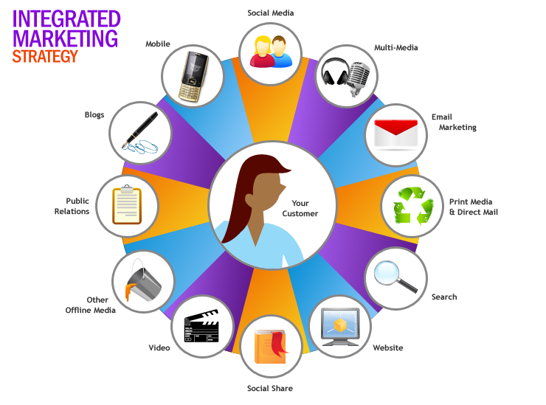Fig.7
http://adelabiancahan.blogspot.com/2015/09/integrated-marketing-communication-imc.html

The figure shows that integrated marketing is a way of organizing for a seamless experience for relationship consumers - a brand. It mixes all the components of marketing communication - sales promotion, advertising, direct marketing. This is an activity that ensures that all modes of communication and interaction are consistent and focus all customers.
Samsung is one of the most heavily promoted companies. Not only does it offer offers, it tends to lower the prices of its products in order to get ahead of its competitors.

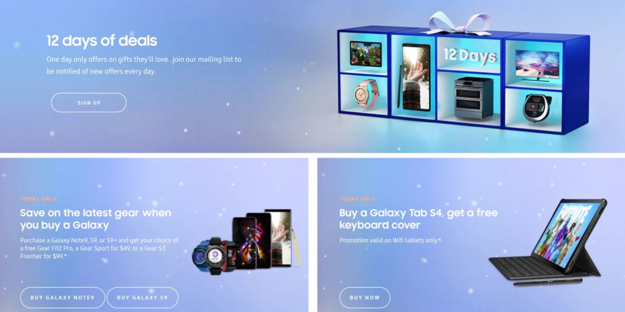Fig. 8
https://www.androidauthority.com/samsung-12-days-of-deals-929746/
Recommendation
Samsung needs to work to expand its mobile computing markets.
It has to offer a strong online business. It must also achieve the high scale of the business with global technologies of its electronic brands.
Controlling the standard and quality is quite a difficult process.
The global business is a supply chain of quality products stemming from consumer views.
Conclusion
This analysis introduced us to the Samsung brand.
I came to the conclusion that it is a world-renowned company that manufactures electronics and other goods.
It is a preferred brand because of its good service, excellent staff and modern and reliable product. It has a mission for its business and globalization with partners and clients.
Samsung is creating a world with advanced technology for new generations.
Samsung's mission is to be the best.
https://www.ukessays.com/essays/business/the-samsung-electronic-company.php

References
- Kotler, P. and Lane Keller, K. (2010). Marketingmanagement. Amsterdam: Pearson Education Benelux.
- Eden, C and Ackermann, F. (1998) Making Strategy: The Journey of Strategic Management, p117, London: Sage Publication
- Smartsheet. (2019). Here’s How the Marketing Process Works | Smartsheet. [online] Available at: https://www.smartsheet.com/strategic-marketing-processes-and-planning [Accessed 29 Dec. 2019].
- Forbes.com. (2019). Samsung Has One Clear Advantage Over Apple. [online] Available at: https://www.forbes.com/sites/jaymcgregor/2018/03/02/samsung-has-one-clear-advantage-over-apple-galaxy-s9-offers-specs-release-date-price-headphone-jack/#679814ad2e71 [Accessed 29 Dec. 2019].
- Saxena, D. and Saxena, D. (2019). Ansoff Matrix – Samsung’s Journey from a Grocery Store to Diversified Conglomerate - Super Heuristics. [online] Super Heuristics. Available at: https://www.superheuristics.com/ansoff-matrix-samsung/ [Accessed 29 Dec. 2019].
- Elma-bpm.com. (2019). ELMA Business Process Management software. [online] Available at: http://www.elma-bpm.com [Accessed 29 Dec. 2019].
- Samsung uk. (2019). uk. [online] Available at: https://www.samsung.com/uk/ [Accessed 29 Dec. 2019].
- Adelabiancahan.blogspot.com. (2019). INTEGRATED MARKETING COMMUNICATIONS (IMC). [online] Available at: http://adelabiancahan.blogspot.com/2015/09/integrated-marketing-communication-imc.html [Accessed 29 Dec. 2019].
- Android Authority. (2019). Samsung's 12 days of deals continues: Save $130 on AKG headphones and much more. [online] Available at: https://www.androidauthority.com/samsung-12-days-of-deals-929746/ [Accessed 29 Dec. 2019].
- UKEssays.com. (2019). The Samsung Electronic Company. [online] Available at: https://www.ukessays.com/essays/business/the-samsung-electronic-company.php [Accessed 29 Dec. 2019].
- Wikipedia.org. (2019). Wikipedia. [online] Available at: https://www.wikipedia.org/ [Accessed 29 Dec. 2019].

