EFFICIENT TEAM WORKING

EWT1

Elena Daniela Marcu 2119677
Certificate for Higher education
Lecturer
Soban Sadiq

- Introduction
- Models of communication
- Communication skills
- The advantages and disadvantages of technology in communication
- Conclusion
- References

INTRODUCTION

Success is depending on communication, regardless of business or private life, and the cost of having poor communication skills can be severe or even life-threatening.
All forms of life communicate. Animals use their bodies to communicate, humans use verbal and non-verbal communication (body language, facial expressions, gestures, voice tone, etc.)
Communication is giving, receiving, or exchanging ideas, information, signals, or messages through appropriate media, enabling individuals or groups to persuade, seek information, give information, or express emotions.
Efficient communication means delivering the message clearly and making sure this is comprehended, in the shortest amount of time.
Communication is a two-way process, where all participants should perform to their responsibility, to insure this is done efficiently. The sender must understand the receiver, well enough to build the message to suit the receiver, not only to make it easier to understand but also to make it easy to remember. In other words, the sender should tailor the message to suit the receiver (or multiple receivers)
Receivers on the other hand should take full responsibility to listen to the message, and not simply to hear it, to decode and interpret the message, and pay attention to the non-verbal part of the delivery. Clarification is a great habit of ensuring correct understanding and ensuring the sender that you understand and follow the line of thought.

MODELS OF COMMUNICATION

According to Denis McQuail, “a model is a selective representation in verbal or diagrammatic form of some aspect of the dynamic process of mass communication.”
To put it another way, communication models give us a visual picture of the various components of a communication situation.

There are 3 categories of communication:
- Linear – One-way communication
- Interactive - two-way communication
- Transactional communication – two-way communication, where the message gets more complex

The Shannon-Weaver model

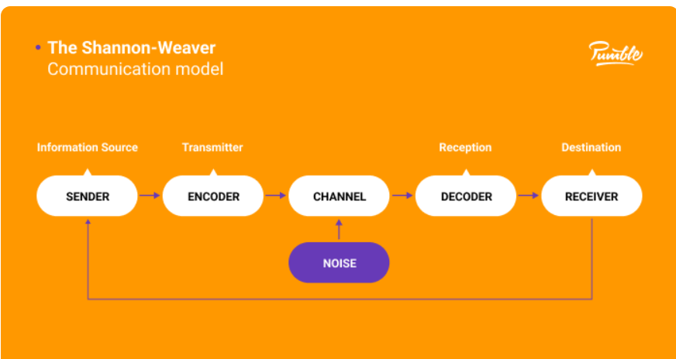

The Shannon-Weaver model of communication may be the most well-known.
Strangely enough, Shannon and Weaver were mathematicians who created their work in the Bell Telephone Laboratories during the Second World War. They sought to identify the most efficient communication channels.
The components of this model of communication:
- Sender
- Encoder
- Channel
- Decoder
- Receiver
The first to discuss the significance of noise in communication was Shannon and Weaver. John Fiske defines noise in his book Introduction to Communication Studies: “anything that is added to the signal between its transmission and reception that is not intended by the source.”
The Shannon-Weaver Model example:
Pedro works on a building site and Maria is his wife. One day Maria phoned Pedro.
‘Hello, Pedro, when you’re coming home, see if you can get me a chicken.
’‘Okay,’ replied Pedro.
When he got home, Pedro took off his boots and coat and went into the kitchen.
‘Maria, where are you?’ He said.
‘Here – in the sitting room,’ she said
Maria is the sender, her mouth is the encoder, the phone is the channel, Pedro’s ears, and brain are the decoder and Pedro is the receiver.
The problem in this process is the lack of feedback, as Pedro was working in a noisy environment, the message got altered, she never asked for feedback, and he did not make sure he comprehended the message
Feedback is just the transmission of the recipient's response back to the sender.
It lets the speaker adapt their message to the audience's response.
The fact that feedback makes the recipient feel involved in the communication process may be its most significant purpose.
Because they feel their perspective is being taken into consideration, this makes the recipient more open to the message.

Berlo’s S-M-C-R model
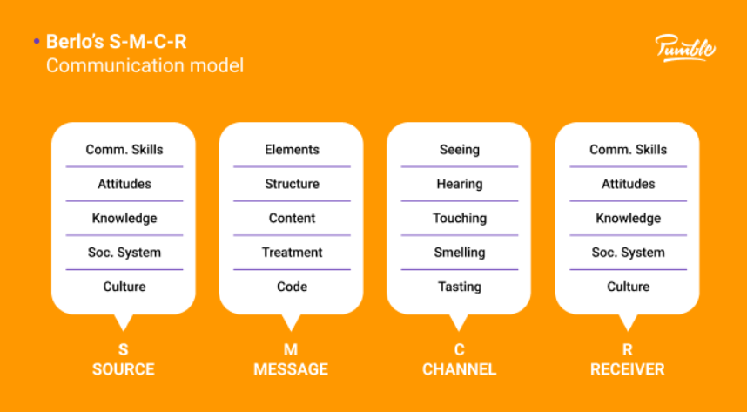

The distinctive aspect of Berlo's communication model is that it provides a thorough explanation of each step's essential components.
Four steps are used to explain communication in this model:
Source
Message
Channel
Receiver
Starting with the source, let's think about the important factors that influence how effectively the message is conveyed.
Source:
The message is carefully put into words by the source or sender and sent to the recipient.
Consequently, how does the sender deliver the information to the recipient?
With assistance from:
Communication skills – For the communication to be successful, the source must first and foremost have strong communication skills. The speaker needs to be aware of when to pause, what to repeat, how to pronounce words, and other such things.
Second, the source needs the right attitude. Without it, not even the great orators would be able to catch receivers’ attention and create a lasting impression
Knowledge is the third element, which doesn’t necessarily mean education, as it means clarity of the information sender wants to transmit.
The sender must be aware of the social system in which the communication takes place, and make sure the speech does not offend anyone
To achieve effective communication, the sender must be acquainted with the culture where the process is taking place, being very important for cross-cultural communication.

Message
- Content.
- Elements — addition to the words (content): gestures, body language, facial expressions, etc. must be considered
- Treatment —The source must be aware of the importance of the message.
- Structure — The source must properly structure the message to ensure the receiver will understand it correctly.
- Code — All the elements, verbal and nonverbal, need to be accurate if you do not want your message to get altered and misunderstood.

The Channel
The way the message travels to the receiver. All our senses are channels of communication. Depending on what type of message we want to transmit, all our five senses: hear, smell, sight, taste, and touch are channels of communication.
The receiver
A receiver is a person the source is speaking to — the destination of the transmitted message.
To understand the message, the receiver should imply the same elements as the source. They should have similar communication skills, attitudes, and knowledge, and be acquainted with the social system and culture in which they communicate.
Communication in real life is too complex to be truly represented by communication models, but they help us examine the steps in the process of communication, so we can better understand how we communicate both at the workplace and outside of it.

Linear models —see communication as a one-way process. These are mainly used in marketing, sales, and PR, in communication with customers.
Interactive models — Used in internet-based and mediated communication, they refer to two-way communication with indirect feedback.
Transactional models — like most dynamic communication models, these are the most complex models of communication, which best reflect the communication process.
Even though none of these models represent our communication 100%, they can help us detect and solve potential problems and improve our overall communication skills.

THE ADVANTAGES AND DISADVANTAGES OF TECHNOLOGY IN COMMUNICATION

It’s common sense these days that communication was revolutionized, and technology replaced personal contact. Mobile phones, emails, and social media are at hand for everybody to be used to communicate to send/receive messages instantly. It made life easier and people from all over the world can interact and exchange information, pictures, music. Distance is not an issue anymore. Businesses thrive with the help of ICT (information communication technology). Video conferences replaced travel, as business or team meetings can be held online. People can work remotely, so there’s no need to commute or relocate to find a better job.
ICT has united people and countries, trades and businesses transforming the world into an independent system.
Students can enroll in international schools and universities and attend courses over the internet or access learning materials via e-learning platforms or e-libraries.
As with anything, the development of technological communication has also downsides. People lost the human touch and personal contact. We cannot read body language, facial expressions, or hear voice tones, this translates into making room for misinterpretation since most of the communication is actually non-verbal.
Another downside is security. Information (message) can be hacked, and this can bring loss or tainted reputation.
Social media can cause addiction, and an overall low level of education as it is not possible to control the quality of the information found over the internet, and people tend to believe everything they read.

CONCLUSION

The word Communication comes from the Latin: communicare which means “to share” or “to be in relation with”. As mentioned at the beginning all forms of life communicate, they share information. Animal communication can be defined as any behaviour of one animal that affects the current or future behaviour of another animal.
Plants and fungi communicate, Recent research has shown that most of the microorganism plant communication processes are neuron-like.
Fungi communicate to coordinate and organize their growth and development such as the formation.
Humans are studying communication as a complex process. Communication is probably the most important aspect of our existence (human or non-human). If water is essential for life to continue to exist, communication is as important.
Aristotle, the Greek philosopher said “Man is, by nature a social animal”, and what would be it without communication

REFERENCES

https://study.com/academy copyright 2003-2022 Study.com 28 August
9 Types of Nonverbal Communication (verywellmind.com) 2022 Dotdash Media, Inc.
Efficient Communication | HWAO Consulting 2013 - 2022 HWAO Consulting.
Harold D. Lasswell
McQuail′s Mass Communication Theory by Denis McQuail (goodreads.com)
Introduction to Communication Studies, John Fiske
Walton, Andy. Advantages & Disadvantages of Information & Communication Technology. The Houston Chronicle. 2013.
Web. https://smallbusiness.chron.com/advantages-disadvantages-information-communication-technology-66948.html
Ian T. Baldwin; Jack C. Schultz (1983). "Rapid Changes in Tree Leaf Chemistry Induced by Damage: Evidence for Communication Between Plants". Science. 221 (4607): 277–279.
Cobley, Paul (2008-06-05), "Communication: Definitions and Concepts", in Donsbach, Wolfgang (ed.), The International Encyclopedia of Communication, Chichester, UK: John Wiley & Sons, Ltd, pp. wbiecc071,
Jones, R. G. (2018). Communication in the real world. Flat World Knowledge
McQuail, D., & Windahl, S. (2016). Communication models: For the study of Mass Communications. Routledge.
Definitions of Communication (communicationtheory.org)

