Entrepreneurship traits and business plan

University of Wales Trinity Saint David

21.07.2021

Entrepreneurship

(LCBB5001)

Student: Andreea Magos

Lecturer: Doreen Nyaa Amundam

Task 1.

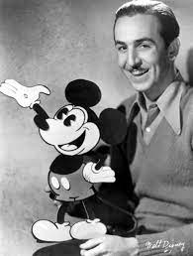
WALT DISNEY (Walter Elias Disney,1901-1966)

Walt Disney will always have a special place in people`s hearts because of his imagination and creation of Mickey Mouse, Donald Duck and many other characters and cartoons. His Disney World is the place every person on the planet wants to visit, regardless of their age. Beside being a creator of amazing cartoons, Walt Disney was known one of the best leaders who risked bringing his imagination into reality even though it was considered foul. His skills and qualities have proven that a man could go beyond if truly believe in themselves. (Leadership Qualities - Styles, Skills, and Traits of Walt Disney, 2021)

Authority Traits of Walt Disney

Montgomery Van Wart suggests that the basic idea of “trait theory” is that there are certain kinds of attributes that leaders have which improve the functioning of organizations as well as improving the stature of the leader (Van Wart and Suino ,2015, p. 54). Disney`s main characteristics were:
Certainty: A pioneer must be positive about these choices. If the pioneer himself shows faltering with respect to something, it shakes the responsibility of the entire labor force. Walt Disney was a sure pioneer. He never showed any hesitance after taking an official choice.
Interest: A pioneer with interest attempts to move past the known. It makes a man push ahead and investigate how much his capacities are. What is more, that is the thing that we can found in Walt Disney's attributes. He was continually attempting to do new things. At the point when he needed to move from making an activity to an event congregation, individuals debilitate him. Yet, his hunger for investigating did not make him stop.

Persistence: Patience and diligence are the things that Walt Disney is made of. He was terminated from his work, got scrutinized by his family, including his soul mate, confronted numerous disappointments, attempted to oversee financial backers, and got various dismissals. He persuaded his partner not to surrender since he was rarely keen on surrendering.

Authority Skills of Walt Disney

Great correspondence: Although Walt Disney was an imperious pioneer, he ensured everybody gets his messages unmistakably. He was continually sharping his relational abilities. What is more, the most magnetic piece of Disney's correspondence was he communicated his words through a couple of sentences, yet in addition through his eyes, voice, and articulation, which worked like wizardry to his representatives.

Inventiveness: Walt Disney had an uncommon ability in narrating. His endless innovative contemplations have made him to dominate this expertise. Prior to each show, he used to play out every one of the characters in various voices and articulations, which merited watching and profoundly propelling.

Persuading power: A pioneer should have an influential capacity to sell his thoughts, regardless of whether to representatives, financial backers, or clients. What is more, Walt Disney had an astonishing ability to make individuals persuaded. He was consistently prepared with his initial words that work like enchantment and immediately set individuals straight so that individuals feel truly keen on paying attention to his thoughts.

Process of creative destruction in Disney`s success
Joseph A. Schumpeter instituted the saying "creative destruction" for this continuous interaction of unending change. Innovative annihilation is the straightforward idea that when we are allowed to tackle issues chasing after new freedoms for our own prosperity, we essentially obliterate the old method of getting things done. In a key entry, Schumpeter takes note of that "Creative Destruction is the essential fact about capitalism. It is what capitalism consists in and what every capitalist concern has got to live in." (Schumpeter, 2008)
Each phase of Walt's prosperity was the consequence of making a conveying something new that was esteemed exceptionally, by Walt and his group, however above all by film houses and film going consumers. Unlike numerous others in the animation business who lashed the standard, worn out items in various variety to an undeniably uninvolved purchaser, Walt kept on improving in quality, sound, and shading, as new advancements opened, and public preferences developed. Doing as such permitted him to charge premium costs, getting more cash to put resources into additional development and quality improvements. (Linetsky, 2020)

Conclusion
Walt Disney was a man of numerous marvels. Around then, individuals did not know numerous things about authority or imaginative approaches to coordinate individuals and accomplish the objective. Administration was just intended to arrange individuals in those days. However, Walt Disney was an exemption on this matter. He was one of those totalitarian chiefs who demonstrated that dictatorship does not simply mean to utilize the force, but making others believe in leader`s words.

References:

The Strategy Watch. 2021. Leadership Qualities - Styles, Skills, and Traits of Walt Disney. [online]
Available at: <https://www.thestrategywatch.com/leadership-qualities-styles-skills-traits-walt-disney/> [Accessed 19 July 2021].
Ni, A.Y., Van Wart, M. and Suino, P., 2015. Theories about Business–Government Relations in Society. In Building Business–Government Relations (pp. 44-69). Routledge.
Linetsky, B., 2020. The Process of Creative Destruction in Walt Disney`s Success. [Blog] barrylinetsky.com, Available at: <https://barrylinetsky.com/the-process-of-creative-destruction-in-walt-disneys-success/> [Accessed 9 July 2021].
Schumpeter, J., 2008. Capitalism, socialism, and democracy. New York: Harper Perennial, pp.82-84.

Task 2

BUSINESS PLAN

MUSIKLAB EVENTS

DATE: 19th July 2021

CONTENTS PAGE

1. Business overview
2. Product and Services
3.Market audit
a. Competitors
- SWOT analysis
- PESTEL analysis
4.Target market
5. Marketing plan
6. Management team
7. Financial plan
- Cash flow
- Profit and loss
8. References

- Business Overview

MusikLAB started as a pilot project, back in 2020, after the owner and Managing Director Andrei Raileanu, PR/AR Manager Andreea Magos and Matthew Harrington, now Artist Scouter and Events Manager, have put together a Romanian Minimal event. After an unexpected successful night, they have decided to keep on going with creating more events, MusikLAB becoming one of the few Romanian Minimal / Micro Minimal events around West Midlands. Since it has been founded in March 2020, our company managed to gain a constant following crowd, with just over 20k plays on SoundCloud, and around 2k followers on social media platforms, we are expecting a 300% growth on social media for the following year. Based in Birmingham UK, but working with worldwide artists, has given us a quick growth opportunity, growth that can be reflected in the way that our events/platforms evolved for the past year.
We have also got the attention of big music labels as Trommel and Meoko, after our team managed to feature Mihai Popoviciu as a special guest for our podcast sessions, a well-known DJ in minimal music industry, with plays in some of most notorious nightclubs around the world and hundreds of releases on some of the biggest record labels.
Our company's main aim is to use all these tools to help upcoming artists to get a chance to show themselves to the audience, by opening a path for them through our podcast sessions, online events, and live events. So far, we have featured over 30 upcoming DJ's, some of them already getting the attention of bigger event promoters and record labels.

- Product and Services

Or company's main activities are Live Music events and Social Media content creations but starting with the following year we are looking to create our own booking agency and record label. Once all these are sorted, our company can offer the following:
-Assisted Recording Studio Sessions
-Social Media promoting campaigns
-Artists and Events scouting and booking
-Venue scouting and bookings
-Professional Photo shoots
-Free Social Media promotion and FREE Recording Studio hours for talented young people that cannot afford to get professional help.

3. Market Audit
a. COMPETITORS
We have identified three competitors to our business:
- DUBOKA: they are one of the biggest minimal music labels in Birmingham so far. With a follower’s base of over 20k ppl, they are organizing events, inviting famous Romanian minimal DJs, and organizing random locations events. By now they do not represent a real competition four our business, as they are only doing 2 big events per year.
- UN. USUAL: they have just moved to Birmingham, and they only focus on getting international DJs on their line-ups, which so far made them cancel 4 events in a row, in only half a year because of the Covid19 guidelines Their prices are also higher than ours, factor that sometimes pulls people of if they do have another alternative.
- RE: CORD: No risk factor related to their label as the sound might be similar, the vibes and the atmosphere are totally different. Not a real threat for the company.
To analyze our business, we have used SWOT analysis and Pestel analysis.

SWOT ANALYSIS:
According to Oxford University Press (2010), SWOT analysis is a tool that helps us understand the strengths, weaknesses, opportunities, and threats of an organization as an edge of assessment of its current position at a specific time and potential future where strengths and weaknesses are internal factors, as opportunities and threats are external factors.

STRENGHTS:

- All our team members are experienced and very passionate about what they are doing, which makes our team strong and quick on thinking and acting.
- Different approach on organizing events
- Exclusivity by offering our customers memberships, for the most intimate environment to dance in.
WEAKNESSES:
- Missing a website. Work in progress but still need a professional in order to sort it out
- Need of an office/meeting room as online meetings cannot always be possible due to different factors like poor internet connection, background noises, etc.
- Not having an investor stops us from putting all the creativity in place and give to the community as much as we want to.
OPPORTUNITIES:
- Romanian Minimal sound has gained a huge attention around the world by its unique vibe and groove.
- So far, there are only 3 other labels doing something similar, in the second city of UK
- Discovering talents as many young people have started producing music on their own, and some are amazingly good.
- With a fund we could become no.1 Minimal Music Record Label in Birmingham, and the single one helping artists for free.
THREATS:
- Brexit: the decision of UK leaving the UE makes it harder to showcase international DJ’s/producers as every single one of them would need to apply for an Artist Visa, also costs are getting higher and so the event might be less profitable than planned.
- Competitors: we already have some competitors, but our events are unique.
- Due to COVID 19 pandemic there is a set back to the whole world economy that has also been affecting UKs economy as well as financial instability that makes people think twice before spending money.
To be able to identify all the factors that will have an impact on our company we have also done a PESTEL analysis.

PESTEL ANALYSIS:
Pestel analysis is a framework used to scan the external environmental factors that affect an organization. CIPD (2020)
The acronym stands for; and based on our business we can see the following factors as helpful or harmful:

POLITICAL: - once UK has left European Union the borders are not open to free passing anymore, which means long hours to wait before entering or exiting the country, which will increase the costs of international artists, and the increase will be reflected on ticket prices.

- Regulations: We do have a Limited Company in order to run our business, however we still need to sing for a Trademark, so everything created under our name would automatically be subject of copyright.

ECONOMIC: - COVID 19 it has been killing the world’s economy including UK where many small to large businesses had to downsize, sell or even close. It has destabilized the economy so bad, that all the advantage that we had built in the last year, is was nearly lost. An economic crisis is at verge.
SOCIAL: - As we are just coming out of a lockdown, socializing is what everyone wants. A nice background music always helps, then move to the dancefloor. So, yes, social factor is on our side this time.
-Diversity: due to the huge diversity of population in United Kingdom our business is facing a positive side again, as we could see on previous events, people love to share stories about their native country, culture, and language.

TECHNOLOGICAL: -Internet and social media had a very important role in growing our business so quick. They are two amazing tools that, used in the right way, can get you the key to a successful business.
-Automation – We intend to build a website and an app where people can connect with other members of our events and share info, photos, videos, come up with ideas, all these supervised by an AI admin, who will make sure will give the right answers as soon as members are asking questions about what we do, who we are, details about future events, etc.

ENVIRONMENTAL: - We support the fight against plastic waste, so at our events you will only find compostable cups, straws or any other disposable. Also, talking about environment, some of our events can be seriously affected by the weather condition at that moment, as some of them are taking place on rooftops or gardens.
LEGAL: We are running under Health and Safety Executive guidelines and constantly updating.
-Regulations as for alcohol sale.

4. Target Market
Target market is the end consumer to which the company wants to sell its end products too. Target marketing involves breaking down the entire market into various segments and planning marketing strategies accordingly for each segment to increase the market share.
To have a clearer image of what impact our products could have on our customers, primary data has been collected within a group of individuals, based on age group, cultural background, and price range.
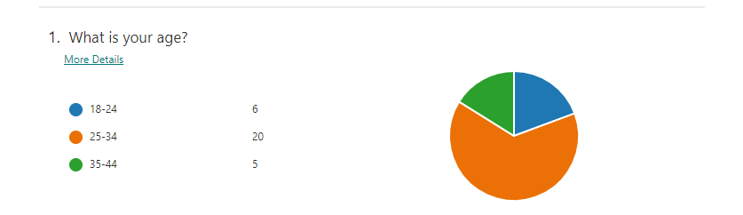

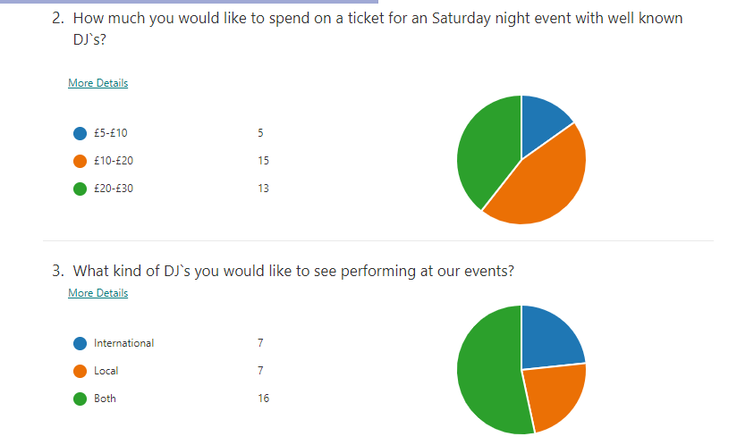
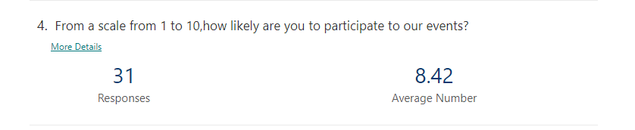

5. Marketing Plan
“Market planning is the process of organizing and defining the marketing aims of a company and gathering strategies and tactics to achieve them.” Entrepreneur Europe (2021)
To define our marketing plan, we have decided to use the 4 Ps marketing factors.
The 4 Ps (Product, Price, Promotion and Place) are four considerations known as a marketing mix. It is necessary to pay attention to those four factors to maximize the chances for a product to be recognize and bought by customers. TechTarget (2019)

PRODUCT AND PLAN
Our product refers to organizing live electronic music events in different locations around the country and not only.

PROMOTION
We are using a combination of digital flyers, short promo videos and online events, all posted on our social media accounts.
We also have a database with our membership owners. Clients will receive announcements by email or text related to our promotions and events. Each consumer will receive a leaflet upon receipt of the order.

PRICE
Our tickets price range can vary from £5 per ticket and up to £30 per ticket, depending on the size of the event, headlining artists and location.
Objectives generally establish the finality of an action, which can be assessed quantitatively and qualitatively and can be achieved in that period. In the activity of any business, the price has a special role, of maximum importance for the achievement of the final objective that it proposes - the maximization of the profit. Price is one of the four classic variables of the marketing mix, which has the greatest influence on the activity of business in general, that of marketing because it affects directly and promptly: profit, sales volume, market share and the position that our company has on the market.
PLACE
Based in Birmingham, UK most of our events are taking place at 7SVN Events Centre Digbeth or SUKI10C Digbeth, but we are scouting venues around the whole country.

6. Management Team
‘’Team management refers to the various activities which bind a team together by bringing the team members closer to achieve the set targets. For the team members, their team must be their priority and everything else should take a back seat. They should be very focused on their goal.’’ MSG (2021)

- PR/AR Manager: Andreea Magos
Qualification: Diploma in Business Management
Experience: 4 years working for Trommel
Skills: Entrepreneur Skills, It Skills, outstanding leadership skills
Job Role: working on the company website, and promoting the business.

- Event Manager/Artist Scout: Matthew Harrington
Qualification: Certificate of International Relations
Experience: 3 years working in Hospitality for Hilton
Skills: Time Keeping, Customer Service, Leadership Skills, Management Skills.
Job Role: scouting artists, music production

- Managing Director: Andrei Raileanu
Qualification: Diploma in General Business Management
Experience: 3 years working as Marketing Manager for Opheem Restaurant.
Skills: Strategic marketing Skills, It Skills, Knowledge of digital marketing, social media.
Job Role: Owning the end-to-end marketing plan campaign planning, budget management, and reporting focused on growing the membership base.

.

7. Financial Plan
“A financial plan is a comprehensive picture of your current finances, your financial goals, and any strategies you have set to achieve those goals. Good financial planning should include details about your cash flow, savings, debt, investments, insurance, and any other elements of your financial life”. (Voigt, Benson 2021)

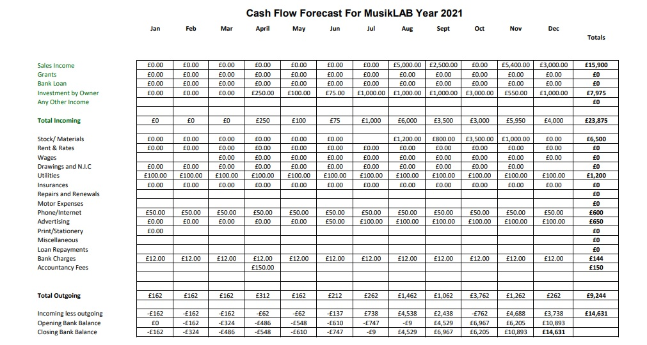

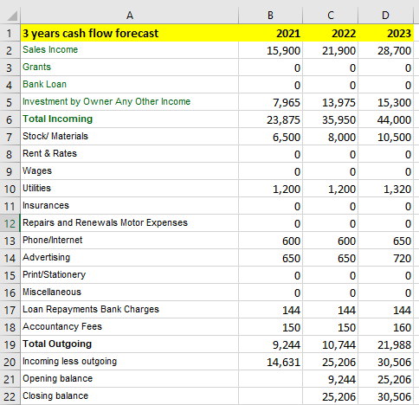

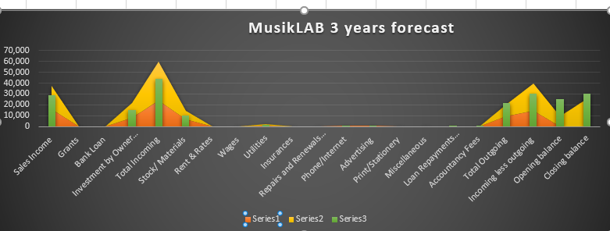

“A profit and loss account shows a company's revenue and expenses over a particular period, typically either one month or consolidated months over a year. These figures show whether your business has made a profit or a loss over that period.” (Kashflow.com,2021)

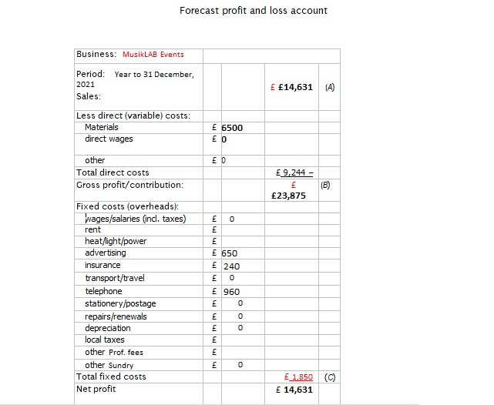

8.References:

A Guide to Profit and Loss Accounts
Available at: https://www.kashflow.com/accounting-terms/profit-and-loss-account/
(Accessed: 20 July 2021)
CIPD (2020) PESTLE Analysis
Available at: https://www.cipd.co.uk/knowledge/strategy/organisational-development/pestle-analysis-factsheet#gref
(Accessed: 20 July 2021).
Definition of 'Target Market'
Available at: https://economictimes.indiatimes.com/definition/target-market
(Accessed: 20 July 2021)

Entrepreneur Europe (2021) Marketing Plan.
Available at: https://www.entrepreneur.com/encyclopedia/marketing-plan
(Accessed: 20 July 2021)
MSG (2021) Team Management – Meaning and Concept
Available at: https://www.managementstudyguide.com/team-management.htm
(Accessed: 20 July 2021)
Oxford University Press. (2010) A Dictionary of Accounting. 4th edn. DOI:10.1093/acref/9780199563050.001.0001
TechTarget (2019) Four Ps
Available at: https://whatis.techtarget.com/definition/Four-Ps
(Accessed: 20 July 2021)

