Introduction

A Brief Overview and Framework

Lego is a company founded in 1932, in Denmark, well known by generations since then, stimulating creativity and inspire people to go over their imagination limits. Lego is famous for their bricks. Every child and adult are shown happiness and find a reason to spend quality time together.
As I framed in a short story about LEGO, I decided to go behind the scenes and see their mission and vision, what objective they have and what strategies they adopted. By doing an internal analysis, researching and enhance the information provided I will be able to identify, which are the strengths and weakness, but also opportunities and threats to our company and if was unfavourable or favourable.
To dive deep in the ocean, the external analysis will help me to identify which external factors, during pandemic had positive or negative impacted us, furthermore we will detect which strategies have been adopted in marketing mix process ended by a Ansoff matrix and personal touch.

Definition of Marketing

According to Phil T. Kotler, Gary Armstrong, Lloyd C. H, and Hongwei He (2019) Marketing is defined as a procedure used by companies to attract customers, develop strong customer relationship, and build customer trust to gain their loyalty.

Figure 1 Source Ana-Maria Gorgan

Situational Analysis
Situational Analysis is framed by internal and external analysis combined altogether to identify which factors have positive or negative impact the business and discover company strengths, weaknesses, opportunities, and threats.

Figure 2 Source: Ana-Maria Gorgan

Objectives and Strategies
Objectives are the goals that company or a person wants to achieve, can be about profitability, productivity, growth, stability, or survival and what plan can be set and follow in order to achieve company goals.

Implementation and Control
Implementation and Control is the process of putting in practical the plan of strategies and monitoring activities for goal achievement.

Macro and Microenvironment

What is micro and macro-environment?
Micro and macro-environment is all the internal and external factors with a favourable or unfavourable impact on organisational marketing strategies. 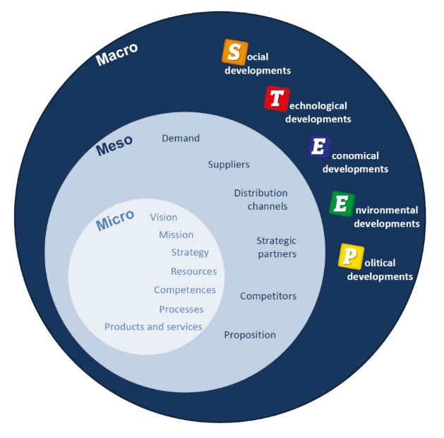
Figure 3 Source A Future Strategy Company

Covid19 outbreak started globally in 2019 and many businesses has been affected, same as LEGO. Down below I will present macro-environmental factors and how had impact on LEGO.

PESTEL Analysis

Figure 4 Source Ana-Maria Gorgan

Political
When Covid-19 outbreak, as many other stores, LEGO had to shut down their physical store due to government restriction, except the one in China and Lego Land Parks.
Economic
Customers have embraced our online shop which doubled our Sales to 43% to DKr23bn (£2.6bn).
Social
We allocated $1 million in order to support families and children in India impacted by Coronavirus crisis, collaborate with Save the Children to provide home-learning by" Learning Though Play " and donate over 30000 de LEGO Sets to Children of NHS workers.
Technological
More games, app and programs were created to keep kids entertain during hard times and help them to learn
Environment
Removing one single use plastic, and by 2030 zero waste.
Renewable energy allocated funds for offshore wind and first large toy company announcing a Science Based Target by reducing carbon.

Legal
Different countries have lack of laws when comes to copycat and presence of counterfeits. Human rights policies The LEGO Group Way, " The Promise. Providing Covid 19 safety and social distancing implemented.
Conclusion
On one side, being a non-essential shop, due to pandemic and virus spread, the physical store had to face door shut and incapability or no presence of strong laws in different countries against copycat prove that legal factors was unfavourable for us. On the other hand, social, technological, and environmental showed favourable and convenient for our company, we helped people during crisis, proving easy learn from home programs and allocating fund but also, we are setting to go zero waste by 2030.

SWOT Analysis
Figure 5 Source: A Gorgan
Strengths
- Global availability- Lego made available its products in +130 countries and 789worlwide
- Innovation by refreshing 60% of their product line and exiting children with new set every year.
- Licensing. Partnership with Star Wars, Disney Frozen, Harry Potter, Lamborghini, F.R.I.EN.D. S, raised Lego into their profits.
e-commerce Lego official online store, due to Covid and store closure, Lego doubled profits and an increase of 27% in traffic compared to previous year o its platform.
- Community. Logo Ideas designed Like a social media platform where Logo fans are allowed to upload their creative work on platform, engaging audience by activities and contests.
Weakness
- Pricing: Even tough Lego is famous for their bricks are famous, the expensive pricing makes customers to consider a cheaper substitute for Lego.
- Video Games: Lego’s video game catalogue is dominate by Bandai Namco’s video game catalogue which is 4 times more variety. Lego needs to expand his video game choices.
- Lego has lost fight against Lego clone from biting into its share.
- Intellectual Property rights not provided Lego has not put measures to stop competition to copy its products and not been successful in implementing and enforcing legal protection on its own products.
Opportunities
- New market share
- Can easily adapt into new market, yearly, Lego’s annual report shares that by 2030, 90% of billions of the 2 billion children would living outside Europe and Asia which can be new market to expand.
- Virtual Reality games which got the feature for children to see toys through Lego’s app via VR googles.
- Customisation: Customise blocks and bricks could trigger adults and children excitement.
- Education and Learning: LEGO education and LEGO foundation. As their vision is to inspire and develop the builders of tomorrow.
Threats
- Copycat products, Not only copy Lego’s toys but also use their brand name to boost sales and offering promotion claiming that they are compatibles with Lego.
- Covid 19 restriction. Due to Covid 19 restriction, all the store faced closure as being non- essential shop.
- Online gaming, the passion and the addiction developed by children to technology and virtual reality can decrease the interest for regular, physical toy.
- Rivals can overtake in toy industry; Lego need to provide continue innovation.

Environmental
Removing one single use plastic, and by 2030 zero waste.
- Renewable energy allocated funds for offshore wind and first large toy company announcing a Science Based Target by reducing carbon.
Legal
- Different countries have lack of laws when comes to copycat and presence of counterfeits. Human rights policies The LEGO Group Way, " The Promise.
Conclusion
On the other hand, social, technological, and environmental showed favourable and convenient for our company, we helped people during crisis, proving easy learn from home programs and allocating fund but also, we are setting to go zero waste by 2030.

Segmentation, Targeting and Positioning

Segmentation
Segmentation is the process of breaking the market into small groups, divided by demographic, geographic, psychographic, socio-economical status, geo demographic.

Figure 6 Source: A Gorgan

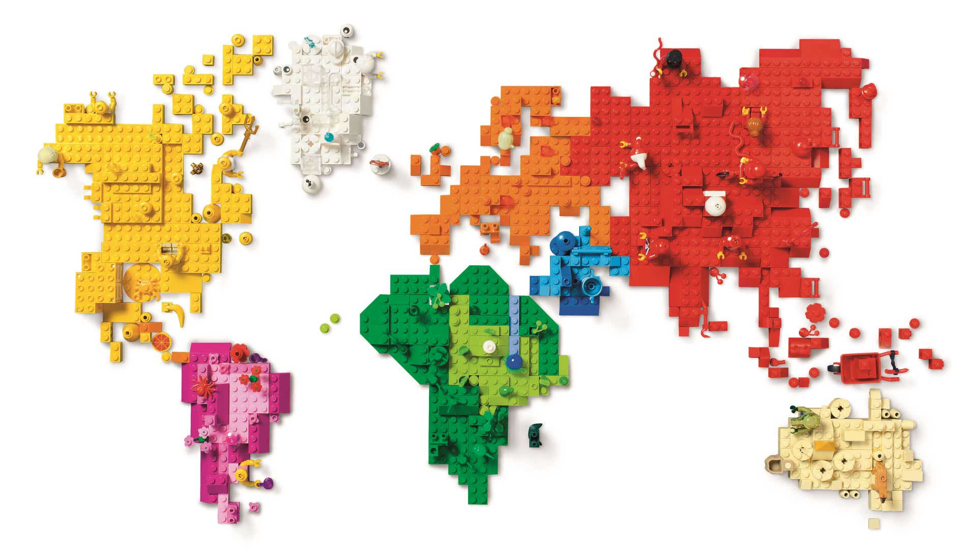
Figure 7 Source: LEGO2021
Our products are available globally over plus 130 countries in Europe but also Asia Pacific, North America, South America. Lifestyle, activities, interest, and opinion
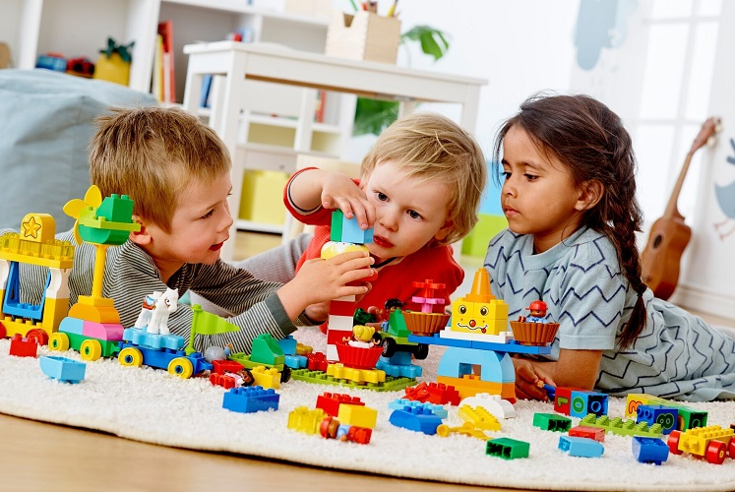
In our posters and advertise people are shown a positive lifestyle, enjoying the idea of creating, building and the time are spending in together. Life of challenge, open to new opportunities and appreciate variety. Ambition and aspire for more and ensure achievement. For a kid, spending time together with his parents increase the feeling of happiness can generate emotions and positivity.
Figure 8 Lego 2021
Our bricks designed for children, but developed in following categories: • Pre-school (includes ages up to 5 years)
• Pre-teens (from age 6 to age 11)
• Teenagers (from age 12 to 17)
• Adults (above 18 year)

Targeting
Targeting is the procedure to identify how actually customers are based on segmentation and include three different approaches such as undifferentiated, differentiated, and Concentrated.
For Lego the predominant approach is differentiated shown in our online shop browse by age and price.

Positioning
Our company, The Lego Group is part of the industry of advanced and expensive toys. As a result of Research and Development, the company produce toys based on movie trend as an example Harry Potter movie or Star Wars franchises making LEGO Sets. Right and appropriate positioning is the knowledge and understanding the demand and the volume. Using actual customers, LEGO History and based on last trends, allow us to licence and partnership with famous brands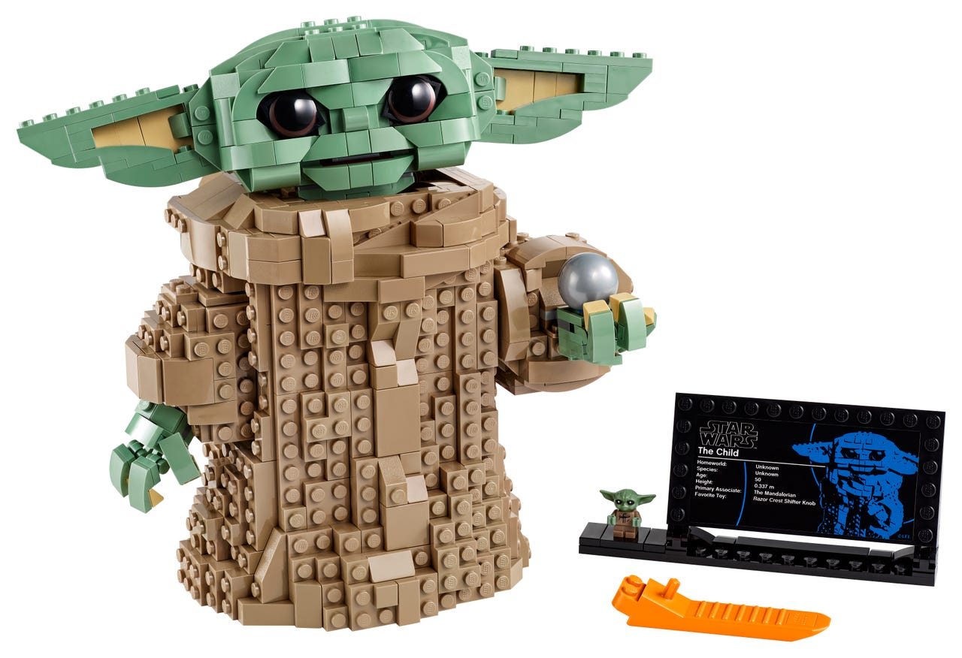
Figure 9 Source LEGO 2021

Marketing Mix and Strategies

Product
By using Family Branding Product, we do offer a variety of products such as:
- LEGO Accessories, backpack and lunch boxes, books, keychain, puzzles and board game, stationery, Role play and costumes. Storage.
- LEGO Home Decor
- LEGO Clothing in partnership with Adidas and Levies
- LEGO Interest including Adults Welcome, Animals, Arts and Crafts, Buildings, Cars, Coding for Kids, Dragons, Fantasy, Movies, Travel, Tv Show, etc.
- LEGO Attractions such as LEGO house, Legoland Parks and Discovery centre.
- LEGO DUPLO
- The strategies adopted within the company are line filling and brand extension in order to keep interest and maintain the innovation and variety to our customers.

