NOSS Assignment 1: Benjamin-David Crook

Task 1: Building a Virtual LAN, using Type 2 Hypervisor Management Software

The below image is displaying the completion of the installation of the Virtual Server for task 1. Each of the different requirements have been met to ensure the requirements have been met.
Requirements needed:
- Windows Server 2019 (64-bit)
- Memory Size Window – 4096 MB
- VDI (Virtual Disk Image) selected
- Hard disk size 25GB, typical for server installation
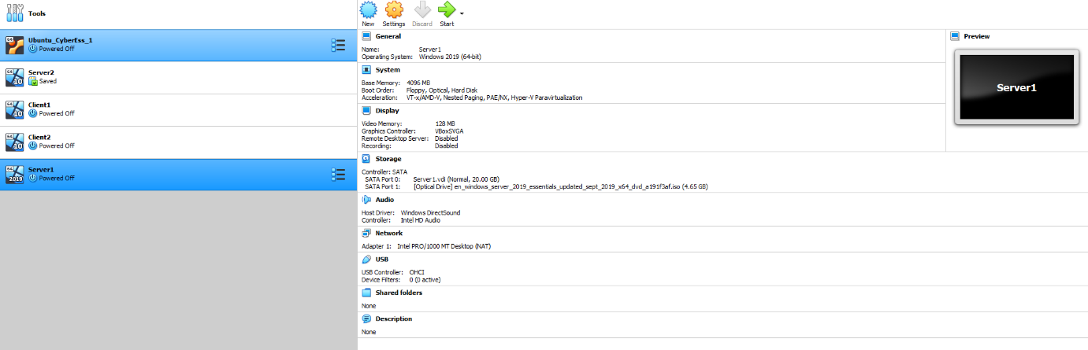
- CPU – 1vCPUs suitable for avoiding performance latency

Installing windows Server 2019
- Time and Currency format: English
- Keyboard or input method: United Kingdom
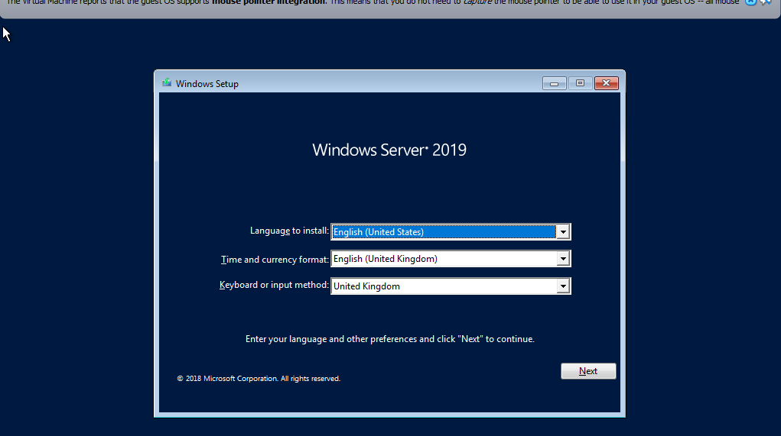

Installing Operating system
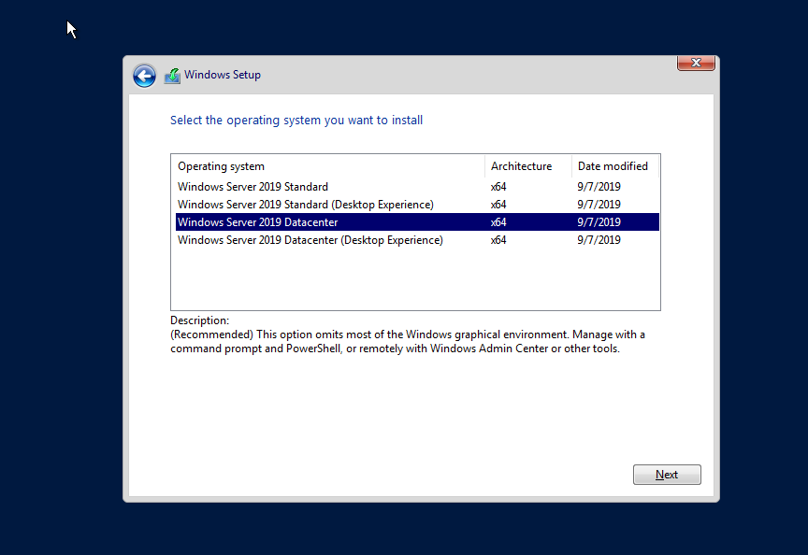
- Windows Server 2019 Datacenter (64-bit)

Server 1 – Selecting where to install windows
- Drive 0 Unallocated Space
- Free space 25.0 as set
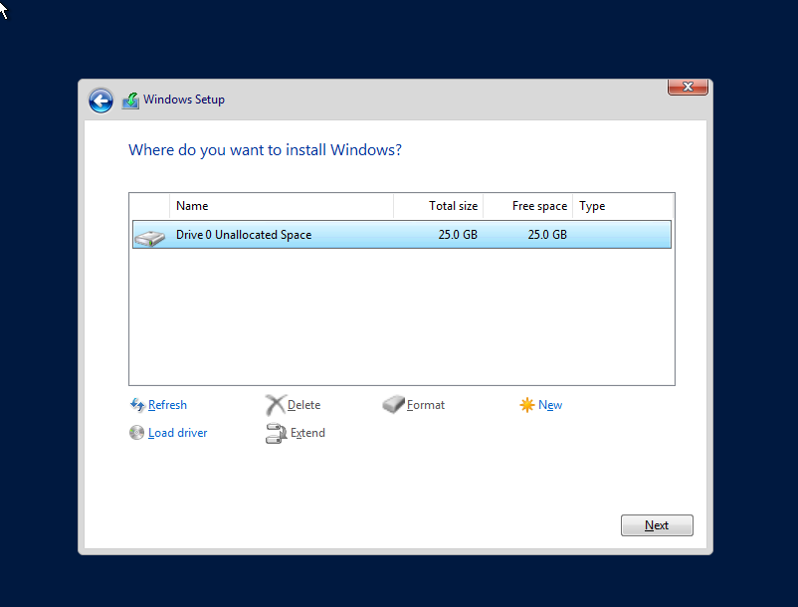

Server 1 – Setting Password windows 2019
- Password needs to meet Windows requirements
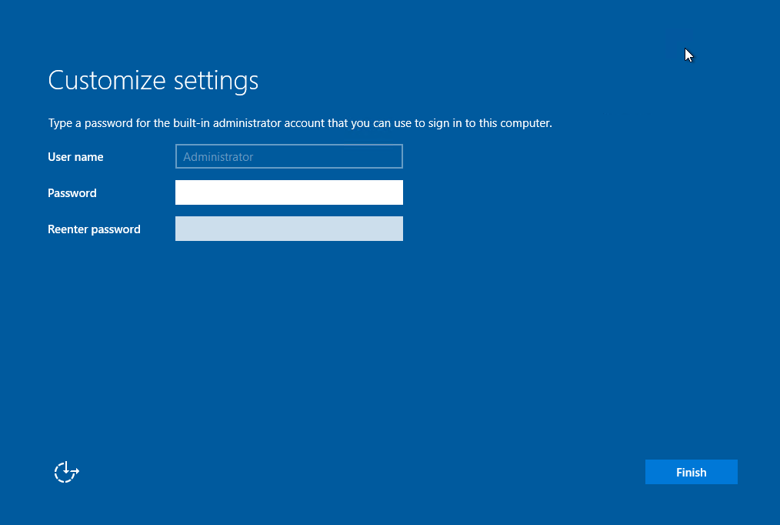

The below image displaying the completion of the installation of the Virtual Server 2
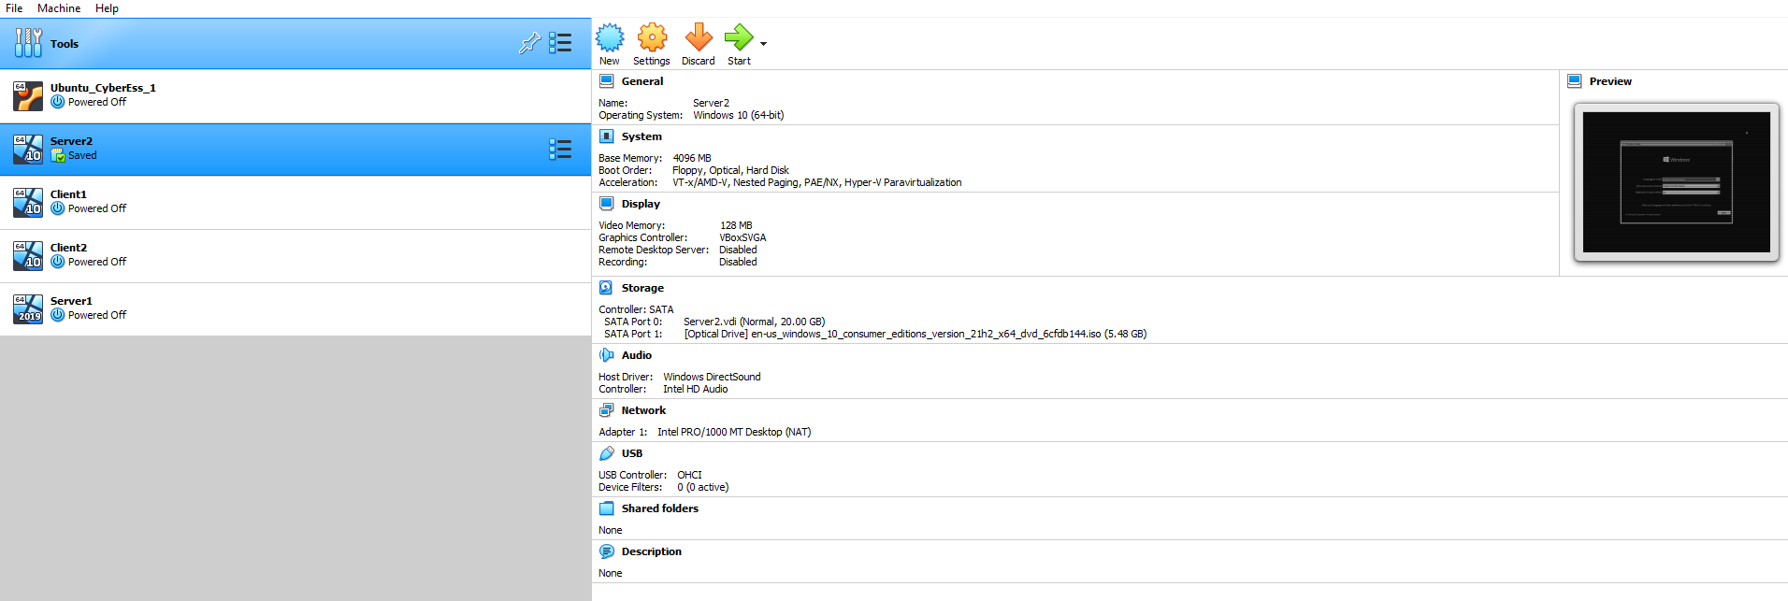

Installation of Server 2 : Windows 10 download (x64):
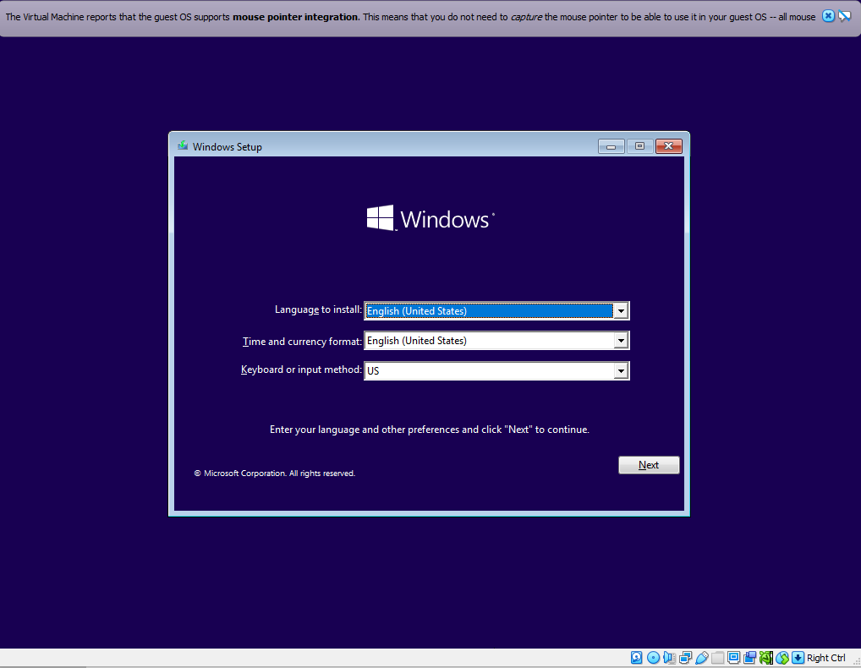

Server 2 : Installing Windows 10 education
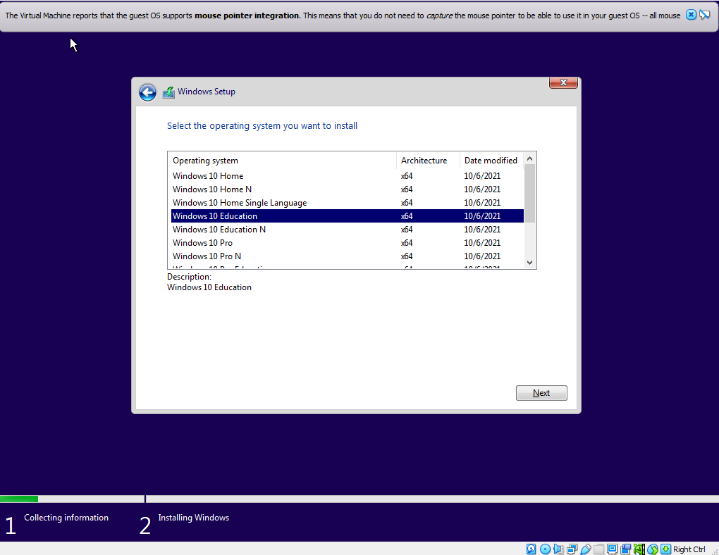

Server 2 : Installing client
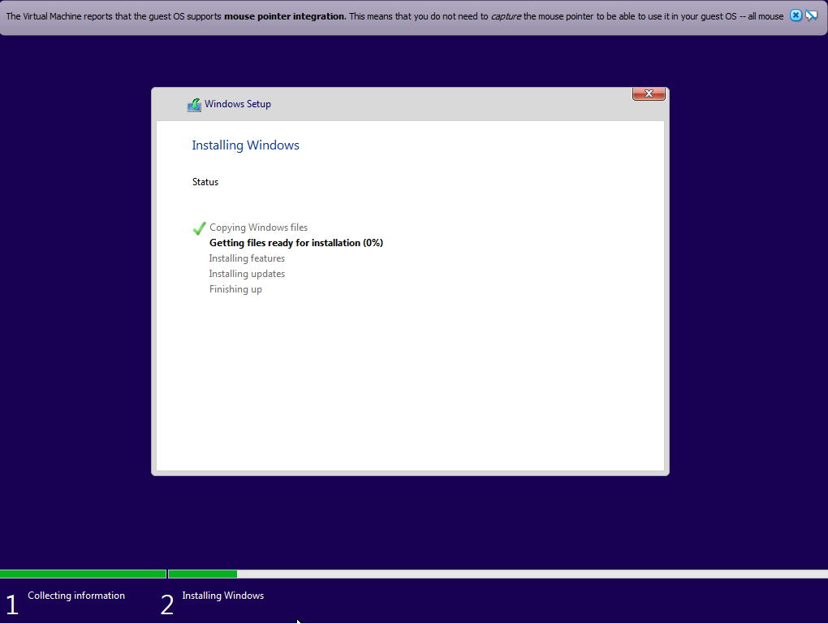

Server 2 : Setting security question win 10
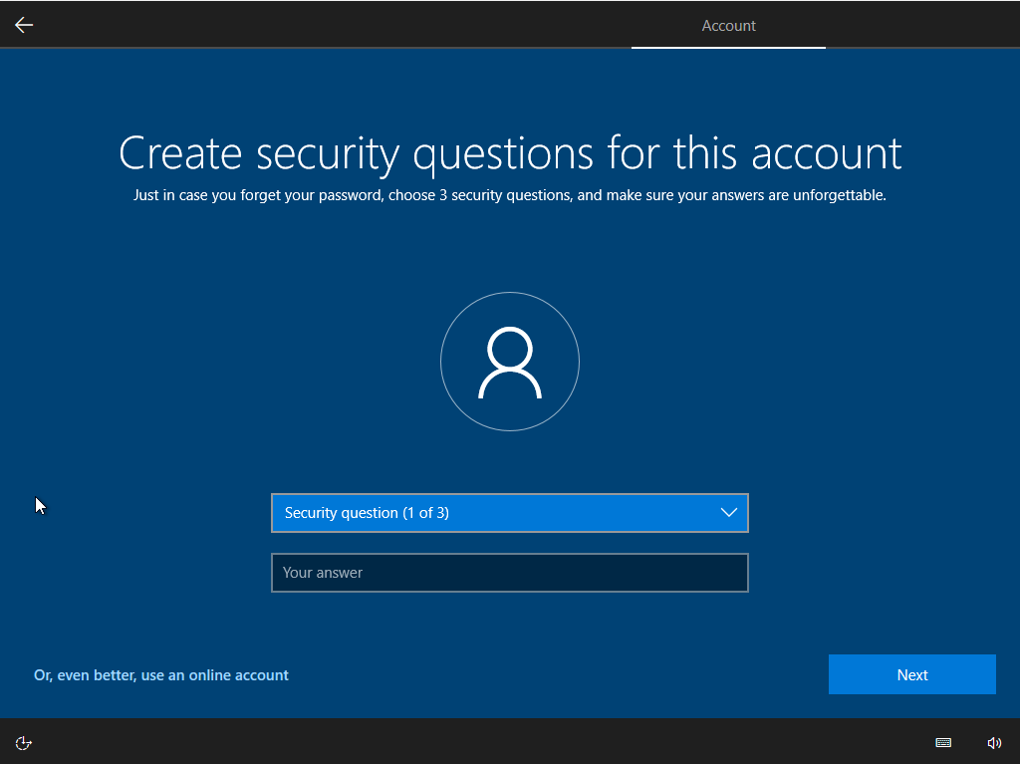
Server 2 : Log in screen
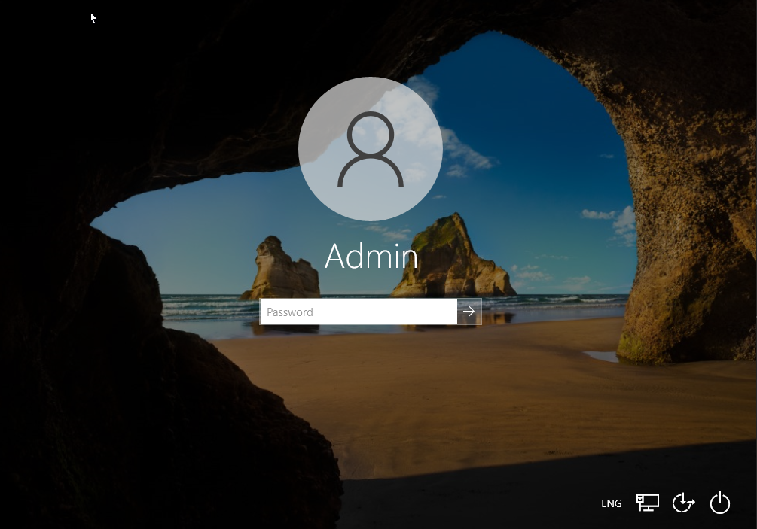

Server 2 : Windows 10 home screen
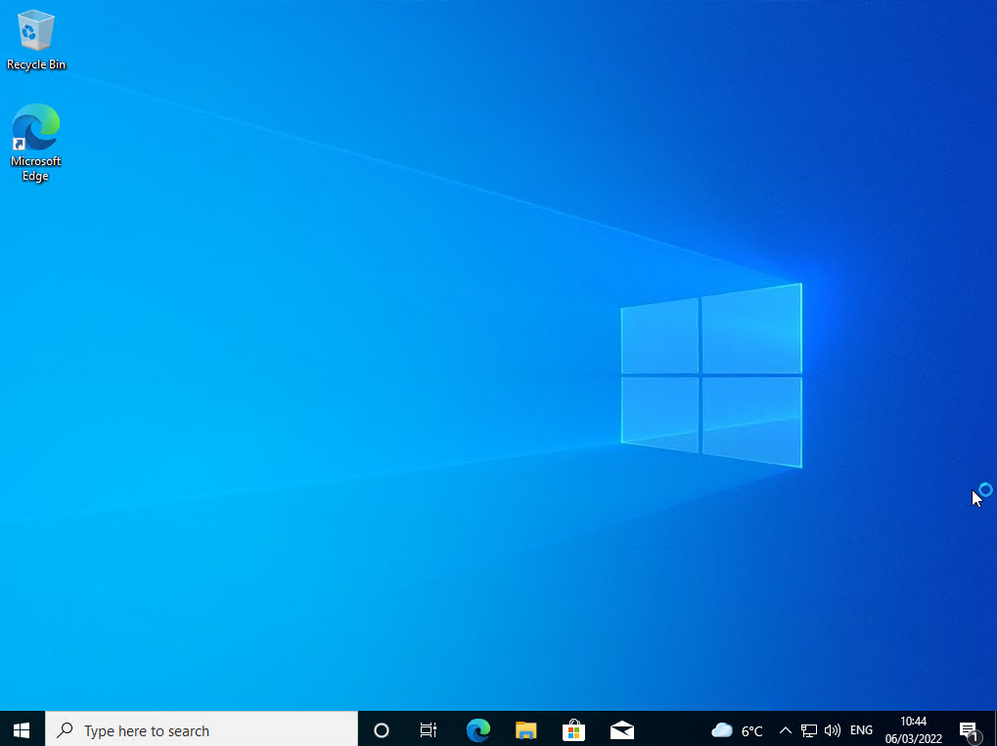

Client 1 – Settings
- The below setting is required for the successful completion of Client 1.
- Windows 10 (64-bit)
- Video Memory – 128 MB
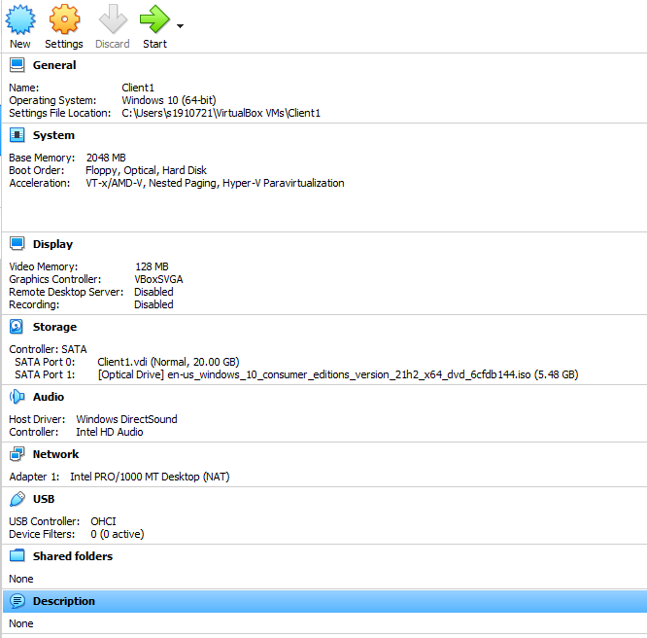
Client 1 – Installing windows 10
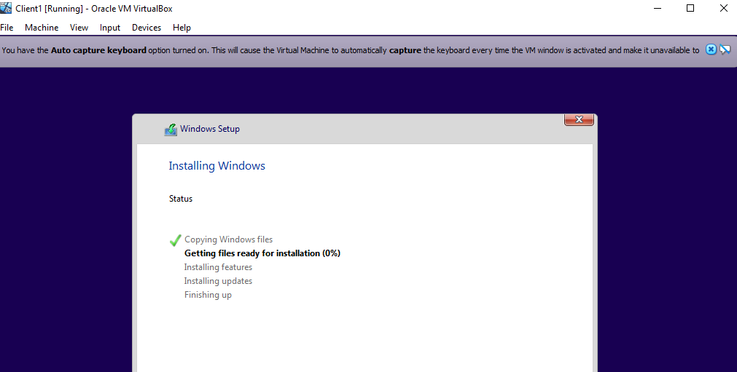

Client 1 – Making a password
- Password are required to ensure the security and safety of the data being held.
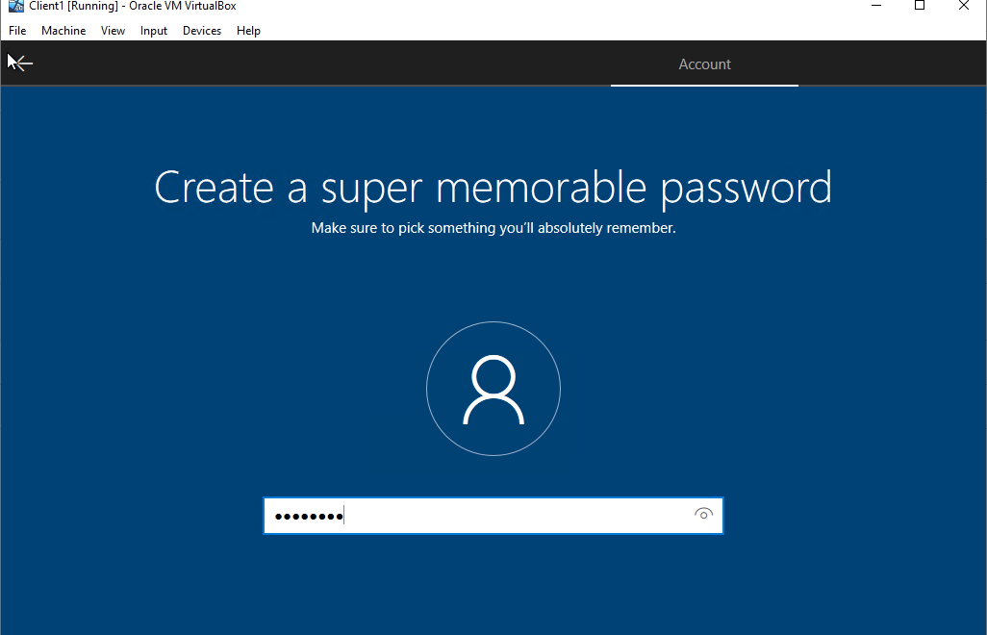

Client 2 – Settings
- The below setting is required for the successful completion of Client 2.
- Windows 10 (64-bit)
- Video Memory – 128 MB
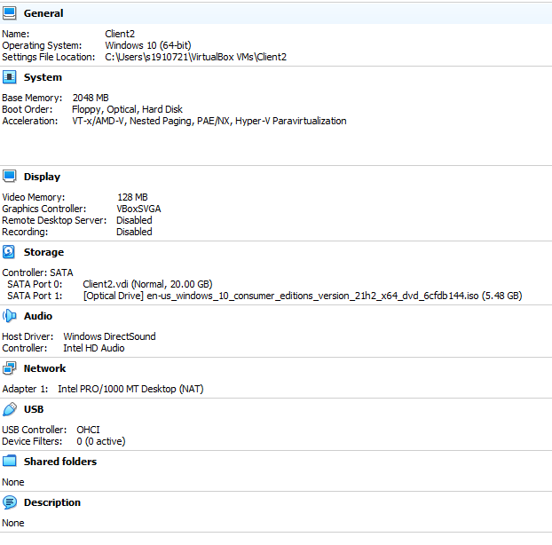
Client 2 – installing windows 10
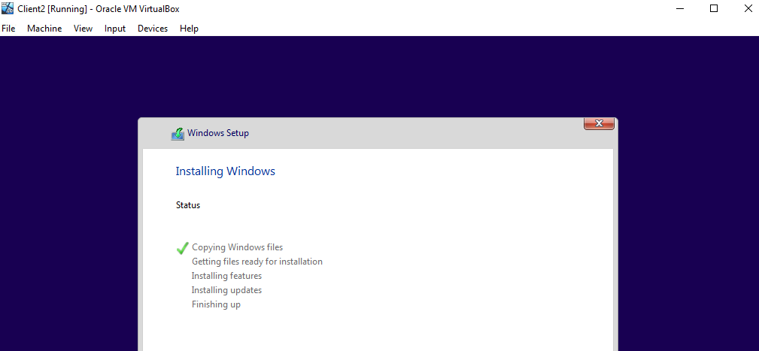

Client 2 – Making a memorable password
- This ensure the security of the data being held, this password has to also meet the standard for Windows 10 security.
Server 1 - Setting NAT field to ‘Internal Network’
- Name: PublicNet
- Attached to: Internal Network
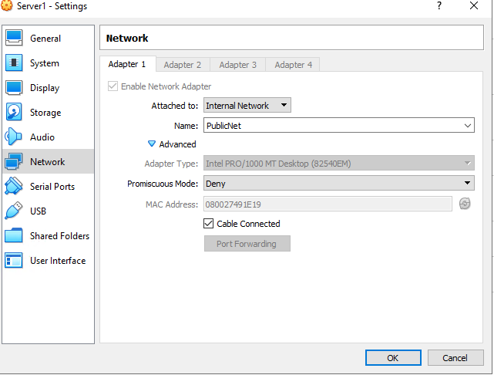

Server 1 – Adaptor enabled in windows
- This is the adaptor that has been enabled in server 1, this will allow for later ping connectivity.
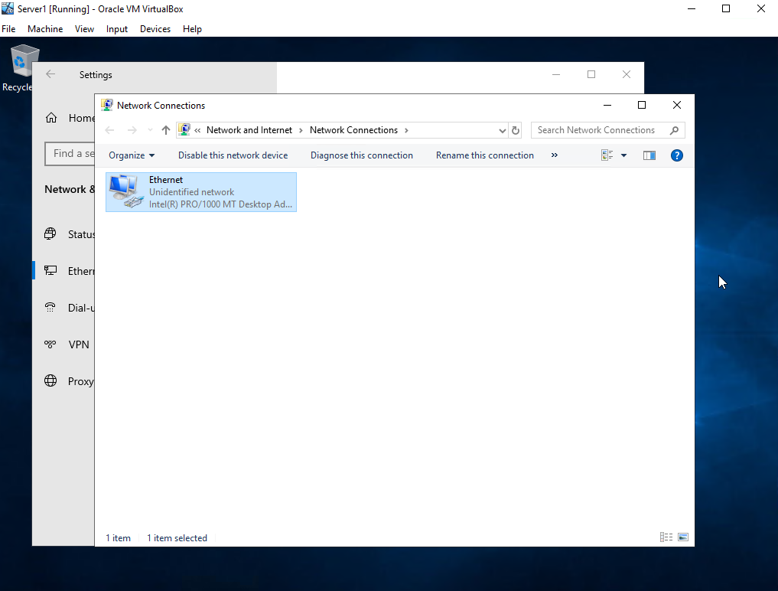
Server 1 – Setting IP address
- This allows for Server 1 to be able to successful ping Server 2
- IP Address requirement: 192.168.10.200
- Subnet Mask: 255.255.255.0
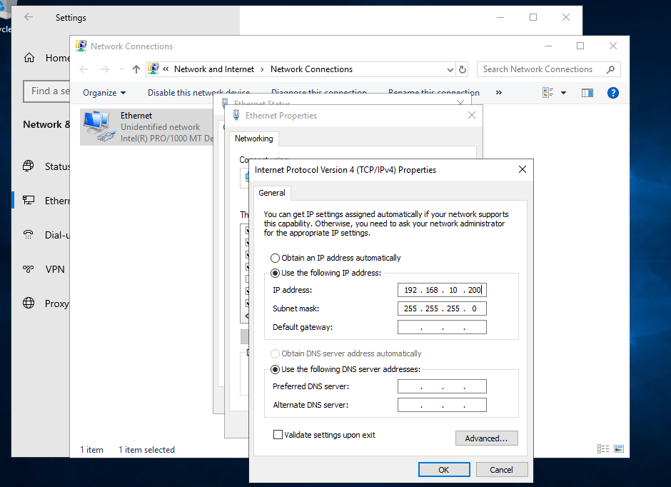
Server 2 – Setting IP address
This allows for Server 2 to be able to successful ping Server 1
- IP address: 192.168.10.201
- Subnet Mask: 255.255.255.0
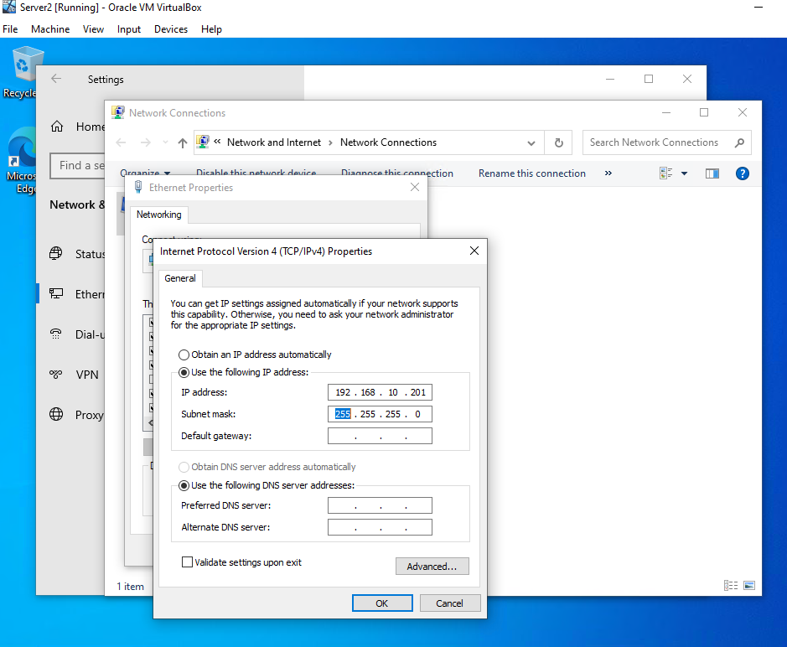

Server 2 pinging Server 1
- This internet protocol allows connected devices to communicate with each other, regardless of any difference in their internal processes, structure, or design [1].
- Packets have been sent and received, this displays the server is alive and active.
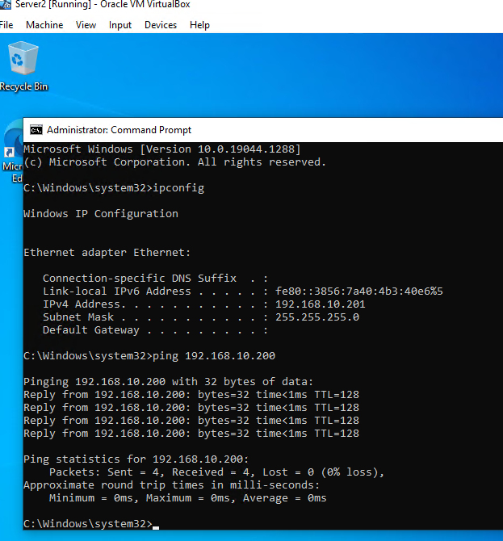
Server 1 – Giving Virtual switch a name
- This allows for the avoidance of confusion when connecting different Virtual switches
- Name: PrivateNet1
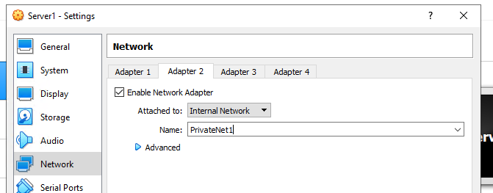

Client 1 – Setting IP address
- This is required to ensure that Client 1 is able to get a ping to Server 1
- IP Address: 192.168.1.2
- Subnet Mask: 255.255.255.0
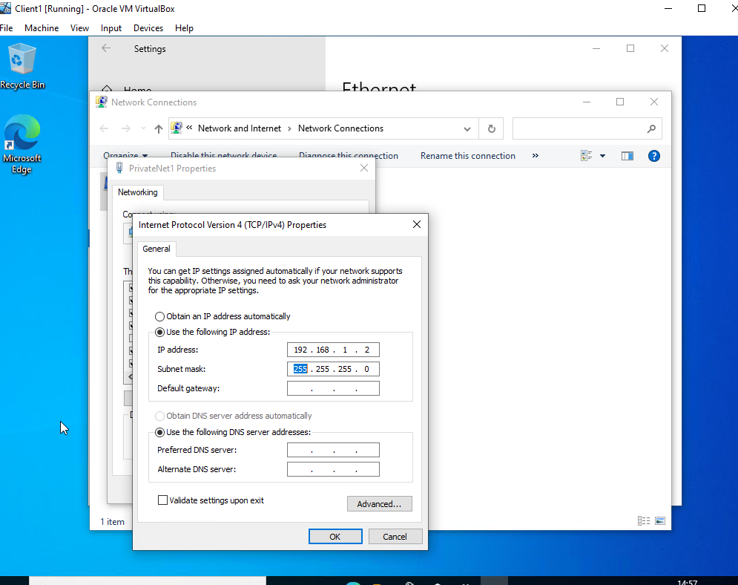

Server 1 – Turning off Firewall for successful ping connection between Server 1 and Client 1
- Fire wall needed to be turned off.
- Firewall enabled in windows sets ping requests to be blocked by default [2]
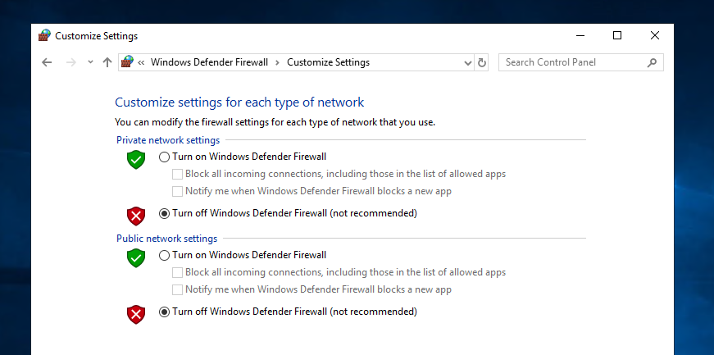

Server 1 – Pinging Client 1 via command line
- Below image displays packages 4 sent and packages 4 being received by server 1 from Client 1 via its unique IP address.
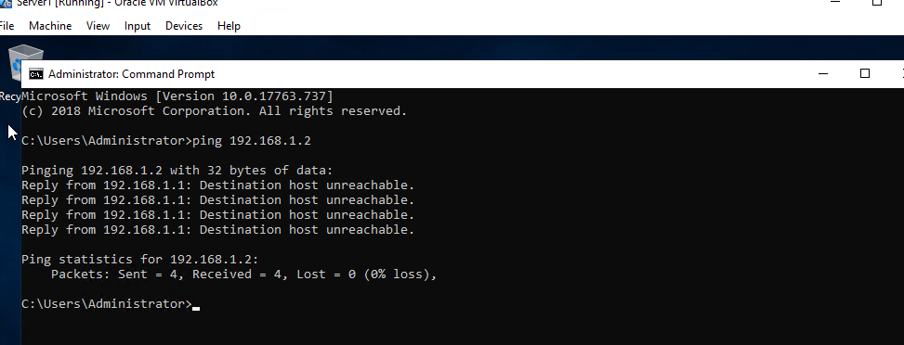

Server 2 – Setting up Adapter 2 (PrivateNet2) this allows a connection between server 2 and client 2
- Name: PrivateNet2
- Attached to: Internal Network
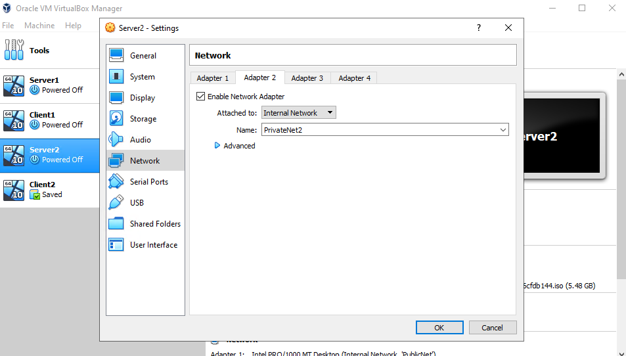
Client 2 – Setting name
- Adding more meaningful name to Network Connections to help avoid confusion, this leads to good practice.
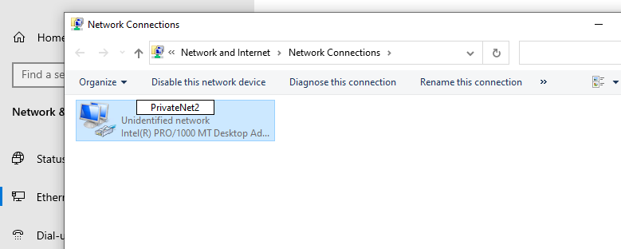

Client 2 – Setting IP address to meet requirements
This is required to allow for Client 2 to ping Server 2.
- IP address: 192.168.11.2
- Subnet Mask: 255.255.255.0
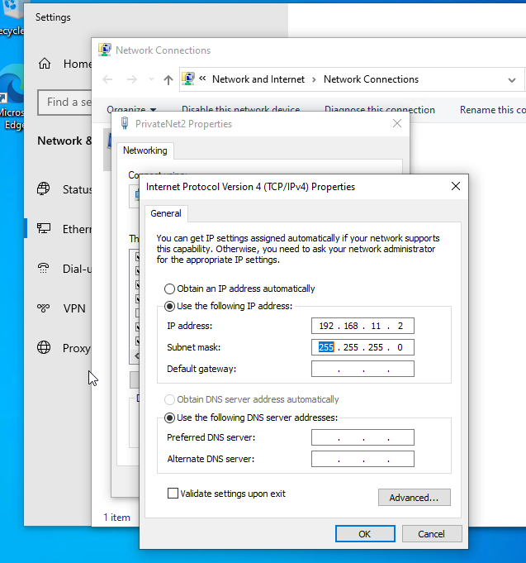
Client 2 – Pinging Server 2 from Client 2
- Packets Sent 4
- Packets Received 4
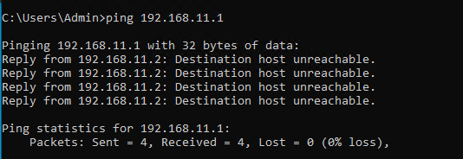
Task 2: Virtual Network Configurations

Server 1 setting pre-requisites for making sure No DNS is setup and that the Firewall is turned off
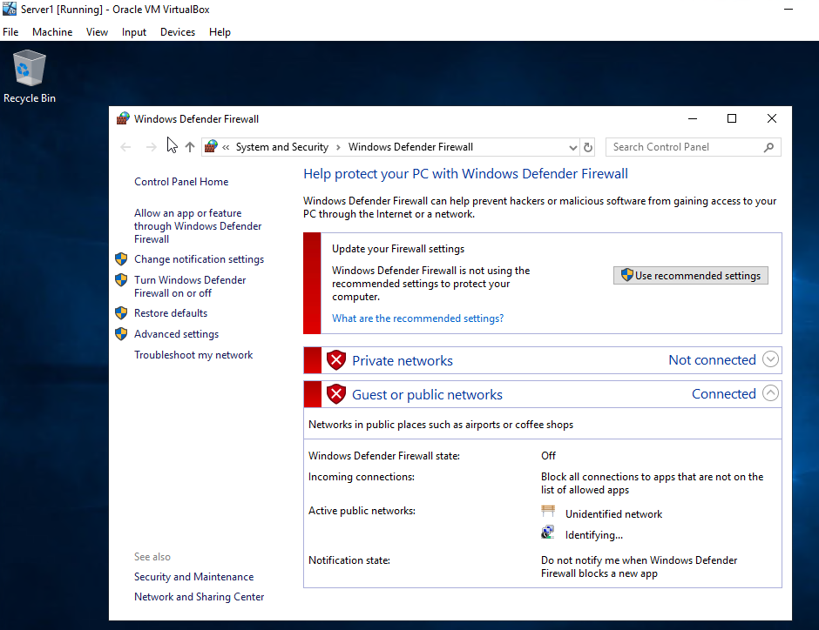
Server 1 – No DNS setup
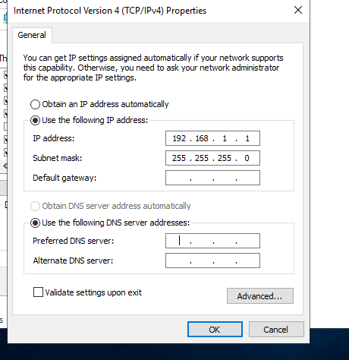
Server 1 – Setting computer name (DC-NWT1)
- Click ‘OK’ to begin restart
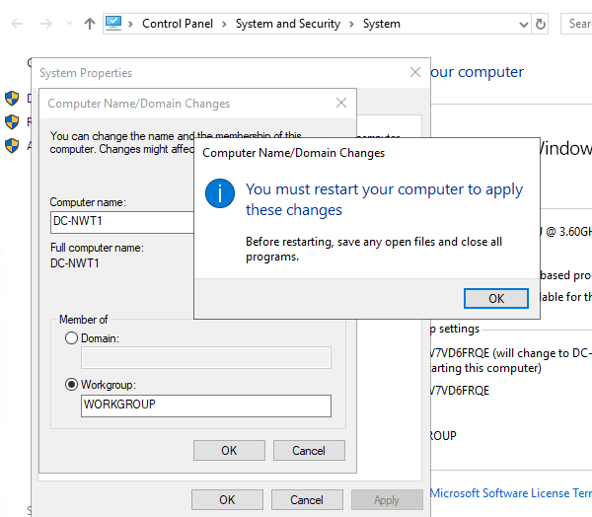
Client 1 – Setting computer name (NWT-CLIENT1)
- Computer name: NWT-CLIENT1
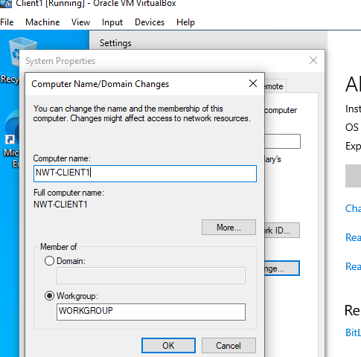

Server 1 – Checking is name change was successful
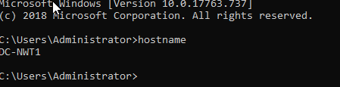
Server 1 – Enabling Active Directory Domain Services
- Select Active Directory Domain Services
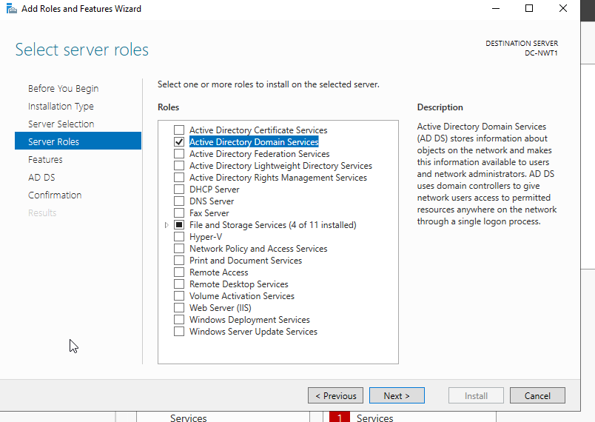

Server 1 – Feature Installation
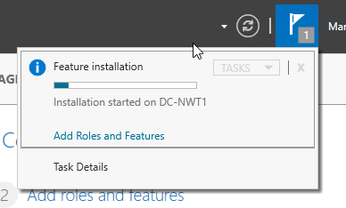

Server 1 – Establishing a new active directory
- This allows for the creation of users and different user groups
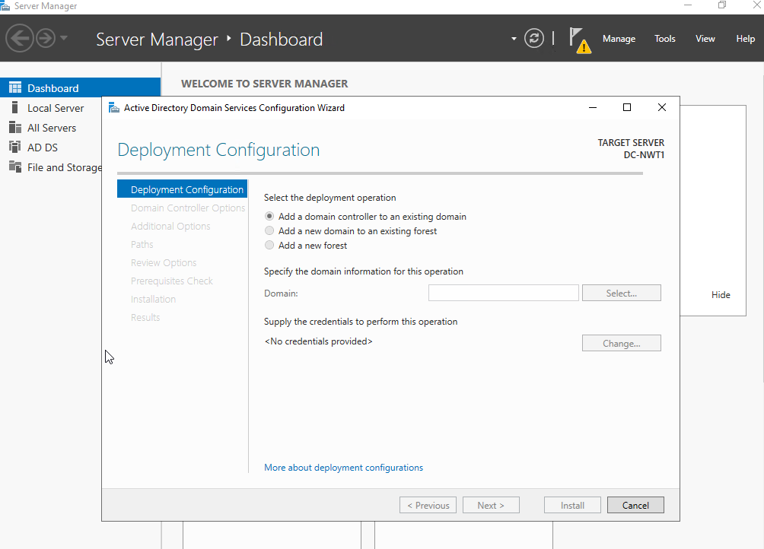

Server 1 – Setting new forest name for the domain
- Add new forest
- Root domain name: nosstask.msft
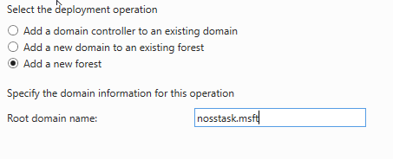

Server 1 – Installing active directory
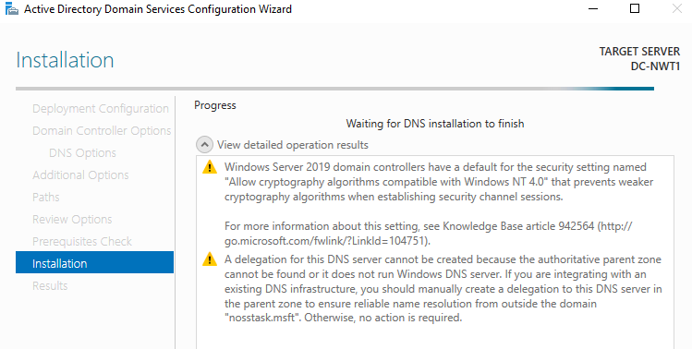

Server 1 – Logging into Created NOSS Account
- Logging into the NOSS account after making the server into a domain controller
- This allows to create domain level accounts
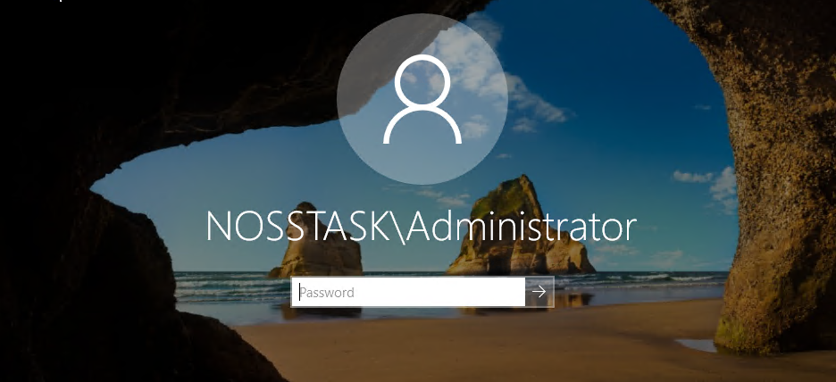

Server 1 – Creating a new user
- First Name: Ben
- Last Name: Crook
- Full Name: Ben Crook
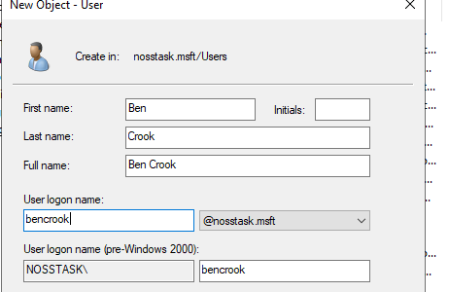

Server 1 – Setting password that matches password requirements
- Password needs to meet Windows requirements
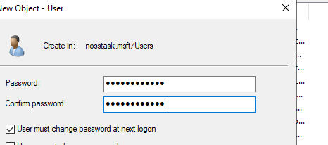
Server 1 – Adding created user account to ‘Domain Admins’ group
- Objective names: Ben Crook
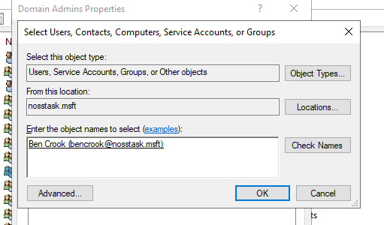
Server 1 – Created user added to the ‘Domain Admins’
- Log in is now successful for created user ‘bencrook’
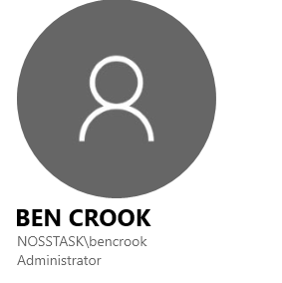
Server 1 - Setting second user account
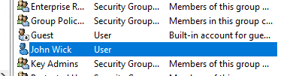

Server 1 – User Description
- This has been set for account to help avoid confusion
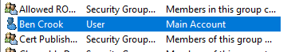

Server 1 – Setting unique log on hours for certain users
- Log on hours made for new user, weekends have logon denied because log in is not required at these set hours
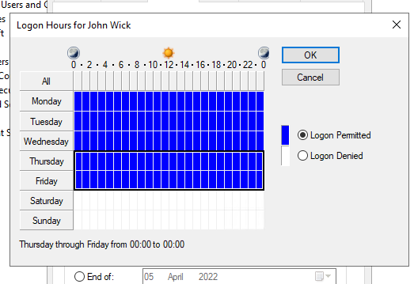

Server 1 – Creating individual folders
- Creating specific folders that allow specific users to do different things, Cisco Lab users with each computers labelled to avoid confusion.
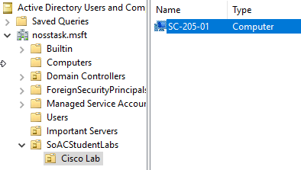

Client 1 – Adding client 1 to the domain ‘nosstask.msft’ present on server 1
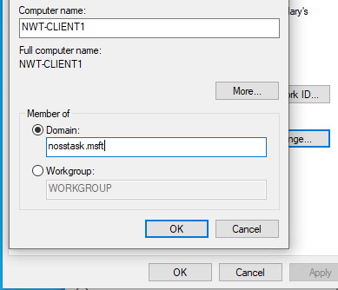

Client 1 – setting DNS server to allow client 1 to join the domain present on server 1
- DNS server IP: 192.168.1.1
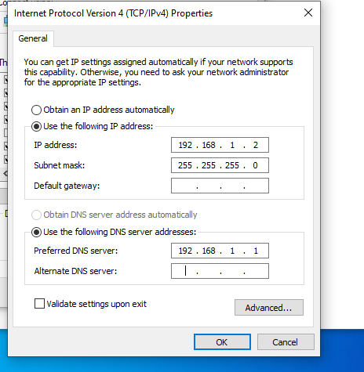

Client 1 – Logging into domain account
- Pre-created account name required
- Pre-created password required
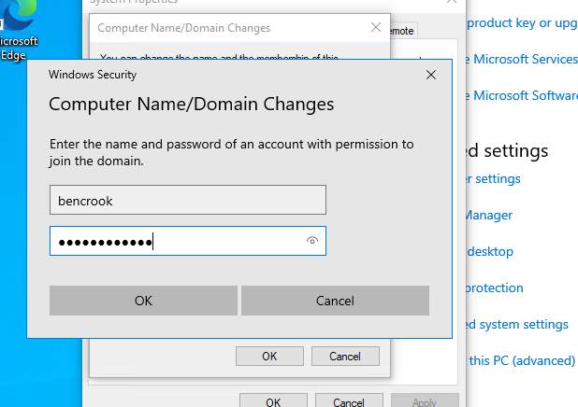
Client 1 – Domain Join
- Successful domain join, welcome message present, now this is on the domain this client will be able to log into any account that is in the domain.
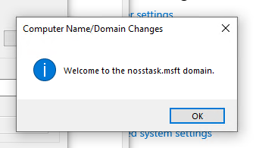

Task 3 : Observational Tasks (1500 Words)
Main Differences between Type 1 and Type 2 Hypervisors
A hyper visor is capable of creating and executing virtual machines, these have been used above in practice.
There are two different types of hypervisors present they are Type 1 and Type 2. The main difference between Type 1 and Type 2 Hypervisor is that Type 1 Hypervisor runs directly on the host’s hardware while Type 2 runs o an operating system similar to other computer programs [3].
The benefits of using Type 1 are that they are highly efficient because they are able to have direct access to physical hardware. This also increases their security [4], this is important due to the sensitive data that would be present on these machines. A vendor used for this would be Oracle VM, this is the most popular used in businesses.
With every benefit comes their downfall a drawback using this is that they usually need a dedicated separate machine to perform its operation and to instruct different VMs [5] this could become demanding and expensive depending on the scale.
The benefits of using Type 2 Hypervisor are that they essentially act as management consoles. There is no need to install a separate software package to be able to manage the created virtual machines, this makes them convenient for testing any new software [6]. The most popular vendor would be Oracle Virtual Box, a lot of universities would use this to perform tasks and complete assignments.
The drawbacks of using Type 2 Hypervisor are they have more points of failure compared to Type 1, this is due to anything that affects the stability of the base operating system can also affect the guest OS and the virtual machine [6].
The use of cloud computing
Cloud computing is the on-demand availability of computer system resources, especially data storages and computing power [8].
Even though this a very popular method in today’s modern age there are advantages and disadvantages of implementing this. A key advantage of using this in a business would be the easy of implementation, Cloud hosting allows business to retain the same applications and business processes without having to deal with the backend technicalities [9].
Another key benefit would be the accessibility of Cloud computing, this allows businesses to be able to access their data anywhere, anytime as long as they have an internet connection present. An internet cloud infrastructure maximizes enterprise productivity and efficiency [10].
As mentioned with advantages comes drawbacks, the main drawback from using this is that you are no longer in control, when moving all of your services and data into cloud, you are handing over your data and information [11].
Possible vendors businesses would use would be the most popular Google Cloud, this company provides a virtual space for businesses to hold and store their sensitive data.
DNS
The domain Name System is the hierarchical and decentralized naming system used to identify computer, services, and other resources reachable through the internet or other internet protocol networks [12].
The benefits of using this in a Active directory is that allows you to create integrated zones, it is replication is faster, more secure and efficient [13].
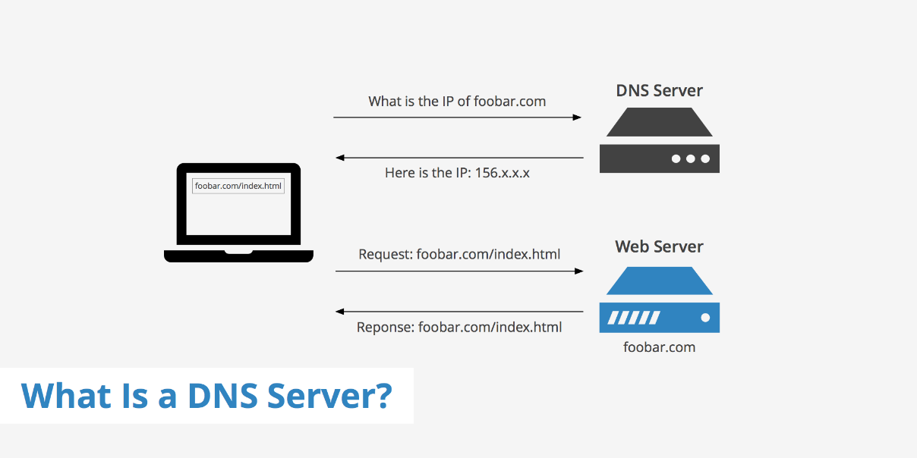
Figure 1 - Image displaying DNS working
Active Directory
The benefits of using this for a business is that it makes administrators jobs easier, and end users while enhancing security for organizations. Administrators enjoy centralized user and rights management [14].
Different terminologies and their purposes
Fire wall
A firewall is a network security device that monitors incoming and outgoing network traffic and decided whether to allow or block specific traffic based on a defined set of security rules. [14]
This has many operations that will be used for the safety of the operating system, as displayed above this helped protect other servers being able to ping and see if there is a live connection.
This also allows for a good amount of flexibility and control.
Ping an IP address
This is a basic internet program that allows a user to test and verify if a particular destination IP address exists and can accept requests in computer network administration [15].
PAE/NX
This determines whether the PAE and NX capabilities of the host CPU will be exposed to the virtual machine. PAE stands for Physical Address Extension. Normally if enabled and supported by the OS [16]. This was put into best practice from the diagrams above.
Brief reflection
To wrap everything up that has been discussed and completed during the presented worksheet. The security aspect shows how it has changed over the different operating systems, Windows 2019 requires the user to have a very detailed password to ensure it meets it requirements, unlike 10 they are less harsh on their requirements, this could be due to the nature of technology and security available.
Guru meditation was something that caused and issue when installing Windows 2019, this put a whole pause on the download and installing of Server 1 this becoming time effective and caused drawbacks and adjusted deadlines, this goes to show that you have to be prepared for any possible outcome when building these for a business and look at all of the different possibilities available.

