Management & Organisational Behaviour
Student Name: Simona-Elena Mezo
Student ID: 2030170

Table of Contents
Introduction 3
Organisational Culture Followed at Premier Inn Hotel 4
Organisational Structure Followed at Premier Inn Hotel 5
Organisational Goals 6
Recent change initiatives are taken by Premier Inn 7
Restructuring of management 7
Changes in the team and community management 7
Changes in supply chain management 8
Organisation’s Strategic Direction 10
Conclusion 13
Reference 14

Introduction
The Premier Inn Hotel is one of the most famous hotel chains in the UK economy. The report will focus on the performance of the organisation, Premier Inn Hotels. The report will discuss the organisational structure followed by the brand, Premier Inn Hotels and analyse how it impacts the working of the organisation. Organisational culture and the goals followed at the brand, Premier Inn Hotels will be analysed through the report to understand the management of the organisation. The recent changes and the initiatives taken by the organisation to implement improvement in the organisation will be evaluated through the report. In addition, the impact of the changes made by the brand will be evaluated in the report. In addition to these topics strategic business decisions and the current business performance of the organisation have been evaluated in the report. The report aims to analyse the working of the hotel chain and how the different factors have impacted the performance of the organisation (Brenk et al., 2019).

Organisational Culture Followed at Premier Inn Hotel
The hotel Premier Inn has been following a diverse culture in the organisation. Charles Handy introduced four types of organisational culture that indicate how each organisation follows the economy. The brand, Premier Inn Hotel follows the Role Culture in the organisation (tools here, 2018). As the organisation has been working in the hospitality industry, the hotel chain must maintain an inclusive nature. The organisation believes in teamwork, which has helped to build a workforce aligned with the organisation's aims and goals. This has helped the organisation build an employee base that is collaboratively been driving towards the growth and achievement of the organisational goals (premier inn, 2023). Moreover, the brand has been following a hierarchical culture organisation which has helped to track the activities within the organisation. This has aided in the process of monitoring the performance of the employees in the organisation. The performance of the employees is one of the driving elements in the organisation that ensures quality performance. The brand has been following an inclusive culture with the employees which has helped in gaining the confidence of the employees and aided in improving the performance of the employees. The organisation, Premier Inn Hotel has been providing employees with different benefits and has a strong base towards corporate social responsibility (premier inn, 2023). The organisation has been raising money for the Great Ormond Street Hospital Children’s Charity since the year 2012. The brand has been associated with providing food to the community. The brand follows strong morale towards sustainability, has been incorporating the importance of not wasting food on the employees, and has been setting itself as a positive example in the hospitality industry (premier inn, 2023).

Organisational Structure Followed at Premier Inn Hotel
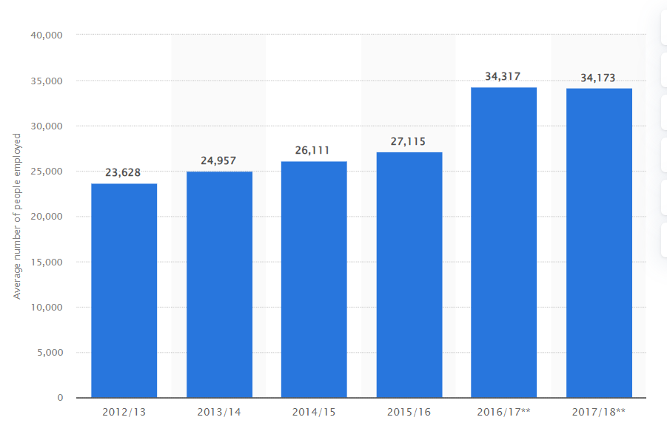
Source: (Statista, 2020)
organisation communicate and relate to the issues in the organisation and then approach The brand, Premier Inn Hotel has been following the hierarchical culture that has helped the to ensure it gives its best performance in each field of operation. The employees in the the appropriate management level to have the issues resolved. This helps to understand how the organisation has been able to follow the role structure in the organisation. The operational managers in the company's management monitor and keep track of the various operations at the different sites of the hotel chain. This has helped to understand how the organisation has been able to control and enhance the performance of the organisation in the economy. The economy has been lagging during the covid. Yet, the brand has been able to improve its performance in the post covid economy with a substantial performance in the sector through strong internal communication (Whitbread, 2023). The company has a strong intranet connection within the organisation, which has helped regulate and resolve the issues that arise at the organisation. The authorities of the organisation have always been active in communication among the employees. The organisation's management comprises the CEO and the managing director operates and overlooks the organisation's working. Over Thirty thousand employees have been working with the brand, and have been working towards the goal of bringing innovation to the brand and strengthening the customer relationship (Statista, 2020).

Organisational Goals
The brand, Premier Inn Hotel has been intent on providing high-quality service to customers at an affordable range. It has been instrumental in the development of the organisation as they have been focused towards developing its corporate social responsibility (Premier Hotels and Resorts, 2023). The organisation has been working with the intention of serving the community. It has taken major steps to reduce food wastage in the organisation as they distribute food in the community to needy people. The brand, Premier Inn Hotel has been associated with Great Ormond Street Hospital Children’s Charity to provide better living standards to the people in the organisation (Whitbread, 2021). The organisation has aimed to provide the employees with an inclusive culture that supports the various segments of the community and supports gender equality, religion, race, etc.

Recent change initiatives are taken by Premier Inn

Restructuring of management
Whiteboard has proposed restructuring the management of Hotel Premier Inn to fund the growth plans. This is an initiative which will reduce operating costs. The company has decided to abolish the post of operation management from each of its nearly 800 hotels. New hotel managers and assistant managers also take the position of operation manager, seeking the investigation of multiple sites instead of one site (Reuters.com, 2018).
Management- The approach brings some business feasibility to the management. Previously people used to report almost 800 operation managers, thus communication failed to follow an organised and transparent path, simultaneously due to reporting to several managers problem-solving and decision-making used to be delayed. Making the chain of command more consolidated and one directional business not only enjoys low operational cost but issues will be addressed and resolved more precisely. Better management, communication and a conflict-free environment help to bring an acceleration in the sales margin. When issues will be solving in an organised and effective way, employee motivation will also increase and these two positive factors are supplementary to customer satisfaction (MBA Knowledge, 2021). The company applied the decision-making theory of management here which talks about the rational behaviour of management under risk and uncertainty (Nicotera, 2019, pp. 102). Adoption of rational choice that is to remove the post of operation management to reduce the company’s operation cost justifies the application. Another management theory that goes with the company’s decision to appoint new hotel managers and assistant managers in the place of operation managers, is the specialisation structure of classical management theory. Three main pillars of classical management theory are hierarchy, specialisation and incentives. Adopting the model, the company can enjoy more systematic and effective task accomplishment, reduction of cost by the removal of mundane unimportant tasks and clear definition of employee roles and responsibilities with fewer scopes of guesswork.

Changes in the team and community management
The working procedure of the company is people-centric and the company intends to follow this in future. The company aims to foster a workplace where every worker can reach their potential, an open-door policy where no one has to face discrimination based on culture, religion, race or gender. The company wants to recruit or manage a more diverse talent. New internal diversity is the target as the company seeks to cope with the harmful consequences of Black Lives Matter. It is a phrase that resembles racism, discrimination and inequality experienced by black people (Campbell, 2021). The matter forced the company to think deeply and they agreed to bring some changes to business commitments. The company is focusing towards globalisation and cultural inclusion in the workplace. Prioritising the essence of inclusive ethnicity, the company wants to respond to Black live matter and implement some changes for the greater good of the organisation and workers (ESG Report, 2021). Here it is noticeable that the company is much more focused on enactment, rather than just relying on words. In the field of community management, the hotel Premier Inn focuses more on two aspects, namely humanising the brand and striving to constantly improve (Copuš and Poláková, 2022).
Actions were taken to account the changes- The company has set the first culture, race and religion network aiming to bring different people into a single platform. The advantages of the initiation are that the company will be able to foster an inclusive workplace irrespective of race, religion and culture (Whitbread, 2023). The four main focus areas of the company are team, guest, partnership and technology. For longevity and business sustainability, the company has to make the workplace diversified. Mutual respect and trust-building usher better coordination, teamwork and communication. Diversity brings new ideas and experiences to the workplace, and people exchange ideas, opinions, and skills (Ability Option, 2022). This way the scope of intrapreneurship increases and a vast knowledge pool fosters the path of innovations. They provided their leaders with equipment and tools thus they can communicate around race.

Changes in supply chain management
The company emphasises supply chain management as they value their customer's needs and quality control over service. The company ensures sustainable sourcing and company effectively eliminates the activity that can harm any rights of human, environmental and animal welfare. The company bring some changes in their supply chain management to implement an industry-leading responsible sourcing programme. Premier Inn performs 100% risk assessment in tier 1 supply chain to alleviate human rights risk. The hotel benefitted greatly by applying these holistic approaches. This is the first hospitality industry which took better cotton initiatives to support sustainable cotton solution programmes. Furthermore, the company is aiming to 100% procurement of critical commodities sustainability.
Management- The approach will help the business in numerous ways. A consistent and healthy supply chain has reduced the risk of supply disruption. When product availability required for a hospitality sector is affluent and unanimous, service excellency rings an impetus to sales margin. Customer service automatically improves when the supply chain is running smoothly. Guests will be more satisfied if they receive well-standard commodities that too at a traditional price they prefer to come back and recommend the hotels to others. 97% of premier inn customers book their stay directly, this statement justifies high customer satisfaction, and it won't be possible if supply chain management was not disruptive (Premier Inn, 2021). Better customer satisfaction implies better service provided by the hotel, and internal management greatly relay on commodities that come through the supply chain. Accommodation, commodities and services are the three pillars of the hotel business.

Organisation’s Strategic Direction
A Force for Good: The brand has been following the business concept of ‘Force For Good' that has been standing upon the pillar concepts of community, opportunity and responsibility. The organisation has developed this strategy to achieve its goals of enhancing its Corporate social responsibility towards the community and society as a whole. The organisation has been intent on reducing its carbon emission rate and with the aid of the organisation's strategic decisions and sustainable business operations Premier Inn Hotel can pull down its carbon emission rate to 39.8% (premier inn, 2018). The goal of the organisation has been to increase their contribution to the people and the community. This has been achieved by the brand by introducing a business strategy where they aim to avoid food wastage. The brand, Premier Inn Hotel has made decisions to distribute the excess food in the community. This has contributed to the company's CSR and has helped to improve the company’s reputation as well. The brand has also been able to step towards sustainability by procuring a sustainable number of single-use plastics (hospitality net, 2019).
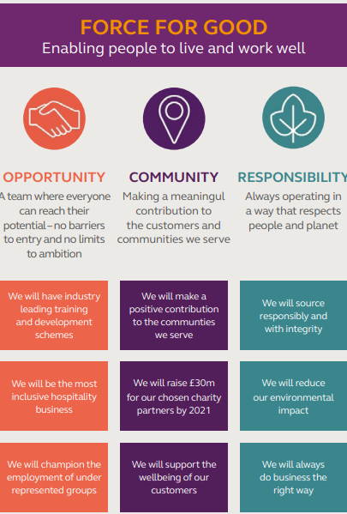
(Premier Inn, 2021)

Whitbread strategy: Industry-leading tracing and development fall under whiteboard culture. The company claims the culture that provides opportunity and support to their team is in their DNA, hereby paramount. This way the company secure a future pipeline of exceptional talent. The company has arranged structured developmental and apprenticeship programmes to make their employee more efficient, skilled and professional. Even though the programme had not stopped during the pandemic, 1 million digital courses were provided to employees.
Management- The initiatives reflect how the company is concerned about human capital and makes a strategy to use employee skills, knowledge and experience to channelise their towards the greater good of the organisation, as well as lucrative employee careers, thus right decision making also bring feasibilities to management (Buckley and Casson, 2019). They listen to their team members through employee forums, surveys and listening groups and project-focused listening programs, and shape diction making which goes in the interest of the company. The current business performance of Premier Inn suggests that 27% more revenue is earned compared to the pre-pandemic era (Price, 2023). The report suggests that the managerial changes made in the organisation have contributed towards its positive growth.

Conclusion
The report shows the structure culture and management followed by the brand Premier Inn. Using Handy’s model of organisational culture it has concluded that the company follows the role culture of management where every member has separate responsibility or role. Different areas where the company has brought changes have been elaborated, with their impact stating how well these were managed. Additionally, strategies applied by the management and how it works in favour of the company are addressed.

Reference
Ability Option, (2022). 5 Benefits of Diversity in the Workplace. [Online] Available at: https://abilityoptions.org.au/5-benefits-of-diversity-in-the-workplace/#:~:text=A%20diverse%20workplace%20is%20an,and%20a%20fair%20work%20culture. [Accessed 23 May 2023].
Brenk, S., Lüttgens, D., Diener, K. and Piller, F., 2019. Learning from failures in business model innovation: Solving decision-making logic conflicts through intrapreneurial effectuation. Journal of Business Economics, 89, pp.1097-1147.
Buckley, P. and Casson, M., 2019. Decision-making in international business. Journal of International Business Studies, 50, pp.1424-1439.
Campbell, A., (2021). What is Black Lives Matter and what are its aims?. [Online] Available at: https://www.bbc.com/news/explainers-53337780 [Accessed 23 May 2023].
Copuš, L. and Poláková, M., 2022. Relationship Between Organisational Culture and National Culture on the Example of Classical Management Approach Theories. THE POPRAD ECONOMIC AND MANAGEMENT, 10, p.345.
ESG Report, (2021). Enabling people to live and work well. [Online] Available at: https://www.premierinn.com/content/dam/pi/websites/desktop/why/force%20for%20good/final-esg-report-v3.pdf [Accessed 24 May 2023].
hospitality net, (2019). Premier Inn Is Removing All Unnecessary Single-Use Plastics From Their Hotels By 2025. [Online] Available at: https://www.hospitalitynet.org/news/4096032.html [Accessed 25 05 2023].
MBA Knowledge, (2021). The Effect of Organizational Culture on Decision Making. [Online]Available at: https://www.mbaknol.com/strategic-management/the-effect-of-organizational-culture-on-decision-making/ [Accessed 23 May 2023].
Nicotera, A.M., 2019. Classical Management Theory. In Origins and Traditions of Organizational Communication (pp. 89-105). Routledge.
Premier Hotels and Resorts, (2023). Social Responsibility. [Online] Available at: https://www.phnr.com/en/social-responsibility [Accessed 25 05 2023].
premier inn, (2018). Our Earth Day commitment is to cut our carbon emissions intensity by 50%. [Online] Available at: https://www.premierinn.com/gb/en/news/2018/world-earth-day.html [Accessed 25 05 2023].
Premier Inn, (2021). Introducing Premier Inn. [Online] Available at: https://cdn.whitbread.co.uk/media/2021/02/26120857/Introducing-Premier-Inn_A4_8pp-Planning-brochure_March-2021_FINAL.pdf [Accessed 24 May 2023].
premierinn, (2023). About us. [Online] Available at: https://www.premierinn.com/gb/en/why.html [Accessed 23 05 2023].
premierinn, (2023). Premier Inn proud to support Great Ormond Street Hospital. [Online] Available at: https://www.premierinn.com/gb/en/why/gosh-childrens-charity.html [Accessed 22 05 2023].
Premierinn, (2023). We value difference at Premier Inn. [Online] Available at: https://www.premierinn.com/gb/en/terms/diversity-and-inclusion.html [Accessed 21 05 2023].
Price, K., (2023). Premier Inn owner reports revenues 27% ahead of pre-pandemic. [Online]Available at: https://www.thecaterer.com/news/premier-inn-whitbread-2023-financial-results-27-ahead-pandemic [Accessed 24 May 2023].
Reuters.com, (2018). Whitbread scraps post of operations manager at its Premier Inns. [Online]Available at: https://www.reuters.com/article/uk-whitbread-jobs-premierinn-idUKKCN1MB3N4 [Accessed 23 May 2023].
Statista , (2020). Premier Inn and restaurants: number of employees 2012-2018. [Online]Available at: https://www.statista.com/statistics/740679/whitbread-premier-inn-and-restaurant-employment/ [Accessed 24 05 2023].
Toolshero , 2018. Handy Model of Organisational Culture explained: the theory. [Online] Available at: https://www.toolshero.com/management/handy-model/ [Accessed 23 05 2023].
Whitbread , (2021). PREMIER INN & GREAT ORMOND STREET HOSPITAL CHILDREN’S CHARITY TEAM UP TO LAUNCH A NEW INCLUSIVE CHRISTMAS CAROL AND RAISE FUNDS FOR THE CHARITY’S ANNUAL CHRISTMAS APPEAL. [Online]Available at: https://www.whitbread.co.uk/premierinn-sign-of-the-season/ [Accessed 24 05 2023].
Whitbread, (2023). Diversity and inclusion We Value Difference. [Online] Available at: https://www.whitbreadcareers.com/about-us/diversity-inclusion/ [Accessed 25 May 2023].
Whitbread , (2023). Our business model and strategy. [Online] Available at: https://www.whitbread.co.uk/about-us/our-business-model/ [Accessed 23 05 2023].

