Component 1: Written Report (Business Plan)
Student Name: Radu Acris
Student Number: 2239621
Lecturer Name: Masud Ibrahim
BA (Hons) Business Management
Entrepreneurship
LCBB5001

Table of Contents
1.Introduction. 4
2.Products and Services offered by the business: 5
2.1.Business Overview: 6
3.Legal format of the business (RAAK LTD). 6
4. Evaluation of the business idea by using the SWOT analysis model. 7
5. The 4Ps of Marketing of my business idea. 8
6.Conclusion: 10
7.Bibliography: 11
8.Appendix A: ,,RAAK LTD’’ 12 months Cash Flow. 12

Business Plan:
,,Roof & Gutter Cleaning Company’’.


Fig.1:(company logo).

,,In business - every business - the bottom line is understanding the process. If you don't understand the process, you'll never reap the rewards of the process’’
(Trump, 2004).

1.Introduction.

This business plan outlines the development of a startup focused on providing gutter and roof cleaning services. The business addresses a critical need for homeowners and property managers to maintain their properties, preventing water damage and extending the lifespan of roofs. The company will operate as a limited liability company (LLC) to protect personal assets while providing operational flexibility.
The core mission of the business is to offer high-quality, reliable, and affordable services to residential clients. Effective management will be key to ensuring efficient operations, strong marketing strategies, and a focus on customer satisfaction. A SWOT analysis will be used to evaluate the business potential by assessing internal strengths and weaknesses, as well as external opportunities and threats. Additionally, the 4Ps of marketing—product, price, place, and promotion—will guide the company’s approach to market positioning and customer acquisition.
This report will present the key elements of the business idea, including the legal structure, management plan, market analysis, and marketing strategy, to demonstrate its viability and potential for success.

2.Products and Services offered by the business:

The domestic cleaning sector in the UK has experienced notable expansion, especially in recent years. In 2023, 17% of UK households used domestic cleaning services, marking a substantial rise from 10% in 2018. This represents a 70% surge in demand, partly due to increased concerns about cleanliness after the COVID-19 pandemic. The industry’s total worth is now estimated to exceed £8 billion, compared to £3 billion in 2018. On average, households spend over £145 monthly on these services (Statista.com, 2024).
The UK cleaning industry, including both domestic and commercial services, contributed around £59.8 billion to the economy in 2021 and is projected to continue growing steadily (Salmon, 2021).
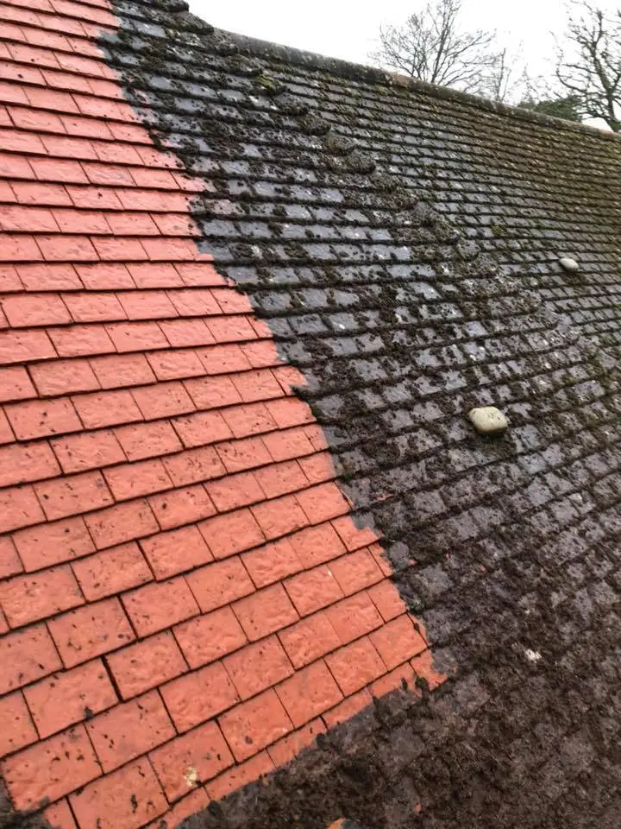
Roof cleaning services are getting popularity as more people recognize the importance of keeping their roofs clean and well-maintained. A clean roof not only boosts the property's visual appeal but also prevents damage from the growth of moss, algae, and lichen. Given that roofs are constantly exposed to weather conditions like UV rays, rain, wind, and snow, regular cleaning is essential to keep them in optimal condition (Nora Johanne Klungseth, 2016). Fig.2.
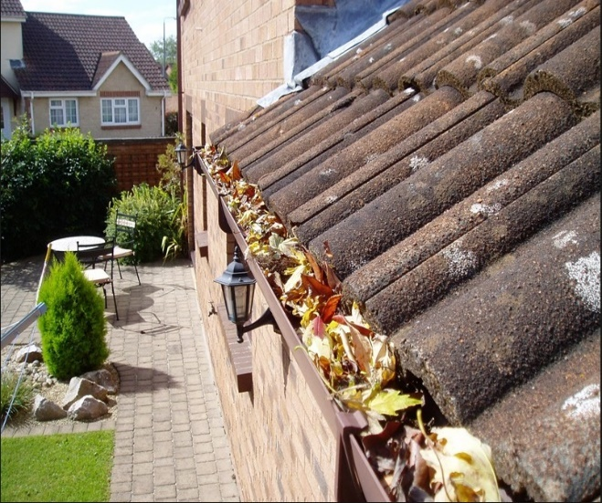
In addition, a dirty roof can result in clogged gutters, according to (Boswell, 2013),gutters are a crucial component of property's exterior, engineered to divert rainwater away and protect the structure and foundation. Without a properly functioning gutter system, water can build up, causing a range of problems that may expose the stability of everyone’s property, potentially
Fig.3.
leading to water damage inside the property. Many homeowners and commercial property owners have the option to choose professional cleaning services, as DIY cleaning can be both hazardous and time-consuming.

2.1.Business Overview:

This startup specializes in professional roof and gutter cleaning services for residential homeowners and property managers. RAAK LTD will proactively engage in regular client education and awareness initiatives, highlighting the risks of improper roof and gutter maintenance and offering guidance on prevention strategies. Through these efforts, the company aims to establish itself as the premier provider of roof and gutter cleaning services in the West Midlands, delivering high-quality solutions that protect and prolong the lifespan of residential properties.
Its main goal is to provide topmost maintenance that prevents water damage and extends the lifespan of clients' roofs. The business aims to address a key market need by delivering affordable and dependable solutions to clients focused on long-term property protection (Mark Fisher, 2014).
By delivering high-quality service, staying current with the latest tools and methods, and addressing environmental issues, I can build a successful and profitable business.

3.Legal format of the business (RAAK LTD).

By establishing the Roof and Gutter Cleaning Company (RAAK LTD) as a Limited Company (LTD), will need considering the following aspects:
- Company Structure: Limited Company (LTD): The startup will be registered as a Limited Liability Company (LLC), a suitable choice for safeguarding personal assets from business liabilities. This structure offers management flexibility, facilitates business growth, and streamlines both fundraising and tax management (Subramoniam, 2018).

- Management Summary: Owner/Manager - Radu Acris will act as the owner and primary manager, overseeing operations, marketing, and customer relations.
(Experience): With a background in construction, as a bricklayer, the knowledge being student at BA (Hons) Business Management, UWTSD (year 2), and SSSTS certification, Radu Acris is well-positioned to handle operations with a strong focus on safety and efficiency.

- Employees: Two field workers will be hired initially to perform cleaning tasks. Workers will be required to have full UK driving licence, experience working at heights, with training provided on using equipment and safety protocols.

- External Professional Services:
- Accountant: For bookkeeping, payroll, tax filing, and financial advice.
- Legal Advisor: To ensure compliance with safety regulations and handle contracts.
- Marketing Consultant: (Part-time) To assist with initial marketing strategies, including online campaigns, branding, and website development.

4. Evaluation of the business idea by using the SWOT analysis model.
- Strengths:
- High Demand for Services: Regular roof and gutter maintenance is essential, especially in the UK’s rainy climate, helping prevent water damage and structural issues.
- Low Initial Capital Investment: Starting a roof and gutter cleaning company generally requires minimal startup costs compared to other industries.
- Skilled Workforce: The availability of skilled labour in the West Midlands area helps maintain high service quality (Anne Green, 2014).
- Flexible Service Offerings: Can easily expand services to include additional home maintenance, such as moss removal, roof inspections, or minor repairs.
- Experience: Strong foundation in safety (SSSTS certified).

- Weaknesses:
- Seasonal Demand: The need for gutter and roof cleaning services may peak during certain times of the year (autumn/winter) and slowdown in others.
- Become visible: Initial challenges in building brand awareness.
- Physical Risks: The work involves heights and physical labour, which can lead to safety concerns and higher insurance premiums.
- Opportunities:
- Green and Sustainable Practices: Offering eco-friendly cleaning solutions or water recycling systems can appeal to environmentally conscious customers.
- Expansion of Services: Diversifying into roof repairs, pressure washing, or solar panel cleaning can help attract more clients and generate year-round revenue. Also Increasing demand for preventive property maintenance due to changing weather patterns.
- Digital Marketing & Online Presence: Leveraging digital marketing, SEO, and social media can attract a wider audience in the West Midlands and build a strong customer base.
- Partnerships: Collaborating with real estate agents, property managers, or construction companies could lead to steady contracts for ongoing maintenance services (Barrie Chanter, 2008).
- Threats:
- Economic Downturns: In times of economic uncertainty, homeowners and businesses may cut back on non-essential maintenance services.
- Weather Dependency: Extreme weather conditions, like heavy rain or storms, can hinder the completion of scheduled work or cause delays.
- Regulatory Changes: Potential changes in safety regulations requiring investment in new equipment.
- Competition: Established competitors offering broader cleaning and maintenance services.

5. The 4Ps of Marketing of my business idea.

Product: | Price:
The core service is gutter and roof cleaning, with optional add-ons like moss removal and roof inspections.  Additional Services: Options for moss removal, minor roof repairs, pressure washing, gutter inspections, and solar panel cleaning.  Eco-Friendly Options: Offering environmentally safe cleaning products and methods to appeal to eco-conscious customers.  Service Quality: Focus on providing high-quality service with trained professionals and advanced equipment to ensure customer satisfaction. | Competitive Pricing: Offering rates that are competitive within the West Midlands market, but reflective of the premium, high-quality service provided.  Tiered Pricing: Packages based on the size of the property, frequency of cleaning, and additional services such as roof inspections or repairs.  Seasonal Discounts: Special offers during peak seasons (e.g., autumn or spring) or for returning customers to encourage repeat business.  Discounts for clients who sign up for annual cleaning contracts or refer other customers. Initial price packages will be £80-£150 per service, depending on the property size.
Place: | Promotion:
Geographic Focus: Targeting residential properties across the West Midlands, including Birmingham, Coventry, Wolverhampton, and surrounding areas.  Local Presence: Establishing a strong local presence through community engagement and partnerships with local businesses, ex. estate agents, and property managers.  Online Booking: All bookings will be processed via the company's website or over the phone, offering convenience to customers. | Digital Marketing: Utilizing online platforms such as Google Ads, social media (Facebook, Instagram), to increase visibility and attract local clients.  Local Advertising: Flyers, brochures, and ads in local newspapers or community centres targeting homeowners and property managers.  Referral Program: Offer discounts or rewards to customers who refer new clients, encouraging word-of-mouth marketing.  Seasonal Campaigns: Running promotional campaigns during high-demand seasons (e.g., before heavy rains in autumn) to remind customers of the importance of roof and gutter maintenance (Thulasipriya & Rodrigues, 2023).

6.Conclusion:

`,,Our roof and gutter cleaning service is dedicated to enhancing your property's safety, appearance, and longevity. Using specialized equipment and eco-friendly methods, we clear debris, prevent water damage, and remove harmful moss and algae. Our skilled team ensures a safe, efficient clean every time, so you can enjoy a low-maintenance, worry-free roof and gutter system. With options for one-time or regular cleanings, we're here to protect and preserve your property year-round’’.
In conclusion, this Roof and Gutter Cleaning startup is well-positioned to respond to the increasing demand for property maintenance services in the West Midlands. By prioritizing high-quality service, safety, and competitive pricing, the company seeks to fulfil a vital need for residential homeowners and property managers. The strategic choice of a Limited Liability Company (LLC) structure provides both financial protection and operational flexibility. Connected with a comprehensive marketing strategy and effective management framework, the business is set to follow sustainable growth. With a robust foundation in specialized services and significant opportunities for expansion, this venture is ready to succeed in the competitive property maintenance landscape.

7.Bibliography:
Anne Green, G. A. T. S., 2014. DETERMINANTS OF THE COMPOSITION, Warwick: Warwick Institute for employment research.
Barrie Chanter, P. S., 2008. Building Maintenance Management. 2 ed. s.l.:John Wiley & Sons, 2008.
Boswell, K., 2013. Exterior Building Enclosures: Design Process and Composition for Innovative Facades. San Francisco: John Wiley & Sons, 2013.
GOV.uk, 2024. GOV.uk. [Online]
Available at: https://www.gov.uk/limited-company-formation/register-your-company
[Accessed 22 october 2024].
Mark Fisher, M. H. V. J., 2014. Cambridge IGCSE® Business Studies Coursebook. Cambridge: Cambridge University Press.
Nora Johanne Klungseth, S. H. B., 2016. Organising in-house cleaning services in public FM. Emerald logo, 34(No. 13/14), pp. 828-854.
Salmon, U., 2021. Risk and Resistance Strategies in the Cleaning Industry. Intersecting inequalities in the time of Covid-19, 21 01.7(1).
Statista.com, 2024. Household Cleaners - United Kingdom, s.l.: Statista.com.
Subramoniam, K., 2018. Limited Liability Partnership - An Emerging form of Business Organization for Entrepreneurs, SMEs and Service Providers. Sage Journals, 2(3).
Thulasipriya, B. & Rodrigues, L. J., 2023. Developing Marketing Strategies for Startup Entrepreneurs: A Literature Review. IUP Journal of Entrepreneurship Development, 20(3), pp. 5-18.
Trump, D. J., 2004. Trump: How to Get Rich. 1 ed. New York: Random House.

 | 8.Appendix A: ,,RAAK LTD’’ 12 months Cash Flow.
 |  |  |  | MONTHS
 | Cash in | Description (as required) | Starting point | 1 | 2 | 3 | 4 | 5 | 6 | 7 | 8 | 9 | 10 | 11 | 12 | TOTAL
 | Loan- start up capital | Personal Savings (3000) + Funding | £28,000 | £0 | £0 | £0 | £0 | £0 | £0 | £0 | £0 | £0 | £0 | £0 | £0 | £28,000
 | Sales (total sales of product and/or services) | Roof and Gutter Cleaning (est.40-50 clients) |  | £2,600 | £2,600 | £3,200 | £3,600 | £4,300 | £5,000 | £5,100 | £6,000 | £6,300 | £6,500 | £7,000 | £7,400 | £59,600
 | Total cash in-flows (A) |  | £28,000 | £2,600 | £2,600 | £3,200 | £3,600 | £4,300 | £5,000 | £5,100 | £6,000 | £6,300 | £6,500 | £7,000 | £7,400 | £87,600
 |  |  |  | MONTHS
 | Cash out-expenses | Description (as required) |  | 1 | 2 | 3 | 4 | 5 | 6 | 7 | 8 | 9 | 10 | 11 | 12 | TOTAL
 | Rent or premises costs |  |  | £220 | £220 | £220 | £220 | £220 | £220 | £220 | £220 | £220 | £220 | £220 | £220 | £2,640
 | Utilities (gas, electricity, water) |  |  | £60 | £60 | £60 | £60 | £60 | £60 | £60 | £60 | £60 | £60 | £60 | £60 | £720
 | Insurance |  |  | £120 | £120 | £120 | £120 | £120 | £120 | £120 | £120 | £120 | £120 | £120 | £120 | £1,440
 | Telephone and internet |  |  | £14 | £14 | £14 | £14 | £14 | £14 | £14 | £14 | £14 | £14 | £14 | £14 | £168
 | Marketing and advertising expenses |  |  | £200 | £200 | £200 | £200 | £200 | £200 | £200 | £200 | £200 | £200 | £200 | £200 | £2,400
 | Vehicle running costs |  |  | £350 | £350 | £350 | £350 | £350 | £350 | £350 | £350 | £350 | £350 | £350 | £350 | £4,200
 | Equipment purchase or leasing |  |  | £3,000 | £3,000 | £2,200 | £2,000 | £600 | £600 | £600 | £600 | £600 | £600 | £600 | £600 | £15,000
 | Postage, printing, stationery |  |  | £20 | £20 | £20 | £20 | £20 | £20 | £20 | £20 | £20 | £20 | £20 | £20 | £240
 | Professional fees (legal, accounting etc.) |  |  | £95 | £95 | £95 | £95 | £95 | £95 | £95 | £95 | £95 | £95 | £95 | £95 | £1,140
 | Wages your own |  |  | £1,200 | £1,200 | £1,200 | £1,200 | £1,200 | £1,200 | £1,200 | £1,200 | £1,200 | £1,200 | £1,200 | £1,200 | £0
 | Staff wages £18~20 hr x 45 clients = ~£1700 |  |  | £1,700 | £1,700 | £1,700 | £1,700 | £1,700 | £1,700 | £1,700 | £1,700 | £1,700 | £1,700 | £1,700 | £1,700 | £0
 | Any other |  |  | £50 | £50 | £50 | £50 | £50 | £50 | £50 | £50 | £50 | £50 | £50 | £50 | £600
 | Total cash out-flows (B) |  |  | £7,029 | £7,029 | £6,229 | £6,029 | £4,629 | £4,629 | £4,629 | £4,629 | £4,629 | £4,629 | £4,629 | £4,629 | £63,348
 |  | Your net cash flow (A-B) | £28,000 | -£4,429 | -£4,429 | -£3,029 | -£2,429 | -£329 | £371 | £471 | £1,371 | £1,671 | £1,871 | £2,371 | £2,771 | £24,252

- Total Income: £87,600
- Total Expenses: £63,348
- Net Profit: £24,252
Key Assumptions:
- Average of 40-50 clients/month.
- Service prices range from £80 to £150.
- Constant marketing push to attract new clients and to grow business.

