Title Page
Student Name: | Dogari Cristina
Student Number: | 2123451
Module Name: | Digital Skills and Research Methods
Module Number: | BMSW4003
Lecturer Name: | Balendran Kandasemy

Table of Contents
Introduction 2
Aim and objectives 2
Literature Review 2
Primary Research 3
Methodology 3
Ethical considerations 3
Finding and analisys 3
Limitation of the study 13
Conclusion 13
References 14
Appendix 15

Introduction

Aim and objectives
In this report I will produce research on the impact of Virtual Learning Environment (VLE) – Moodle on students’ learning experience at the University of Wales Trinity Saint David London Campus. Moodle is a learning environment software program. It provides a central space on the web where students can also communicate with each other, to prepare for exams, students can access various resources, courses, homework, useful links anytime and anywhere. (LINGER LEARNING,2021)
My purpose of research is to find out the impact of Virtual Learning Environment (VLE)- on students` learning experience. My objectivities are to find out how those students are finding in Moodle. To get feedback from the students regard to Moodle and improve the Moodle based on students’ feedback and ideas.

Literature Review
In the report of Barker and Gosman: “The learning impact of a virtual learning enviroment:students`views” a research is also offered to students to find out what they think about the impact of VLE on students’ learning experience . All 650 second year students at sixth form college (SFC) were invited to complete the survey. During the two weeks just 248 useable questionnaires were completed. From their research were the following answers: the overall results for the question ‘Does the use of a VLE have a positive impact on student learning? Aggregated statement responses indicate that 53% of respondents either ‘agree’ or ‘strongly agree’. (University of Cumbria,2021)
The overall results for the question ‘Does the use of a VLE in teaching and learning help develop independent learning?’. Of the respondents 66.9% ‘agree’ or ‘strongly agree’ that the opportunity to learn using Moodle at a time, place, and pace to suit oneself encourages independent learning, 57.7% ‘agree’ or ‘strongly agree’ with the statement that courses at SFC are set up in such a way that they encourage independent learning, 73.8% ‘agree’ or ‘strongly agree’ that resources on Moodle are mainly for information purposes. This data confirms that the use of a VLE encourages students to learn, this platform offers the opportunity to learn anytime and anywhere, with flexibility for students with busy lives and the data suggest that the use of a VLE has a positive impact on student learning (University of Cumbria,2021)

Primary Research

Methodology
In this report I used primary research to collect the data. Primary research is the study of a subject through direct observation and investigation. Primary research may come from information you personally collect from others (Dawson,2009). One method of collecting data is survey. A survey is a research method used to collect data from a group of people to obtain information on various topics of interest (QuestionPro,2022). I did a survey to collect data, I created a questionnaire, and I sent it to the students from the University of Wales Trinity Saint David London Campus. In the questionnaire I have nine questions. In those questions I have qualitative and quantitative data. I used the cluster sampling method, and sample size what I used, are twenty people from my class who answered my questionnaire.
I used the questionnaire to collect the date because it is a faster method. I do not waste much time, but more people will agree. If you do an interview and you have thirty people, only three people will possibly agree with the interview, because not everyone has time for an interview, but it will be harder for me too.
To collect the date, I created a Questionnaire on the Forms application, then I copied the link and sent it to twenty-five people in my class by email, and I got a reply from twenty.

Ethical considerations
I made sure that the questionnaire was anonymous and confidential, that the answers were anonymous and that there were no questions that would reveal the identity of the participants. I did not offer false hope and anxiety to the participants, I took care to treat them with respect. No one was forced to answer, only those who wanted to answer.

Finding and Analysis
Analysis is the section where I describe what I did with the collected data. This will include details of statistical procedures if quantitative, and qualitative may include analysis of participants' views. Finding is the reporting following the disclosure of the analysis. These are the research questions I found answers to during my research (CLASSROOM,2020). In this section I will analyse my findings, collected data from 20 people.

Result Analysis:
Question 1:Qualitative,Nominal
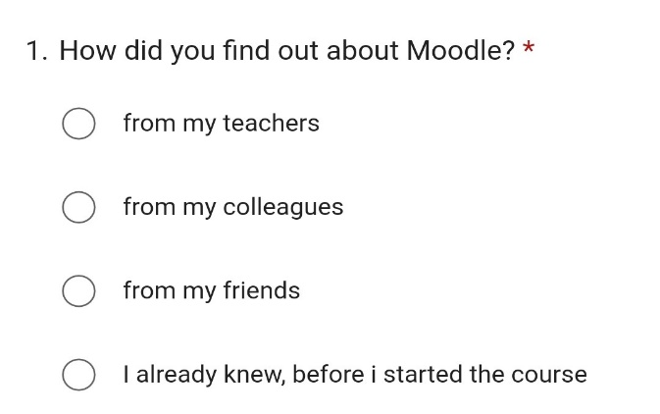
 | From teachers | From colleagues | From friends | Already knew
Find out about Moodle | 16 | 1 | 1 | 2

Interpretation:
When asked how they find out about Moodle, 80% said that they know from their teachers. This means that students are required to access the platform to get information and learn online. The next 10% said they already knew.

Question 2:Quantitative,Continuous
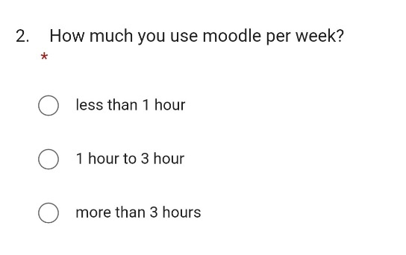

 | less than 1 hour | 1 hour to 3 hours | more than 3 hours
Use Moodle per week | 6 | 11 | 3

Interpretation:
Regarding the frequency the platform is used,55% use Moodle from one hour to 3 hours, and 30% less than one hour. It shows that students mostly use Moodle, but not so much, it follows that students are not so interested and do not need. And only a small part of 15% said they use more than 3 hours.

Question 3:Qualitative,Nominal
 | during lessons | after lessons | at home
When do you use Moodle | 10 | 6 | 13
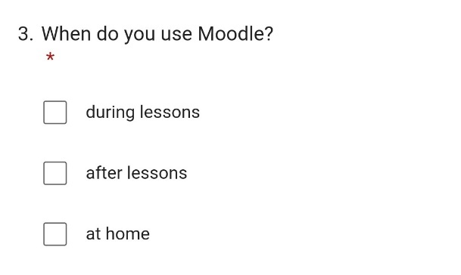

Interpretation:
To this question they could answer with several answers, and most chose, that they use it at home being 45%, and 34% during lessons, and not by far 21% after lessons. As a result, most students access it whenever they want.
Question 4:Qualitative,Nominal
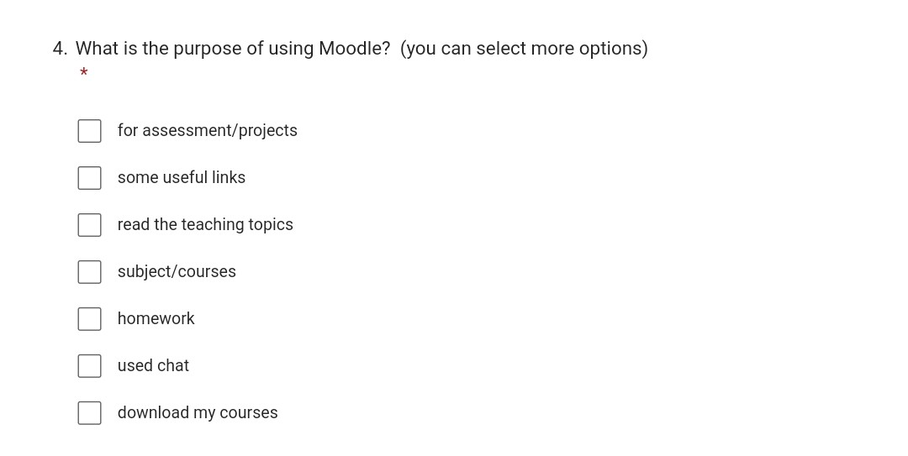

 | assessment/projects | useful links | read the teaching topics | subject/courses | homework | used chat | download courses
purpose of using Moodle | 15 | 6 | 10 | 11 | 8 | 0 | 4

Interpretation:
Another question is about the purpose of using Moodle. Almost 30% of students use Moodle for assessment/project, as around 20% say they use for subject/courses, read the teaching topics, and 16% for homework. Used chat is 0%, which leads us to conclude that students do not know about the existence of the chat, and they continue to use social networks such as (Facebook) or (WhatsApp).
Question 5:Qualitative,Ordinal

 | strongly agree | agree | disagree | strongly disagree
Moodle improved your digital skills | 4 | 14 | 2 | 0

Interpretation:
When questioned if Moodle has improved their digital skills,70% said they agree, 20% strongly agree and only 10% said they did not agree. This shows a good result about the impact of Moodle on students. Being new to students and getting to know such a modern platform for the first time, helps students develop their digital skills.

Question 6:Qualitative,Nominal
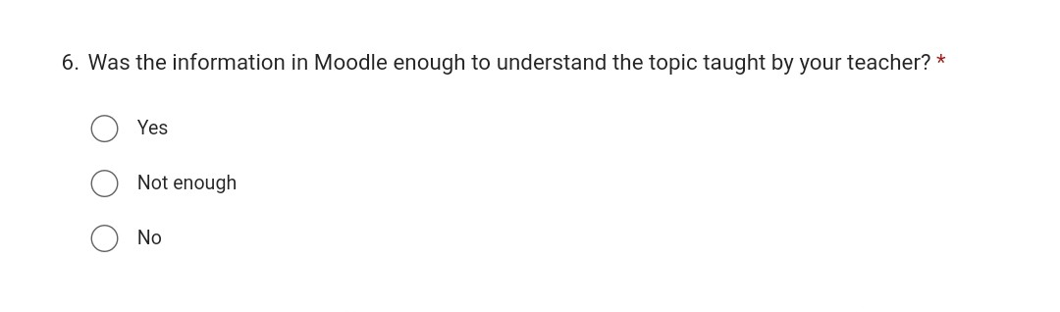
 | Yes | Not enough | No
Enough information on Moodle | 14 | 4 | 2

Interpretation:
When asked if there was enough information on Moodle to understand the topic taught by the teacher, 70% confirmed that it was, and 30% said that it was not enough. Some students prefer to search the internet for additional information. Thus, more information should be added to popularize the platform and use it more often by students, which is needed in courses.

Question 7:Qualitative,Nominal
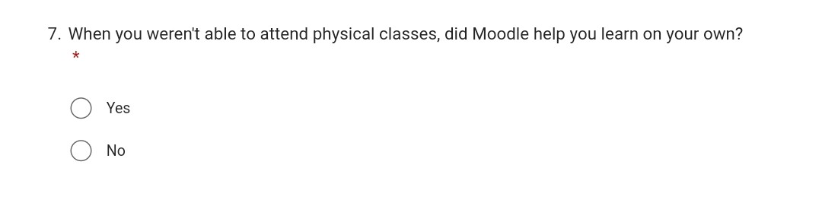
 | Yes | No
Moodle help you learn on your own | 19 | 1

Interpretation:
When asked if they could not attend classes and if Moodle helped them learn on their own, 95% said yes, and only 5% said no. It turns out that Moodle is helpful, and you can learn on your own in case you missed classes, which is an advantage for students not to lose information, motivating them to learn even if they are missing.

Question 8:Qualitative,Ordinal
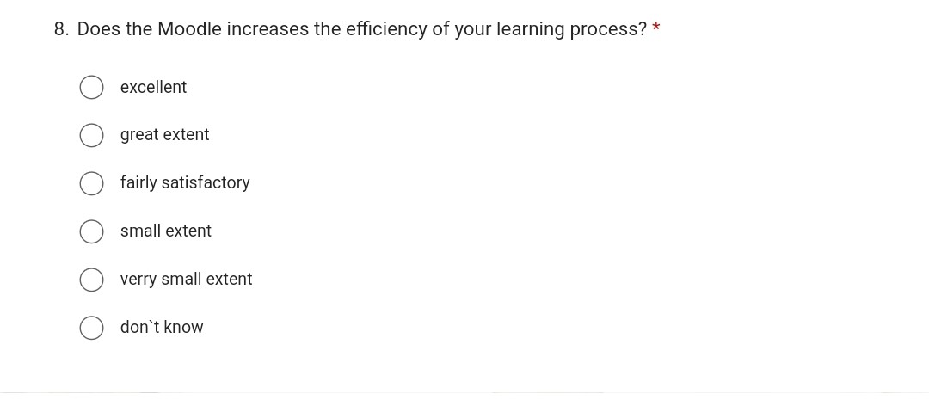
 | excellent | great extent | fairly satisfactory | small extent | verry small extent | don’t know
Moodle increases the efficiency of your learning process | 4 | 8 | 6 | 1 | 0 | 1

Interpretation:
When they were asked if Moodle increases the efficiency of their learning proces, most responded positively(90%), while 5% responded negatively and 5% that they do not know.

Question 9:Qualitative,Nominal
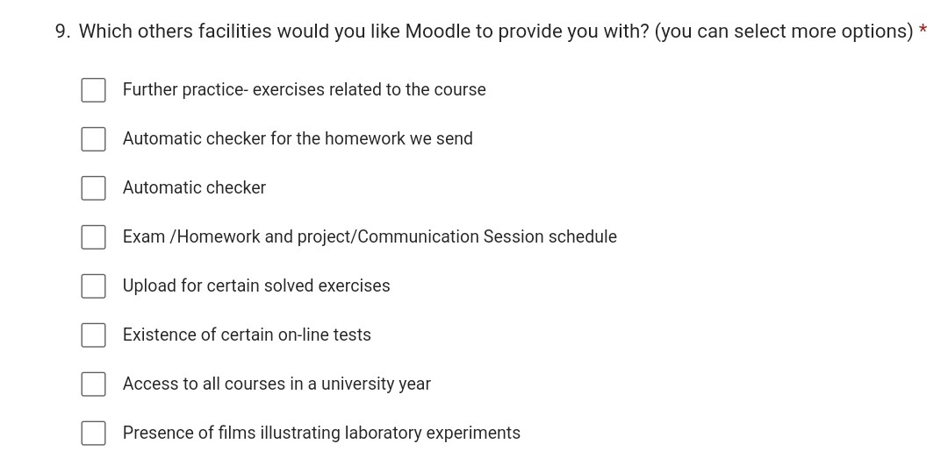

 | further practice | automatic checker for the homework | automatic checker | exam/homework...  session schedule | upload for certain exercises | existence on-line tests | access to all courses in a university year |  | presence of films illustrating laboratory experiments
Other facilities would you like in Moodle | 15 | 8 | 4 | 8 | 6 | 3 | 7 |  | 2

Interpretation:
When asked what other facilities would you like Moodle to provide you with, most of them have answered: Further practice- exercises related to the course, then Automatic checker for the homework they send, Exam /Homework and project/Communication Session schedule, Access to all courses in a university year, Upload for certain solved exercises. These answers show that students really want to use the platform, as long as they offer them various materials that will help them in their learning process.

Limitation of the Study
Simple size(People) are the limitation of the study. To conclude some information, we need to have enough sample size to make a more accurate conclusion. The larger the sample, the more accurate the results will be, if is small is difficult to identify meaningful relationships in data (WORDVICE,2012-2022).
Time is the limitation of the study because I have a deadline to finish the report. I did not have enough time to analyse the results in more detail, also the answers were collected very hard from the participants, they are being available only in a certain period.
Simple method(questionnaire) is the limitation of the study, because in the questionnaire you have a limited number of answers and questions as in my case, not to be more than 10 questions. In this case, you cannot find out the opinion of the participants, to find out more detailed information, answers that you may not have even thought to ask. In the case of the questionnaire, you don't know if they answered honestly or just randomly chose some answers without being honest. when you make a conclusion cannot analyse the results because they are all different.

Conclusion
After reviewing the responses from students at the University of Wales Trinity Saint David London Campus, I can make some conclusions. Moodle offers new opportunities for students, most of them use them at home for assessment, project, courses, read the teaching topics, homework.
It has a positive impact on students by improving some digital skills, helping them to learn on their own in the event of an unfrequented lesson. Moodle is a support for students to facilitate their learning.
The data confirms that the use of VLE encourages independent learning, as it gives students the flexibility to access any time and place. The literature review also shows that using VLE has increased students’ motivation to learn.
Students would use Moodle more often, if it will provide some exercises on classes to practice to be better, more information about the course and topics and other materials that would motivate them to use the platform more often.

References
Lingel Learning (2021) Moodle is used by businesses, schools and universities all around the world [Online] Available from: https://lingellearning.com/what-is-moodle-lms/( Accessed:18 April 2022)
University of Cumbria (2021) The learning impact of a virtual learning environment: students’ views [Online] Available from: http://insight.cumbria.ac.uk/id/eprint/1455/ (Accessed:18 April 2022)
Dawson C. (2009) Introduction to research methods: a practical guide for anyone undertaking a research project. 4th ed., Oxford: How to Books
QuestionPro (2022) What is a Survey – Definition, methods, characteristics, and examples [Online] Available from: https://www.questionpro.com/blog/surveys/ (Accessed:30 April 2022)
CLASSROOM (2020) The Difference Between Analysis & Findings in a Research Paper [Online] Available from: https://classroom.synonym.com/difference-between-analysis-findings-research-paper-4215.html( Accessed:30 April 2022)
WORDVICE (2012-2022) How to Present the Limitations of the Study [Online] Available from: https://blog.wordvice.com/how-to-present-study-limitations-and-alternatives/ (Accessed:5 May 2022)

Appendix
1 My questionnaire:
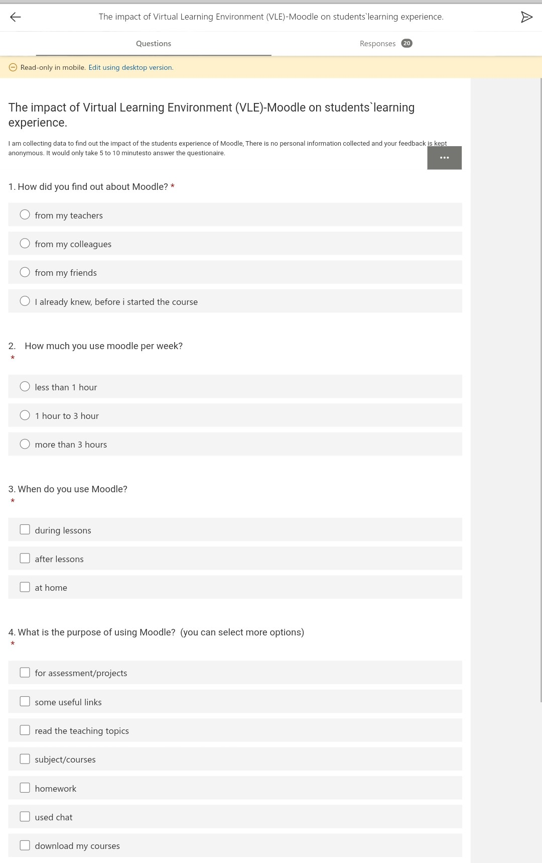
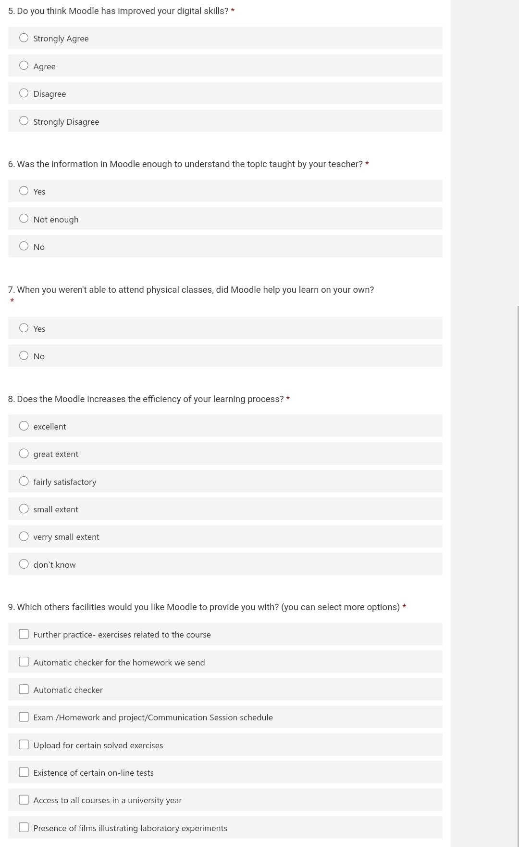
2 My result table:
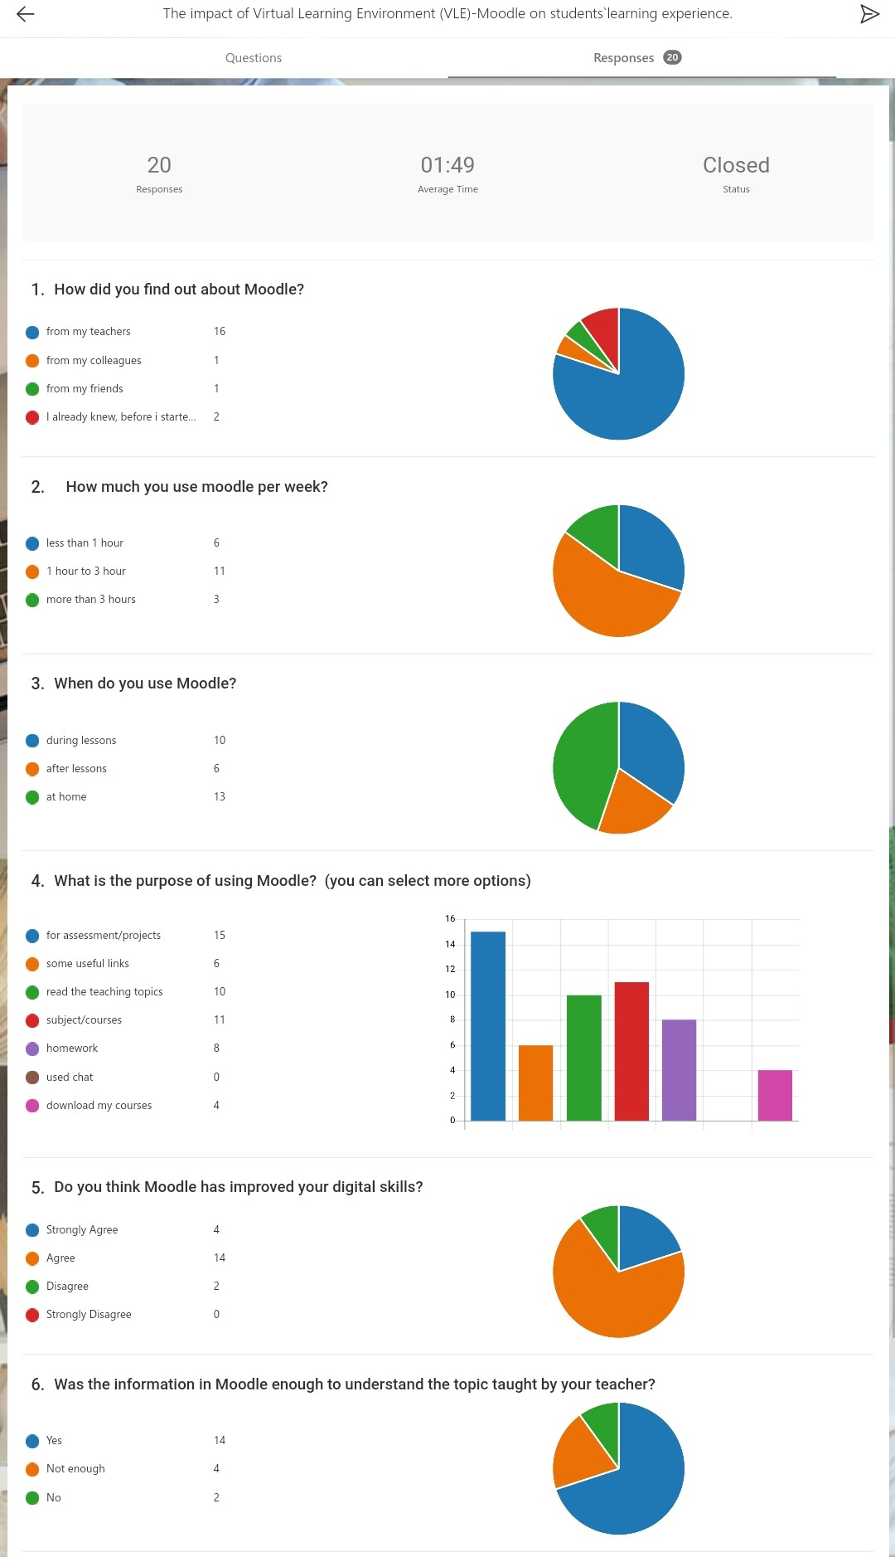
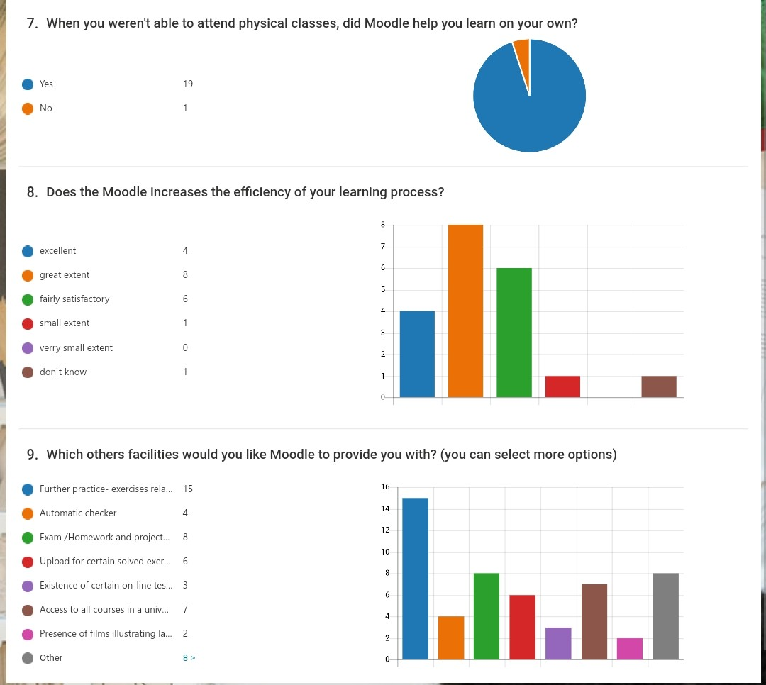

3 Any other evidence:


