Operating Systems Assignment

Contents
1 Introduction 2
2 Key Functions of General Operating Systems 2
3 Use of Windows OS CLI Commands 6
3.1 Process Management 7
3.2 File and Directory Management 8
3.3 Network Testing and Monitoring 9
3.4 User Administration 11
3.5 Task Scheduling 12
4 Use of Linux OS CLI Commands 12
4.1 Process Management 13
4.2 File and Directory Management 14
4.3 Network Testing and Monitoring 15
4.4 User Management 16
4.5 Task Scheduling 16
5 Use of Windows OS scripts 17
6 Use of Linux Bash Scripts 20
7 Conclusion 23
References 24

Introduction
This report presents practical activities demonstrating the use of Windows and Linux operating systems through command-line interfaces and scripting. It discusses system administration functions such as process administration, file administration, networking, administration of users, and scheduling of tasks, as well as the Batch and Bash scripting to aid in performing routine tasks and enhance the efficiency of system administration.

Key Functions of General Operating Systems
A general-purpose operating system (OS) is a type of system software that controls the hardware resources of a computer and supplies the interface between the computer and the users and application software. The most common operating systems are Apple macOS, Linux, and Microsoft Windows, which all perform the same basic, functions, but implement them in different ways. The operating system serves as a mediator between the users, applications, and hardware, efficiently and securely utilizing the computing resources[1].
One of the main responsibilities of an operating system is to manage processes. Multitasking is the ability of modern operating systems to run several programs at the same time. Operating system creates schedules and ends processes and allocates processor time for efficient performance. It handles threads, schedules processes and blocks concurrent applications from interfering with each other. On Microsoft Windows, processes can be observed and controlled by the Task Manager that shows the CPU usage and memory usage of currently running processes, and can allow the user to kill unresponsive applications. Similarly, in Linux, administrators can use commands like ps and top to check on running processes and system performance[2].
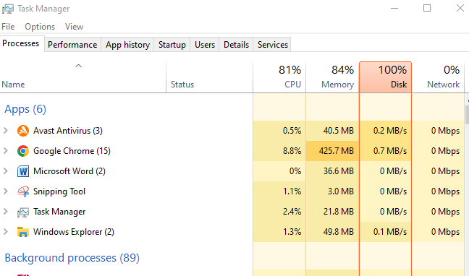
Figure 1: Windows Task Manager showing active processes.
Another essential function is memory management. The operating system uses the Random Access Memory (RAM) to load programs, and frees up memory when programs are closed. It also includes virtual memory, which enables systems to utilize storage space as an extension of memory when there isn't enough RAM on hand. Good memory management enhances system stability and allows for multiple systems to run simultaneously without running out of memory[3]. Task Manager's Performance tab in Windows shows the amount of memory used and lets you watch the memory allocation as it happens.
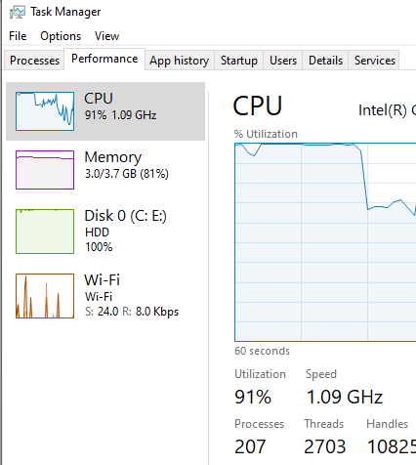
Figure 2: Windows Task Manager's performance monitoring.
The operating system also provides services for managing the file system operations, such as organising, storing, retrieval, and protection of files and directories. The File systems like NTFS in Windows and ext4 in Linux provide data integrity and manage access rights and permissions to users. Users can use file management tools to create, edit, move and delete files efficiently, such as windows File Explorer, and Linux shell commands like ls, cp and mkdir [4].
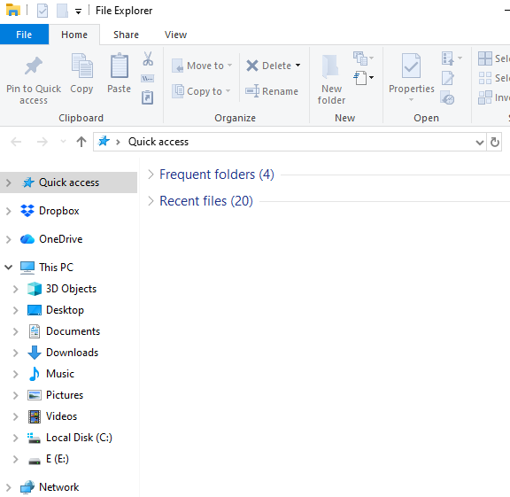
Figure 3: File Explorer used for file and directory management.
Another important role is device management. Operating systems use device drivers to interact with hardware devices, allowing components like network adapters, storage devices, keyboards, and printers to operate. Windows Device Manager helps users see the installed hardware, update drivers and troubleshoot hardware issues and make sure software is compatible with the physical devices.
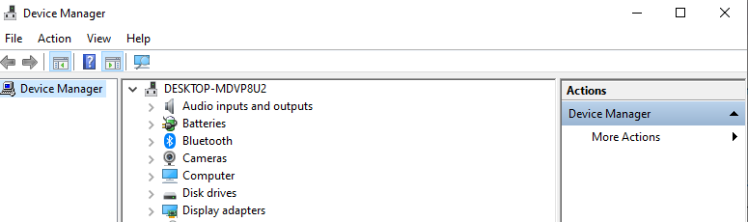
Figure 4: Device Manager showing hardware devices installed.
Lastly, security and user management safeguards system resources against unauthorized access. Operating systems use usernames and passwords to verify the identity of users, set programmatic rights, encrypt sensitive data, and use firewalls to protect users from threats in the network. Security is achieved in Windows Security through the combination of antivirus protection, firewall management, and security monitoring, whereas in Linux, it is done through user accounts, file permissions, and privilege escalation mechanisms like sudo [5].
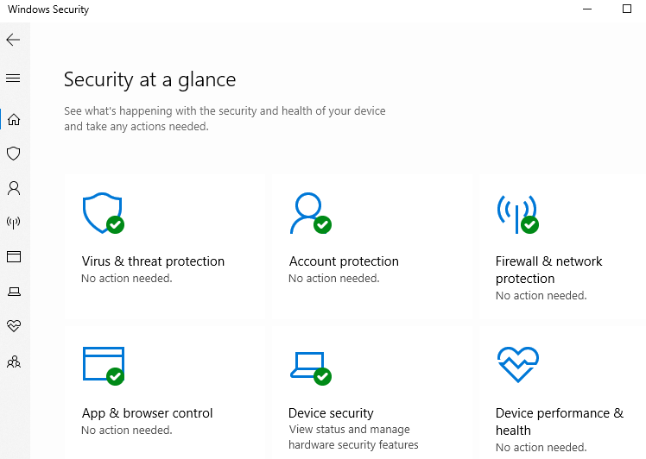
Figure 5: Windows Security system protection interface.

Use of Windows OS CLI Commands
The Windows Command-Line Interface (CLI) is the effective way to communicate with the operating system using text commands, which makes it an ideal solution for users and system administrators. The CLI is faster in completing system tasks, can be automated using scripts and provides direct access to system management functions, unlike graphical user interface (GUI)[6]. For many tasks, including monitoring system performance, managing files, diagnosing network problems, administering user accounts, and scheduling tasks, Command Prompt is a crucial tool for IT professionals and system administrators.

Process Management
Process management is one of the most common tasks for the Windows CLI, allowing users to view and track all running processes and system services. All running processes were listed along with their Process IDs (PIDs) and memory usage with the tasklist command, which gives an overview of the system activity. To get more detail, the tasklist /v command is used, which provides verbose output including the process status, user associated with the process, CPU time, and window title. These commands help administrators detect applications that consume too many resources and might be causing problems.
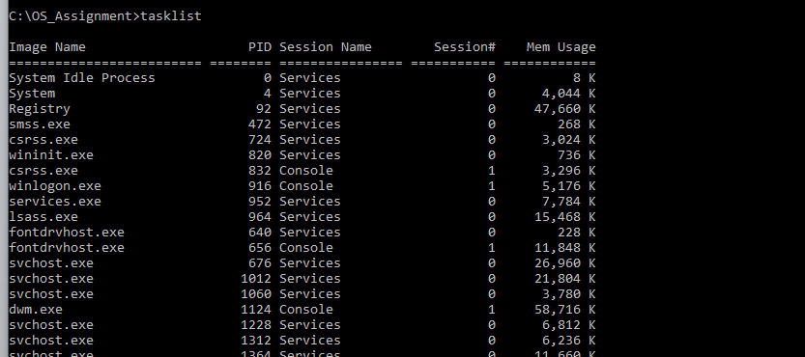
Figure 6: Output of the tasklist command showing active processes.
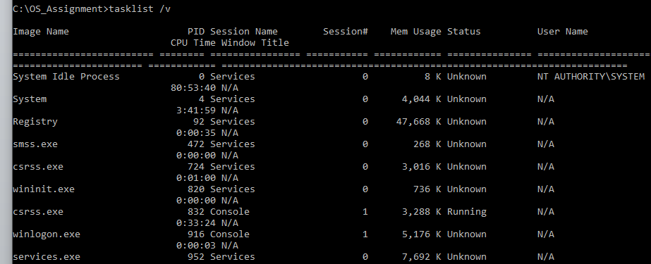
Figure 7: Verbose process information displayed using the tasklist /v command.

File and Directory Management
The Command Prompt also provides several commands for file and directory management, enabling users to organise files without using File Explorer. The dir was used to show the contents of the current directory, and mkdir was used to make a new folder to store the files of the assignments. Using the echo command with output redirection, a text file was then created to show how easy it is to create files directly from the command line. Lastly, the copy command was used to duplicate the file, which is a simple backup. These are just some of the commands for efficient file management in a CLI environment for everyday administration tasks.
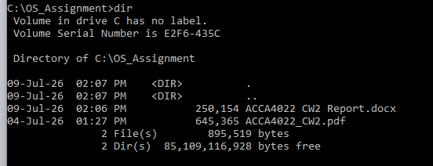
Figure 8: Listing the contents of the directory with the dir command.
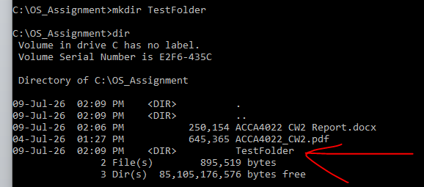
Figure 9: Creating a new directory with the mkdir command.
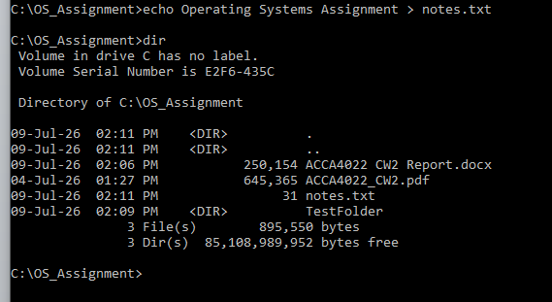
Figure 10: Creating a text file with the echo command.

Network Testing and Monitoring
The commands for Windows CLI are also useful for network testing and monitoring. The ipconfig command has been run to show the computer's TCP/IP configuration, which shows information about network adapters as well as IP configuration. The ping google.com -n 4 command was used to test whether there was any Internet connection by sending four Internet Control Message Protocol (ICMP) echo requests to the Google servers and reporting the response times.
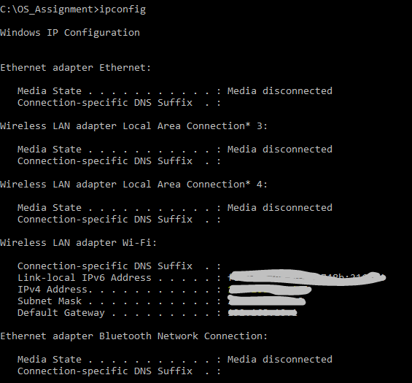
Figure 11: Network configuration displayed using the ipconfig command.
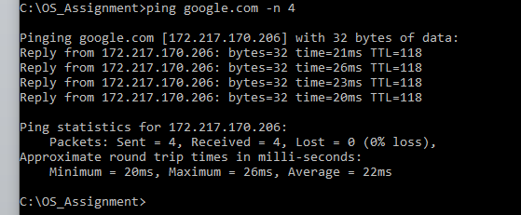
Figure 12: Connectivity test using the ping command.

User Administration
Administrators can also use the Windows CLI to get information on user accounts. The whoami command returned the account name being used to log into the system, and the net user command displayed all of the local user accounts set up on the computer. These commands are especially helpful for authentication and access control to the system.
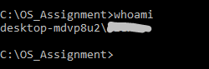
Figure 13: Current user account displayed using the whoami command.
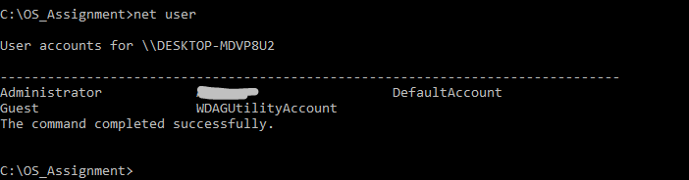
Figure 14: Local user accounts displayed using the net user command.

Task Scheduling
Finally, Windows provides command-line access to Task Scheduler, enabling users to review automated system tasks. The schtasks /query command showed all scheduled tasks that are set for the system, including maintenance, update and background service tasks. This functionality shows how administration processes can be tracked and managed directly from the command line without the graphical Task Scheduler UI.
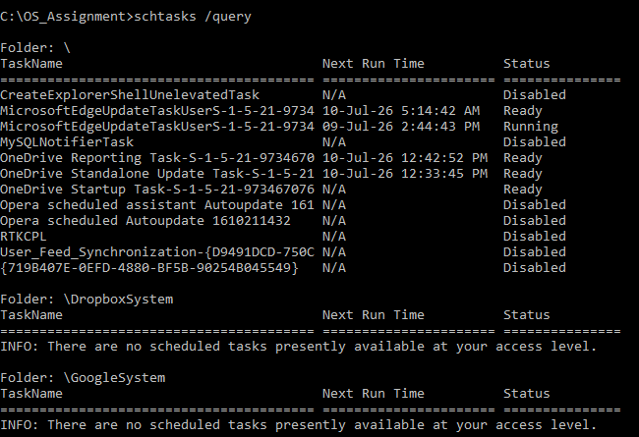
Figure 15: Scheduled tasks listed with schtasks /query.

Use of Linux OS CLI Commands
The Linux operating system offers a very powerful command-line interface (CLI), which allows an administrator or user to carry out system administration tasks using textual commands. The Linux CLI also offers direct access to system resources, which makes it an ideal tool for automation, troubleshooting, process management, network diagnostics, file administration and task scheduling. The command line is still a useful tool for enterprise and cloud-based Linux systems, especially because it's flexible, fast and offers scripting options[7].

Process Management
There are a number of commands available in Linux that are used for process management, that is, to be able to check and control processes that are running. The ps -ef command was used to list all the processes that are running on the system and their Process ID (PID), owner and status. The top command was used to get real-time updates about the usage of the CPU, memory, active processes, and system load. These commands help administrators detect resource intensive processes and track overall system performance.
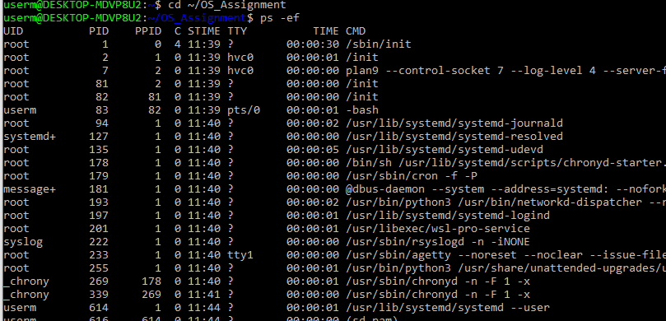
Figure 16: Running processes displayed by the ps -ef command.
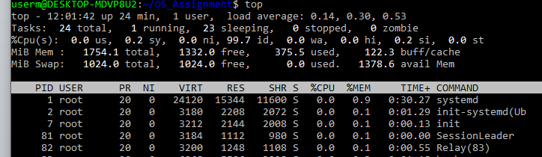
Figure 17: Real-time process monitoring using the top command.

File and Directory Management
In addition, Linux also has a wide variety of commands to manage files and directories in order to keep things organized without the need for a GUI file manager. pwd returned the current working directory, and mkdir made a new directory to put the assignment files in. The "cd" command was used to navigate to different directories and a new text file was created using "touch". Lastly, a simple file backup operation was used for the duplication using the cp command. These commands demonstrate how routine file management tasks can be completed quickly using the command line.
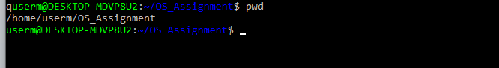
Figure 18: Using the pwd command to display the current working directory.

Figure 19: Creating a new directory using the mkdir command.
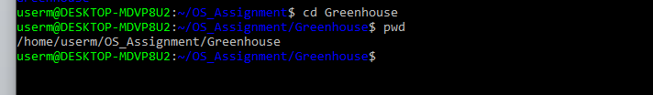
Figure 20: Using the cd command to navigate to the Greenhouse directory.

Figure 21: Creating a file using the touch command.
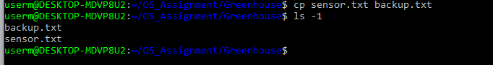
Figure 22: Copying a file using the cp command.

Network Testing and Monitoring
Additionally, there are many network testing and monitoring tools on the Linux command line. The ip addr command showed the network configuration of the system (its IP address information and interface status). The availability of Internet was checked by pinging google.com with 4 ICMP echo request packets and the time for them to return, along with packet transmission statistics. All active network port(s) and listening services were then inspected with the command ss -tuln which enabled the administrator to check what network services are listening and accepting connections.
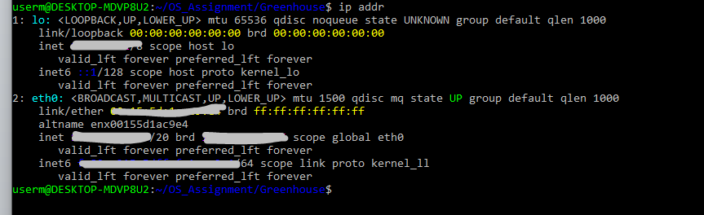
Figure 23: Output from the ip addr command, showing the configuration of the network interfaces.
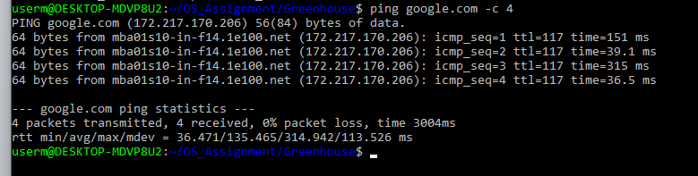
Figure 24: Network connectivity test using ping command.

User Management
The Linux operating system offers basic but powerful user control tools to identify and manage user accounts and permissions. The currently logged in user's username was displayed using the whoami command, which would help administrators to ensure that the correct user is logging into the system before performing administrative actions.
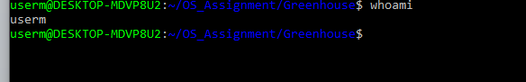
Figure 25: Current user displayed using the whoami command.

Task Scheduling
The cron scheduling service is the most common way to schedule tasks in a Linux based system. To view the system scheduling configuration, the command ls -l /etc/cron* was used to list cron configuration directories that handle hourly, daily, weekly and monthly automated processes. These directories include scripts for performing routine maintenance tasks like software updates, backups, and log management.
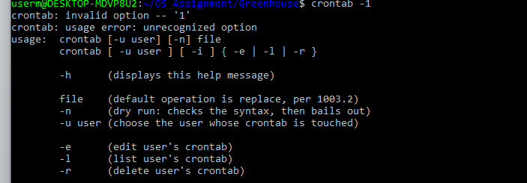
Figure 26: Linux cron scheduling directories displayed using the ls -l /etc/cron* command.

Use of Windows OS scripts
The first Batch script models a simple greenhouse temperature monitoring system which helps greenhouse operators to keep the growing conditions within the greenhouse appropriate. Script asks for the name of the crop and the temperature of the greenhouse, and stores the two values as variables. The script automatically checks via conditional (IF) statements whether the greenhouse is colder, hotter, or in the recommended temperature range, and then it prints out the proper action (e.g., "ON" or "OFF" the heater or cooling fan). In this example, the need to make simple environmental monitoring decisions manually can be automated using Batch scripting to enhance efficiency of the operation.
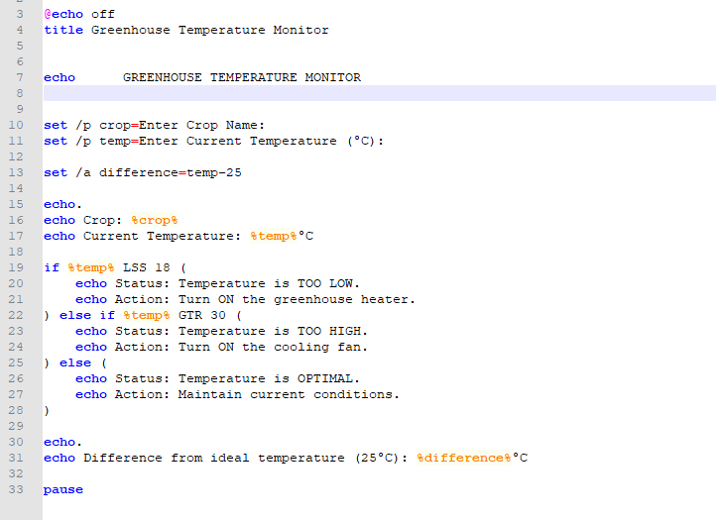
Figure 27: Greenhouse Temperature Monitor Batch script.

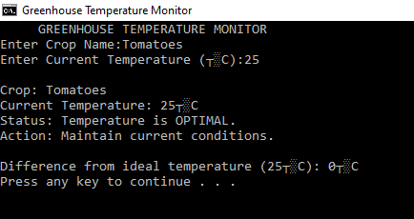
Figure 28: The Greenhouse Temperature Monitor script running with user input and automatic temperature assessment.
The second Batch script simulates a greenhouse irrigation monitoring system which automatically determines irrigation based on soil moisture readings. The script asks the user about the crop and the percentage of soil moisture left in the field, these two values are stored as variables. It then does an arithmetic sum to work out the extra moisture that is needed to bring the recommended moisture level up to 60%. The script uses conditional (IF) statements to determine if irrigation is needed based on the measured soil moisture value and a set threshold. A CHOICE command sets up a basic loop that will enable the user to analyze several crops in one run – this is an example of how a Batch script can be used effectively to complete repetitive monitoring jobs. This example illustrates how the Command Line Automation can help in the environmental monitoring for better decision making in greenhouse Management.
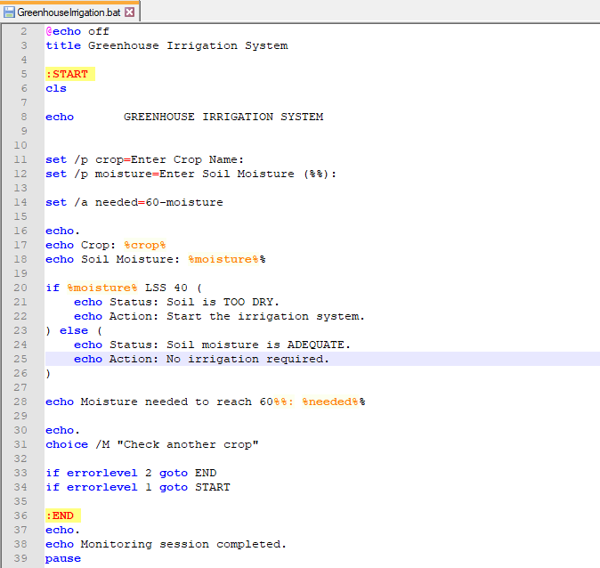
Figure 29: Batch script for greenhouse irrigation monitoring including variables, user input, arithmetic operations, conditions and looping.

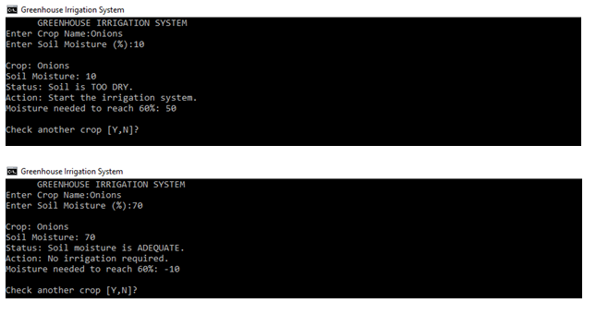
Figure 30 illustrates the run of the greenhouse irrigation monitoring script, where irrigation recommendations are being automatically made based on soil moisture readings.

Use of Linux Bash Scripts
Bash scripting is a basic, yet powerful way to automate repetitive tasks in Linux operating systems [8]. Bash scripts can automate repetitive tasks, provide consistency, and enhance administration efficiency by leveraging user input, variables, arithmetic expressions, conditionals, and looping structures. The following are examples of basic business tasks that can be automated using Bash programming and standard Linux shell commands.
The first bash program that was created is an Employee Salary Calculator. Before calculating the gross salary, the script asks the user for the employee's name, number of hours worked, and hourly pay rate. Then a conditional statement is used to determine whether the employee would be eligible for a performance bonus for the computed salary. In this example, variables, user interaction, arithmetic and conditional logic are used to automate a payroll-related calculation.
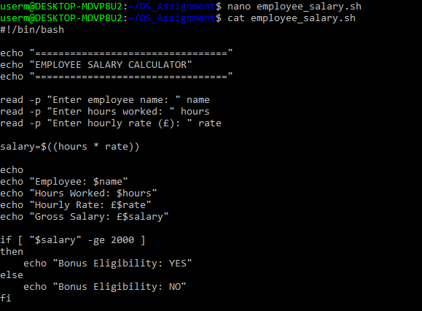
Figure 31: Bash script to calculate an employee's salary.
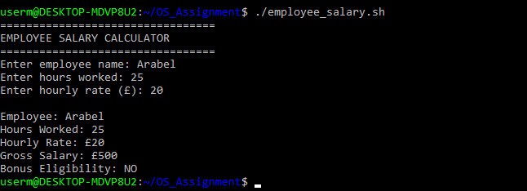
Figure 32: Execution of the Employee Salary Calculator Bash script.
The second Bash script is an Electricity Bill Calculator that calculates the amount of electricity charges that a customer pays, using the energy that they have consumed. The script asks the customer for his/her name and how many electric units he/she has used before computing the total bill according to a predetermined unit price. The script is asking for the customer's name and the number of electricity units he/she has consumed before computing the total bill according to a fixed unit rate. A conditional statement has been included that specifies if electricity use is high or not, and recommends an appropriate action. A while loop is used to make it easier to use because multiple customer calculations can be done in one program run without restarting the program. This script shows how to use variables, input from the user, arithmetic calculations, conditional statements and loops to automate repetitive billing calculations in Bash scripting.
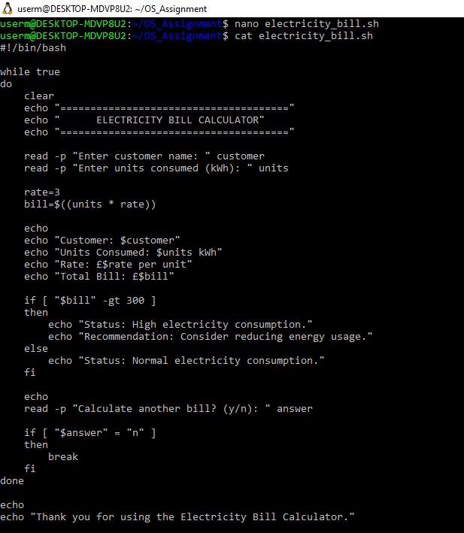
Figure 33: Electricity Bill Calculator Bash script.
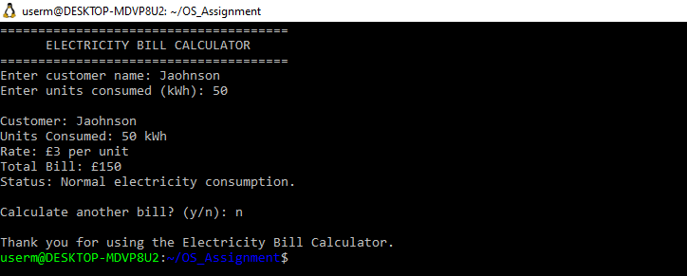
Figure 34: Execution of the Electricity Bill Calculator Bash script.
Both Bash scripts show that Linux shell scripting is used to automate common administrative tasks through the interaction with users and decision-making and mathematical processing. Bash scripts are more efficient than doing these calculations by hand, error free and produce consistent results. The use of scripting is widespread among Linux system administrators who use the language to automate system maintenance, reporting, scheduling, monitoring and other system functions, making shell a very important part of modern computing.

Conclusion
In conclusion, the command-line administration and task automation execution, performed in this report, showed how the Windows and Linux operating systems can be effectively used. It was possible to perform a variety of commands on the CLI and to control processes, organize files, monitor network activity, manage users, and view the scheduled tasks for both operating systems. Through the use of variables, accepting input from users, performing calculations, using decision making structures, and performing looping operations, the development of Batch and Bash scripts further demonstrated how scripting can be used to automate repetitive tasks, reduce manual work and to enhance operational efficiency for today's system administration.

References
[1] G. Silberschatz, A., Baer Galvin, P. and Gagne, Operating System Concepts Essentials Second Edition. John Wiley & Sons, Inc., 2014.
[2] T. R. Nemeth, E., Snyder, G. and Hein, Linux administration handbook. Addison-Wesley Professional., 2006.
[3] J. I. Jalaman, J.R.C. and Teleron, “Optimizing operating system performance through advanced memory management techniques: A comprehensive study and implementation.,” Eng. Technol. J., vol. 9, no. 10.47191, 2024.
[4] C. Cohen, D. and Sturm, The Software Developer’s Guide to Linux: A practical, no-nonsense guide to using the Linux command line and utilities as a software developer. Packt Publishing Ltd., 2024.
[5] M. D. Santana, “Eliminating the Security Weakness of Linux and UNIX Operating Systems.,” in Computer and information security handbook, Morgan Kaufmann., 2025, pp. 217–233.
[6] A. Das, “Command-Line Customer Success: Automating Lead Management and Client Retention Using unix Tools In Modern CRM Environments.,” 2023.
[7] M. Yadav, “From Legacy to Agile the Role of Linux in Cloud Computing and Digital Transformation.,” Int. J. Sci. Eng. Technol., vol. 7, no. 3, 2019.
[8] S. R. Madamanchi, “Modern approaches to Unix automation: Shell scripting, configuration management, and security. International,” J. Res. Appl. Sci. Eng. Technol., vol. 13, no. 6, pp. 3190–3201, 2025.

