
Portfolio (Poster + Essay)
Introduction to Health and Social Care

Helen Ketley 2526591

DANIEL HARUNA LCHS4003

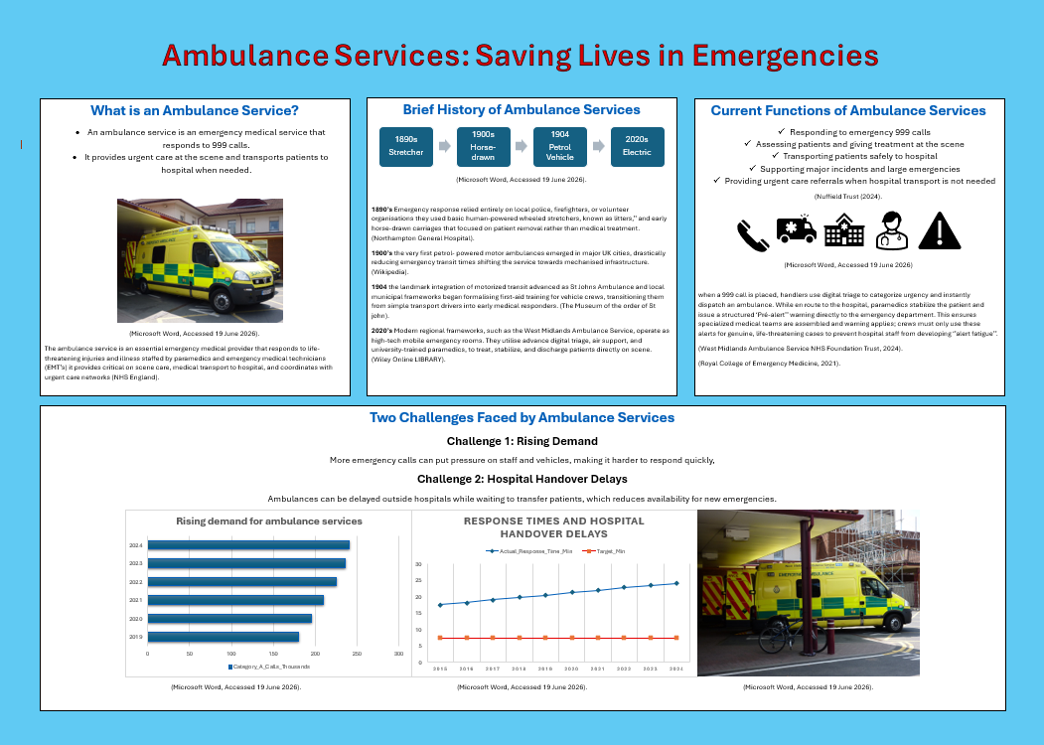
Community Mental Health Services; Origins, Function, and Significance

Community mental health services represent a major shift in how mental health care is delivered, moving away from large psychiatric hospitals towards support within people’s local communities. Rather than being confined in institutions, individuals receive help through psychological therapy, social support and peer assistance in their everyday neighbourhoods. This essay examines where these services originated, the historical background that influenced their growth, evaluates how they operate in the present day, and explains why they matter for improving the lives of those who use them.

The development of community mental health services began in the middle of the twentieth century during a period known as deinstitutionalization. Before this time, people with mental health conditions were often locked away in large asylums that cut them off from society. This approach reflected both moral judgements and outdated medical thinking about mental illness. The situation changed when new psychiatric drugs, such as antidepressants and antipsychotics, were introduced in the 1950s. These medications made it possible for many patients to live outside hospitals while still receiving treatment. At the same time, writers like Erving Goffman exposed the harmful conditions inside asylums, adding pressure to reform the system. In America President Kennedy passed the Community Mental Health Centres Act in 1963, which created local treatment centres to replace state hospitals,
The UK developed its own version of community psychiatry through the National Health Service. Later legislation, including the Care Act 2014; made it legal duty for local authorities to access and provide care for people with mental health needs. The Health and Care Act 2022 went further by requiring NHS organisations and local councils to work together on mental health services. Important ideas about teamwork between professionals, such as those explained by Thomas and Pollard, helped shape how these services operate by encouraging different specialists to understand each other’s roles and work together for the benefit of patients.

Looking at how community mental health services work in practice today show that they have strengths but also serious weaknesses.
Moden approaches include combined primary care, travelling teams of specialists, open day centres, and groups where people support each other. In England, Community Mental Health Teams usually work within secondary care systems and often set high standards for severity before accepting someone onto their caseload, The Care Quality Commission carried out major survey in 2025, gathering responses from over 12,000 people who had received mental health treatment. Their findings showed growing demand and strict admission rules mean many people wait too long for help, sometimes becoming worse while waiting. Another report from Care Quality Commission in 2026 highlighted that care frequently breaks down between primary and secondary services, and that the amount of support available varies significantly depending on where you live. Official guidelines from the National Institute of Care Excellence recommend assertive community treatment for people with severe conditions, but access to this type of care is not consistent. The good side of community services includes less stigma around mental illness, better access to help and a focus on helping people recover and keep working or maintaining relationships with family.
However limited resources, high thresholds for entry, and poor coordination between different parts of the system mean that many people cannot get the support they need.

The value of community mental health services for improving users’ quality of life is clear. When professionals from different backgrounds worker together as a team, they can provide more coordinated care, which reduces the need for hospital stays and helps people live more independently. Guidance issued by NHS England in 2025 explains that rehabilitation services give individuals the chance to live on their own, keep working, and rebuild family connections, all of which are important for wellbeing. Support from peers and community-run projects also strengthens people’s sense of control over their own recovery. Getting help early in community settings prevents problems from turning into crises, which means fewer emergency hospital admissions and better long-term results. The work of Thomas and Pollard shows that effective teamwork between different professionals tackles common problems such as communication barriers. Ethic issues, and differences in how team’s function, all of which are vital for providing good mental health care. Studies show that when different services collaborate well. Outcomes improve for people with complex needs.

In summary, community mental health services grew out of the deinstitutionalization movement that started in the 1960s, supported by new medications, criticism of old practices, and changes in law like the Care Act 2014 and Health and Care Act 2022, Although problems remain with access and funding, these services continue to plat a vital role in supporting recovery, social inclusion, and personal empowerment. Their main contribution is changing mental health care from isolating people in institutions to supporting them within their communities, which significantly improves the quality of life for those who use these services.

Care Quality Commission (2026) community mental health survey 2025, Manchester; CQC.
Available at;
https;//www.cqc.org.uk/publicaions/(Accessed; 22 June 2026).
Care Quality Commission (2026a) people waiting too long for mental health care; CQC annual report. Manchester; CQC.
Available at;
https;//www.cqc.org.uk/press-release/people-waiting-too-long-for-mental-health-care.
(Accessed; 22 June 2026).
Day, J. (2013) interprofessional working; An Essential Guide for Health and Social Care
Professionals.2nd edition. Andover; Cengage Learning.
NHS England
Available at;
www.england.nhs.uk
NHS England (2025) commissioner guidance for adult community mental health rehabilitation services. London; NHS England.
Available at;
https;//www.england,nhs.uk/long-read/commissioner-guidance-adult-community-mental-health-rehabilitation-services/
(Accessed 22 June 2026).
Northampton General Hospital
Available at;
https//www.northamptongeneral.nhs.uk
NICE (2023) psychosis and schizophrenia in adults; prevention management.NG178. London; National Institute for Health and Care Excellence.
Available at;
https;//www.nice.org.uk/guidance/ng178.
(Accessed 22 June 2026).
The museum of the order of St john
Available at;
https;//museumstjohn.org.uk
Thomas, J. and Pollard, K. (2014) Interprofessional Working in Health and Social Care; professional perspectives.2nd edition. Basingstoke; Palgrave McMillan
UK Government (2014) Care Act 2014. London; Department of Health.
Available at;
Wikipedia
Available at;
https;//en.wikipedia.org
Wiley Online Library
Available at;
https;//onlinelibrary.wiley.com
http;//www.gov.uk/care-act-2014
(Accessed 22June 2026).
UK Government (2022) Health and Care Act 2022.London; Department of Health.
Available at;
https;//www.gov.uk/health-and-care-act-2022
(Accessed 22 June 2026).

.

