Name: Nabila Nazam
2324644
Programme: BSc (Hons) Health and Social Care
Module: Digital Transformation in the Health and Care Professions
Module code: BMHP6026
Lecturer: Matrin Svejda, Tomy Adattu Chacko and Zakiyyah Ahmed
Internal Verifier: Chloe Harries
Assignment Title: Component 1: Written Report
(A Critical Evaluation of Electronic Patient Records (EPRs) as a Digital Transformation within the NHS)

Table of Contents
Introduction 3
Overview of Electronic Patient Records and NHS Implementation 4
Impact on Workforce 5
Impact on Patients/Services Users 7
Impact on Communities 8
Conclusion 9
References 10

Introduction
The shift to a digital organisation has gained immense significance in health and social care, offering a chance to enhance efficiency, quality of care, and patient outcomes by leveraging innovative technologies. The National Health Service (NHS) in the UK has digitised various processes to modernise the way healthcare is delivered, and launched initiatives to support integrated care services, with many location-specific solutions implemented to meet individual requirements across the country (NHS England, 2026). The Electronic Patient Record (EPR) is one key innovation, a digital copy of patient information that can be accessed, updated, and shared securely and securely by authorised health care professionals in other environments.
Over the past decade, the uptake of EPR systems has significantly upped in the NHS as part of a digital transformation plan designed to replace paper-based records and enhance information sharing (The Health Foundation, 2025).
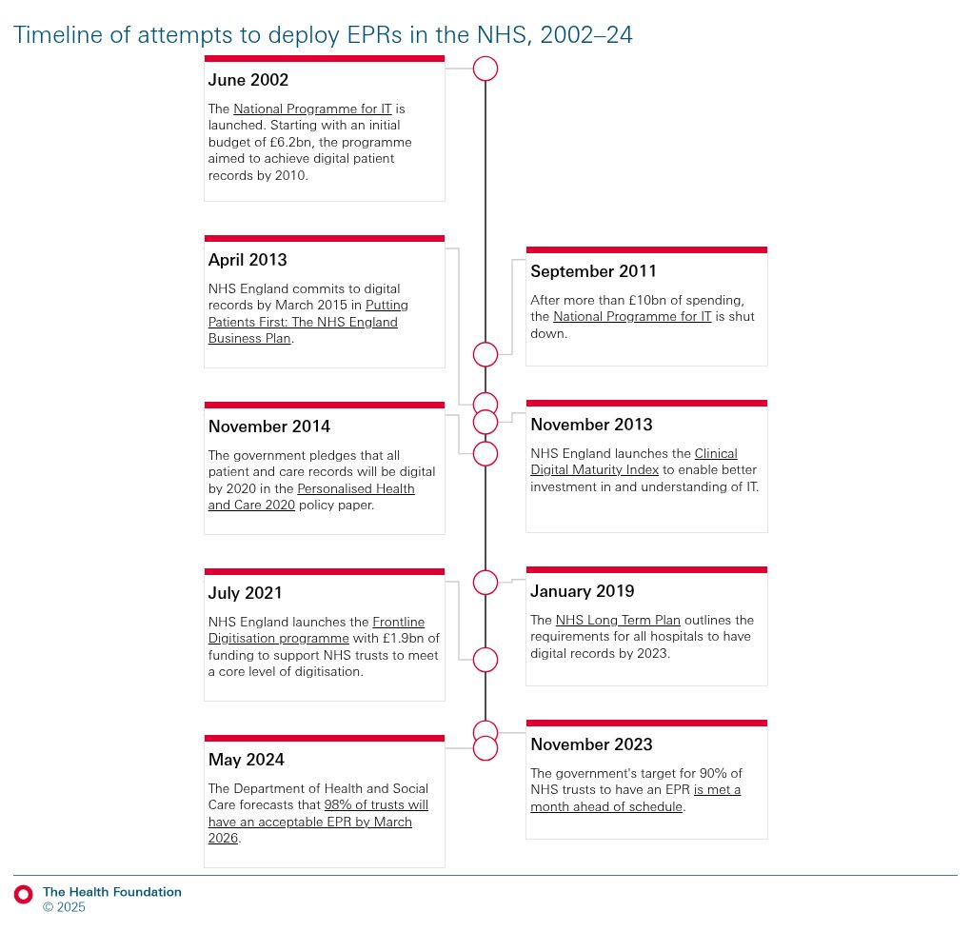
Figure 1: Timeline of Attempts to deploy EPRs in the NHS, 2002-24
Source: The Health Foundation (2025)
In today's health care environment, EPRs play a crucial role in facilitating clinical decision making, patient safety, coordinated health care delivery, and efficient service delivery (Smith-Mitchell, 2025). This report assesses the way EPRs are being implemented within the NHS and examines their impact on NHS staff, service delivery, patients and communities, including any positive and negative.

Overview of Electronic Patient Records and NHS Implementation
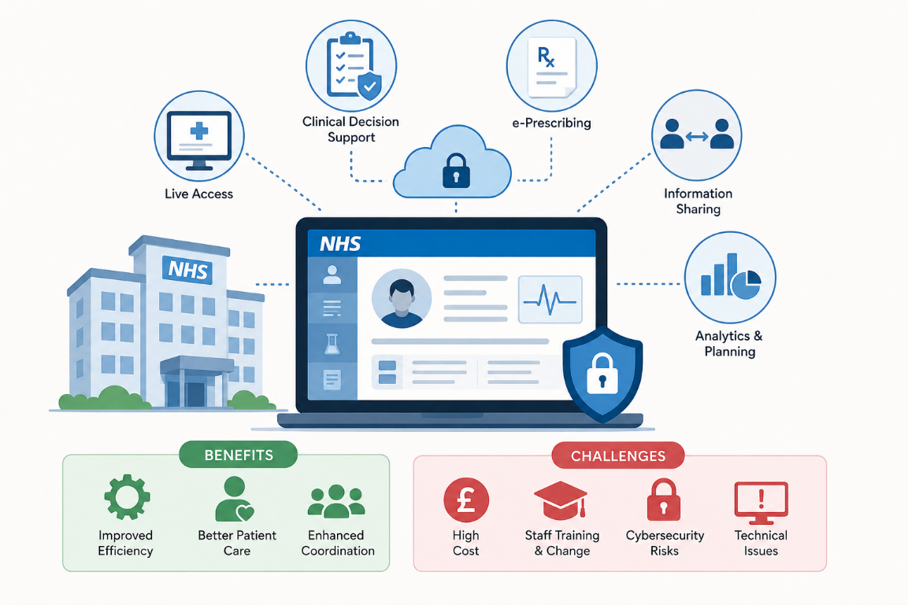
Figure 2: NHS Electronic Patient Records Overview
Source: Self-Made
Electronic Patient Records (EPRs) are digital records that hold patients' health information digitally so authorised health care professionals may view, modify and share the clinical information of a patient securely in various health care settings (NHS England, 2026). This significantly improves efficient management of patient information through the care pathway, as EPRs supersede the paper-based approach to records.
EPRs have been highlighted as an important aspect of the NHS digital transformation programme, set to deliver benefits for healthcare quality, efficiency and patient outcomes using digital technologies (NHS England, 2026). The NHS Long Term Plan places a priority on the need to digitise health services and increasing the availability of integrated digital records, which will underpin coordinated and personalised care (NHS England, 2026). In recent years, the use of EPR systems has rapidly grown within NHS hospitals, primary care practices and community healthcare providers, leading to the shift from paper-based records to digital record-keeping.
EPR systems provide a number of notable advantages to healthcare deliverability (Bourquard and Berler, 2021). These comprise live access to patient information, clinical decision support, electronic prescribing, improved inter-departmental information sharing and service planning and oversight analytics tools. These capabilities can facilitate healthcare providers in decision-making and provide more seamless care.
Many advantages have been observed since the implementation of EPR into healthcare systems such as efficiency of the system, better access to patient information, and healthcare providers' system co-ordination between them (Health Services Safety Investigations Body, 2025). However, challenges remain. Making EPR systems a part of your business is a significant financial commitment, investment in training staff, and organisational change. In addition, cybersecurity dangers, technical issues, and some healthcare professionals' resistance may impede successful implementation and impact services continuity (Tully et al., 2020).

Impact on Workforce
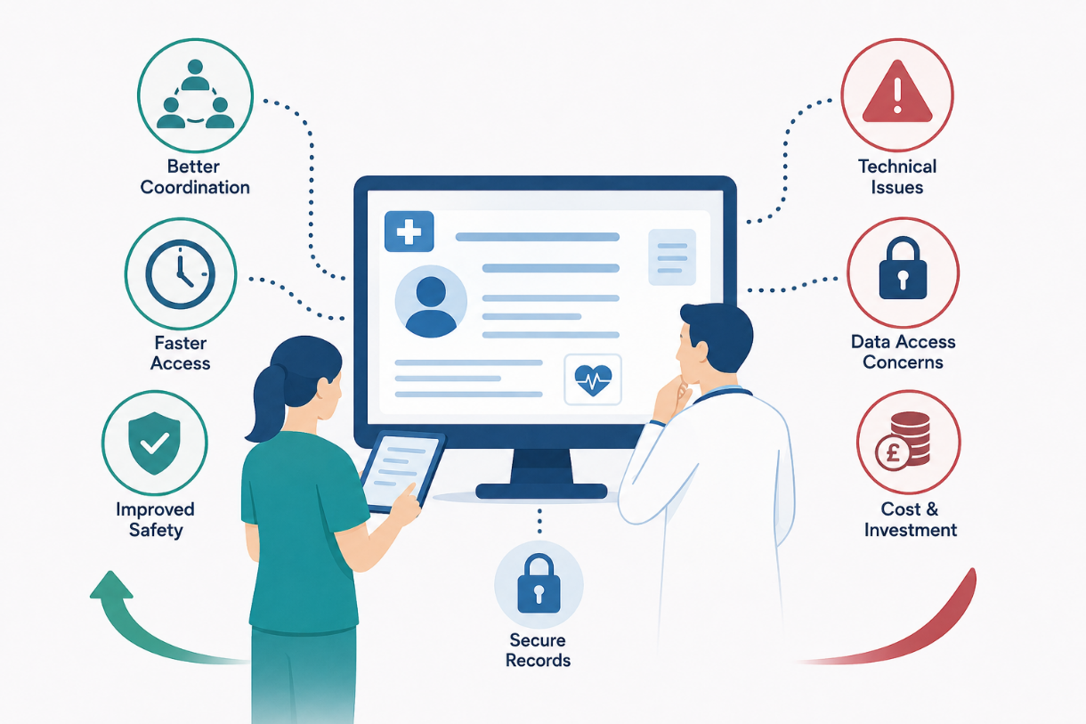
Figure 3: Electronic Health Records: Benefits and Challenges
Source: Self-Made
EPRs have revolutionised the service delivery experience for both patient and health services within the NHS with significant advantages in the way that patient information is accessed, ensured accuracy and shared (Brady et al., 2024). The improved care coordination is one of the top benefits. EPR systems enable patients to be tracked as they move among a range of healthcare environments including hospitals, primary care and community services. It allows healthcare providers to have a full picture of each patient's medical records and reach informed decisions, thereby facilitating integrated and continuous care (Adeniyi et al., 2024).
Additionally, EPRs can streamline the delivery of service, as they offer instant access to patient records, laboratory data, and treatment plans. This helps to improve the efficiency of accessing paper records and allows healthcare professionals to access patient information more promptly, which can lead to faster medical interventions and care (Alomar et al., 2024). Moreover, digital records can reduce the duplication of diagnostic tests and procedures because the healthcare providers can easily refer to the previous investigations and clinical records. This helps to optimise service provision and minimise waste in the healthcare system. There is another important benefit that comes from this; patient safety is extremely improved (World Health Organisation, 2021). Keeping accurate and timely records with elements of electronic prescribing and clinical alerts can help minimise medicines errors and contribute to safer clinical decisions.
Despite these advantages, there are some service delivery difficulties remaining. Technical problems, software errors, or cyber security issues can create downtime and interfere with clinical operations and the delivery of patient care (Scantlebury et al., 2021). In times of such events, healthcare organisations may be forced to go onto manual processing, which not only slows down, but also raises the chances of mistakes. Data access issues are also a potential concern since erroneous data will be entered into an EPR system, resulting in inappropriate treatment decisions. Further, EPR system implementation needs significant financial investment in infrastructure, software and maintenance and employees training (Al-Worafi, 2023). Another challenge is interoperability; with some NHS organisations operating with different digital systems that cannot build on the information others provide or access it as effectively as they want, thus impeding a seamless exchange of data (NHS England, 2025).
Overall, EPRs have significantly improved the efficiency of healthcare, by promoting better information sharing, reducing duplication and improving health safety. Their success will be dependent, however, on the reliability, availability and continuous investment in interoperable digital systems as well as in sufficient staff training. However, EPR has ushered in a new era in service delivery; some technical and organisational hurdles need to be overcome to fully realise its benefits.

Impact on Patients/Services Users
The introduction of Electronic Patient Records (EPRs) into the National Health Service (NHS) has had an impact on patient and service user experiences. According to NHS England (2026), in the 2024 survey, overall satisfaction of English providers of secondary care was slightly higher than the 3.4* recorded in the comparable survey carried out in 2021.
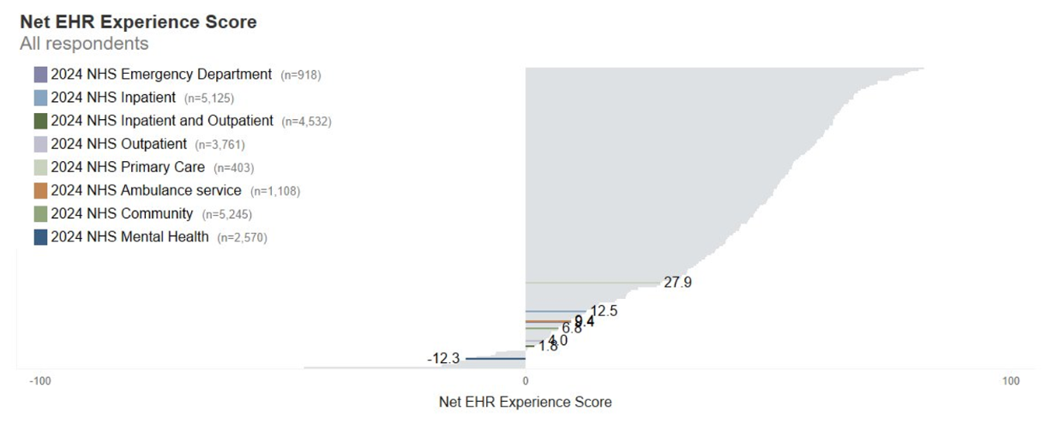
Figure 4: NET EHR Experience Score
Source: NHS England (2026)
The most significant advantage is the enhancement of the quality of care. EPRs allow healthcare practitioners to access detailed information about patients in real-time, enabling more informed care provision decisions and minimising the risk of disjointed care provision (Hardie et al., 2022). EPR systems also have various capabilities that contribute to patient safety, including electronic prescribing, alerting systems for allergies, and monitoring of medications to minimise clinical and medication errors.
Another significant benefit of the programme is better continuity of care. Healthcare providers can retrieve patient information from various healthcare settings to gain multidisciplinary view of patient's history and treatment needs (Alsubaie et al., 2024). Furthermore, patient portals connected to EPR systems enable users to access their medical records, schedule and park their test outcomes to guarantee better patient engagement in managing their own health and wellbeing.
There are, however, some concerns. Another concern is privacy, as patients may be concerned about who accesses their personal health information and how it is shared. Data breaches and cyberattacks are examples of cybersecurity threats which can taint people of digital health care systems (Salama, Altrjman and Al-Turjman, 2024). In addition, some have raised concerns that greater emphasis on digital documentation could also minimise in-person clinical interactions and thereby impact communication and the clinician–patient relationship. Digital literacy is a challenge too, because some patients, especially older adults and those at a disadvantaged position, may have difficulty accessing and effectively utilising web health record systems (Shaw, 2023).
In general, EPRs have improved patient safety, quality of care, and engagement while also promoting the efficient and coordinated delivery of health care services. But privacy, cybersecurity and issues of digital exclusion are still important. The potential advantages usually outweigh the disadvantages, but continued improvement of data security and both digital access and usability are key to making sure that every patient can reap the advantages that technology can offer.

Impact on Communities
The impact of EPRs extends beyond clinical care within the individual patient to broader community contexts (Jacquemard, Doherty and Fitzsimons, 2020). An important advantage is enhanced population health management. Healthcare organisations can analyse large volumes of health data generated through EPR systems to better understand patterns of disease and track health trends, thus informing targeted public health interventions (Zainab and Mgbole, 2024). This facilitates evidence-based decision making and enhances the ability to respond to local health needs better.
Additionally, EPRs support better resource utilisation by delivering precise data to healthcare administrators, including service utilisation, patient results, and workforce needs (Al-Worafi, 2023). This enables NHS organisations to better understand and allocate resources, ensuring more people can access services, and service quality is enhanced. Moreover, EPRs facilitate integrated care by allowing information exchange among hospitals, general practitioners, community activities and social care providers (Sullivan et al., 2023). Better communication and collaboration among health and social professionals support patients to have the support they need in a coordinated way across settings. Additionally, EPR systems enhance public health monitoring by allowing for quick detection of disease outbreaks, disparities in health, and new health issues (Muguku et al., 2025).
These benefits can be coupled with a number of potential obstacles for communities. Digital inequality has long been a concern, as certain communities lack access to digital technologies and the Internet (Robinson, Ragnedda and Schulz, 2020). EPRs are primarily intended to be used by healthcare providers but any digital services involved, like patient portals, could make them less accessible for disadvantaged groups, potentially exacerbating existing inequalities. However, the issue of data control and personal health information use could also dampen public trust in digital health systems. Moreover, there are disparities in digital maturity throughout the NHS, as some organisations and regions are generating a greater level of digital maturity than others, which is leading to different levels of quality and efficiency of services (The NHS Alliance, 2025).
In summary, EPRs can help to address health disparities by enabling better care coordination, population health management, and resource planning. In the absence of ongoing investments in digital infrastructure, effective digital data systems, and policies for dealing with digital exclusion, EPRs can inadvertently exacerbate current inequities between communities.

Conclusion
The NHS has undergone one of its biggest digital transformations in recent years with the introduction of Electronic Patient Records (EPRs). EPR systems have also contributed to the NHS's digital transformation initiative, replacing many traditional paper-based systems and helping healthcare organisations to provide more effective, integrated and patient-focused healthcare. The results of this report have confirmed that the introduction of the EPR has helped to better share information in health care environment, promoted patient safety by ensuring access to accurate and comprehensive patient information, and streamlined the services by eliminating delays and duplication of work.
The adoption of EPRs has also shown positive effects on the health care workforce in areas of clinical decision making, facilitating direct interaction among the health care professionals, and enabling an integrated approach to care delivery. However, from the patient's point of view, EPR has also helped to improve the continuity of care, greater engagement in health management, and outcomes of healthcare. On a community basis, they have improved population health management, service planning and public health monitoring.
Nevertheless, various obstacles remain that hinder the effective rollout and adoption of EPR systems. Cyber security risks, compatibility and interoperability problems across systems, expenses of implementation and digital inclusion problems are key considerations. In conclusion, the advantages of EPRs, far outweigh their drawbacks, and they have contributed to the revolution in how healthcare is delivered in the NHS. However, investments that build digital infrastructure, train staff, strengthen cyber defences and ensure equitable access to digital services are crucial in order to make the greatest use of their contribution to economic expansion and maximise their long-term benefits while minimising risks.

References
Adeniyi, A.O., Arowoogun, J.O., Chidi, R., Okolo, C.A. and Babawarun, O. (2024) The impact of electronic health records on patient care and outcomes: A comprehensive review. World Journal of Advanced Research and Reviews, 21(2), pp.1446-1455.
Alomar, D., Almashmoum, M., Eleftheriou, I., Whelan, P. and Ainsworth, J. (2024) The impact of patient access to electronic health records on health care engagement: systematic review. Journal of Medical Internet Research, 26, p.e56473.
Alsubaie, S.S., Bukhamseen, Z.F.A., Alyami, F.S.A., Alotaibi, M.F., Alkahtani, F.A., Alkhamsan, M.S., Alaseel, A.J., Albahri, M.A.S., Bahrani, J.I.A.A. and Khamees, Z.H.A. (2024) Multidisciplinary approaches in general medical practice: enhancing collaboration for better patient care. J Ecohumanism, 3(7), pp.2659-2669.
Al-Worafi, Y.M. (2023) Electronic patient records in developing countries: achievements and challenges. Handbook of Medical and Health Sciences in Developing Countries: Education, Practice, and Research, pp.1-21.
Bourquard, K. and Berler, A. (2021) Health information exchange: The overarching role of integrating the healthcare enterprise (IHE). In Introduction to nursing informatics (pp. 101-137). Cham: Springer International Publishing.
Brady, A.M., Fortune, J., Ali, A.H., Prizeman, G., To, W.T., Courtney, G., Stokes, K. and Roche, M. (2024) Multidisciplinary user experience of a newly implemented electronic patient record in Ireland: An exploratory qualitative study. International Journal of Medical Informatics, 185, p.105399.
Hardie, T., Horton, T., Thornton-Lee, N., Home, J. and Pereira, P. (2022) Developing learning health systems in the UK: priorities for action. The Health Foundation, 10.
Health Services Safety Investigations Body (2025) Patient safety issues associated with electronic patient record (EPR) systems – a thematic review. Retrieved from: < https://www.hssib.org.uk/patient-safety-investigations/electronic-patient-record-epr-systems-thematic-review/investigation-report/pdf/> [Accessed on June 16, 2026]
Jacquemard, T., Doherty, C.P. and Fitzsimons, M.B. (2020) Examination and diagnosis of electronic patient records and their associated ethics: a scoping literature review. BMC Medical Ethics, 21(1), p.76.
Muguku, P.W., Odhiambo, F., Wangari, D., Badawy, A., Owiny, M., Abade, A. and Githuku, J. (2025) Bridging the Preparedness Gap: Malaria Surveillance Data Quality, and Response Capacity in Kenya’s Epidemic-Prone Counties, 2024. International Journal of Epidemiology And Public Health Research, 7(4), pp.2836-2810.
NHS England (2025) Interoperability. Retrieved from: < https://www.england.nhs.uk/long-read/interoperability/> [Accessed on June 16, 2026]
NHS England (2026) 2024 Electronic Patient Record (EPR) Usability Survey for secondary care – key findings. Retrieved from: < https://www.england.nhs.uk/digitaltechnology/digitising-the-frontline/2024-electronic-patient-record-epr-usability-survey-for-secondary-care-key-findings/> [Accessed on June 16, 2026]
NHS England (2026) Digital to support personalised care. Retrieved from: < https://www.england.nhs.uk/personalisedcare/technology-to-support-personalised-health-and-care/> [Accessed on June 16, 2026]
NHS England (2026) Digital transformation. London: NHS England. Retrieved from: < https://www.england.nhs.uk/digitaltechnology/> [Accessed on June 16, 2026]
NHS England (2026) Digitising the frontline. Retrieved from: < https://www.england.nhs.uk/digitaltechnology/digitising-the-frontline/> [Accessed on June 16, 2026]
Robinson, L., Ragnedda, M. and Schulz, J. (2020) Digital inequalities: contextualizing problems and solutions. Journal of Information, Communication and Ethics in Society, 18(3), pp.323-327.
Salama, R., Altrjman, C. and Al-Turjman, F. (2024) Healthcare cybersecurity challenges: a look at current and future trends. Computational intelligence and Blockchain in complex systems, pp.97-111.
Scantlebury, A., Sheard, L., Fedell, C. and Wright, J. (2021) What are the implications for patient safety and experience of a major healthcare IT breakdown? A qualitative study. Digital Health, 7, p.20552076211010033.
Shaw, R.J. (2023) Access to technology and digital literacy as determinants of health and health care. Creative nursing, 29(3), pp.258-263.
Smith-Mitchell, T. (2025) The role of hospital information systems (HIS), electronic patient or medical records (EPR/EMR), electronic health records (EHR), and telehealth in enhancing healthcare services. Scientia. Technology, Science and Society, 2(8), pp.28-36.
The Health Foundation (2025) Electronic patient records: why the NHS urgently needs a strategy to reap the benefits. Retrieved from: < https://www.health.org.uk/reports-and-analysis/analysis/electronic-patient-records-nhs-strategy> [Accessed on June 16, 2026]
The NHS Alliance (2025) Digital transformation in the NHS: a reference guide. Retrieved from: < https://thenhsalliance.org/resources/digital-transformation-in-the-nhs-a-reference-guide> [Accessed on June 16, 2026]
Tully, J., Selzer, J., Phillips, J.P., O'Connor, P. and Dameff, C. (2020) Healthcare challenges in the era of cybersecurity. Health security, 18(3), pp.228-231.
World Health Organisation (2021) Global patient safety action plan 2021-2030: towards eliminating avoidable harm in health care. World Health Organization.
Zainab, O.A. and Mgbole, T.J. (2024) Utilization of big data analytics to identify population health trends and optimize healthcare delivery system efficiency. World Journal of Advanced Research and Reviews, 24(1), pp.2159-2176.

