Foreign Languages & Cultural Awareness (BMIH5003)
BMIH5005

Name: Florentina Babache
Student ID: 2240975
Assessment: Foreign Languages & Cultural Awareness (BMIH5003)
Lecturer: Giulia Chifari

Table of Contents
Scenario: 4
Explanation of Cultural Misunderstanding: 4
Reflective Analysis: 4
Training Plan: 5
Implementation: 6
Reflection: 7
Description: 7
Feelings: 7
Evaluation: 7
Analysis: 8
Conclusion: 8
Action Plan: 8
Presentation Notes: 8
Slide:1 Introduction: 8
Slide:2 The Benefits of Multilingualism: The Irish Language: 9
Slide:3 Politeness in Business Context: 9
Slide:4 Mastering a Single Language Fluently 9
Slide:5 Importance of language awareness skills 9
Slide:6 Practical Application in the Hotel Industry 10
Slide:7 Conclusion: 10
References 10

Scenario:
Mr. Takahashi, a Japanese client, was served by an assistant of Novotel Hotel, James. The customer was expressing discontent with his breakfast and being overly critical. Mr. Takahashi requested a traditional Japanese breakfast, but upon receiving it, he appeared perplexed and averse to eating because it had not been prepared as he had expected. James observes the reaction to the distress expressed by Mr. Takahashi (Mayo, 2004). The customer discerned that James was exerting undue effort to appear cordial. James was afflicted with anxiety and perspiration as a result of his first day of work at the Novotel Hotel.

Explanation of Cultural Misunderstanding:
Cultural misunderstanding could be attributed to the discrepancy between Western and Japanese cuisine in terms of presentation and culinary attributes. Japan's breakfast comprises a harmonious amalgamation of miso soup, grilled seafood, pickled vegetables, and rice. Each dish is delectably prepared and presented due to the Japanese people's profound regard for harmony and aesthetics in cuisine. Monsieur Takahashi is perplexed and vehemently affected by the Western-style brunch offered at the restaurant of the Novotel Hotel, as he had expected it to adhere to specific cultural norms (Paauwe, 2004).

Reflective Analysis:
As James observes Mr. Takahashi and the server, he reflects on the behaviours and competencies that may be employed to prevent future cultural misunderstandings. James acknowledges the importance of understanding the complexities associated with various culinary styles and techniques of food presentation. James can improve his capacity to accommodate his guests' dietary preferences and deliver meals that reflect their values and beliefs by acquiring an all-encompassing understanding of the brunch traditions observed in various cultures.
James must develop the maturity level to understand the importance of interacting with people of various cultural backgrounds (Rees & Smith, 2014). It is imperative that James conscientiously address attendees' concerns in culturally heterogeneous environments, exhibiting compassion for their anguish and deftly resolving any obstacles or complications that may emerge.
James recognises the importance of conforming to customers' cultural norms and behaviours. James ought to demonstrate flexibility instead of rigidly adhering to conventions to accommodate the requirements of the customers of Novotel Hotel.
James has an exhaustive comprehension of the fundamental tenets of culinary arts and the skill required to present cuisine visually. James can optimise client satisfaction and prevent cultural misinterpretations by maintaining consistency and accuracy in every facet of service.
James thinks empathy is pivotal in fostering customer relationships and surmounting cultural obstacles. James improves customer satisfaction by demonstrating compassion and acquiring cultural awareness and perspective knowledge (Sparrow, Hird, & Cooper, 2015).
This enables him to provide more beneficial interactions and experiences for his clients.
To prevent further cultural miscommunications, James may benefit from introspection to assess the root causes of his errors and pinpoint areas where he can develop his abilities and conduct more effectively. James consistently provides outstanding service to guests at the restaurants of the Novotel Hotel by demonstrating reverence for their cultural heritage and enriching their dining experience with sensitivity, understanding of different cultures, proficient communication, versatility, and adaptability.

Training Plan:
The Novotel Hotel places great emphasis on providing outstanding service. Modern hospitality's cornerstone is accepting and appreciating cultural diversity; this commitment recognises and appreciates it (Starr, 2014). The recent incidents of cultural misunderstanding at our establishment have underscored the criticality of providing cultural competency training to our personnel and upholding our exceptional service standing. This approach ensures that all staff members receive thorough training in cultural sensitivity to interact with clients of various cultural backgrounds compassionately and efficiently, fulfilling this requirement.
Our training programme aims to augment our personnel's cultural consciousness. Using rigorous training and energetic group discussions, our personnel comprehensively understand the various cultural nuances, preferences, and behaviours that influence our guests' experiences. Hospitality professionals investigate ethnic diversity in multiple contexts, including modes of communication and dietary practices (Storey, 1992).
Our instructional methodology not only prioritises the cultivation of cultural comprehension but also furnishes staff with the necessary aptitudes for effective communication. Staff is guided to listen and actively understand their guests' cultural preferences. Moreover, they should be able to communicate clearly and be courteous enough for international collaborations. They can be made to effectively communicate by making them enact a situation and playing roles whereby misinterpretations will be reduced and satisfaction among the visitors maximized.
Our training programme ensures that delegates from other socio-cultural backgrounds receive the orientation on how to become perceptive and sensitive. In creating connections grounded in mutual consideration, staff undergo cultural awareness training for developing the skills to respect the individual culture and norms of the customers. Visitors are greeted through simulations that foster respectful communication and foster empathy.
Also, flexibility is one of the aspects included in the training program. Service personnel are educated to accommodate ethnic preference among patrons without compromising on quality. The employees are enabled to identify and embrace cultural diversity for more inclusive engagements between the customers and the personnel (Thorpe & Holloway, 2008).
Conclusion The strategies on how to effectively handle the cultural differences will form part of the training program. To assist guests on how to avoid cultural misinterpretation, we have assembled a series of proactive steps on how to deal with these situations effectively. The ability for staff to adjust service and communication tactics that reflect cultural elements and preferences enables the staff to achieve the best customer experience.

Implementation:
The comprehensive training program will be done through mentoring, interactive seminars, and simulated situations. The effectiveness of the training will be evaluated through surveys and focus groups that gather feedback. The training program within the Novotel Hotel is consistently assessed and adapted if needed to ensure that each staff member is equipped to have productive conversations with customers who have diverse cultural backgrounds. The Novotel Hotel offers all staff an extensive training program to ensure cultural competency that will enable them to effectively work within the hospitality industry in the most excellent way possible. According to Ulrich, our vision is to offer superior service that views customers beyond the confines of cultural standards, all the while creating memorable experiences for visitors through the development of a sense of understanding and appreciation for cultural diversity and effective communication, adaptability, and practical methods to solving cultural misunderstandings. We achieved our goal by implementing a predetermined strategy, transparent communication, and mutual aid, primarily due to our unified team dynamic and the exchange of valuable information. Scholarly investigations suggest that clear objectives and transparent communication among group participants are critical for success.

Reflection:
I have come to recognise the importance of cultural sensitivity. In the past, my perception of cultural awareness encompassed merely respecting the traditions and conventions of various civilisations (Watson & Reissner, 2014). Proficiency in culture extends beyond surface-level recognition and is critical for providing outstanding hospitality service, as my personal experiences and academic trajectory attest.

Description:
Upon initial reflection regarding my work at the setting, an Irish customer had issues with his cup of tea as he wanted it salty instead of sweet. He called me out shouting, and the whole room went silent. I walked over to him, and he burst out on me, which was fearful. The notions of diversity and inclusion occupied the forefront of my thoughts. My undivided attention would be required to accommodate visitors of diverse cultural backgrounds.
Feelings:
At the setting, I encountered apologies regarding the issue that my comprehension of the visitors' cultures might be flawed and that I might have inadvertently provoked offence (Wetherly & Otter, 2014). However, as my proficiency and understanding expanded, I experienced increased comfort when establishing rapport with people of diverse cultural backgrounds.

Evaluation:
Based on personal observation and experience, authentic hospitality necessitates a thorough understanding of various cultures. Exhibiting profound respect for cultural customs and preferences elicits immense delight from visitors. An Irish tourist encountered me during my hotel internship and conveyed an apology for being too aggressive. A positive impact was generated due to my recognition and fulfilment of the guest's request, which enhanced their experience. I have also acquired knowledge regarding the influence of cultural sensitivity on visitor loyalty and satisfaction. By exhibiting cultural sensitivity and understanding, I effectively forged long-lasting relationships with clientele, adeptly represented the Novotel Hotel, and provided them with exceptional and memorable experiences. Internships and work placements facilitated my development as a culturally conscious individual later in life.

Analysis:
Cultural consciousness is the mental state in which one actively seeks to understand and embrace diversity. Curiosity, empathy, and a willingness to gain knowledge are essential qualities (Whitmore, 2009). Through my interactions with many clients and colleagues, I have developed a profound admiration for cultural diversity and an authentic inquisitiveness towards alternative viewpoints. Through introspection, I realised the criticality of perpetually seeking knowledge and expanding one's cultural consciousness. I proactively sought occasions to engage in cultural immersion, training, and thought-provoking dialogues with diverse visitors and colleagues. These experiences broadened my understanding of different cultures and enhanced my admiration for the diversity inherent in the hospitality industry.

Conclusion:
My reflection analyses the diverse benefits cultural awareness training can offer the hospitality industry. Guests experience elevated satisfaction and ease when our services are customised to suit their specific requirements. Moreover, it cultivates an all-encompassing professional atmosphere that appreciates and applauds diversity. Ultimately, understanding and empathy are promoted in this age of intensifying globalisation.

Action Plan:
The subsequent course of action involves augmenting my comprehension and contemplating the significance of cultural sensitivity. Participating in cultural immersion via endeavours such as language courses or journeying while actively soliciting the perspectives of visitors and associates can yield advantageous outcomes. I aim to improve my understanding of cultural diversity to foster growth as a proficient and empathetic professional in the hospitality industry.

Component 4:

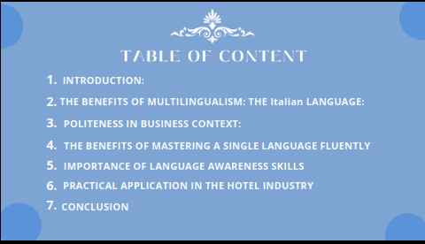
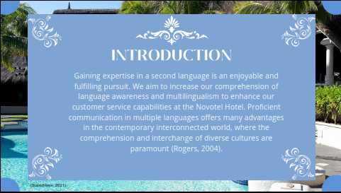
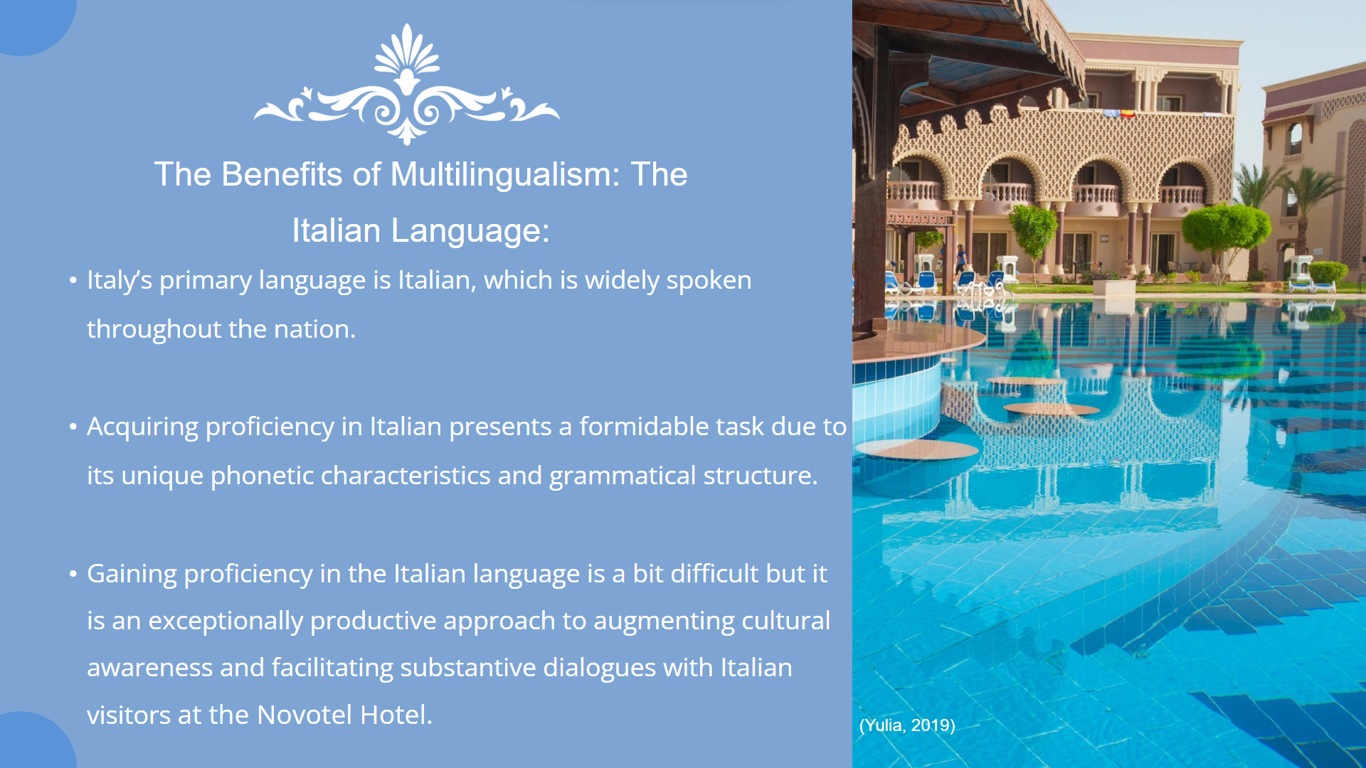
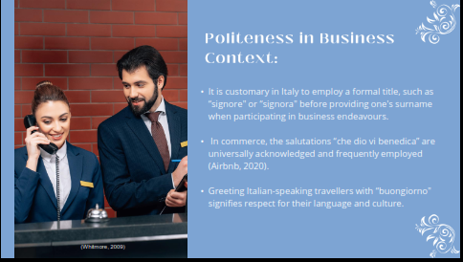

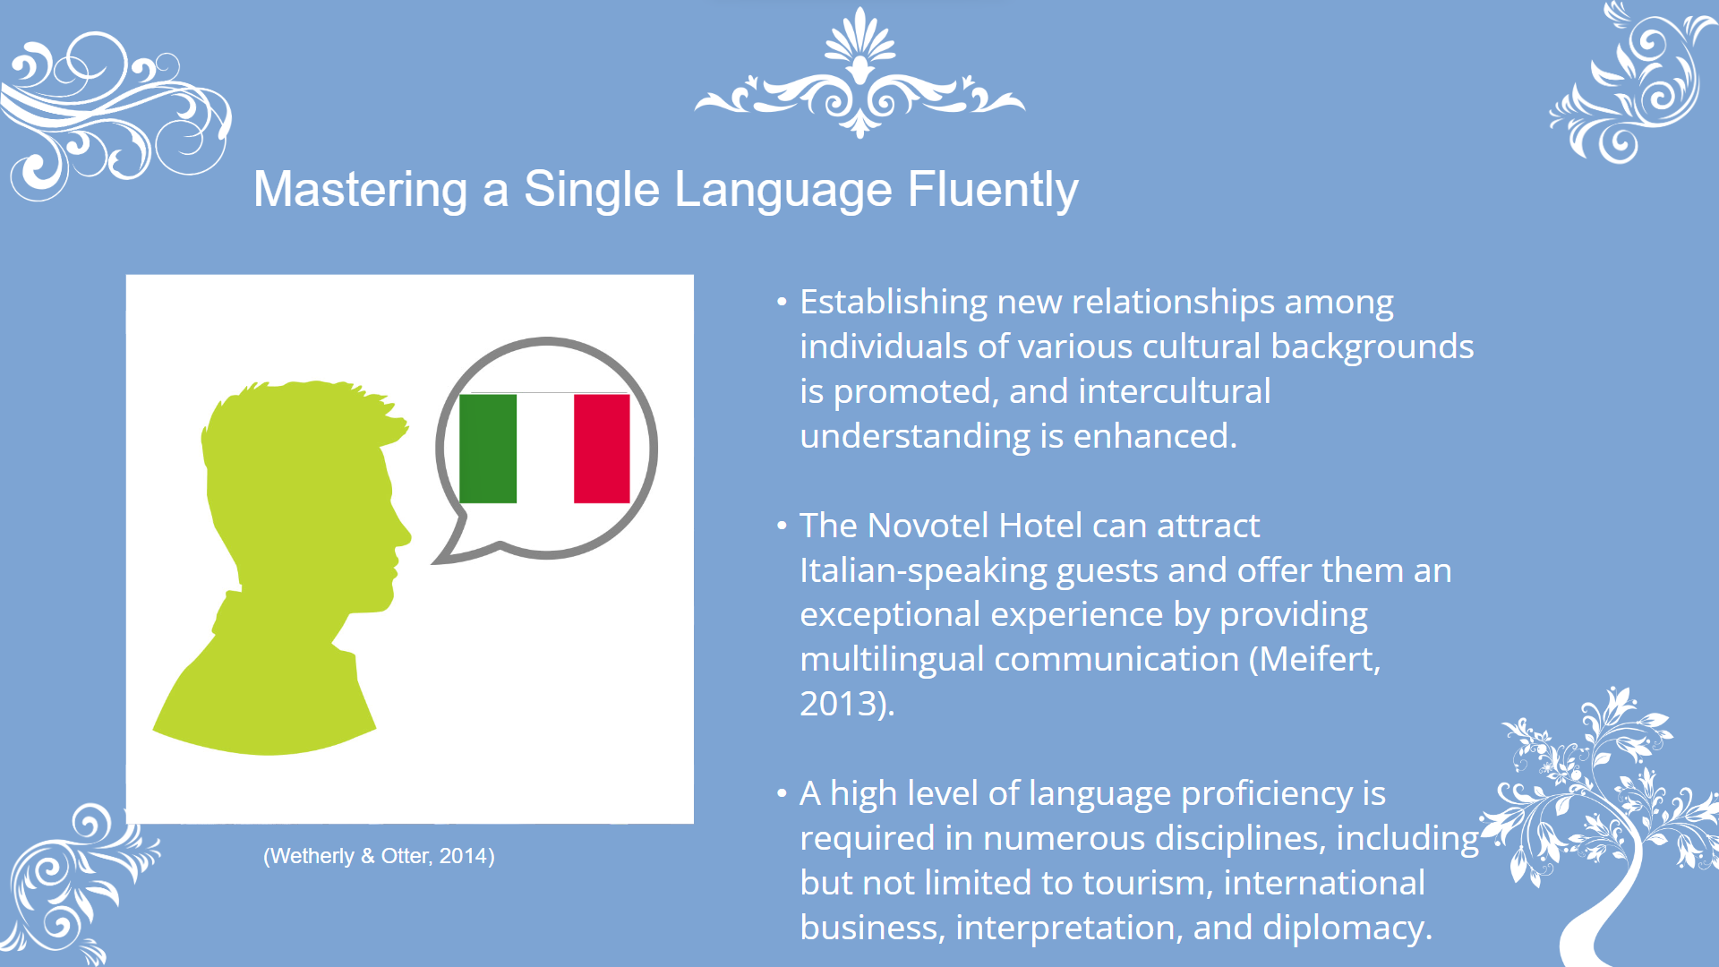
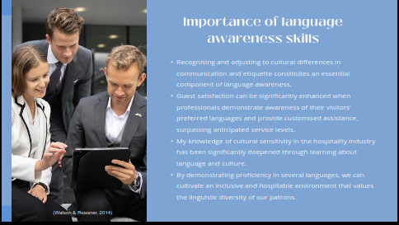

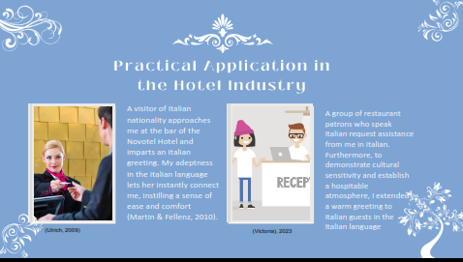
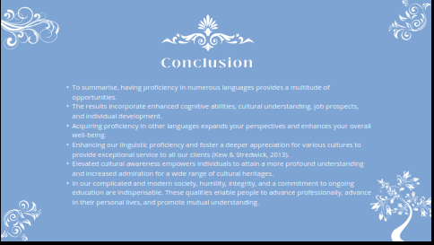
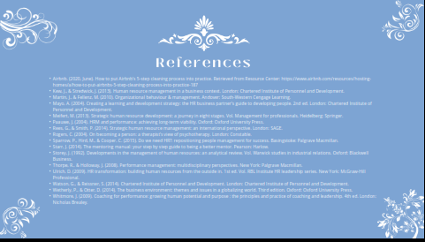


References
Airbnb. (2020, June). How to put Airbnb's 5-step cleaning process into practice. Retrieved from Resource Center: https://www.airbnb.com/resources/hosting-homes/a/how-to-put-airbnbs-5-step-cleaning-process-into-practice-187
Kew, J., & Stredwick, J. (2013). Human resource management in a business context. London: Chartered Institute of Personnel and Development.
Martin, J., & Fellenz, M. (2010). Organizational behaviour & management. Andover: South-Western Cengage Learning.
Mayo, A. (2004). Creating a learning and development strategy: the HR business partner’s guide to developing people. 2nd ed. London: Chartered Institute of Personnel and Development.
Meifert, M. (2013). Strategic human resource development: a journey in eight stages. Vol. Management for professionals. Heidelberg: Springer.
Paauwe, J. (2004). HRM and performance: achieving long-term viability. Oxford: Oxford University Press.
Rees, G., & Smith, P. (2014). Strategic human resource management: an international perspective. London: SAGE.
Rogers, C. (2004). On becoming a person: a therapist’s view of psychotherapy. London: Constable.
Sparrow, P., Hird, M., & Cooper, C. (2015). Do we need HR?: repositioning people management for success. Basingstoke: Palgrave Macmillan.
Starr, J. (2014). The mentoring manual: your step by step guide to being a better mentor. Pearson: Harlow.
Storey, J. (1992). Developments in the management of human resources: an analytical review. Vol. Warwick studies in industrial relations. Oxford: Blackwell Business.
Thorpe, R., & Holloway, J. (2008). Performance management: multidisciplinary perspectives. New York: Palgrave Macmillan.
Ulrich, D. (2009). HR transformation: building human resources from the outside in. 1st ed. Vol. RBL Institute HR leadership series. New York: McGraw-Hill Professional.
Watson, G., & Reissner, S. (2014). Chartered Institute of Personnel and Development. London: Chartered Institute of Personnel and Development.
Wetherly, P., & Otter, D. (2014). The business environment: themes and issues in a globalizing world. Third edition. Oxford: Oxford University Press.
Whitmore, J. (2009). Coaching for performance: growing human potential and purpose : the principles and practice of coaching and leadership. 4th ed. London: Nicholas Brealey.

