

ACS report

Student Name: Mohammed Thufyel khan
Student ID: 2024419461
Module Code: LCLM4001
Module: Academic Skills
Lecturer: Tim Hopkins

Table of Contents
1 Introduction 3
2 Description of Experiences 3
3 Analysis 4
4 Conclusion 4
5 References 5

1 Introduction

This report offers a reflection on my experiences throughout the term, with an emphasis on the skills, insights, and habits I developed over the first term.
Reflection is looking at your self or your experiences to learn from them (University of Sussex, 2025). The module combined technical practice, challenged my existing abilities and encouraged me to adopt more effective learning strategies. In particular, I improved my time management by balancing deadlines across multiple tasks and prioritising work based on urgency and complexity. The report will outline key experiences, examine their impact, and highlight how they have contributed to both my academic progress and professional growth. The reflection will focus on two specific examples – Time management and Paraphrasing.

2 Description of Experiences

During week 1 we learnt about time managment using all the different tequnicks and skills how to use time management. The included the Esisenhower Matrix, The 4 D Method and the Pomodoro Method. Managing the workload was a challenge, as the project ran alongside other academic commitments. I adopted a more structured approach to time management by creating weekly task lists, using calendar reminders, and setting intermediate milestones to avoid last-minute rushes. To help me learn about this we mad our own Eisenhower Matrix. (See image below).
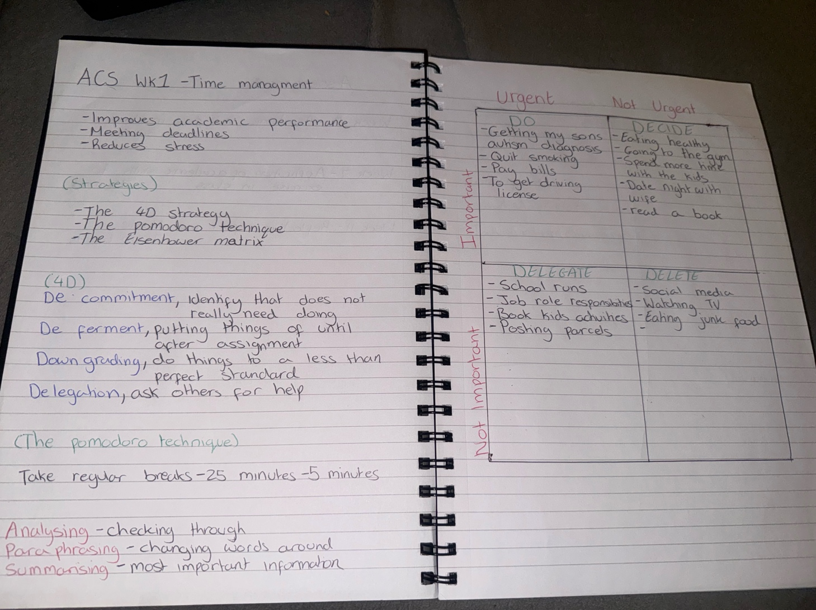

In week 4 and 5 we looked at Paraphrasing. We had to write a sentence about ourself and use a series of steps to make paraphrases. First we underlined the important information, then found synonyms for key words. Then we change the order of the words – for example moving the end of the sentence to the beginning. The we had longer sentences on the board to paraphrase. (See image below)

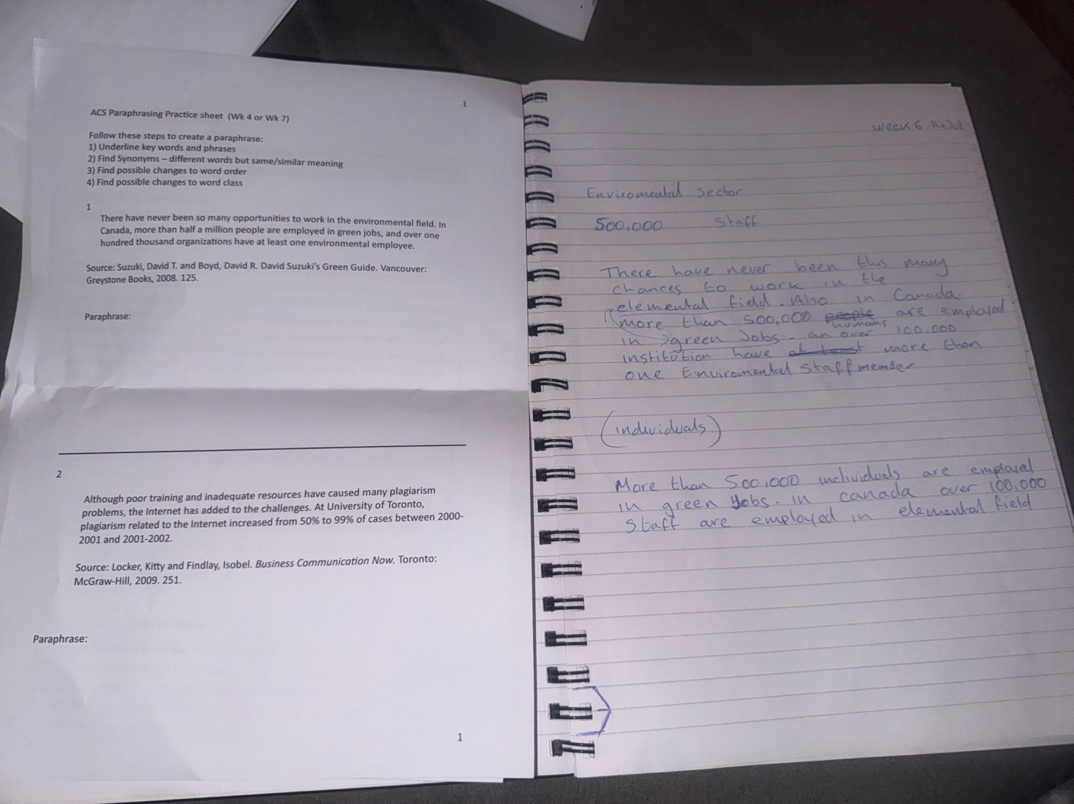

3 Personal Reflection
One of the most significant areas of personal growth during the term was improving my ability to manage time effectively. In the early stages, I often underestimated how difficult it would be learning about time mangment. By practising more frequently I adopted a more structured approach, using weekly planning tools and the Eisenhower Matrix to separate urgent tasks from important ones. This shift allowed me to allocate time more strategically, ensuring steady progress without leaving critical work until the last moment.

3.1 Evaluation
Using the Eisenhower Matrix has been useful, depending on thebsize of the task you need to make a decision about. Paraphrasing can also be useful, when you need to find a way to say things in your own words. It helps your understanding – you cannot paraphrase well without understanding the source.

3.2 Analysis
Time management is one of the most valuable skills anyone can have, both in personal and professional life. For me, it’s about more than just keeping a calendar or ticking tasks off a list—it’s about making the best use of my time so I can focus on what matters most. In today’s busy world, it’s easy to feel overwhelmed by constant demands, but having a clear plan helps me stay in control. Good time management means I can prioritise important tasks, avoid rushing at the last minute, and still produce quality work. It also reduces stress because I’m not constantly scrambling to meet deadlines. I’ve noticed that breaking big goals into smaller, manageable steps keeps me motivated and moving forward. It’s also important for balance—without planning, work could easily take over my life, leaving little time for rest, hobbies, or family. Employers value people who manage time well because it shows reliability, discipline, and independence. To me, time management isn’t just about doing more—it’s about doing the right things at the right time, without burning out. It takes practice and self-discipline, but the payoff is worth it: better productivity, less stress, and a stronger sense of control over my life.

Consider:
To improve my Time management I will use the different tools introduced in the class, depending on which is most useful in the situation I will use the different tools introduced in class, selecting the ones most useful for each situation. I will apply the Eisenhower Matrix to prioritize tasks based on urgency and importance, ensuring I focus on what truly matters. The Pomodoro Technique will help me maintain focus and productivity by working in 25-minute intervals with short breaks. I will also use the 4D Strategy—Do, Defer, Delegate, Delete—to make quick and effective decisions about managing tasks. By combining these strategies, I can work more efficiently, reduce stress, and consistently meet deadlines.
I’ve realised that paraphrasing is one of the most valuable skills I can develop as a student. It’s not just about swapping a few words around—it’s about fully understanding the material and then expressing it in my own words while keeping the meaning the same. Doing this helps me avoid plagiarism, but it also pushes me to think more deeply about what I’ve read. When I paraphrase, I have to break the information down, process it, and then rebuild it in a way that feels natural to me. This makes it easier to remember and connect with other ideas I’ve learned. It’s also great for making complicated or technical information easier to understand, which improves the clarity of my writing. In assignments, paraphrasing lets me use information from different sources without relying too much on direct quotes. Over time, it has helped me improve my vocabulary, sentence flow, and confidence when writing. I’ve come to see paraphrasing as more than just an academic requirement—it’s a skill that strengthens understanding, communication, and creativity. I know that continuing to practise it will make me a stronger writer, a more thoughtful learner, and a better communicator in both my studies and my future career.

4 Conclusion

Looking back at this module, I’ve realised just how important time management and paraphrasing skills are for my studies. Tools like the Eisenhower Matrix, Pomodoro Technique, and 4D Strategy have given me practical ways to organise my time, stay productive, and avoid unnecessary stress. Learning how to paraphrase effectively has helped me understand information better, avoid plagiarism, and express ideas clearly in my own words. Overall, these skills have boosted my confidence in handling my workload. I know they’ll be just as valuable in my future career and personal life, helping me stay focused, adaptable, and in control.

5 References

These should start on a new page. You should have 3-10 sources.

Univeristy of Sussex (2025) What is Reflection? Available at: https://www.sussex.ac.uk/skills-hub/writing-and-assessments/reflective-writing, (Accessed: 11 August 2025)

