Appendix AP2

REQUEST FOR AUTHORISED ABSENCE

Use this form to request any term-time leave from your programme of study. You do not need to apply for leave during vacation periods. Please read the guidance notes before completing the form.

PERSONAL DETAILS
Student Name: Mohammed Usman | Student ID Number: 1711892
UWTSD Email:
1711892@student.uwtsd.ac.uk

REQUESTED DATES FOR AUTHORISED ABSENCE:
From: 27th March 2019 To: 20th May 2019 TOTAL DAYS: 5

REASON FOR ABSENCE: (Please check the appropriate box )
Illness
Please provide a medical certificate or equivalent indicating the start and duration of the condition.
Bereavement (death of relative or close friend)
Please provide a death certificate.
Significant adverse personal circumstances
Please supply appropriate supporting independent evidence.

Use the space below to detail your request:

Ive been suffering from lower back pains following an injury sustained.

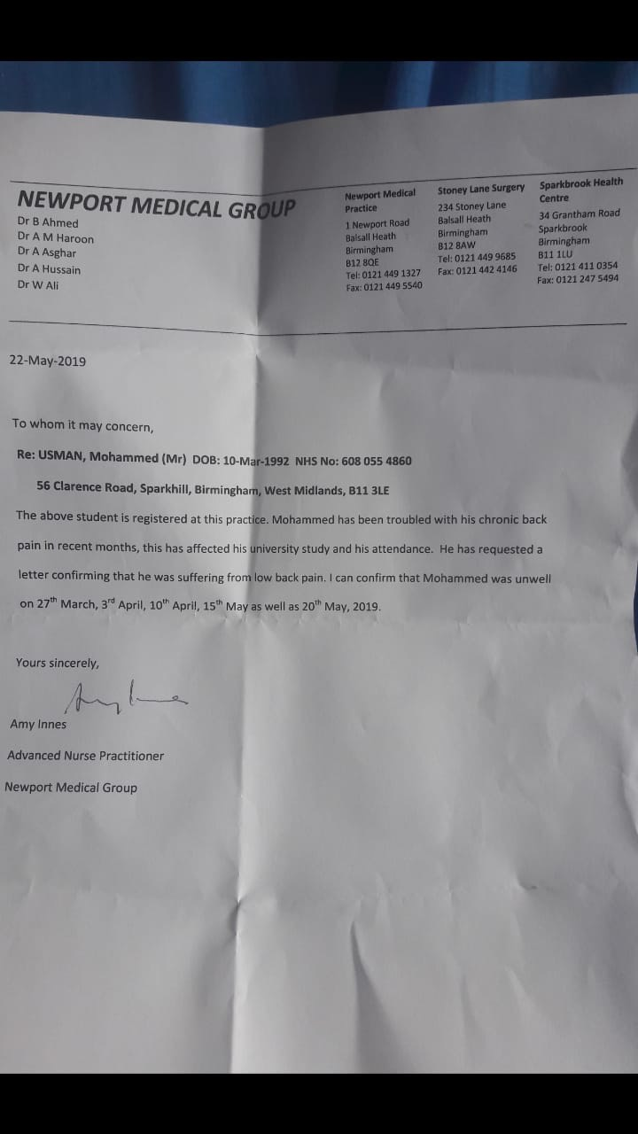

(this box will expand as you type or you may attach additional sheets)

Declaration: I understand that my request for leave can only be granted at the discretion of the University and that if my request is not granted then I will continue to attend classes and meet all my programme obligations as normal. I also understand that if my request is not granted and I don`t attend my classes it may contravene my visa conditions and I will be liable to disciplinary action as detailed in the University’s Attendance Policy. It is my responsibility to ensure that I am up-to-date with all programme learning commitments, including assessment. If my absence impacts my assessments, I recognize that any claim for extenuating circumstances must be considered through an application using Appendix GA1. I will discuss all course requirements affected by this absence with lecturer(s).

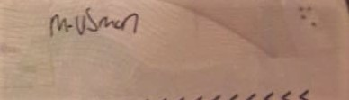
Student Signature: Date: 26/05/2019

NOTES FOR GUIDANCE IN COMPLETION OF THIS FORM
Under the conditions of the University of Wales Trinity Saint David Birmingham Learning Centre Attendance Policy, students must not exceed a 20% absence rate during term time. Any time that you are not present on the premises for your timetabled sessions during term time will count towards your 20% unless you apply for, and are granted, an ‘authorised absence’ from your studies.
The information below explains what you must do if you are unable to attend the University during term time.

Acceptable reasons for authorised absence(s)
If there is a need to apply for authorised absence there must be a valid reason supported by verifiable documentary evidence. Acceptable reasons for authorised absences include:
- serious illness or hospitalisation of yourself or a dependent;
- bereavement (immediate family); or
- Birth (immediate family).
Your studies are an opportunity and attendance is a critical requirement to assure the best-possible academic outcome for every student. You should therefore not ask for approval to be absent from teaching sessions during term-time for the purposes of tourist travel, religious occasions or social occasions (e.g. weddings). Students who make this type of request when teaching is occurring during term time should not be offended if a request is refused where it is felt that absence may significantly damage academic progress.

Documentary evidence
All requests must be supported by verifiable independent documentary evidence, which must include the relevant dates. It is not possible to provide a definitive list of all acceptable independent documentary evidence, but the following are typical examples of what may be acceptable, depending on the exact individual circumstances:
- a signed and dated letter from a medical practitioner, registered with the General Medical Council (GMC) confirming the illness and its anticipated duration – this would normally be on headed notepaper or equivalent;
- a letter or appointment card that confirms attendance at a dentist, doctor’s surgery, hospital or similar event;
- a copy of a Death or Birth Certificate; or
- a signed and dated letter from a coroner, legal practitioner, police officer, court official, minister of religion or other professional – this would normally be on headed notepaper or equivalent.

When to apply for authorised absence
For planned absence, this form should be submitted in advance of the requested period of absence (e.g. birth or emergency travel abroad). If your absence could not be foreseen, for example because of ill health or accident, ideally you (or, in an emergency, a friend/relative) should contact the Birmingham Learning Centre by email to inform them that you will be absent before the session(s) take place. You should submit the authorised absence request form and the supporting evidence on the first day that you return to classes. You must submit the request at the earliest opportunity to avoid triggering attendance disciplinary measures. No request for authorised absence will be accepted 3 weeks after the date of each absence, such requests will be regarded out of time and inadmissible.

Length of absence
You should use this form to seek written permission for short periods of absence in term time (usually no more than one or two weeks), for example when you are ill or to return home due to bereavement. Longer absences in term time require more detailed guidance, and in some cases may require an interruption (deferment) to your studies to the next term or semester. In such cases it is a requirement that you make an appointment to discuss the matter with Senior Student Services Officer in the first instance.

Assessment Submission
Being given an authorised absence does not exempt you from having to apply for extenuating circumstances relating to assessment submission, where appropriate.

Making your Leave of Absence Request
In the event of absence from your scheduled classes, you must email the Student Services team (birminghamstudentservices@uwtsd.ac.uk). Your contact will be acknowledged by email and you will be signposted to Moodle in order to complete the LOA form, along with the provision of documentary evidence.
You may submit your LOA form and evidence by email upon your return to campus. Please note that completion of an LOA form does not guarantee that your absence will be authorised. Upon receipt of paperwork, the Student Services team will review your request and you will receive an Outcome Slip confirming whether your absence has been authorised or whether it will count against your term attendance rate.

