Cheapo
Shada Jameel
MA Advertising

Table of Contents:

Chapter ……………………………………………………………………………………………. Page
List of Illustrations ………………………………………………………………………………... 3
Introduction ………………………………………………………………………………………….. 4
Chapter 1
Cheap labour is the best form of labour ………………………………………………… 6
Chapter 2
The T-shirt Shop Named Cheapo …………………………………………………………… 11
Conclusion …………………………………………………………………………………………….. 29
Bibliography …………………………………………………………………………………………… 31

List of illustrations:

Figure 1: The Guardian, 2013. Dhaka: many dead as garment factory building that supplied west collapses [Picture]
Figure 2: Shada Jameel, 2022. Cheapo store exhibition. [Picture]
Figure 3: A Streetcar Named Desire, 1951. [picture]
Figure 4: Fashion textiles museum blog, 2021. Exhibition Archives: T-shirt: Cult – Culture – Subversion. [Picture]
Figure 5: Vogue, 2017. Katharine Hamnett, London’s Activist Fashion Warrior, Is Back with a Sustainable Buy-Now Collection [picture]
Figure 6: The Guardian, 2016. Maria Grazia Chiuri's Dior debut spells out her feminist message [picture]
Figure 7: Shada Jameel, 2022. Cheapo Store exhibition. [Picture]
Figure 8: Susan Barnett, 2015. Not in your face. [Picture]
Figure 9: Prettylittlething, n.d. Your pretty little thing t-shirt dress. [Picture]
Figure 10: Shada Jameel, 2022. Cheapo store t-shirts. [Picture]
Figure 11: Shada Jameel, 2022. Cheapo store banner. [Picture]

Introduction:

In the 15th and 16th century, the development of advertising began with prints. In the 17th century it emerged in weekly newspapers and continued to grow to TV adverts, posters, radio, magazines and even window shop displays. In the digital age, our communications techniques have developed widely through technology (Joshi, 2022).

Contemporary advertising has enhanced and improved their tools and techniques to understand consumers’ behaviours and desires. This is through data collection, different methods used are, surveys, interviews, yearly sales documents, and web-based data tracker analysis e.g., Google analytics. Companies have refined their method to motivate the consumer to purchase products purely out of desire and not necessity (Goworek, 2020).

This praxis will explore the fast fashion industry as one of the highest over-consumptive industries. This will also include the drive of consumer behaviours to over consume with the knowledge of its negative impact on the environment, the use of cheap labour and the use of child labour including the unsafe working environment. It will also examine the continuing increase of production demands.

The praxis is heavily influenced by postmodernism characteristics such as pop art, anti-design, re-appropriation, and culture jamming. This is explored in detail in chapter 2 in relation to the fast fashion and the concept of the praxis.

The praxis is inspired by the work of fashion designers and artists such as Katharine Hamnett, Susan A. Barnett, and Vivienne Westwood. I also examine the theory of commodity fetishism by Marx’s in relation to fast fashion and the overconsumption behaviours. It is the key in examining the consumer behaviours to material products when the products are “given a very high and desirable symbolic value in society” (BusinessToday, 2022).
To understand the consumer behaviours, the praxis will begin by evaluating and assessing fast fashion and its impact on the environment and the garment workers.

Chapter 1
Cheap labour is the best form of labour

Fast fashion is a manufacturing and marketing industry that is centred around producing high volumes of clothing. It takes advantage of trends by producing affordable, mass replication and low-quality products to fuel the consumers hedonic over consumptive behaviour (Stanton, 2022).

According to Bethan Alexander senior lecturer at London College of Fashion, the concept of high street fashion was discovered in the 1870s in the UK. Bethan (2020) explains:
…one could argue that the UK was a pioneer of fast fashion, because of the innovation seen within manufacturing method back in 1800s with Arkwright’s spinning innovations, which shifted to garment making with the industrial revolution (O’Neill, 2020).

In the 20th century, the fast fashion industry gained extreme popularity among consumers. Bethan (2020) continues:
It was only after World War 2 that consumers became more receptive to the value of purchasing mass- produced clothing. This coincided with the creation of many fast fashion retail companies, like H&M, Zara, Topshop, Primark, which were all launched between 1947 and 1969 – and all focused on low- priced, trendy clothing. Mass production and mass consumerism – as well as mass marketing communications – took off in the 1950s, which triggered a shift in manufacturing to off-shore factories, which were more competitive on price, to enable even lower prices (O’Neill, 2020).

Fast fashion has created an economic growth, by being affordable and accessible for many consumers. The phenomena has caused an extensive amount of damage and problematic issues to the environment, exploiting workers and encouraging child labour. The affordable and low prices of clothing suggests that the materials used to produce the clothing items are also inexpensive e.g., the textiles used, chemical dye, and manufacturing techniques. This also encourages companies to work with low- priced suppliers which some companies fail to inspect the working conditions and safety for the garment workers. In the UK, around 1.2million tonnes of used and unused garments are thrown in landfills, where most of them are burnt or buried each year. Most of the unused garments are unsold items that are disposed by retailers and manufacturers (A. Lawson, 2020).

Sustainable luxury fashion designer Stella McCartney described the disturbing amount of waste from the fast fashion industry to be:
…equivalent of one garbage truck of textiles is burned or landfilled every second and right now, less than 1% of material used to produce clothing is recycled into new clothing, meaning 99% of all textiles and fashion are waste… that’s about
100 billion dollars’ worth of materials wasted each year. (A.Lawson, 2020).

The industry is also powered by cheap labour, to produce high profits with low production price. Over the years, the low production costs and low-quality working conditions has led to terrible disasters in garment factories. In 2005, a garment factory collapsed in Bangladesh, this incident killed 64 workers and injured more than 100 workers. In 2010, another factory in Bangladesh caught on fire due to the emergency exists being blocked by an excessive number of garments. The fire killed 26 workers and injured more than 100 workers. Another factory caught fire 2012 killing 112 workers and injured more than 150 workers. In 2013, the most catastrophic incident was the collapse Rana Plaza building in Bangladesh, killing 1,138 workers, and injured 2,600 people. The Rana Plaza was a factory who was famously known for supplying to the Canadian brand Joe Fresh and amongst others, the factory has manufactured for the UK’s well known fast fashion brand Primark and the Italian international fast fashion brand Benetton (Connor, 2014). This incident has exposed the dangers and poor conditions of the underpaid garment workers that are forced to work in. It is also an estimate of 1.4 million worker who were injured in the garment factories each year. Brands manage their factories through subcontractors to avoid liability and eliminate the responsibility to improve working conditions (Bynum, 2021).
The incident has had companies who have worked with the Rana Plaza like Benetton who donated 1 million dollars (Smithers, 2015). According to Primark official website, they have also donated 14 million dollars to towards the victims and their families (Primark, n.d.).

Since the incident of Rana Plaza, over 200 brands globally which includes brands like H&M, Zara, and Adidas, have been presented with a legally binding contract to ensure that garment workers safety in garment factories. This has resulted in 38,000 inspections in 1,600 factories covering two million workers since 2013 (Chan, 2021).



Fig 1: The Guardian, 2013. Dhaka: many dead as garment factory building that supplied west collapses [Picture]

The concept of using t-shirts for the praxis with absurd and ridiculous slogans printed on the back, reflects on the low wage, child labour and unsafe working environment of fast fashion. A small space was constructed to imitate a classic t-shirt store which was named Cheapo. 24 T-shirts were attached to the wall for display and to promote to the audience for purchase. The t-shirts were sold for £2.50 to imitate the fast fashion brands. Some stores like Primark, Bohoo, Missguided and H&M, retail their items from £1 which raises the question of how much profit is generated on these items and how much are they sold for by suppliers to companies and how low are the garment workers’ wages are. Although, the concept is imitating fast fashion brands by selling mass produced garments for low price, I will be donating all the money generated from the products to UNICEF. This will be helping children across countries where child labour is endemic (Wood, 2019).

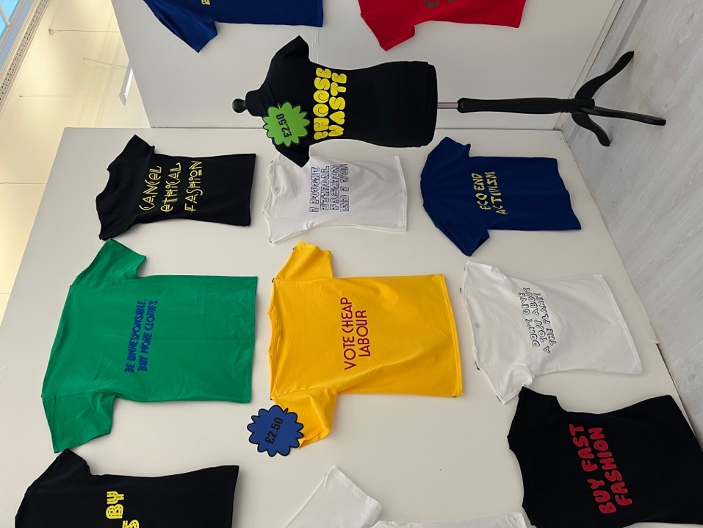
Fig 2: Shada Jameel, 2022. Cheapo store exhibition. [Picture]

According to Pietz (1988), a historian and political activist: “[M]aterial objects turned into commodities conceal exploitative social relations, displacing value-consciousness from the true productive movement of social labour to the apparent movement of market prices and forces”. (Nyfeler, 2012).

In 2016, 38 people were accused and convicted for murder in garment factories in Bangladesh. Child labour has increased and has become a widespread issue in Bangladesh. The work, the workers do in the fast fashion factories is referred to “supply chain slavery”. Majority of the employees of these factories are women, immigrants, and children. The industry is making trillions, but the struggle is for the workers that are on very low wage. There has been reports of bullying and abuse verbally and physically, mainly towards women workers. Tereza Kuldova says that “the fashion industry is one in which there is a “Structural violence” — of rights, humanity, and individuality” (Sachdeva, 2017).

Although, statistics show there is a decline in child labour between 2000 and 2012 (The Guardian, 2017), however between 2013 and 2017 there was an increase of 8.4million (UN News, 2021). 2021 figures have shown that 160 million children in poverty areas have no right to be children. They don’t have access to education and proper food (Baruta, 2021).

Chapter 2
The T-shirt Shop Named Cheapo

For this praxis, the preferred item of clothing to print the slogans were t-shirts due to the repetition it has throughout history. T-shirts started as an item of underwear to be worn under shirts. In the 19th century, t-shirts emerged when Labourers in America started to cut their jumpsuits in half to cope with the heat during work. In 1913, they became a standard item of clothing in the US Navy’s uniform (Galore, 2022).

Scott Fitzgerald was to first name the garment in his novel, This Side of Paradise (1920). Marlon Brando and James Dean made t-shirts desirable as a piece of clothing on its own in 1950’s through the Hollywood movies, A Streetcar Named Desire (1947) and Rebel Without a Cause (1955). The T-shirt became a symbol of masculinity and associated with movement of rebellion. This perception of it being associated with the rebellious movement is the reason it is believed that the t-shirts were the appropriate item of clothing to carry the ironic messages (Galore, 2022).
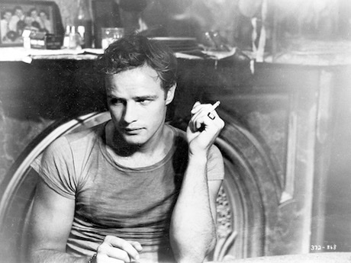
Figure 3: A Streetcar Named Desire, 1951. [picture]
“It was rebellious because T-shirts were undergarments … It was a tough political statement,” says Dennis Nothdruft, curator of the exhibition titled T-shirt: Cult — Culture — Subversion, which was exhibited at the Fashion and Textile Museum in London (Harris, n.d.).

The T-shirt: Cult – Culture – Subversion exhibition featured a collection of Vivienne Westwood’s t-shirt designs, from the styles from her Kings Road boutique in Chelsea. Westwood is a British fashion designer who is responsible in shaping modern punk scene in the 1970’s (Hawkins, 2018). She expressed her punk fashion phenomenon as “seeing if one could put a spoke in the system” (Artists of assange, n.d.).

They also featured her modern ‘Climate Revolution’ messages from her environmental outlook of today. They also displayed, Henry Holland, a British fashion designer who is recognised for his recycled slogan design t-shirts, Jeremy Deller, an English artist his slogan T-shirts like “My Drug Shame” and “My Booze hell” were also showcased including Katherine Hamnett, a British fashion designer and activist who has her famous slogan t-shirt “Choose Life”. The inspiration of re-appropriating the slogans of the t-shirts used for the praxis like “Choose Waste” developed from the designer, Katherine Hamnett (Hawkins, 2018).

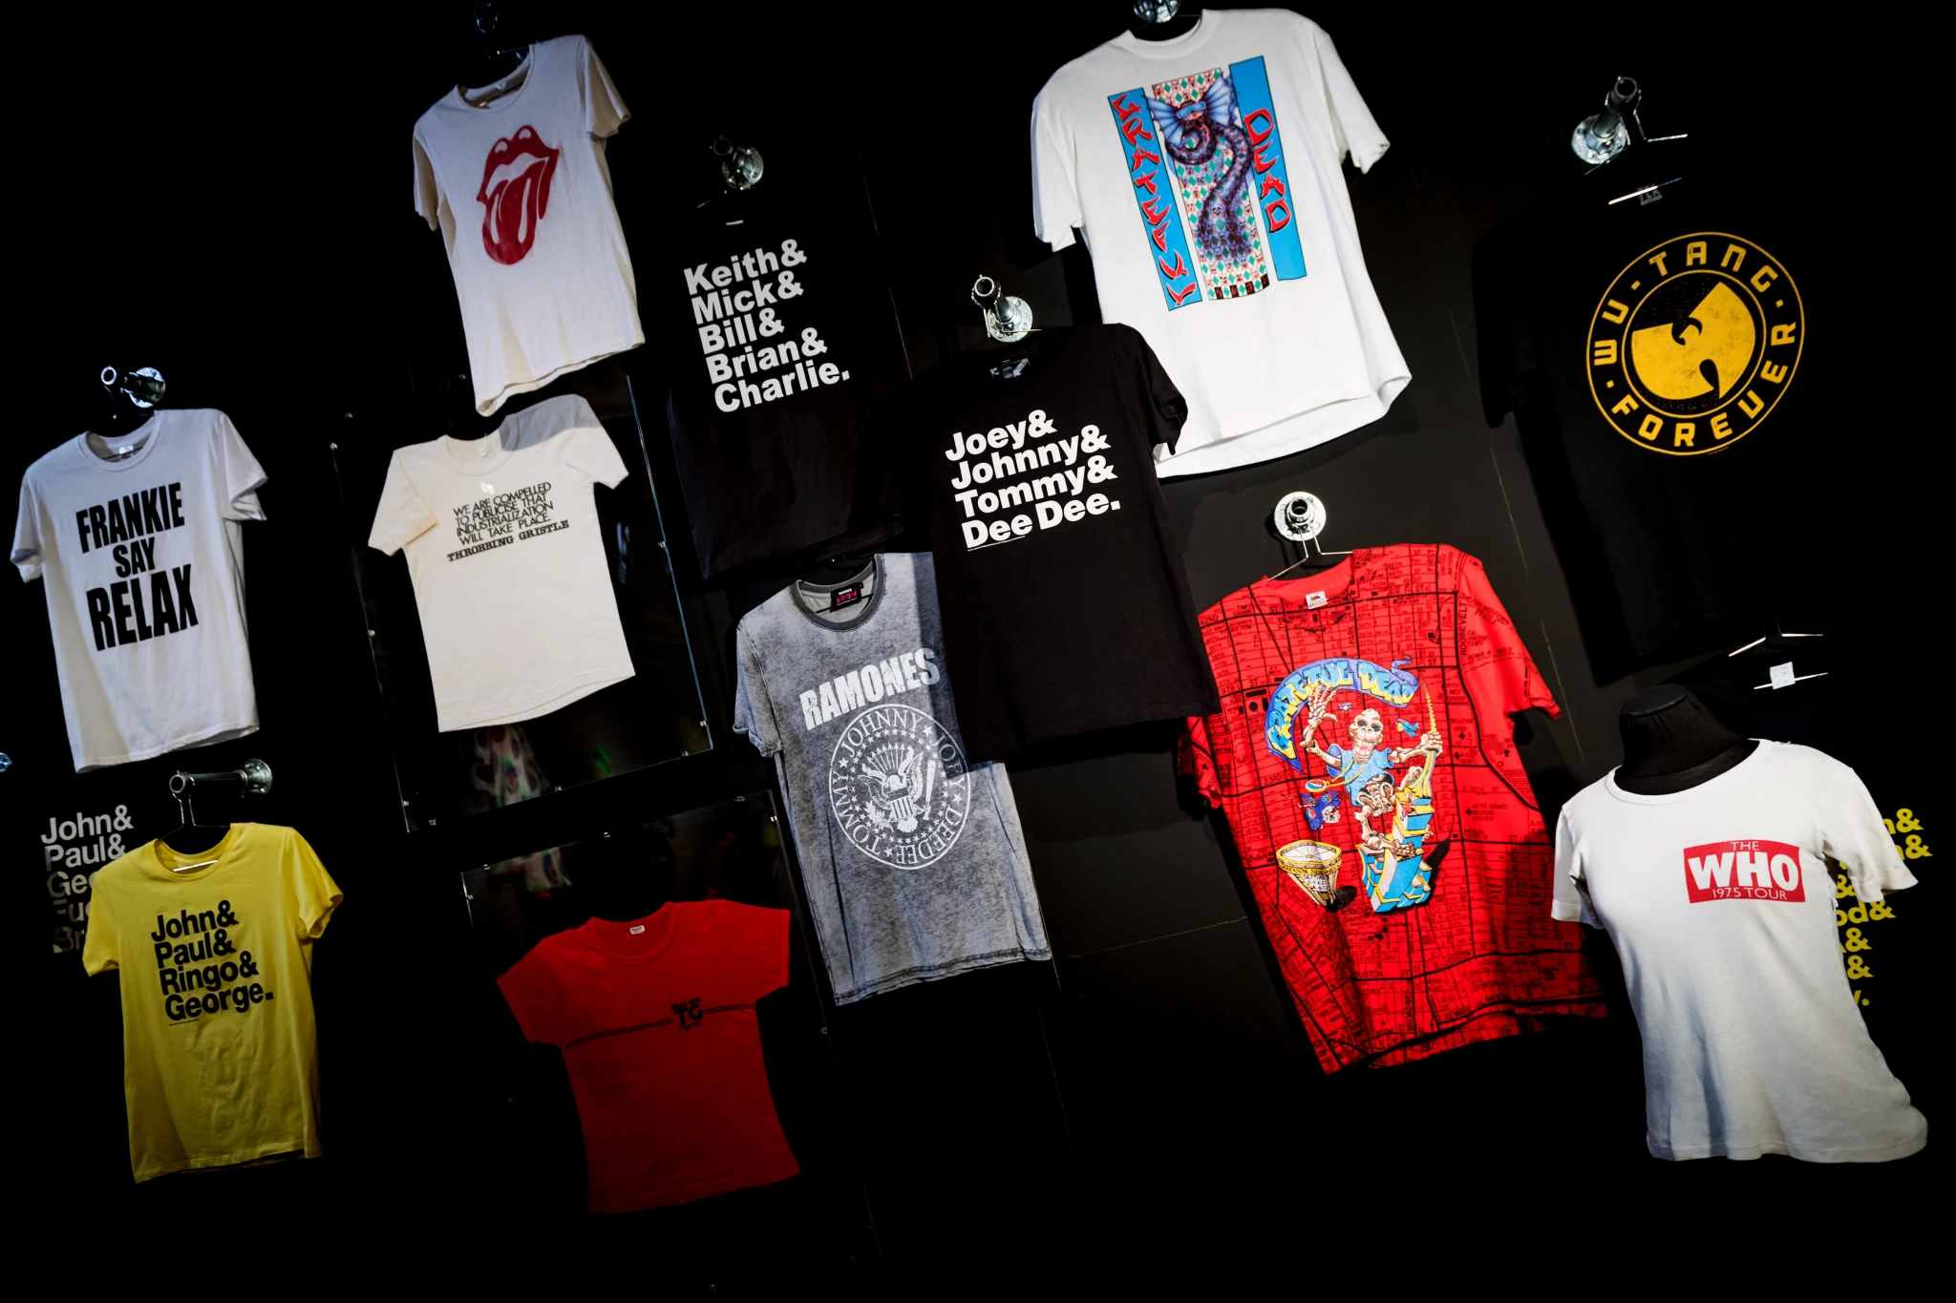

Fig 4: Fashion textiles museum blog, 2021. Exhibition Archives: T-shirt: Cult – Culture – Subversion. [Picture]

Although, t-shirt printing started to make an appearance in the 1950s and 1960s, in 1970s t-shirts became a powerful messaging platform that we are aware of it today. It was the punk movement that developed it into a form of self-expression. It rose in popularity due to the rock band logos that were printed on t-shirts and protesting for the Vietnam war with messages printed on t-shirts (Harris, n.d.). In 1984, Katharine E. Hamnett, wore a t-shirt with a message on anti- nuclear war when she met British Prime minister then, Margaret Thatcher (Galore, 2022).

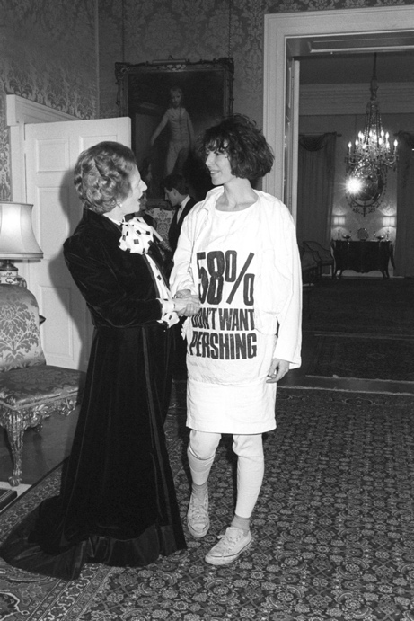

Fig 5: Vogue, 2017. Katharine Hamnett, London’s Activist Fashion Warrior, Is Back with a Sustainable Buy-Now Collection [picture]

Nothdruft explained:
It was about shocking and outraging people and challenging the status quo…. blank canvas (t-shirts) … that associates you with specific cultural movement or tribe. In its most pure form, it’s the most democratic garment (Harris, n.d.)

T-shirts have become the silent voice. It is popular amongst activists and movements especially, feminism. Christian Dior, a French luxury fashion brand and Jonathan Simkhai, an American fashion designer created a t-shirt with the phrases, ‘we should be feminists’ and ‘feminist AF’. Celebrities who support the feminism movement were spotted wearing the t-shirts, like Emily Ratajkowski, an American model and actress (Glamour, 2020).
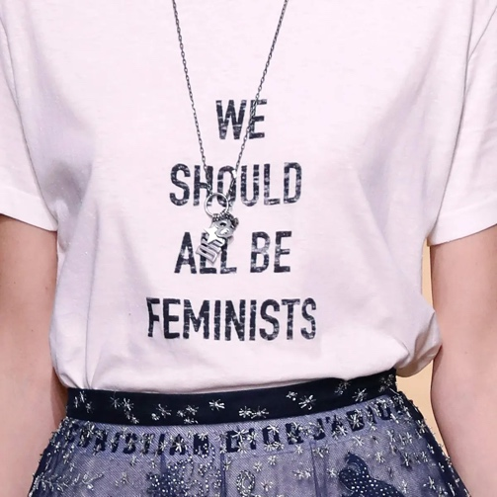

Fig 6: The Guardian, 2016. Maria Grazia Chiuri's Dior debut spells out her feminist message [picture]

The language used on the t-shirts for this praxis were printed to be ironic to the audience and they were also created in a kitschy style typefaces and colourful fonts. The concept of the ironic messages is to demonstrate the consumers beliefs when wearing fast fashion garments, the difference between fast fashion t-shirts that are purchased directly from stores and the t-shirts exhibited for this praxis is that it openly relays the problems of fast fashion in a contradictory manner.
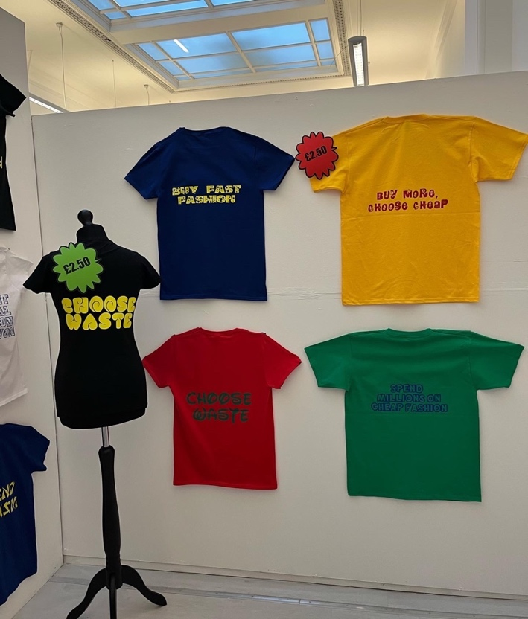
Fig 7: Shada Jameel, 2022. Cheapo Store exhibition. [Picture]
Susan Barnett, a fine art photographer (2009) explored the concept of graphic t-shirts in her work of T: A Typology of T-shirts book. In her work, she suggests that her photography is not about the t-shirts prints and slogans but about “self-identity and validation”. Each of individuals revealed a part of themselves by promoting their “hopes, ideals, likes, dislikes, political views and personal mantras”. It is described as a ‘badge of honour’ for the individuals to voice their belief’s “yes, I belong to this group, not the other” (Barnett, 2009).
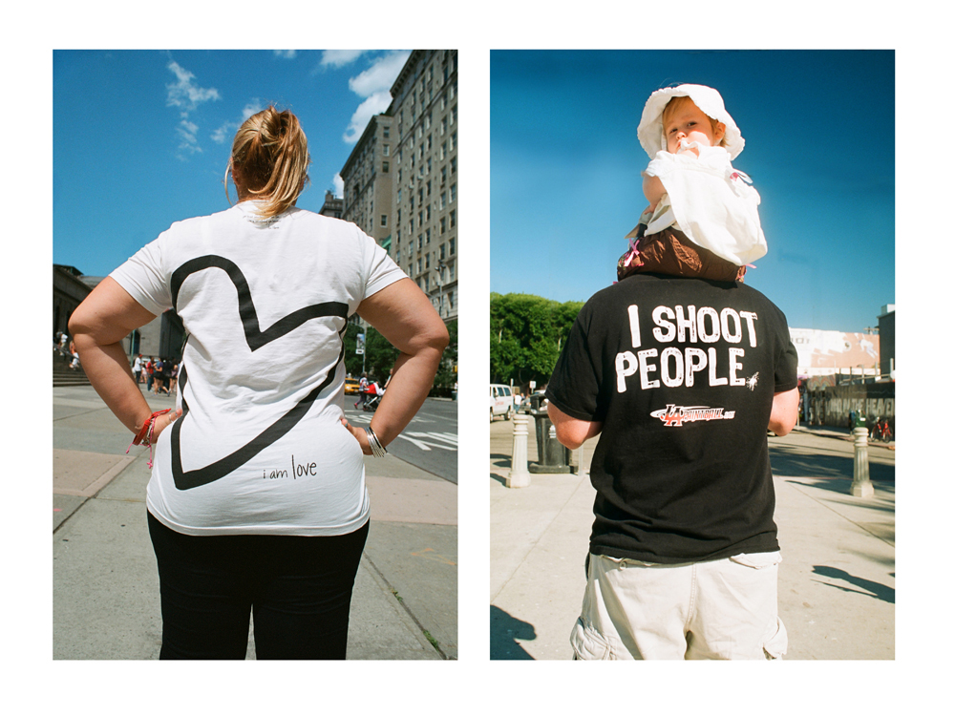
Fig 8: Susan Barnett, 2015. Not in your face. [Picture]

Barnett explains photographing the individuals from the back challenges the traditions of a portrait of the face and examines us as an audience of the “body type, dress, demeanour and their facial expression might be”. The concept of willing to wear a t-shirt with a message of the wearer’s beliefs on their back connotes that these individuals want to be seen (Barnett, 2009).

Graphic and slogan t-shirts are still used by activists and protestors to portray their philosophy and thoughts on certain subjects like politics or environmental issues. The subversive t-shirts designed for the praxis highlights the negative identity traits of the wearer e.g. “I don’t give a toss about the planet”. Barnett explanation of having the messages printed at the back challenges the traditional concept of the print being at the front of the t-shirt. This is where the inspiration behind the concept of the Cheapo t-shirts occurred. The decision to have them printed at the back challenges the wearer to reveal their negative traits and beliefs on fast fashion. As consumers, we purchase garments made in countries like Bangladesh, Indonesia, and Cambodia, with the knowledge that these clothing could have been made in low quality working condition and by low paid garment workers. Although, the pieces of garments that we purchase on weekly or monthly basis don’t highlight the issues clearly in a message but on the contrary, we are carrying those messages on ourselves when wearing those fast fashion brands, the difference is it’s not visible.

For the exhibition, 24 t-shirts were fixed to the wall and 6 were displayed on mannequins. The mannequins were used to display clearly, that the messages were printed at the back of the t-shirts. The individual highlighting their negative traits to the audience with the lack of knowledge of the wearer e.g., gender, race, and facial expression. It gives the audience a sense of the wearer self-assurance and self-confidence about the messages they are conveying about their identity and beliefs. This concept operates on postmodern level by using the method of fast fashion marketing. Low-cost t-shirts are produced by fast fashion brands to promote individuals’ identity or their own brand by printing their own logos however, this praxis uses fast fashion brands promoting skills to undermine the industry, in an ironic approach.
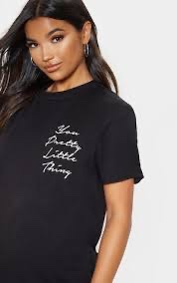
Fig 9: Prettylittlething, n.d. Your pretty little thing t-shirt dress. [Picture]

The print used on the t-shirts for the slogans are kitsch, tasteless and playful designs, and fonts. They have a dramatic, futuristic curves and bubble font typeface with rounded letterforms. Other typefaces used, were Disney’s logotype and Graffiti style typeface which is also considered as one of the symptoms of postmodernism. Other characteristics of postmodern in graphic design have been identified as “retro, techno, punk, grunge, beach, parody, and pastiche were all conspicuous trends. Each had its own sites and venues, detractors, and advocates” (Drucker, 2008).
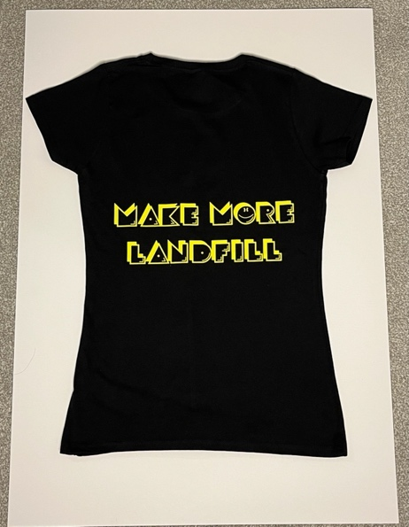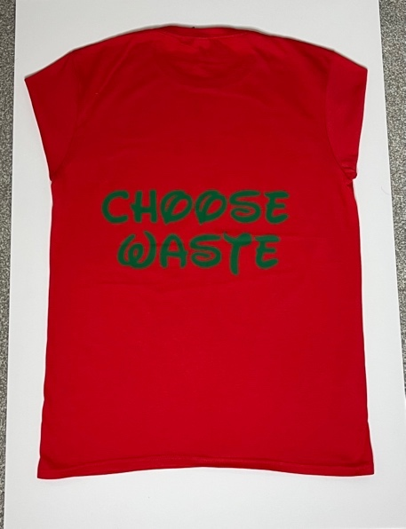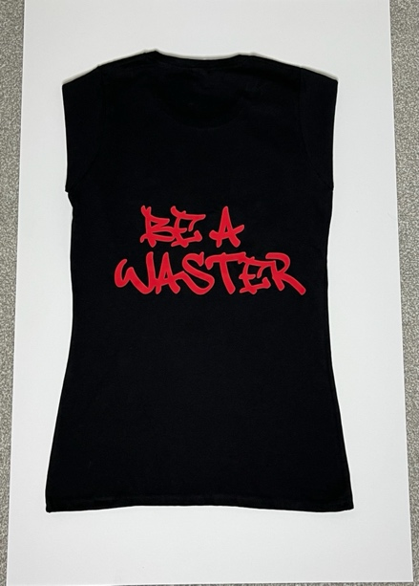
Fig 10: Shada Jameel, 2022. Cheapo store t-shirts. [Picture]
Postmodernism is a philosophical attitude or style of dialog which challenges a viewpoint associated with explanation of logic which dates to the 17th century; however, it became a critical theory in the 1960s. Postmodernism is associated with challenging beliefs and a focus on the grand narratives in the maintenance of economic and political power. It argues that there is no actual truth, but the truth is created by society. It explains that the information that we are given is invented by society (Duignan, 2016).

Postmodernism is a form of reaction and expression. The traits of postmodernism in art and design are parody and pastiche, it is common in postmodern expression. The t-shirts fonts that are considered absurd in nature. This is to create a reaction and an expression that challenges current situation in the fast fashion industry.

Postmodernism is the one of the most provocative movements in art and design history. From 1970- 1990, It has destroyed the conventional designs and ideas of art through self-awareness about design itself. In the 1970s the extreme movement of post modernism begun and continued into the 1980s where it became the leading look for the ‘designer decade’. Most art and fashion designs used bright colours, theatrical and exaggerated style statements. This new phase was distributed mainly by magazines and music (V&A, 2011)

Most postmodern typography designs are personal and bias and are practiced by many individual style designers. These styles include a wide range different typefaces challenging the traditional rules of “hierarchy and composition” including the “layering and overlapping” of typography, which is evident in the praxis (Hass, n.d.).

Culture jamming is another concept which is related to this praxis. It is also known as guerrilla communication, it is a method used to protest by many different movements in particular, anti-consumerism movement. This method is used in attempt to disturb and undermine the ‘media culture’ and its ‘mainstream cultural institutions’, in effort to “expose the methods of domination” (Binay, 2005).

Culture jamming is a type of disorder that plays with the audience’s emotions. It is used to interrupt the unconscious though process of the viewer and stir up a type of reaction from them. The use of slogan’s like ‘Choose Life’ by Katherine Hamnett and re-appropriating it to ‘Choose Waste’ in a Disney logotype, using a typeface that is associated with fairy-tale princess characters, sensational and thrilling experience with an ironic message evoke a type of behavioural change within the consumers and audience (Summer- Effler, 2002).

The definition of reappropriation is the reclaiming of the word that once perceived socially inappropriate, belittling, and negative, brought back into an acceptable usage. This starts from the original target of the word was used on (Brontsema, 2004).

The levelling of high and low culture in art is a postmodern characteristic. This notion of good taste and bad taste is broken down by irony. Kitsch arises when both cultures are blurred or broken down, which forms a combination of both cultures. The combination of both cultures does not always result in kitschy art. Kitsch does not have to be a combination of both cultures; it just simply suggests the piece of work is just tasteless. This is ironically appreciated because of its low and tasteless qualities which is often related to nostalgia (Eden, 2018).

The concept of a t-shirt store was to have a low and tasteless qualities, as part of the settings of the store, I decided to play tasteless pop music style was music. The playlist included pop artists of the 1980s and 1990s e.g., Madonna Like a Virgin, Britney Spears Oops… I did it again and Aqua Barbie girl. It was claimed previously that background music stores had an effect of encouraging consumers buying habits (Parkinson 2016).

In addition, I dressed as a store sales assistant with a poor choice and taste in clothing, with a t-shirt that displays the message “I am a hypocrite”. As part of the store décor, a banner was designed for the entrance with characteristics of pop art, which are explained by Richard Hamilton (1957) as, “Popular (designed for a mass audience), Transient (short-term solution) …Low cost… Young… Witty, and Gimmicky”. The colours used for the banner were bright and vibrant colours. Pop arts primary colours are red and yellow as they were the most prominent colours used in the famous work of the artists Roy Lichtenstein (Tate, n.d.).

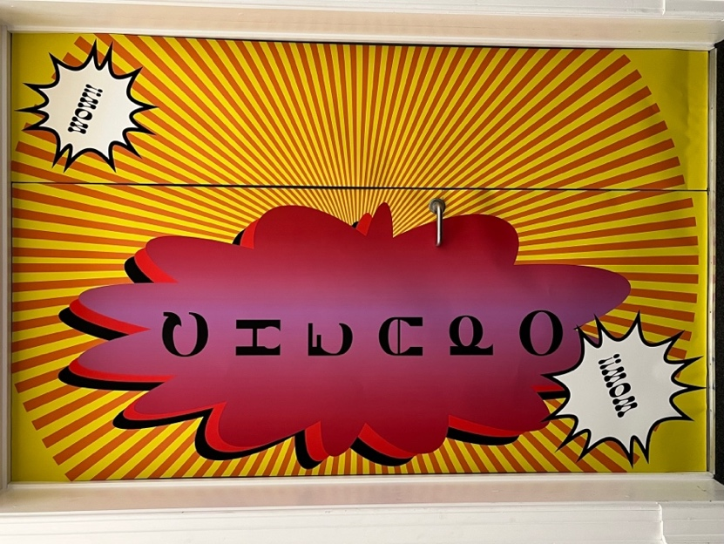
Fig 11: Shada Jameel, 2022. Cheapo store banner. [Picture]

Pop art is an art movement that began in mid 1950s in the UK. The movement was a rebellious challenge towards the traditional fine arts that were presented in museums. It was seen as the first indicator to postmodernism. Pop art uses images from popular culture to stress on the dull and kitschy elements of the culture through the sense of irony. It takes inspirations from Hollywood movies, advertising, pop music comic books and other forms of popular culture (Tate, n.d.).

Pop artists aim is to change the perception of art. It breaks down the boundaries between “high art” and “low art” in popular culture. The concept is that there is no hierarchy of culture (Eden Gallery, 2021).

Another movement that relates to the praxis is anti-design. Anti-design is the opposite of design, it rules out everything that design stands for. It is a rebellious and unconventional way of design which is created intentionally to challenge the stereotypical rules and layout of design. It creates an entirely unusual and creative but practical designs. Anti- design movement started in Italy late 1960s, also known as Radical Design movement. It began as a response to the “industrial design, architecture, furniture, and décor”. It trickled down to fashion, art, and food (Khode, 2022).

Some of the anti-design’s examples are, “colour palettes that clash, misalignment and asymmetry, overlapping imagery and text, no grids, or layouts, mismatched and crowded elements and unclear typography”. This was evident on the t-shirts with clashing of colours e.g., bright red/vibrant green and black/yellow. In the 90s, anti-designs trends were extremely evident, it became even more fashionable especially when the internet and Photoshop was developed. The music and entertainment industry also encouraged the trend through like, “movies like Austin Powers with the groovy fonts and flower power for their poster to rave culture, including the neon colours use and the distorted designs used in their flyers” (Khode, 2022).

Anti-design incorporates many “exaggerated and expressive qualities”, for the purpose of challenging the practical value of an object or design. Anti-design initiated the vivid and bold colours, including incorporating the embellishment and decorations. It is also considered “kitsch, irony and distorted” designs (Martinique, 2006).

The idea of the t-shirts being printed by the t-shirt print store is also considered as anti-design. This also relates to concept of ‘readymade’ which was discovered in April 1917 by Marcel Duchamp. The notion of ‘readymade’ objects is considered a work of art by re-adjusting, re-modifying and reassess its use. In 1917 Duchamp submitted an artwork as an anonymous artist to the ‘Society of Independent Artists salon’ in New York which stated if the artist paid the application fee, they were prepared to accept any form of work of art. The artwork submitted was a signed upside down urinal and dated with the name “R.Mutt, 1917,” and labelled “Fountain”. The board rejected the “Fountain” and claimed it was not “a true work of art”. Duchamp at the time was part of the board and resigned in protest later (Mann, 2017).

Artist Beatrice Wood stated, “Whether Mr Mutt with his own hands made the fountain or not has no importance. He CHOSE it. He took an ordinary article of life, placed it so that its useful significance disappeared under the new title and point of view—created a new thought for that object” (Mann, 2017)

For years, Duchamp has defended the use of “ready-made” and “existing objects” that are utilised in everyday life. The idea is that “art is primarily a concept and not an object” is what makes the Fountain a fascinated piece of art. This relates to the idea of the praxis, where taking readymade t-shirts and using t-shirt print shop to produce the prints on the clothing and later placing them in an art exhibition presents a different concept to the t-shirts. They are now considered to be art pieces (Mann, 2017).

Chapter 3
Consumer behaviour

Karl Marx, a German philosopher, economist, historian, and journalist was well known for his fundamental political theories. His work remains widely influenced by revolutionary movements and political systems (Garner, 2021).

Marx theory on capitalism observed that the increase of consumption is needed for the continuation of profit. This means “production produces consumption and consumption creates the consumer who will then buy the goods” (Rickson & Norton, 2020).

The concept of purchasing online and it arrives to our door, as consumers we do not consider the stages of the product production which includes the making of the product, and the delivery. This is called commodity fetishism. ‘Commodity fetishism is the relationship between the production and exchange as social relationships, this means money and the product and not the relationship between people’. Marx explained that these commodities are often viewed objects appearing with no thought towards the physical and mental labour that was involved when creating the garment or product (Rickson & Norton, 2020).

Marx’s concept of capitalism is a method of the production and consumption of everlasting demand of different variations and innovations. Capitalism necessity is to constantly create newness to keep the sales afloat. Fast fashion is the machine that drives the novelty of delivering to the commodities. It keeps creating endless trends for production and consumption His opinion of the fashion industry has always been negative. It’s the outline of the fashion industry in releasing seasonal trends is a symbol of capitalist production. He accuses the capital in the following words “The murderous, meaningless caprices of fashion”. This includes the recruiting and sacking workers with no notice or reason and disorder of the capitalist production. He also mentions the ‘sudden placing of large orders that have to be executed in the shortest time possible’ (Leslie, 2018).

Underneath, the fast fashion industry lies exploitation as discussed earlier in chapter 1 and this has been a challenge in the fashion industry for over 150 years. In the 19th century cotton mills in Britain were men, women and children who laboured for poor wages, for 6 days a week (Leslie, 2018).

Clothing is not only produced for being on trend or fashionable. It is also created for “social universal needs”. The production of the clothing has a meaning once the garment is consumed by the individual. Marx reference’s in Grundrisse, “A product, a garment becomes a real product, a real garment only in being worn, becoming worn out, being consumed, through use, it disintegrates and negates itself (…) Consumption creates the motive for production; it also creates the object which is active in production as its determinant aim” (Leslie, 2018).

Marx describes commodity fetishism as the habit of adoration that separates the garment from the production. Elizabeth Wilson (2004) explains “that the whole production process is being fetishized, from the machines to the creation of an object to the worker”. Wendling (2009) also described this as “eternal form of human wealth” (Nyfeler, 2012).

The Cheapo store, t-shirts were displayed strategically fixed on the constructed walls to be desired by the consumers. This is when notion of commodity fetishism was evident at the exhibition that the consumers fetishized and desired the garment. The messages displayed on the t-shirts were produced to a re-establish a connection between the consumer and the worker. It serves as a reminder of the workers who produced the garments and the destruction on the environment.

Belk (1998) outlines “commodity fetishism as being the false path to happiness”. This symbolises the consumers desire for the garment and excluding the workers participation and labour. Wearing a brand does not consider the factory worker but makes us appreciate the brand design. Fetishizing and desiring a garment have become a common habit between the consumer and worker where the consumer is unaware of worker and therefore a wall is created between production and consumption (Nyfeler, 2012).

Commodity Fetishism signifies, that a humanly created object “acquires a life of its own” (Wilson, 2004). Wilson (2004) continues to define fetishized commodities, “including of course garments, taking on a meaning far beyond their use value. They are thus like figures of speech or metaphors” (Nyfeler, 2012).

Fashion has become a fantasy to many people. They aspire to “being in fashion”, “in trend” or “being fashionable”, Marx calls this ‘commodity’. He informed in his fetishism of commodities and the secret thereof the capital (1867) that the industrial production and garment industry was always going to be the capitalist favourite (Sachdeva, 2017).

The mass production took off in the 20th century with the rise of fast fashion internationally. It is when the fashion supremacy became evident between the fashion designers and the labourers. These labours are employed to finish a garment to fulfils the desires of the consumers consumption. Fast fashion as a commodity increases in value as it decreases in usefulness. Consumers should buy clothes out of necessity and but in the contemporary era it is bought for taste and desire. Clothing has no social value until they are displayed for purchase to satisfy the desires of the consumers. One who has access to the latest fashion trends, is one who possess power. “Exchange values themselves depend on the “labour time” invested to produce an object” (Sachdeva, 2017).

Conclusion:

At the start of this praxis, the aim was to change the consumer behaviours and understand the consumers behaviours and desires that drives overconsumption. This causes an enormous amount of demand on fast fashion brands and pressure on suppliers used to accommodate those requirements. This trickles down to the garment worker which results in cheap labour and child labour to achieve the demands of the fast fashion brands and the consumers.

The praxis was designed to be ironic, dark, humorous, and contradictory by using postmodern characteristics and traits of reappropriation, culture jamming, pop art and anti-design including the use of high and low art cultures. The messages displayed on the t-shirts were to raise awareness and a reminder on the current issues and damages of fast fashion. Although, consumers are aware of their overconsumption behaviours, we choose to neglect and overlook the situation. The concept of the Cheapo, as a parody of a t-shirt store was to force the audience to consider the implication caused by us, as consumers.

The use of tasteless and kitschy style concept has assisted in grasping the audience’s attention, from the pop art inspired store banner, the kitschy style typefaces used on the t-shirts and the overdramatic and popular 90’s pop music. It was designed as a parody of fast fashion brands marketing techniques used to attract the consumers into stores.

The kitsch and pop art style concept assisted in the effectiveness of the praxis. The main purpose of this praxis was to demonstrate to the consumers and highlight their behaviours and engagement in the activity of overconsumption which contributes towards the increased problems of fast fashion. This was and can continue to be achieved by using irony to grasp the attention of consumers because after all, “Irony is just honesty with the volume cranked up” (George Saunders, n.d.).

Bibliography:

Books:

- Barnett, S, Heiferman, M, and Harold, K. (2016) T: A Typology of T-Shirts. USA: Dewi Lewis Publishing
- Davidson, P. M. (1992) The consumerist manifesto: advertising in postmodern times. Routledge.
- Dawkins, R. (1989). The Selfish Gene. Oxford: Oxford University Press.
- Macey, D. (2000) Dictionary of Critical Theory. London. The Penguin Group.
- Mautner, T. (2005) Dictionary of Philosophy. London. The Penguin Group.
- Kulka, T. (1996) Kitsch and Art. USA. Pennsylvania State University Press.
- Risal, N. (2022) Role of Fashion Involvement and Hedonistic Consumption towards Fashion Apparel Industry. Nepal: INASP.
- Wayne. M. (2003) Marxism and media studies key concepts and contemporary trends. Pluto Press.

Journals:
- Boden, S. and Williams, J. S. (2002) Consumption and Emotion: The Romantic Ethic Revisited. Sociology. 36 (3), (Accessed 29th October 2022). https://doi.org/10.1177/0038038502036003001
- Brontsema, R. (2004) A Queer Revolution: Reconceptualizing the Debate Over Linguistic Reclamation. Colorado Research in Linguistics, 17, (Accessed 31st October 2022). https://doi.org/10.25810/dky3-zq57
- Galinsky, D. A, Hugenberg, K, Groom, C, and Bodenhausen, V.G. (2003) The reappropriation of stigmatizing labels: Implications for social identity. Identity Issues in Groups (Research on Managing Groups and Teams, 5, (Accessed 31st October 2022) https://doi.org/10.1016/S1534-0856(02)05009-0
- Hashem, T, Homsi M. D, Alotoum, F. and Haikal, K. E. (2016) Clothing Consumption Addictive Motives. Journal of Marketing Management, 4 (1), pp 183 –192.
- Kang, J, and Paops, P. H. (2011) Motivational Antecedents of Social Shopping for Fashion and its Contribution to Shopping Satisfaction. Clothing and Textiles Research Journal, 24 (4), pp 331- 347.
- Macdonald, J. B. (2009) Marx and the Figure of Desire. A Journal of Economics, Culture & Society. 11 (4), (Accessed 14th October 2022) https://www.tandfonline.com/doi/pdf/10.1080/08935699908685606?needAccess=true
- Miller, K. (2013) Hedonic customer responses to fast fashion and replicas. Journal of Fashion Marketing and Management. 17 (2), pp160 – 174.
- Rovik, K. T. (2018) The Meaning of the Feminist T-Shirt: social media, Postmodern Aesthetics, and the Potential for Socio-political Change. Media and Communication. 6 (2) , (Accessed 31st October 2022) https://www.researchgate.net/publication/325924027_The_Meaning_of_the_Feminist_T-Shirt_Social_Media_Postmodern_Aesthetics_and_the_Potential_for_Sociopolitical_Change
- Siddique, S. and Rajput, A. (2022) Self-expressiveness and hedonic brand affect brand love through brand jealousy. Future Business Journal. 23 (8), (Accessed 30th August 2022) https://fbj.springeropen.com/counter/pdf/10.1186/s43093-022-00136-6.pdf.
- Summers. E.E. (2002) The Micro Potential for Social Change: Emotion, Consciousness, and Social Movement Formation. Sociological Theory. 20 (1), (Accessed 29th October 2022).

Website:

- A. (n.d.) Vivienne Westwood. Available at: https://artistsforassange.org/vivienne-westwood/ (Accessed: 29th December 2022).
- Barnett, A. S. (2015) Not in your face. Available at: https://www.lensculture.com/articles/susan-barnett-not-in-your-face (Accessed: 23rd October 2022).
- Baruta, C. (2021) The detrimental effects of fast fashion on children’s rights. Available at: https://www.humanium.org/en/the-detrimental-effects-of-fast-fashion-on-childrens-rights/ (Accessed: 15th November 2022).
- Bernardi, A. (2022) The 10 Most Used Fabrics in Fast Fashion and What You Need to Know About Them. Available at: https://theprettyplaneteer.com/what-are-fast-fashion-clothes-made-of/ (Accessed: 10th November 2022).
- Britannica. (n.d.) Advertising. Available at: https://www.britannica.com/topic/advertising (Accessed: 30th October 2022).
- Bucci, J (2018) Fashion Archives: A look into the history of the graphic t-shirt. Available at: https://startupfashion.com/fashion-archives-a-look-at-the-history-of-the-graphic-tee/ (Accessed: 22nd October 2022).
- BusinessToday. (2022) The Curious Case of Commodity Fetishism. Available at: https://www.businesstoday.com.my/2022/04/16/the-curious-case-of-commodity-fetishism/ (Accessed: 25th October 2022).
- Chan, E. (2021) It Has Been 8 Years Since the Rana Plaza Disaster. What’s Changed?. Available at: https://www.vogue.co.uk/news/article/rana-plaza-disaster-8-years (Accessed: 4th November 2022).
- Chandrashekar, R. (2021) Fast fashion's mental health impact: How sustainability, upcycling can help reduce environmental, psychological stress. Available at: https://www.firstpost.com/living/fast-fashions-mental-health-impact-how-sustainability-upcycling-can-help-reduce-environmental-psychological-stress-9473031.html (Accessed: 30th October 2022).
- Cochrane, L. (2017) Not heard Nirvana? Nevermind … How fashion co-opted the band T-shirt. Available at: https://www.theguardian.com/fashion/2017/jul/26/nirvana-nevermind-fashion-co-opted-band-t-shirt (Accessed: 30th November 2022).
- Dey, S (2019) The Slogan T-Shirt: Fashion’s Tryst with Political Activism. Available at: https://thevoiceoffashion.com/centrestage/the-year-of-dissent/the-slogan-tshirt-fashions-tryst-with-political-activism--3438 (Accessed: 2nd December 2022).
- DiLonardo, J.M. (2022) What Is Fast Fashion—and Why Is It a Problem? Available at : https://www.treehugger.com/fast-fashion-environmental-ethical-issues-4869800 (Accessed: 10th November 2022).
- Duignan, Brain. (2016) Postmodernism. Available at: https://www.britannica.com/topic/postmodernism-philosophy (Accessed: 10th November 2022).
- Eden Gallery. (2021) Available at: https://www.eden-gallery.com/news/what-is-pop-art (Accessed: 29th December 2022).
- Eden, M. (2018) Postmodernism and Its Discontents. Available at: https://www.trebuchet-magazine.com/postmodernism-its-discontents/ (Accessed: 30th December 2022).
- Emma. (2021) Slogan clothing – The fashion history. Available at: https://www.myvintage.uk/post/slogan-clothing-a-fashion-history (Accessed: 22nd October 2022).
- Fashion and Textiles Museum. (n.d.) Exhibition Archives: T-shirt: Cult – Culture – Subversion. Available at: https://fashiontextilemuseumblog.wordpress.com/2021/02/24/exhibition-archives-t-shirt-cult-culture-subversion/ (Accessed: 23rd October 2022).
- Galore, F. (2022) The history of t-shirt. Available at: https://www.fabricsgalore.co.uk/blogs/fabric-news/the-history-of-the-t-shirt (Accessed: 22nd October 2022).
- Garner, T. (2021) Who was Karl Marx?. Available at: https://www.livescience.com/who-was-karl-marx.html (Accessed: 5th November 2022).
- Glamour. (2020) The funniest, chicest ways celebs have made their point very clear via a slogan T-shirt. Available at: https://www.glamourmagazine.co.uk/gallery/celebrity-slogan-t-shirts (Accessed: 22nd October 2022).
- Goworek, K. (2020) Best data collection methods for improving your customer’s base. Available at: https://tasil.com/insights/data-collection-methods/ (Accessed: 29th December 2022).
- Hass, A. (n.d.) Graphic design and print production fundamentals: Postmodern. Available at: https://opentextbc.ca/graphicdesign/chapter/1-8-post-modern/ (Accessed: 11th November 2022).
- Harris, W (n.d.) The history of t-shirt. Available at: https://www.realthread.com/blog/history-of-the-tshirt (Accessed: 22nd October 2022).
- Hawkins, L. (2022) T-shirt power: the London exhibition exploring the subversive sway of the slogan tee. Available at: https://www.wallpaper.com/fashion/t-shirt-cult-culture-subversion-exhibition-fashion-textiles-museum (Accessed: 22nd October 2022).
- Hymann, Y. (2021) Child labour in the fashion industry. Available at: https://goodonyou.eco/child-labour/ (Accessed: 15th November 2022).
- Igini, M. (2022) 10 Stunning Fast Fashion Waste Statistics. Available at: https://earth.org/statistics-about-fast-fashion-waste/ (Accessed 1st November 2022).
- Joshi, S. (2022) History of advertising 101: What you need to know. Available at: https://www.g2.com/articles/history-of-advertising (Accessed: 29th August 2022).
- Khode, K. (2022) Everything to know about the anti-design movement. Available at: https://www.9works.co/blog/everything-to-know-about-the-anti-design-movement (Accessed: 30th December 2022).
- Krueger, B. M (2019) Everything to know about the history of t-shirt. Available at: https://www.vogue.com.au/fashion/trends/everything-to-know-about-the-history-of-the-tshirt/image-gallery/65641e7e0e07560fceb738db1e973e7a (Accessed: 15th November 2022).
- Larbi, M. (2017) Teespring is now selling Eat Sleep Rape Repeat and other pro-rape t-shirts. Available at: https://metro.co.uk/2017/10/19/teespring-is-now-selling-eat-sleep-rape-repeat-and-other-pro-rape-t-shirts-7011926/ (Accessed: 12th November 2022).
- Lawson, A.H. (2020) The UK’s fast fashion habit is getting worse – and it’s destroying the planet. Available at: https://www.greenpeace.org.uk/news/the-uks-fast-fashion-habit-is-getting-worse-and-its-destroying-the-planet/ (Accessed: 10th November 2022).
- Leach, F. (2020) Exploitation and sweatshops are at the core of fast fashion: It’s time to dismantle the system. Available at: https://www.euronews.com/green/2020/07/10/exploitation-and-sweatshops-are-at-the-core-of-fast-fashion-it-s-time-to-dismantle-the-sys (Accessed: 11th November 2022).
- Leslie, E (2018) 'The murderous, meaningless caprices of fashion': Marx on capital, clothing and fashion. Available at: https://www.culturematters.org.uk/index.php/culture/clothing-fashion/item/2809-the-murderous-meaningless-caprices-of-fashion-marx-on-capital-clothing-and-fashion (Accessed: 3rd October 2022).
- Mann, J. (2017) How Duchamp’s urinal changed art forever. Available at: https://www.artsy.net/article/artsy-editorial-duchamps-urinal-changed-art-forever (Accessed: 29th December 2022).
- Molloy, A (2015) Alexander McQueen: Five ways the designer courted controversy and created a legacy. Available at: https://www.independent.co.uk/news/people/alexander-mcqueen-five-ways-the-designer-courted-controversy-and-created-a-legacy-10106312.html (Accessed: 24th October 2022).
- Nisen, M. (2013) How Nike Solved Its Sweatshop Problem. Available at: https://www.businessinsider.com/how-nike-solved-its-sweatshop-problem-2013-5?op=1&r=US&IR=T (Accessed: 24th October 2022).
- Nyfeler, K. Judith (2012) ...And who sewed your clothes?. Available at: https://www.diva-portal.org/smash/get/diva2:533640/FULLTEXT03 (Accessed: 10th October 2022).
- O’Connor, C. (2014) These Retailers Involved in Bangladesh Factory Disaster Have Yet To Compensate Victims. Available at: https://www.forbes.com/sites/clareoconnor/2014/04/26/these-retailers-involved-in-bangladesh-factory-disaster-have-yet-to-compensate-victims/?sh=5b5c196b211b (Accessed: 30th December 2022).
- O’Neill, L. (2020) A Five-Minute History of Fast Fashion in the UK. Available at: https://www.vice.com/en/article/v74z9x/fast-fashion-history-zara-topshop-boohoo-missguided (Accessed: 12th November 2022).
- Parkinson, J. (2016) What is shop music doing to your brain? Available at: https://www.bbc.co.uk/news/magazine-36424854 (Accessed: 28th August 2022).
- Poynor, R. (2011) Did We Ever Stop Being Postmodern? Available at: https://designobserver.com/feature/did-we-ever-stop-being-postmodern/30798 (Accessed: 2nd November 2022).
- Regan, H. (2020) Asian rivers are turning black. And our colourful closets are to blame. Available at: https://edition.cnn.com/style/article/dyeing-pollution-fashion-intl-hnk-dst-sept/index.html (Accessed: 10th November 2022).
- Reidy, T (2022) Pretty stupid but that’s the appeal’: why vintage slogan T-shirts are back. Available at: https://www.theguardian.com/fashion/2022/oct/15/pretty-stupid-but-thats-the-appeal-why-vintage-slogan-t-shirts-are-back (Accessed: 30th October 2022).
- Rickson, Olive, and Norton, Esta. (2020) Fast Fashion: A Marxist analysis. Available at: https://marxiststudent.com/fast-fashion-a-marxist-analysis/ (Accessed: 20th October 2022).
- Sachdeva, A (2017) Fashion: Of Desires Provoked and Left Unfulfilled. Available at: https://medium.com/@Alisha2494/fashion-a-tale-of-production-and-consumption-of-desires-provoked-and-left-unfulfilled-f17536e8d052 (Accessed: 31st August 2022).
- Sandhu, S. (2020) How the Band Tee Became a Vehicle for Cultural and Generational Appropriation. Available at: https://medium.com/write-like-a-girl/the-band-tee-as-a-vehicle-for-cultural-and-generational-appropriation-da4c736f2f8f (Accessed: 2nd November 2022).
- Smithers, R. (2015) Rana Plaza disaster: Benetton donates $1.1m to victims' fund. Available at: https://www.theguardian.com/world/2015/apr/17/rana-plaza-disaster-benetton-donates-victims-fund-bangladesh (Accessed: 30th December 2022).
- Tate. (n.d.) Pop art. Available at: https://www.tate.org.uk/art/art-terms/p/pop-art (Accessed: 30th December 2022).
- V&A. (n.d.) What is postmodernism. Available at: https://www.vam.ac.uk/articles/what-is-postmodernism (Accessed: 10th November 2022).
- Wittig, Shea. (2019) The Real Cost of Fast Fashion: An Essay Exploring the Fashion Industry’s Social and Environmental Issues. Available at: https://ecowarriorprincess.net/2019/05/real-cost-fast-fashion-essay-fashion-industrys-social-environmental-issues/ (Accessed: 17th September 2022).
- Wood, Z. (2019) £1 bikini revealed the changing shape of fast fashion. Available at: https://www.theguardian.com/fashion/2019/jun/22/one-pound-bikini-missguided-fast-fashion-leaves-high-street-behind (Accessed: 28th August 2022).
- Y.O.U underwear. (2021) How the Fashion Industry Contributes to Water Pollution. Available at: https://www.youunderwear.com/en-gb/blogs/y-o-u-blog/how-the-fashion-industry-contributes-to-water-pollution (Accessed: 11th November 2022).

Other:

- Binay, A. (2005) Investigating the Anti-Consumerism Movement in North America: The Case of Adbusters. M.A. The University of Texas at Austin. Available at: https://repositories.lib.utexas.edu/bitstream/handle/2152/1824/binaya18966.pdf?sequence=2&isAllowed=y (Accessed: 1st November 2022).
- Reyes, R.A. (2003) “The other Asian”: Linguistic, ethnic, and cultural stereotypes at an after -school Asian American teen videomaking project. Ph.D. Thesis. University of Pennsylvania. Available at: https://repository.upenn.edu/dissertations/AAI3087455/ (Accessed: 1st November 2022).
- Outhouse, E. M, (2013) The influence of the postmodern graphic design genre on contemporary graphic design as analysed in the context of generic participation. M.A. Iowa State University. Available at: https://dr.lib.iastate.edu/server/api/core/bitstreams/903eac67-5edb-44d8-acb0-c5793dec4eb3/content (Accessed: 21st December 2022).

Pictures:

Al- Mahmood, Z.S. (2013) Dhaka: many dead as garment factory building that supplied west collapses. Available at: https://www.theguardian.com/world/2013/apr/24/bangladesh-building-collapse-shops-west (Accessed: 2nd November 2022).

BFI. (n.d.) A Streetcar Named Desire (1951). Available at: https://www2.bfi.org.uk/films-tv-people/4ce2b6bf4cb8b (Accessed: 2nd November 2022).

Morley, C.J. (2016) Maria Grazia Chiuri's Dior debut spells out her feminist message. Available at: https://www.theguardian.com/fashion/2016/sep/30/maria-grazia-chiuri-christian-dior-debut-feminist-message-paris-fashion-week (Accessed: 2nd November 2022).

Mower, S. (2017) Katharine Hamnett, London’s Activist Fashion Warrior, Is Back with a Sustainable Buy-Now Collection. Available at: https://www.vogue.com/article/katharine-hamnett-launches-sustainable-buy-now-collection (Accessed: 2nd November 2022).

Prettylittlething. (n.d.) Prettylittlething black t-shirt dress. Available at: https://www.prettylittlething.com/prettylittlething-black-t-shirt-dress.html (Accessed: 29th December 2022).

Smithson, A. (2012) Susan Barmett: Not in your face. Available at: http://lenscratch.com/2012/06/susan-barnett-2/ (Accessed: 29th December 2022).

