PROBLEM SOLVING AND DECISION MAKING (BMSW4004_LON)


NAME: NEH NATACH CHE

STUDENT NUMBER: 2018139

DATE: 30/08/2021

LECTURER: KOUSHIK MODAK

TITLE: PROBLEM IN HEALTHCARE AND SOCIAL CARE SYSTEM

WORD COUNT: 3515
TABLE OF CONTENT
1. INTRODUCTION ………………………………………………………………………………..3
1.1 EXECUTIVE SUMMARY ……………………………………………………………………. 3
1.2 BACKGROUND ………………………………………………………………………………. 4
2. MAIN BODY ……………………………………………………………………………………. 6
2.1 ANALYSIS …………………………………………………………………………………….. 7
2.1.1 FISHBONE ………………………………………………………….………………………. 7
2.1.2 PESTLE ……………………………………………………………… .…………………….. 11
3. RECOMMENDATION …………………………………………………………………………. 12
4. CONCLUSION ………………………………………………………………………………….13
5. REFERENCES ……………………………………………………………………………….. 14

1. INTRODUCTION
1.1 EXECUTIVE SUMMARY
The health and social care of the United Kingdom has transcended from a complex, dragging system of curtailing and administering patients and appointments to a more centralised and well-facilitated system, fronting the NHS trust with adequate support to offer better services to the British people. Relative to the former mode of administering medications, funding, recruitment to fulfil the ever-pressured health and social care system, the NHS has positively leapt the country’s health care more considerably. ONS (2018) supports that since its birth over 70 years ago, the NHS has improved significantly, offering better services to patients with sobering reduction of cancer survival rates and infectious diseases and improving lives through better care.
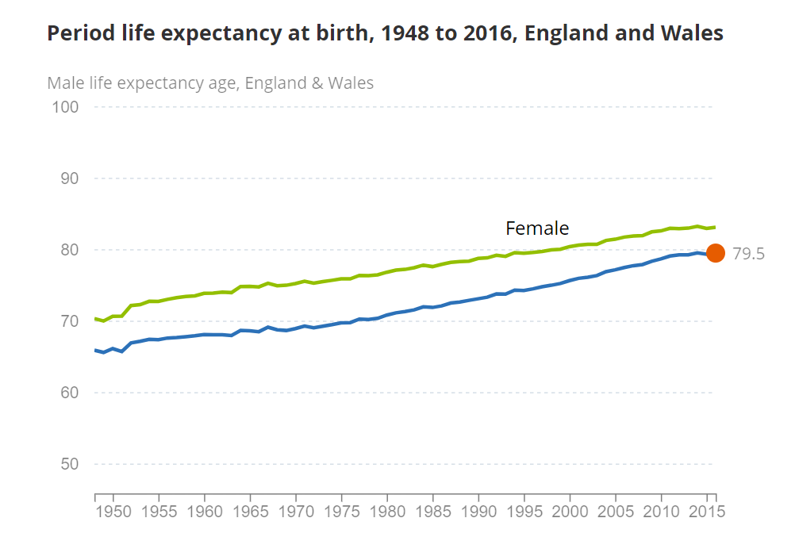
Fig. 1 A chart illustrating the life expectancy since NHS existence (Source: ONS, 2018)
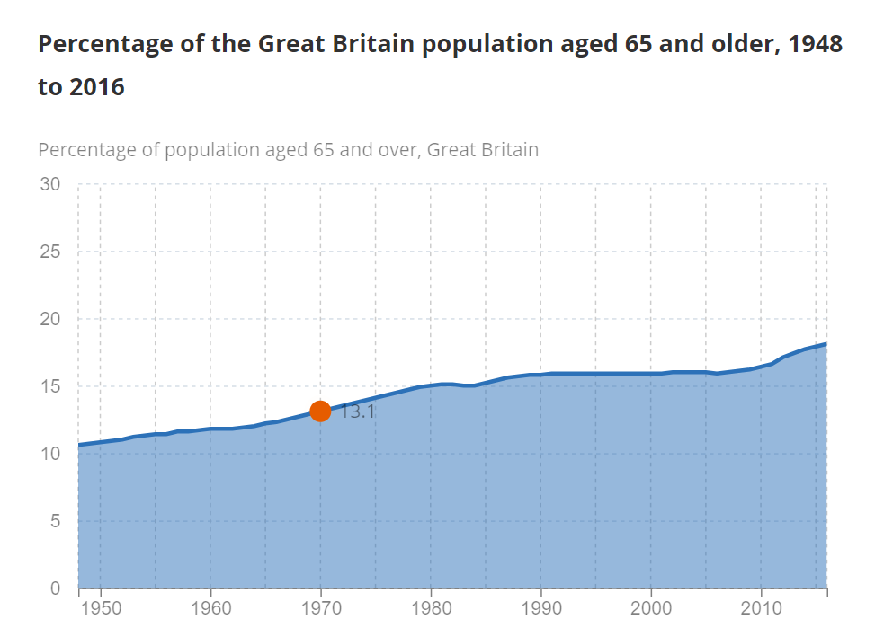

Fig. 2 A chart illustrating the ageing population since NHS existence (Source: ONS, 2018)
Interestingly, the healthcare system cannot produce significant efficiency without an appropriate measure of resources in terms of management, technology, funding and staffing to produce magnificent results similar to Kelly’s et al. (2018) assertion about the NHS. Despite the significant support the trust has from the UK economy and other charities to forfeit improvement to saving lives and other goals, there is an unfulfilled gap in delivery through inadequate funding and lower workforce, impacting productivity.
This paper highlights the significant problems in the healthcare and social care system, effects on the country and recommendations to improve the system for future course. The document also highlights the decision-making, analysis, code of conduct, legislation and diverse avenues required to capture real situations.
The document expresses the appropriate function in each analysis, including PESTLE and fishbone to assess, background of the problems relative to other European and the western healthcare and social care setting, structures involved and the extent of application in a given situation. Elwell-Sutton et al. (2019) support that quality healthcare is paramount to the growth of a nation. However, OECD (2018, p11) agrees that healthcare attention is not only crucial to national development but guarantees nation-building through confidence growth of the ageing population.
The document closes with recommendations appropriate to facilitate the health and social care system to avoid hiccups in the health sector to ensure the smooth running of the nation despite other quality structures already in place to aid effective management.
1.2 BACKGROUND
Health and social care cannot be under-estimated among education, engineering, sciences, medicine, laws, and agriculture as determinants for nation-building (Adeyemo, 2019, p39). Thus, a challenge in the latter draws impact to livelihood, ultimately affecting the intent of the others, ubiquitous to the COVID-19 global pandemic, claiming millions of lives and stalling activities and the economy. NHS Trust oversees healthcare management and day-to-day administration with several employee portfolios under its belt, including consultants, surgeons, doctors, accountants, nurses, midwives, and others. The care system, on the contrary, operates under the directives of the local councils with help from the central government. Although both systems offer support to people's health, social care experiences more considerable pressure.
Holt and Butcher (2020) support that social care is means-tested relative to the healthcare system under the NHS, with lesser support from the central government to bolster the revenue generated from local council taxes. Understandably, the required resources to run hospitals, clinics, and NHS approved centres, including general practices, are higher due to mass technology and equipment, estate maintenance for hospitals, transportation, and logistics. However, data and information published for various councils and charities invite significant funding attention to improve the massive gap within the social care system.
A report forwarded by the House of Commons (2012, p20) admits that funding underpins health and social care quality. The committee added that a desirable need to restructure the budget for social care and an integrated model of care similar to NHS be put in place. Although the central government responded a couple of years after with £2billion to both the NHS and the social care authorities to address the issue, the continuity of formulating a robust integrated care model to make policies to local events remains unchanged. AgeUK (2019) agrees that the country host over 1.5million of the older population whose care assistance are not met, and the figure is expected to rise to over 2 million.
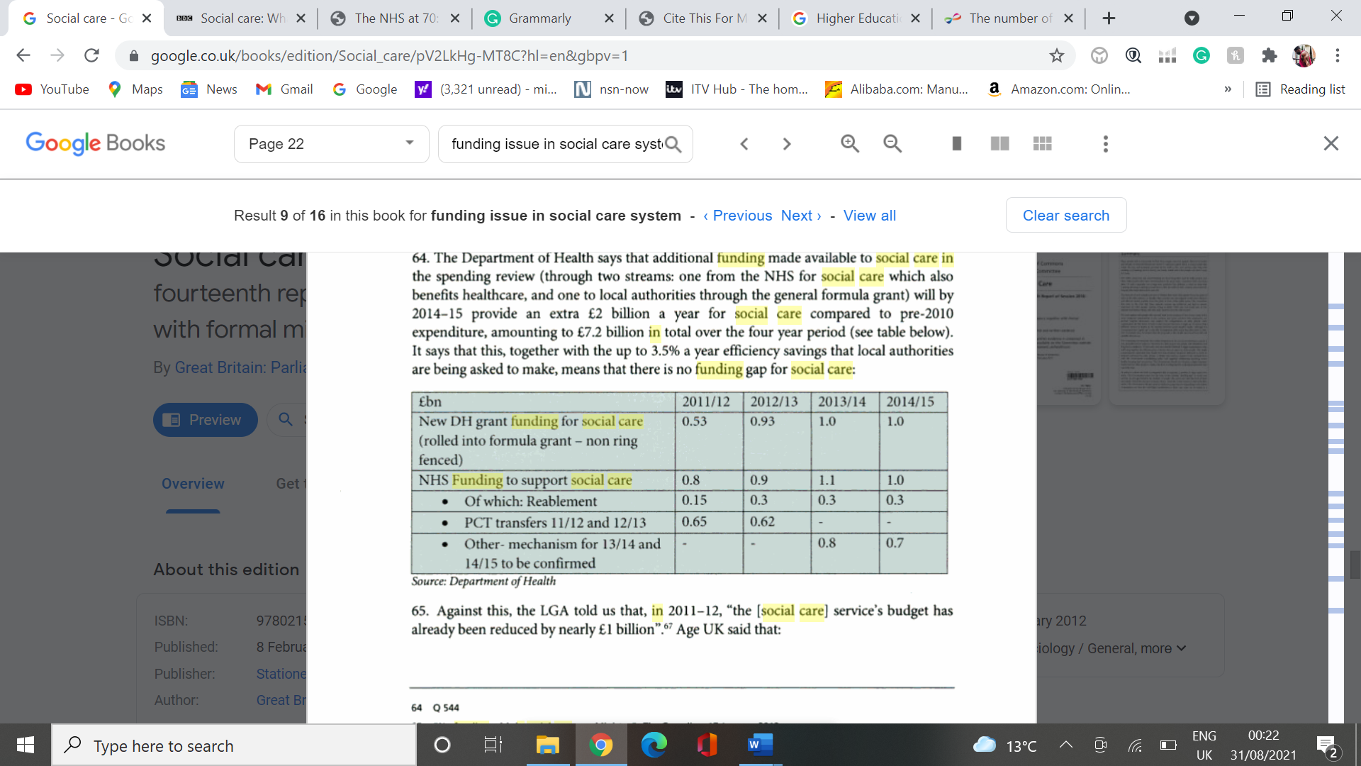
Fig. 3 A table illustrating central government funding towards NHS and Social Care between 2011 to 2015( Source: House of Common, 2012, p 64).
Lack of Workforce
A nation's quest to attain dominance in healthcare demands an enormous collaboration of varieties of experts to amalgamate ideas, policies, and directives to run a centralised system such as the NHS. Described as one of the leading employers in the world, amassing over 1.5 million employees from various functions (Palmer and Rolewicz, 2020), the NHS strives in many ways to fight diseases and formulate other prevention programmes to support poor and needy countries. Supporting the fight against the Ebola disease in West Africa, Sierra Leone typifies an example of NHS contribution to the world outside the UK.
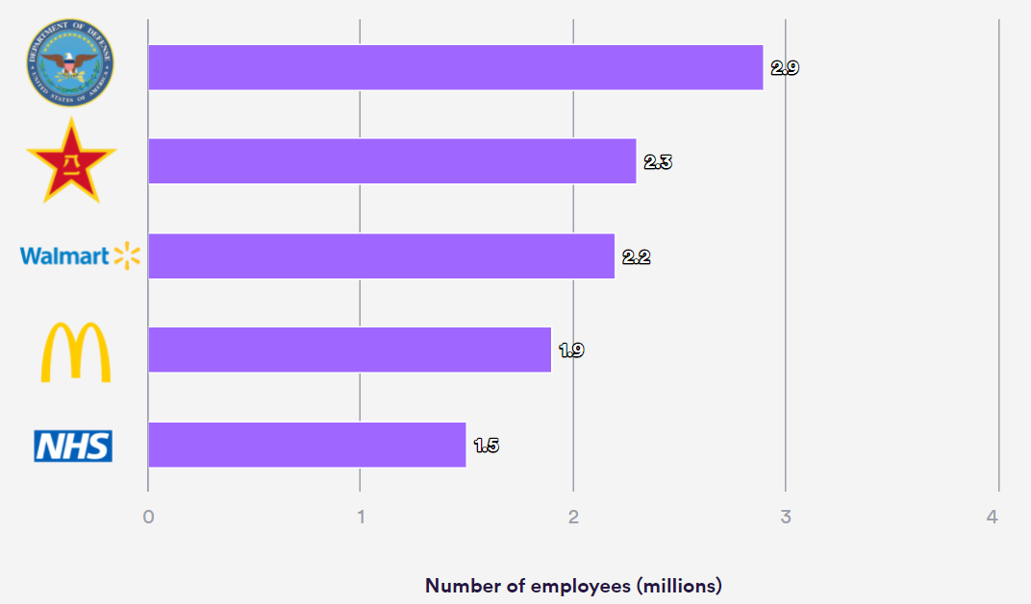
Fig 4. A chart illustrating the world’s largest employers (Source: Nuffieldtrust, 2019)
A social care system represents the existence of providing emotional, social, and physical support to people's livelihood to maintain their dignity, control, and independence (NHS.UK, 2021). To solidify extended healthcare to people, Arts et al. (2013, p39) agree that social care in recent definition offers traditionally assigned healthcare in a social setting while healthcare is progressively committed to detail medical care. An indication that both systems provide longer-lasting ingredients ideal with each other in the wake of modern nation-building. Due to the growing population in old age and the effects of deterioration in their health coupled with caring for the younger and disabled population, the demand for a workforce is on its rise (Kingsfund, 2021).
Although there is a recorded rise in the number of adult social care in England from 1.39 million in 2006/7 to around 1.6 million in 2010 for several reasons, the UK Parliament (2021) agrees that the NHS and social care has reached an unprecedented all-time low in the workforce. It is estimated that several reasons attest that predominantly inadequate workforce planning is the main driver. Likewise, to all businesses, the recent COVID-19 pandemic has significantly contributed to the existing staffing pressure through loss of lives, the phobia to return to a healthcare environment and the personal capacity to cope in another wave similarly in any future breakout of another pandemic.
2. MAIN BODY
Health is wealth and saving lives today secures growth and stability in the economy and ultimately encourage all other functions such as engineering, sciences, laws, entertainment and education in optimal requirement. Therefore, careful measures must be put in place to find problems and seek alternative solutions to reduce or extinct the issue drastically. In reaching out for robust measures to solutions, careful steps need employing to avoid any gaps in decision-making. It is kind that courteous reinforcement is installed to ensure frequent reviews to maintain renewal of the measures against real-time.
The NHS and social care have experienced several challenges which have impacted the healthcare system against successful trajectory over time. However, the few significant problems demanding critical attention, including lack of adequate funding to ensure smooth supply and other implementation coupled with a shortage of working staff, need addressing sooner to avoid institutional mishap.
Indeed, the central government's response to an already proposed recommendation within the healthcare budgeting served a significant boost in 2014/2015 in fig 3. However, the continuity and regular review to match funding newer programmes invite frequent reviews. The discoveries of poor quality at several care homes during the peak of COVID-19 exposed the drivers to why most lives were lost in care homes and hospitals.
2.1 ANALYSIS
In making decisions for effective and reliable healthcare and social care system, there is the need for a root cause analysis to ascertain the associated factors stemming from each identified problem.
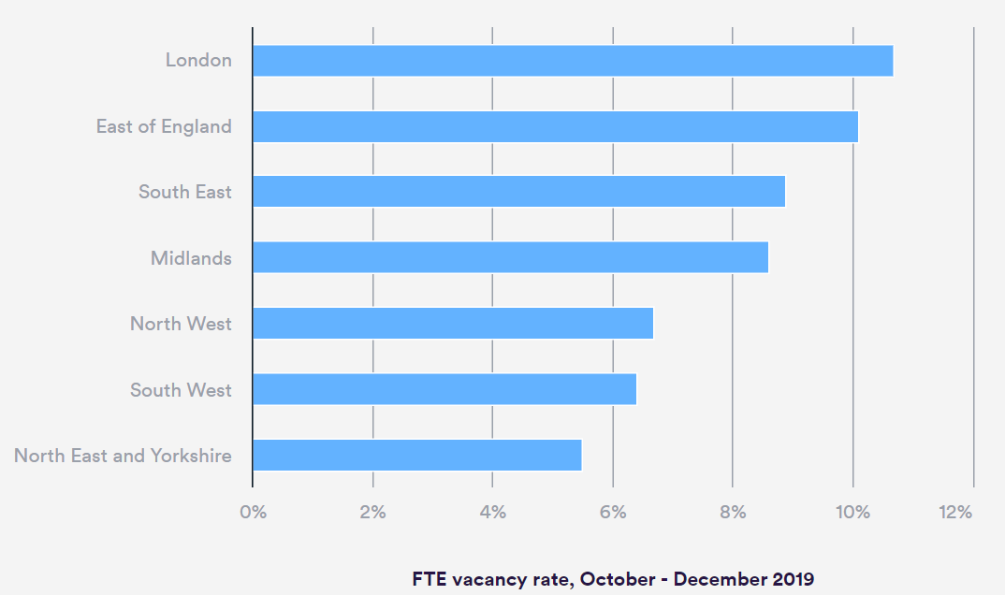
Fig. 5. A chart showing the NHS clinical staff shortages by region (hospital and healthcare services). (Source: Nuffield Trust, 2020)
2.1.1 FISHBONE
Funding
Recruitment
Training
Planning
Appointment
Compliance
Logistics
layout
Building safety
PEOPLE/STAFF
ENVIRONMENT
EQUIPMENT
POLICIES/PROCESS
LACK OF WORKFORCE
Fig. 6. A diagram illustrating the lack of workforce in health and social care system (Source: Author, 2021)
One paramount problem the NHS and the social care faces is lack of workforce within the sector and in drawing analysis from the problem are categorised under the following.
- People / Staff: Organisations survive under vigorous management, nevertheless, without appropriate pointers to manage the inflow, and outflow of employees draw diverse mishaps in reaching organisational success. Among the drivers to staffing issue include the following;
- Recruitment – According to Grove (2020), the NHS is the second largest employer in the UK, posing over 1.2 million in healthcare and 1.5 million in the social care sector. Ideally, such enormous figures could translate into job satisfaction, quality recruitment and role functionality. However, the NHS agrees to shortage of working staff due to the variety of factors highlighting recruitment as a significant drawback in healthcare in fig. 6.
The NHS trust heavily leans on international healthcare migrant professionals from varied countries worldwide who are relatively sieved through a long and vigorous visa application and interviews before assuming roles at respective allocations within the UK. Although outsourcing recruitment is deemed a cheaper option, either via private agencies or NHS trust, nurses, for example, cost the trust around £140,000 per nursing degree apprenticeship scheme relative to an average of £7000 from overseas (Leone, 2020).
The challenge in the process remains the length, frustration, and time frame, justifying recruitment as the number one factor in the shortage of workforce, citing BREXIT and its associated laws as an example.
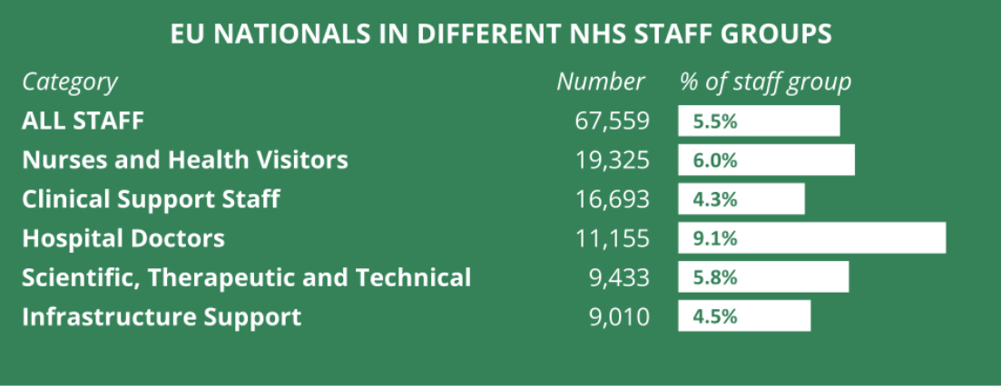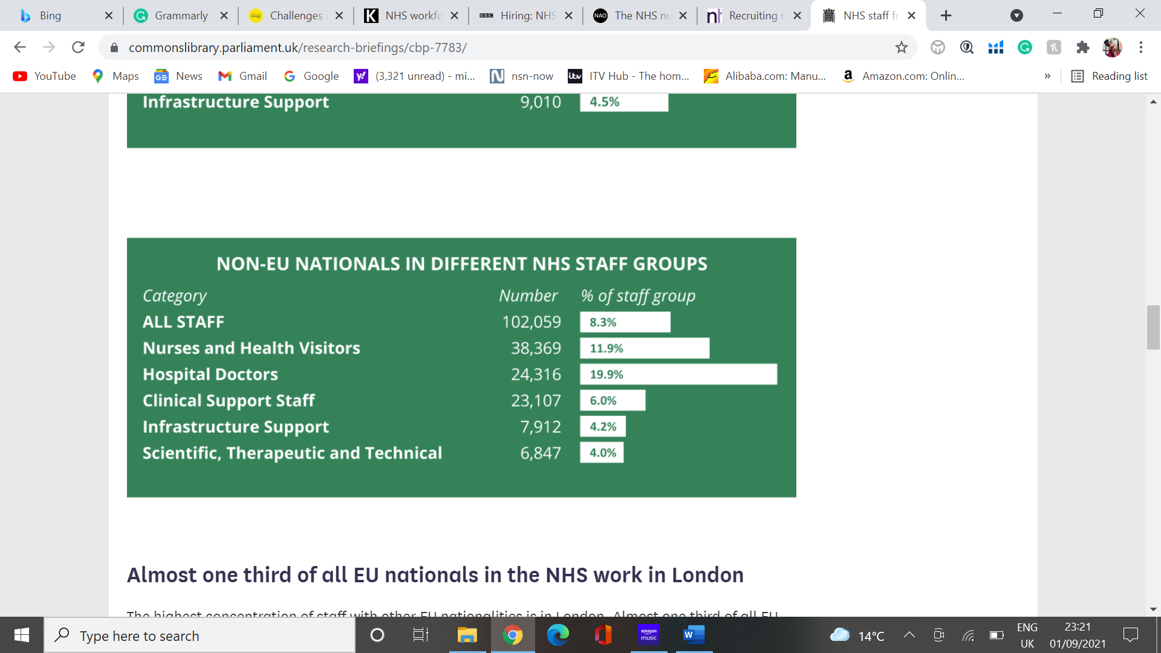
Fig 7. Tables showing the demographics across NHS roles (Source: Baker, 2021).
- Training – Certification to complement professional's currency and competency remain an ultimate dilemma in arriving at a strategic driven programme for both the NHS and the social sector. Basarab-Horwath and Morrison (2005, p17) support that despite the conflicting demands and entitlement to fulfil staffing shifts per situations like the COVID-19 pandemic, it is crucial to remain eligible and competent in the healthcare profession to avoid public scrutiny and reputation, inviting quality and confidence in the public and patient relationship.
Interestingly, the social care benefit from the vast array of in-house refresher programs with a cloud of funding from the central government relative to NHS Trust with an external program to dictate the pace of certification meant to tweak, for example, when political pressure arises. Another vital contributor of this factor is the funding and cost involved to maintain competency to specific function remains a high cost to the Trust.
- Planning – Organisations with apt planning significantly position their companies at a competitive advantage over others within industries. Similar to the business world, there is more strategic planning at the NHS Trust and care authorities orchestrating programmes and policies for most locals and their care homes. NHS as a centralised system operates on fair budgeting and resource allocation with qualified personnel to various regions across the nation based on demands and population.
It is hard to quantify demands to ascertain the necessary logistics and resources such as ambulance vehicles, helicopters and other sophisticated platforms to ease pressure on each region. However, planning becomes hard to facilitate without appropriate extensive data measures, returning massive pressure on fewer professionals to execute without any technological assistance. The lead-on to poor planning ultimately results in mental drainage among the staff and physical breakdown. The COVID-19 pandemic exemplifies a perfect template of the physical pressure the healthcare and social care has and have been experiencing for over a decade. It is fair to state that with the Trust's seventh decade of existence, problems of such calibre would have been ironed yet remain a barrier to the organisation's overall success.

- Appointment – The NHS clinical service operates solely on appointments post triage from the general practitioner to ascertain the priority of injury or illness. Interestingly, most hospitals admit patients based on a treatment from the A and E dependent on the seriousness of the injury or illness. However, the number of illnesses planned on the appointment is consumed, whereas some are unattended, heaping piles of injuries and illnesses in severe conditions after consultation. The reasons for failure to attend could be traffic, forgetfulness, and other activities deemed essential or sheer unwillingness. The reasons ultimately appear to amass incredible pressure and frustrations on the healthcare professionals.
2. PROCESS: It appears the only parameter under the measure for the identified problem is compliance. It is fair to challenge any practice or surgery or individuals whose practices contradict the appropriateness of the quality returns expected of health care or social care. With few other agencies, including care quality and few internal auditors, the national audit office is set up to ensure robust checks to counterbalance any complaints via snap checks, weekly checks, monthly checks, and assurance auditing. Recommendations need to be realistic and practical to capture the interest of care homeowners, local councils, and practices to avoid the total shut down of some homes who may fall culprit to the wrong side.
3. EQUIPMENT: Involved in this part of the analysis are funding and logistics.
- Funding - is crucial to the survival of the health and social care in reaching strategies and future programmes through day-to-day running of hospitals, training of professionals, care homes, investing in technologies and equipment to maintain operational effectiveness. Currently the NHS reports increasing demands of workforce to absorb the sudden surge in appointments accrued as a result of delay in treatment while battling with COVID-19 for the nation. However, funding through increment in salaries, wages and future projections on staffing courses need constant reviewing to arrive at a decision at the earliest convenience with the central government to avoid future gaps during or post pandemic.
- Logistics – Logistics has migrated from an olden traditional concept of demand and supply to a careful, transparent, and more responsive concept of the supply chain where ends of the chain have clear visibility to demands against real-time. In healthcare, there is a constant supply of drugs, medications, PPE, facility furniture, food, and many others depend heavily on quality logistics to achieve success. Nevertheless, regarded as one of the major employers across the globe, the NHS conspicuously lean more on daily logistics through reliable drivers, contractors, and other reliable agencies to ensure smooth running without a dip. The absence of logistics or delay could be catastrophic to the overall success of the health care system. The shortage in PPE during the peak of the COVID-19 pandemic in 2020 highlights why logistics remains a jewellery in the running of health and social care.
4. ENVIRONMENT: Although not a direct contributor to the identified problem, conscious steps are to be taken to reduce the carbon monoxide emissions and other innovations to employ sustainable operation of hospitals, clinics, care homes, and residential homes. It is equally essential that a building or facility's safety and layout comply with an allocated permit and ensure a quality environment.

2.1.2 PESTLE
- POLITICAL: Politics in all positions tend to, directly and indirectly, impact the NHS and social care system. The advent of BREXIT, for example, sought an obscured future in the minds of health professionals with limitations and varied amendments to medications and logistics, especially with equipment imported from the European countries. BREXIT again appear to affect the workforce within the health sector. Part of the reason the NHS pride itself is its employee diversity. It heavily relies on overseas recruitment either via private agencies or the Trust itself. Having BREXIT in place presents enormous paperwork with new policies and visa processing, stretching the interest of professionals and ultimately leaving both parties pressured and frustrated.
- ENVIRONMENTAL: There is increasing awareness and campaigns across the country on the effects of the public smoking lifestyles, carbon monoxides from factories and vehicles, of which the NHS is not new to; with ambulances running in towns and cities all the time, for example. Posing stricter policies and introducing careful strategies into electric vehicles and other better avenues sets the country on an equal page against the fight. The effect of significant environmental hazards presents breathing and respiratory illnesses in the public and absolute pressure on health care.
- SOCIAL: Better healthcare improves livelihood and shifts life expectancy to lower mortality and an ageing population among the British people. On the contrary, the ageing population presents associated diseases like Diabetes, Alzheimer, and Dementia which are the common illnesses among the elderly in social care homes. The effect of the increasing number of the elderly demands a higher number of adult care workers, amassing significant pressure on the recruitment agencies and the NHS Trust to fill the vacancies within the sector.
Another interesting social impact on health and social care is a better care stigma rise due to the influence of social media awareness of information. People in modern Britain are aware of their health and available information, meaning that there is always a bar the public have set to expect, which, when not reached, drastically reduce the confidence in the health care.
- TECHNOLOGY: Relative to the past, technology and innovation has transcended from a complex, cumbersome gadget and obscured interpretation to a more simple, transparent, and more accessible interpretation to detections. The world currently sits on an intelligent platform. Information is easier to acquire and transmit from as little as watches, helping to dictate better lifestyle and education into certain happenings within the human body. Constant innovation within the tech world also requires a heavy budget to purchase and maintain machines and training consultants to look after the equipment.
- ECONOMY: One of the significant contributors of tax into the economy appears to come from the NHS due to a large number of employees under its umbrella spanning from varied roles in logistics, technology, consultants, doctors, nurses, midwives, sonographers, paediatricians, health visitors and many others including cleaners. It is fair to mention that the Trust and a local council responsible for various local care homes require clear and massive funding to enable an optimal delivery in all scopes. With inflation, interest rates and taxes on imported materials and logistics at global customs, there is an ever-growing appetite of demanding funding from the central government to absorb any expenses.
- LEGAL: The nation currently operates under freedom of opinions and speech, presenting an easy platform to query or complain against any consultation an individual receives without any fear. The effect of this draw fair and transparent service from the health professionals and build confidence in the public. However, the unsatisfied patients have the law's support to seek litigation from the court against any rendered treatment for retribution. The NHS is not a stranger to legal battles in courtrooms for various reasons. Despite individual rights at all lengths, the Trust spends an incredible amount of money in court battles which stretches the available funds earmarked for other importance.

3. RECOMMENDATIONS
There is a growing appetite to mould better health and social care in all political manifestos and individual contributions. The tremendous support rallied behind the NHS in the fight against the COVID-19 is of no difference and a symbol of total support towards the Trust in achieving the best health status for the nation. However, in achieving this quest, there are barriers and challenges required to be surmounted.
The document highlights the lack or shortage in the workforce and one of the reasons hails from the recent COVID-19. Although an ever-failing aspect on the lips of all reporters, the following recommendations are aligned to curb the problem;
- Recruitment: It is suggested that careful amendments and constant review be put in place to appropriately lay swift and effective means of the immigration process and visa application to bolster the workforce within the shortest time possible.
- Training: It is recommended that the central government review the budget to the health (NHS) and social care sector to carry out proper certification planning within the appropriate time frame to enable respective professionals to be competent and current to execute specific functions. By doing this, the Trust can ooze immense pressure on professionals, which are meant to break them mentally and emotionally, creating absences and vacancies.
- Funding: It is suggested that the government carefully drafts strategic incentive packages through salary increment on constant reviews, living accommodation reviews and tax reduction to boost the morale of the health and social care professionals.

4. CONCLUSION
Britain sits at a comfortable and better health ranking among other nations like Germany and Canada. There is a need to put careful and thorough checks in vital places to achieve perpetual accolades to maintain such prestige. There is every reason to encourage stringent checks through strong auditing from the national audit office, internal audits from the Trust, and Quality Care controls and policies within the social care sector. It can be concluded that all stakeholders within the health sector, ranging from the central government through the NHS Trust, the healthcare professionals, local authorities, residents to the general public, play a significant part in undertaking a thorough analysis to impact the direction of healthcare effectively.

5. REFERENCES
Adeyemo, K., 2019. Higher education policy in the Philippines and ASEAN integration. 1st ed. Leiden: Brill Sense, p.39.
AgeUk, 2019. The number of older people with some unmet need for care now stands at 1.5 million. [online] Age UK. Available at: <https://www.ageuk.org.uk/latest-press/articles/2019/november/the-number-of-older-people-with-some-unmet-need-for-care-now-stands-at-1.5-million/> [Accessed 27 August 2021].
Baker, C., 2021. NHS staff from overseas: statistics. [online] House of Commons Library. Available at: <https://commonslibrary.parliament.uk/research-briefings/cbp-7783/> [Accessed 27 August 2021].
Committees.parliament.uk. 2021. Overhaul needed to tackle NHS and social care workforce burnout emergency - Committees - UK Parliament. [online] Available at: <https://committees.parliament.uk/committee/81/health-and-social-care-committee/news/155698/overhaul-needed-to-tackle-nhs-and-social-care-workforce-burnout-emergency/> [Accessed 27 August 2021].
Dayan, M., Ward, D., Gardner, T. and Kelly, E., 2018. The NHS is 70. How Good is the NHS?. [online] Nuffieldtrust.org.uk. Available at: <https://www.nuffieldtrust.org.uk/files/2018-06/the-nhs-at-70-how-good-is-the-nhs.pdf> [Accessed 29 August 2021].
Elwell-Sutton, T., Finch, D. and Bibby, J., 2019. The nation's health | The Health Foundation. [online] The Health Foundation. Available at: <https://www.health.org.uk/publications/long-reads/the-nations-health> [Accessed 11 August 2021].
Holt, A. and Butcher, B., 2020. Social care: What are the challenges facing the system?. [online] BBC News. Available at: <https://www.bbc.co.uk/news/health-50377846> [Accessed 27 August 2021].
House of Commons, 2012. Government response to the House of Commons Health Committee report on social care (fourteenth report of session 2010-12). 1st ed. London: The Stationery Office, pp.20-69.
Kingsfund.org.uk. 2021. Social care workforce. [online] Available at: <https://www.kingsfund.org.uk/projects/time-think-differently/trends-workforce-social-care> [Accessed 27 August 2021].
Leone, C., 2020. Recruiting nurses from overseas: the main challenges facing trusts. [online] The Nuffield Trust. Available at: <https://www.nuffieldtrust.org.uk/news-item/recruiting-nurses-from-overseas-the-main-challenges-facing-trusts> [Accessed 27 August 2021].
Muller, R., Arts, W. and Muffels, R., 2001. Solidarity in Health and Social Care in Europe. 1st ed. Dordrecht: Springer Netherlands, p.49.
NHS.uk. 2021. Working in social care. [online] Available at: <https://www.healthcareers.nhs.uk/working-health/working-social-care> [Accessed 27 August 2021].
OECD, 2018. Delivering Quality Health Services: A Global Imperative. 1st ed. Geneva, Switzerland: World Health Organisation, p.11.
Ons.gov.uk. 2018. NHS70: Marking 70 years of the National Health Service - Office for National Statistics. [online] Available at: <https://www.ons.gov.uk/peoplepopulationandcommunity/healthandsocialcare/healthandwellbeing/articles/nhs70marking70yearsofthenationalhealthservice/2018-06-26> [Accessed 29 August 2021].
Rolewicz, L. and Palmer, B., 2020. The NHS workforce in numbers. [online] The Nuffield Trust. Available at: <https://www.nuffieldtrust.org.uk/resource/the-nhs-workforce-in-numbers#1-what-kinds-of-staff-make-up-the-nhs-workforce> [Accessed 31 August 2021].
The Nuffield Trust. 2020. NHS clinical staff shortages by region (hospital and community health services). [online] Available at: <https://www.nuffieldtrust.org.uk/chart/nhs-clinical-staff-shortages-by-region-hospital-and-community-health-services> [Accessed 27 August 2021].

