Ticu Rostas
1907848
Task 1

Effective TEAMWORK and Communication
Tutor: Tim Hopkins

Content

- Introduction……………………………………………………………….2
- Types of Communication…………………………………………… 2
- Communication theories…………………………………………….3
- Theories at workplace/ Personal Experience………………5
- Conclusion………………………………………………………………….6
- References………………………………………………………………….6
- Appendices…………………………………………………………………7

1: Introduction

In the following portfolio, I will be demonstrating my own understanding of the communications skills and theories that we have discussed during the first term of this module -Effective Teamwork and Communication. To do so, I will be briefly analysing how these communication theories are being used at my own workplace and how they could be improved. Likewise, I’ll be including in class exercise as my evidence to show my understanding.

2: Types of Communication

According to Martínez, A. et al (1998) communication means " A way to establish contact with others through ideas, facts, thoughts and behaviours, looking for a reaction to the statement that has been sent”. I believe that this statement covers the basic meaning of what communication means and people what to gain by communicating. Furthermore, there are a range of types of communication that can be used to send the message to obtain a response. Here are some of the types of communications that can be used;

- Verbal communication: Also known as oral communication. It’s the easiest way of communicating and getting feedback.

- Non-verbal communication: In this type of communication the sender does not have to speak in order to send the message across to the other person. For example (appendix A), just by looking at the picture of the baby you can tell She is very upset.
- Written communication: There are a range of written communications that we as people use in day to day bases for example; letters, reports, product information etc. We use this sort of communication to send information from A to B.
- Para verbal: Is the how we say or write the words we use. For example, we had an in-class exercise (Appendix B) where we had to act like we were a Director of communication of an company and we had to send an email to Miss Marry December to aware her that she was chosen to go on a course for non-verbal communication because she was lacking this skill. This is an excellent opportunity to practice how the use Words/ Message/ Media to send across a message to the reader-Mary. This is because the use of words can affect the reader in a different way if you not careful. Therefore, I’ve used email as my form of media to ensure it is formal. I’ve chosen my word very carefully so that She will not feel like she is picked on. Overall the message that I’ve hopefully send to Mary is that course will be a good opportunity to enhance her non-verbal communications skills, to make a better employee.

I believe that communication is one of the most important skills that we as student, teacher, workers should always try to improve. This is because this module taught me that the words, we use not always matches with the message we try to get across to the reader.

3: Communication Theories

During the first term of this module we have mainly been though about the following communication theories; Shannon and Weaver, Schramm and David Berlo

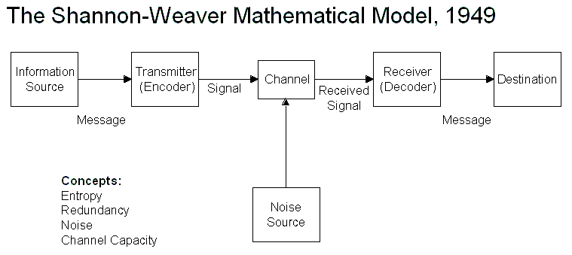
1: Shannon and Weaver (appendix C)
The communication theory of Shannon and Weaver was first presented to the world when two Americans, Claude Elwood Shannon an electronic engineer and mathematician joined with Warren Weaver a scientist in 1949. They both decided to work together to produce the article ‘Bell System Technical Journal” called “A Mathematical Theory of Communication” and also called as “Shannon-Weaver model of communication”.’ (All About Theories for Communication). Furthermore, The Shannon model was designed originally to explain the process of communication that happen whilst using a telephone or computer that can encode the words using codes like binary digits or radio waves.

How Shannon and Weaver describes communication by looking appendix C:
- First starts with the information source (sender) who chooses the encoder (medium/form) to how the receiver will get the message.
- Transmitter (encoder) is the person/ machine chosen by the sender to send the message to the receiver.
- Channel is the medium the sender chooses to use to send the message to the receiver.
- Noise source is anything that can interfere with the message that has been send from the sender to the receiver, for example weak phone signal whilst speaking to someone.
- Decoder the machine which can decode the message sent by the sender.
- Receiver is the person who receives the message that was sent by the sender.
Unfortunately, the Receiver is the end point of Shannon and Weaver. In another words the receiver does not give the sender any feedback after receiving the message. However, an advantage of this model of communication is that it shows how Noise source can have a big impact on how much of the message the receiver gets. For example, during one of our lessons at university we had a case study (appendix D) about a Pedro and Maria his wife. This case study was about Pedro having a conversation over the phone with his wife while working in a construction site. Maria his wife asked Him to buy a chicken on his way home, but the words he understood over the phone were ‘I see you in the kitchen’. He misunderstood his wife mostly like because of the loud environment he was surrounded by. This was my opinion because I personally work in a busy construction site, and I know how hard is to understand things over the phone in such noisy environment.

2. Wilber Schramm model is also known as Osgood and Schramm Model of Communication or Encode-Decode Model of Communication. This theory of communication was first presented in 1954. This was when Schramm ‘suggested that there is a two-way process where the both the sender and receiver take turns to send and receive messages. Likewise, Schramm was well known his book called The Process and Effects of Mass Communications (1961).
Schramm’s Model has different parts for communications where
- Sender is the person who sends the message.
- Encoder is the person who turns the message to be sent into codes.
- Decoder is the person who gets the encoded message which has been sent by the encoder and converts it into the language understandable by the person.
- Interpreter is the person who works to understand and analyse the message. The message is received after interpretation. Interpreter and receiver are the same person.
- Receiver is the person who gets the message. He/she decodes and interprets the actual message.
- Feedback is the process of acknowledging to the received message by the receiver.
- Medium or media is the channel used to send the message (QS Study, n.d)
This communication theory is more focused the interaction that happens between the sender and the receiver. By looking at (appendix E) you can see that theory is in a circular form, suggesting feedback on the message received. Therefore, the receiver becomes the sender (McCabe, 2009). Whereas, the Shannon and Weaver theory diagram describes a one-way system.
In my option, I believe that Schramm model is a better communication theory then Shannon and Weaver. This is because Schramm model shows how the receiver understand the message sent by the sender. Likewise, I believe that as sender you need to know if the receiver successfully receives for message and understands it. This model shows that there are interactions between the sender and receiver. And as a student/work you must interact with the teacher/co-workers to show you understand what the teacher is talking about. Likewise, to show your co-workers that you have understood the task you have been assisted to do.
3. Finally, the third and the last theory of communication that we have been learning about in this module during our first there the theory of Berlo also known as the SMCR (appendix F). SMCR are the 4 main components of this theory-Source, Message, Channel and Receiver (Nazirah A). This theory concentrate on how the sender and receiver should have the same communication stills, knowledge, culture etc. I believe that this theory shows how important it is understanding the content of the message and what you are trying to communicate to the receiver.
For example, one of the case studies (appendix G) which we did as an in-class exercise about Barry and his staff. This case study was about the difficulties that Barry faced as a restaurant manager. One of the problems that Barry had with his staff was language barriers between Him and his staff as many of the them English was not their first language. This case study shows how important Berlo theory of communication is. This is because Barry placed large signs all over the kitchen saying, ‘keep hot food hot and cold food cold’. But because the staff could not read English, they didn’t understand what signs does were saying, therefore they will not know what to do with the cold/hot food. Overall it is very important to be aware of Berlo’s theory to ensure that the person who you are sending the message can understand what you are trying to communicate to him.

4: Theories at workplace/ Personal Experience
I work in the construction industry now, I’m a Crane Supervisor and Slinger signaller. Meaning that my job roles are to ensure that personnel in my lifting team are aware of their job roles, the risks they are placing their self’s and others and what are their daily task. Likewise, I need to make sure that they are working safely using the correct accessories/equipment and ensuring that does equipment’s have a valid date of use.
During work, I communicate via all the three theories of communication that I have discussed above to communicate with my team. As an example, of the theories that I use at work I’ve drawn Shannon and Weaver’s communication process and related it how I give instructions to the Crane operator while lifting with the crane and how the theories of Schramm and Berlo are also used in the process of lifting with the crane (appendix H).
I’ve used Shannon and Weaver’s communication process to show how it applies when doing a lift with the crane.
- Sender will be either a crane supervisor or a slinger.
The message will be then sent by…
- Encoder, by using the radio or hand signals
Hand signals only used if the crane operator can visually see the sender/slinger.
- The channels are either verbal using radio or non-verbal using hand gestures.
- The noise is the site environment e.g. loud drilling, other machinery etc.
- Decoder can be the radio or if the driver can visually see the sender’s message/instruction.
- The recipient is the crane operator.
Then the operator will show that he has received the message/ instruction by moving the crane as instructed by the sender/slinger.
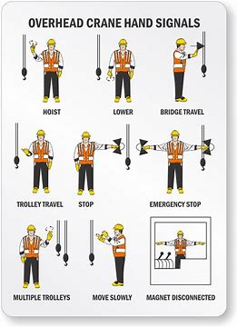
Alongside the Shannon and Weaver theory of communication, Berlo is also implicated while doing the lift. This is because both the sender/slinger and the receiver/operator need to speak the same language, they need to have same knowledge and skills even if the channel of communication is verbal or non-verbal. This is because while using the crane the slinger and operator must know both the commands that will be used during a lift (appendix I).For example, to hoist up via non-verbal channel you must use your index finger pointing toward the sky and moving your hand in circle as shown in the parallel picture.

Likewise, Schramm model of communication is also used. This happens when the crane operator manoeuvres the crane as instructed by the slinger.

In my experience, I believe that the way we communicate at work while carrying out a lift is very important. This is because lifting objects, materials are one of the most dangerous part of construction. Because if anything goes wrong you are not the only one that is in danger but everyone one site and people outside the site. If something falls you never know which direction is going to drop. In my own opinion the use of communication at my workplace well put in place and there’s noting that I could suggest improving the system we use to communicate while lifting with the crane.

5: Conclusion

Overall, this module has helped me understand the process of communication via using the above theories of communication. Likewise, it made me realize how communication in a business organization can affect the business. Furthermore, it made me realise how these theories apply at my own workplace.

6: References

Martínez, A., and Nosnik, A. ‘Practical Organizational Communication’, in Management Manual, Mexico City, Mexico: Editorial Trillas, 1998. https://www.lifepersona.com/definition-of-communication-according-to-5-authors (accessed 27.11.19)
Nazirah Abdullahalim, ‘Berlo Model Dialogue Analysis’ [online] available at: https://www.academia.edu/4871068/Berlo_Model_Dialogue_Analysis, (accessed 10.12.19)
Communication theory (n.d., no author), ‘Shannon and Weaver Model of Communication’ in ‘Communication Models, Interpersonal Communicatio’n, [online] available at:
https://www.communicationtheory.org/shannon-and-weaver-model-of-communication/ (accessed: 01.12.19)
Google books (n.d., no author) ‘Communication Models for the Study of Mass Communications’, [online] available at: https://books.google.co.uk/books?id=rn5ACwAAQBAJ&printsec=frontcover&dq=Communication+Models+for+the+Study+of+Mass+Communications&hl=en&sa=X&redir_esc=y#v=onepage&q=schramm&f=false (McCabe, 2009, p. 27) (accessed: 26.11.19)
My Safety Labels (n.d., no, no author), ‘Crane Warning Labels’, [online] available at:
https://www.mysafetylabels.com/crane-warning-labels ,(accessed:12.12.2019)
QS Study, (n.d., no author) ‘Schramm’s Model of Communication’ , Business Studies at https://www.qsstudy.com/business-studies/schramms-model-communication (accessed 1.12.19)

7: Appendices

A

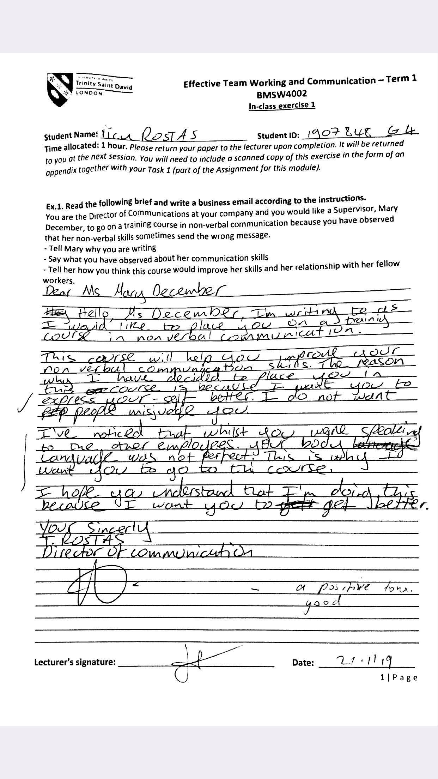
B

C

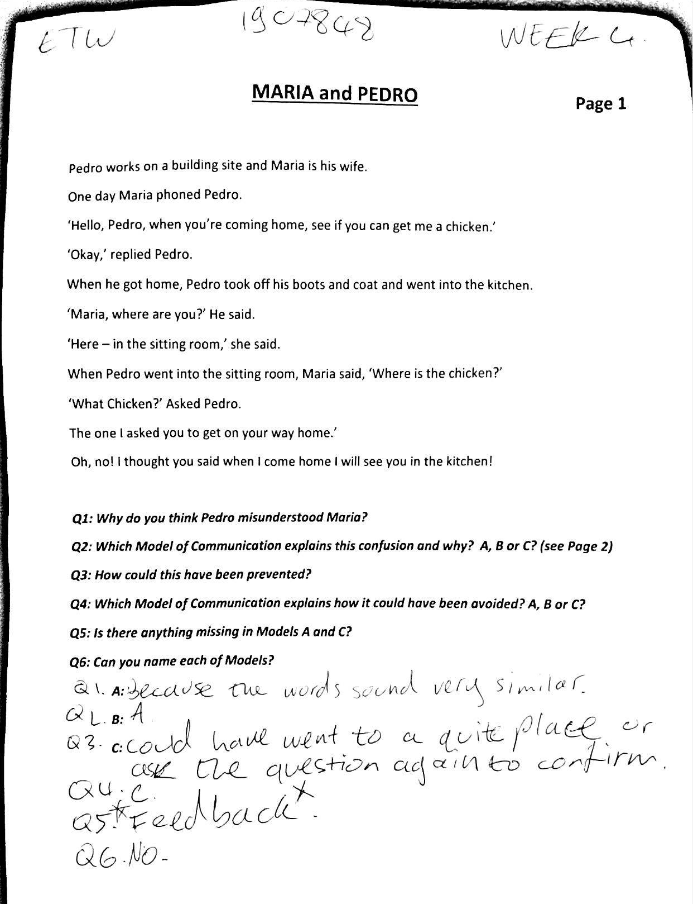
D

E
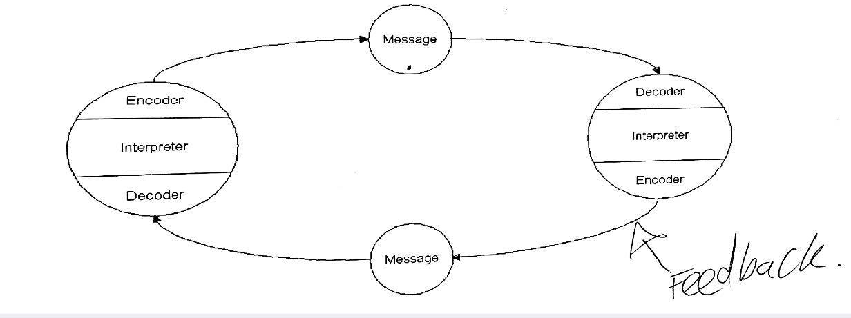

F.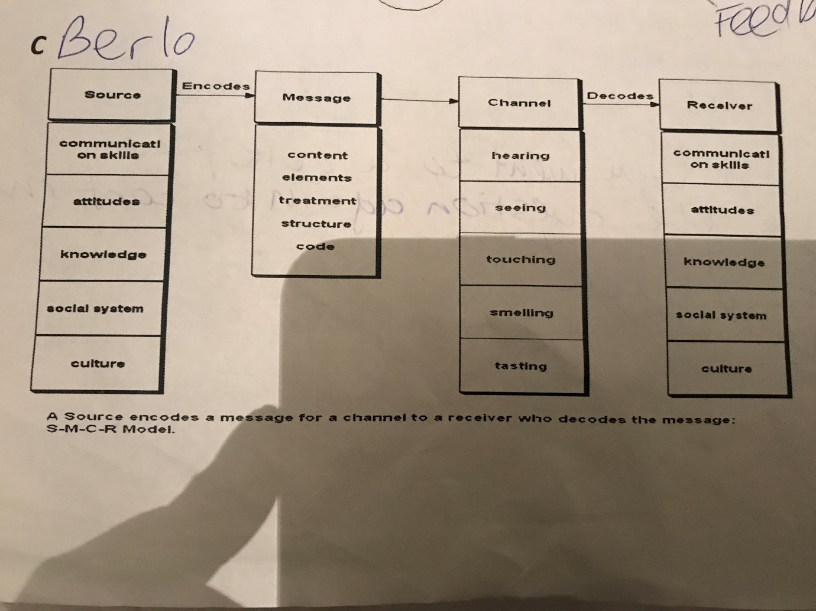

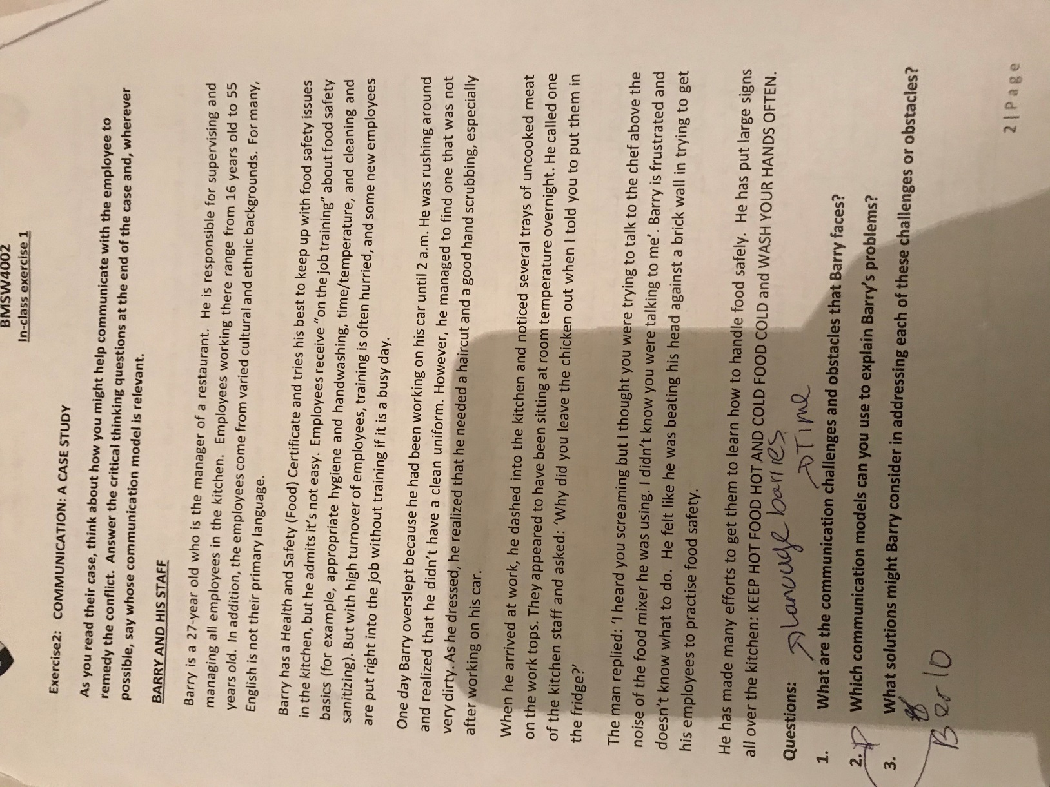
G.

H.
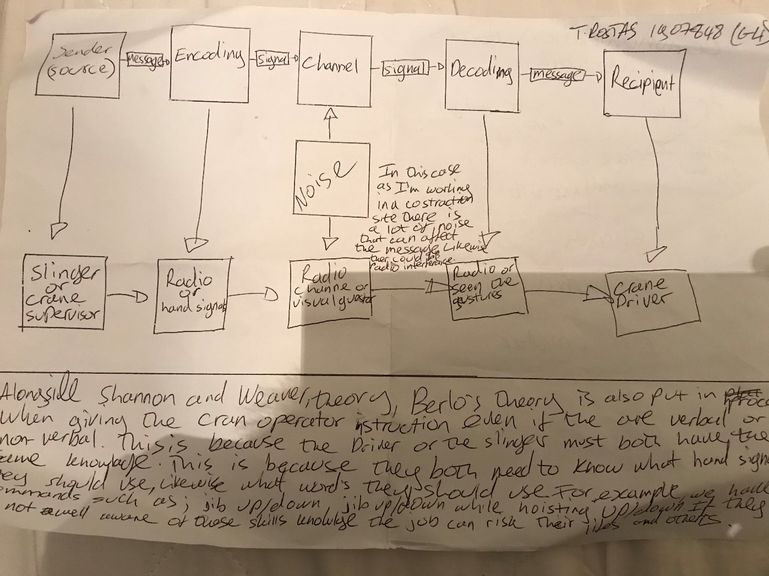

I.



